CLOUDFLARE + WAZUH

Threat Detection &
SOC Monitoring Lab
Step-by-step technical documentation with lab evidence

Project repository | https://github.com/mr-jamal/wazuh-manager-monitoring-lab
Technical article | https://medium.com/@muhammadjamalbakhsh70/building-a-cloudflare-wazuh-threat-detection-lab-on-kali-linux-f22a90870222
Lab environment | Kali Linux + Wazuh + Cloudflare event data
Primary focus | Service health, event inspection, custom rule alert review

Prepared as a portfolio-ready record of the lab evidence supplied.

1. Executive Summary
This project documents a hands-on SOC lab using Wazuh on Kali Linux to inspect Cloudflare security event data. The supplied screenshots show the Wazuh Manager service status, a Wazuh Threat Hunting alert associated with custom rule ID 100500, and the details of a Cloudflare event showing a blocked request to /login.
The objective is to demonstrate a repeatable analyst workflow: confirm that the monitoring service is running, locate an alert, inspect the event fields, and document the evidence. This document distinguishes observed screenshot evidence from steps that a reader may need to configure in their own environment.

2. Project Objectives
- Verify Wazuh Manager service health on the Linux lab machine.
- Review Cloudflare security events surfaced in Wazuh Threat Hunting.
- Inspect a Level 8 alert associated with custom rule ID 100500.
- Review event context such as the action, HTTP path, host, source IP, and rule metadata where available.
- Maintain reproducible documentation for a cybersecurity portfolio.

3. Architecture and Data Flow
At a high level, the lab workflow represented by the evidence is:
Cloudflare  event source | Event collection /  integration | Wazuh Manager  and rules | Threat Hunting  alert view | Analyst  investigation
Note: the screenshots support the presence of Cloudflare event data in Wazuh. The exact transport, collector configuration, and integration implementation should be documented from the actual configuration files if a fully reproducible deployment guide is required.

4. Prerequisites
- A Kali Linux system or VM with the Wazuh Manager package installed.
- Permission to run service status and log commands with sudo.
- Access to the Wazuh dashboard and the Threat Hunting view.
- Cloudflare event data already being forwarded or otherwise ingested into the Wazuh environment.
- A custom Wazuh rule with ID 100500 if reproducing the exact alert shown in the screenshots.
Use only systems, accounts, and event data you are authorized to administer. Avoid publishing API tokens, credentials, private IP details, or sensitive customer data.

5. Step 1 — Check Wazuh Manager Service Status
Open a terminal on the Wazuh Manager host and run:
sudo systemctl status wazuh-manager --no-pager
Interpret the result:
- active (running): the service is currently running.
- inactive (dead): the service is stopped.
- failed: the service failed to start or exited with an error.
If the service is stopped, start it and check again:
sudo systemctl start wazuh-manager
sudo systemctl status wazuh-manager --no-pager
If the service fails, inspect recent logs:
sudo journalctl -u wazuh-manager -n 50 --no-pager
sudo tail -n 50 /var/ossec/logs/ossec.log
Evidence: the supplied service screenshot shows the Wazuh Manager in active (running) state at the time captured.
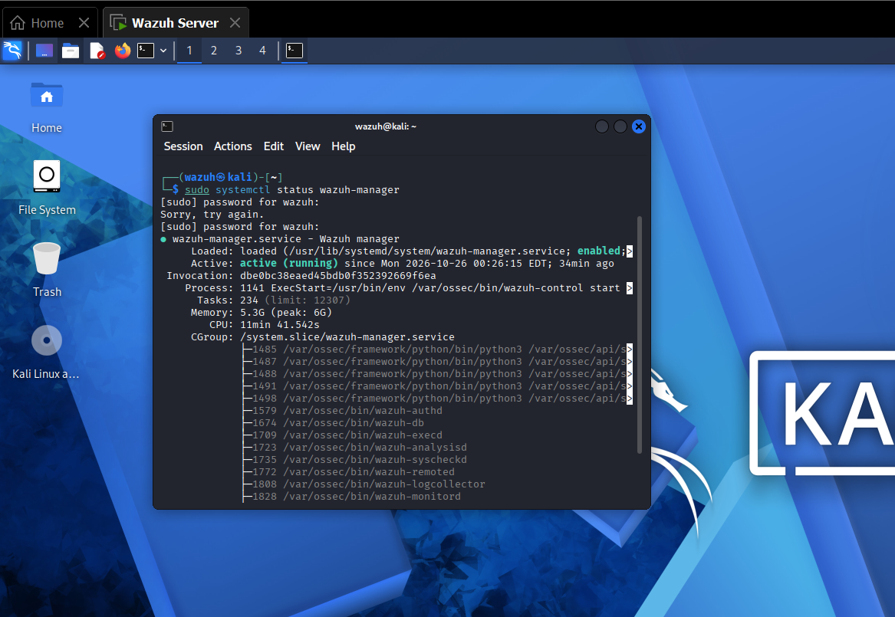
Figure 1. Supplied screenshot of Wazuh Manager service status.

6. Step 2 — Open Wazuh Threat Hunting
Sign in to the Wazuh dashboard, open Threat Hunting (the precise menu label can vary by Wazuh version), and set a suitable time range covering the event. Search or filter by rule ID 100500 when that field is available.
Review the alert row and note the timestamp, rule ID, rule level, description, and any integration or data-source fields shown.
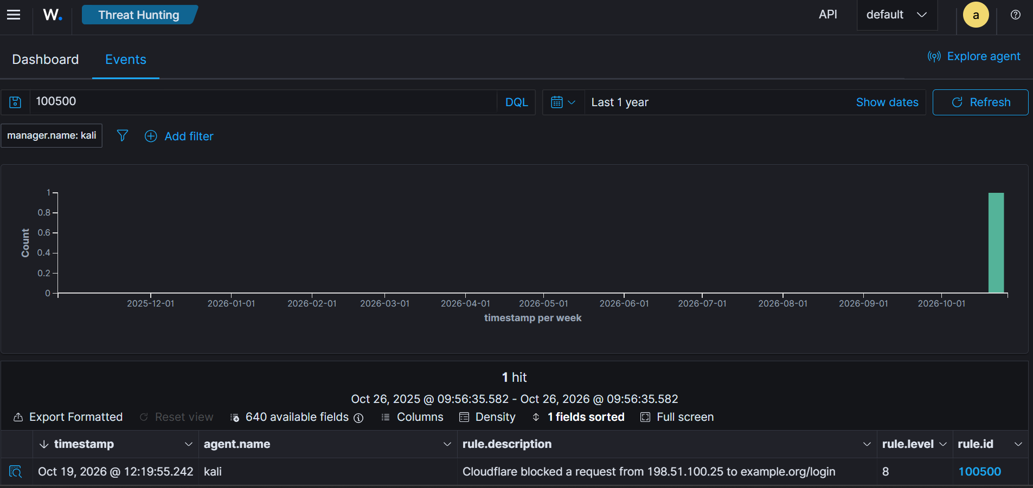
Figure 2. Supplied screenshot of the Wazuh alert / Threat Hunting view.

7. Step 3 — Inspect Alert Details
Open the alert or its document/details view. Inspect the underlying event rather than relying on severity alone. Based on the supplied project notes and screenshots, the observed event was associated with Cloudflare, a blocked request to /login, custom rule ID 100500, and a Level 8 alert.
When reviewing an event, capture these fields where present:
- Timestamp and timezone
- Rule ID, rule level, and rule description
- Event source or integration name
- Recorded action (for example, block)
- HTTP host and request path
- Source IP and any other useful network context
The address 198.51.100.25 is within a documentation-reserved IPv4 range. If that value appears in the sample event, do not describe it as a verified real attacker IP.
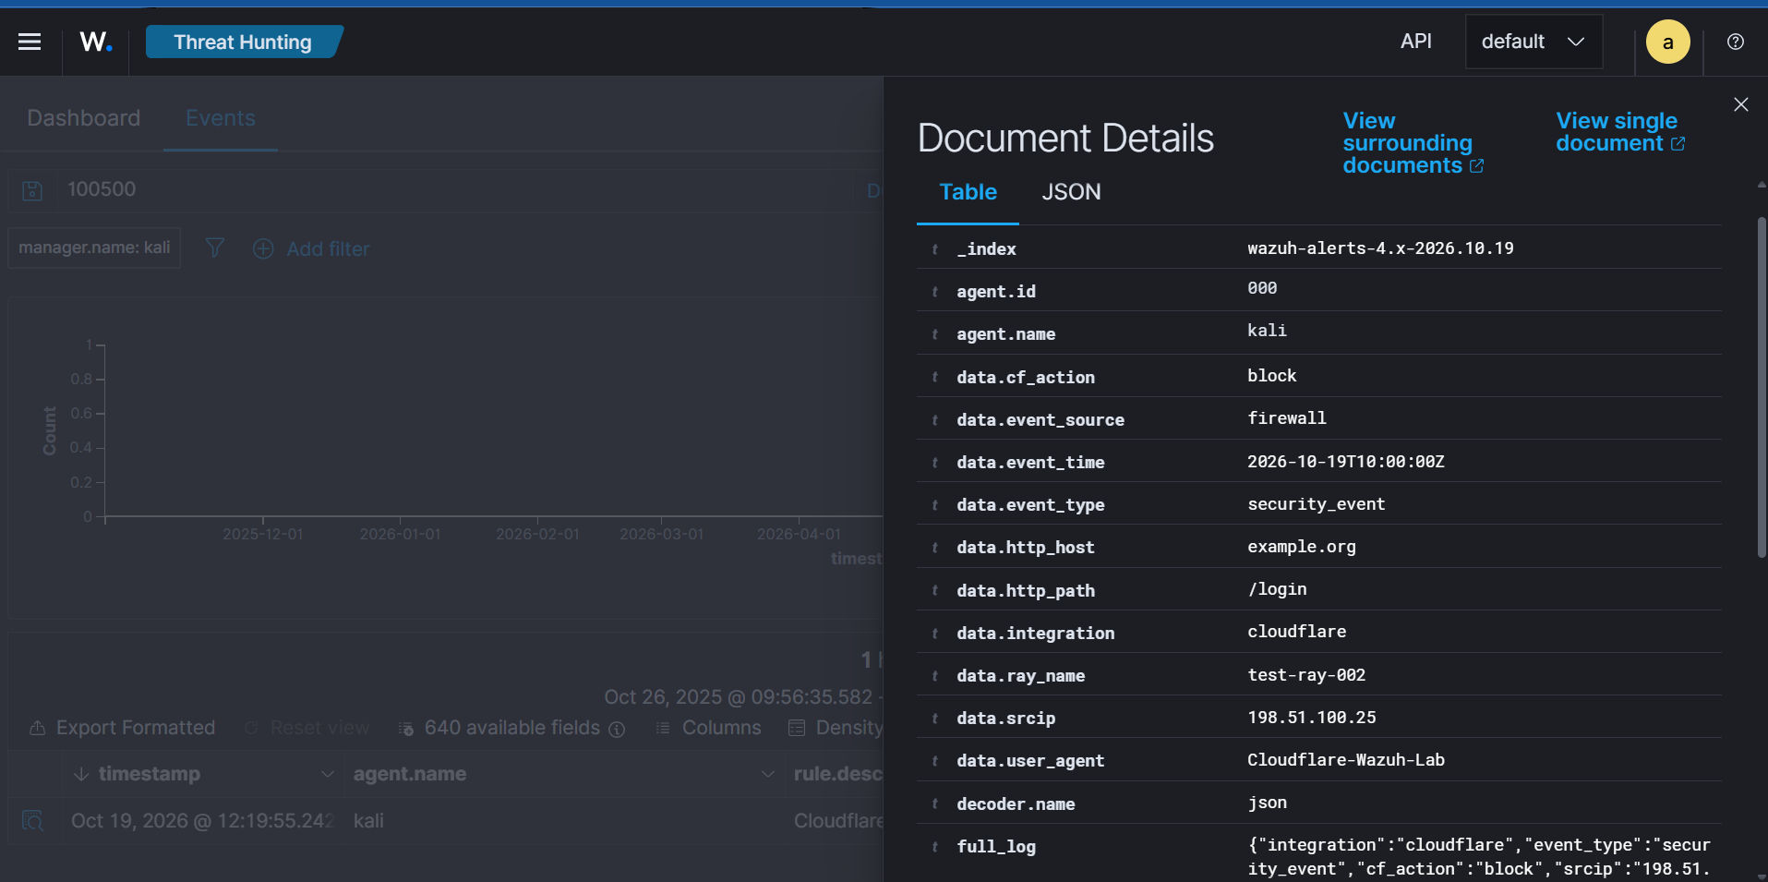
Figure 3. Supplied screenshot of Cloudflare event details.

8. Step 4 — Understand the Custom Rule
The evidence identifies custom rule ID 100500 and shows a Level 8 alert. The actual rule XML/YAML and decoder configuration were not included with the screenshots, so this document does not invent the rule logic. To make the project fully reproducible, add the exact rule definition and explain which event fields it matches.
On a typical Wazuh manager, local rules are commonly maintained in:
/var/ossec/etc/rules/local_rules.xml
Inspect the file and search for the rule ID:
sudo grep -n -A 20 -B 5 '100500' /var/ossec/etc/rules/local_rules.xml
Only edit the rule if you understand the matching conditions and have a backup. After a rule change, validate configuration and restart/reload services only according to the procedure supported by your installed Wazuh version. Do not copy a generic rule and assume it matches your Cloudflare event; verify it against the actual event fields.

9. Step 5 — Troubleshooting Checklist
Symptom | Checks
Manager is inactive or failed | Run systemctl status and journalctl commands; inspect /var/ossec/logs/ossec.log.
No recent alerts appear | Expand the dashboard time range; verify the manager is running and event ingestion is healthy.
Cloudflare events are missing | Verify the configured collection/integration path and inspect relevant integration logs/configuration.
Rule 100500 does not match | Confirm the rule exists, its conditions match the actual event fields, and the alert is not filtered out.
Images do not display on GitHub | Ensure the README image paths and filenames exactly match the committed files.

10. Results and Evidence
- Wazuh Manager status was shown as active (running) in the supplied screenshot.
- A Level 8 alert associated with custom rule 100500 was visible in Wazuh Threat Hunting.
- The event details showed a Cloudflare-related blocked request to /login.
- The evidence demonstrates basic service validation and alert triage in a lab environment.
These results are limited to what the screenshots demonstrate. They do not independently prove a production deployment, comprehensive detection coverage, or a confirmed real-world attack.

11. Portfolio Links
GitHub repository: https://github.com/mr-jamal/wazuh-manager-monitoring-lab
Medium walkthrough: https://medium.com/@muhammadjamalbakhsh70/building-a-cloudflare-wazuh-threat-detection-lab-on-kali-linux-f22a90870222

12. Recommended Improvements
- Add a sanitized copy of the exact custom rule 100500 and explain each matching condition.
- Document the actual Cloudflare-to-Wazuh ingestion method and configuration used.
- Include a small test matrix with event input, expected rule, actual alert, and outcome.
- Record software versions and lab topology so another analyst can reproduce the result.
- Redact credentials, API tokens, account identifiers, and sensitive IP information before sharing screenshots.

Appendix A — Quick Commands
sudo systemctl status wazuh-manager --no-pager
sudo systemctl is-active wazuh-manager
sudo journalctl -u wazuh-manager -n 50 --no-pager
sudo tail -n 50 /var/ossec/logs/ossec.log
sudo grep -n -A 20 -B 5 '100500' /var/ossec/etc/rules/local_rules.xml

Appendix B — Combined Evidence Overview
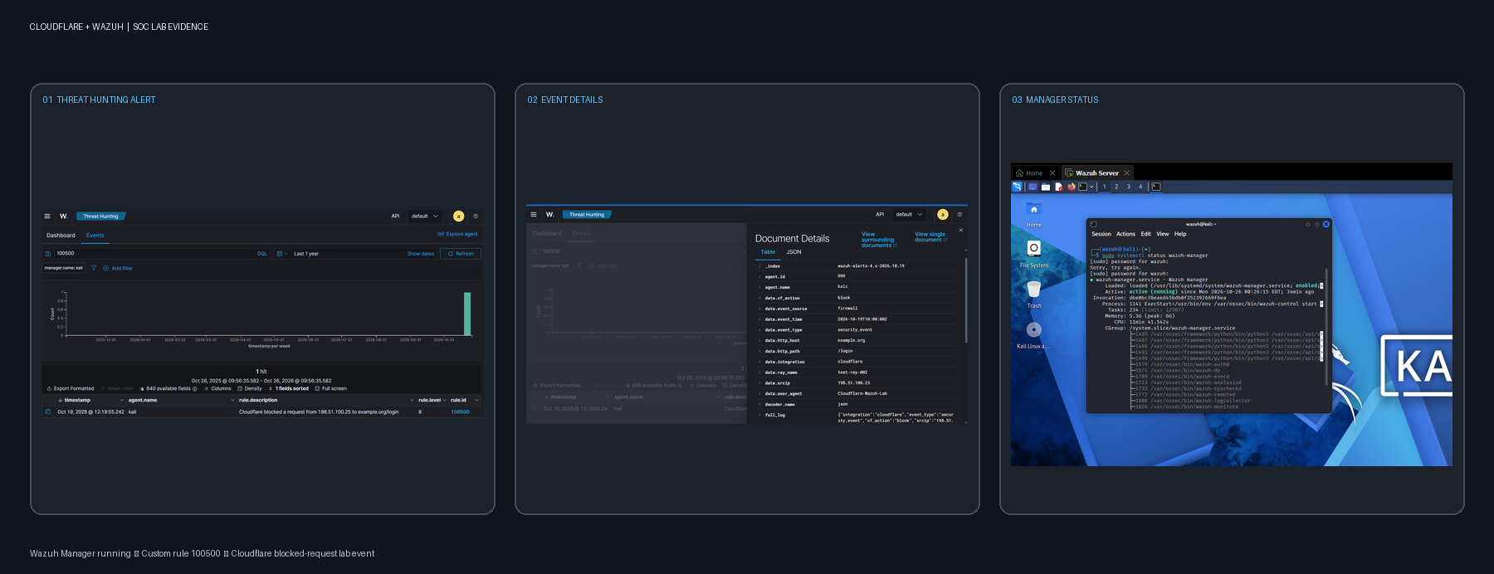
Figure 4. Combined screenshot overview prepared from the supplied lab screenshots.

End of documentation

