This document convers configuration of lambda and cloud watch scheduling for current project. It is divided in 2 configuration sections (Lambda Setup and cloud watch Setup).

Lambda Setup – Perform following steps to setup current project as lambda function.

1. Create jar of current project. Make sure all dependent libraries and config.properties are in jar.
2. Login to AWS – Go to Lambda, click create function -> Author from Scratch and enter details as follows –

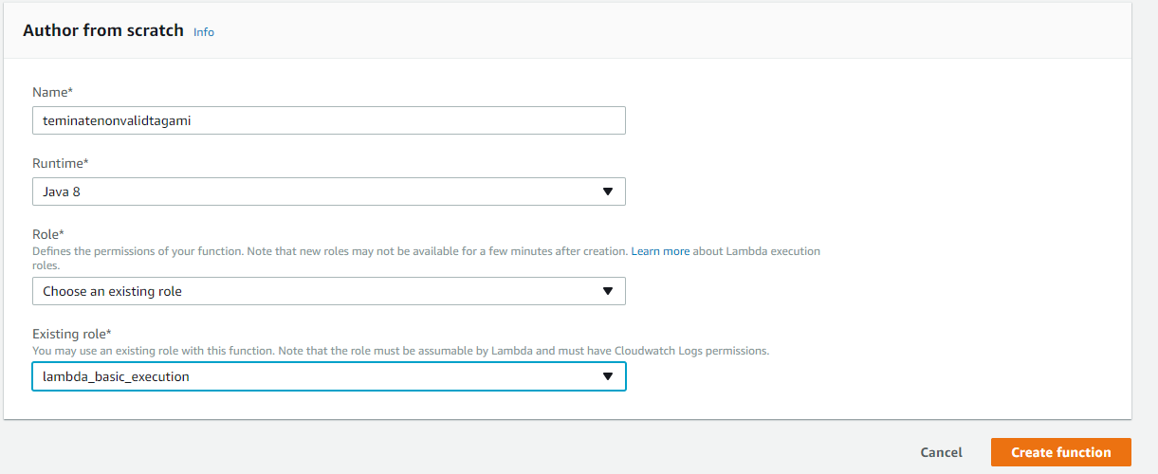

Name – Name of the function you want refer to

Runtime – Java 8

Role – Create a role (Create a custom role) or choose existing role.

Click Create function when done.

1. Scroll down (Skip trigger configuration) – Enter following -

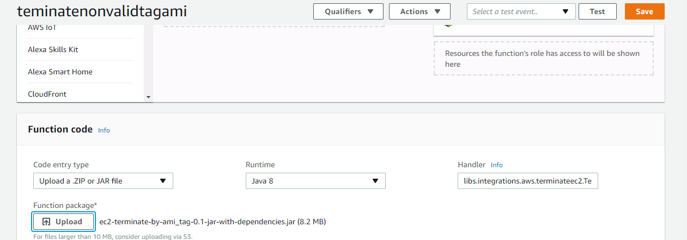

Provide name of handler which in this is libs.integrations.aws.terminateec2.TerminateNotMatchingAMITag::terminateInvalidTagInstances

Also, click upload and select jar file containing libs and configurations

1. Scroll down – and provide memory details –

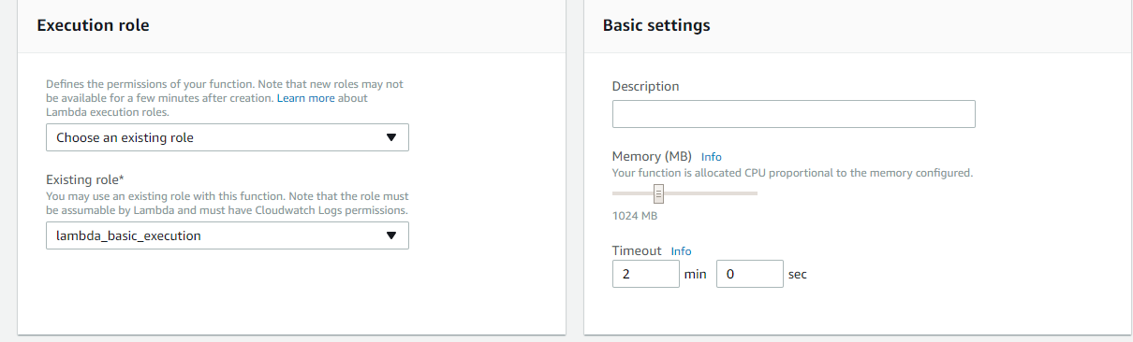

Here we provided memory and time lambda function can take before timed out.

You can setup other resources as well like tags, Network (VPC), DLQ resources. For this example just click save.

Cloud Watch Setup – Perform following steps to invoke above lambda every 10 min.

1. Go to CloudWatch

Click Rules and Create Rule button. You will see something like this. Select Schedule from the radio button.

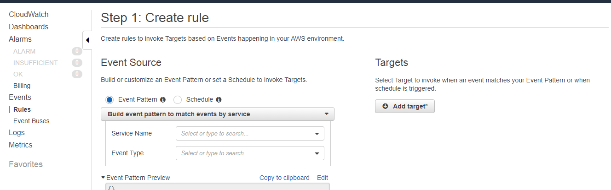

1. You will see something like this – enter value as shown in figure.

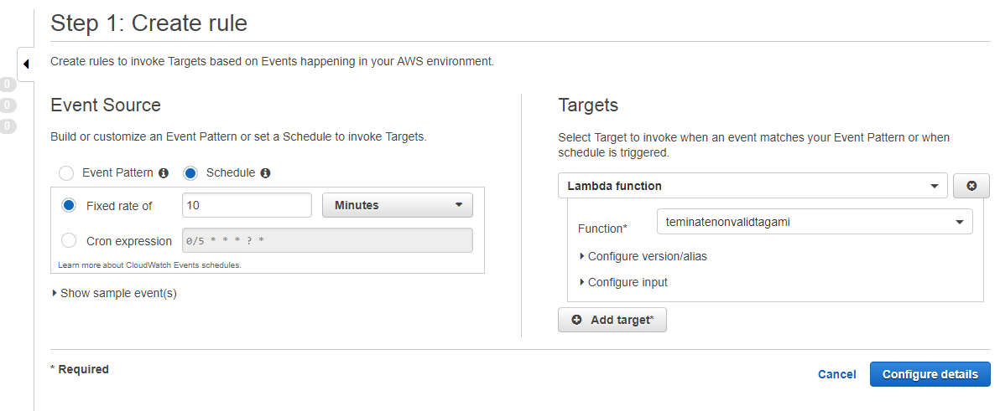

Select the lambda function you created. Click Configure details.

Provide name of rules and click create Rule.

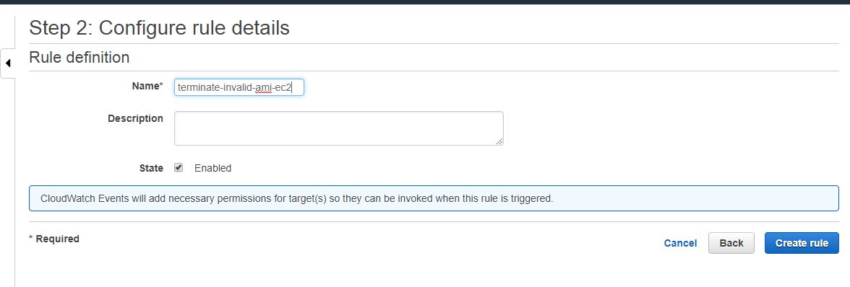

This finishes the setup, your lambda will be called every 10 minutes.

**Refer to README and Javadoc before creating and applying above steps.**