1. Lambda Setup – like other lambda examples. Choose VPC and subnet where elastic cache cluster will be running

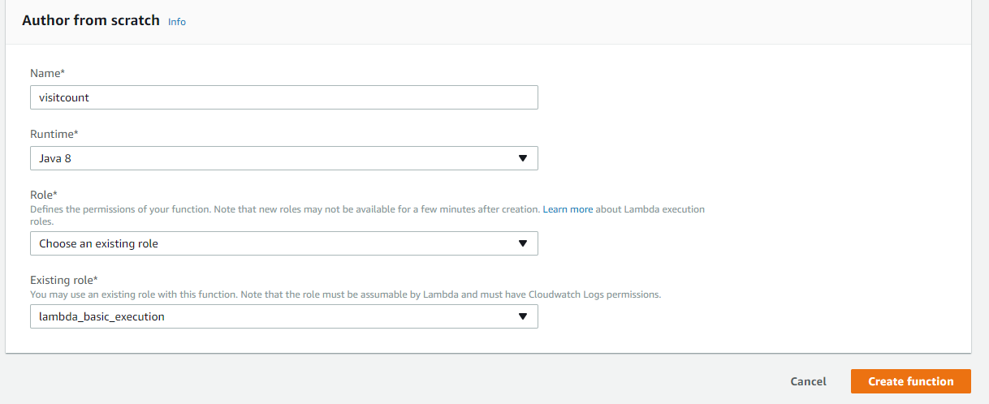

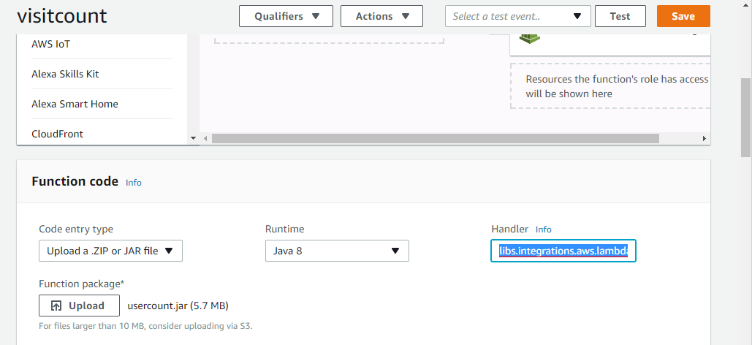

* Handler - libs.java.aws.lambda.apigateway.uservisit. UserHandler::visit

1. API Gateway –

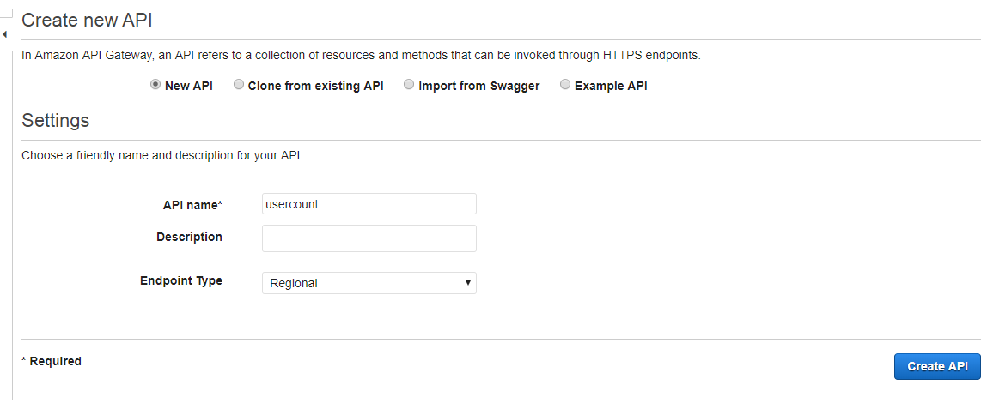

Select Action, Create Method – Select GET. Provide following information –

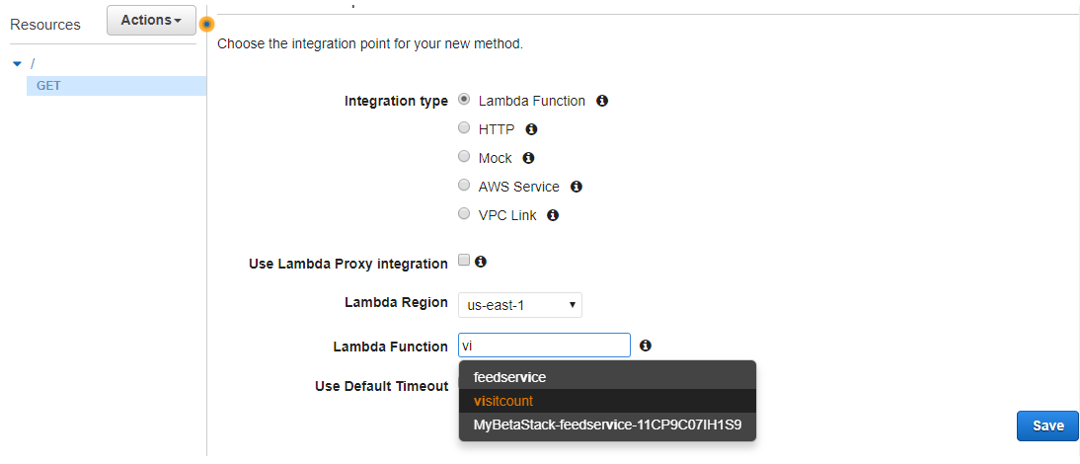

Click Method Request and go to URL Query String Parameters and provide user query string –

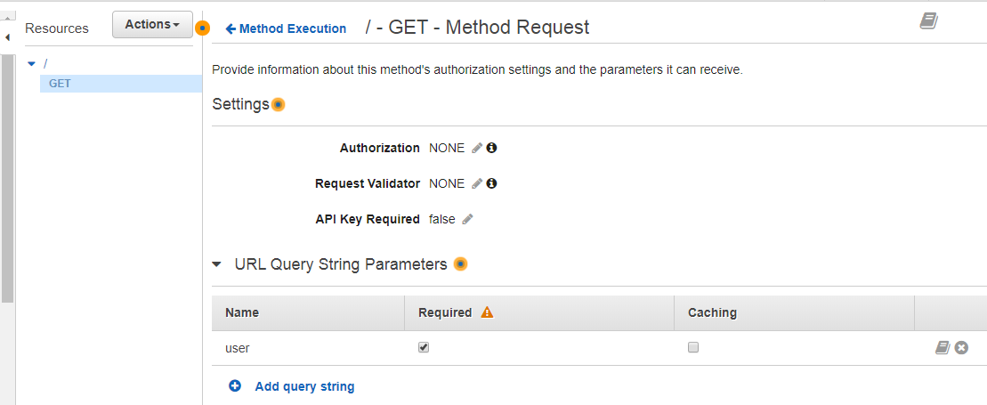

Click Integration Request

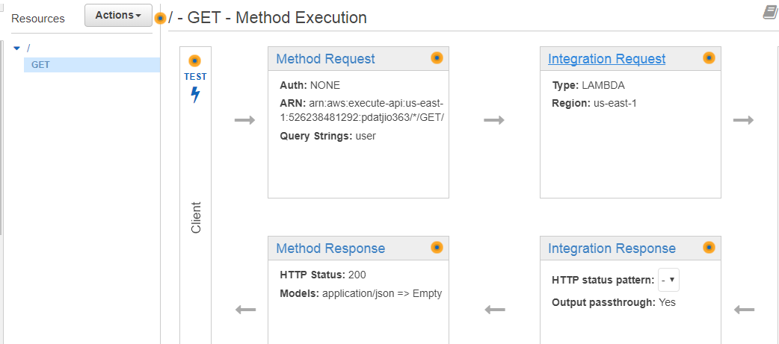

Enter information as below –

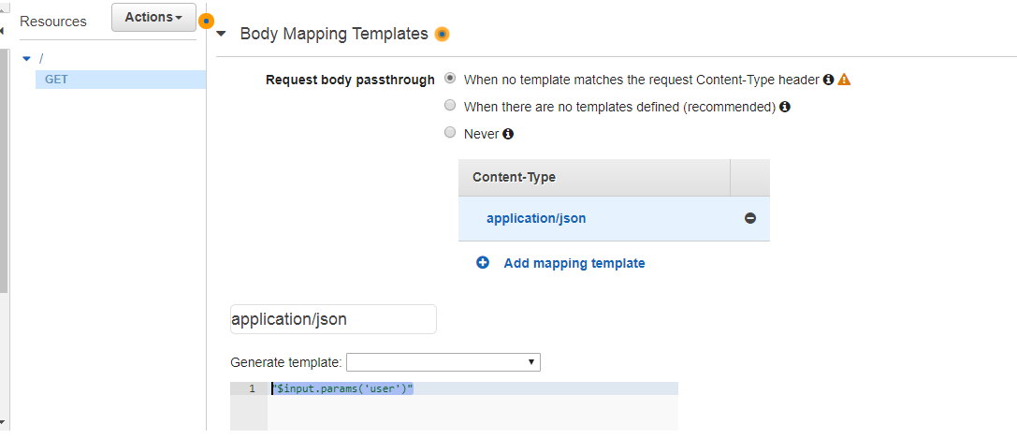

Finally Deploy API, create or select a stage

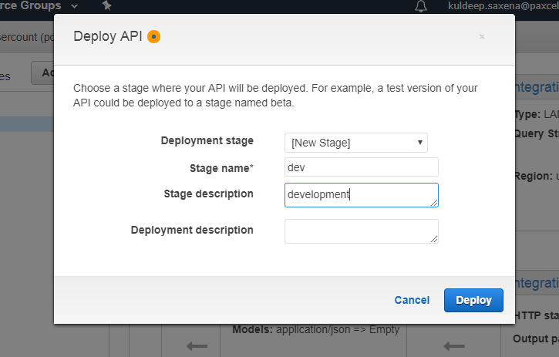

After deployment you will see a URL to invoke to.

3. Elastic Cache cluster setup –

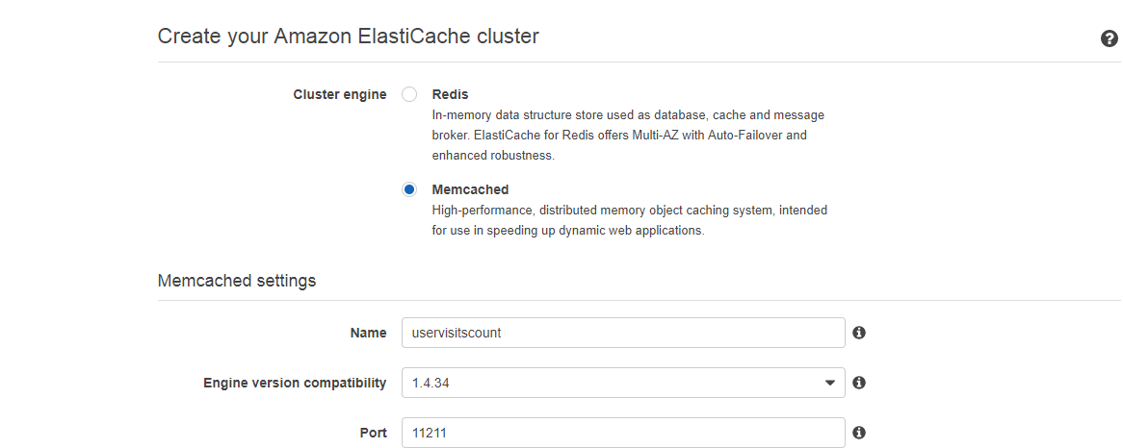

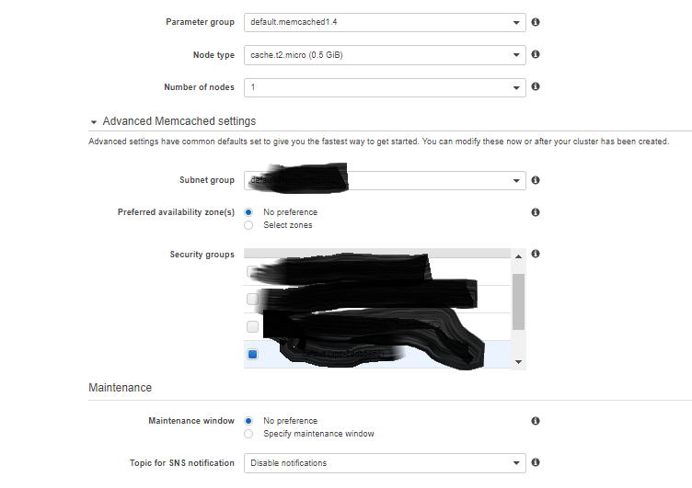

Make sure you select same VPC and subnet where lambda is running, such that lambda can connect to cluster.

Click create.

