Independent reanalysis of the cocaine-exposed Drosophila brain: the atlas reproduces, but sex markers do not agree with the deposited sample labels
Mahabubur Rahman
Student Project 2 — scRNA-seq reanalysis of GSE152495
September 2026
Repository: https://github.com/mr-mahabubur-rahman/project2_drosophila_brain

Abstract
Acute cocaine consumption is reported to alter gene expression across the Drosophila melanogaster brain in a cell-type-specific and sexually dimorphic manner (Baker et al. 2021). We reanalysed the underlying single-cell data (GEO: GSE152495; eight samples, sex × treatment × two biological replicates) using an independent Scanpy-based pipeline.
Quality filtering retained 86,177 cells against the 86,224 reported, a difference of 0.05%. Leiden clustering at the published resolution yielded 30 clusters rather than 36; a resolution sweep reached 36 at approximately 1.33, and the reported plateau in cluster number at resolution 0.8 was not observed. Twenty-four clusters were assigned cell-type identities from two independent marker panels, recovering populations corresponding to Kenyon cells, surface glia and the paper's unannotated antennal/optic lobe cluster.
Three errors in the supplied data were identified and corrected before analysis: space-delimited features.tsv.gz files that prevent gene-symbol assignment; the gene nanchung (nan), which pandas parses as a missing value; and five fly symbols replaced by vertebrate ortholog names in the reference, one of which (trh = trachealess) would cause a cluster to be misidentified as serotonergic under case-insensitive matching.
Differential expression could not be interpreted as a treatment effect. Sex-specific markers do not agree with the deposited sex labels: roX1 and roX2 read 3.85–3.97 and 2.16–2.40 in all four sucrose samples and 0.06–0.12 and 0.008–0.015 in all four cocaine samples, while Yp1–Yp3 show the reverse. The split follows treatment, crossing both declared sexes. Consequently, when cocaine is compared with sucrose within each declared sex, the sex markers appear among the most significant genes in both comparisons — roX1 and roX2 at approximately −9.5 log₂FC with adjusted p below machine precision.
Sample identities were verified three ways: per-sample cell counts in Supplemental Table S2 match all eight deposited matrices exactly (total 88,991); the GEO sample titles agree; and the authors' Supplemental Code documents the same assignment from CellRanger output directory through to the Seurat objects. The discrepancy therefore did not arise during analysis or deposition.
We report the reproduction results, document the discrepancy in full, and refrain from interpreting any differential expression result as a cocaine effect. Resolving the discrepancy requires information not contained in the deposited data.
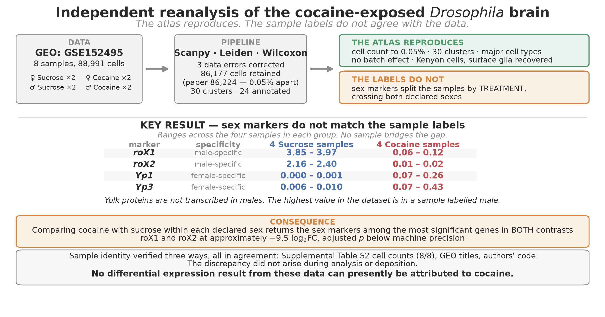
Figure 1. Graphical abstract. Overview of the data, pipeline, what reproduces, and the sex-marker discrepancy.

1. Introduction

1.1 Drosophila as a model for psychostimulant response
Cocaine acts on the vertebrate nervous system principally by blocking monoamine reuptake, elevating synaptic dopamine, serotonin and noradrenaline. The molecular targets of this action are conserved well beyond vertebrates. Drosophila melanogaster possesses a dopamine transporter whose crystal structure accommodates cocaine (Wang et al. 2015), a cocaine-sensitive serotonin transporter (Corey et al. 1994), and a vesicular monoamine transporter whose overexpression attenuates behavioural responses to the drug (Chang et al. 2006). Roughly 75% of human disease-associated genes have fly orthologs (Pandey and Nichols 2011).
Behaviourally, flies exposed to cocaine show impaired negative geotaxis, reduced startle responses, increased grooming and, at higher exposures, seizures (McClung and Hirsh 1998; Filošević et al. 2018). Repeated intermittent exposure produces sensitisation. These phenotypes are sexually dimorphic: male flies show greater locomotor impairment and more pronounced compulsive grooming than females (Baker et al. 2021), paralleling sex differences in human psychostimulant use, where women escalate to compulsive use more rapidly (Becker and Koob 2016) and, after the same intranasal dose, reach lower peak plasma cocaine levels than men (Lukas et al. 1996).
The genetic architecture of cocaine consumption in flies has been mapped using the Drosophila Genetic Reference Panel, implicating dopaminergic neurons and the mushroom bodies — the central integrative structures underlying experience-dependent modification of behaviour (Highfill et al. 2019). Notably, RNAi knockdown in glia also altered consumption, indicating that the response is not confined to neurons.

1.2 Why single-cell resolution
Bulk transcriptomic profiling of whole brain averages expression across every cell type present. A response confined to one population — Kenyon cells, say, or surface glia — is diluted by the tens of thousands of cells that do not respond, and may fall below detection entirely. Worse, opposing responses in different cell types can cancel, producing an apparent absence of effect where substantial regulation is occurring.
Single-cell RNA sequencing removes this averaging. The adult fly brain is small enough (~100,000 cells) that the entire organ can be surveyed in a single experiment, and reference atlases of the aging and midbrain transcriptome already exist (Davie et al. 2018; Croset et al. 2018). This makes Drosophila unusually well suited to asking which cell populations respond to an acute drug exposure, rather than merely whether the brain as a whole does.

1.3 The dataset reanalysed here
Baker et al. (2021, Genome Research 31:1927–1937) applied this approach to acute cocaine consumption. Flies of both sexes consumed a fixed volume of sucrose or cocaine-supplemented sucrose in a capillary feeder assay; brains were dissected immediately and dissociated for 10x Genomics sequencing, in duplicate, giving eight samples in a 2 × 2 × 2 design. Unsupervised clustering of 86,224 cells yielded 36 populations spanning the major neuronal and glial classes.
Their principal conclusions were that acute cocaine elicits rapid, widespread transcriptional change across the brain; that the response is cell-type specific, with Kenyon cells and glia among the strongest responders; and that it is profoundly sexually dimorphic, with 691 differentially expressed genes in males against 322 in females and little overlap between the sexes.

1.4 Rationale for independent reanalysis
Deposited single-cell data can be reanalysed independently, and doing so serves two distinct purposes that are worth separating.
The first is reproduction: does an independent pipeline, using different software and different statistical choices, recover the published result? A finding that survives Scanpy as well as Seurat, Leiden as well as shared nearest-neighbour clustering, and Wilcoxon as well as MAST is more robust than one demonstrated only once.
The second is verification: are the published conclusions supported by the data as analysed, independent of whether they replicate? These come apart more often than is comfortable. Single-cell differential expression is vulnerable to several confounds that are not always reported — pseudoreplication, where thousands of cells from two animals are treated as thousands of independent observations (Squair et al. 2021); ambient RNA from lysed cells partitioning into droplets (Young and Behjati 2020); and systematic differences in capture efficiency or cell viability between experimental groups, which produce expression differences that are technical in origin but statistically indistinguishable from biological ones.
None of these is detectable from a published figure. All are detectable from the deposited data, and each requires a specific check.

1.5 Aims
This reanalysis therefore set out to:
- reconstruct the processing pipeline independently in Scanpy and determine which published findings reproduce;
- assign cell-type identities using marker evidence rather than cluster correspondence, so that comparison with the original is made on biological rather than numerical grounds;
- test the differential expression results against explicit controls — replicate-level pseudobulk aggregation, a formal sex × treatment interaction model, cluster-size matching, and comparison against alternative groupings of the same samples; and
- report clearly which conclusions are supported by these data, which are confounded, and which the design cannot resolve.

2. Methods
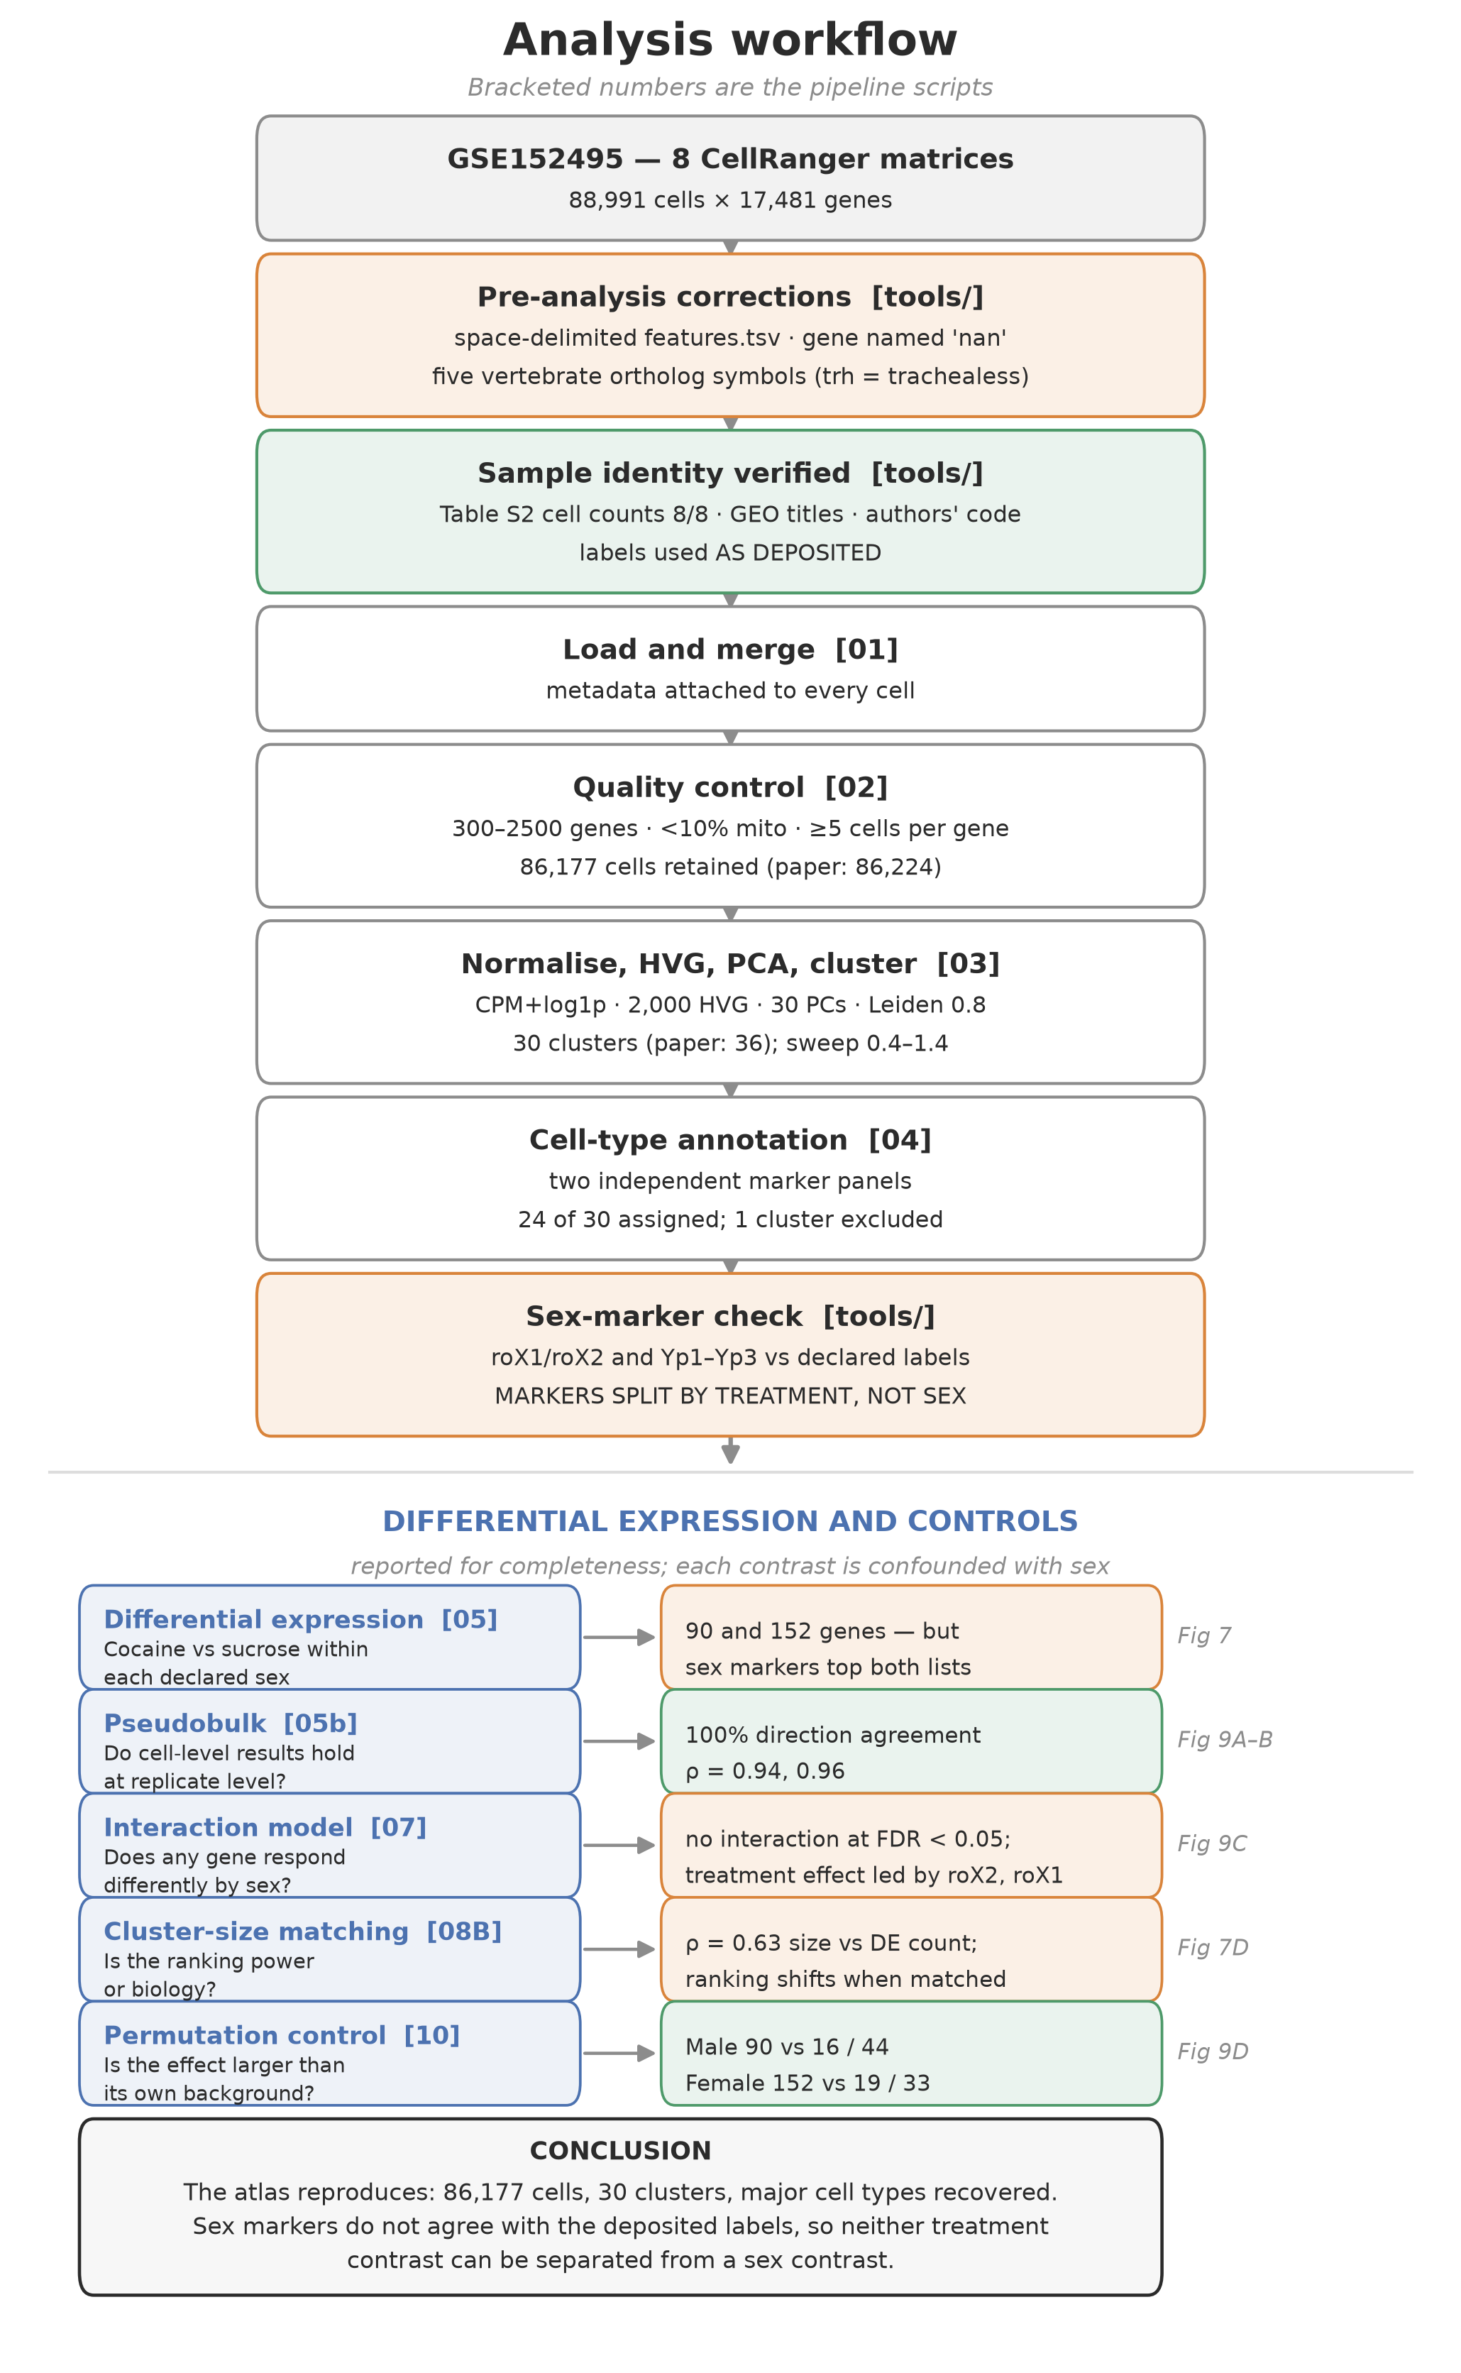
Figure 2. Analysis workflow. Numbers in brackets refer to the pipeline scripts in scripts/ and tools/.

2.1 Data and sample identity
Count matrices for GSE152495 were obtained pre-processed as eight CellRanger v3 output directories, produced by the original authors against D. melanogaster Release 6. Three problems were corrected before analysis; each would have propagated silently.
Delimiter. The supplied features.tsv.gz files were space- rather than tab-delimited, which scanpy.read_10x_mtx cannot parse. All three fields collapsed into one column and gene-symbol assignment failed. Files were converted with field content unchanged (17,481 lines each); originals retained.
Gene nomenclature. nanchung (Dmel_CG5842, FlyBase symbol nan) is interpreted by pandas as a missing value rather than text, leaving one gene unnamed and preventing HDF5 serialisation. It was renamed CG5842, which survives CSV round-trips. narrow abdomen (na, Dmel_CG1517) is unaffected, as lowercase na is not in the default missing-value list.
The reference substitutes vertebrate ortholog names for five fly symbols, resolved by gene ID against FlyBase (Thurmond et al. 2019): VGlut1 = VGlut (CG9887), Adcy1 = rut (CG9533), Pde4 = dnc (CG32498), Trhn = Trh (CG9122), Tret1 = Tret1-1 (CG30035). Note that trh (lowercase) in this reference is Dmel_CG42865, trachealess — an unrelated tracheal transcription factor, not tryptophan hydroxylase. Marker matching was therefore performed case-sensitively; a case-insensitive match returns trachealess and would label a cluster serotonergic on the strength of a tracheal gene.
Sample identity. Sample assignment was verified against three independent sources, which agree:
- Supplemental Table S2 lists per-sample cell counts. All eight match the deposited matrices exactly (9,072 / 11,693 / 13,193 / 11,033 / 13,072 / 9,367 / 10,437 / 11,124; total 88,991).
- GEO sample titles correspond to the same assignment.
- The authors' Supplemental Code documents the mapping from CellRanger output directories to Seurat objects: S1 and S2 female sucrose, S3 and S4 male sucrose, S5 and S6 female cocaine, S7 and S8v2 male cocaine.
Labels were therefore used as deposited. An earlier version of this analysis applied a marker-based reassignment; Supplemental Table S2 showed that reassignment to be incorrect, and it was reverted. The reversion is recorded in the repository history and in docs/data_provenance.md.
The sex markers nonetheless disagree with these labels (§3.3), a discrepancy that could not be resolved from the deposited data.

2.2 Quality control
Cells with fewer than 300 or more than 2,500 detected genes were removed, following the original study's criteria, as were cells exceeding 10% mitochondrial reads and genes detected in fewer than 5 cells. The original study applied no mitochondrial threshold; it was retained here because high mitochondrial fraction marks damaged cells, and brain dissociation is harsh. Mitochondrial genes were identified by the mt: prefix and ribosomal genes by RpS/RpL.

2.3 Normalisation, dimensionality reduction and clustering
Counts were normalised to 10,000 per cell and log₁ₚ-transformed. The log-normalised matrix was retained for differential expression. Two thousand highly variable genes were selected per sample (batch_key='sample', Seurat flavour) and ranked by consistency across samples. The matrix was subset to these genes; total_counts and pct_counts_mt were regressed out and values scaled to unit variance with a maximum of 10.
Principal component analysis used the ARPACK solver. The first 30 components (16.9% of variance; Supplementary Figure S2) were used to build a 15-nearest-neighbour graph and for UMAP embedding (McInnes et al. 2018). Leiden clustering (Traag et al. 2019) was performed at resolution 0.8, with a sweep across 0.4–1.4. No batch integration was applied. All stochastic steps used a fixed random seed (0).

2.4 Cell-type annotation
Cluster markers were identified by Wilcoxon rank-sum test of each cluster against all other cells, on log-normalised values. Cell types were assigned using two independent panels: the published top-three markers for each of the original 36 clusters, and a canonical Drosophila neuronal and glial panel with every symbol verified by gene ID. Assignments required agreement between panels; clusters resolving to different identities under the two panels were left unannotated.
One cluster (3,196 cells) was excluded from differential expression analysis because it showed mixed neuronal and glial markers, so its differentially expressed genes could not be assigned to any cell type. The exclusion was first made under the superseded label assignment, when the cluster also showed the largest difference in sequencing depth between treatment arms. Under the deposited labels that difference is modest (median 745 versus 608 detected genes per cell, 1.23-fold, against up to 1.47-fold in retained clusters), so the exclusion now rests on mixed identity alone. Including the cluster would raise the summed per-cluster totals in §3.4 from 1,282 and 1,256 to 1,378 and 1,308 (ratio 1.05 rather than 1.02), which does not affect any conclusion. Differential expression was therefore carried out on 23 cell-type groups: 19 annotated cell types and four unannotated groups.

2.5 Differential expression
Cocaine was compared with sucrose within each declared sex using the Wilcoxon rank-sum test on log-normalised values, with sucrose as reference, so that positive log₂ fold changes indicate higher expression in the cocaine-labelled samples. Genes were considered differentially expressed at |log₂FC| > 1 and Benjamini–Hochberg-adjusted p < 0.05. The original study used MAST with a natural-log threshold (|ln FC| > 1, equivalent to |log₂FC| > 1.443) and Bonferroni correction; counts at that threshold are also reported, but gene counts are not directly comparable between the two analyses.
Three comparisons were performed: pooled across all cells within each declared sex; within each cell-type group and declared sex, excluding groups with fewer than 20 cells in either arm; and overlap between the two declared sexes.

2.6 Sex-marker check
Mean log-normalised expression of roX1, roX2 (male-specific lncRNAs of the dosage-compensation complex), Yp1–Yp3 (female yolk proteins) and Sxl was computed per sample after quality control. msl-2, mle and tra, which are sex-specifically regulated after transcription and therefore present in both sexes at the RNA level, served as negative controls. The check is reproduced by tools/make_sexmarker_figure.py.

2.7 Replicate-level controls
Pseudobulk aggregation. Raw counts for the 2,000 highly variable genes were summed within each sample, giving one profile per biological replicate; genes with fewer than 50 total counts were removed (1,755 retained). Profiles were converted to log₂ counts per million and compared within each declared sex by two-sample t-test with Benjamini–Hochberg correction (n = 2 versus 2). Concordance with the cell-level result was assessed by sign agreement and Spearman correlation over the cell-level significant genes present in this gene set (37 in each arm).
Interaction model. Counts for all 12,189 post-QC genes were summed per sample, and genes with at least 50 total counts (9,397) were converted to log₂ CPM. For each gene, an ordinary least-squares model expression ~ sex + treatment + sex:treatment was fitted across the eight samples using effect coding (±0.5), so that main effects are averages across the other factor. Interaction and main-effect p-values were Benjamini–Hochberg-adjusted separately.

2.8 Permutation control
Within each declared sex, the four samples can be split two-versus-two in three distinct ways: the treatment split, the replicate axis (Cocaine R1 + Sucrose R1 versus the rest) and a diagonal pairing (Cocaine R1 + Sucrose R2 versus the rest). The two non-treatment splits carry no treatment difference and serve as nulls. Each was tested with the same cells, test and thresholds as the treatment contrast.

2.9 Cluster-size matching
Because cluster size correlated with differentially expressed gene count (Spearman correlation across the 23 cell-type groups, with cell and gene counts summed across both declared sexes), each group was downsampled to 400 cells (200 per treatment arm, both declared sexes pooled) and re-tested over three random seeds. Groups with fewer than 50 cells in either arm were skipped.

2.10 Pathway enrichment
Over-representation analysis used GSEApy (Fang et al. 2023) against the Enrichr Drosophila libraries (Kuleshov et al. 2016): GO Biological Process 2018, GO Molecular Function 2018 and KEGG 2019. Up- and down-regulated genes were tested separately, with up to 150 genes per list ranked by adjusted p-value. Terms were considered enriched at adjusted p < 0.05. Per-cell-type enrichment was run for the six groups with the most differentially expressed genes summed across both arms. Enrichr tests against all annotated fly genes, whereas the differential expression test could only detect brain-expressed genes surviving quality control; adjusted p-values are therefore optimistic for brain-expressed terms.

2.11 Software and availability
Python 3.11 with scanpy 1.11.5 (Wolf et al. 2018), anndata 0.12.19, numpy 2.4.6, pandas 2.3.3, scipy 1.17.1, scikit-learn 1.9.1, python-igraph 1.0.0, leidenalg 0.12.0, umap-learn 0.5.12, gseapy 1.3.1 and matplotlib 3.11.2. The environment was managed with uv; the lockfile (requirements.lock.txt), all analysis code, result tables and figure-generating scripts are available at https://github.com/mr-mahabubur-rahman/project2_drosophila_brain. Count matrices are not redistributed; tools/download_data.sh and tools/organize_data.sh rebuild them from GEO.

3. Results

3.1 Quality control reproduces the published cell count
After filtering, 86,177 of 88,991 cells were retained (96.8%), against the 86,224 reported — a difference of 47 cells, or 0.05%. Gene count fell from 17,481 to 12,189. The agreement indicates the filtering criteria and input data were correctly identified (Figure 3).
Sequencing depth varied approximately two-fold between samples (median 675–1,195 genes per cell), and was not confounded with treatment: within each declared sex, one deeper and one shallower replicate fell in each arm.
Mitochondrial fraction varies by sample, not by group. Per-sample medians span 19-fold and scatter across all four groups:
Sample | Median mt %
Female_Cocaine_R2 | 0.700
Male_Sucrose_R2 | 0.472
Male_Sucrose_R1 | 0.319
Male_Cocaine_R1 | 0.277
Male_Cocaine_R2 | 0.251
Female_Cocaine_R1 | 0.158
Female_Sucrose_R1 | 0.086
Female_Sucrose_R2 | 0.037

Cell-level group means suggest a female-specific treatment difference (0.571% cocaine versus 0.103% sucrose) and a male difference in the opposite direction (0.348% versus 0.528%), but both are driven by single replicates — Female_Cocaine_R2 and Male_Sucrose_R2 respectively. This is dissection-to-dissection variation, not a group-level property, and any mitochondrial gene appearing in a treatment comparison should be interpreted with that in mind.
A
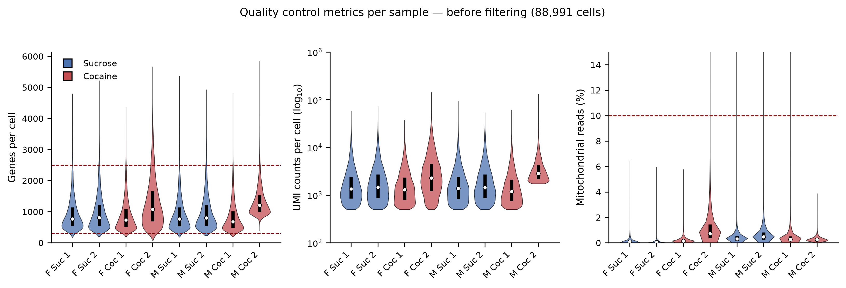
B
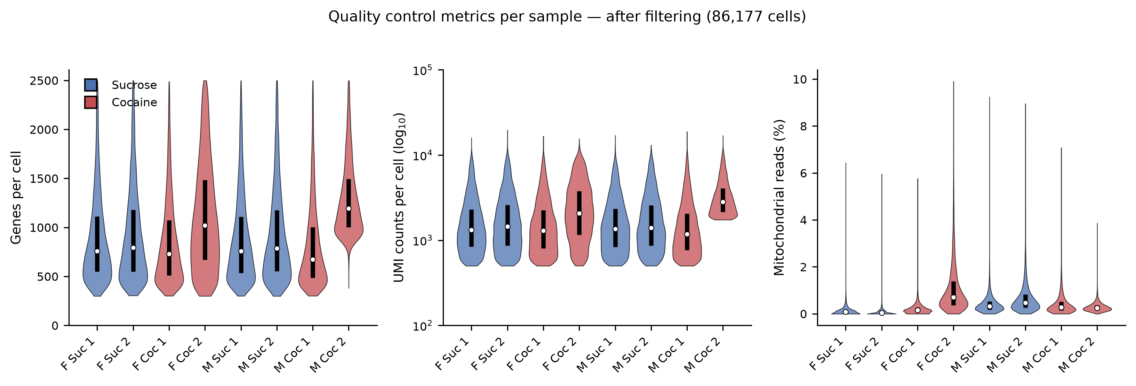
Figure 3. Quality control. Genes per cell, UMI counts per cell and mitochondrial fraction per sample (A) before filtering (88,991 cells) and (B) after filtering (86,177 cells). Dashed lines mark the thresholds; samples are coloured by treatment.

3.2 Clustering recovers 30 populations; 24 were assignable
Leiden clustering at resolution 0.8 yielded 30 clusters against the 36 reported (Figure 4A). A resolution sweep gave a monotonic increase (19, 24, 30, 33, 34, 37 at resolutions 0.4 to 1.4), reaching 36 at approximately 1.33 (Figure 4B). The published stability argument — that cluster count plateaus at resolution 0.8 — was not reproduced. This may be a property of Leiden rather than a disagreement about the data.
The embedding is not driven by batch (Figure 4C, D). Only one of 30 clusters exceeded 30% composition from a single sample (34.3%, against 12.5% under even mixing), and that cluster remained 74.5% female among depth-matched cells against a 56.4% background, indicating a genuine population rather than an artefact.
Twenty-four clusters received cell-type labels using two independent marker panels (Figure 5; Supplementary Figure S5). Six clusters (13,526 cells, 15.7%) were left unannotated where the panels disagreed. Populations corresponding to the paper's Kenyon cells (C11), surface glia (C22) and unannotated antennal/optic lobe cluster (C16) were identified by marker gene rather than cluster number. The paper's C17 (astrocytes) could not be confidently identified: the cluster matching on Eaat1 was repo- and alrm-negative, while the genuine astrocyte-like population contains only 143 cells.
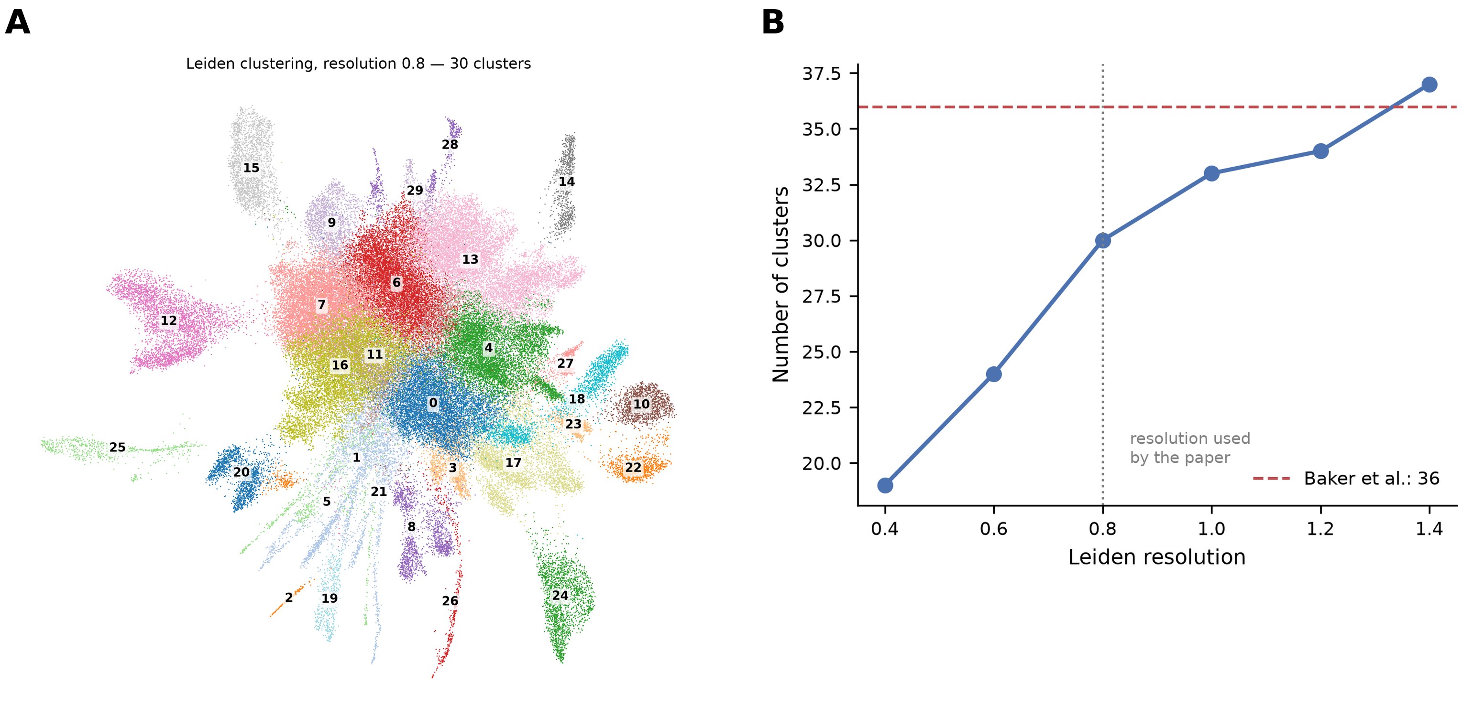
C
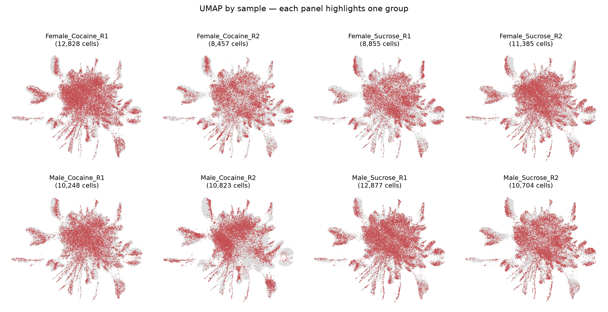
D
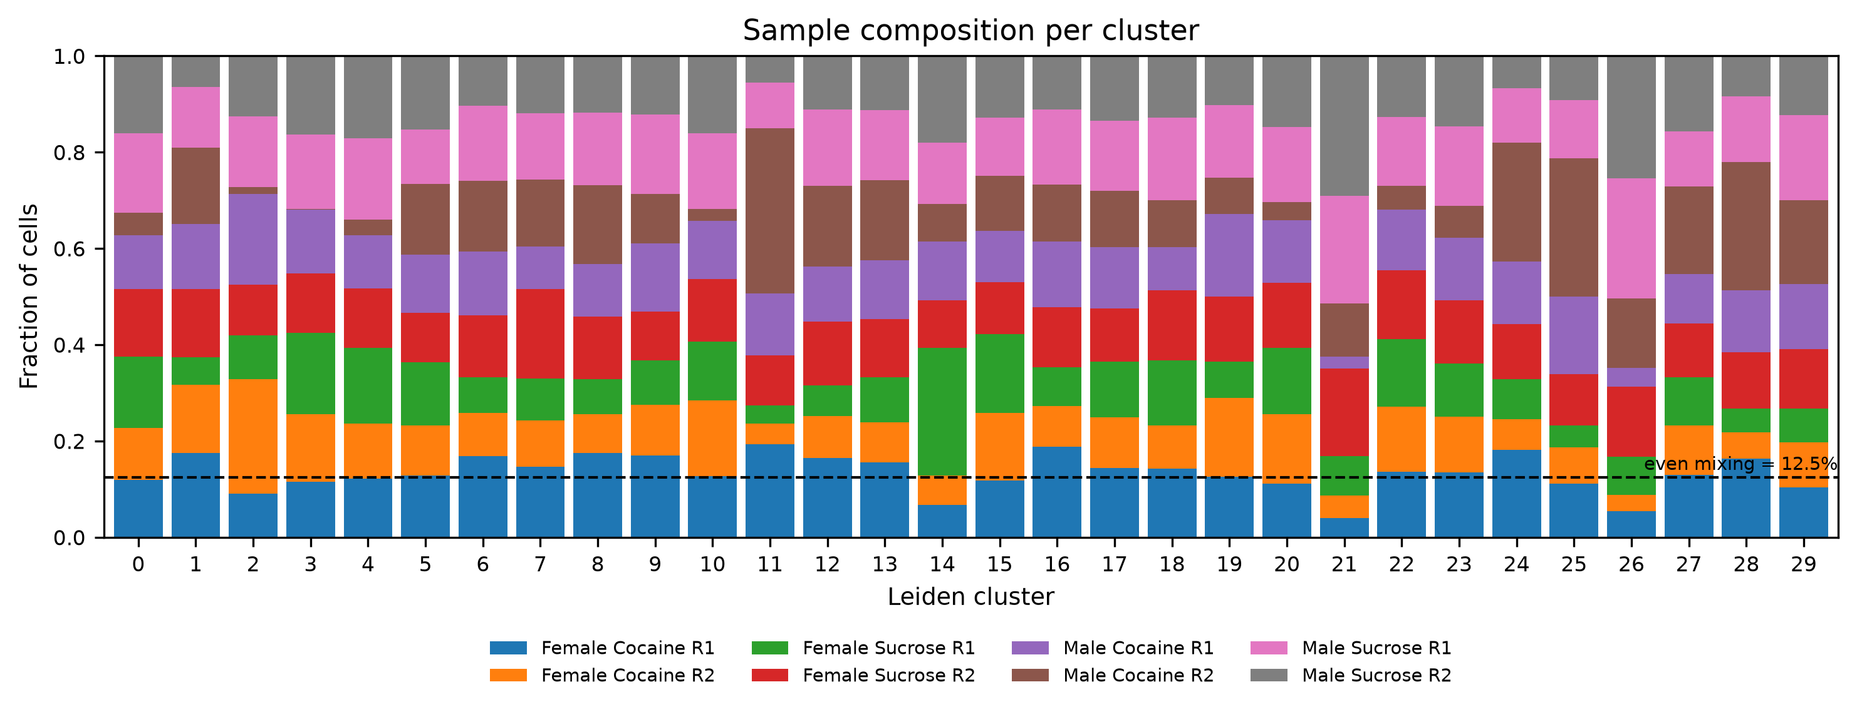
Figure 4. Clustering. (A) UMAP of 86,177 cells coloured by Leiden cluster at resolution 0.8 (30 clusters). (B) Cluster number across resolutions 0.4–1.4; the dashed line marks the 36 clusters reported by Baker et al. (C) UMAP split by sample. (D) Sample composition of each cluster; the dashed line marks even mixing (12.5%).
A
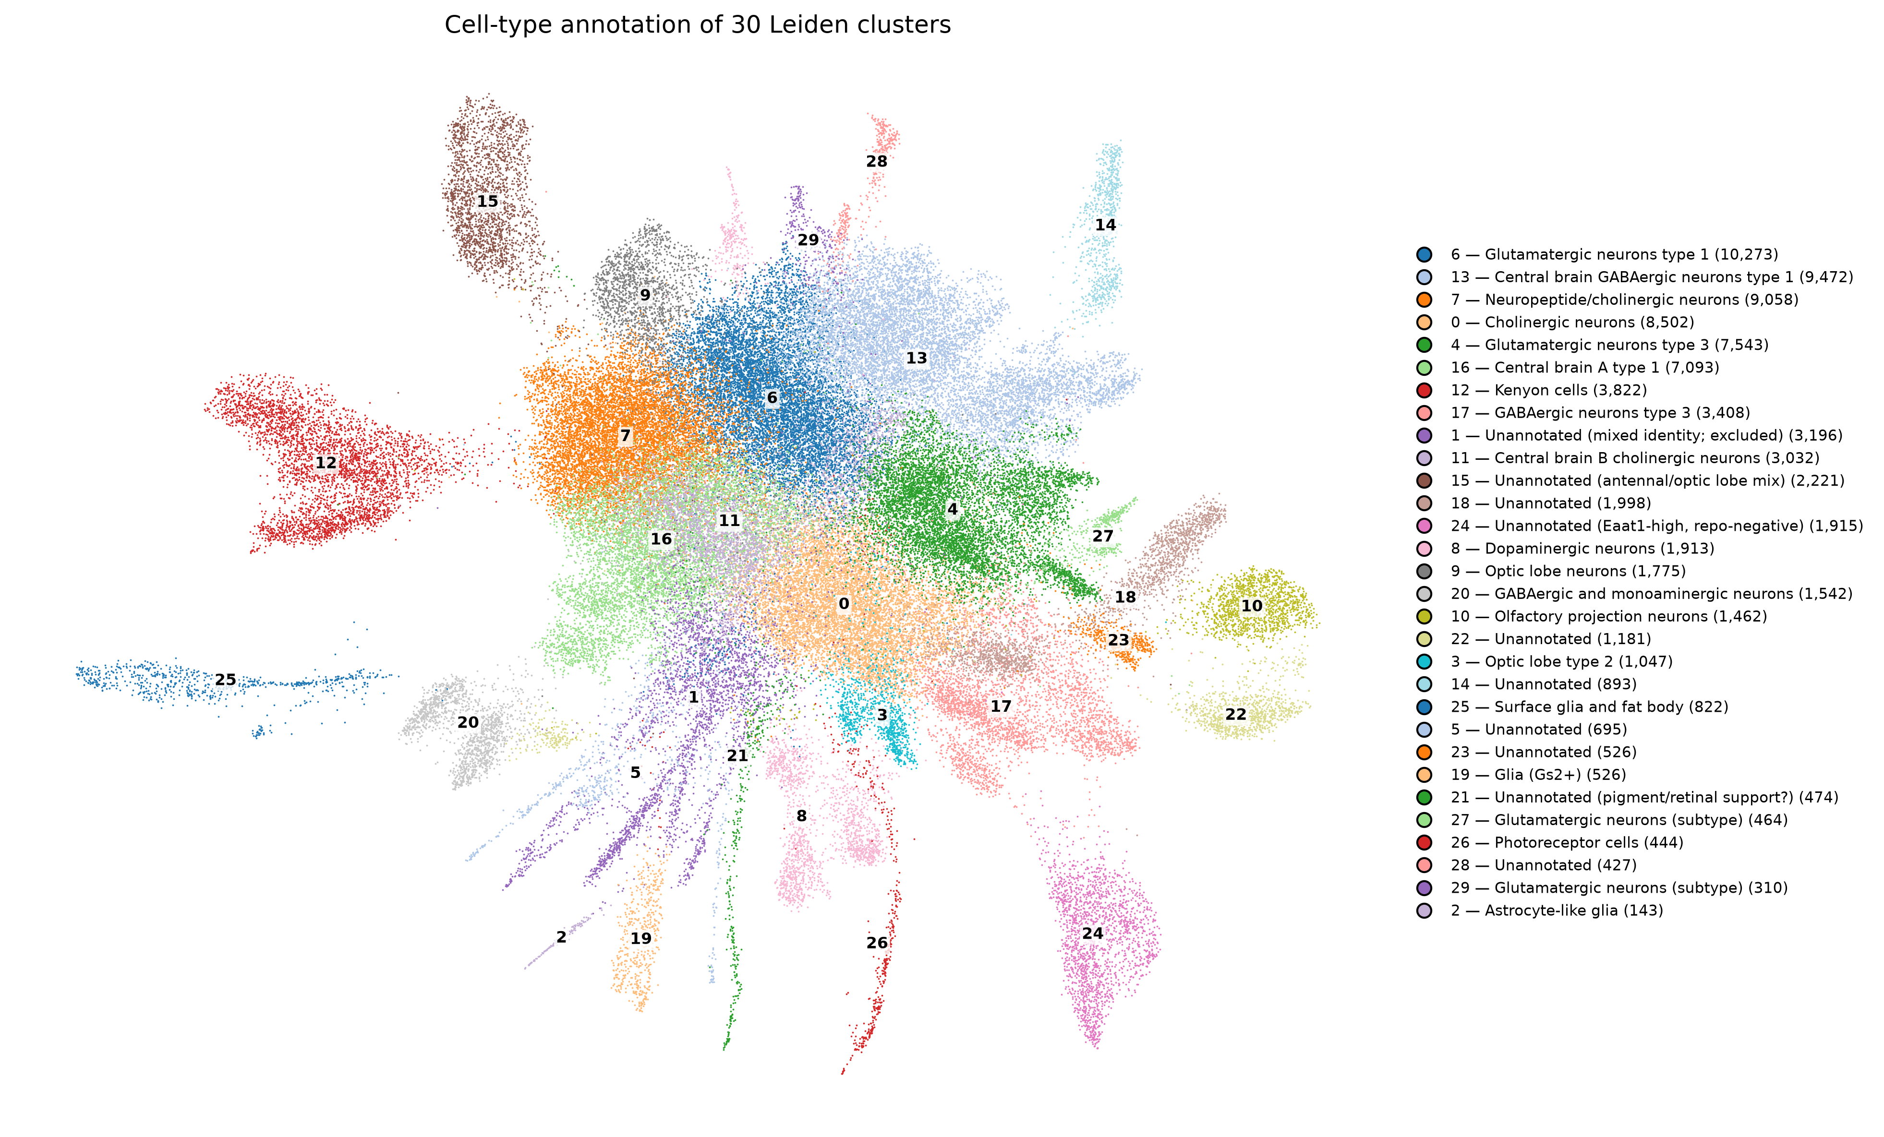
B
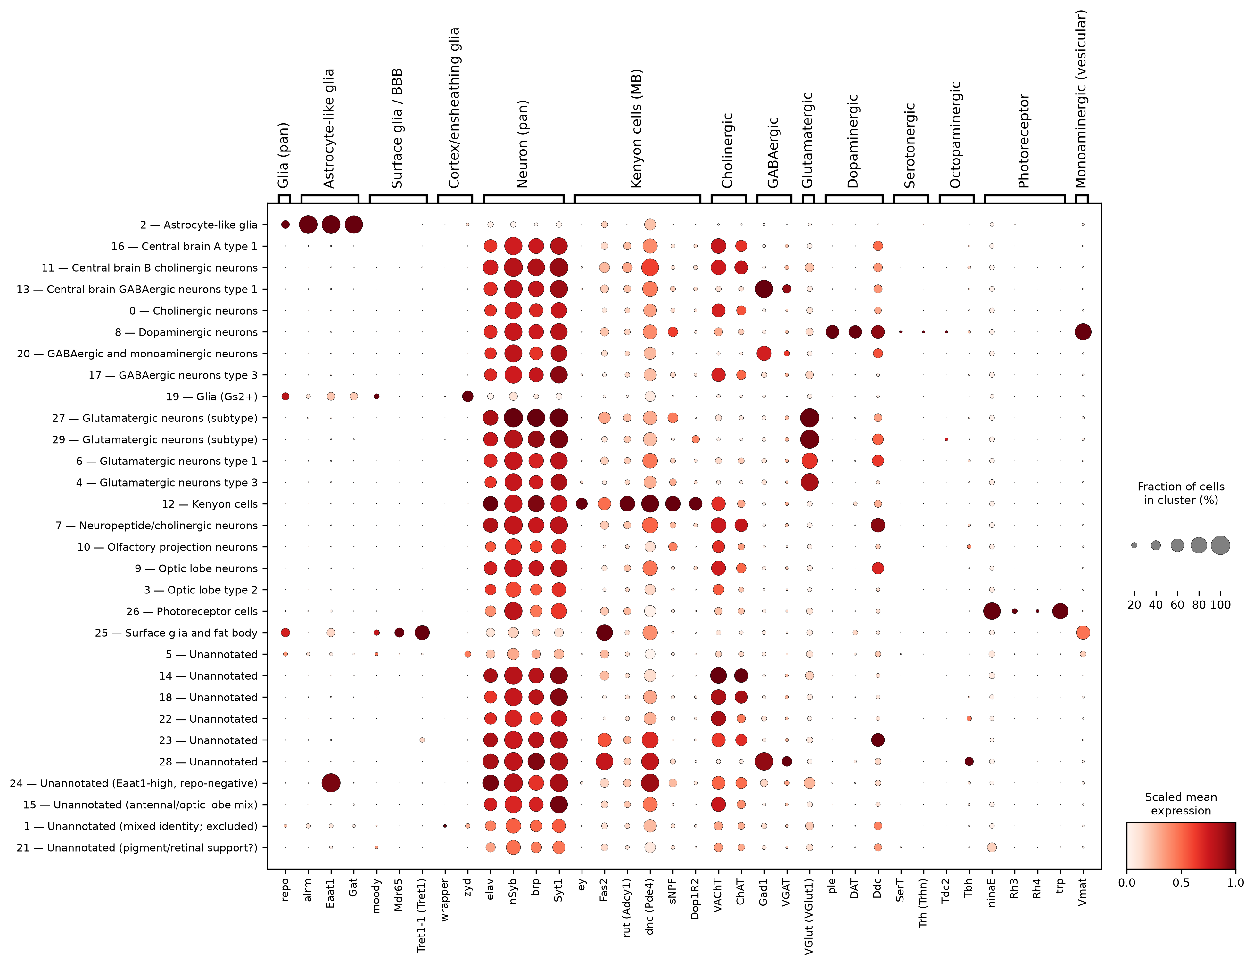
Figure 5. Cell-type annotation. (A) UMAP coloured by assigned cell type. (B) Expression of canonical marker genes across the 30 clusters; dot size shows the fraction of cells expressing each gene and colour the scaled mean expression.

3.3 Sex markers do not agree with the deposited sample labels
This is the principal finding and it precludes interpretation of the differential expression results below.
Five transcript-level sex markers separate the eight samples cleanly, but the split follows the treatment field of the sample name rather than the sex field (Figure 6; mean log-normalised expression per sample):
Marker | Specificity | All four Sucrose samples | All four Cocaine samples
roX1 | male (dosage-compensation lncRNA) | 3.846 – 3.972 | 0.059 – 0.116
roX2 | male (dosage-compensation lncRNA) | 2.160 – 2.396 | 0.008 – 0.015
Yp1 | female (yolk protein) | 0.000 – 0.001 | 0.065 – 0.255
Yp2 | female (yolk protein) | 0.003 – 0.003 | 0.028 – 0.153
Yp3 | female (yolk protein) | 0.006 – 0.010 | 0.069 – 0.428
Sxl | female (supporting only) | 0.682 – 0.971 | 1.222 – 1.747

roX1 and roX2 are lncRNAs of the dosage-compensation complex, expressed almost exclusively in males. Yolk proteins are transcribed in female fat body and are absent from males. The ranges do not overlap for any of these five markers, and the highest yolk-protein value in the dataset (Yp3 at 0.428) occurs in a sample labelled male. Sxl follows the same split, but because its sex specificity arises largely through alternative splicing, which 3′ counting cannot resolve, it is treated as supporting rather than primary evidence.
Genes whose expression is post-transcriptionally regulated and therefore present in both sexes at the RNA level show no comparable separation: mle (0.248–0.359) and tra (0.044–0.098) overlap between the two groups, and msl-2 (0.038–0.077) differs by about 1.4-fold on average, against more than 30-fold for roX1 and more than 100-fold for roX2. Only the markers that are sex-specific at the transcript level split the samples strongly, which argues against a generic technical artefact.
The consequence is direct. Comparing cocaine with sucrose within each declared sex returns the sex markers as significant in both comparisons, with roX1 and roX2 among the most significant genes of all:
Gene | Male-labelled contrast (log₂FC) | Female-labelled contrast (log₂FC)
roX2 | −9.620 | −9.629
roX1 | −9.539 | −9.125
Yp1 | +7.684 | +6.453
Yp3 | +5.234 | +3.479
Yp2 | +5.217 | +3.829
Sxl | +1.065 | +1.588

All six are significant in both arms. For roX1, roX2 and Sxl the adjusted p is below machine precision in both; for the yolk proteins it ranges from 3 × 10⁻²⁰⁷ (Yp3, male-labelled) to 0.0096 (Yp2, female-labelled). Each nominal treatment contrast is separating males from females. The original report is consistent with this: Baker et al. list roX2 among the genes that responded globally to cocaine, down-regulated after consumption (their Supplemental Tables S5 and S6).
Sample identity was verified against Supplemental Table S2, the GEO titles and the authors' Supplemental Code (§2.1); all three agree, and no computational step in either their pipeline or ours could have introduced the discrepancy. Neither their code nor ours, as originally written, checked sex markers against the sample labels.
Two explanations are consistent with the evidence and cannot be distinguished from the deposited data: the sex annotation may have been transposed at some point before sequencing, or sex and treatment may covary for a reason not described in the methods.
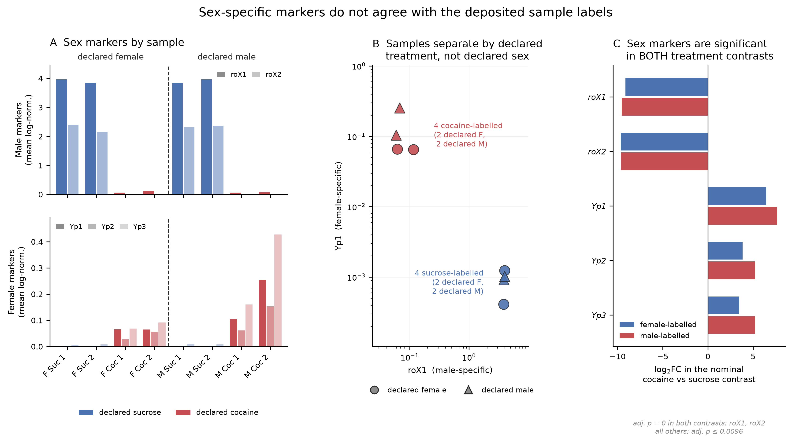
Figure 6. Sex-specific markers do not agree with the deposited sample labels. (A) Mean log-normalised expression of male (roX1, roX2) and female (Yp1–Yp3) markers in each sample. (B) Samples plotted by roX1 against Yp1 expression (log scales) separate by declared treatment, not by declared sex. (C) Log₂ fold changes of the sex markers in the nominal cocaine-versus-sucrose contrast within each declared sex; all are significant in both contrasts.

3.4 Differential expression results, reported but not interpreted
The results below are recorded for completeness and as evidence bearing on §3.3. None should be read as a cocaine effect, since each contrast is confounded with sex.
Pooled within each declared sex, the male-labelled contrast returned 90 differentially expressed genes (75 up, 15 down) and the female-labelled contrast 152 (126 up, 26 down) at |log₂FC| > 1 and BH-adjusted p < 0.05 (Figure 7A, B) — a ratio of 0.59, favouring the female-labelled arm. At the paper's stricter threshold (|log₂FC| > 1.443) the counts were 20 and 61. Baker et al. report 691 and 322, a ratio of 2.15 favouring males. Summing across the 23 cell-type groups analysed (§2.4) gives 1,282 and 1,256, a ratio of 1.02 (Figure 7C).
Overlap between the two arms was 53 genes unique to the male-labelled contrast, 115 unique to the female-labelled contrast, and 37 shared, of which one changed direction. The shared set includes roX1, roX2, Yp1–Yp3 and Sxl.
Cluster size correlated with differentially expressed gene count (Spearman ρ = 0.634 across the 23 groups), so the raw ranking partly measures statistical power. Downsampling every group to 400 cells over three seeds gave central brain B cholinergic neurons highest (69.0 ± 8.0), followed by the unannotated Eaat1-high cluster (43.7 ± 11.3), the antennal/optic lobe cluster (39.7 ± 15.7) and surface glia (38.3 ± 7.4); Kenyon cells ranked sixth (26.3 ± 4.6) (Figure 7D).
Pathway enrichment placed oxidative phosphorylation as the top term in female-labelled Kenyon cells (adjusted p = 6.5 × 10⁻¹⁵), with axon guidance and cell adhesion in the male-labelled arm (Figure 8). Under the earlier, incorrect label assignment the same analysis placed oxidative phosphorylation in the male arm — illustrating that this enrichment tracks specific samples rather than either biological variable.
The pattern is not specific to Kenyon cells. Of the six cell-type groups tested, oxidative phosphorylation or mitochondrial electron transport was the top term in four of the female-labelled contrasts (central brain B cholinergic neurons, dopaminergic neurons, Kenyon cells and the antennal/optic lobe cluster) and appeared in only one male-labelled contrast. A mitochondrial signal that recurs across cell types in one arm is consistent with the sample-level mitochondrial variation described in §3.1, although that variation was measured on mitochondrially encoded reads and most OXPHOS genes are nuclear.
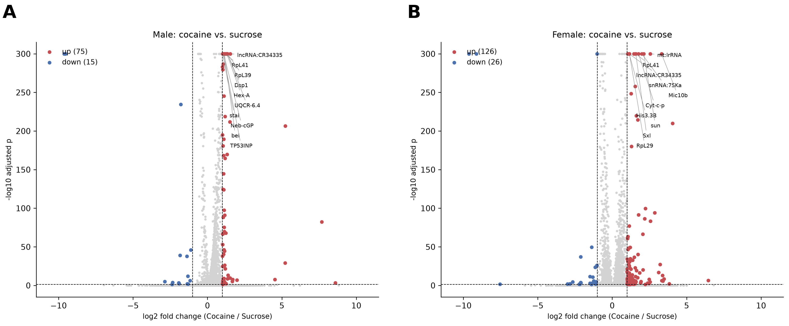
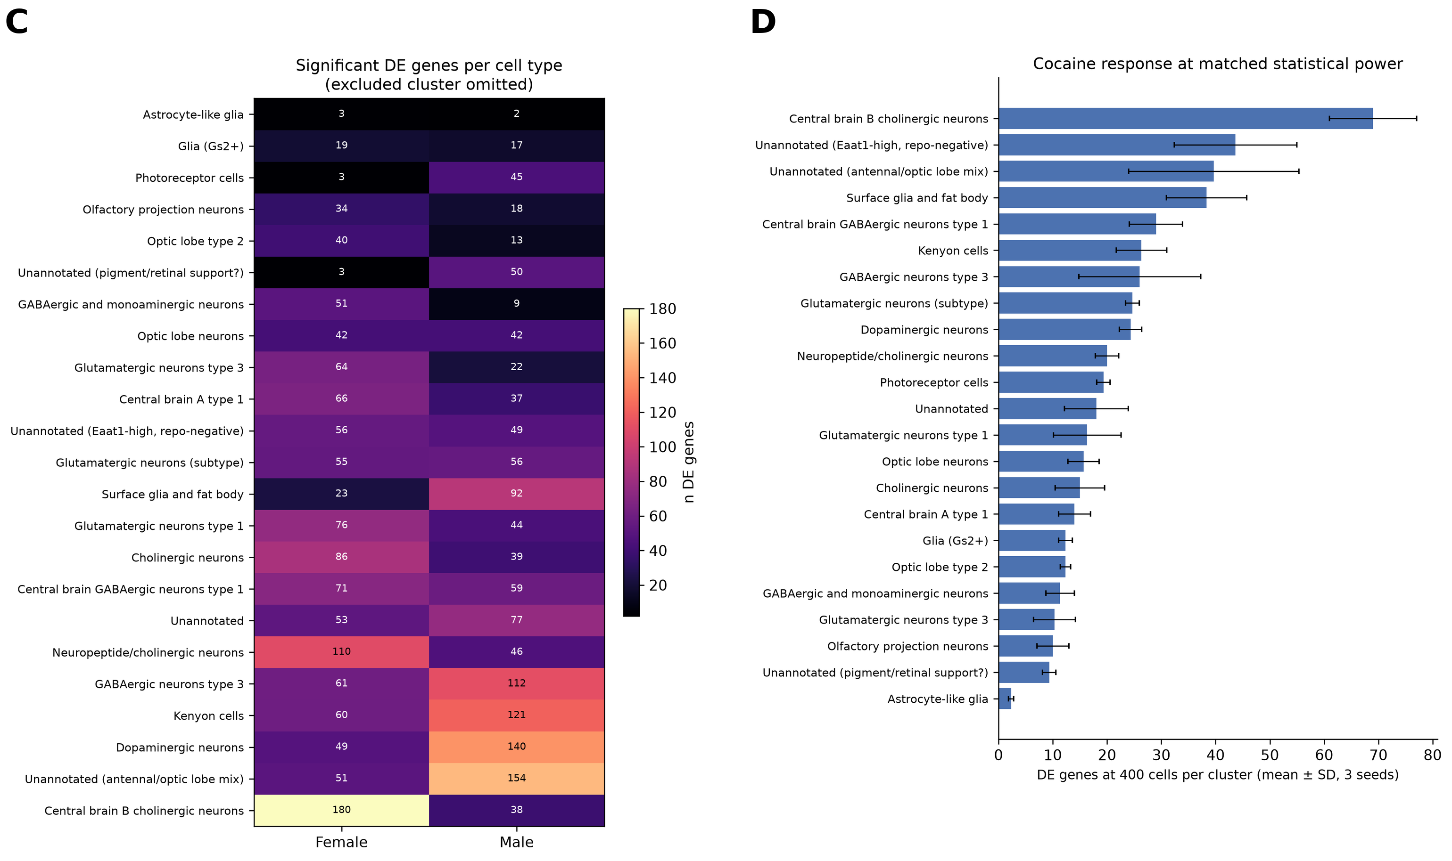
Figure 7. Differential expression, reported but not interpreted as a cocaine effect. Volcano plots of the nominal cocaine-versus-sucrose contrast in (A) the male-labelled and (B) the female-labelled samples; dotted lines mark |log₂FC| = 1. (C) Significant genes per cell-type group and declared sex (mixed-identity cluster omitted). (D) Significant genes per group after downsampling to 400 cells (mean ± SD, three seeds).
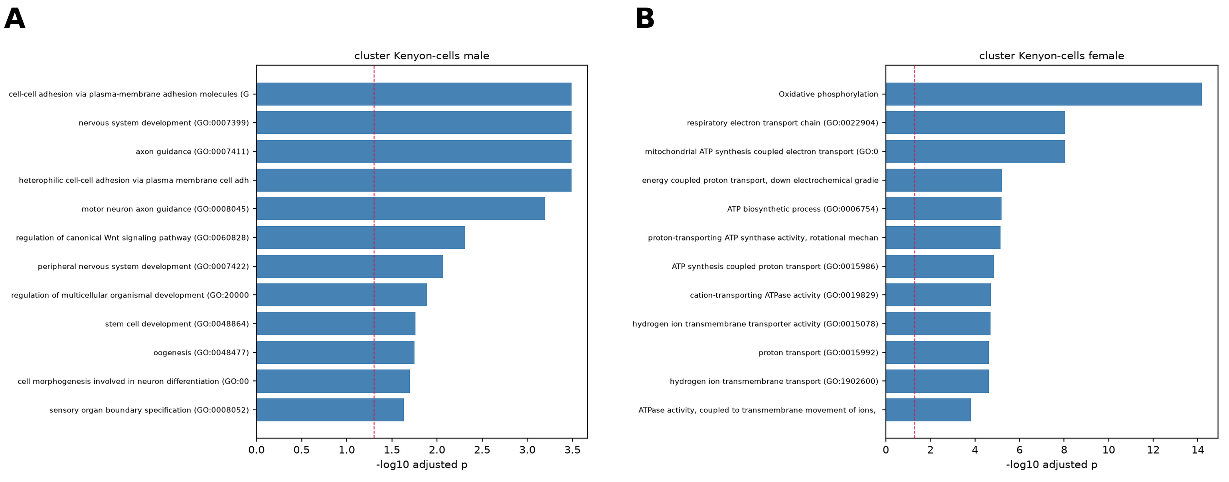
Figure 8. Pathway enrichment in Kenyon cells. Top enriched terms among genes differentially expressed in (A) male-labelled and (B) female-labelled Kenyon cells. The red line marks adjusted p = 0.05.

3.5 Statistical controls
Four controls were applied. Their results are reported here because they characterise the data, though they inherit the interpretive limitation of §3.3.
Replicate-level aggregation. Summing counts per sample gave no genes significant at n = 2 versus 2 (minimum adjusted p 0.080 in the male-labelled arm and 0.052 in the female-labelled arm), as expected. Direction agreement with the cell-level test was 100% in both arms, with Spearman ρ = 0.941 (p = 4.5 × 10⁻¹⁸) and 0.957 (p = 1.9 × 10⁻²⁰) over 37 genes each (Figure 9A, B).
Interaction model. Fitting expression ~ sex + treatment + sex:treatment to pseudobulk profiles returned no gene with a significant interaction term at FDR < 0.05 (minimum adjusted p = 0.75; Figure 9C). With four residual degrees of freedom this is expected rather than informative. It does mean that the sexual dimorphism reported by the original study, which rests on comparing separate per-sex gene lists rather than on an interaction test, is not demonstrated for any individual gene in these data (Gelman and Stern 2006).
The main effects are more informative. Twenty-three genes showed a significant main effect of treatment at FDR < 0.05. The two strongest were roX2 (−8.50 log₂, adjusted p = 0.0049) and roX1 (−7.96, adjusted p = 0.0052), with Yp1 sixth (+4.68, adjusted p = 0.018). The main effect of declared sex on the same two male-specific lncRNAs was close to zero (roX1 −0.25, roX2 +0.10 log₂). At replicate level, therefore, the sex markers are explained by the treatment label and not by the sex label — the same pattern as §3.3, obtained without cell-level pseudoreplication.

Permutation control. Within each declared sex, four samples permit two independent null contrasts besides the treatment split — the replicate axis and a diagonal pairing — each using identical cells, test and thresholds (Figure 9D):
 | Treatment | Replicate axis (null) | Diagonal (null)
Male-labelled | 90 | 16 | 44
Female-labelled | 152 | 19 | 33

Both treatment contrasts exceed the mean of their two nulls (3.0-fold and 5.9-fold). Given §3.3, this is expected: the treatment split separates the samples along the axis the sex markers identify, while the null splits mix them.
Cluster-size matching is reported in §3.4.
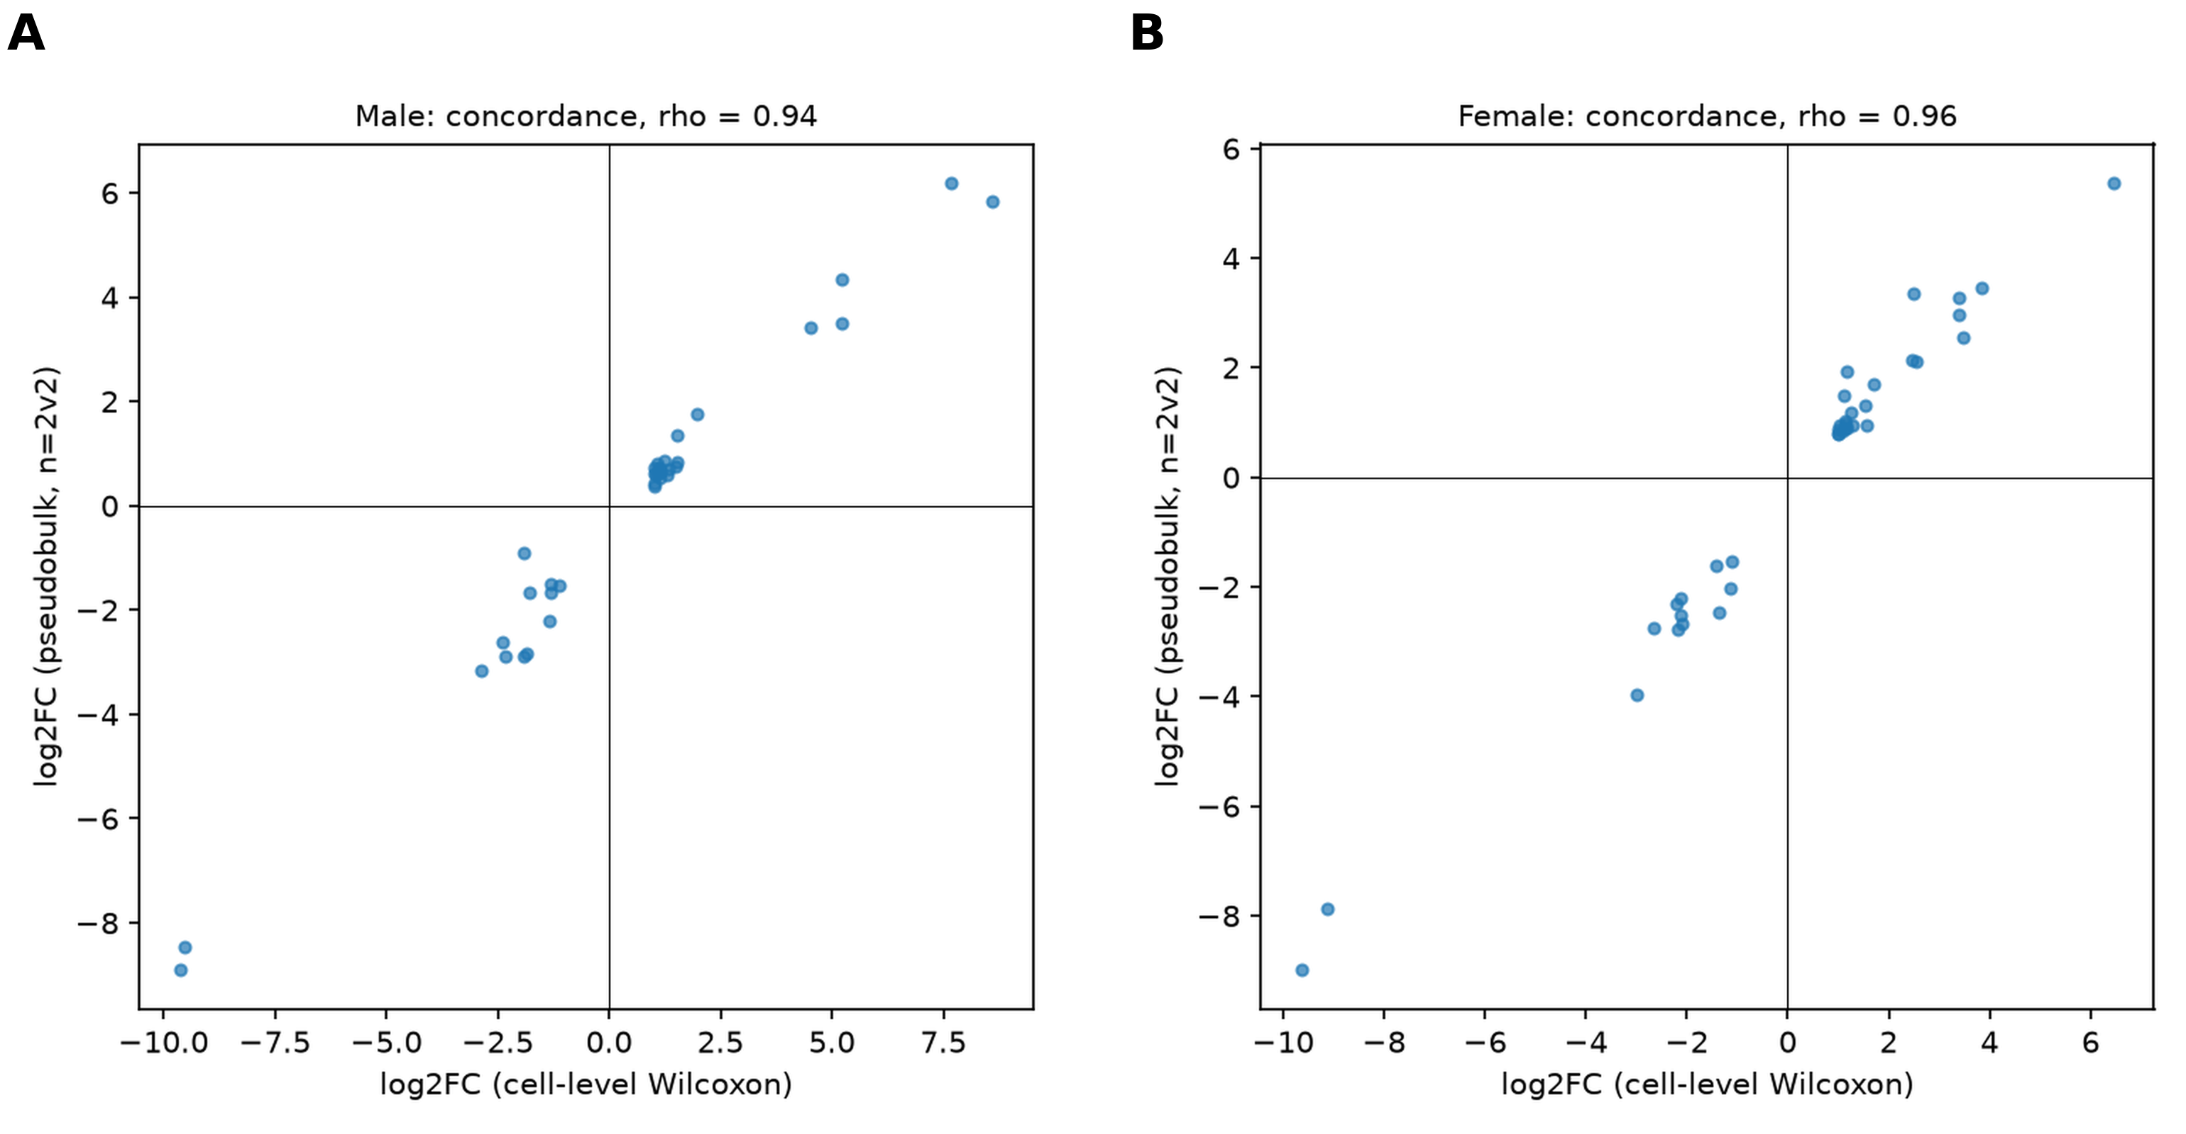
C
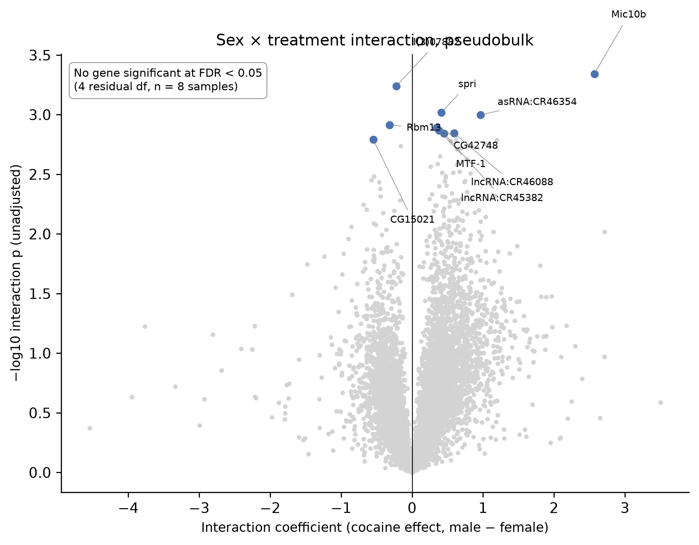
D
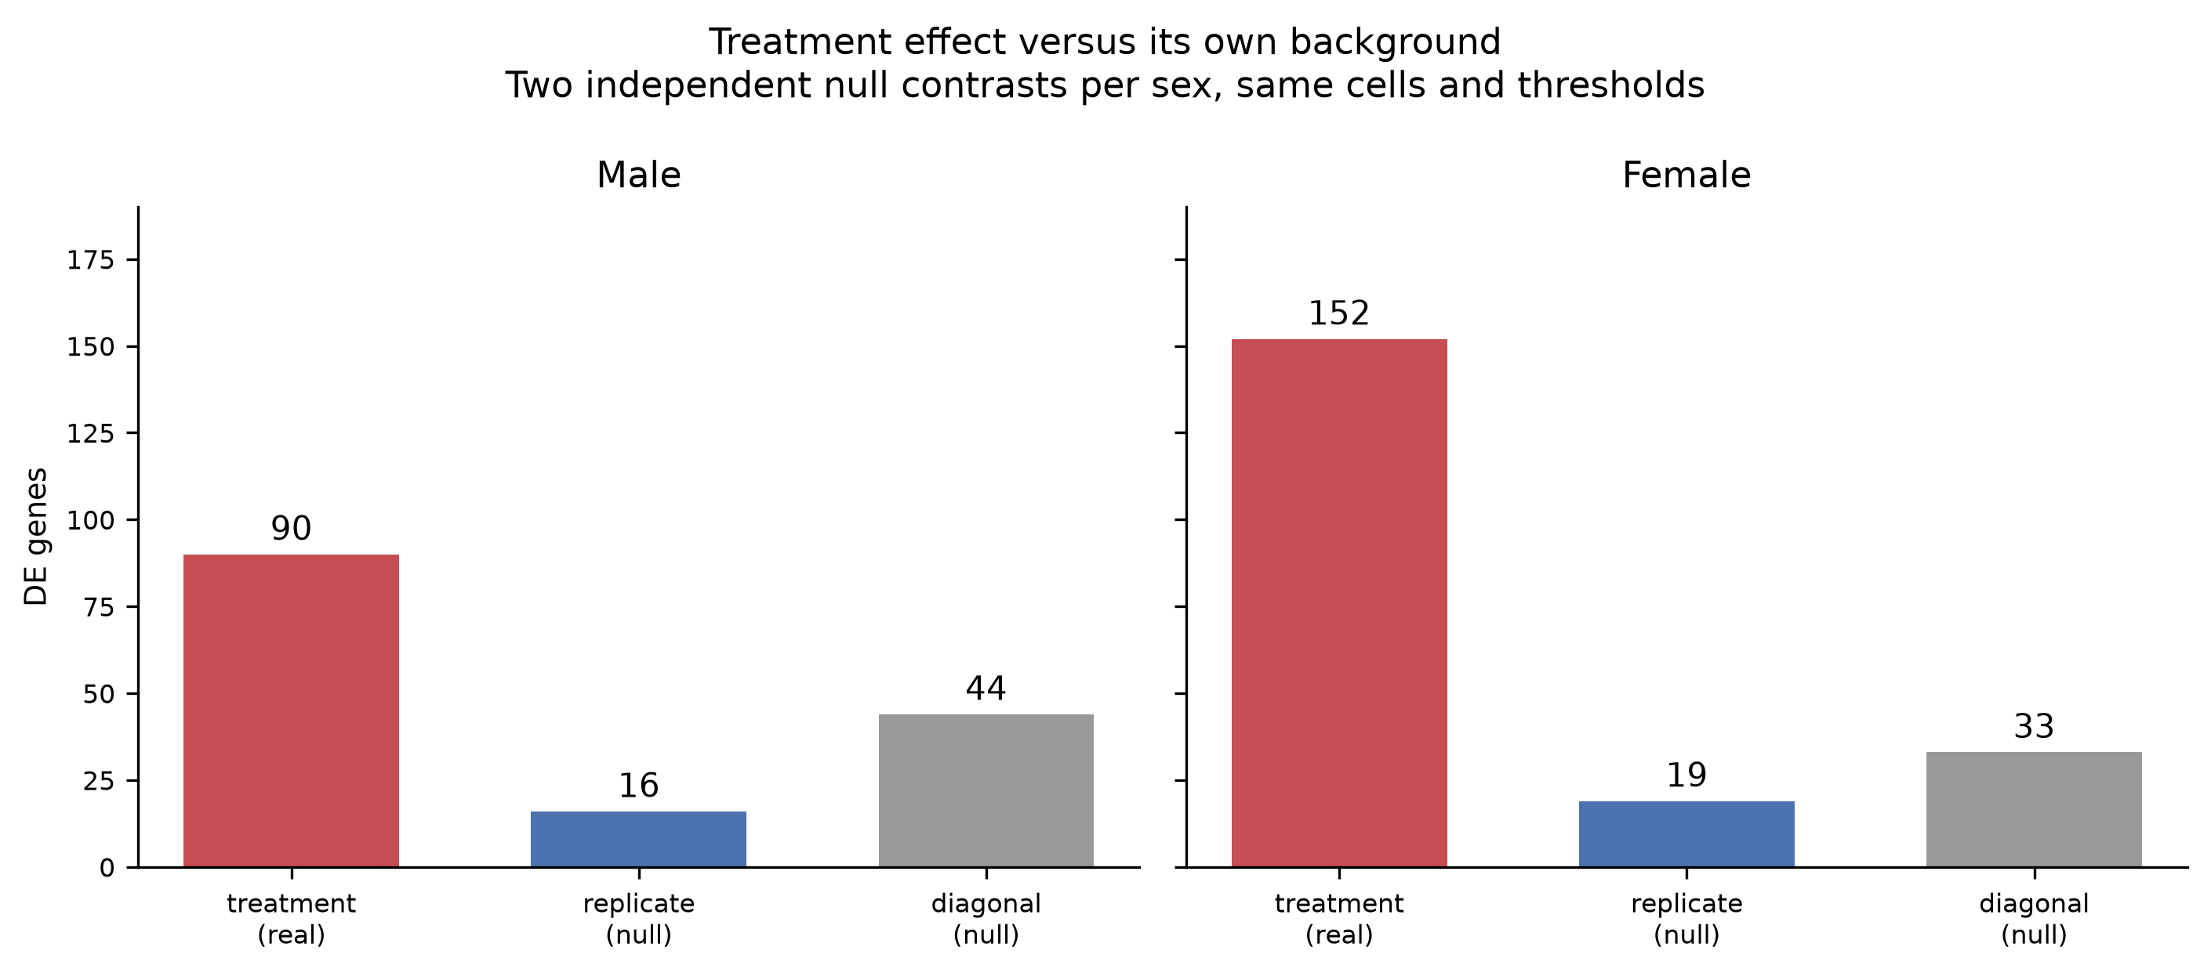
Figure 9. Statistical controls. Agreement between cell-level Wilcoxon and pseudobulk log₂ fold changes for the 37 cell-level significant genes in (A) the male-labelled and (B) the female-labelled arm. (C) Sex × treatment interaction coefficients from the pseudobulk model; no gene is significant at FDR < 0.05. (D) Differentially expressed genes for the treatment split compared with two null splits of the same samples.

3.6 Partial reproduction of Baker et al. Figure 3
At the paper's threshold, the gene × cell-type matrices contained 168 genes across 23 cell-type groups in the male-labelled arm and 88 across 23 in the female-labelled arm, against 133 and 54 reported (Figure 10A). Venn analysis across six cell types gave Jaccard indices of 0.048–0.116, consistent with the limited overlap the original describes (Figure 10B).
A
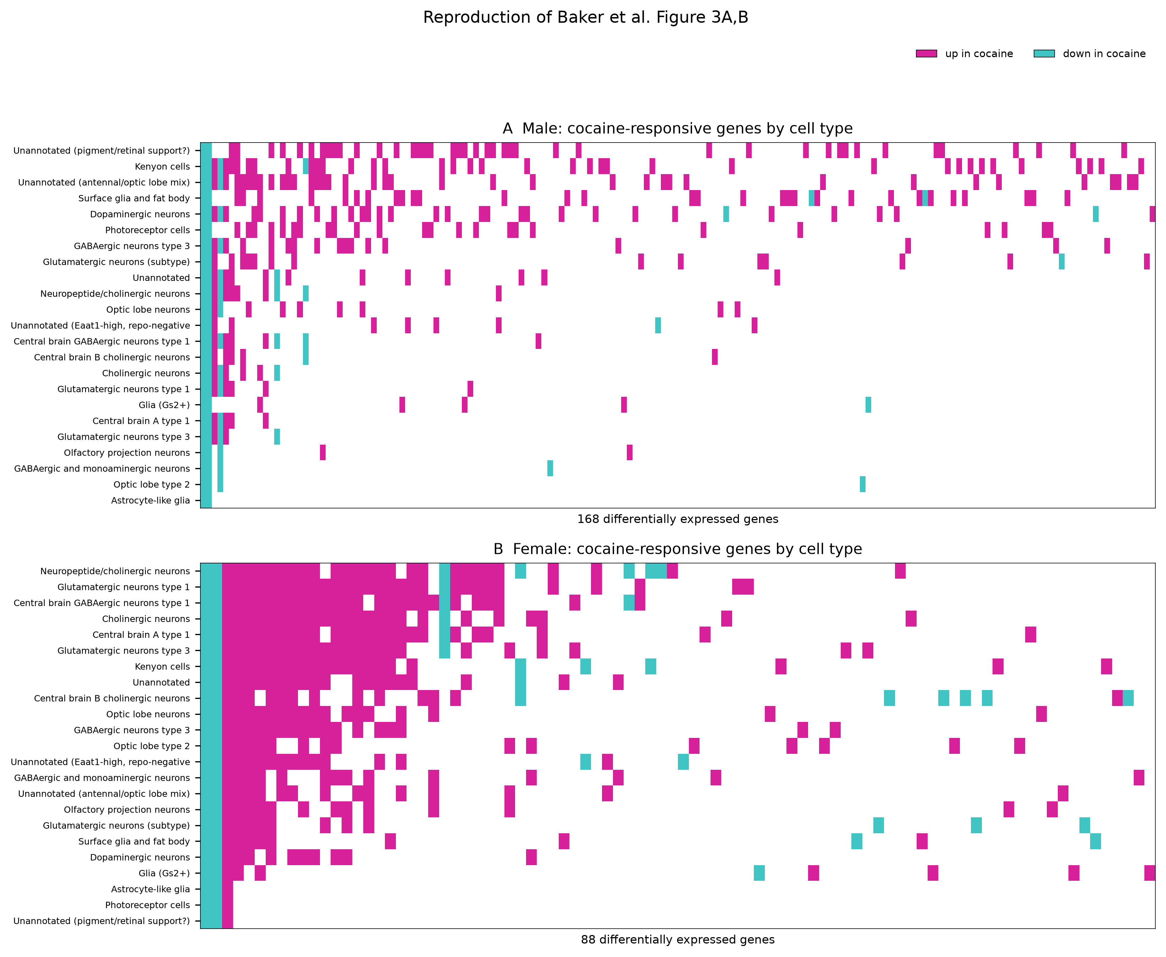
B
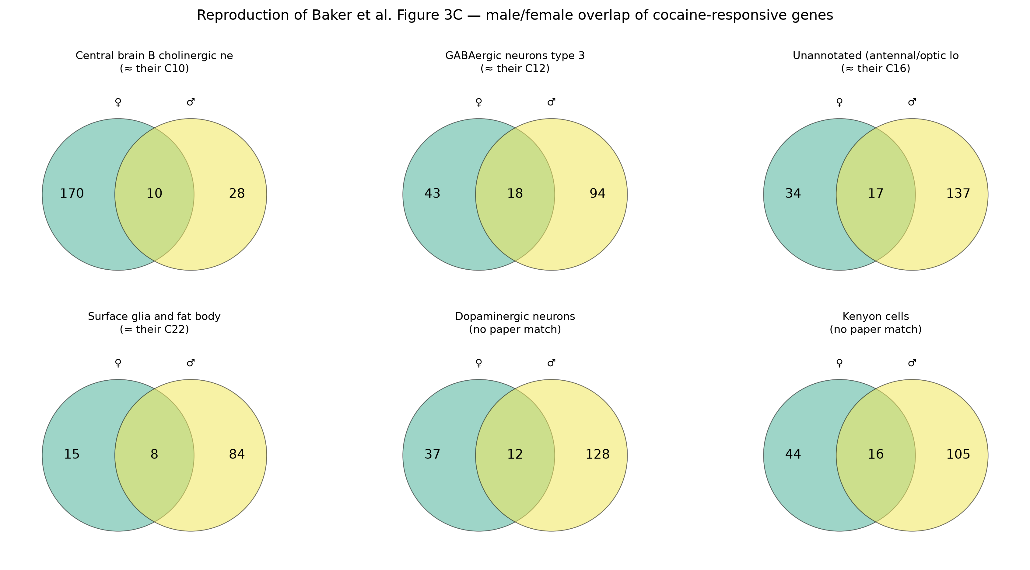
Figure 10. Partial reproduction of Baker et al. Figure 3. (A) Genes differentially expressed at the paper's threshold (|log₂FC| > 1.443) in each cell-type group, in the male-labelled (top) and female-labelled (bottom) arms; magenta, up in cocaine-labelled samples; cyan, down. (B) Overlap between the two arms in six cell types matched to the paper's clusters by marker genes.

4. Discussion

What reproduces
Three published results reproduce under an independent pipeline. Cell count after quality control matched to within 0.05%, confirming that the filtering criteria and input data were correctly identified. Clustering recovered the major neuronal and glial populations, and the embedding shows no evidence of batch effect — only one of 30 clusters exceeded 30% composition from a single sample, and that cluster proved to be a genuine biological population. Cell types corresponding to the paper's Kenyon cells, surface glia and unannotated antennal/optic cluster were identified independently by marker gene.
The atlas, in other words, reproduces. What cannot be reproduced from these data is any conclusion about cocaine.

The labelling discrepancy
Sex-specific markers place all four sucrose-labelled samples in one group and all four cocaine-labelled samples in the other. The evidence is not marginal: roX1 and roX2 differ by more than 300-fold between the groups at replicate level and roughly 700-fold in the cell-level test, and yolk proteins, which males do not transcribe, read 0.010 or less in every sucrose sample. The replicate-level model reaches the same conclusion: the treatment label explains roX1 and roX2, and the declared sex label explains almost none of their variation.
The sample identities themselves are not in doubt. Per-sample cell counts in Supplemental Table S2 match the eight deposited matrices exactly; the GEO titles agree; and the authors' Supplemental Code documents the same assignment from CellRanger output directories onward. The discrepancy therefore did not arise during analysis or deposition — in either their pipeline or ours.
Neither analysis checked it. The authors' code assigns sex as a hard-coded string based on which output directory a matrix came from; no marker-based verification appears anywhere in it. Our own pipeline, as first written, did the same. The check that revealed the problem — comparing roX1/roX2 and Yp1–Yp3 against the declared labels — takes under a minute and is not, at present, standard practice. The signal was nonetheless visible in the original analysis: roX2 appears in the published list of genes responding globally to cocaine.
We do not claim to know which explanation is correct. A transposition of the sex annotation before sequencing would account for it, as would some aspect of the experimental design not described in the methods. What we can say is that in the data as deposited, the cocaine-versus-sucrose contrast within each declared sex separates samples along an axis that sex markers identify as sex. On that basis we decline to interpret any differential expression result here as a drug effect, and we suggest the same caution applies to the corresponding results in the original report until the discrepancy is resolved.

What this does not show
It does not show that the biological conclusions of Baker et al. are wrong. Acute cocaine may well produce cell-type-specific and sexually dimorphic transcriptional change in the fly brain; the behavioural data in that paper, which we did not reanalyse, are independent of this issue. The claim here is narrower: that the deposited data cannot be used to demonstrate it without first resolving the labelling question.
Nor does it show that the original analysis was careless. The pipeline is documented, the code is public, and the supplementary material is detailed enough that we were able to verify sample identity three independent ways — which is more than many published datasets permit, and is the reason this discrepancy was findable at all.

Methodological observations
Several observations stand independently of the labelling question.
Marker verification should be routine. A dataset with a declared sex variable can be checked against sex markers in one line of code. The same applies to any declared variable with a known transcriptional signature. Neither the original analysis nor ours did this by default.
Reference gene symbols require checking. Five fly symbols in this reference are replaced by vertebrate ortholog names, and one substitution (trh = trachealess) silently returns an unrelated gene under case-insensitive matching. Marker panels taken from the literature will not match a reference without verification by gene ID.
Gene counts need a background. Reporting that a contrast yields n differentially expressed genes is uninterpretable without knowing what an equivalent incorrect contrast yields. In these data, null contrasts within each declared sex returned 16 to 44 genes at the same thresholds.
Cell-level differential expression needs replicate-level support. Applying a per-cell test across tens of thousands of cells from two animals per group inflates significance (Squair et al. 2021; Zimmerman et al. 2021). Pseudobulk aggregation here returned no significant genes within either declared sex, as expected at n = 2.

Limitations of this reanalysis
The discrepancy is unresolved. We have not determined whether the sex annotation is wrong or whether something else explains the pattern. That determination requires information the deposited data does not contain.
An earlier version of this analysis applied an incorrect label reassignment, inferred from the deposition order in the authors' published code. Supplemental Table S2 showed it to be wrong and it was reverted; the history is preserved in the repository. It is included here because the error is instructive — a plausible reconstruction from one source was refuted by another, and only the cell counts, which are intrinsic to the files, settled it.
Six clusters (15.7% of cells) are unannotated, including the cluster ranking second under size-matched analysis.
The paper's astrocyte finding could not be assessed. The genuine astrocyte-like population identified here contains 143 cells, too few for differential expression.
Enrichment used a whole-genome background, which is optimistic for brain-expressed terms.

Conclusion
An independent reanalysis of GSE152495 reproduces the published cell count to within 0.05% and recovers the cell-type atlas, but finds that sex-specific markers in the deposited data do not agree with the deposited sex labels. The consequence is that neither treatment contrast can be separated from a sex contrast, and no differential expression result from these data — ours or the original — can presently be attributed to cocaine. Resolving the discrepancy requires information not contained in the deposited data, such as the original sample records.

References
Baker BM, Mokashi SS, Shankar V, Hatfield JS, Hannah RC, Mackay TFC, Anholt RRH. 2021. The Drosophila brain on cocaine at single-cell resolution. Genome Res 31: 1927–1937. doi:10.1101/gr.268037.120
Becker JB, Koob GF. 2016. Sex differences in animal models: focus on addiction. Pharmacol Rev 68: 242–263. doi:10.1124/pr.115.011163
Chang H, Grygoruk A, Brooks E, Ackerson LC, Maidment NT, Bainton RJ, Krantz DE. 2006. Overexpression of the Drosophila vesicular monoamine transporter increases motor activity and courtship but decreases the behavioral response to cocaine. Mol Psychiatry 11: 99–113. doi:10.1038/sj.mp.4001742
Corey JL, Quick MW, Davidson N, Lester HA, Guastella J. 1994. A cocaine-sensitive Drosophila serotonin transporter: cloning, expression, and electrophysiological characterization. Proc Natl Acad Sci 91: 1188–1192. doi:10.1073/pnas.91.3.1188
Croset V, Treiber CD, Waddell S. 2018. Cellular diversity in the Drosophila midbrain revealed by single-cell transcriptomics. eLife 7: e34550. doi:10.7554/eLife.34550
Davie K, Janssens J, Koldere D, De Waegeneer M, Pech U, Kreft Ł, Aibar S, Makhzami S, Christiaens V, Bravo González-Blas C, et al. 2018. A single-cell transcriptome atlas of the aging Drosophila brain. Cell 174: 982–998.e20. doi:10.1016/j.cell.2018.05.057
Fang Z, Liu X, Peltz G. 2023. GSEApy: a comprehensive package for performing gene set enrichment analysis in Python. Bioinformatics 39: btac757. doi:10.1093/bioinformatics/btac757
Filošević A, Al-Samarai S, Andretić Waldowski R. 2018. High throughput measurement of locomotor sensitization to volatilized cocaine in Drosophila melanogaster. Front Mol Neurosci 11: 25. doi:10.3389/fnmol.2018.00025
Gelman A, Stern H. 2006. The difference between "significant" and "not significant" is not itself statistically significant. Am Stat 60: 328–331. doi:10.1198/000313006X152649
Highfill CA, Baker BM, Stevens SD, Anholt RRH, Mackay TFC. 2019. Genetics of cocaine and methamphetamine consumption and preference in Drosophila melanogaster. PLoS Genet 15: e1007834. doi:10.1371/journal.pgen.1007834
Kuleshov MV, Jones MR, Rouillard AD, Fernandez NF, Duan Q, Wang Z, Koplev S, Jenkins SL, Jagodnik KM, Lachmann A, et al. 2016. Enrichr: a comprehensive gene set enrichment analysis web server 2016 update. Nucleic Acids Res 44: W90–W97. doi:10.1093/nar/gkw377
Lukas SE, Sholar M, Lundahl LH, Lamas X, Kouri E, Wines JD, Kragie L, Mendelson JH. 1996. Sex differences in plasma cocaine levels and subjective effects after acute cocaine administration in human volunteers. Psychopharmacology 125: 346–354. doi:10.1007/BF02246017
McClung C, Hirsh J. 1998. Stereotypic behavioral responses to free-base cocaine and the development of behavioral sensitization in Drosophila. Curr Biol 8: 109–112. doi:10.1016/s0960-9822(98)70041-7
McInnes L, Healy J, Melville J. 2018. UMAP: Uniform Manifold Approximation and Projection for dimension reduction. arXiv:1802.03426.
Pandey UB, Nichols CD. 2011. Human disease models in Drosophila melanogaster and the role of the fly in therapeutic drug discovery. Pharmacol Rev 63: 411–436. doi:10.1124/pr.110.003293
Squair JW, Gautier M, Kathe C, Anderson MA, James ND, Hutson TH, Hudelle R, Qaiser T, Matson KJE, Barraud Q, et al. 2021. Confronting false discoveries in single-cell differential expression. Nat Commun 12: 5692. doi:10.1038/s41467-021-25960-2
Thurmond J, Goodman JL, Strelets VB, Attrill H, Gramates LS, Marygold SJ, Matthews BB, Millburn G, Antonazzo G, Trovisco V, et al. 2019. FlyBase 2.0: the next generation. Nucleic Acids Res 47: D759–D765. doi:10.1093/nar/gky1003
Traag VA, Waltman L, van Eck NJ. 2019. From Louvain to Leiden: guaranteeing well-connected communities. Sci Rep 9: 5233. doi:10.1038/s41598-019-41695-z
Wang KH, Penmatsa A, Gouaux E. 2015. Neurotransmitter and psychostimulant recognition by the dopamine transporter. Nature 521: 322–327. doi:10.1038/nature14431
Wolf FA, Angerer P, Theis FJ. 2018. SCANPY: large-scale single-cell gene expression data analysis. Genome Biol 19: 15. doi:10.1186/s13059-017-1382-0
Young MD, Behjati S. 2020. SoupX removes ambient RNA contamination from droplet-based single-cell RNA sequencing data. GigaScience 9: giaa151. doi:10.1093/gigascience/giaa151
Zimmerman KD, Espeland MA, Langefeld CD. 2021. A practical solution to pseudoreplication bias in single-cell studies. Nat Commun 12: 738. doi:10.1038/s41467-021-21038-1

Supplementary figures
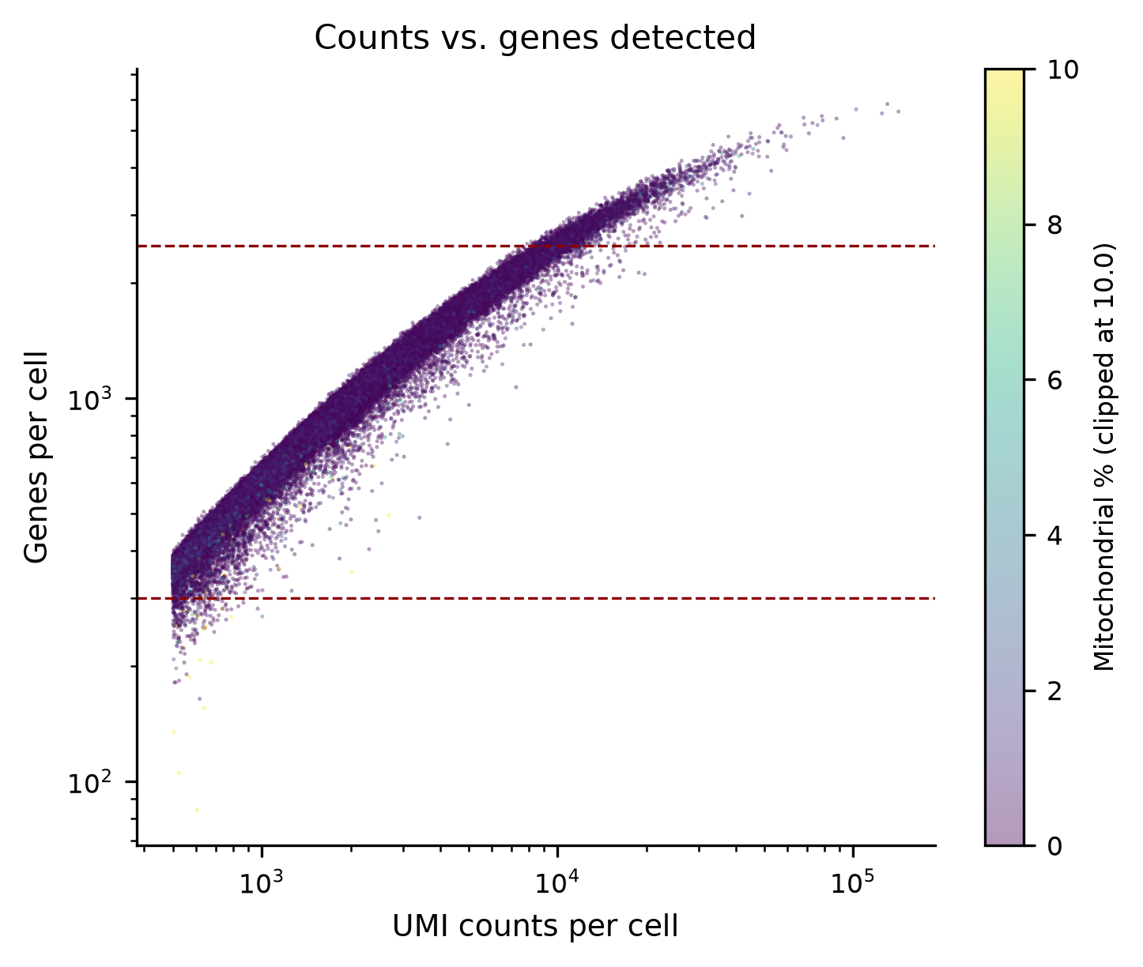
Supplementary Figure S1. UMI counts against genes detected per cell before filtering, coloured by mitochondrial fraction; dashed lines mark the gene-count thresholds.
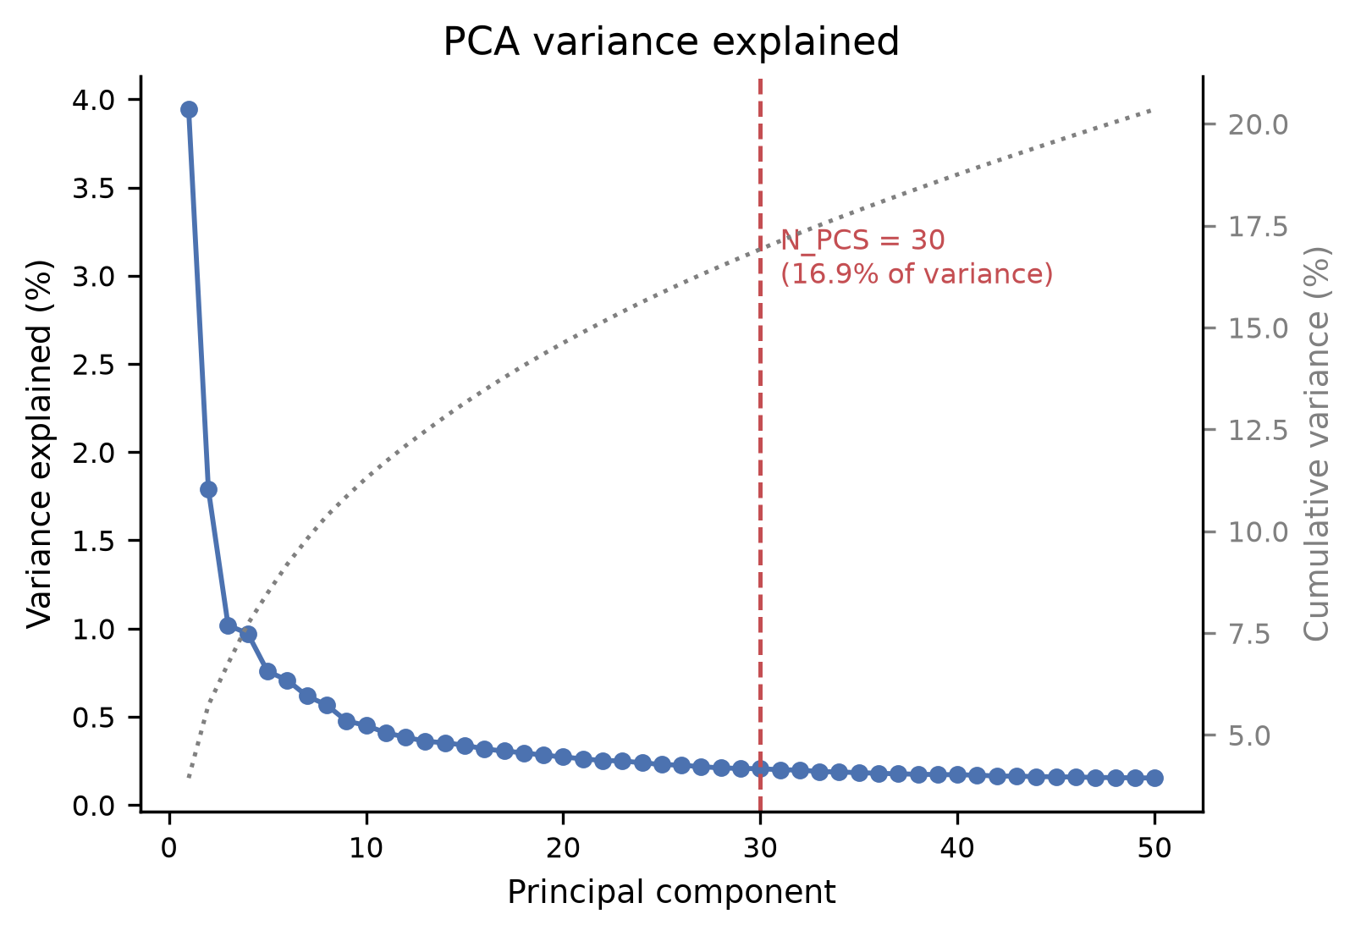
Supplementary Figure S2. Variance explained by the first 50 principal components; 30 components (16.9% of variance) were retained.
A
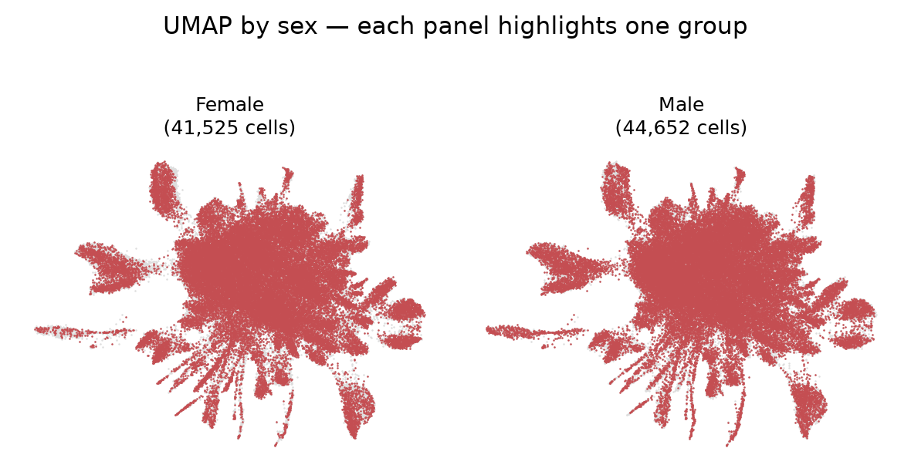
B
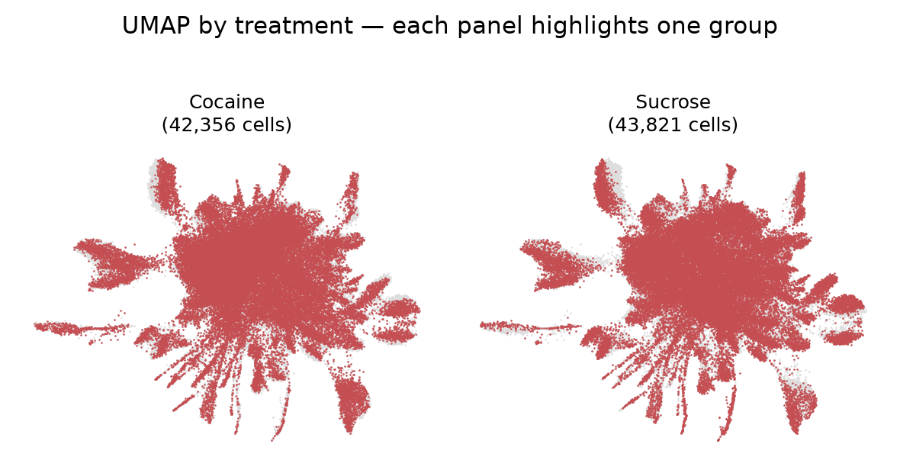
Supplementary Figure S3. UMAP split by (A) declared sex and (B) treatment.
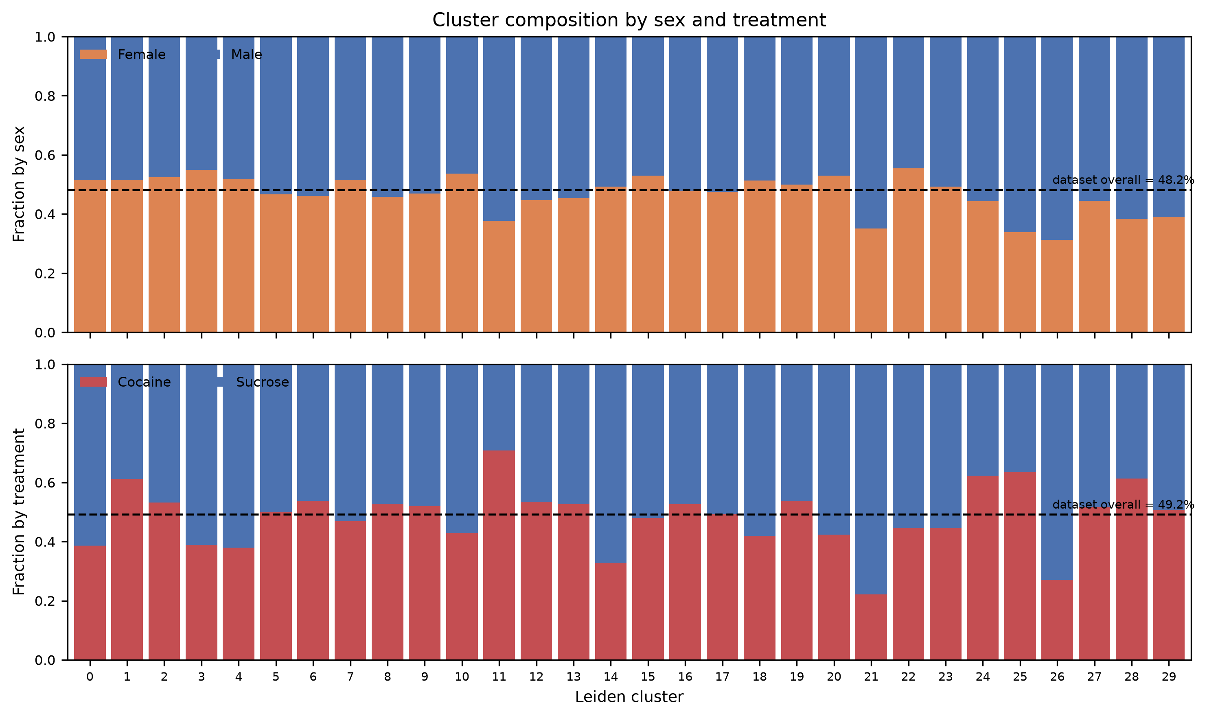
Supplementary Figure S4. Composition of each cluster by declared sex (top) and treatment (bottom); dashed lines mark the dataset-wide proportion.
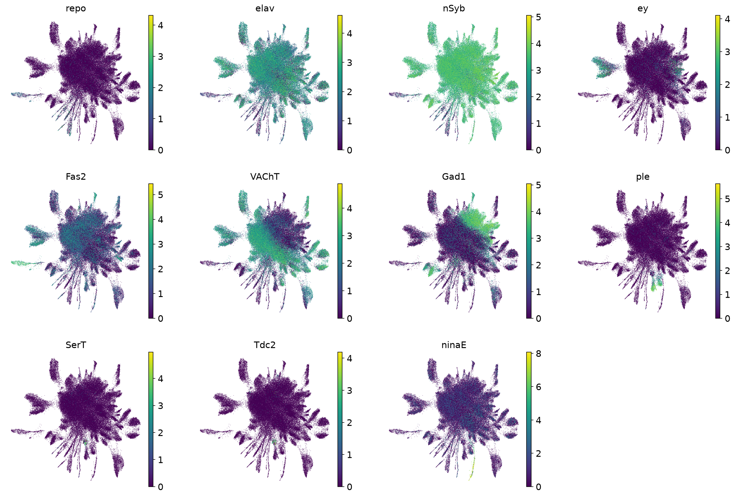
Supplementary Figure S5. Expression of canonical markers on the UMAP embedding: repo (glia), elav and nSyb (neurons), ey and Fas2 (Kenyon cells), VAChT (cholinergic), Gad1 (GABAergic), ple (dopaminergic), SerT (serotonergic), Tdc2 (octopaminergic/tyraminergic) and ninaE (photoreceptors). Colour shows log-normalised expression.
Appendix A. AI Usage Disclosure

A.1 Statement
English is not my first language. I used an AI assistant to improve the clarity and readability of this report so that it is accessible to a wide audience. I also used AI assistance for figure scripts and report assembly, as listed below. All analysis decisions, interpretations and conclusions are my own. Every AI-generated output was reviewed by me. Reported numbers were checked against the pipeline's result tables, partly with AI assistance, and the key values were reproduced by running the code myself.

A.2 Tool used
Claude (Anthropic), model Claude Opus 5, September 2026.

A.3 Prompts and purposes
The complete prompt log is in reports/AI_prompt_log.md. The AI assistant was used to:
- combine my drafts into one report and produce the Word document;
- check reported numbers against the result tables, which identified two errors that I then confirmed (§3.5, §3.6);
- revise the figure scripts for the sex-marker figure, graphical abstract and flowchart, which I then ran on my own machine;
- verify the Lukas et al. 1996 reference;
- improve the English throughout.

A.4 Validation
- Reported numbers were checked against the pipeline's result tables (results/tables/), and the per-sample sex-marker values and the excluded-cluster depth ratio were reproduced by running the scripts myself.
- The AI-assisted review found and corrected two errors in an earlier draft: the interaction-model result (§3.5) and outdated counts in §3.6. I confirmed both corrections against interaction_global.csv and Figure 10.
- All figures were regenerated on my own machine from the repository scripts.
- The Lukas et al. 1996 reference was verified against the published abstract, which led to a correction in the Introduction.
- The AI assistant accessed only material I provided: files uploaded to the conversation and this project's public GitHub repository.

A.5 Declaration
I confirm that this disclosure is complete and accurate, and that I take full responsibility for the content of this report.
Signature: Mahabubur Rahman Date: September 21, 2026

