Independent Scanpy reanalysis of careg:EGFP reporter dynamics and Müller glia activation in the regenerating zebrafish retina after MNU-induced photoreceptor ablation
Mahabubur Rahman, Chandrani Dey, Md Abir Hasan Siddique Rahi, Md Ariful Amin, Anik Kumar Saha, Md Sohel Rahman, Anamika Jahan Tuli, Khadija Al Ferdous and Md Tangimul Islam
Single-Cell RNA-Seq Analysis · Project 1 · Milestone 1 draft report
Repository: https://github.com/mr-mahabubur-rahman/sc-project1-zebrafish-retina · Tag: v1.0-peerreview
Primary reference: Bise et al. (2023), Frontiers in Molecular Neuroscience 16:1160707 · Data: NCBI GEO GSE202212
Group members. All correspondence to the group leader.
# | Name | Role | Email
1 | Mahabubur Rahman | Group Leader | mr.mahabub@gmail.com
2 | Chandrani Dey | Member | cds01307@gmail.com
3 | Md Abir Hasan Siddique Rahi | Member | abirhasan2525@gmail.com
4 | Md Ariful Amin | Member | ariful.amin12@gmail.com
5 | Anik Kumar Saha | Member | anik.ksaha21@gmail.com
6 | Md Sohel Rahman | Member | sohel5926@stu.gau.edu.bd
7 | Anamika Jahan Tuli | Member | jahananamika001@gmail.com
8 | Khadija Al Ferdous | Member | azfat2017@gmail.com
9 | Md Tangimul Islam | Member | rifat.tangimul@gmail.com

Abstract
Zebrafish regenerate lost photoreceptors by reprogramming Müller glia into proliferative progenitors, a capacity absent in mammals. Bise et al. (2023) identified the regeneration-responsive element careg as a reporter of activated Müller glia after methylnitrosourea (MNU) photoreceptor ablation. Their single-cell RNA-sequencing data (control and 3, 7 and 10 days post-MNU, two replicates each) were reanalysed here using an independent Python/Scanpy pipeline rather than the published Seurat workflow, to establish which conclusions are robust to analytical choice. Of 20,097 cells, 15,893 (79.1%) passed quality control and resolved into thirteen retinal populations, including horizontal cells and a small retinal ganglion cell population the published analysis did not recover. The reporter result reproduced closely: EGFP-positive cells rose from 0.56% of control cells to 5.40% at 3 dpMNU, declining to 2.45% and 2.80% at 7 and 10 dpMNU — within 0.2 percentage points of the published values throughout. Müller glia were enriched 3.75-fold and held 42.6% of all reporter-positive cells. Because EGFP-positive cells proved to be sequenced eleven-fold more deeply than negative cells, positivity was re-examined within depth quartiles; at matched depth the induction was stronger, not weaker, rising from 0% of control cells to 54.3% at 3 dpMNU. All 23 genes tested from the published EGFP-positive signature were recovered as significantly upregulated. Subclustering resolved resting and activated Müller glia, the latter reporter-active, ascl1a-positive and depleted of control cells. The published immature/mature rod distinction did not reproduce: the diagnostic paralog inversion failed for two of three gene pairs, while the equivalent test in cones reproduced exactly, identifying the rod result as specific to that comparison rather than a limitation of the pipeline. Two sensitivity analyses tested the analytical choices most likely to explain that failure. Applying Harmony batch correction removed 79.6% of the condition variance against 30.4% of the technical variance, yet left the reporter time course identical to two decimal places and the rod verdict unchanged; re-clustering at the published resolution likewise left it unchanged. Batch structure and clustering granularity are therefore eliminated, and normalisation remains the leading explanation.
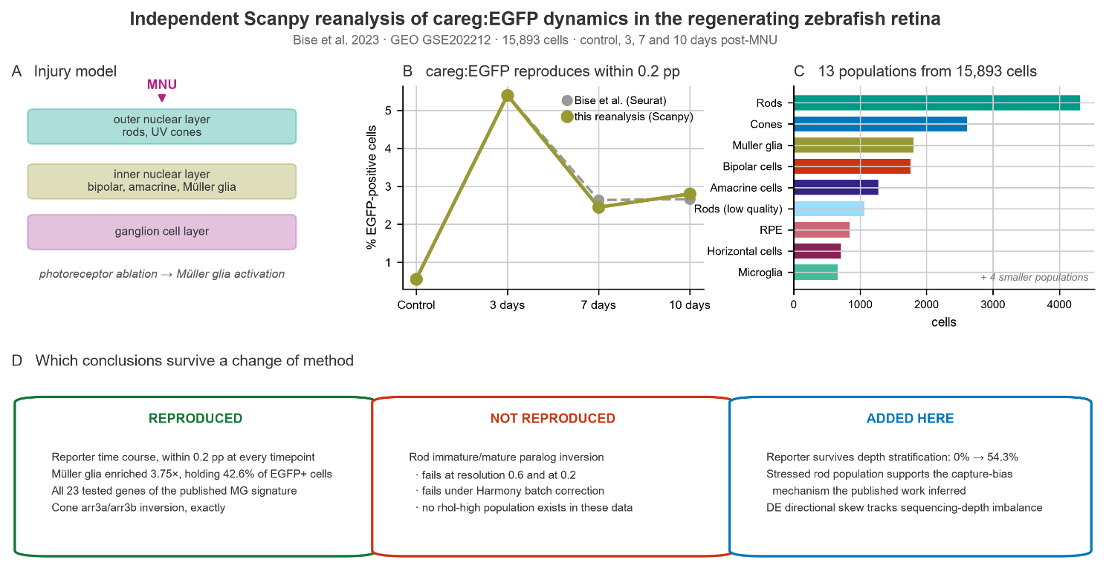
Graphical abstract. (A) MNU ablates the outer nuclear layer, triggering Müller glia activation. (B) careg:EGFP positivity across the injury time course, this reanalysis against the published values. (C) The thirteen populations recovered from 15,893 cells; the nine largest are shown. (D) Which published conclusions survive an independent analysis, which do not, and what this reanalysis adds.
Keywords: zebrafish, retina regeneration, Müller glia, single-cell RNA-seq, careg, reproducibility

1 Introduction

1.1 Retinal structure and the regenerative divide
The vertebrate retina is a laminated neuroepithelium of three nuclear and two plexiform layers, an architecture conserved between zebrafish and humans (Raymond and Barthel, 2004). Photoreceptors — rods for scotopic vision and spectrally distinct cone subtypes for photopic vision — occupy the outer nuclear layer and synapse onto bipolar and horizontal cells in the outer plexiform layer. Müller glia span the full retinal thickness, providing metabolic and structural support.
Despite this conserved organisation, the consequences of photoreceptor loss diverge sharply. In mammals photoreceptor death is irreversible, whereas zebrafish restore both retinal structure and visual function (Wan and Goldman, 2016). This difference does not arise from a specialised stem cell population but from the intrinsic plasticity of Müller glia themselves. This report reanalyses the single-cell data of Bise et al. (2023) with an independent pipeline, to establish which of their conclusions depend on the analytical choices made and which survive a change of method. §1.4 sets out that rationale in full.

1.2 Müller glia as facultative stem cells
Following injury, zebrafish Müller glia dedifferentiate, re-enter the cell cycle and divide asymmetrically to produce a multipotent progenitor that proliferates and differentiates into replacement neurons (Bernardos et al., 2007; Nagashima et al., 2013; Goldman, 2014). Müller glia were first identified as a potential source of neural regeneration in the postnatal chicken retina (Fischer and Reh, 2001). The reprogramming step — the transition from quiescent glial support cell to neurogenic progenitor — remains incompletely understood at the molecular level.

1.3 The careg reporter
Non-coding regulatory elements provide biosensors for the switch from quiescence to regenerative mobilisation. Pfefferli and Jaźwińska (2017) identified careg, a 3.18 kb element from the connective tissue growth factor a (ctgfa) promoter, transiently upregulated in regeneration-participating cells of zebrafish fin and heart. Bise et al. (2023) extended this to neural tissue, showing that careg:EGFP is silent in uninjured retina, induced in a subset of Müller glia from one day after MNU treatment, sustained throughout the regenerative period, and extinguished by 90 dpMNU once repair is complete.
MNU is an alkylating agent that induces apoptotic photoreceptor death, predominantly of rods, and has been established as a non-surgical retinal degeneration model in zebrafish (Tappeiner et al., 2013; Maurer et al., 2014). Bise et al. (2023) further demonstrated damage to UV cones and the outer plexiform layer. EGFP serves as a transcriptional surrogate for regenerative activation: because the transgene was added to the alignment reference, reporter transcripts are countable per cell alongside the endogenous transcriptome.

1.4 Rationale for independent reanalysis
Reproducibility in computational biology has two distinct meanings. Re-executing published code on published data establishes only that the pipeline is deterministic. Recovering the same biological conclusion through independent methodological choices — different normalisation, clustering and annotation — tests whether the finding survives the decisions every analyst must make. The second is the stronger claim, and it is the one attempted here.
This reanalysis therefore uses Python/Scanpy (Wolf et al., 2018) rather than Seurat, log-normalisation rather than SCTransform, and Leiden community detection (Traag et al., 2019) at a different resolution, with entirely independent cluster annotation. Where results agree, the agreement is informative. Where they diverge, the divergence identifies which conclusions depend on analytical choice.

1.5 Research questions
- Cell type identification. Which retinal populations are recoverable from these data?
- Kinetics of the regenerative response. How does cellular composition shift across control → 3 → 7 → 10 dpMNU?
- EGFP reporter dynamics. Which populations express the reporter, when does it peak, and does it subside by day 10?
- Müller glia reprogramming. Can quiescent, activated and progenitor states be distinguished?
- Photoreceptor vulnerability and recovery. How do rod and cone transcriptomes respond to injury?

2 Materials and Methods

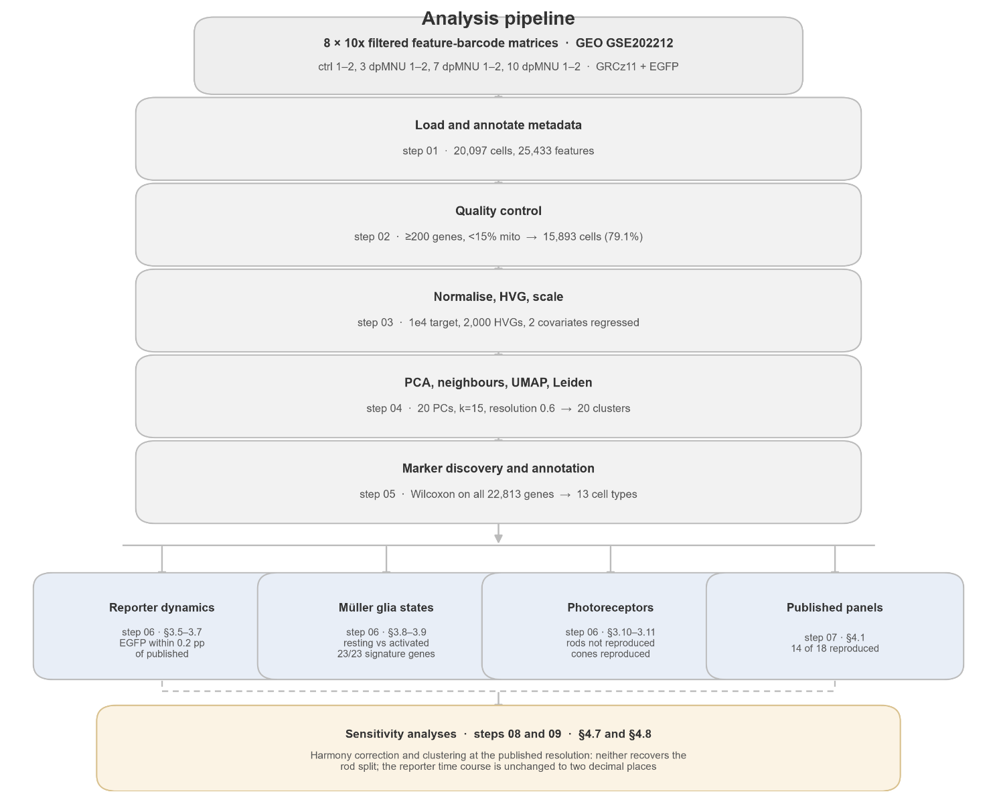

Figure 1A. Analysis pipeline. Each stage names the notebook that produces it and the key quantity it yields. The four branches correspond to the Results sections indicated; the sensitivity analyses in §4.7 and §4.8 test the analytical decisions made at the clustering and batch-correction stages.

2.1 Dataset
Eight 10x Genomics Chromium 3′ filtered feature-barcode matrices from GEO accession GSE202212 (Bise et al., 2023): two uninjured controls treated with heat-inactivated MNU — a control for chemical exposure independent of injury — and two biological replicates each at 3, 7 and 10 days post-MNU. The reference was NCBI GRCz11 manually modified to include the EGFP transgene sequence, giving 25,433 features; 22,813 genes were retained after filtering.
Table 1. Cells recovered per sample, before and after quality control.
Sample | Condition | Before QC | After QC | % lost | Median mito (%)
ctrl1 | Control | 1,155 | 906 | 21.6 | 5.96
ctrl2 | Control | 2,116 | 1,609 | 24.0 | 5.48
3dp1 | 3 dpMNU | 2,873 | 2,317 | 19.4 | 8.74
3dp2 | 3 dpMNU | 2,388 | 1,844 | 22.8 | 6.20
7dp1 | 7 dpMNU | 3,444 | 2,562 | 25.6 | 10.30
7dp2 | 7 dpMNU | 1,480 | 1,165 | 21.3 | 6.31
10dp1 | 10 dpMNU | 4,124 | 3,333 | 19.2 | 8.09
10dp2 | 10 dpMNU | 2,517 | 2,157 | 14.3 | 6.65
Total |  | 20,097 | 15,893 | 20.9 | —
Recovery was unbalanced in two respects with direct analytical consequences. Controls contributed the fewest cells (3,271 before QC, 2,515 after) against 6,641 at 10 dpMNU, so control estimates carry the widest sampling uncertainty. Replicates within a condition also differed substantially — 7dp1 recovered 3,444 cells against 7dp2's 1,480, a 2.3-fold difference attributable only to technical variation.
A systematic difference exists between the two runs of each injured pair: replicate 1 consistently shows higher mitochondrial content than replicate 2 (8.74 vs 6.20 at 3dp; 10.30 vs 6.31 at 7dp; 8.09 vs 6.65 at 10dp), indicating a processing or dissociation difference between runs. This becomes important in §3.4.
All proportion analyses were therefore computed within each sample, with replicate values reported individually, since pooling cells before computing proportions would weight each condition by whichever replicate happened to capture more cells.

2.2 Software environment
Python 3.11.15 with Scanpy 1.11.5 (Wolf et al., 2018), AnnData 0.11.4, NumPy 2.4.6, pandas 2.3.3, SciPy 1.17.1, matplotlib 3.11.1, leidenalg 0.12.0 and gseapy 1.3.1. harmonypy 0.2.0 was installed for the sensitivity analysis in §4.7 and is not used in the primary pipeline. Environments were managed with uv; exact versions are recorded in docs/session_info.json and pinned in requirements.txt and uv.lock. A single random seed (0) was applied to PCA, UMAP, Leiden clustering and gene scoring.
Figure accessibility. Categorical colours are drawn from colour-vision-deficiency-safe schemes (Okabe-Ito; Tol, 2021). The assignment of colour to cell type was optimised to maximise the smallest perceptual distance between any two categories in CAM02-UCS, evaluated simultaneously under normal vision, deuteranopia, protanopia and tritanopia. This was verified rather than assumed: testing the palette used in the draft version found that rods and retinal ganglion cells sat 2.3 units apart under simulated protanopia — effectively the same colour, and both populations appear on the same embedding. The minimum distance across all categories and all three deficiency forms is now 8.8, with no pair below 5. Thirteen categories cannot be separated by hue alone under any palette, so every figure carrying categorical colour also identifies populations by direct label or by a legend ordered to match the plot; continuous scales use perceptually uniform colour maps. The verification is reproducible via scripts/colour_check.py and shown in Supplementary Figure S3.

2.3 Quality control
Zebrafish gene symbols follow lower-case convention, so mitochondrial genes were identified by the mt- prefix, ribosomal protein genes by rps/rpl, and haemoglobins by hba/hbb/hb-. Applying the human MT- convention would match nothing and silently disable the mitochondrial filter; this was verified explicitly.
Cells were retained with at least 200 detected genes and fewer than 15% mitochondrial counts; genes were retained if detected in at least 3 cells. Threshold diagnostics were computed and inspected before filtering. 15,893 of 20,097 cells were retained (79.1%).

2.4 Normalisation, feature selection and dimensionality reduction
Counts were normalised to 10,000 per cell and log1p-transformed. Raw counts were preserved in a dedicated layer and the complete log-normalised matrix in .raw.
This distinction is not cosmetic. Feature selection reduced the matrix to 2,000 highly variable genes for clustering, which is standard and appropriate — but all differential expression and marker discovery were performed on the full 22,813-gene matrix retained in .raw. Restricting statistical tests to the highly variable subset would exclude 91% of the transcriptome, including genes central to the comparisons attempted here: meig1 and guca1b for the rod paralog test, and cx52.6, without which horizontal cells could not have been identified (§4.4).
2,000 highly variable genes were selected with sample as batch key.
Two technical covariates were regressed out, total_counts and pct_counts_mt, using sc.pp.regress_out. Regression was applied after subsetting to highly variable genes rather than to the full matrix. The covariates are the same and the result on the retained genes is identical, but regressing 22,813 genes across 15,893 cells costs hours of compute for genes that are discarded before PCA. This deviation is recorded in cfg.REGRESS_ON_HVG_SUBSET rather than applied silently.
The matrix was then scaled with clipping at ±10.

2.5 Batch structure and the decision not to integrate
Bise et al. applied Seurat anchor-based integration across samples. Integration was deliberately not applied here. In this experimental design each timepoint comprises its own pair of 10x runs, so condition and sequencing batch are completely confounded; correcting on sample identity would remove the biological injury response together with the technical batch effect.
To make this an evidence-based decision rather than a default, variance in the first 20 principal components was decomposed by factor:
Factor | Mean variance explained across the first 20 PCs
condition | 0.0201
replicate | 0.0023
sample | 0.0244
Replicate is the informative term, since replicates within a condition differ only technically. Condition explains nearly nine-fold more principal component variance than replicate, so technical batch structure is small relative to biological signal. Figure 2C supports this visually: most clusters contain cells from all eight samples. The confound is a property of the experimental design and cannot be resolved by any computational method; it is stated as a limitation rather than treated as removed. This decision is tested empirically in §4.7, where correction is shown to remove four-fifths of the condition variance while removing less than a third of the technical variation.

2.6 Cell type annotation
Cluster markers were identified by Wilcoxon rank-sum test on the full gene set, matching the test used in the published analysis. Annotation was performed manually, requiring concordant evidence from multiple markers, using the canonical panel specified in the project guide supplemented by markers from Ogawa and Corbo (2021) and Hoang et al. (2020). Every assignment is recorded with supporting markers, conflicting evidence, a confidence level and a written rationale in tables/cluster_annotations.csv. Clusters whose evidence did not support a confident assignment were labelled Unresolved rather than forced into a category.
An important methodological observation arose during annotation. Gene-set panel scores computed with sc.tl.score_genes proved unreliable in this dataset, assigning the highest rod score to clusters whose markers were unambiguously oligodendrocyte (mbpa, plp1b, cldnk) and mesenchymal (col1a1b, col1a2, pdgfra). This is attributable to ambient rod mRNA: rods dominate the tissue and lyse readily during dissociation, so free rho transcripts contaminate all droplets and inflate rod scores globally. Panel scores were consequently rejected and annotation performed from data-driven marker rankings.

2.7 Reporter positivity
A cell was defined as EGFP-positive if its raw transgene count was at least 1. The observed count distribution justifies this threshold: it decays monotonically from 310 cells at one count (76 at two, 34 at three, trailing to a maximum of 14) with no bimodal separation, so any higher threshold would be arbitrary. 64% of positive cells carry exactly one count, and requiring at least two counts would reduce the positive fraction from 3.03% to 1.08%. Continuous log-normalised values are reported alongside every binary call so that no conclusion rests on the threshold alone.

2.8 Differences from the published analysis
Table 2. Published method against this implementation.
Step | Bise et al. (2023) | This analysis | Equivalent?
Alignment | Cell Ranger 3.0.2, GRCz11 + EGFP | inherited (matrices supplied) | n/a
Cell QC | scater; ~12 ± 2% removed | ≥200 genes, <15% mito | No
Doublet removal | explicit | none | No
Normalisation | SCTransform | normalize_total + log1p | No
Integration | Seurat anchors, 30 dims | none (§2.5) | No
Clustering | SNN modularity, res 0.2 | Leiden, res 0.6 | No
Marker / DE test | Wilcoxon rank-sum | Wilcoxon rank-sum | Yes
Enrichment | topGO, Fisher exact | gseapy / Enrichr | No
Differential expression thresholds. All differential expression used the Wilcoxon rank-sum test with Benjamini-Hochberg correction. A gene was reported as differentially expressed at adjusted p < 0.05 and |log2 fold change| ≥ 0.25. Both thresholds are defined in scripts/config.py as DE_PADJ_CUTOFF and DE_LOG2FC_CUTOFF so that no figure or table applies a different cut. Where the published analysis reports a threshold, it uses adjusted p alone with no fold-change floor; comparisons of DEG counts note this difference where it matters.
SCTransform models gene expression as regularised negative binomial residuals (Hafemeister and Satija, 2019) and is a fundamentally different estimator from log-normalisation, not a cosmetic variant. It weights highly expressed genes differently — precisely the regime occupied by rod phototransduction transcripts in this tissue. This difference is relevant to interpreting the rod result in §3.10.
UMAP embeddings are not reproducible as images. Coordinates depend on normalisation, feature selection, PCA and random initialisation; even re-executing identical code on another machine shifts them, and cluster numbering is arbitrary between analyses. All comparisons with published figures are therefore made on quantities — percentages, marker identities, relative abundances — never on visual correspondence.

3 Results

This section follows the biological narrative of the injury and the response to it. §3.1 and §3.2 establish what was recovered from the data and with what confidence. §3.3 and §3.4 describe how the cellular composition changes after ablation, and why most of that change reflects capture bias rather than biology. §3.5 to §3.9 concern the Müller glia response: when the reporter is induced, in which cells, whether that induction survives correction for a sequencing-depth confound, and what distinguishes activated glia from resting ones. §3.10 and §3.11 turn to the photoreceptors themselves — the rods whose published substructure did not reproduce, and the cones whose did.

3.1 Quality control
Quality control retained 15,893 of 20,097 cells (79.1%), with per-sample loss ranging from 14.3% to 25.6%. Mitochondrial content was confirmed non-zero, verifying that the mt- prefix matched real genes.
The filtering waterfall in Figure 1 shows that the minimum-gene threshold removed very few cells — Cell Ranger's filtered matrices have already excluded most empty droplets — and that nearly all loss is attributable to the 15% mitochondrial cut. Cell loss tracks the replicate rather than the condition (Table 1): the first run of each injured pair consistently carries higher mitochondrial content. Injured retinas dissociate into a population containing more stressed singlets, but the magnitude of that effect differs between runs, a technical source of variation that propagates into §3.4.
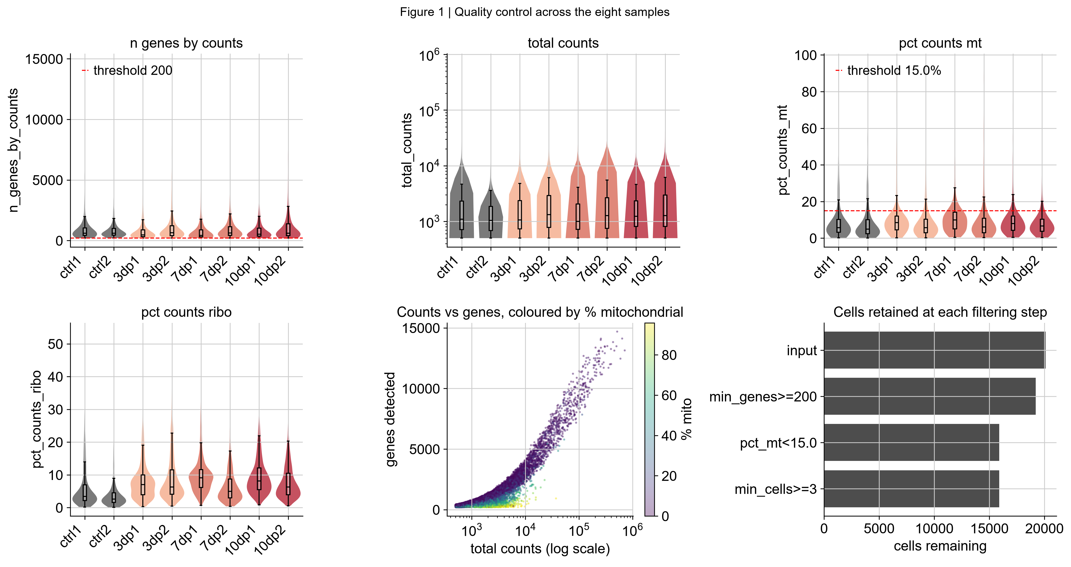
Figure 1. Quality control across the eight samples. Violin plots of detected genes, total counts, mitochondrial and ribosomal percentage per sample, with the applied thresholds marked in red; a counts-versus-genes scatter coloured by mitochondrial content; and the cell-retention waterfall. Nearly all cell loss is attributable to the mitochondrial threshold rather than to the minimum-gene filter.

3.2 Thirteen retinal populations, including horizontal cells and retinal ganglion cells
Leiden clustering at resolution 0.6 produced 20 clusters, annotated to thirteen cell types plus an unresolved fraction.
Table 3. Annotated cell populations, ordered by abundance.
Cell type | Clusters | Cells | % | Key markers
Rods | 0, 2 | 4,314 | 27.1 | rho, pde6a/b, gnb1b
Cones | 9, 10 | 2,614 | 16.4 | gnat2, pde6c, arr3a
Müller glia | 6, 7 | 1,807 | 11.4 | rlbp1a, glula, slc1a2b
Bipolar cells | 13, 17 | 1,758 | 11.1 | cabp5a, grin1b, trpm1b
Amacrine cells | 3 | 1,274 | 8.0 | slc32a1, pax6a, snap25a
Rods (low quality) | 4 | 1,062 | 6.7 | rho with mt-co2 dominant
RPE | 11, 12 | 847 | 5.3 | rpe65a, tyrp1b, stra6
Horizontal cells | 8 | 712 | 4.5 | cx52.6, rem1, tnr
Microglia | 16 | 661 | 4.2 | apoc1, ccl34b.1, apoeb
Unresolved | 1, 14 | 365 | 2.3 | —
Erythrocytes | 5 | 202 | 1.3 | hbba1, hbaa1
Oligodendrocytes | 19 | 129 | 0.8 | mbpa, plp1b, cldnk
Retinal ganglion cells | 15 | 97 | 0.6 | rbpms2b, gap43, islr2
Pericytes | 18 | 51 | 0.3 | col1a1b, col1a2, pdgfra
Confidence audit: 82.9% of cells lie in high-confidence assignments, 14.4% medium and 2.6% low. The three low-confidence clusters (1, 14 and 18) support no conclusion in this report.
Horizontal cells were identified by cx52.6 (mean 1.010) and rem1 (1.342), each five- to ten-fold above any other cluster; the next highest values are 0.112 and 0.242, both in the 15-cell multiplet cluster. cx52.6 encodes a connexin associated with zebrafish horizontal cell gap junctions. cabp5a was present (0.770) but far below the bipolar clusters (3.004 and 2.736), excluding bipolar identity.
Retinal ganglion cells were recovered as a discrete rbpms2b-positive cluster of 97 cells. Bise et al. state that their analysis captured very few ganglion cells and that no cluster was characterised by unique rbpms2b expression. This is a genuine divergence from the published result, discussed in §4.4.
Two clusters resisted assignment. Cluster 1 (15 cells) showed 12,462 genes and 398,264 counts per cell, approximately 100-fold the dataset median, and is best interpreted as multiplet droplets — the population that the published scater-based filtering removed. Its behaviour is visible in Figures 4 and 5, where it is positive for markers of nearly every cell type simultaneously. Cluster 14 (350 cells) expressed only cytoskeletal and heat-shock genes without a defining identity marker.
Research question 1 is answered: all major retinal populations were recovered — rods, cones, Müller glia, bipolar, amacrine, horizontal and retinal ganglion cells, and microglia — together with RPE, oligodendrocytes, erythrocytes and pericytes.
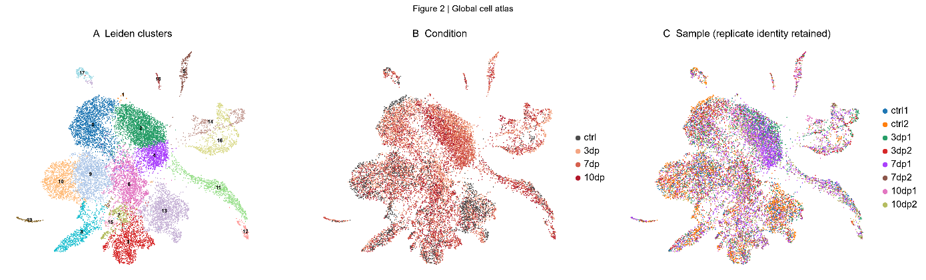

Figure 2. Global cell atlas. (A) UMAP coloured by Leiden cluster at resolution 0.6. (B) Coloured by condition. (C) Coloured by sample, retaining replicate identity — this panel is the batch check, and most clusters contain cells from several samples, consistent with the variance decomposition in §2.5.
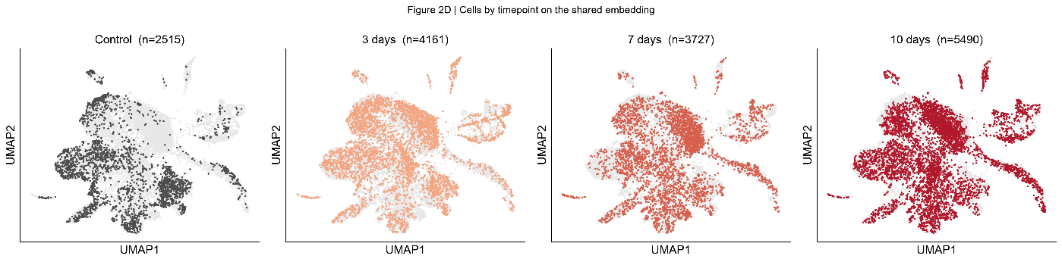
Figure 2D. The same embedding split by timepoint, with cells from the plotted condition highlighted against all others in grey. Control cells are visibly sparse in the upper-central region and in the right-hand arc, both of which fill in after injury. Cell counts are post-QC.
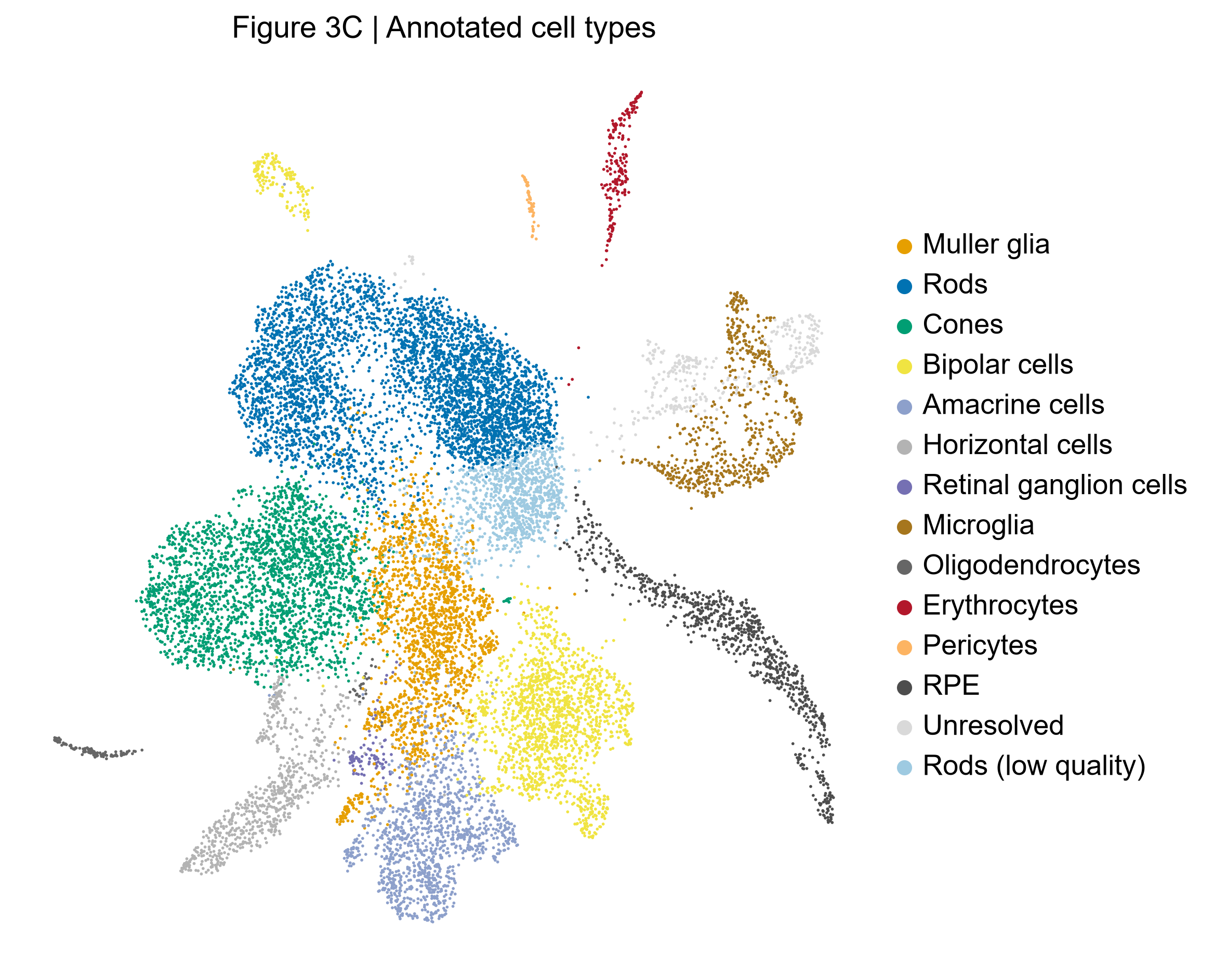
Figure 3. Annotated cell types across 15,893 cells. Müller glia (orange) occupy a central, elongated territory bridging photoreceptors and inner neurons; the low-quality rod population (pale blue) sits adjacent to but distinct from healthy rods.
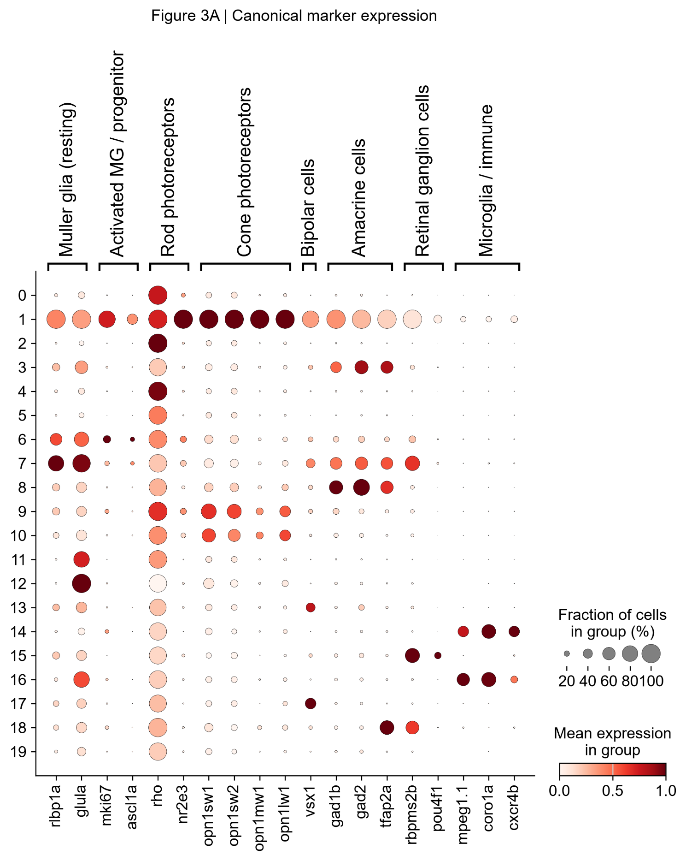

Figure 4. Canonical marker expression by Leiden cluster — the evidence underlying the annotation in Table 3. Dot size indicates the fraction of cells expressing each gene; colour indicates mean scaled expression. Grouping by cluster rather than by assigned cell type is deliberate: the assignment is the conclusion drawn from this panel, not an input to it. Cluster 1 is positive across nearly every marker panel simultaneously, which is diagnostic of multiplets rather than of a cell type.
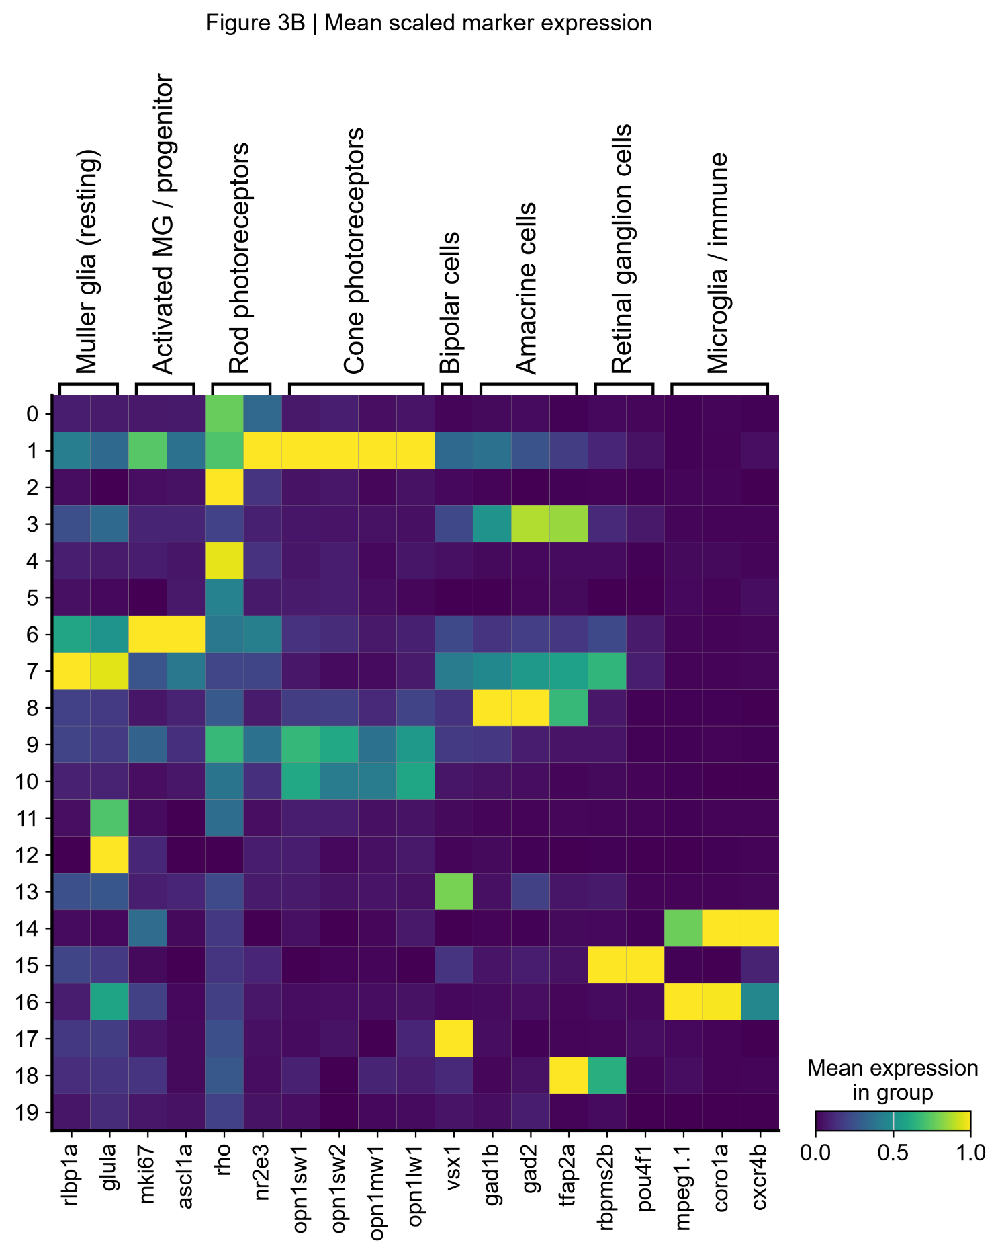

Figure 5. Mean scaled marker expression by cluster, the matrixplot equivalent of Figure 4. Cluster 6 shows the strongest mki67 and ascl1a signal of any cluster, anticipating the activated Müller glia subpopulation resolved in §3.8.

3.3 Composition shifts are dominated by capture bias
Table 4. Cell-type composition across the time course (%, mean of the two replicate values per condition).
Cell type | Control | 3 dpMNU | 7 dpMNU | 10 dpMNU
Rods | 12.16 | 33.24 | 25.46 | 28.36
Rods (low quality) | 0.66 | 5.00 | 9.82 | 6.09
Cones | 26.05 | 16.80 | 14.30 | 15.02
Bipolar cells | 25.76 | 10.64 | 9.01 | 6.77
Müller glia | 8.39 | 11.67 | 10.89 | 13.52
Horizontal cells | 9.29 | 3.84 | 4.47 | 2.85
Amacrine cells | 8.48 | 4.56 | 11.22 | 8.95
Microglia | 2.22 | 4.05 | 4.96 | 4.74
RPE | 5.08 | 2.86 | 5.54 | 7.88
Retinal ganglion cells | 0.62 | 0.12 | 1.02 | 0.86
Rods rose 2.7-fold, from 12.16% of control cells to 33.24% at 3 dpMNU. Bise et al. report the same direction and attribute it explicitly to a bias in cell survival and capture efficiency, noting that comparable biases have been described in other vertebrate retinal injury models (Macosko et al., 2015). The present analysis reproduces the observation independently.
Declines are not interpretable. Cones fall from 26.05% to 15.02%, bipolar cells from 25.76% to 6.77% and horizontal cells from 9.29% to 2.85%. None of these populations plausibly dies at that rate within three days, and no such loss is reported in the published immunofluorescence. Proportions are constrained to sum to unity, so over-capture of rods mechanically depresses every other population. No claim of cone, bipolar or horizontal cell loss is made from these data.
Increases against that dilution are meaningful. Microglia rise from 2.22% to 4.96% despite the rod inflation, so the underlying increase must be larger than the proportion suggests — consistent with an inflammatory response to photoreceptor death. This is also the most reproducible trend in the dataset: the two replicate values agree closely at every timepoint (Figure 8). Müller glia (8.39 → 13.52%) and RPE (5.08 → 7.88%) rise likewise, and the Müller glia increase is corroborated independently by the reporter data (§3.5–3.6).
Research question 2 is answered, with the essential qualification that single-cell proportions measure what was captured, not what was present in the tissue.
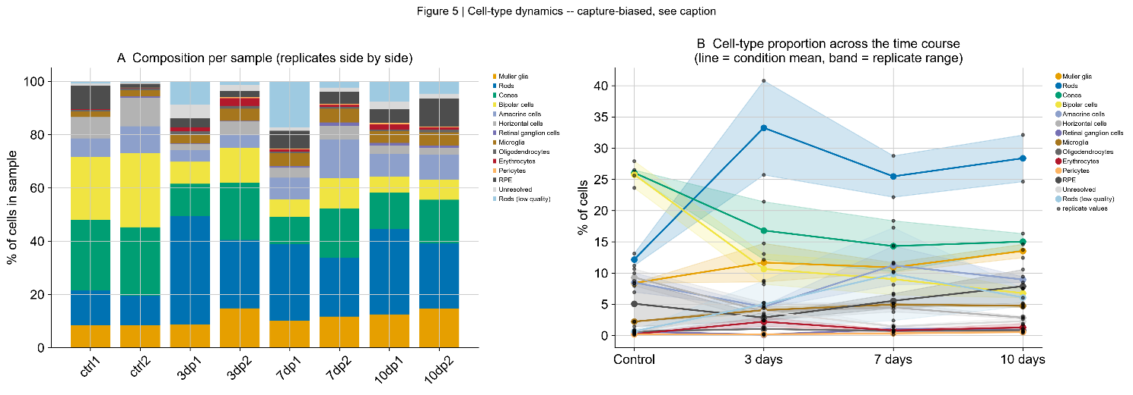
Figure 6. Cell-type dynamics across the regeneration time course. (A) Composition per sample, with the two replicates of each condition side by side; note that the two controls are near-identical while the injured pairs differ visibly. (B) Per-population trajectories, line showing the condition mean and band the replicate range. The width of the rod and low-quality rod bands is the basis for the caution in §3.4.
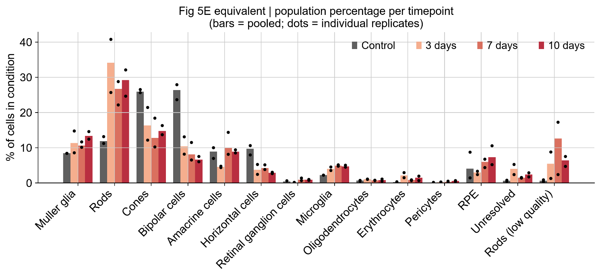
Figure 7. Population percentage per timepoint, the equivalent of Bise et al. Figure 5E. Bars show pooled percentages and dots the two individual replicates. Müller glia and microglia show tight replicate agreement; rods and low-quality rods do not.

3.4 A stressed rod population, with important replicate variability
Cluster 4 (1,062 cells) carried unambiguous rod identity but was topped by mt-co2, with 12.6% median mitochondrial content and 320 detected genes per cell, against 2.6% and 496 genes for the healthy rod cluster. It was annotated Rods (low quality).
Its abundance rises with injury, from 0.66% of control cells to 9.82% at 7 dpMNU, but the replicate values disagree substantially:
Table 5. Rods (low quality) as a percentage of cells in each sample.
Condition | Replicate 1 | Replicate 2 | Ratio
Control | 0.88 | 0.44 | 2.0×
3 dpMNU | 8.76 | 1.25 | 7.0×
7 dpMNU | 17.25 | 2.40 | 7.2×
10 dpMNU | 7.50 | 4.68 | 1.6×
Replicates within a condition differ only technically, so a seven-fold gap requires a technical explanation — and the quality control data provide one. The mitochondrial content of each sample (Table 1) tracks these values directly: 7dp1 has the highest mitochondrial content in the dataset (10.30%) and the highest low-quality rod fraction (17.25%), while 7dp2 has 6.31% and 2.40% respectively.
The conclusion this supports, and its limit. A stressed rod population is consistently present after injury and near-absent from controls — every injured sample exceeds every control. Its abundance, however, tracks per-sample dissociation quality, so the magnitude is not reliably estimated and the apparent peak at 7 dpMNU cannot be established from these data. The population is real and injury-associated; its time course is not determined.

3.5 The careg:EGFP time course reproduces closely
Table 6. EGFP-positive cells across the injury time course, against the published values. Percentages are means of the two replicate values.
Condition | This analysis | Replicate values | Bise et al. | Difference
Control | 0.56% | 0.55, 0.56 | 0.54% | +0.02
3 dpMNU | 5.40% | 3.63, 7.16 | 5.40% | 0.00
7 dpMNU | 2.45% | 3.43, 1.46 | 2.64% | −0.19
10 dpMNU | 2.80% | 2.16, 3.43 | 2.66% | +0.14
Every timepoint agrees within 0.2 percentage points, with identical kinetics: a near-silent baseline, a sharp peak at 3 dpMNU, and a partial decline that does not return to control levels by day 10 — remaining approximately five-fold above control.
This answers research question 3 directly. The project specification asks whether expression subsides by day 10. It declines from the peak but does not return to baseline, which is consistent with the published immunofluorescence, in which reporter protein persists to 30 dpMNU and is undetectable only at 90 dpMNU.
Three qualifications are necessary. The two controls agree to within 0.01 percentage points, so the baseline is very well determined. Injured conditions vary about two-fold between replicates, and the direction is not systematic — replicate 2 is higher at 3dp, replicate 1 at 7dp — so this is per-sample variation rather than a batch offset. The overlapping ranges at 7 dpMNU (1.46–3.43) and 10 dpMNU (2.16–3.43) mean those two timepoints are not distinguishable from one another.
EGFP transcripts were detected at low frequency in every population, including erythrocytes (0.50%) and RPE (0.24%), neither of which can transcribe a careg reporter. This establishes an ambient contamination floor of approximately 0.2–0.5%, within which the control value of 0.56% falls. The resolution of this ambiguity is given in §3.7.
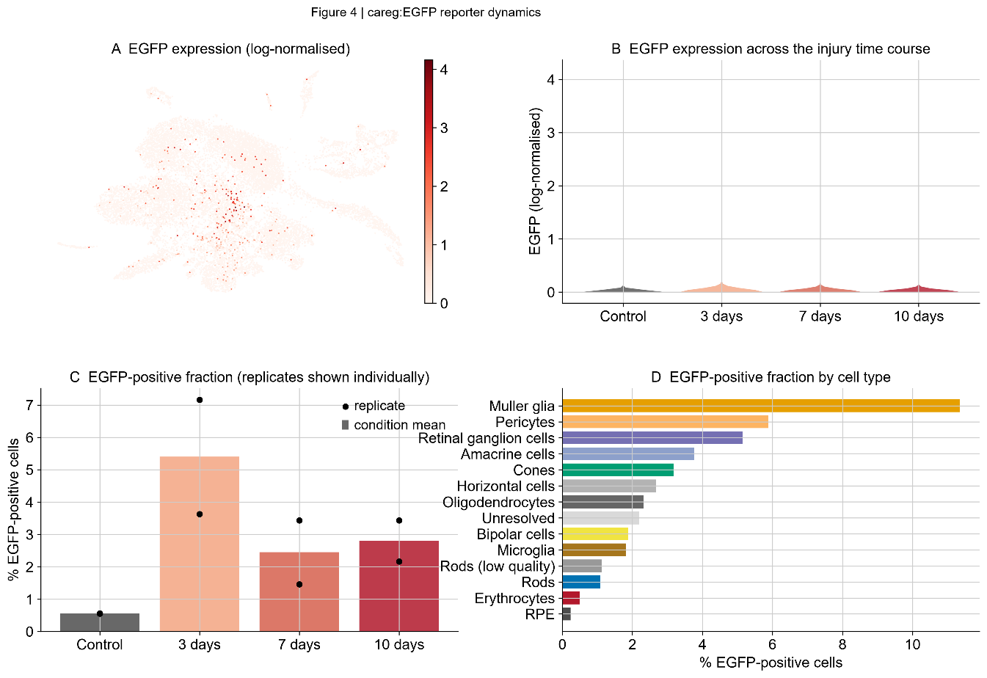
Figure 8. careg:EGFP reporter dynamics. (A) EGFP expression on the UMAP. (B) Expression distribution per condition — dominated by zeros, since 97% of cells carry no transgene transcript, and shown for completeness; panel C is the informative view. (C) EGFP-positive fraction with individual replicates overlaid, showing the two-fold spread at 3 dpMNU. (D) EGFP-positive fraction by cell type.
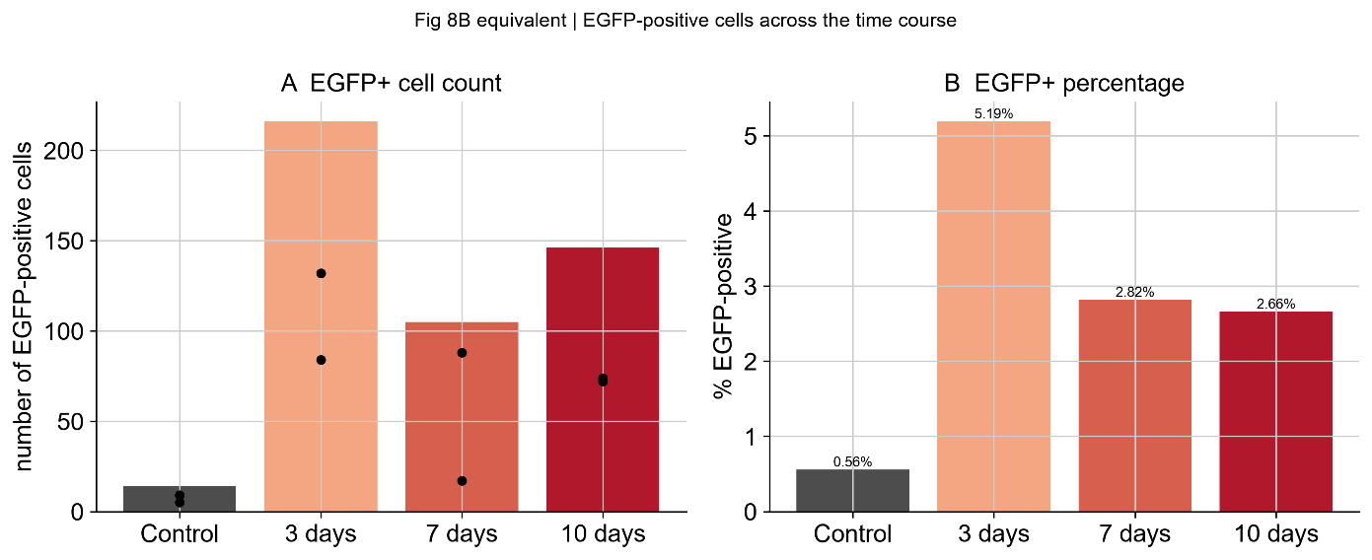
Figure 9. EGFP-positive cells across the time course, the equivalent of Bise et al. Figure 8B. Left: absolute counts with individual replicates overlaid. Right: percentage positive. Percentages here are pooled across replicates (0.56 / 5.19 / 2.82 / 2.66) and differ slightly from the replicate means in Table 6; published values for comparison are 0.54 / 5.40 / 2.64 / 2.66.
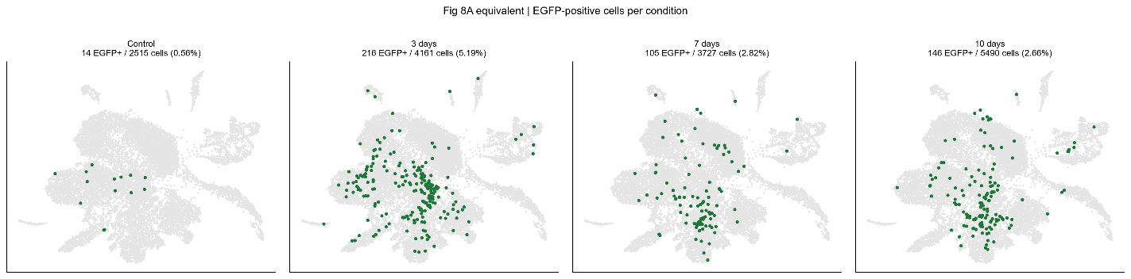
Figure 10. EGFP-positive cells highlighted per condition on the shared embedding, the equivalent of Bise et al. Figure 8A. Fourteen scattered positive cells in control become 216 concentrated over the Müller glia territory at 3 dpMNU.

3.6 Müller glia are the reporter-enriched population
Table 7. EGFP positivity by cell population, ordered by percentage positive.
Cell type | Cells | EGFP⁺ | % | Enrichment | Share of EGFP⁺
Müller glia | 1,807 | 205 | 11.34 | 3.75× | 42.62%
Pericytes | 51 | 3 | 5.88 | 1.94 | 0.62
Retinal ganglion cells | 97 | 5 | 5.15 | 1.70 | 1.04
Amacrine cells | 1,274 | 48 | 3.77 | 1.24 | 9.98
Cones | 2,614 | 83 | 3.18 | 1.05 | 17.26
Horizontal cells | 712 | 19 | 2.67 | 0.88 | 3.95
Oligodendrocytes | 129 | 3 | 2.33 | 0.77 | 0.62
Bipolar cells | 1,758 | 33 | 1.88 | 0.62 | 6.86
Microglia | 661 | 12 | 1.82 | 0.60 | 2.49
Rods (low quality) | 1,062 | 12 | 1.13 | 0.37 | 2.49
Rods | 4,314 | 47 | 1.09 | 0.36 | 9.77
Erythrocytes | 202 | 1 | 0.50 | 0.16 | 0.21
RPE | 847 | 2 | 0.24 | 0.08 | 0.42
Müller glia comprise 11.4% of cells but hold 42.6% of all reporter-positive cells, enriched 3.75-fold over the dataset rate. Bise et al. report EGFP transcripts in nearly 10% of Müller glia, describing this as an outstanding proportion relative to other cell types; the present figure of 11.34% agrees closely.
Nine of thirteen populations fall between 0.24% and 3.77%, forming a continuum bracketed by erythrocytes and RPE — the ambient floor. Müller glia sit three-fold above the next population. The 1.0–1.2-fold values for cones and amacrine cells are consistent with ambient contamination in abundant populations and are not interpreted as reporter activity. Pericytes and retinal ganglion cells show nominally higher percentages but on 51 and 97 cells respectively, corresponding to three and five positive cells — too few to interpret, as the positive/total labels in Figure 11 make explicit.
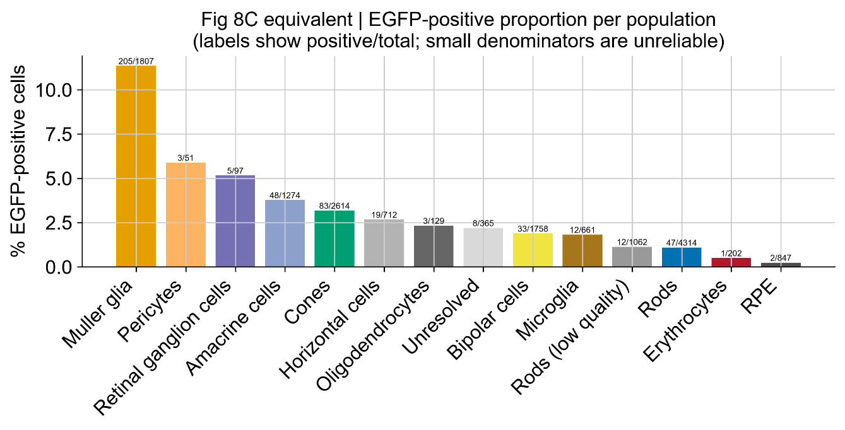
Figure 11. EGFP-positive proportion per population, the equivalent of Bise et al. Figure 8C. Labels give positive/total. Müller glia at 205/1807 are the only population substantially above the ambient background, while pericytes (3/51) and retinal ganglion cells (5/97) rest on denominators too small to interpret.
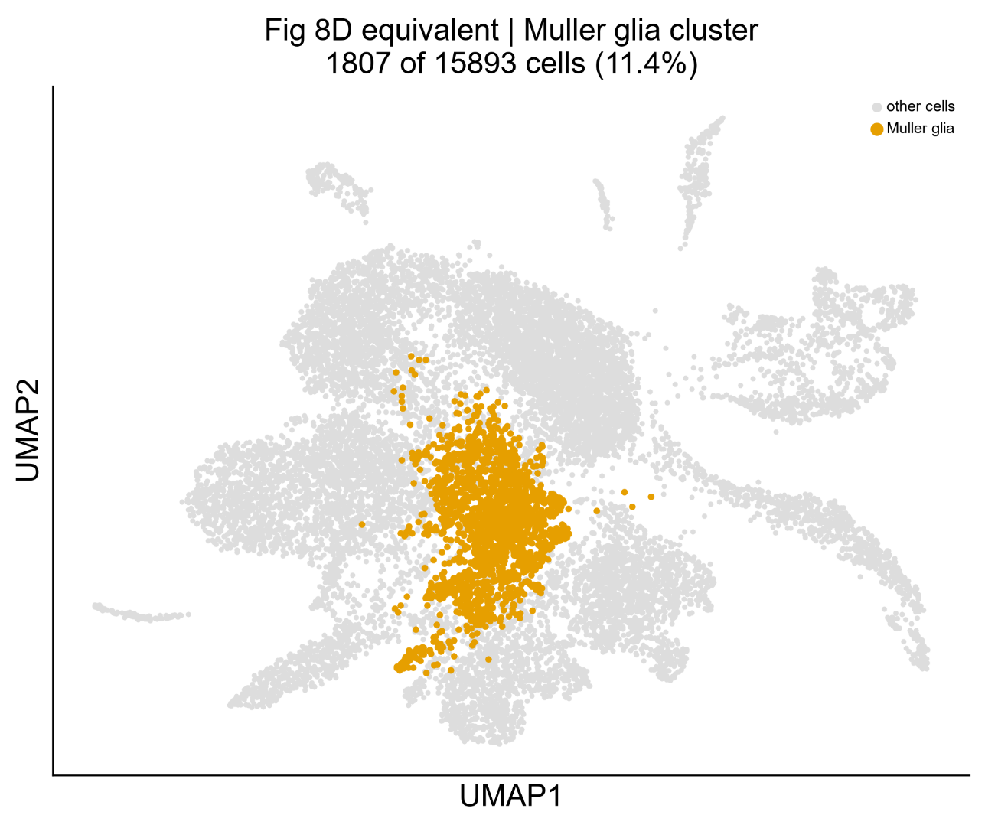
Figure 12. The Müller glia population located within the whole-retina embedding, the equivalent of Bise et al. Figure 8D. 1,807 cells, 11.4% of the dataset, occupying a central position that borders both photoreceptor and inner neuron territories.

3.7 The reporter result survives correction for sequencing depth
EGFP-positive Müller glia proved to be sequenced far more deeply than negative cells — 15,044 median counts against 1,360, an eleven-fold difference — with identical mitochondrial content (5.4% against 5.3%), so this is a depth difference rather than a quality difference. Deeper cells are more likely to capture at least one transgene transcript by sampling alone, so positivity might reflect detection rather than expression. This is the most serious potential confound in the analysis and was therefore tested directly.
Table 8. EGFP-positive rate (%) within Müller glia sequencing-depth quartiles.
Depth quartile | Median counts | n | Control | 3 dpMNU | 7 dpMNU | 10 dpMNU
Q1 | 627 | 455 | 3.57 | 5.88 | 2.22 | 2.89
Q2 | 1,042 | 449 | 1.27 | 3.00 | 2.50 | 5.26
Q3 | 2,640 | 451 | 5.26 | 13.40 | 5.17 | 4.97
Q4 | 14,726 | 452 | 0.00 | 54.35 | 28.44 | 18.82
Both effects are real and separable. Depth strongly affects detection: positivity rises from 3.74% in the lowest quartile to 31.19% in the highest. But the injury effect is independent of depth. In Q4, where every cell has comparable sequencing depth, no control cell is EGFP-positive while 54.35% of 3 dpMNU cells are, and the full kinetics are preserved (0 → 54.35 → 28.44 → 18.82). Q3 shows the same pattern at lower magnitude.
Depth cannot explain a difference between groups of equal depth. The reporter induction is therefore genuine, and the pooled figures understate it: at the depth where detection is most sensitive, uninjured retina shows no reporter at all. This agrees precisely with the published immunofluorescence, which finds no EGFP in uninjured retina, and resolves the ambient-floor ambiguity of §3.5 — the 0.56% control value is contamination, not baseline expression.

3.8 Müller glia resolve into resting and activated states
Subclustering the 1,807 Müller glia at resolution 0.3, over the full gene set, gave eight subclusters, of which three are informative.
Table 9. Müller glia subcluster evidence. Gene values are mean log-normalised expression.
 | Subcluster 0 | Subcluster 2 | Subcluster 5
Cells | 264 | 260 | 241
% EGFP-positive | 18.56 | 27.69 | 0.83
% derived from control | 22.0 | 1.9 | 24.9
rlbp1a | 2.921 | 1.148 | 1.278
glula | 4.076 | 1.727 | 2.022
glulb | 1.323 | 0.668 | 0.413
gfap | 1.523 | 0.857 | 0.387
apoeb | 3.486 | 1.734 | 1.591
pcna | 0.292 | 1.249 | 0.322
mki67 | 0.230 | 1.640 | 0.489
ascl1a | 0.121 | 0.356 | 0.128
Subcluster 2 is proliferative — mki67 seven-fold and pcna 4.3-fold above subcluster 0 — reporter-active, overwhelmingly injury-derived (1.9% of its cells from control against approximately 16% expected under uniform sampling), and has downregulated glial identity markers, with rlbp1a falling from 2.921 to 1.148 and glula from 4.076 to 1.727.
Critically, ascl1a is 2.9-fold enriched — the master regulator of Müller glia reprogramming in zebrafish, not a generic proliferation marker. Its enrichment specifically in the EGFP-high, identity-low, control-depleted population identifies this as a reprogramming state rather than merely a population of dividing cells. Concurrent loss of identity markers and cell-cycle entry is the defining transcriptional signature of dedifferentiation.
Subcluster 0 is the reciprocal — highest identity markers, lowest proliferation, well represented in control — and is interpreted as resting Müller glia. Subcluster 5 provides an internal control on this reasoning: comparable in size and control representation to subcluster 0, but with twenty-fold lower reporter activity, demonstrating that EGFP does not simply track cell number or condition.
Two states are supported by these data, not three. Subclusters 3 and 6 are transcriptionally intermediate and are described as a gradient rather than assigned a separate identity. Subcluster 7 shows the strongest activation signature (31.58% EGFP-positive, ascl1a 0.480, mdka 3.064) but comprises only 19 cells and is not interpreted. Research question 4 is therefore answered: quiescent and activated states are resolved; a separately clustering progenitor population is not, at this depth.
This last point warrants care in comparison with the published work. Bise et al. found EGFP predominantly in activated Müller glia and largely absent from clusters of proliferating progenitors at 7 dpMNU, concluding that reporter expression and progenitor proliferation are separable. In the present data, subcluster 2 is simultaneously EGFP-high and mki67-high. Two interpretations are compatible: either this analysis does not separate activated glia from their progeny at this cell number, or the populations overlap more than the published partition indicated. The observation is reported without a preferred explanation.
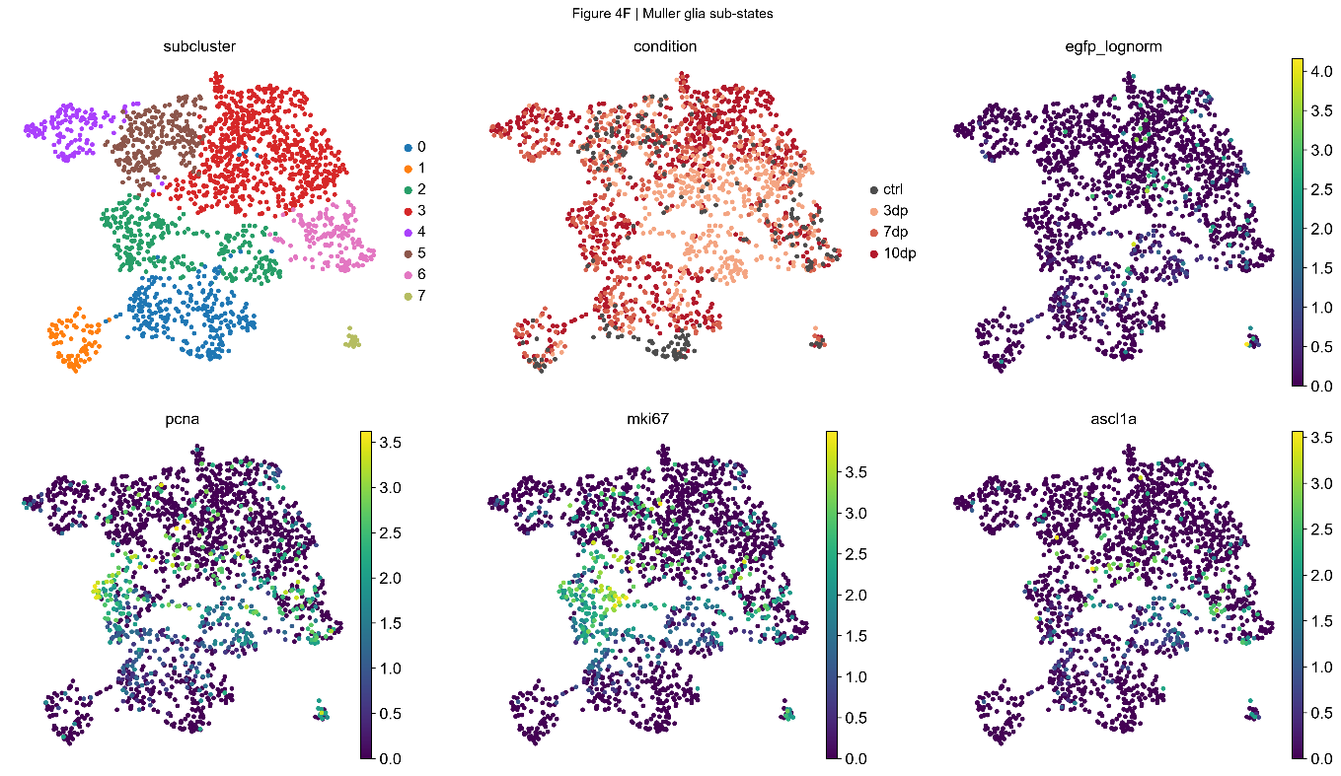

Figure 13. Müller glia sub-states. Subcluster assignment, condition of origin, EGFP expression and proliferation markers on the Müller-glia-only embedding. The pcna- and mki67-high region in the mid-left corresponds to subcluster 2 and contains almost no control cells; control cells concentrate in the lower region where proliferation markers are near zero. ascl1a is sparser and patchier than the proliferation markers, consistent with a transient reprogramming factor.
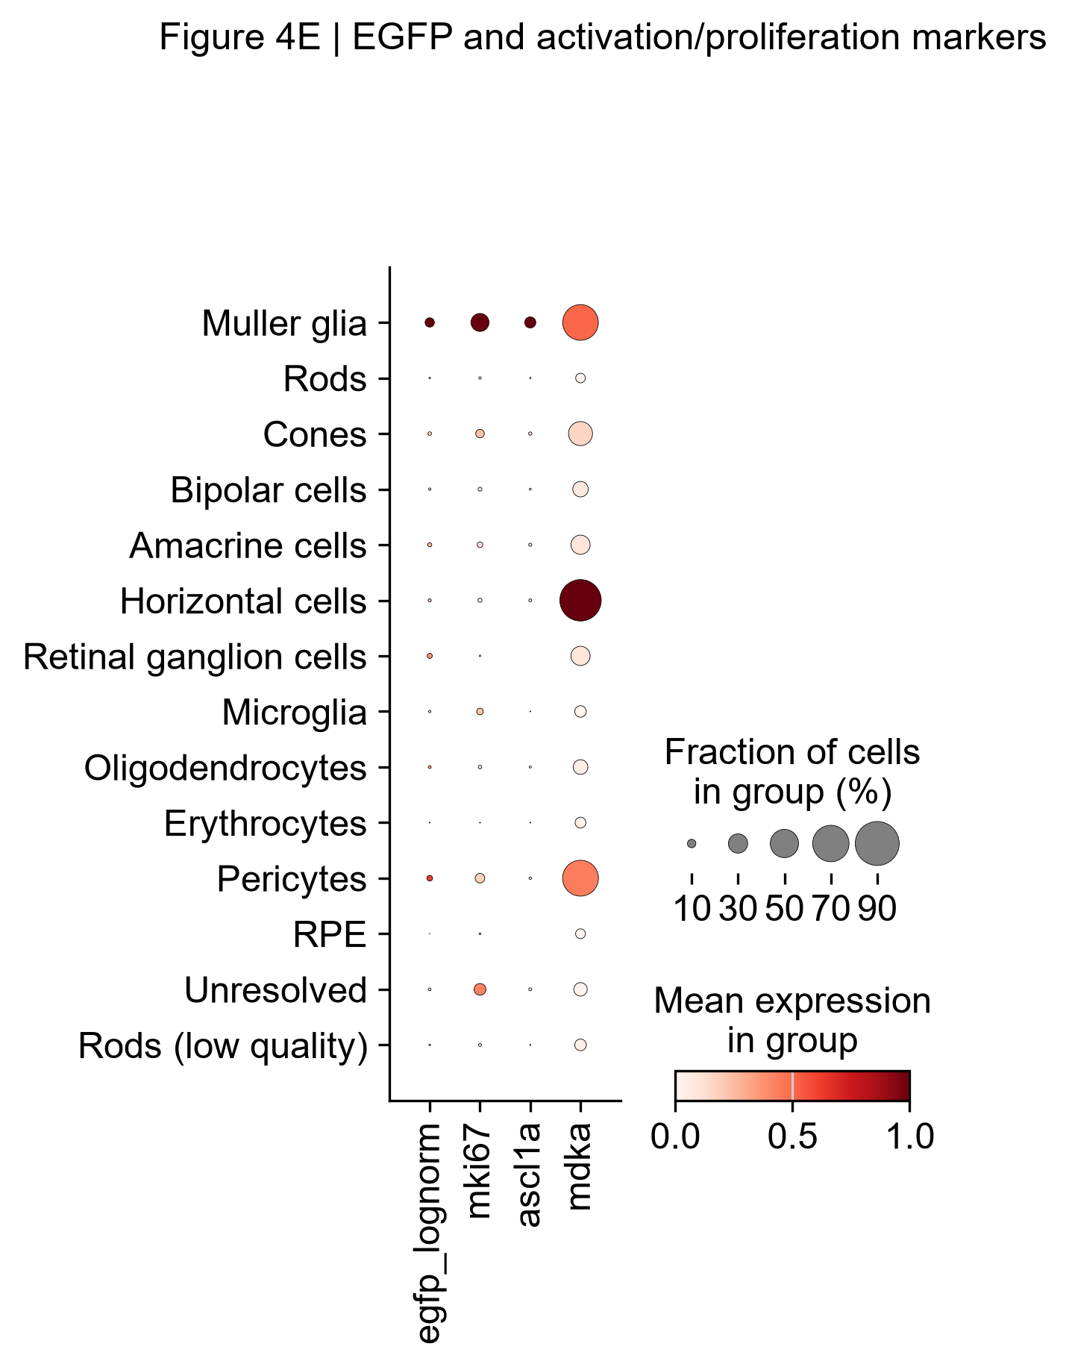

Figure 14. EGFP and activation markers by cell type. Müller glia are the only population simultaneously positive for EGFP, mki67 and ascl1a. Note that pcna, her4.1 and stat3 were not available in this dataset, and that mdka is broadly expressed across several populations, so it does not behave as an activation-specific marker here despite appearing in the published EGFP-positive signature.

3.9 The published EGFP-positive Müller glia signature is fully recovered
Differential expression between EGFP-positive and EGFP-negative Müller glia (205 against 1,602 cells) recovered all 23 genes tested from the published signature, every one significantly upregulated.
Table 10. Recovery of the published EGFP-positive Müller glia signature. All 23 genes tested were significantly upregulated.
Gene | log2FC | p-adjusted | Gene | log2FC | p-adjusted
mmp9 | 2.009 | 2.2×10⁻¹⁴ | icn | 1.226 | 2.5×10⁻¹⁰
txn | 1.771 | 3.2×10⁻²⁰ | cabp5a | 1.205 | 1.7×10⁻⁹
hbegfa | 1.652 | 1.7×10⁻¹³ | id1 | 1.170 | 1.2×10⁻¹¹
lgals2a | 1.468 | 5.7×10⁻¹⁵ | mdka | 1.112 | 2.0×10⁻⁷
glulb | 1.367 | 1.0×10⁻¹⁶ | sncga | 1.057 | 1.2×10⁻¹¹
stm | 1.335 | 1.5×10⁻⁵ | mt2 | 1.017 | 5.7×10⁻⁷
ddr1 | 1.327 | 3.1×10⁻¹⁵ | col18a1a | 1.009 | 4.5×10⁻¹²
crabp1a | 1.295 | 1.5×10⁻¹² | selenop | 0.935 | 8.7×10⁻⁸
gfap | 1.271 | 6.1×10⁻¹⁴ | col15a1b | 0.934 | 4.3×10⁻¹³
apoeb | 1.229 | 8.0×10⁻⁹ | pleca | 0.895 | 1.7×10⁻⁹
 |  |  | six3b | 0.823 | 5.0×10⁻⁹
 |  |  | fxyd6l | 0.797 | 4.0×10⁻⁶
 |  |  | cahz | 0.693 | 2.1×10⁻⁴
EGFP itself ranked first with a log2 fold change of 31.07, an internal control confirming that the comparison behaves as expected.
The total DEG count is not interpretable. 12,750 genes reached significance, 12,475 of them upregulated (98%) — a direct consequence of the eleven-fold depth difference documented in §3.7. This comparison is therefore presented as targeted validation of the published signature, not as an independent gene count. For the same reason no heatmap panel is shown: with only two groups, z-scoring forces every gene to the same two values and conveys nothing beyond what Table 10 states.

3.10 The immature/mature rod distinction does not reproduce
Bise et al. describe two rod populations distinguished by an inverse usage of paralogous phototransduction genes: an immature cluster high in rho, pde6ga and guca1a, and a mature cluster high in rhol, pde6gb and guca1b. Because coordinated reciprocal usage of three paralog pairs is specific and unlikely to arise by chance, it constitutes a decisive test.
Table 11. Paralog expression across rod subclusters (mean log-normalised expression).
Subcluster | rho | rhol | pde6ga | pde6gb | guca1a | guca1b
0 | 6.353 | 1.122 | 3.815 | 4.698 | 1.673 | 1.286
1 | 7.631 | 1.271 | 3.928 | 5.717 | 2.908 | 1.023
2 | 6.216 | 1.687 | 4.317 | 4.735 | 1.615 | 1.876
3 | 5.618 | 1.509 | 3.804 | 4.055 | 1.805 | 1.711
Two of the three pairs fail to split. rho exceeds rhol in every subcluster, and pde6gb exceeds pde6ga in every subcluster. Only guca1a/guca1b divides, and it does so discordantly with the other markers. Critically, no subcluster carries the rhol-high mature signature: rhol remains between 1.1 and 1.7 throughout while rho ranges from 5.6 to 7.6. The published immature/mature rod distinction is therefore not reproduced.
Rod subclusters instead separate by cellular stress. Median sequencing depth is comparable across subclusters 0, 1 and 2 (659, 875 and 888 counts), which excludes sequencing depth as the explanation — an alternative that had to be tested before any biological interpretation could be offered.
This verdict is unchanged when the analysis is repeated at the published clustering resolution of 0.2 (§4.8) and when batch correction is applied (§4.7). In no treatment does any rod group carry the rhol-high mature signature: rhol never exceeds 1.7 while rho ranges 4.3–7.6 under every condition tested.
Table 12. Rod subcluster quality and composition.
 | Subcluster 0 | Subcluster 1 | Subcluster 2 | Subcluster 3
Cells | 418 | 3,149 | 1,786 | 23
Median counts | 659 | 875 | 888 | 232,063
Median genes | 362 | 317 | 511 | 12,154
% mitochondrial | 4.8 | 10.1 | 2.6 | 5.4
% from control | 8.4 | 1.1 | 13.7 | 0.0
meig1 | 0.315 | 1.078 | 0.253 | 0.798
ppdpfa | 3.913 | 5.753 | 3.659 | 3.374
Subcluster 1 detects fewer genes at equal depth than subcluster 2 (317 against 511) with four-fold higher mitochondrial content, and draws only 1.1% of its cells from controls. Reduced transcriptional complexity at matched depth, combined with high mitochondrial load and near-exclusive injury origin, indicates cellular stress rather than an immature differentiation state. Subcluster 3 (23 cells, 232,063 median counts) is a multiplet artefact and was excluded from interpretation.
meig1, the axoneme-morphogenesis gene proposed by Bise et al. as an immature-rod marker on the basis of its requirement for sperm axoneme assembly in mice (Zhang et al., 2009), is four-fold elevated in subcluster 1. However, the published immature rods were defined by low phototransduction gene expression alongside high meig1, whereas subcluster 1 here is simultaneously high in rho, pde6gb, gnat1, gngt1 and meig1. This combination does not match the described immature signature. prom1 was absent from this annotation and could not be tested.
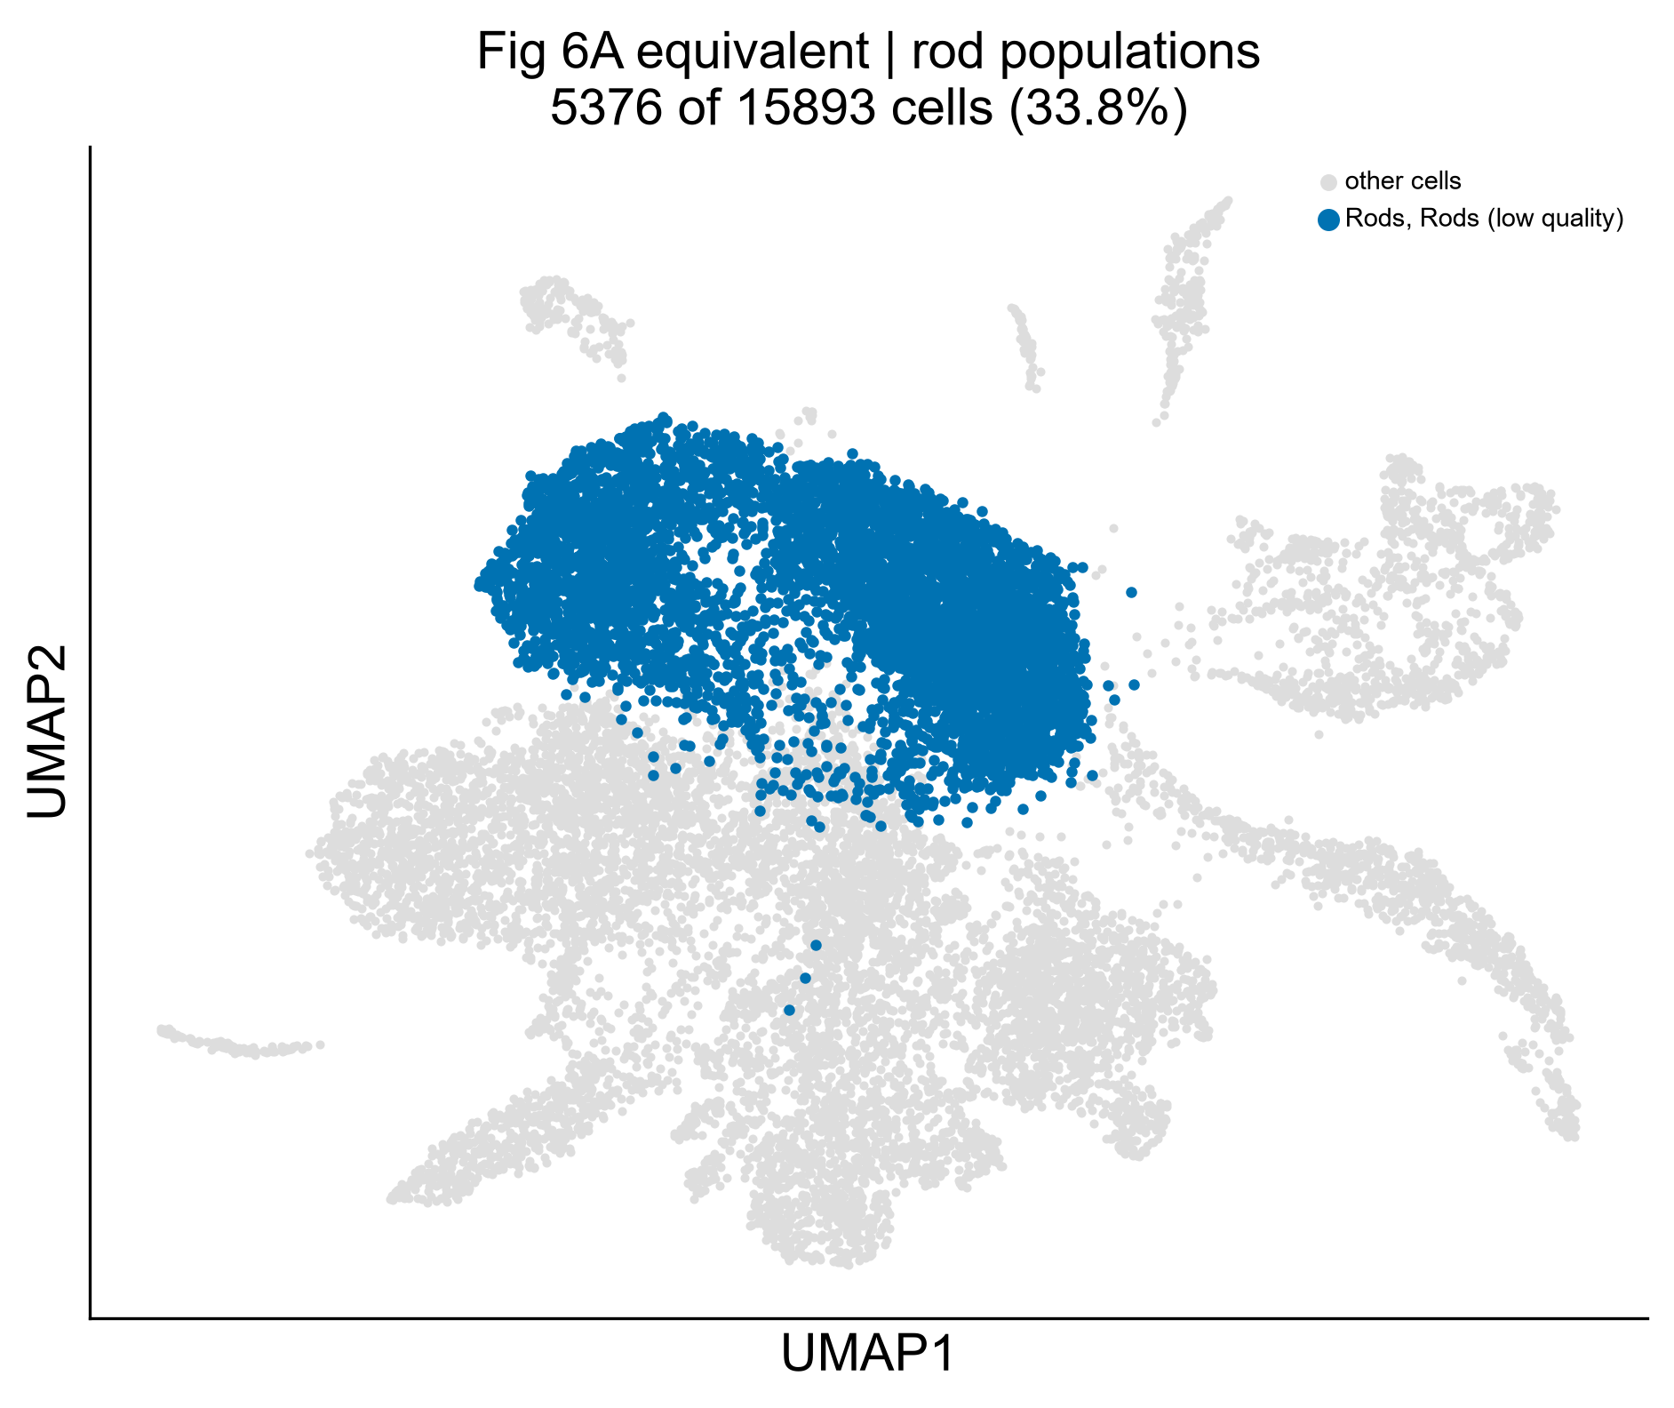
Figure 15. Rod populations located within the whole-retina embedding, the equivalent of Bise et al. Figure 6A. Rods and low-quality rods together comprise 5,376 cells (33.8%), forming one contiguous territory with a graded extension rather than two discrete islands.
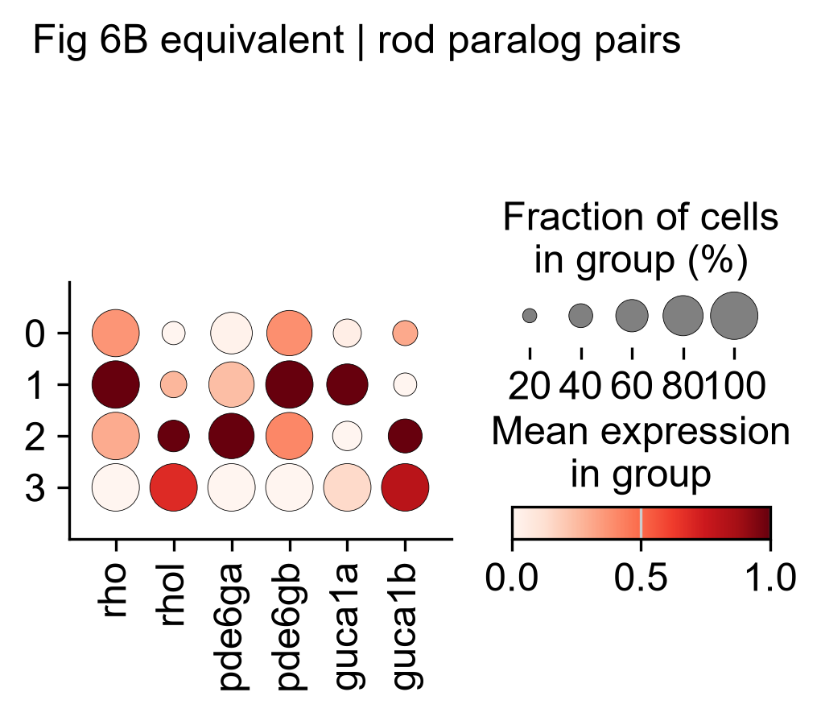
Figure 16. Rod paralog pairs across subclusters, the equivalent of Bise et al. Figure 6B. Colour is scaled independently per gene, so it shows each subcluster's rank for that gene rather than absolute expression: the apparent contrast in the rhol column is a scaling effect, since rhol ranges only 1.1–1.7 across all subclusters while rho ranges 5.6–7.6 (Table 11). Dot size, which shows the fraction of cells expressing each gene, is visibly smaller for rhol and guca1b throughout. No subcluster carries the rhol-high mature signature.
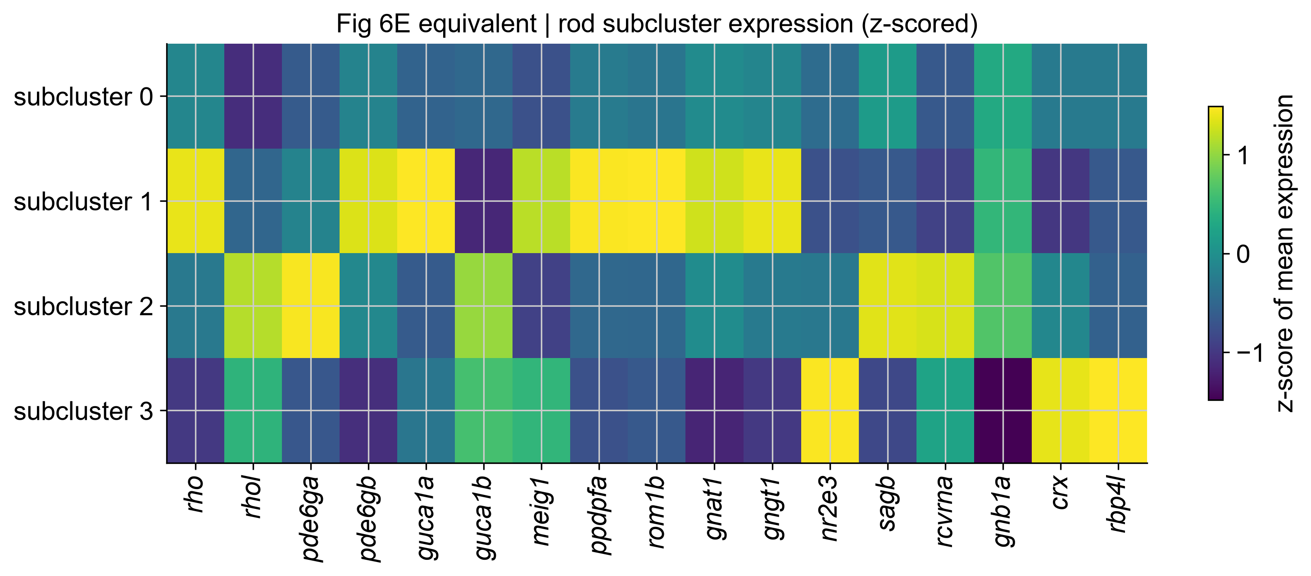
Figure 17. Rod subcluster expression, z-scored across the four subclusters. Subcluster 1 is elevated across nearly the entire panel simultaneously — rho, pde6gb, guca1a, meig1, ppdpfa, rom1b, gnat1 and gngt1 together — which is the signature of a collapsed transcriptome concentrating reads into abundant transcripts rather than of a distinct maturation programme. Subcluster 3 is the 23-cell multiplet artefact.
Rod injury response. Differential expression at 3 dpMNU versus control gave 332 genes (179 up, 153 down) — a balanced result, in marked contrast to the skewed comparisons elsewhere in this analysis. Rod sequencing depth is flat across conditions (756, 818, 806 and 982 median counts), which explains the balance. The count is comparable to the 74–182 genes per rod cluster per timepoint reported by Bise et al. Every significant gene also passed a fold-change threshold of 0.25, so no gene is significant on a trivial effect size.
Four of the most strongly upregulated genes are mitochondrial (mt-nd1, mt-nd2, mt-atp6, mt-co1), reinforcing the stress interpretation, while rbp4l and zgc:162144 (retinal degeneration 3-like) — both reported as upregulated by Bise et al. — are also among the top hits. Downregulated genes include the phototransduction components gnb1a, gnb1b, gnat1 and pde6b.
GO enrichment of the 179 upregulated genes recovered three of the four categories Bise et al. report for their rod cluster A: cytoplasmic translation (GO:0002181), ribosome assembly (GO:0042255) and energy-coupled proton transport (GO:0015985, p = 3.2×10⁻¹⁴, driven by seven ATP synthase subunits) — their “proton motive force-driven ATP synthesis”.
The same signature, a different interpretation. Bise et al. read elevated translation and oxidative phosphorylation as indicating growth and biogenesis in immature rods. The present data are equally consistent with cellular stress, in which a collapsed transcriptome concentrates reads into abundant housekeeping transcripts — supported here by the mitochondrial content, the reduced gene detection at matched depth, and the failed paralog test.
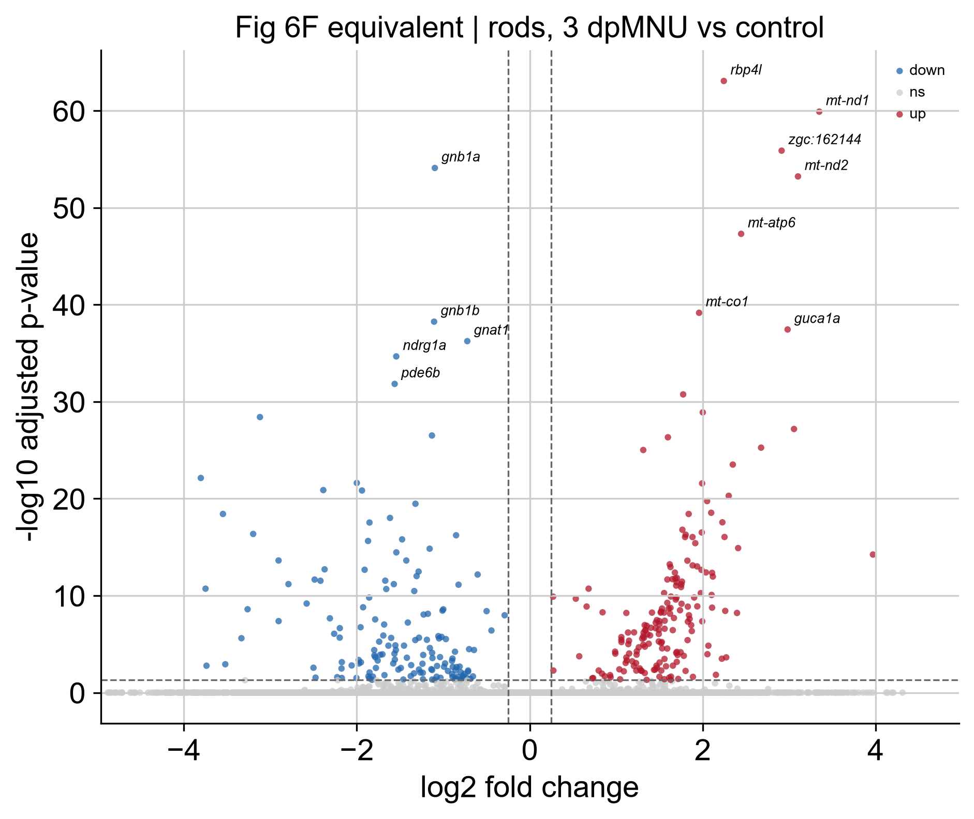
Figure 18. Rods, 3 dpMNU versus control, the equivalent of Bise et al. Figure 6F. 332 genes reach significance, 179 up and 153 down. Every labelled upregulated gene except rbp4l and guca1a is mitochondrial (mt-nd1, mt-nd2, mt-atp6, mt-co1), while the downregulated genes are phototransduction components (gnb1a, gnb1b, gnat1, pde6b). rbp4l and zgc:162144 (retinal degeneration 3-like) are both reported as upregulated by Bise et al. Axis limits are set from the significant genes; 6,133 non-significant genes with extreme fold changes at near-zero expression fall outside the plotted range.
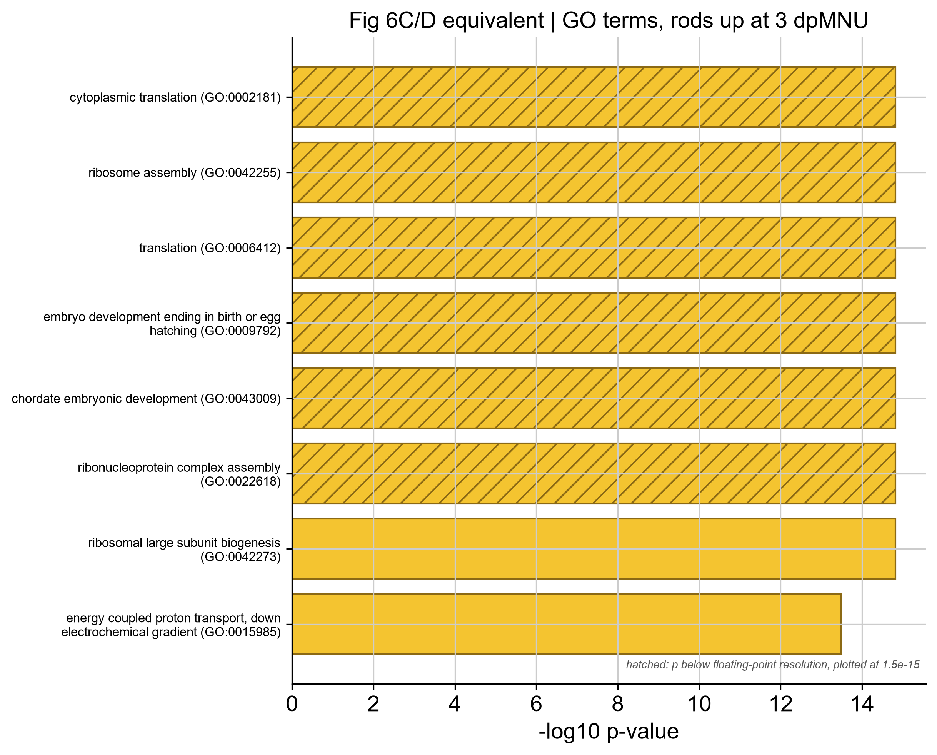
Figure 19. GO terms enriched among genes upregulated in rods at 3 dpMNU, the equivalent of Bise et al. Figure 6C/D. Eight terms are plotted from 179 input genes. Hatched bars mark six terms whose p-values fell below floating-point resolution and are plotted at the smallest resolvable value (1.5×10⁻¹⁵); their true significance is higher than shown. Three of the four categories reported by Bise et al. for their rod cluster A are recovered. The two development terms are driven by the same ribosomal protein genes annotated to developmental phenotypes — a known artefact of ribosomal gene annotation in zebrafish — and are not evidence of a developmental programme. Enrichr is not methodologically equivalent to the published topGO analysis.

3.11 UV cones are resolved, reproducing the published subtype split
Cone subclustering at resolution 0.3 gave seven subclusters. Subcluster 4 (285 cells, 10.9% of cones) is the UV population, identified by five concordant markers, each falling outside the range spanned by all six other subclusters.
Table 13. UV cone markers in subcluster 4 against all other cone subclusters.
Marker | Subcluster 4 | Range in the other six subclusters
opn1sw1 (UV opsin) | 5.068 | 0.703 – 2.950
arr3b | 3.344 | 0.783 – 2.075
arr3a | 0.830 | 2.428 – 3.910
tbx2a | 1.088 | 0.103 – 0.590
cngb3.2 | 1.770 | 0.295 – 1.103
guca1e | 1.484 | 0.177 – 1.161
The arr3 paralog inversion reproduced exactly. The arr3a/arr3b ratio is between 1.7 and 4.7 in every other subcluster but 0.25 in subcluster 4 — an order of magnitude away and in the opposite direction, with the two genes trading values (arr3a 3.3 → 0.83; arr3b 1.6 → 3.34). tbx2a is a UV cone fate transcription factor, so its enrichment reflects the identity programme rather than the phototransduction machinery, which strengthens the call further.
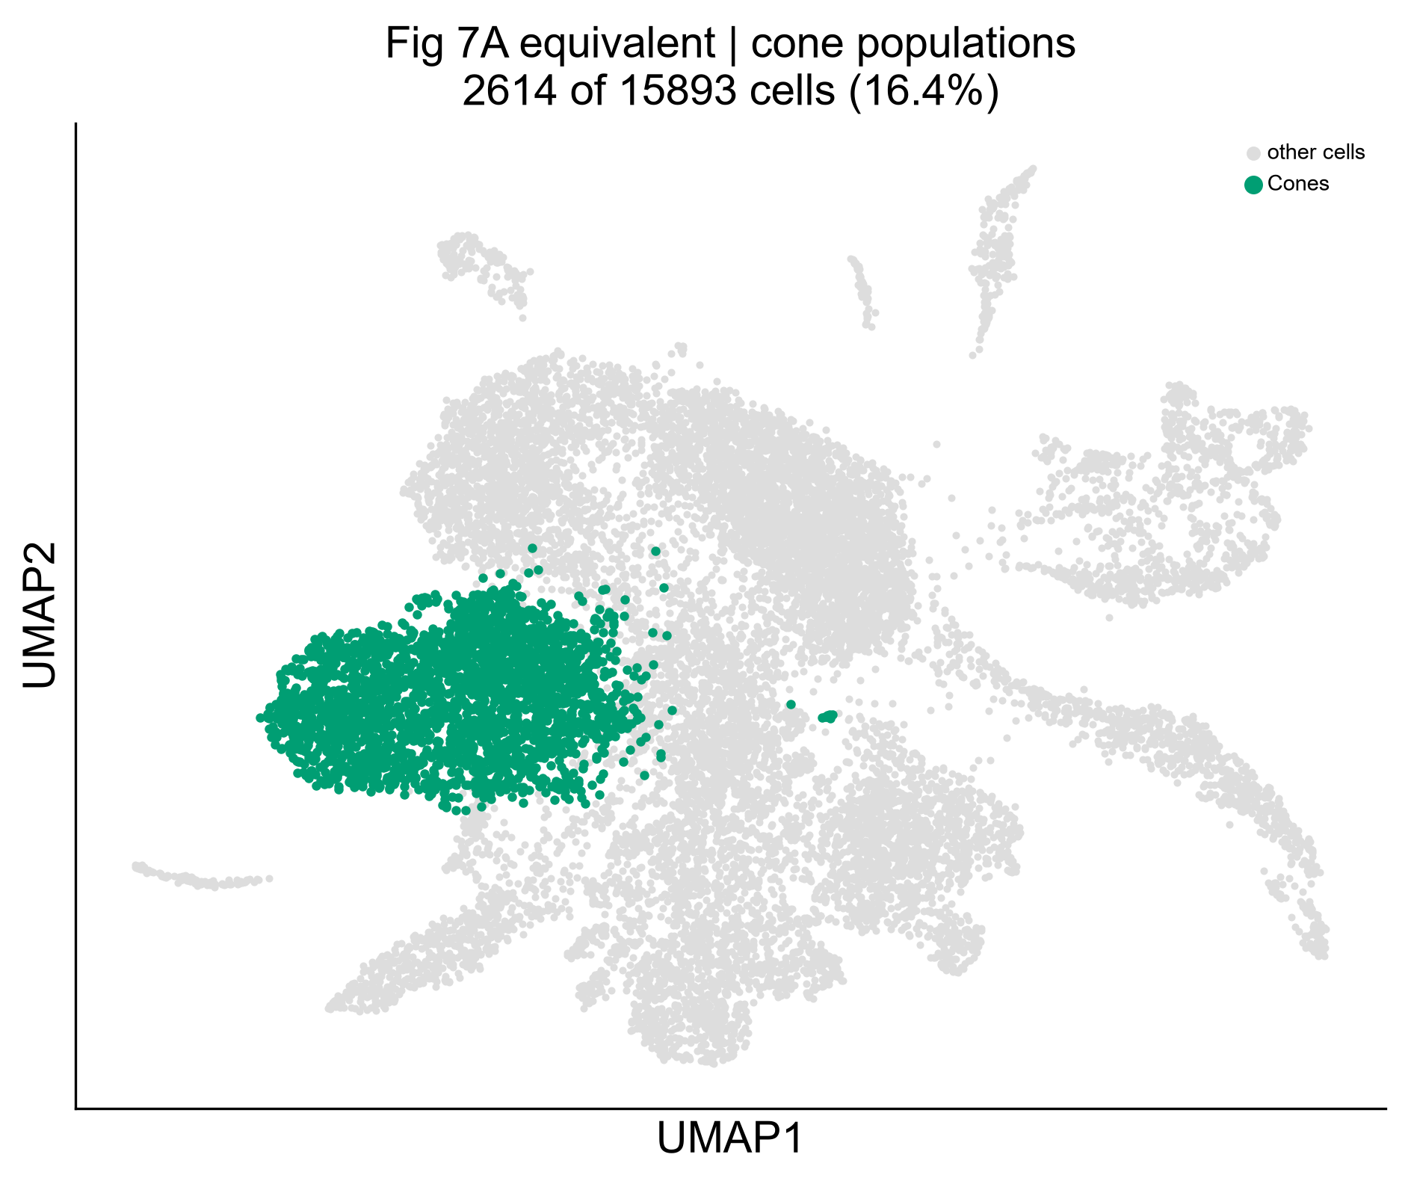
Figure 20. Cone populations located within the whole-retina embedding, the equivalent of Bise et al. Figure 7A. 2,614 cells, 16.4% of the dataset. Unlike the published panel, which plots an already-subclustered object, this shows the annotated cone population within the whole-retina embedding; the UV/non-UV split appears in Figures 21 and 22.
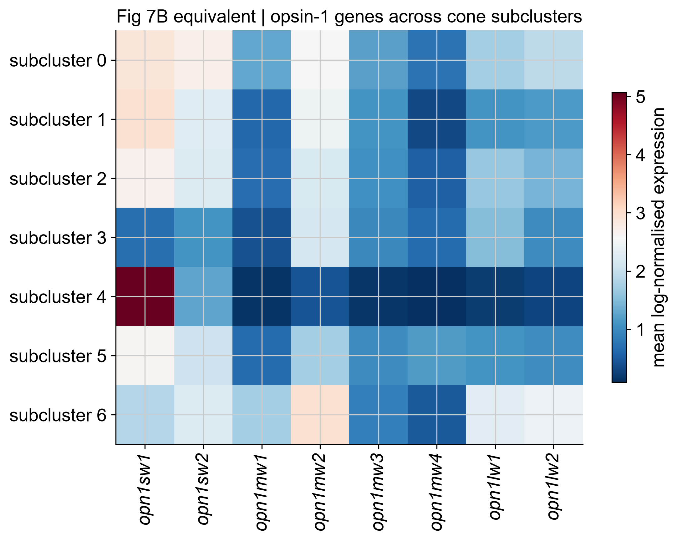
Figure 21. Opsin-1 gene expression across cone subclusters, the equivalent of Bise et al. Figure 7B. Subcluster 4 shows opn1sw1 at 5.068 against 0.703–2.950 elsewhere, with all other opsins at the floor. Subclusters 0, 1, 2 and 5 are nearly indistinguishable and probably represent one non-UV population over-partitioned at this resolution.
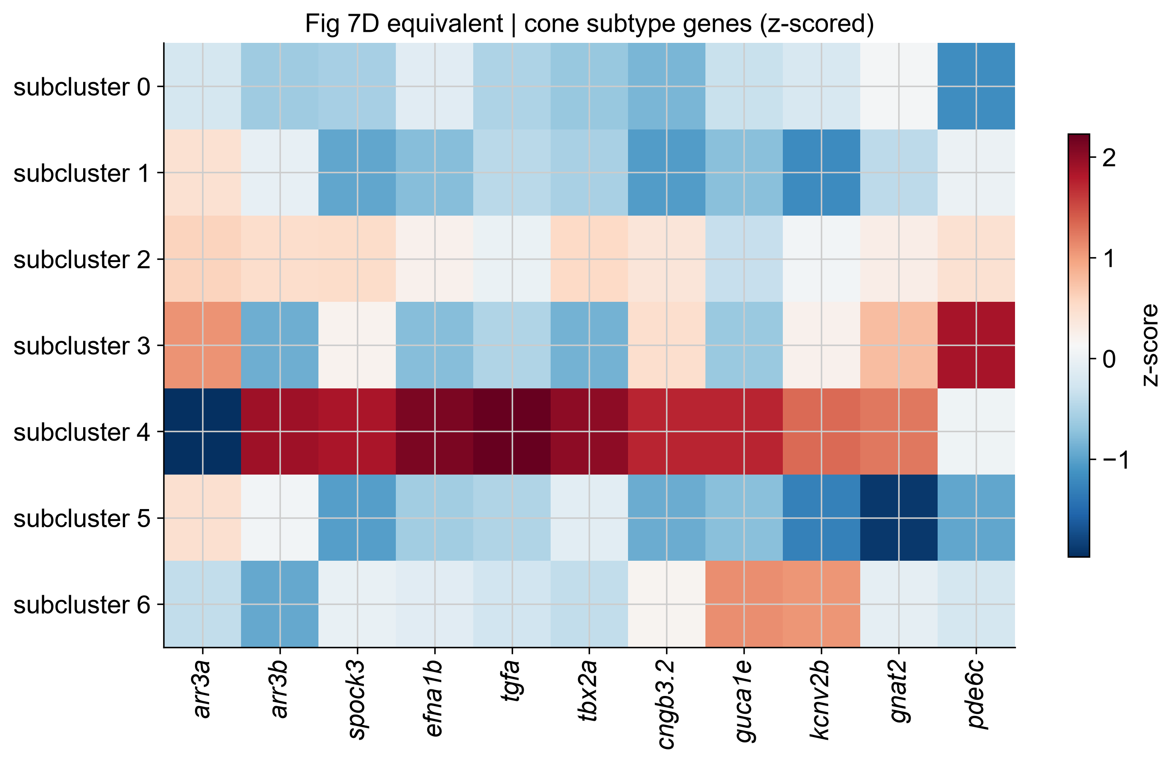
Figure 22. Cone subtype genes, z-scored, the equivalent of Bise et al. Figure 7D. Subcluster 4 shows the complete UV signature: arr3a strongly negative, arr3b strongly positive, with spock3, efna1b, tgfa, tbx2a, cngb3.2, guca1e and kcnv2b all elevated together. gnat2 and pde6c, which mark all cones rather than UV cones specifically, are correctly not enriched.
Table 14. UV cone abundance across the time course.
 | Control | 3 dpMNU | 7 dpMNU | 10 dpMNU
UV cones (n) | 109 | 106 | 18 | 52
Non-UV cones (n) | 543 | 571 | 458 | 757
UV as % of cones | 16.7 | 15.7 | 3.8 | 6.4
This is a four-fold decline by 7 dpMNU with partial recovery at day 10. Bise et al. show by immunofluorescence that MNU destroys UV cones, with UV cone outer segments absent at 5 dpMNU and restored only at 40 dpMNU. These transcriptomic data independently support a conclusion the published work established by microscopy, though 18 cells at 7 dpMNU is a small denominator and the compositional caveat of §3.3 applies.
Cone injury response. 15 of the 16 genes named by Bise et al. were recovered at 3 dpMNU: all nine reported as downregulated (neurod1, rorcb, cry3a, nfil3-5, rimkla, ipmkb, opn6b, kera, grk1b) and six of seven reported as upregulated (rbp4l, guca1c, rcvrn3, ckbb, gpx4b, arr3a). The exception, arr3b, is explained by pooling: the paper reports arr3a up in non-UV and arr3b up in UV cones, and this test pooled all cones, 89% of which are non-UV.
Cone DEG counts are depth-confounded and not comparable. 674, 326 and 3,694 genes at 3, 7 and 10 dpMNU respectively, with 96% upregulated at 10 dpMNU. Median cone sequencing depth is 1,358 (control), 1,483 (3dp), 1,116 (7dp) and 1,968 (10dp) counts — the DEG count tracks depth almost exactly.
GO enrichment of the cone injury response returned ribosome assembly, translation and ATP synthesis — the same generic categories as the rod panel, not the visual perception and cone photoreceptor recovery terms reported by Bise et al. The appearance of ribosomal and mitochondrial terms in two independent cell types after injury is consistent with the transcriptome-collapse interpretation advanced in §3.10, and Figure 24 therefore does not reproduce the published Figure 7F.
No claim of cone recovery is available from these data. The series ends at 10 dpMNU, whereas the restoration of UV cone outer segments reported by Bise et al. occurs at 40 dpMNU and was assessed by immunofluorescence, not transcriptomics. Research question 5 is therefore answerable for the injury response but not for recovery.
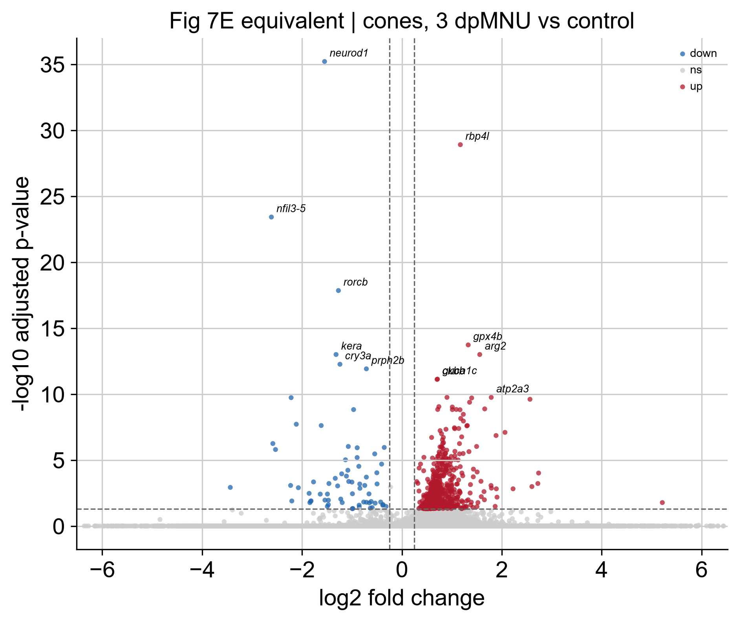
Figure 23. Cones, 3 dpMNU versus control, the equivalent of Bise et al. Figure 7E. neurod1 is the most strongly downregulated gene and rbp4l the most strongly upregulated, both as reported in the published analysis. The upregulated population is dense at modest fold changes while the downregulated side is sparser with larger effects, consistent with the depth imbalance described above. Axis limits are set from the significant genes.
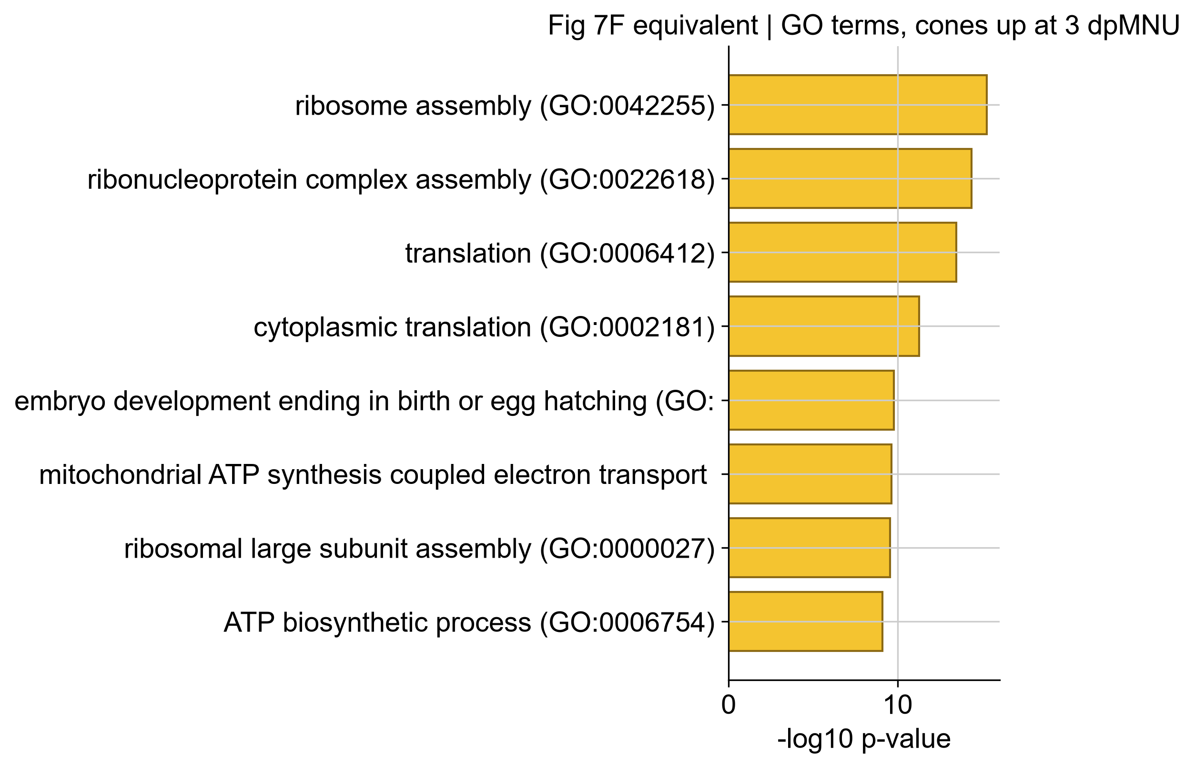
Figure 24. GO terms enriched among genes upregulated in cones at 3 dpMNU. The categories returned — ribosome assembly, translation, ATP synthesis — are the same generic terms as the rod panel rather than the visual perception terms reported by Bise et al., and this panel therefore does not reproduce the published Figure 7F.

4 Comparison with the published analysis

The comparison proceeds from the specific to the general. §4.1 sets out panel-by-panel what was and was not reproduced. §4.2 asks why the reporter result survived a change of method when the rod result did not, and narrows the candidate explanations. §4.3 to §4.5 examine three findings that emerged from this reanalysis rather than from the published one. §4.6 states what the analysis cannot support, and §4.7 and §4.8 test the two analytical decisions most likely to have driven the difference from the published result.

4.1 Figure correspondence
Of the eleven figures in Bise et al. (2023), four contain single-cell transcriptomic data. The remaining seven — Figures 1–4 (immunofluorescence of retinal sections) and Figures 9–11 (TOR signalling, phospho-rpS6 immunostaining, rapamycin treatment) — report protein localisation and pharmacological intervention, and have no transcriptomic counterpart by construction. No analysis of these data could reproduce them, and none was attempted.
Table 15. Status of all eighteen reproducible panels.
Panel | Content | Status in this reanalysis
5C | UMAP atlas | Content reproduced; coordinates not comparable
5D | Canonical marker dot plot | Reproduced
5E | Population % per timepoint | Reproduced
6A | Rod clusters on UMAP | Reproduced (locator panel)
6B | Rod paralog dot plot | Not reproduced at any resolution or correction
6C/D | GO terms, rods | 3 of 4 categories reproduced
6E | Rod gene heatmap | Reproduced; shows uniform elevation, not two states
6F | Rod volcano | Reproduced — 332 DEGs, balanced direction
7A | Cone clusters on UMAP | Reproduced (locator panel)
7B | Opsin heatmap | Reproduced — UV population identified
7D | Cone subtype genes | Reproduced — arr3 inversion exact
7E | Cone volcano | Gene level reproduced (15/16); counts depth-confounded
7F | GO terms, cones | Not reproduced — generic stress terms returned
8A | EGFP⁺ cells on UMAP | Reproduced
8B | EGFP⁺ per timepoint | Reproduced — within 0.2 pp at every timepoint
8C | EGFP⁺ % per population | Reproduced — MG 11.34% against ~10%
8D | Müller glia on UMAP | Reproduced (locator panel)
8E | EGFP⁺/⁻ MG signature | Reproduced at gene level (23/23, Table 10)
Note that the project guide directs comparison against “Figures 1 & 2” for the cell atlas and “Figures 3 & 4” for EGFP kinetics. In the published article those are immunofluorescence figures; the single-cell atlas is Figure 5 and the reporter analysis Figure 8. Figure numbering in this report follows the published article.

4.2 Why the reporter reproduced and the rods did not
The two pipelines differ at every major processing step, and a substantial difference in analysed cell number separates them. That the reporter kinetics nonetheless agree to within 0.2 percentage points at every timepoint indicates the measurement is robust to analytical choice. This is expected on mechanistic grounds: EGFP positivity is a near-binary determination on a transgene with no endogenous paralog, no ambiguity of gene identity, and a strong biological signal. Such a measurement is insensitive to normalisation and clustering decisions, since it depends only on whether a transcript was captured.
The rod distinction is the opposite case. It rests on graded differences in the relative expression of paralogous genes — quantities directly affected by the normalisation method. SCTransform's regularised negative binomial residuals treat highly expressed genes differently from log-normalisation, and rod phototransduction transcripts are among the most abundant in retinal tissue.
The cone result provides a decisive control. The same code, the same subclustering resolution and the same paralog-inversion logic reproduced the arr3a/arr3b split exactly (§3.11). The pipeline is therefore demonstrably capable of resolving photoreceptor subtype structure, and the rod failure is specific to that comparison rather than a general limitation.
The distinction between the two cases is instructive. UV cone identity is categorical — a cone expresses arr3b or arr3a, and the ratio differs by an order of magnitude between populations. Rod maturation is graded — both paralogs are expressed in every rod, and the classification depends on relative levels. Categorical identity survives a change of normalisation; graded ratios in highly expressed genes need not.

Four explanations, two eliminated by direct test
1. Normalisation — untested, and now the only remaining candidate. SCTransform models expression as regularised negative binomial residuals (Hafemeister and Satija, 2019), a different estimator from log-normalisation rather than a variant of it. It weights highly expressed genes differently, and rod phototransduction transcripts are the most abundant in retinal tissue — precisely the regime where the two methods diverge most. Testing this would require sc.experimental.pp.normalize_pearson_residuals, the closest available analogue in Scanpy, and is proposed as future work.
2. Clustering granularity — eliminated (§4.8). Re-clustering the whole dataset at the published resolution of 0.2 and repeating the test on the rod clusters that emerge gives the same verdict: one of three pairs splits, discordantly, and no cluster carries the coordinated pattern the published result requires.
3. Batch structure — eliminated (§4.7). Applying Harmony correction does not recover the split; the verdict is unchanged at one of three pairs, the same pair, and still discordant.
4. Cell number — untested. A population defined by graded expression differences may not separate at the cell numbers available here, and this cannot be tested without additional data.
5. Stress dominating rod variance — supported by the evidence. The rod subclusters differ in mitochondrial content and transcriptional complexity at matched sequencing depth (§3.10), and the stressed population is 98.9% injury-derived. If stress is the largest axis of variation among rods, it may partition the cells before any maturation axis can.

Three independent tests, one answer
The paralog test was applied under three different analytical treatments:
Table 17. The rod paralog verdict under three analytical treatments.
Treatment | Rod groups | Pairs splitting | Coordinated pattern
Primary (resolution 0.6, subclustered) | 4 subclusters | 1 of 3 | No
Harmony-corrected (§4.7) | 3–4 subclusters | 1 of 3 | No
Resolution 0.2, global clustering (§4.8) | 4 clusters | 1 of 3 | No
In every case the pair that splits is guca1a/guca1b, and in every case it splits discordantly with the other two. In no treatment does any group carry the rhol-high mature signature: rhol never exceeds 1.7 while rho ranges 4.3–7.6, under every condition tested. The failure to reproduce is therefore not attributable to the two analytical choices that most plausibly differed from the published work.

4.3 Sequencing depth as a systematic confound
Three comparisons in this analysis differ in whether the compared groups had matched sequencing depth, and the differential expression results follow that difference exactly:
Table 16. Directional skew in differential expression tracks the depth imbalance between compared groups.
Comparison | Depth difference | DEG direction | Interpretable?
Rods, 3dp vs control | none (818 vs 756) | 179 up / 153 down | Yes
Cones, 10dp vs control | 1,968 vs 1,358 | 96% up | No
Müller glia, EGFP⁺ vs EGFP⁻ | 15,044 vs 1,360 | 98% up | No
The directional skew tracks the depth imbalance precisely. This is an empirical demonstration of why cell-level differential expression without depth correction is unreliable, and it converts the pseudobulk limitation (§4.6) from an assertion into an observation. It also motivated the stratified analysis in §3.7, which showed that the reporter finding survives depth correction — and is in fact strengthened by it.

4.4 Retinal ganglion cells and horizontal cells
Recovery of a discrete rbpms2b-positive cluster where the published analysis reported none is unexplained. At 97 cells (0.6%), stochastic capture variation is plausible; alternatively, clustering at resolution 0.6 may resolve a population that partitioning at 0.2 absorbed into a neighbouring cluster. This is consistent with the general observation that this analysis produced 20 clusters from fewer cells than the published 17. The observation is reported without a preferred explanation, and the small cell number precludes further inference. Note also that the ganglion cell cluster is embedded within the Müller glia and amacrine territory rather than isolated (Figure 3), which makes it more vulnerable to ambient contamination than a well-separated cluster would be.
Horizontal cells were identified only after differential expression was extended to the full gene set. cx52.6 is not a highly variable gene, so a marker analysis restricted to the 2,000-gene subset could not have detected it. This is a concrete illustration of why feature selection must not propagate into statistical testing, and it moved 712 cells — 4.5% of the dataset — from Unresolved to a confident assignment.

4.5 An observed correlate of the capture bias
Bise et al. attribute increased rod representation after MNU to differential survival and capture efficiency, inferring the mechanism from the composition shift and citing analogous observations in other retinal injury datasets (Macosko et al., 2015). The present analysis identifies a candidate population directly: mitochondrion-dominated, gene-poor rods, near-absent from controls and present in every injured sample. Two independent observations converge on this — the Rods (low quality) cluster at the whole-dataset level (§3.4) and the stressed rod subcluster within the rod subset (§3.10).
The strength of this observation is limited by replicate variability. The population's abundance varies seven-fold between replicates of the same condition and tracks per-sample mitochondrial content, so it supports the capture-bias mechanism qualitatively without establishing a time course.
A methodological corollary is worth stating. Removing these cells on standard quality-control grounds would have discarded a biologically informative population. A mitochondrial threshold that identifies technical artefact in healthy tissue may identify a phenotype in damaged tissue, and quality control in injury models should be reported as an analytical choice with biological consequences rather than applied as a default.

4.6 Limitations

Each limitation below is stated with the conclusion it bounds. The first three constrain how far the differential expression results can be pushed; the fourth and fifth constrain the composition and recovery claims; the last three are scope statements rather than defects.
1. No doublet detection. Bise et al. removed approximately 12 ± 2% of cells as doublets or dying cells using scater. No equivalent step was applied here. Cluster 1 (15 cells) and rod subcluster 3 (23 cells) are evident multiplets identified by clustering rather than by filtering; others may remain undetected within larger clusters. This is the most consequential methodological gap.
2. Condition and batch are confounded by experimental design. Each timepoint comprises its own pair of 10x runs. The variance decomposition in §2.5 shows the technical component is small relative to the biological signal, but it cannot be eliminated, and this limits both analyses equally.
3. Differential expression is descriptive, not inferential. Cell-level Wilcoxon tests treat cells as independent observations, but cells within a replicate are correlated and only two replicates exist per condition. Adjusted p-values consequently overstate significance. A pseudobulk design across the eight samples would be the statistically correct approach; §4.3 demonstrates the practical consequence.
4. Unbalanced recovery. Controls contributed the fewest cells (2,515 after quality control), so control estimates carry the widest uncertainty. Replicate 1 of each injured pair consistently carries higher mitochondrial content, indicating a systematic processing difference between runs.
5. No recovery claim is possible. The time course ends at 10 dpMNU, whereas structural restoration in the published work occurs at 30 dpMNU (rods, outer plexiform layer) and 40 dpMNU (UV cone outer segments), assessed by immunofluorescence.
6. Transcript abundance is not protein abundance. EGFP mRNA need not track reporter protein, which persists on a different timescale; the published immunofluorescence time course extends to 90 dpMNU.
7. 2.3% of cells remain unresolved, and prom1 was absent from the annotation, preventing one component of the rod paralog comparison.
8. GO enrichment is not methodologically equivalent. Enrichr uses different background gene sets and versions from topGO, so term lists are not directly comparable even given identical input genes. Six rod terms also returned p-values below floating-point resolution and could not be plotted.

4.7 Batch correction tested, and not adopted
The decision not to integrate (§2.5) rested on an argument: condition and sequencing batch are completely confounded, so correcting on sample risks removing the injury response along with the batch effect. To test that argument rather than rely on it, the pipeline was re-run with Harmony correction applied to the PCA embedding and the two analyses compared. The uncorrected analysis remains primary; the corrected object is retained in results_integrated/ and the comparison tables in tables/integration_check/.

The correction removed biological signal preferentially
Table 18. Mean variance explained across the first 20 principal components, before and after Harmony correction on sample.
Factor | Uncorrected | After Harmony | Reduction
condition | 0.0201 | 0.0041 | 79.6%
replicate | 0.0023 | 0.0016 | 30.4%
sample | 0.0244 | 0.0060 | 75.4%
Replicate is the purely technical term, since replicates within a condition differ only in handling; condition carries the injury response. A well-behaved batch correction should therefore remove replicate variance preferentially.
The opposite occurred. Harmony removed 79.6% of the condition variance while removing only 30.4% of the replicate variance, and the ratio between the two fell from 8.7-fold to 2.6-fold. This is the confound made concrete: because each sample belongs to exactly one condition, correcting on sample identity necessarily removes condition differences, and here it did so far more effectively than it removed the technical variation it was applied to eliminate. Harmony also stopped before convergence at the default limit of ten iterations, itself consistent with a batch structure that cannot be cleanly separated from the biological one.
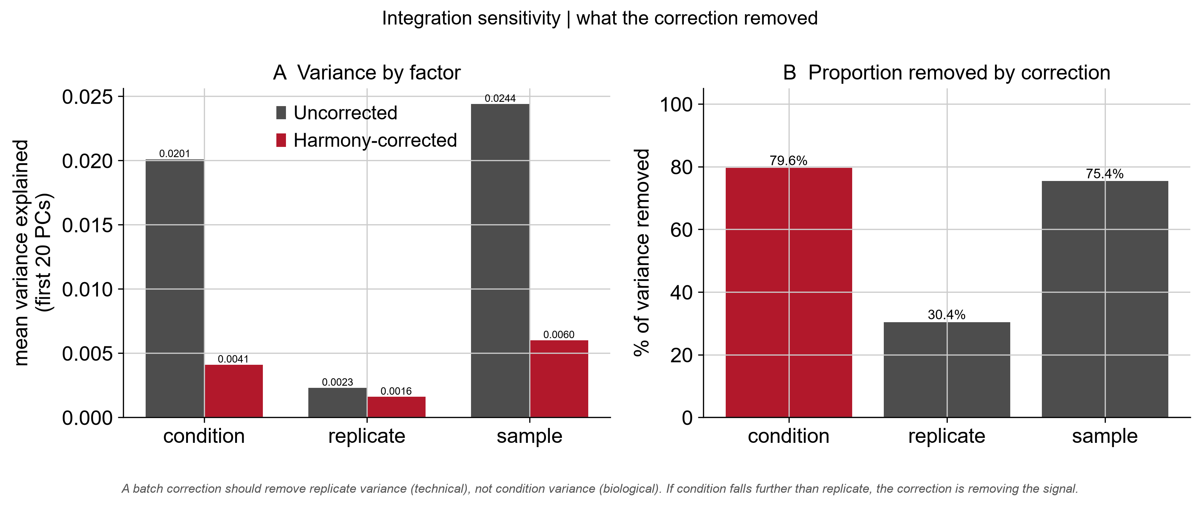
Figure 25. What Harmony correction removed. (A) Mean variance explained across the first 20 principal components by each factor, before and after correction. (B) The proportion removed. Replicate is the purely technical term and is what a batch correction should eliminate; condition carries the injury response.
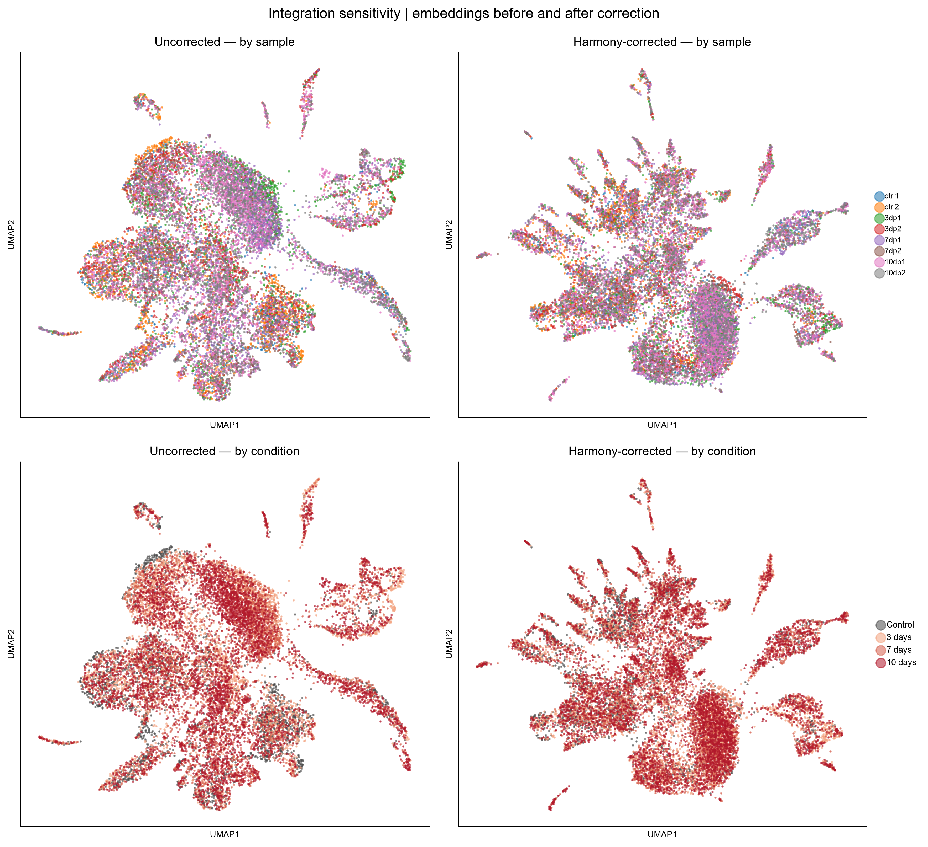
Figure 26. Embeddings before and after correction. Top: coloured by sample — the samples were already well mixed before correction (compare Figure 2), so little batch structure remained to remove. Bottom: coloured by condition — control cells form coherent patches in the uncorrected embedding but are dispersed after correction, the 79.6% loss of condition variance made visible. The corrected embedding is also more fragmented, consistent with correction applied to structure that is not batch-driven.

What the correction damaged
The number of clusters was essentially unchanged, but the partitions differ substantially in composition (adjusted Rand index 0.62), so correction rearranged the structure rather than simplifying it. Three integrated clusters fell below 0.8 purity against the original annotation, and the affected populations are precisely those on which this report's two novel observations rest.
Table 19. Integrated clusters that merged previously distinct populations.
Integrated cluster | Cells | Majority type | Purity | Mixed with
0 | 3,797 | Rods | 0.735 | Rods (low quality), 24.5%
1 | 928 | Microglia | 0.700 | Unresolved, 27.7%
19 | 39 | Retinal ganglion cells | 0.615 | Müller glia, 15.4%
Retinal ganglion cells were largely dispersed. Of the 97 cells annotated as RGCs in the primary analysis, only 39 remain in the majority integrated cluster — 40% retained, at 0.615 purity. The divergence from the published analysis reported in §4.4 would substantially disappear under correction.
The stressed rod population was dissolved. Rods and low-quality rods merged into a single cluster, eliminating the distinction on which §3.4 and §4.5 depend. The consequence is visible in the composition estimates: the uncorrected rod series peaks at 3 dpMNU and declines (34.10 → 26.70% at 7 dpMNU), whereas the integrated series stays flat (38.62 → 38.37%), because the stressed population's own dynamics have been absorbed into the aggregate.
Two populations survived correction cleanly: horizontal cells (0.926 purity, 651 of 712 cells) and cones (0.970). The pattern is consistent — abundant, transcriptionally distinct populations were preserved, while small or subtle ones were degraded.
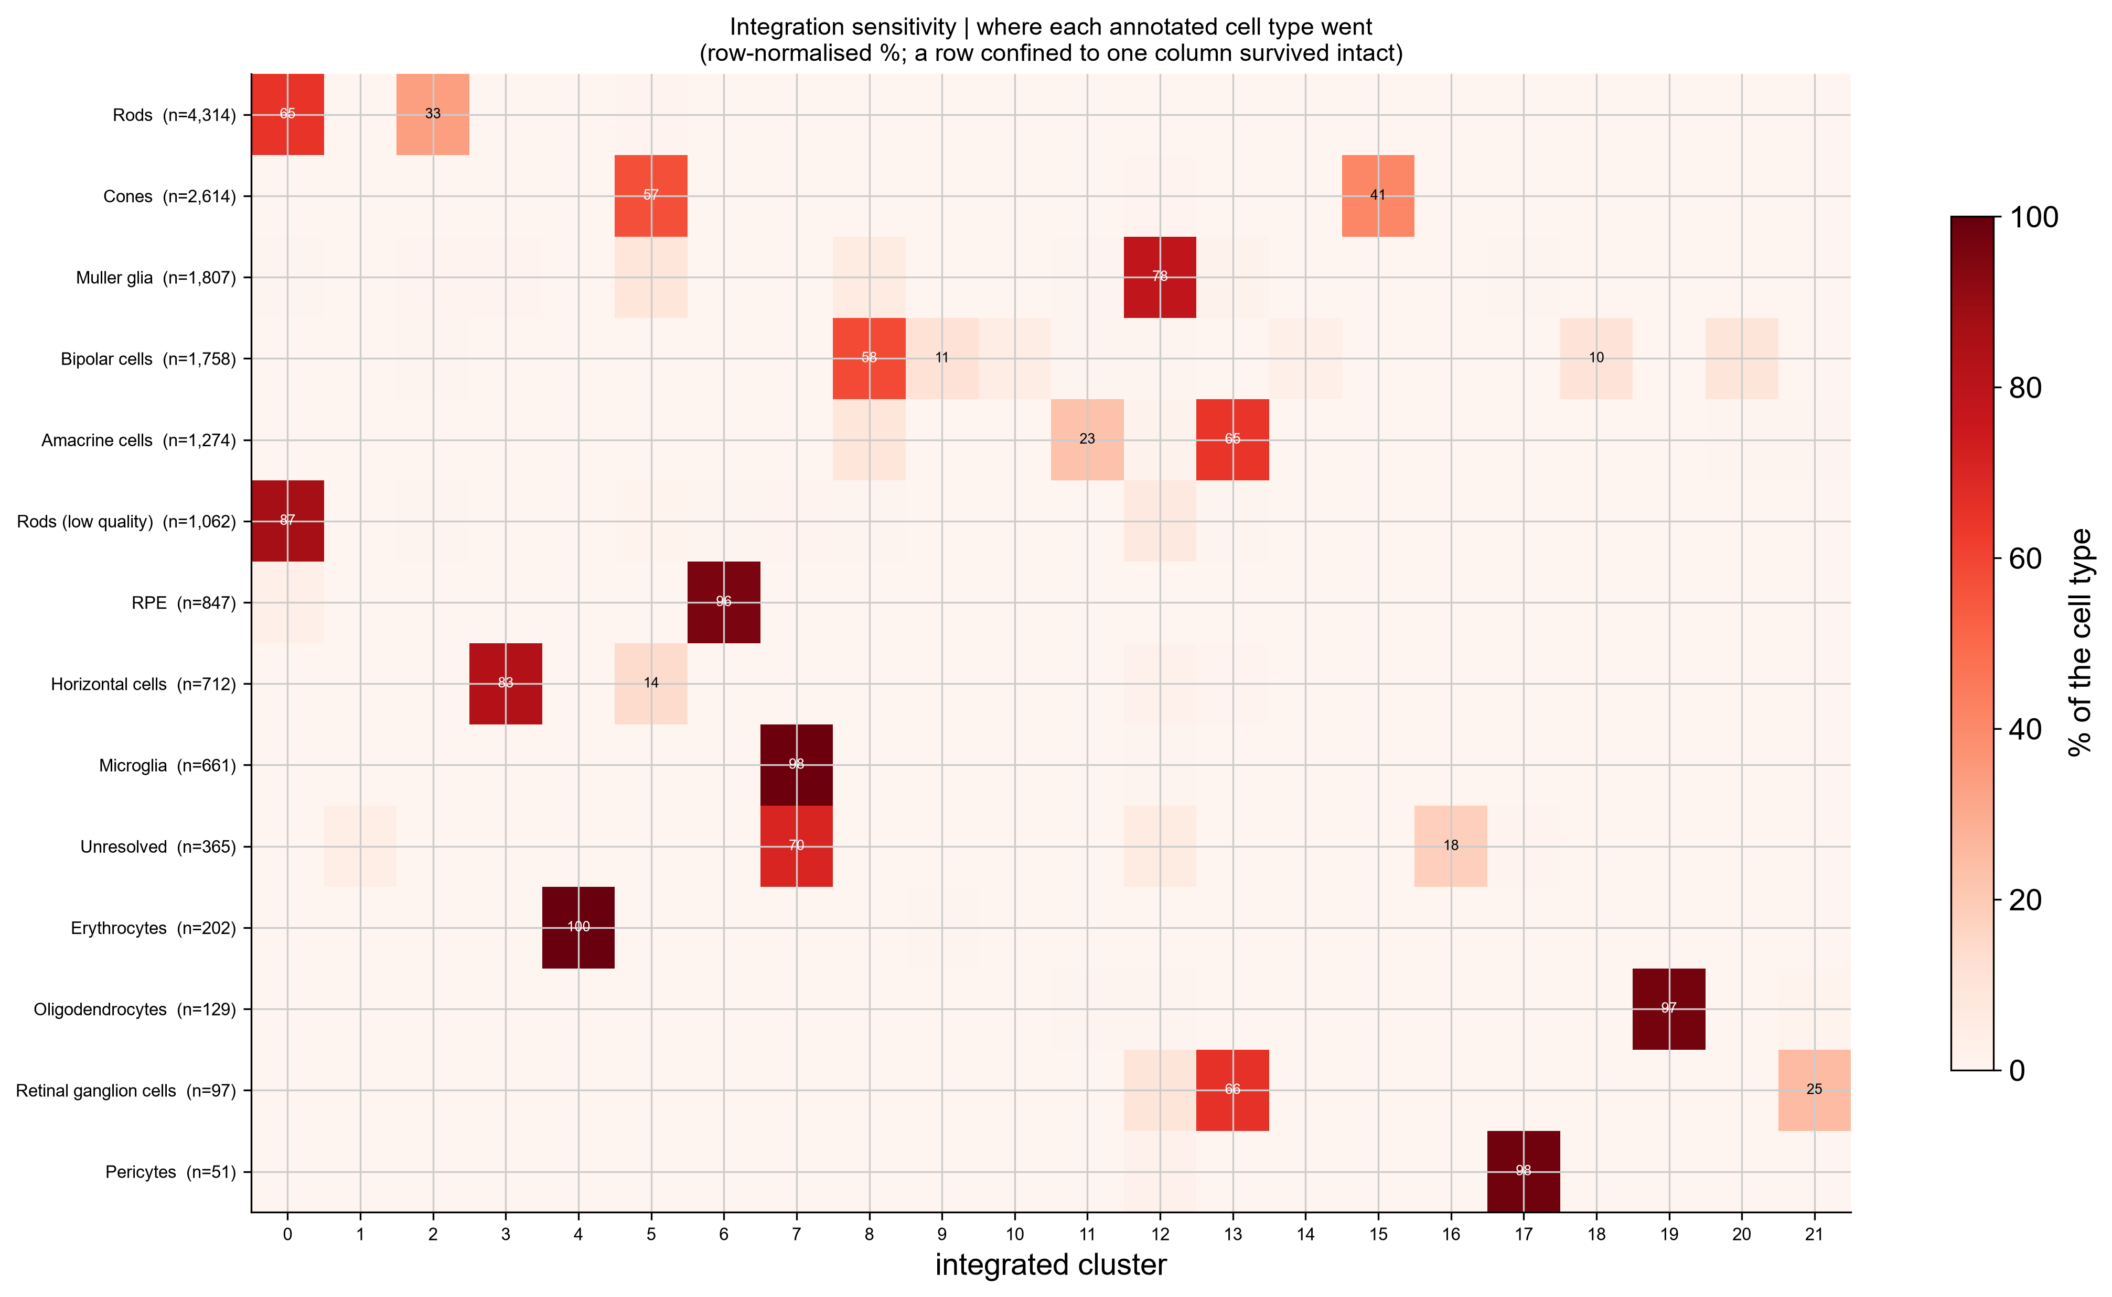
Figure 27. Where each annotated cell type ended up after correction, row-normalised. Rows confined to a single column survived intact — erythrocytes (100%), microglia (98%), pericytes (98%), oligodendrocytes (97%), RPE (96%) and horizontal cells (83%). Rods and low-quality rods both funnel into cluster 0, merging the distinction on which §3.4 depends; retinal ganglion cells split 66%/25% across two clusters; bipolar cells fragment across at least five.

What the correction did not change
Table 20. Integration sensitivity summary.
Quantity | Uncorrected | Integrated | Changed?
Number of clusters | 20 | 20–22 | No
Adjusted Rand index between partitions | — | 0.621 | Yes
Integrated clusters below 0.8 purity | — | 3 | Yes
EGFP time course, maximum difference | — | 0.00 pp | No
Rod paralog pairs splitting (of 3) | 1 | 1 | No
The reporter time course is exactly invariant. EGFP-positive percentages are identical to two decimal places at every timepoint (0.56 / 5.39 / 2.45 / 2.80), because positivity is a raw transgene count call that does not depend on the embedding or on clustering. The central result of this report is therefore unaffected by the batch-correction decision — not approximately, but exactly.
Müller glia remain the reporter-enriched population, at 12.12% positive after correction against 11.34% before, still separated from every other population by a clear margin. Cell-type enrichment values move by around one percentage point in either direction, as expected when cells shift between clusters; only the small-population estimates move appreciably, and those were already flagged as unreliable.
The rod paralog verdict is likewise unchanged. After correction, one of three pairs splits — the same pair, guca1a/guca1b, and still discordantly with the other two.
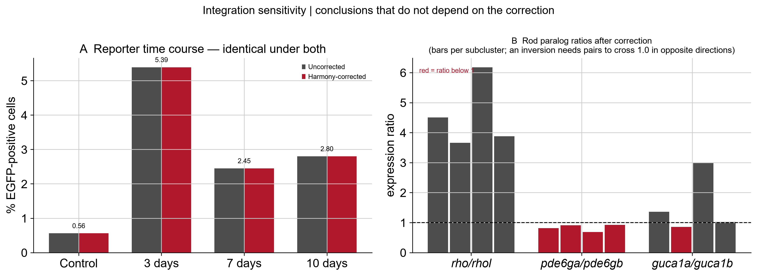
Figure 28. Conclusions that do not depend on the batch-correction decision. (A) EGFP-positive percentage per condition under both analyses; the bars are identical to two decimal places. (B) Rod paralog ratios per subcluster after correction. An inversion would require the same subcluster to lie above the line for one pair and below for another, consistently across pairs; rho/rhol is above 1.0 in every subcluster and pde6ga/pde6gb below it in every subcluster.

4.8 Clustering resolution tested as a sensitivity analysis
Bise et al. clustered at resolution 0.2 and reported 17 clusters, among them two rod populations. The primary analysis here clustered at 0.6 and tested the paralogs by subclustering within an annotated rod population — a different procedure at a different granularity, and one of the candidate explanations in §4.2. It was therefore tested directly.

Rod clusters must be identified relative to background
An absolute expression threshold does not identify rod clusters in this dataset. At resolution 0.2, mean rho ranges from 3.09 to 7.49 across the twelve clusters with no gap: every cluster carries substantial ambient rho, because rods dominate the tissue and lyse readily during dissociation. This is the same effect that made gene-set panel scores unusable in §2.6, and an initial attempt using an absolute cut of rho ≥ 3.0 selected all twelve clusters.
Selection was therefore made relative — rho above the 60th percentile of the cluster means — with an additional requirement on nr2e3, a rod-specific transcription factor expressed at much lower absolute levels and correspondingly less exposed to ambient contamination. nr2e3 discriminates cleanly where rho does not: 0.148–0.322 in the four selected clusters against 0.043–0.096 in the eight rejected ones, a three- to seven-fold separation.
Table 21. Rod clusters identified at resolution 0.2. Selection required rho above the 60th percentile of cluster means and nr2e3 above the median.
Cluster | Cells | rho | nr2e3 | gnat1 | Selected
3 | 3,470 | 7.487 | 0.148 | 5.075 | Yes
0 | 1,894 | 6.275 | 0.322 | 4.538 | Yes
1 | 2,922 | 5.098 | 0.291 | 3.402 | Yes
5 | 1,547 | 4.293 | 0.320 | 2.544 | Yes
8 | 199 | 4.500 | 0.077 | 2.222 | No
9 | 851 | 3.866 | 0.053 | 2.039 | No
11 | 51 | 3.612 | 0.046 | 1.469 | No
4 | 1,709 | 3.357 | 0.081 | 1.791 | No
7 | 580 | 3.210 | 0.043 | 1.514 | No
6 | 129 | 3.180 | 0.057 | 1.510 | No
2 | 1,540 | 3.154 | 0.096 | 1.538 | No
10 | 1,001 | 3.087 | 0.043 | 1.338 | No

The paralog test at the published granularity
Table 22. Paralog expression across the four rod clusters at resolution 0.2. Pattern reads A where the first paralog exceeds the second and B where the second exceeds the first; the published structure requires one cluster reading AAA and another BBB.
Cluster | Cells | rho | rhol | pde6ga | pde6gb | guca1a | guca1b | Pattern
0 | 1,894 | 6.275 | 1.689 | 4.359 | 4.792 | 1.671 | 1.899 | ABB
1 | 2,922 | 5.098 | 1.006 | 3.000 | 3.475 | 0.919 | 1.143 | ABB
3 | 3,470 | 7.487 | 1.256 | 3.894 | 5.594 | 2.777 | 1.029 | ABA
5 | 1,547 | 4.293 | 0.507 | 2.228 | 2.891 | 0.755 | 0.634 | ABA
rho exceeds rhol in all four clusters. pde6gb exceeds pde6ga in all four. Only guca1a/guca1b splits, two clusters each way, and discordantly with the other pairs. No cluster reads AAA and none reads BBB, so the coordinated reciprocal pattern the published result requires does not appear at the published resolution.

Resolution is not portable between algorithms
Clustering at resolution 0.2 produced 12 clusters against the 17 reported. Leiden and Seurat's SNN modularity optimisation solve related but distinct problems, so the same nominal resolution parameter does not yield the same partition. This is worth stating in its own right: matching a published resolution value does not match a published granularity, and any reanalysis that assumes otherwise is comparing different things.
Clustering granularity therefore does not explain the failure to reproduce the rod split. Of the explanations offered in §4.2, this and batch structure (§4.7) are eliminated by direct experiment; normalisation remains the leading candidate.

5 Conclusions
An independent Python/Scanpy reanalysis of the data of Bise et al. (2023) reproduces their central single-cell conclusion. careg:EGFP is induced after MNU photoreceptor ablation, peaks at 3 dpMNU, declines without returning to baseline by 10 dpMNU, and marks Müller glia specifically — 11.34% positive, 3.75-fold enriched, holding 42.6% of all reporter-positive cells. Agreement to within 0.2 percentage points at every timepoint, obtained through different normalisation, clustering and annotation, establishes these kinetics as robust to analytical choice rather than an artefact of processing.
The result also survives its most serious potential confound. EGFP-positive Müller glia are sequenced eleven-fold more deeply than negative cells, but within matched depth quartiles the induction is stronger, not weaker — rising from 0% of control cells to 54.3% at 3 dpMNU. At the depth where detection is most sensitive, uninjured retina shows no reporter at all, in exact agreement with the published immunofluorescence.
All 23 tested genes from the published EGFP-positive Müller glia signature were recovered as significantly upregulated. Subclustering resolved resting and activated states, the latter reporter-active, ascl1a-positive, proliferative and depleted of control cells — the expected dedifferentiation signature.
The published immature/mature rod distinction did not reproduce; the diagnostic paralog inversion failed for two of three pairs, and rod heterogeneity in these data is instead organised by cellular stress. That the equivalent test in cones reproduced exactly identifies this as specific to the rod comparison rather than a limitation of the pipeline, and suggests that the distinction between categorical and graded transcriptional differences determines which findings survive a change of method.
Both conclusions were tested against the analytical choices most likely to have driven the difference. Applying batch correction leaves the reporter time course identical to two decimal places and the rod verdict unchanged, while removing four-fifths of the biological signal (§4.7); re-clustering at the published resolution of 0.2 likewise leaves the rod verdict unchanged (§4.8). Two of the four candidate explanations for the rod failure are therefore eliminated by direct experiment, and normalisation remains the leading candidate.
Two observations extend beyond replication. A mitochondrion-dominated rod population, near-absent from controls, provides direct observational support for the dissociation and capture bias that the original authors inferred from composition alone. And the systematic relationship between sequencing-depth imbalance and directional skew in differential expression (§4.3) demonstrates empirically why cell-level testing without depth correction is unreliable in this kind of comparison.

6 Bibliography
Bernardos RL, Barthel LK, Meyers JR, Raymond PA (2007). Late-stage neuronal progenitors in the retina are radial Müller glia that function as retinal stem cells. Journal of Neuroscience 27:7028–7040.
Bise T, Pfefferli C, Bonvin M, Taylor L, Lischer HEL, Bruggmann R, Jaźwińska A (2023). The regeneration-responsive element careg monitors activation of Müller glia after MNU-induced damage of photoreceptors in the zebrafish retina. Frontiers in Molecular Neuroscience 16:1160707. doi:10.3389/fnmol.2023.1160707
Fischer AJ, Reh TA (2001). Müller glia are a potential source of neural regeneration in the postnatal chicken retina. Nature Neuroscience 4:247–252.
Goldman D (2014). Müller glial cell reprogramming and retina regeneration. Nature Reviews Neuroscience 15:431–442.
Hafemeister C, Satija R (2019). Normalization and variance stabilization of single-cell RNA-seq data using regularized negative binomial regression. Genome Biology 20:296.
Hoang T, Wang J, Boyd P, Wang F, Santiago C, Jiang L, et al. (2020). Cross-species transcriptomic and epigenomic analysis reveals key regulators of injury response and neuronal regeneration in vertebrate retinas. bioRxiv [Preprint]. doi:10.1101/717876 [VERIFY: a peer-reviewed version was subsequently published; cite that version if you consulted it.]
Macosko EZ, Basu A, Satija R, Nemesh J, Shekhar K, Goldman M, et al. (2015). Highly parallel genome-wide expression profiling of individual cells using nanoliter droplets. Cell 161:1202–1214.
Maurer E, Tschopp M, Tappeiner C, Sallin P, Jaźwińska A, Enzmann V (2014). Methylnitrosourea (MNU)-induced retinal degeneration and regeneration in the zebrafish: histological and functional characteristics. Journal of Visualized Experiments 92:e51909.
Nagashima M, Barthel LK, Raymond PA (2013). A self-renewing division of zebrafish Müller glial cells generates neuronal progenitors that require N-cadherin to regenerate retinal neurons. Development 140:4510–4521.
Ogawa Y, Corbo JC (2021). Partitioning of gene expression among zebrafish photoreceptor subtypes. Scientific Reports 11:17340.
Pfefferli C, Jaźwińska A (2017). The careg element reveals a common regulation of regeneration in the zebrafish myocardium and fin. Nature Communications 8:15151.
Raymond PA, Barthel LK (2004). A moving wave patterns the cone photoreceptor mosaic array in the zebrafish retina. International Journal of Developmental Biology 48:935–945.
Stuart T, Butler A, Hoffman P, Hafemeister C, Papalexi E, Mauck WM III, et al. (2019). Comprehensive integration of single-cell data. Cell 177:1888–1902.
Tappeiner C, Balmer J, Iglicki M, Schuerch K, Jaźwińska A, Enzmann V, et al. (2013). Characteristics of rod regeneration in a novel zebrafish retinal degeneration model using N-methyl-N-nitrosourea (MNU). PLoS ONE 8:e71064.
Traag VA, Waltman L, van Eck NJ (2019). From Louvain to Leiden: guaranteeing well-connected communities. Scientific Reports 9:5233.
Wan J, Goldman D (2016). Retina regeneration in zebrafish. Current Opinion in Genetics and Development 40:41–47.
Wolf FA, Angerer P, Theis FJ (2018). SCANPY: large-scale single-cell gene expression data analysis. Genome Biology 19:15.
Zhang Z, Shen X, Gude DR, Wilkinson BM, Justice MJ, Flickinger CJ, et al. (2009). MEIG1 is essential for spermiogenesis in mice. Proceedings of the National Academy of Sciences USA 106:17055–17060.

Appendix A — AI Usage Disclosure

A.1 Tools and models
Tool | Model | Applied to | Dates
ChatGPT | Free version | Drafting the initial project prompt that opened the Claude session | 29 Aug 2026
Claude | Opus 5 | Pipeline code (scripts/ and notebooks/); debugging; figure generation; report drafting and revision; design and implementation of the sensitivity analyses in §4.7 and §4.8 | 29–31 Aug 2026

A.2 Prompt log
The academic integrity policy requires the exact prompts submitted, recorded verbatim. The analysis was carried out in a single continuous session with Claude, opened with an initial project prompt drafted in ChatGPT and developed iteratively from there. The complete transcript is the authoritative record and is stored under docs/prompts/; the table below indexes it by stage of the work.
Individual messages within the session were mostly short and practical, with the substance emerging through iteration on real outputs rather than through single well-formed prompts. The record of that iteration, including the errors caught and corrected in A.4, is the substantive disclosure.
# | Stage of work | Member | Transcript | Outcome and what was modified
0 | Initial project prompt (ChatGPT) | Mahabubur Rahman | 00_master_prompt.md | Set the constraints the whole project followed: baseline parameters preserved unless evidence justified changing them; no invented replacement genes; no forced annotations; no automatic batch integration; observed results labelled separately from interpretation.
1 | Environment setup and data loading (steps 0.0–01) | Mahabubur Rahman | 01_prompts_selected.md | EGFP confirmed present in features.tsv.gz before proceeding rather than assumed.
2 | Quality control and filtering (step 02) | Mahabubur Rahman | 01_prompts_selected.md | Verified that the mt- prefix matched real genes; the human MT- convention would have matched nothing and silently disabled the mitochondrial filter.
3 | Normalisation, HVG, clustering (steps 03–04) | Mahabubur Rahman | 01_prompts_selected.md | Baseline parameters retained. Batch integration not applied; the decision was taken from the variance decomposition rather than by default.
4 | Cell type annotation (step 05) | Mahabubur Rahman | 01_prompts_selected.md | Gene-set panel scores rejected after they assigned rod identity to oligodendrocyte and mesenchymal clusters; annotation performed from data-driven marker rankings instead. Cluster 8 identified as horizontal cells from cx52.6.
5 | EGFP and Müller glia analysis (step 06) | Mahabubur Rahman | 01_prompts_selected.md | A sequencing-depth confound was identified in the EGFP comparison and tested by stratification (§3.7) rather than left unexamined.
6 | Paper figure reproduction (step 07) | Mahabubur Rahman | 01_prompts_selected.md | Two rendering faults found and corrected: infinite values silently dropping six GO bars, and volcano axes stretched by non-significant genes at near-zero expression.
7 | Integration sensitivity analysis (step 08) | Mahabubur Rahman | 01_prompts_selected.md | Tested the batch-correction decision rather than asserting it. A harmonypy version incompatibility in the Scanpy wrapper was found and worked around.
8 | Resolution sensitivity analysis (step 09) | Mahabubur Rahman | 01_prompts_selected.md | A first attempt using an absolute rho threshold selected all twelve clusters as rods; corrected to relative selection with the rod-specific marker nr2e3.
9 | Report drafting and revision | Mahabubur Rahman | 01_prompts_selected.md | Claims checked against the underlying tables; §3.4 weakened after seven-fold replicate variability was found in the stressed rod population.
Representative prompts
The prompts below are reproduced verbatim from the working session. They are a selection of 24 from the 149 submitted, chosen as the points at which an output was questioned, an error reported, a claim rejected, or a procedure confirmed before work was overwritten. The same selection, with the basis on which it was made, is recorded in docs/prompts/01_prompts_selected.md; the second column gives each prompt’s position in the session.
# | In file | Prompt (verbatim) | What it achieved
1 | 33 | do I need to run the code : annotation_table = annotation.build_annotation_table(adata, annotations)  io_utils.save_table(annotation_table, "cluster_annotations.csv")  display(annotation_table)  adata = annotation.apply_annotations(adata, annotation_table) again or to run next code: | Checked whether a cell needed re-running before proceeding rather than assuming state.
2 | 38 | I dont run the code for: Figure 3C — annotated UMAP  fig = plotting.figure_03_annotated_umap(adata)  4. Cell-type proportions (research question 2) | Noticed a figure cell had not been executed.
3 | 42 | Did I get Figure 5: Quantification of Cell-type proportion shifts during regeneration? | Verified that a required project figure had actually been produced.
4 | 67 | yes I need draft report. But before that Compare my tables and Figures side-by-side with the original paper and our reproduced figures | Requested a side-by-side comparison with the published figures before any report was drafted.
5 | 68 | Did I reproduce any of figures of the main paper? | Asked directly what had and had not been reproduced.
6 | 69 | So we can't reproduce Figures 1–4 and 9–11 are immunofluorescence, TOR signalling and rapamycin experiments. No scRNA-seq counterpart exists. Right. Do we reproduce others figures from our data? | Established which published figures have no transcriptomic counterpart and why.
7 | 70 | You said, Figure 5 (design, UMAP atlas, marker dot plot, cluster percentages) — your Figures 2, 3 and 5 cover panels C, D and E. Done. But I can't match with them | Rejected an over-stated claim of correspondence; the panels did not in fact match.
8 | 71 | Except Figures 1–4 and 9–11, Do we reproduce? | Pressed for a complete accounting of the remaining panels.
9 | 74 | Before writing the report, we need to reproduce all the figures except Figures 1–4 and 9–11 are immunofluorescence, TOR signalling and rapamycin experiments. Do you rewrite the notebooks that I can run in jupyter lab? | Directed that the reproducible panels be produced before writing began.
10 | 75 | one question: where are the notebooks for the figures 5a, 5B, 6A, 7A, 7C, 8D? | Identified panels for which no notebook existed.
11 | 77 | how to run paper figures, Step 07 paper figure reproduction, Build notebooks? | Asked how to execute the new reproduction step.
12 | 99 | In this figure, the position of figure name placed wrongly | Caught a title overlapping the plot content.
13 | 105 | do I replace paper figures? or will both old and new exist | Checked whether replacing files would leave stale outputs behind.
14 | 107 | I want the Fig 5D equivalent | canonical markers either top or below the figure without overlapping. | Specified the required placement of a figure title.
15 | 108 | and same problems in step_05. I wnat to fix this also | Identified the same fault in a second notebook.
16 | 112 | Sorry I confused: here is step_05: | Supplied the actual notebook after a mismatch was found.
17 | 113 | Do I need download it. Before download, Do I need to run in old step_05: Kernel → Restart Kernel and Clear All Outputs | Checked whether a kernel restart was needed before replacing a notebook.
18 | 114 | Do I replace step_05 | Confirmed the replacement procedure before overwriting work.
19 | 116 | Before running 06 and 07, Do I need to follow: Kernel → Restart Kernel and Clear All Outputs then Run All: | Confirmed the restart procedure before re-running downstream steps.
20 | 118 | where Do I insert: annotation_table = annotation.build_annotation_table(adata, annotations) | Asked where a cell belonged rather than pasting it arbitrarily.
21 | 120 | We can fix NameError Traceback (most recent call last) Cell In[14], line 3 1 # Confidence audit: how many cells rest on weak calls? 2 audit = ( ----> 3 annotation_table.groupby("confidence")["n_cells"].agg(["count", "sum"]) 4 .rename(columns={"count": "n_clusters", "sum": "n_cells"}) 5 ) 6 audit["pct_of_dataset"] = (100 * audit["n_cells"] / adata.n_obs).round(1) NameError: name 'annotat […] | Reported a NameError caused by cells being ordered wrongly in the notebook.
22 | 121 | here is this: "6": {"cell_type": "Muller glia", "positive_markers": ["rlbp1a", "glula", "mdka", "crabp1a", "fabp7a"],  "conflicting_markers": [], "confidence": "high",  "rationale": "MG identity (rlbp1a, glula). Present at 5.5% in controls, so this is the "  "main MG population, not an activated subset. mdka and crabp1a are elevated "  "and both appear in the paper's EGFP-positive MG si […] | Supplied the annotation entry under discussion so the correction was made against the real text.
23 | 122 | without changing NameError: name 'annotation_table' is not defined. can I continue to run next code? | Asked whether the analysis could proceed with the error unresolved.
24 | 132 | last night night you said that GO enrichment fails gracefully. It uses gseapy's Enrichr with `organism='Fish'`, which needs network access. If it can't reach Enrichr it says so and continues. Note this is not the paper's method — they used topGO with a custom background, so term lists will differ even on identical input. Say that in Methods.. but in this case I think we did not GO enrichment, why? | Questioned why GO enrichment had not run; this uncovered an invalid organism parameter that had silently disabled it.
These span cell type annotation (1, 21–23), figure verification (2, 3, 12, 14, 15), the paper-reproduction exercise (4–11), file and kernel handling (13, 16–20) and the GO enrichment failure (24). The last is the clearest instance of a check that changed the analysis: asking why enrichment had produced nothing uncovered an invalid organism parameter that had disabled it silently.

A.3 Author contributions
Member | Contribution
Mahabubur Rahman | Conceptualization; methodology; software; formal analysis; data curation; visualization; writing - original draft; project administration. Built and executed the complete pipeline, performed all cluster annotation and analysis, and wrote the report.
Chandrani Dey | Validation; writing — review and editing
Md Abir Hasan Siddique Rahi | Validation; writing — review and editing
Md Ariful Amin | Validation; writing — review and editing
Anik Kumar Saha | Validation; writing — review and editing
Md Sohel Rahman | Validation; writing — review and editing
Anamika Jahan Tuli | Validation; writing — review and editing
Khadija Al Ferdous | Validation; writing — review and editing
Md Tangimul Islam | Validation; writing — review and editing

A.4 Errors identified and corrected
Documenting caught errors is evidence of critical rather than passive use. Errors identified during this project included:
• Statistical tests confined to 2,000 of 22,813 genes. Code selecting between the log-normalised layer and .raw tested only whether a layer existed; after feature selection that layer persisted in reduced form, so all differential expression and marker discovery ran on 8.8% of the transcriptome. Detected by investigating why GO enrichment returned no terms — only ten genes had passed the significance filter. Correction changed a substantive conclusion: horizontal cells (712 cells, 4.5% of the dataset) were identified only after the fix, since cx52.6 is not a highly variable gene.
• Marker gene availability checked against the wrong matrix, silently excluding meig1, rom1b and guca1b from the rod evidence table — precisely the genes required for the paralog inversion test. Detected by comparing a dot plot against a table that should have contained the same genes.
• Gene-set panel scores assigned rod identity to oligodendrocyte and mesenchymal clusters, an artefact of ambient rod mRNA. The scores were rejected and annotation performed from data-driven marker rankings.
• An absolute threshold used to identify rod clusters at resolution 0.2 (mean rho ≥ 3.0) selected all twelve clusters, because ambient rho contaminates every droplet — the same effect documented in §2.6. Detected because the summary reported twelve rod clusters out of twelve. Corrected by selecting relative to the distribution of cluster means and additionally requiring nr2e3.
• Six GO terms omitted from the rod enrichment figure because p-values below floating-point resolution produce an infinite −log10 value, which matplotlib silently drops. The affected terms are now plotted at the resolution limit and marked as such.
• scanpy.external.pp.harmony_integrate transposes Harmony's output, which was correct for harmonypy versions below 2.0 but fails on 2.0 and above with an obsm shape error. The integration module calls harmonypy directly and orients the result by array shape.
• Invalid organism parameter in the enrichment call ('Fish'), rejected by gseapy 1.3.1, which requires 'zebrafish' or 'fish'. GO enrichment was reported as not performed until this was traced.
• Misnumbered figure references in the project guide, which directs comparison against Figures 1–4 for the atlas and EGFP kinetics; those are immunofluorescence figures in the published article.

A.5 Verification performed
- Confirmed every marker gene exists in the zebrafish annotation (ZFIN / Ensembl)
- Verified cx52.6 as a horizontal cell marker in the primary literature
- Executed every notebook and inspected the outputs rather than assuming correctness
- Confirmed pct_counts_mt is non-zero, i.e. the mt- prefix matched real genes
- Verified the EGFP feature name directly in features.tsv.gz
- Checked all published values against the article itself, not against a summary of it
- Re-derived at least one statistic manually from the raw matrix
- Can explain every line of the pipeline without assistance

A.6 Statement
On behalf of the group:
Mahabubur Rahman, Group Leader Signature: Date: September 10, 2026

Appendix B — Reproducibility
Repository: https://github.com/mr-mahabubur-rahman/sc-project1-zebrafish-retina · Milestone 1 tag: v1.0-peerreview
Eight notebooks execute in sequence, each loading a checkpoint rather than inheriting kernel state, so any stage can be re-run independently. Package versions are recorded in docs/session_info.json and pinned in requirements.txt and uv.lock. A single random seed (0) is applied throughout; UMAP coordinates may nevertheless differ across platforms and BLAS implementations, while cluster membership is stable.
The two sensitivity analyses write to separate locations so the primary results are never overwritten: step 08 to results_integrated/ (git-ignored) and tables/integration_check/, and step 09 to tables/resolution_check/ and figures/resolution_check/. Both comparison table sets are small and are committed.
Sequencing data are not committed to the repository — they are available from GEO accession GSE202212, and data/README.md documents the expected directory layout. docs/method_comparison.md sets out the published method against this implementation step by step, and tables/paper_figure_reproduction_status.csv records the status of each published panel.
Supplementary figures. Two diagnostic panels supporting parameter choices in the Methods.
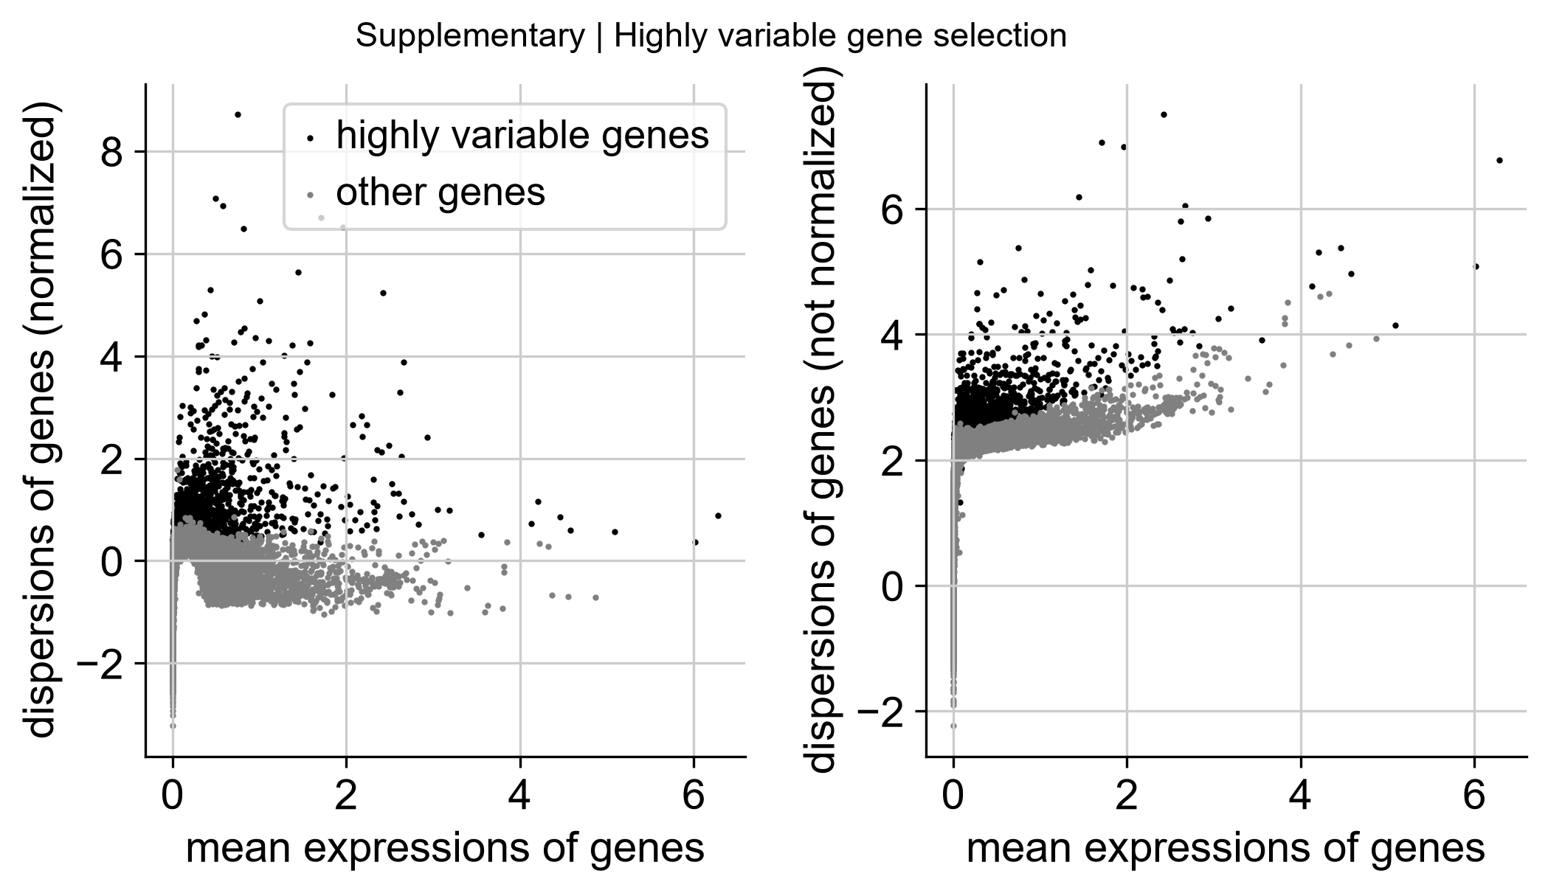
Figure S1. Highly variable gene selection. Mean expression against dispersion, with the 2,000 selected genes in black. The selection follows the upper envelope of the mean–dispersion relationship, as expected.
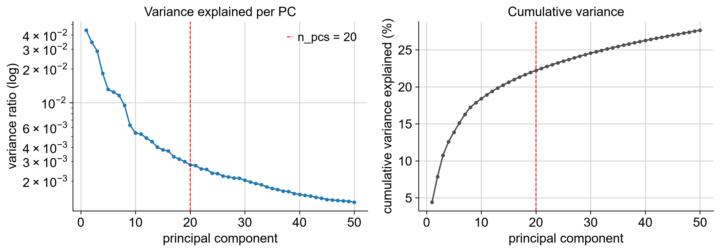
Figure S2. Principal component variance. Left: variance ratio per component on a log scale, with the chosen n_pcs = 20 marked. Right: cumulative variance explained. The curve breaks around PC 9–10 and flattens through the teens; by PC 20 each component contributes under 0.3%, and cumulative variance is approximately 22%.

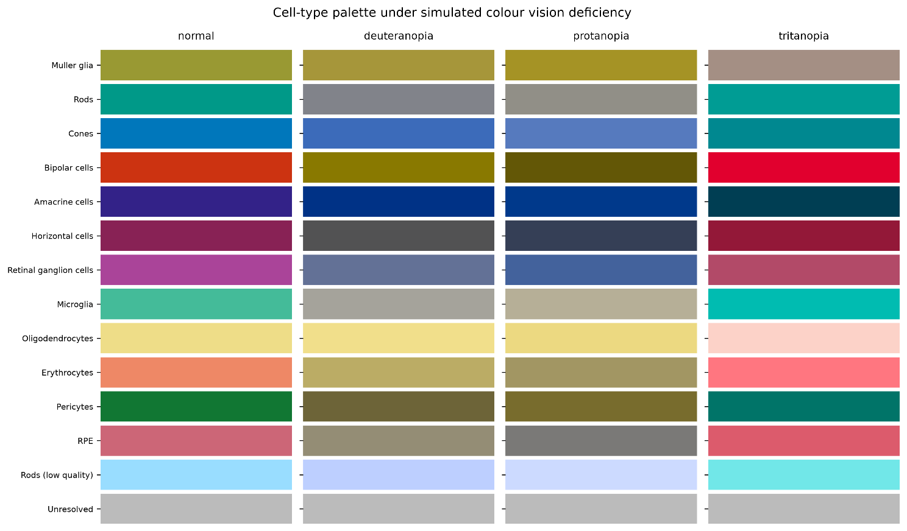
Figure S3. The cell-type palette under simulated colour vision deficiency. Each column shows the same thirteen colours as they appear under normal vision, deuteranopia, protanopia and tritanopia. Colour assignment was optimised to maximise the smallest perceptual distance between any two categories across all four conditions; the minimum is 8.8 in CAM02-UCS units, against 2.3 for the palette used in the draft, where rods and retinal ganglion cells were indistinguishable under protanopia.

