BEUMER Digitalization – Customer Feedback System
Project Report

Executive Summary
The BEUMER Digitalization – Customer Feedback System is a web-based application developed to collect, store, and analyze structured customer feedback from multiple BEUMER plant locations worldwide. The system enhances digital customer engagement by providing a modern user interface, secure backend processing, and scalable database storage using MongoDB. The solution enables BEUMER to monitor customer satisfaction trends, support analytics, and improve digital service strategies.
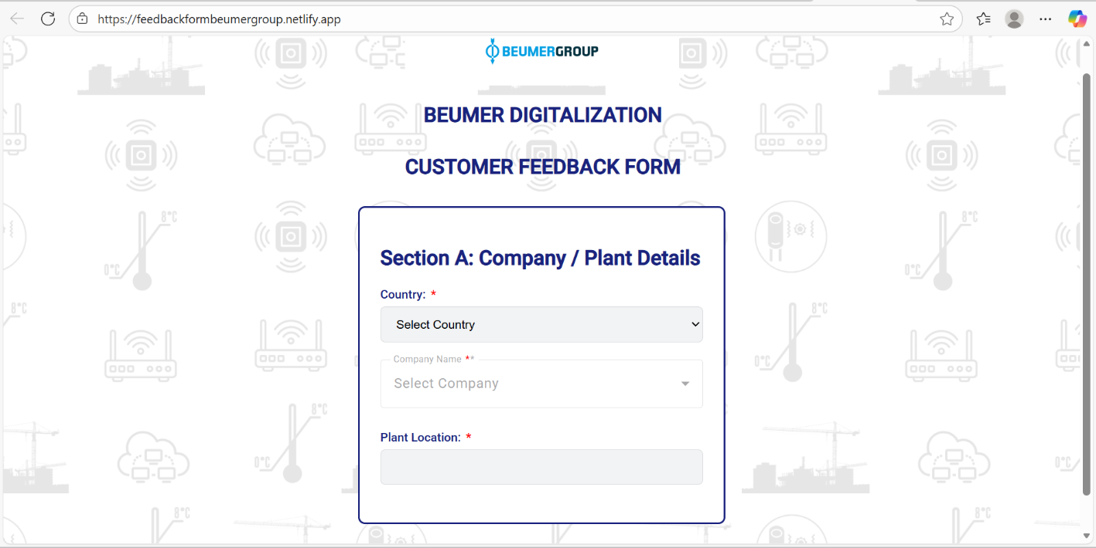

Project Overview
The system is implemented as a full-stack web application enabling real-time feedback submission and backend processing.
Architecture Stack:
Frontend (React JS – Netlify) | Backend REST API (Node.js + Express) | Database (MongoDB – Cloud / On-prem)
Core Objectives
- Modernize the user interface and improve user experience
- Deploy the system online for global customer access
- Integrate backend APIs with database connectivity
- Store customer feedback securely in MongoDB
- Improve form validation, logic, and workflow
- Ensure system security, reliability, and scalability

System Architecture
Frontend
- Developed using React JS
- Deployed on Netlify for global accessibility
- Responsive and user-friendly interface
- Dynamic country → company dropdowns
- Validation-driven feedback forms
Backend
- Developed using Node.js and Express
- REST API endpoints:
  - POST /api/submitFeedback – Submit customer feedback
  - GET /api/getFeedback – Retrieve stored feedback
- Implements data validation, sanitization, duplicate checks, and error handling
Database
- MongoDB Atlas / On-prem MongoDB
- Collection: feedback_records
- Feedback stored with timestamps for historical analysis
- Secure credentials managed using environment variables

Deployment Details
Frontend Deployment
- Hosted on Netlify
- Production URL: https://feedbackformbeumergroup.netlify.app
- Continuous deployment enabled via GitHub
Backend Deployment
- Hosted on cloud platforms (Render / Heroku / DigitalOcean / AWS)
- Environment configuration:
- MONGO_URI=
- PORT=4000
Database Configuration
- MongoDB cluster configured with access controls and backups
- Collections auto-created on first data insertion

Key Functional Enhancements
Improved Form Usability
- Dynamic country-to-company selection
- Mandatory field validation before submission
- Real-time error messages with auto-scroll to invalid fields
System Logic
- Frontend sends structured JSON payloads using POST requests
- Backend validates, sanitizes, and prevents duplicate entries
Sample Stored Document:
{
"country": "Germany",
"company": "Example Cement",
"location": "Berlin",
"satisfactionLevel": 4,
"submittedAt": "2025-01-25T11:40:55Z"
}

Security and Reliability
- Backend secured using Helmet middleware
- Input sanitization and CORS handling enabled
- Sensitive credentials protected using environment variables
- Feedback data stored reliably in MongoDB

Testing and Validation
Functional Testing
- Verified submissions with valid and invalid inputs
- Tested missing fields and incorrect formats
- Confirmed correct data storage in MongoDB
Performance Testing
- Tested concurrent submissions
- Average API response time: < 300 ms

Conclusion
The BEUMER Digitalization Customer Feedback System is fully deployed and operational. It provides a secure, scalable, and reliable platform for collecting customer feedback and supporting analytics-driven decision-making. The system demonstrates BEUMER’s commitment to digital transformation and customer experience enhancement, and it forms a strong foundation for future reporting, analytics, and service optimization.

Project Status
- Status: ✅ Operational
- Frontend: React JS / Netlify
- Backend: Node.js + Express
- Database: MongoDB (Cloud / On-prem)
- **System Ready for Use:

