* **What is Software?**

Software, is a collection of computer programs and related data that provide the instructions for telling a computer what to do and how to do.

* **What is software engineering?**

Software engineering is **the branch of computer science that deals with the design, development, testing, and maintenance of software applications**. Software engineers apply engineering principles and knowledge of programming languages to build software solutions for end users.

* **Type of software**
* **System Software**
* **Programming Software**
* **Application Software**
* **System Software**

System software provides the basic functions for computer usage and helps run the computer hardware and system.

* **Programming Software**

Programming is the process of designing, writing, testing, debugging, and maintaining the source code of computer programs. This source code is written in a programming language. The purpose of programming is to create a program that exhibits a certain desired behavior.

**Application Software**

Application software is the general designation of computer programs for performing user tasks.

* **Types of application software**

❖ Mobile App:

Application that runs on mobile platform.

Example: Facebook app,

❖ Desktop App:

Application that runs stand-alone in a desktop or laptop computer.

Example: Microsoft Word, Web Browser.

❖ Web App:

Apps that run on a web browser(Mozilla, Google Chrome etc.)

1. **What is SDLC? Explian each phase of SDLC**

The Software Development Life Cycle (SDLC) refers to a methodology with clearly defined processes for creating high-quality software

The Software Development Life Cycle (SDLC) refers to a methodology with clearly defined processes for creating high-quality software. in detail, the SDLC methodology focuses on the following phases of software development:

1. Requirement Gathering

2. Analysis

3. Designing

4. Implementation

5. Testing

6. Maintenance

1.Identify the Current Problems

“What are the current problems?” This stage of the SDLC means getting input from all stakeholders, including customers, salespeople, industry experts, and programmers. Learn the strengths and weaknesses of the current system with improvement as the goal.

2.Plan

“What do we want?” In this stage of the SDLC, the team determines the cost and resources required for implementing the analyzed requirements. It also details the risks involved and provides sub-plans for softening those risks.

In other words, the team should determine the feasibility of the project and how they can implement the project successfully with the lowest risk in mind.

3.Design

“How will we get what we want?” This phase of the SDLC starts by turning the software specifications into a design plan called the Design Specification. All stakeholders then review this plan and offer feedback and suggestions. It’s crucial to have a plan for collecting and incorporating stakeholder input into this document. Failure at this stage will almost certainly result in cost overruns at best and the total collapse of the project at worst.

4.Build

“Let’s create what we want.”

At this stage, the actual development starts. It’s important that every developer sticks to the agreed blueprint. Also, make sure you have proper guidelines in place about the code style and practices.

For example, define a nomenclature for files or define a variable naming style such as camel case. This will help your team to produce organized and consistent code that is easier to understand but also to test during the next phase.

5.Code Test

“Did we get what we want?” In this stage, we test for defects and deficiencies. We fix those issues until the product meets the original specifications.

6.Software Deployment

“Let’s start using what we got.”

At this stage, the goal is to deploy the software to the production environment so users can start using the product. However, many organizations choose to move the product through different deployment environments such as a testing or staging environment.

This allows any stakeholders to safely play with the product before releasing it to the market. Besides, this allows any final mistakes to be caught before releasing the product.

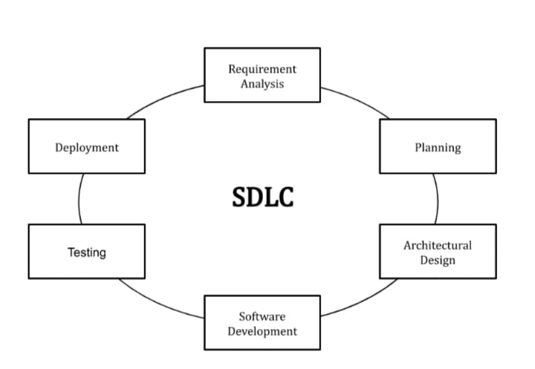

* **What is DFD? Create DFD diagram on flipcart**

DFD is the abbreviation for Data Flow Diagram. The flow of data of a system or a process is represented by DFD. It also gives insight into the inputs and outputs of each entity and the process itself.

DFD- Data Flow Diagrams

Graphical representation of flow of data inside application. Used for visualization and data processing.

**DFD elements are:**

◦External Entity

◦Process

◦Data Flow

◦Data Store

* 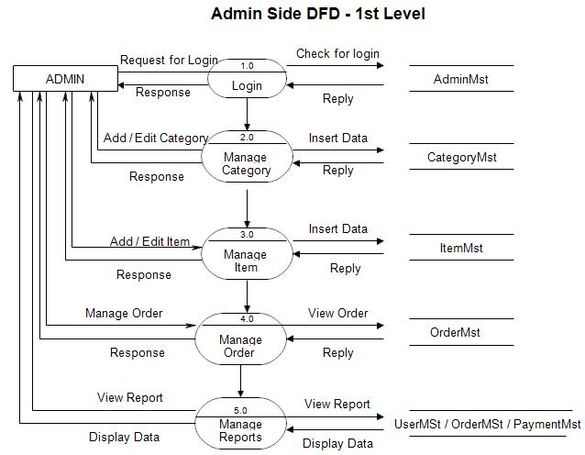**what is flow chart? Create a flowchart to make addition of two number**

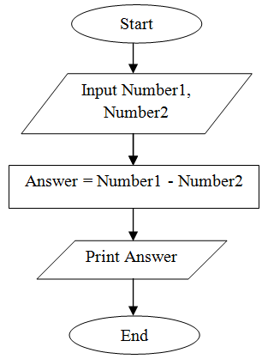

* **What is use case diagram? Create a use-case on bill payment on paytm.**

Use-case diagrams **describe the high-level functions and scope of a system**. These diagrams also identify the interactions between the system and its actors. The use cases and actors in use-case diagrams describe what the system does and how the actors use it, but not how the system operates internally.

