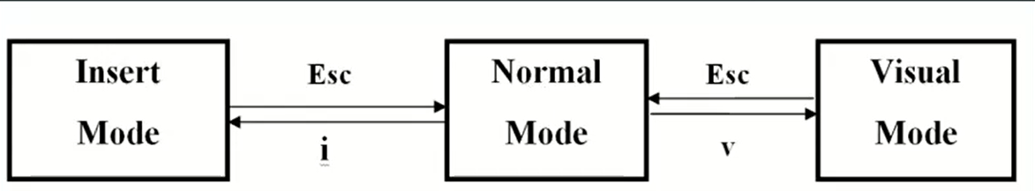

مود سومی هم وجود دارد به نام command mode که در حال normal اگر shift+: وارد این حات میشوید

:q! => exit without saving

:wq => save and exit

x => delete a character

A => go to end line and switch to insert mode

dw => delete a word

dd => delete a line

d$ = delete from cursor to end of file

d3w => delete three words

u => undo

U => undo all changes on a line

p =>paste

y(VISUAL) =>copy

d => cut

/name => to search a name

n => go to next search result

N=> got to previous search result