**LAB_3:**

**Naveen Kuhar**

Section A: Create a JavaFX Application for Simple HR Management (150 Marks)

1. Create a new JavaFX application project in your preferred Java IDE (for example, IntelliJ IDEA).
2. Name the project as "HR Management Your Name."

I kept my project name as _lab3

**Section B: Create Four GUI Pages for Login, Dashboard, Admin, and Employee (150 Marks)**

* + 1. **Login Page:**
       - 1. Email and Password Fields
         2. Login button
    2. **Dashboard Page:**
       - 1. Four buttons: Admin, Employee, Logout, Exit
    3. **Admin Page:**
       - 1. Table View
         2. Buttons for Create, Update, Delete, View, and Back
    4. **Employee Page:**
       - 1. Table View
         2. Buttons for Create, Update, Delete, View, and Back

Section C: Create Database Tables (150 Marks)

1. In your MySQL database, create tables for storing employee data, such as "Employee Detail," Admin, and "Salary."
2. Define the table structures to accommodate employee information and salary details.
3. Define the table structures to accommodate Admin information and salary details.

1) Creating a database SQL commands

CREATE DATABASE IF NOT EXISTS hr_management;

USE hr_management;

-- Admin Table

CREATE TABLE IF NOT EXISTS Admin (

id INT AUTO_INCREMENT PRIMARY KEY,

name VARCHAR(100) NOT NULL,

email VARCHAR(100) UNIQUE NOT NULL,

password VARCHAR(100) NOT NULL

);

-- Employee Table

CREATE TABLE IF NOT EXISTS Employee (

id INT AUTO_INCREMENT PRIMARY KEY,

name VARCHAR(100) NOT NULL,

position VARCHAR(100),

salary DOUBLE

);

-- Salary Table (Optional for future extensions like JUnit tests)

CREATE TABLE IF NOT EXISTS Salary (

employee_id INT PRIMARY KEY,

base_salary DOUBLE,

bonus DOUBLE,

FOREIGN KEY (employee_id) REFERENCES Employee(id)

);

-- Sample Admin User for Testing Login

INSERT INTO Admin (name, email, password) VALUES ('Admin User', 'admin@example.com', 'password123');

EER diagram for relationship between employee and salary

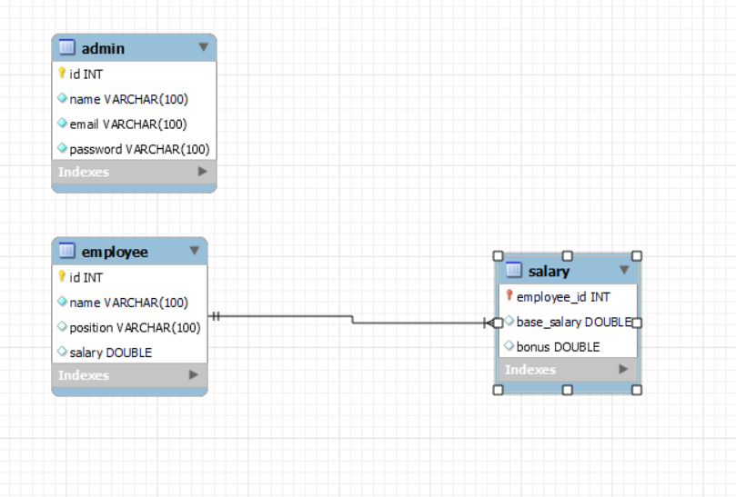Section D: GitHub and Documentation (360 Marks)

1. Create Java classes representing the structure of the database tables (for example, Employee and Admin).
2. These classes will be used to model the data retrieved from and inserted into the database.

Admin.java

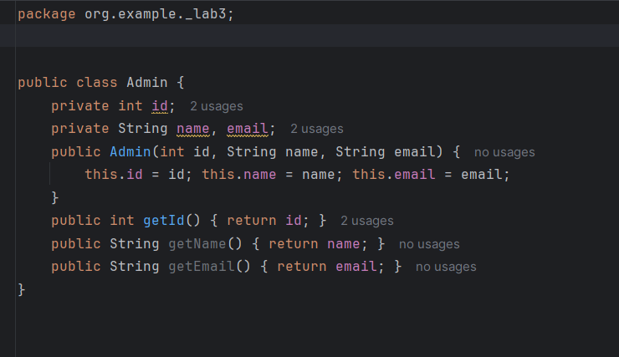

Employee.java

Section E: Write Database Connection Code (100 Marks)

1. Implement the database connection code in your JavaFX application.
2. Ensure it includes the necessary database URL, username, and password.
3. Take a screenshot of the code where you establish the database connection.

Section F: Use Open JDBC Jar to Connect Database (50 Marks)

1. Download and include the appropriate JDBC driver (for example, MySQL Connector/J) in your project.
2. Ensure your project's build path includes the JDBC driver JAR file.

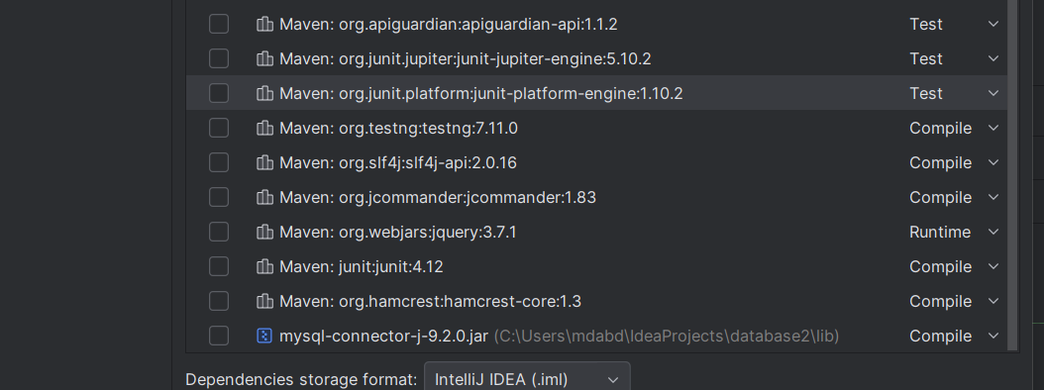

Section G: Create DAO Classes and Use ORM (100 Marks)

1. Create Java models that map to the database tables (for example, Employee DAO, Admin DAO, and Login DAO).
2. Use Object-Relational Mapping (ORM) techniques to simplify database interactions.

Login DAO

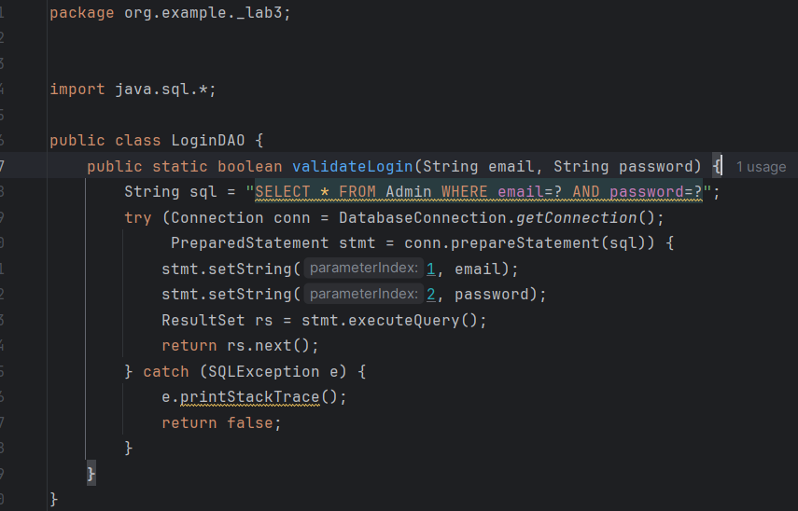

AdminDAO

EmployeeDAO

Section H: Implement the Login Module (75 Marks)

1. Implement a login module to restrict access to HR data.
2. Users should log in using a username and password.

Section I: Implement the Dashboard Module (100 Marks)

1. The dashboard page will have four buttons: Admin, Employee, Logout, Exit.
2. The Logout button will take the user to the Login page.
3. The Exit button will exit the application.
4. Display a welcome message, "Welcome, Username," and the current date.

Section J: Implement the Admin Module (125 Marks)

1. Create, update, delete, and view Admin records.
2. Include functioning Logout and Back buttons.

Create:

Update

Delete

BACK

Section K: Implement the Employee Module (125 Marks)

1. Create, Update, Delete, and View Employee Records.
2. Include functioning Logout and Back buttons

Create:

Update

Delete

BACK

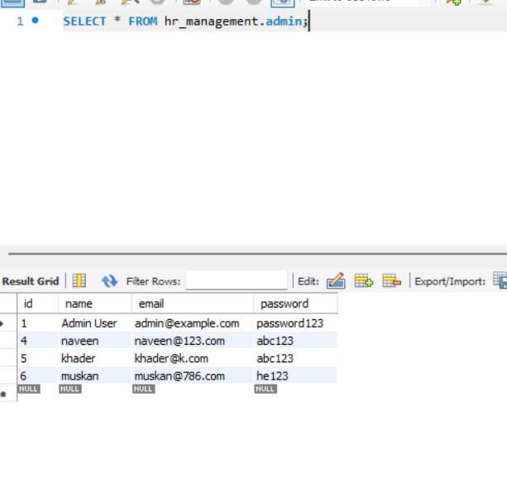 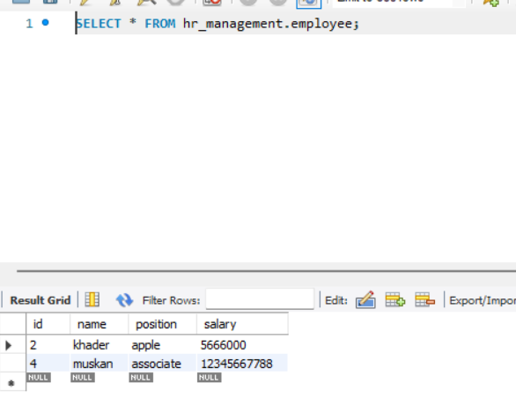

Section L: Implement JUnit Testing for Calculating Yearly Salary (300 Marks)

1. Write JUnit test cases to calculate yearly salaries for employees based on the provided data.
2. Ensure the tests cover various scenarios, including different employee roles and salary structures.

**Section M: GitHub Repository and Documentation (125 Marks)**

* + - 1. Upload your JavaFX HR Management project to a GitHub repository.
      2. Create a well-documented README file in your repository, providing instructions on setting up and running your application, including login details.
      3. Submit a DOCX or PDF document that includes:

Screenshots of your GUI layout

Screenshots of your database table structures

Screenshots of relevant portions of your code

Screenshots of your JUnit test cases and results

A link to your GitHub repository