**TEST_2B**

**Naveen Kuhar**

**Section A: Scene Creation (320 Marks)**

1. Develop two JavaFX scenes: one for the login page and the other for CRUD operations.
2. Design the layout for each scene.

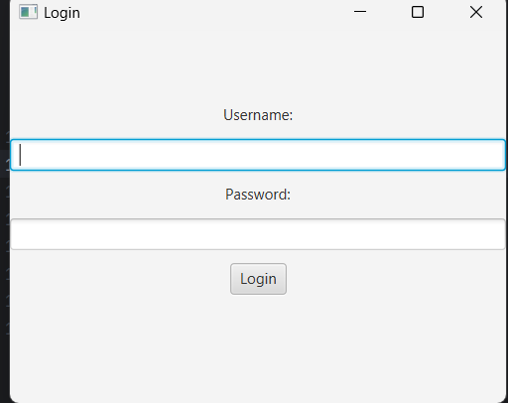

ection B: Database Design (120 Marks)

1. Design a sample database for your application. Create tables for the login and CRUD operations.
2. Plan the structure of these tables and specify the fields they should contain.
3. Take a screenshot of the visual design of your database from Designer View in MYSQL and include these screenshots in your test submission.

Section C: Controller and View Implementation (160 Marks)

1. Develop controllers and views for your application scenes.
2. Ensure that the views are well-designed and user-friendly.
3. Establish necessary bindings between the application's views and the respective controllers.
4. Ensure smooth data flow between these components.

Logincontroller.java

CRUDController.java

Section D: Perform Login CRUD Operation (400 Marks)

1. Perform login operation from your database.
2. Perform CRUD operation from your database.

ADD

Delete

UPDATE

Section E: Data Modelling (120 Marks)

1. Develop data classes that represent the structure of your database tables.
2. These classes will be used to model the data you retrieve from and insert into the database.
3. Implement Object-Relational Mapping (ORM) techniques or create models representing the database tables.
4. Ensure seamless interaction between your application and the database.

Section F: GitHub and Documentation (320 Marks)

1. Upload your JavaFX project to a GitHub repository.
2. Create a well-documented DOCX or PDF file.
3. Provide screenshots of your GUI layout with your name, student ID, and date.
4. Provide screenshots of your database table structure and sample data.
5. Provide screenshots of relevant portions of your code.
6. Provide a link to your GitHub repository.