IMPLEMENTATION MULTIMEDIA DEVELOPMENT LIFE CYCLE IN INTERACTIVE MULTIMEDIA DESIGN FOR TRADITIONAL INDONESIAN MUSIC INSTRUMENTS INTRODUCTION

**Aditya I Zuhdi1, Zahrotul Mustafidah2, Muhammad R N Alam3, Safira A Irawan4**

1,2,3,4 Informatics Engineering Study Program, Faculty of Informatics, Telkom Purwokerto Institute of Technology

Email: 120102217@ittelkom-pwt.ac.id, 220102212@ittelkom-pwt.ac.id, 320102070@ittelkom-pwt.ac.id, 420102162@ittelkom-pwt.ac.id

(Received: dd mmm yyyy, Revised: dd mmm yyyy, Accepted: dd mmm yyyy)

Abstract

This research aims to address the lack of interactive multimedia-based educational media in introducing traditional Indonesian musical instruments to the public, especially children. The issue arises from the fact that the diversity of traditional musical instruments in Indonesia has not been presented attractively in an interactive media format. Therefore, this study utilizes the Multimedia Development Life Cycle (MDLC) method as a guide in designing and developing interactive multimedia. The MDLC stages, namely Concept, Design, Material Collecting, Assembly, Testing, and Distribution, are implemented to ensure that each step of the system development is well-organized. The results of alpha testing indicate that all features of the interactive multimedia work well. Beta testing, involving 36 respondents, yields a rating of 4.52 out of 5, demonstrating that this interactive multimedia is excellent and suitable for use as a learning media for traditional Indonesian musical instruments. This research addresses the gaps in the presentation of educational information by providing an interesting and effective media, especially in the context of traditional musical instruments. Thus, it is expected that this interactive multimedia can enrich the knowledge of the public, especially children, about the cultural wealth of traditional Indonesian musical instruments.

**Keywords**: *traditional musical instruments, interactive multimedia, MDLC, education, system development*

*This is an open access article under the* [*CC BY*](https://creativecommons.org/licenses/by/4.0/) *license.*



*\*Corresponding Author: Aditya I Zuhdi*

# INTRODUCTION

In today's era of digitalization, we are better prepared to accept the changes that occur caused by rapid technological advances. With the development of increasingly sophisticated technology, now we can provide an introduction to musical instruments in Indonesia using interactive media, ranging from educational information media that include elements of local culture, animation, film, and others[1]. One very interesting way to display information is interactive multimedia[2].

The advantage that interactive multimedia has is the emphasis on user engagement and experience, which means users gain freedom in controlling the system. This arises because interactive multimedia is usually equipped with a number of controller features that can be operated by the user, allowing them to make choices according to their wishes for the next stage in the process[3].

In previous research on interactive multimedia, [4] produced an Android-based educational application that aims to facilitate elementary school students in understanding traditional West Javanese musical instruments to increase interest in learning and stimulate the development of children's mindsets. Further research [5] produced interactive game media introducing Indonesian cultural diversity using the Multimedia Development Life Cycle method. Further research [6] resulted in a Learning Media for Introduction to Indonesian Traditional Musical Instruments for students of SDN 249 Turungan Datu which can display interactive materials and interactive musical instruments. Further research [7]produced a media learning method for Harapan Jaya Elementary School students for interesting and useful learning media to introduce art and traditional traditions of the archipelago. The next research instruments [8] resulted in an application for the introduction of Javanese gamelan musical.

The problem that is the main focus of this research is the lack of supporting learning media to recognize traditional musical instruments as an effort to preserve traditional culture. Another thing that causes the lack of learning media is the interest in learning media in delivering material and the lack of use of learning technology about traditional musical instruments, such as only reading books that display pictures and less varied so that students feel bored quickly. Based on the description of the background and problems above, a research was carried out "Implementation of Multimedia Development Life Cycle in the Development of Interactive Multimedia Introduction to Indonesian Traditional Musical Instruments" to help solve existing problems. In addition, the existence of interactive multimedia as a companion for learning activities creates varied and interesting learning.

The MDLC method has six stages, namely Concept, Design, Material Collecting, Assembly, Testing and Distribution[9]. The main plus of this method lies in the organized structure of system building from the concept stage to testing. This approach allows systematic and coordinated system development, ensuring good integration for each element throughout the development process. Thus, the resulting multimedia application can go through thorough testing before being deployed to the intended user or target in the context of this study[10].

# RESEARCH METHODE

* 1. **Stage of Research**

Research methods are a series of steps to be carried out in a study. So that the steps taken by the author in this design do not deviate from the core of the discussion and are easier to understand, the sequence of research steps will be arranged systematically so that it can be used as a clear guideline and facilitate the resolution of existing problems. The method chosen for this study is the Multimedia Development Life Cycle (MDLC), which is illustrated in Figure 1 below.

The Multimedia Development Life Cycle (MDLC) method is a multimedia development model consisting of six stages. These stages are :

1. **Concept**

This stage aims to design the system by determining the purpose of creating the system and identifying users who will use the system. System requirements analysis is also carried out at this stage.

1. **Design**

The design phase involves creating a program specification, including material requirements for the program, program display, and program architecture. The design process includes program structure, UML design, and program design.

1. **Material Collecting**

The stage of collecting the materials to be used begins first. The material that has been collected will then be used at the next stage, namely assembly.

1. **Assembly**

The manufacturing stage involves the creation of all multimedia materials. The program creation process is based on the design stage, program structure, UML design, and program design.

1. **Testing**

This stage is carried out after completing the manufacturing stage (assembly). Testing is carried out by the maker (alpha testing) using black box testing and beta testing methods. The main purpose of this stage is to ensure that the system functions properly and in accordance with predetermined needs.

1. **Distribution**

At the distribution stage, the results of system development are stored and ready for distribution. This process involves storing system test results, and if needed, performing compression if the system exceeds the available storage capacity.

* 1. **Supporting Theories**

In this research process, there are several supporting theories that will be the basis for this research and are related to pre-existing theories. The supporting theories are described as follows:

Multimedia

Multimedia is a form of media that combines various elements of information, including text, graphics, animation, video, and sound, with the aim of conveying information or providing entertainment to its audience[11]. There is a significant difference in learning outcomes between the use of interactive multimedia and textbooks in a learning context. The application of multimedia in the learning process can create a more interesting and effective learning experience, which in turn can increase students' understanding of the material delivered[12].

Interactive Multimedia

Interactive multimedia is a tool equipped with controllers that allow users to select and interact, just like in gaming systems and other applications. Essentially, interactive multimedia is a combination of media elements such as images, audio, text, and others, forming a unity that is able to present information through interactive communication [13]. The use of interactive multimedia in learning has great potential to interest students by providing direct direction, thus facilitating the understanding of the material. In its application, the effectiveness of learning must be adjusted by paying attention to the factors of students and the learning environment itself, so that learning objectives can be achieved optimally[14].

MDLC

The Multimedia Development Life Cycle (MDLC) method is an approach used in the design and development of media applications, which is a combination of various elements such as images, sound, video, animation, and other media elements [15]. MDLC includes six stages, namely Concept, Design, Material Collecting, Assembly, Testing, and Distribution. This approach ensures that the media application development process is carried out in a structured manner, from the concept stage to testing, so that each step can be well organized. By using MDLC, the resulting media applications can be thoroughly tested before being distributed to users, ensuring the quality and success of those applications.

Indonesian Traditional Musical Instruments

In general, tools can be interpreted as an object that is used to facilitate humans in carrying out an activity. Music, on the other hand, is a medium used to express art, with the ear acting as its absorber. Traditional music, which was born and developed in various regions throughout Indonesia, has elements such as rhythm, melody, expression, and song structure that unite to form a unity. Region, in this context, refers to a region that has certain distinctive features in its geographical location[16].

The hallmark of traditional music lies in the content of the songs and instruments used. This type of music has distinctive characteristics, where the verses and melodies use the local language and style[17]. Thus, regional musical instruments can be interpreted as an object that becomes a symbol and characteristic of a number of regions, with the aim of helping humans express feelings through rhythms and melodies played by these musical instruments.

# RESULTS AND DISCUSSION

Through the application of the MDLC method in the development of interactive multimedia aimed at introducing traditional Indonesian musical instruments, this approach is realized in an interactive educational game format and provides various menu options to support system functionality. Here are the details of the stages carried out in this study:

Concept

In this stage, researchers develop the concept of system flow in a short and easy-to-understand manner. The goal is to make the system an effective educational tool in introducing traditional Indonesian musical instruments to the public, especially children. The concept plot designed in this educational system is designed to facilitate children's understanding of traditional Indonesian musical instruments in a fun way. The concept flow built on the interactive multimedia introduction of traditional Indonesian musical instruments is as follows:

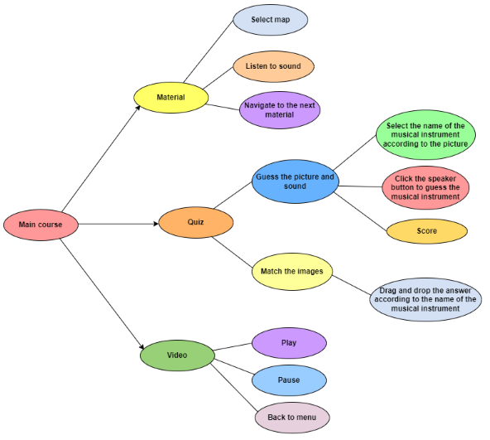

Figure 2 Interactive Multimedia Concept Introduction to Indonesian Musical Instruments

Design

At this design stage, a research design is made involving the Unified Modeling Language (UML), and system design as a visual representation of the system to be implemented. The resulting design is best designed to attract users, especially children, to be interested in using this interactive multimedia. The UML, and program design as follows:

1. UML Plan

In the development of interactive multimedia for the introduction of traditional Indonesian musical instruments, Unified Modeling Language (UML) is used which serves to provide visual representations or images to users of various programming languages and general engineering processes. The diagrams used include:

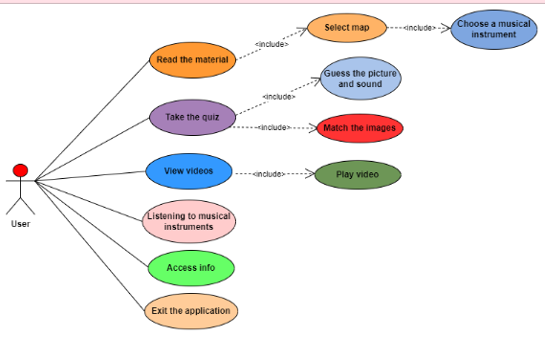

Figure 3. Use Case Diagram for Interactive Multimedia

From Figure 3, you can see the use case diagram of interactive multimedia being developed. This use case diagram shows how the user interacts with the system. In this interactive multimedia, there are one actor and seven main use cases, as well as two use cases included in the material menu, two use cases included in the quiz menu, and one use case included in the video menu.

1. Program design

Program design is an important element in the development of interactive multimedia, because from this design will be determined guidelines for the appearance and layout of menus and content that will be displayed on interactive multimedia that is being built. Here is the program design:

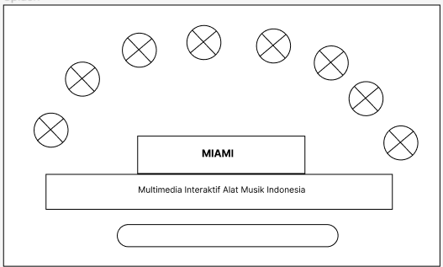

Figure 4. Initial Display Design

The first is the design of the splash screen In the middle of the screen will be given text in the form of the title of the multimedia to be built, namely "MIAMI" which stands for "Multimedia Interactive Indonesian Musical Instruments". Below the title text, there is a long horizontal bar that may serve as a progress or loading indicator.

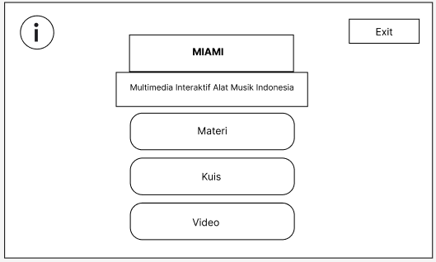

Figure 5. Main menu display

The second on the initial screen will be designed with two buttons consisting of information on the upper left side and out on the upper right side. In the middle of the screen will be given text in the form of the title of the multimedia to be built, namely "MIAMI" which stands for "Multimedia Interactive Indonesian Musical Instruments". Below the title text, there are three large buttons namely "Material", "Quiz", and "Video" which each provide access to related content.

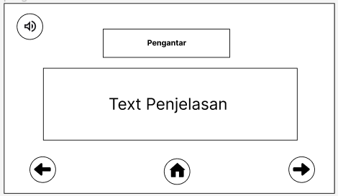

Figure 6. Musical Instrument Introduction View

On the introductory page after pressing the material button will be designed with a display in the form of a page title in the middle of the top, Below the page title, there is a box containing an introduction to what is a traditional Indonesian musical instrument Below the selection box, there is a home button that is clicked will lead back to the initial page. On the upper left side, there is a button to turn on or off the dubbing of the explanatory text. On the right and bottom left there is a back button and a button to direct to the next page.

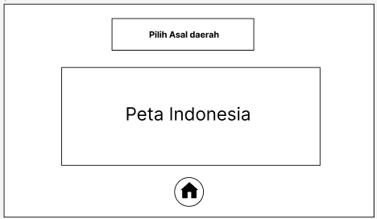

Figure 7. Map View of Indonesia

Next the page select area, will be designed with a display in the form of a page title in the middle of the top, Below the page title, there is a large area that will display a map of Indonesia Below the selection box, there is a button that is clicked will lead back to the initial page. On the upper right side, there is an exit button to return to the main page. At the bottom of the page, there is a home icon that serves as a navigation to the next page.

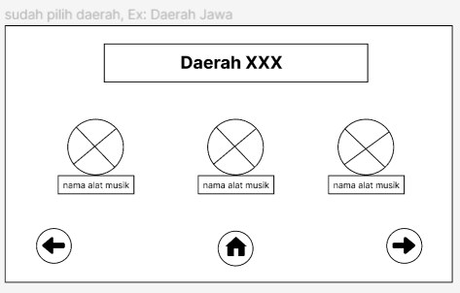

Figure 8. Area page views

On the regional page will be designed with a page title that displays the name of the selected region, for example: "Java Region". Below the page title, there are three round icons that each display the name of a musical instrument from the area, for example: "Gamelan", "Angklung", and "Flute". On the upper right side, there is an exit button to return to the main page. At the bottom of the page, there are arrow navigation buttons to the left and right to move between regional pages.

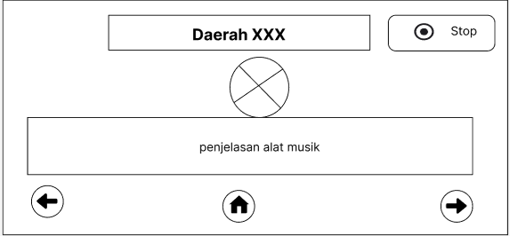

Figure 9. Musical Instrument Page View

On the page the selected musical instrument will be designed with a display in the form of a navigation bar at the top of the page, which displays the name of the selected region, for example: "Java Region". On the right side of the navigation bar, there's a stop button to stop the instrument's sound. Below the navigation bar, there is a large area that displays images or specific information about the selected instrument, for example: "Gamelan". Below the area, there is a text describing the instrument. At the bottom of the page, there are left and right arrow navigation buttons to move between pages of musical instruments. At the bottom of the middle of the page, there is a home icon that serves as a navigation to the start page.

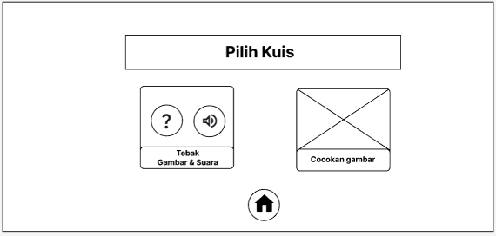

Figure 10. Quiz Menu Display

The quiz menu will be designed with a display in the form of a page title in the upper center, namely "Select Quiz". Below the page title, there are two buttons that offer different quiz options, namely "Guess the Image &; Sound" and "Match images". At the bottom of the page, there is a home icon that serves as a navigation to the start page.

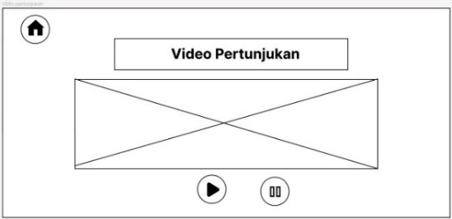

Figure 11. Video Page Views

The video page will be designed with a display in the form of a navigation bar at the top of the page, which displays the name of the selected region, for example: "Java Region". On the right side of the navigation bar, there is a stop button to stop the video. Below the navigation bar, there is a large area that will display videos of musical instrument performances from the area, for example: "Gamelan Performance Video". Below the video area, there are control buttons to play or pause the video. On the upper right side, there is a home button to return to the main page.

* 1. Material Collecting

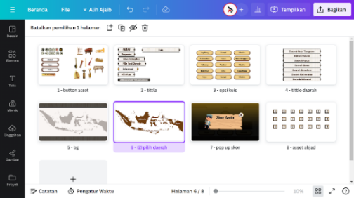

Figure 12. Asset Collection Process with Canva

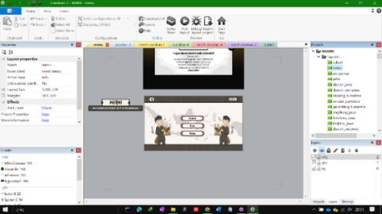

Figure 13. Combining Assets using Construct 2

Asset creation is created by utilizing Canva as a key design tool. Canva is used to create visual images that represent various traditional Indonesian musical instruments that will be presented in interactive multimedia. For images of musical instruments and characters use the graphics available in Canva. As for button design assets, page titles, display layouts are created manually, not using templates from canva.

After the assets are collected, proceed with merging assets using Construct 2. In this stage, the application of element behavior, interaction between pages, transitions, and designing frame placement so that interactive multimedia applications provide an attractive user experience. This is so that users can enjoy information about traditional Indonesian musical instruments with an attractive visual display, and the material can be conveyed well.

Assembly

At this stage, researchers develop interactive multimedia as well as possible in order to convey information about traditional Indonesian musical instruments to users. Here are the results of the manufacturing process:

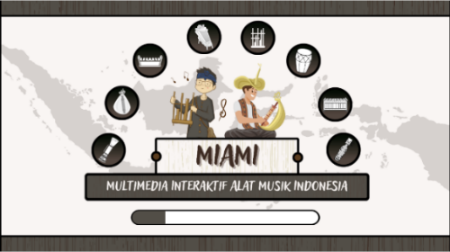

Figure 14. Splash Screen Page Interface

After the user opens MIAMI interactive multimedia (Indonesian Musical Instrument Interactive Multimedia), the splash screen page will appear, on this page two cartoon characters playing traditional Indonesian musical instruments are displayed against the background of a blurred world map. The character on the left plays angklung, while the right character plays sasando. Around them, black icons depict various other traditional musical instruments such as gamelan, kendang, sape, etc. A sign that says "MIAMI" is located in the center of the screen with the tagline "MULTIMEDIA INTERACTIVE INDONESIAN MUSICAL INSTRUMENTS" just below it. The next interface is the main page.

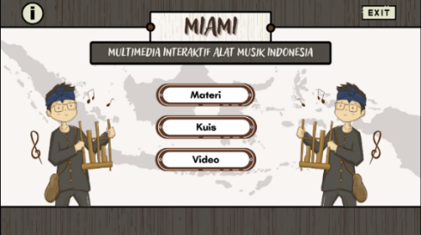

Figure 15. Home Interface

The main page will be designed with a display in the form of a page title in the middle of the top, namely "MIAMI" which stands for "Interactive Multimedia Indonesian Musical Instruments". Below the page title, there are three buttons that offer different content options, namely "Material", "Quiz", and "Video". The "Materials" button will direct users to a page containing learning materials about traditional Indonesian musical instruments. in addition there are Information and Exit buttons.

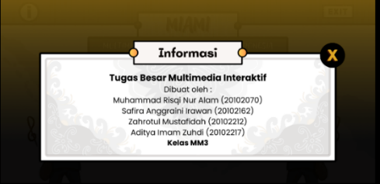

Figure 16. Information Button Interface

When the information button is clicked on the main page, the information page will open. On the page, an interactive multimedia developer profile that introduces traditional Indonesian musical instruments will be displayed.

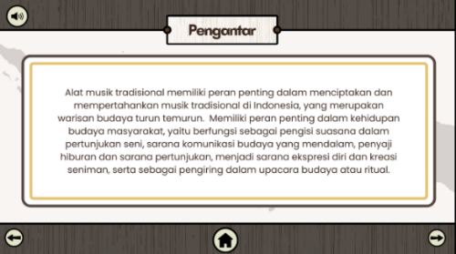

Figure 17. Introductory Page View

When the user selects the material button, it will then be directed to the introduction page. This introductory page contains the preface and its dubbing which can be turned off by selecting the voting button in the upper left corner.

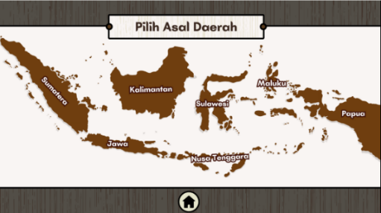

Figure 18. Map View Select Regional Origin

After passing the introduction, the user will be presented with a menu select regional origin. In this menu, users can select areas based on large islands on the map to learn musical instruments located in their respective areas. Furthermore, when choosing one of the regions, for example Java.

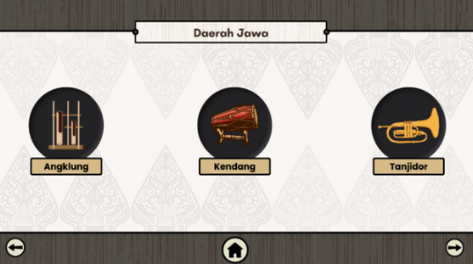

Figure 19. Display Types of Regional Musical Instruments

On this area page, users will be presented with three menus containing types of traditional musical instruments from the selected region, for example Java, namely the Angklung, Kendang, and Tanjidor menus. Each menu is represented by an icon depicting the instrument. If the user clicks on one of the instrument options, the system displays more information from the intended instrument.

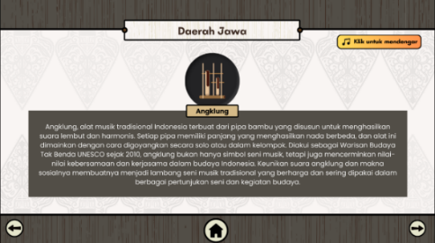

Figure 20. Musical Instrument Explanation Display

After the user selects one of the musical instruments, for example angklung, the system will open the musical instrument explanation page. On this page, users will be presented with complete information about angklung, such as how to play, history, and related culture. At the top of the page, there is a navigation bar that displays the name of the region and the name of the selected instrument. On the right side of the navigation bar, there's a stop button to stop the instrument's sound.

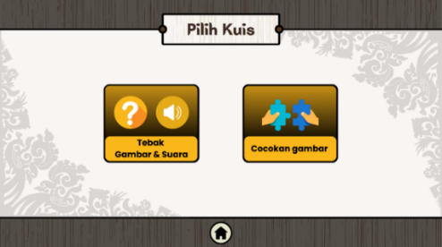

Figure 21. Quiz Menu Display

After the user selects the quiz menu, the system will display a page containing two choices of quiz types, namely "Guess the Image &; Sound" and "Match images". On this page, users can select any of the quiz types they want to play by clicking the corresponding button. The "Guess the Image & Sound" button will take users to a page containing quizzes involving images and sounds of traditional Indonesian musical instruments. The user must guess the name of the instrument being displayed or listened to. The "Match image" button will take the user to a page containing a quiz involving images to be matched. The user must match the image of the musical instrument with its name or region of origin. Furthermore, the quiz page interface is in accordance with the user's choice.

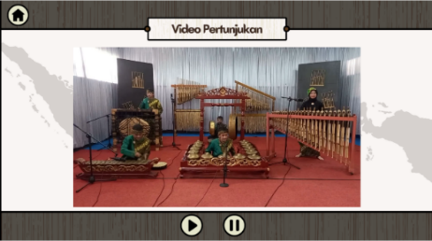

Figure 22. Performance Video Display

After the user selects a video, the system will redirect the user to the show video page. On this page, users will be presented with a video featuring performances of traditional Indonesian musical instruments from the selected region. There is a large area displaying videos. Below the video area, there are control buttons to play or pause the video. On the upper left side, there is a home button to return to the main page.

Testing

At this stage, two trials are carried out, namely, Alpha Testing is an internal trial conducted by the researcher himself to ensure that the product or service is functioning properly. Furthermore, beta testing is an external trial conducted by users to get feedback about a product or service through a questionnaire.

Alpha Testing

In this test, testing was carried out on the display and function of each button in the interactive multimedia of Indonesian musical instruments as in Table 1.

Table 1. Alpha Testing

|  |  |  |  |  |
| --- | --- | --- | --- | --- |
| **No** | **Components tested** | **Test Scenarios** | **Testing** | **Information** |
| 1 | Home | "Materials" button | BlackBox | Succeed |
|  |  | "Quiz"  button | BlackBox | Succeed |
|  |  | "Video"  button | BlackBox | Succeed |
|  |  | "Information"  button | BlackBox | Succeed |
|  |  | “Exit”  button | BlackBox | Succeed |
| 2 | Material Introduction Page | "Sound-on" button | BlackBox | Succeed |
|  |  | "Sound-off"  button | BlackBox | Succeed |
|  |  | "Back"  button | BlackBox | Succeed |
|  |  | "Next"  button | BlackBox | Succeed |
|  |  | "Home"  button | BlackBox | Succeed |
| 3 | Material Page | "Original Map of Java District" button | BlackBox | Succeed |
|  |  | "Angklung Musical Instrument" button | BlackBox | Succeed |
|  |  | "Kendang Musical Instrument" button | BlackBox | Succeed |
|  |  | "Tanjidor Musical Instrument"  button | BlackBox | Succeed |
|  |  | "Listening to a Musical Instrument" button | BlackBox | Succeed |
|  |  | "Stop" button | BlackBox | Succeed |
|  |  | "Home" button | BlackBox | Succeed |
|  |  | "Back" button | BlackBox | Succeed |
|  |  | "Next" | BlackBox | Succeed |
| 4 | Quiz Page | button  "Guess the Image &; Sound" | BlackBox | Succeed |
|  |  | button  "Image Match" | BlackBox | Succeed |
|  |  | button  "Quiz Answers" | BlackBox | Succeed |
|  |  | button  "Sound-on" | BlackBox | Succeed |
|  |  | button  "Sound-off" | BlackBox | Succeed |
|  |  | button  "Close Skor Chaste" | BlackBox | Succeed |
|  |  | button  "Close Skor Chaste" button | BlackBox | Succeed |
|  |  | “Next" button | BlackBox | Succeed |
|  |  | "Back" button | BlackBox | Succeed |
|  |  | "Home" button | BlackBox | Succeed |
| 5 | Video Page | "The Original Map of Java District" button | BlackBox | Succeed |
|  |  | “Play" button | BlackBox | Succeed |
|  |  | "Pause" button | BlackBox | Succeed |
|  |  | "Back" button | BlackBox | Succeed |
|  |  | "Home" button | BlackBox | Succeed |

Based on Table 1. Five tests were carried out on the features of interactive multimedia, each component can run properly without any errors.

Beta Testing

In the beta testing phase, interactive multimedia that has been developed was tested by 36 respondents through Google Forms. Processing the questionnaire results through Beta Testing helps reveal the extent of eligibility and response to such interactive multimedia. With 14 assessment indicators and a five-value scale, this evaluation provides a clearer picture of how the solution meets user needs and desired learning objectives. The scale is as follows:

Strongly Disagree (STS) = 1

Disagree (TS) = 2

Neutral (N) = 3

Agree (S) = 4

Strongly Agree (SS) = 5

For example, indicator 1 is used, namely "Attractive and satisfying multimedia visual display".

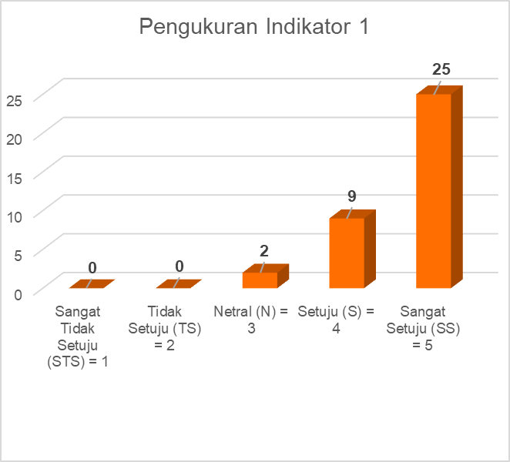

Figure 29. Measurement of Indicator 1

In the picture, it was found that 25 respondents gave a value of strongly agree, 9 respondents agreed, 2 respondents were neutral, then none of the respondents filled in disagree, strongly disagree. From these results, a rating calculation for indicator 1 is carried out, with the following calculation

Strongly Disagree = 1 * 0 = 0

Disagree = 2 * 0 = 0

Netral = 3 * 2 = 6

Agree =4*9=36

Strongly Agree = 5 * 25 = 125

Total = 167

Rating = 167/36

= 4.64

The calculation of ratings on other indicators is also carried out with the following results:

Table 2. Assessment Rating

|  |  |  |
| --- | --- | --- |
| **No** | **Indicator** | **Value** |
| 1 | Indicator 1 | 4,64 |
| 2 | Indicator 2 | 4,44 |
| 3 | Indicator 3 | 4,61 |
| 4 | Indicator 4 | 4,53 |
| 5 | Indicator 5 | 4,56 |
| 6 | Indicator 6 | 4,50 |
| 7 | Indicator 7 | 4,64 |
| 8 | Indicator 8 | 4,56 |
| 9 | Indicator 9 | 4,31 |
| 10 | Indicator 10 | 4,33 |
| 11 | Indicator 11 | 4,61 |
| 12 | Indicator 12 | 4,61 |
| 13 | Indicator 13 | 4,44 |
| 14 | Indicator 14 | 4,50 |
| Total = 63,28 / 14 = 4,52 | | |

From the evaluation results, the score obtained at 4.52 out of a scale of 5 indicates that the interactive multimedia that has been made is suitable for use as a medium of information about traditional Indonesian musical instruments at this time.

Distribution

Once the test is successfully completed, the app is ready for publishing. The publication process is carried out through the itch.io platform, where interactive multimedia can be accessed and played on users' computer devices and mobile phones through the following link https://zahromstfd.itch.io/miami

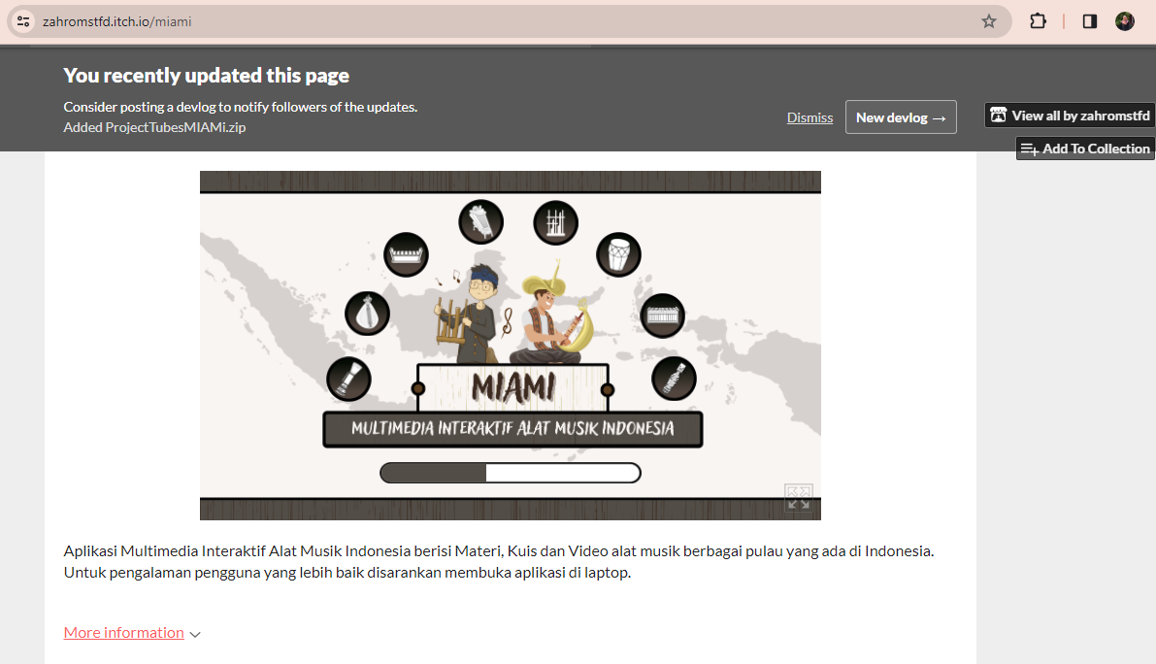

Figure 23. Application display on itch.io

# CONCLUSION

From the results of this study, it can be concluded that the application of the Multimedia Development Life Cycle (MDLC) method in the development of interactive multimedia introduction to traditional Indonesian musical instruments gives positive results. The stages of MDLC, namely Concept, Design, Material Collecting, Assembly, Testing, and Distribution, are proven to be able to produce an interesting and educational information media.

Alpha testing shows that all features on this interactive multimedia work properly. This gives confidence that users can access information about traditional Indonesian musical instruments smoothly through this application. The focus of research on the lack of interactive multimedia-based educational information media about traditional musical instruments was successfully overcome by making this interactive multimedia. Through beta testing involving 36 respondents, a rating result of 4.52 out of a scale of 5 was obtained. This confirms that this interactive multimedia is very good and worthy of use as a learning medium, especially for children who need an interesting and educational approach.

Thus, this interactive multimedia can be an effective solution in providing understanding and introduction to the diversity of traditional Indonesian musical instruments to the wider community, as well as answering the need for interesting and informative learning media**.**

**REFERENCES**

[1] S. Muhajaroh, A. P. Kurniawan, and Y. Siradj, “Perancangan Model 3D Dan Sound Untuk Aplikasi Interaktif Pengenalan Alat Musik Tradisional Berbasis Augmented Reality,” 2020.

[2] D. Aldo, M. Ilmi, and H. Hariselmi, “Pengembangan Multimedia Interaktif Hewan Berbisa dengan Metode Multimedia Development Life Cycle,” *Journal of Information System Research (JOSH)*, vol. 4, no. 2, pp. 364–373, Jan. 2023, doi: 10.47065/josh.v4i2.2669.

[3] E. Br Sembiring, dan Jenita Ompusunggu, and P. Negeri Batam Program Studi Teknik Multimedia dan Jaringan Jl Ahmad Yani, “Rancang Bangun Multimedia Interaktif Pembelajaran Alat Musik Tradisional Melayu menggunakan Metode Godfrey.”

[4] D. Joana Laksana, A. Budiman, and W. Apriandari, “Game Edukasi Pengenalan Alat Musik Tradisional Menggunakan Metode MDLC Berbasis Android,” *Jurnal Ilmiah Teknik Informatika dan Sistem Informasi*, 2021.

[5] W. T. Atmojo, F. Fitri Nurwidya, and E. Dazki, “Media Pembelajaran Pengenalan Keragaman Budaya Indonesia Dengan Metode Multimedia Development Life Cycle.”

[6] D. Basmin, “MEDIA PEMBELAJARAN GAME EDUKASI MENGENAL ALAT MUSIK TRADISIONAL INDONESIA DI SDN 249 TURUNGAN DATU,” 2022.

[7] M. Baihaiki, “Implementasi Game Edukasi Kesenian Budaya Indonesia Berbasis Dekstop dengan Metode MDLC pada SDS Harapan Jaya Jakarta Barat,” *Jurnal Sosial dan Teknologi (SOSTECH)*, vol. 1, no. 7, 2021, [Online]. Available: https://greenvest.co.id/

[8] D. A. Asmara, G. Susilo, and M. Lutfi Mahasinul, “APLIKASI PENGENALAN ALAT MUSIK GAMELAN JAWA,” *Jurnal TRANSFORMASI*, vol. 16, no. 1, pp. 43–53, 2020.

[9] W. T. Atmojo, F. Fitri Nurwidya, and E. Dazki, “Media Pembelajaran Pengenalan Keragaman Budaya Indonesia Dengan Metode Multimedia Development Life Cycle.”

[10] B. Widiyanto *et al.*, “PENGENALAN TUJUH KEAJAIBAN DUNIA MELALUI AUGMENTED REALITY SEBAGAI EDUKASI ANAK USIA DINI BERBASIS MOBILE.”

[11] A. Z. Shoumi, “PERAN MULTIMEDIA DALAM PENDIDIKAN PADA APLIKASI RUANG GURU,” *PROSIDING SEMINAR NASIONAL CENDEKIAWAN*, Oct. 2019, doi: 10.25105/semnas.v0i0.5809.

[12] R. Oktavia, “Pengaruh Multimedia Interaktif Pada Pembelajaran Biologi Jaringan Tumbuhan Terhadap Keaktifan Dan Pengetahuan Siswa SMAN 6 Darul Makmur,” *Edunesia : Jurnal Ilmiah Pendidikan*, vol. 1, no. 3, pp. 73–81, Nov. 2020, doi: 10.51276/edu.v1i3.66.

[13] A. Aulia, P. Guru Sekolah Dasar, and U. Negeri Padang, “Pengembangan Multimedia Interaktif Berbasis Articulate Storyline 3 untuk Meningkatkan Minat Belajar Peserta Didik pada Pembelajaran Tematik Terpadu di Kelas III SD.”

[14] N. A. Suryandaru, “PENERAPAN MULTIMEDIA DALAM PEMBELAJARAN YANG EFEKTIF,” *Jurnal Pendidikan dan Pengajaran Guru Sekolah Dasar (JPPGuseda)*, vol. 03, pp. 88–91, 2020, [Online]. Available: http://journal.unpak.ac.id/index.php/jppguseda

[15] H. Anggreani and P. Rosyani, “Perancangan Aplikasi Pengenalan Jenis - Jenis Dinosaurus Pada Anak - Anak Usia Dini Berbasis Flash,” *KERNEL: Jurnal Riset Inovasi Bidang Informatika dan Pendidikan Informatika*, vol. 2, no. 2, pp. 77–81, Feb. 2022, doi: 10.31284/j.kernel.2021.v2i2.2293.

[16] A. G. Pradana and S. Nita, “Rancang Bangun Game Edukasi ‘AMUDRA’Alat Musik Daerah Berbasis Android,” 2019.

[17] L. Novia and D. Zalilludin, “Aplikasi Media Pembelajaran Mengenal Alat Musik Tradisional Untuk Anak-Anak Berbasis Augmented Reality Pada Perangkat Mobile,” 2021.