Types of Networks

Introduction
A network is a group of linked devices (computers, phones, servers, etc.) that exchange information, resources, and services. Networks can differ in terms of functionality, size, coverage area, and purpose. In disciplines like computer science, IT infrastructure, cybersecurity, and telecommunications, an understanding of various network kinds is crucial.

The main network types that are now in use are explained in detail in this document, together with their features, benefits, drawbacks, and practical applications.

- Types of Networks
Geographical location and the extent of the network's reach are frequently used to classify networking. The main categories of networks consist of:
Personal Area Network, or PAN
Local Area Network, or LAN
Campus Area Network, or CAN
Metropolitan Area Network, or MAN
Wide Area Network, or WAN
Wireless Local Area Network, or WLAN
Storage Area Network, or SAN
Virtual Private Network, or VPN

- Personal Area Network (PAN)
Definition:- The smallest kind of network, known as a PAN, is used to link personal devices that are close together (often within 10 meters).

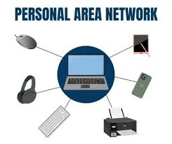

Examples:-
Bluetooth pairings (phone and earphones)
Laptop and mobile hotspot connection
A smartwatch linked to a phone
USB cables that connect devices

Benefits:-
Simple to assemble
Low price
Extremely portable

Restrictions:-
Short-range
Restricted quantity of devices

- Local Area Network (LAN)
Definition:- Computers in a local geographic area, like a home, workplace, school, or building, are connected by LAN.

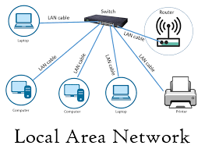

Examples:- Computer labs Networks in offices
WiFi networks at home
Networks of small businesses

Features: -
Fast (100 Mbps to 10 Gbps)
Minimal latency Under the control of one organization

Benefits:-
Safe Quick data transmission
Simple to maintain

Restrictions:-
Limited to a narrow region
The cost of setup can change.

5. Campus Area Network (CAN)
Definition:- A corporate park, military post, or university campus are examples of bigger areas where CAN connects several LANs.

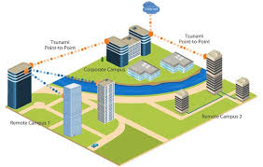

Examples:-
University networks that connect several departments
The hospital network is spread across several buildings and corporate office towers.

Benefits:-
Centralized administration
Greater coverage than LAN, Accommodates big user bases

Restrictions:-
Requires expert upkeep
More costly than LAN

6.Metropolitan Area Network (MAN)
Definition:- A city or sizable town is covered by MAN. It is made up of several LANs linked together in a city.

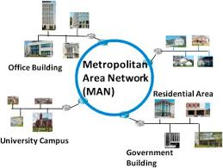

Examples:-
Include internet service providers (ISPs) for the entire city.
Networks of government cities
Zones with public WiFi
Networks for cable TV

Benefits:-
Covers a lot of ground
Fast connections between several areas

Limitations:-
Expensive setup and upkeep
More difficult to secure than LAN

7. Wide Area Network (WAN)
Definition:- WAN covers vast geographical areas, including continents, nations, and towns. It connects several MANs and LANs.

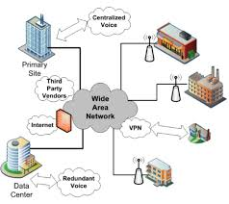

Examples: The Internet (the largest WAN), corporate branches connected worldwide, and bank networks throughout India.

Features:
Uses fiber optics, satellite connectivity, and leased lines
Communication over long distances

Benefits:
Extremely wide coverage area
Facilitates worldwide connectivity

Limitations:
Expensive infrastructure; slow in comparison to LAN
More vulnerable to security threats

- Wireless Local Area Network (WLAN)
Definition:- A wireless LAN that connects devices in a constrained region over WiFi.

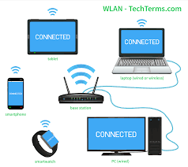

Examples: Home Wi-Fi in public restaurants and offices Wi-Fi

Benefits:
No physical wires
Simple to grow
Many mobile devices are supported.

Limitations:
Signal interference may occur
Less secure than connected LAN

- Storage Area Network (SAN)
Definition: A specialized high-speed network that provides access to consolidated storage resources.

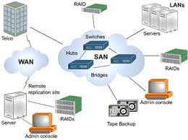

Used In:
Data centers
Cloud services
Banks and financial institutions
Large enterprises

Advantages: High-speed data access
Improves storage scalability Centralized backup

Limitations: Expensive to deploy
Requires professional management

- Virtual Private Network (VPN)
Definition: VPN creates a secure “tunnel” through a public network (like the Internet) to protect data transmission.

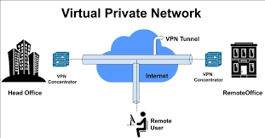

Examples:
Employees accessing office network from home
Secure connection while using public
Wi-Fi Bypassing geo-restrictions

Advantages:
High security
Remote access
Encrypts communication

Limitations:
Slow due to encryption
Requires proper configuration

