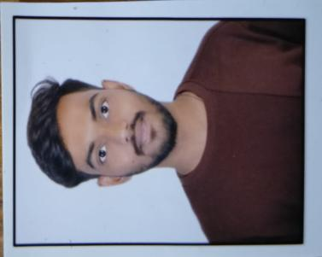POOJIT

**JAGADEESH NAGALOTI**

Bengaluru, Karnataka | 9538212512 | [poojitnagaloti611@gmail.com](mailto:poojitnagaloti611@gmail.com) |

[www.linkedin.com/in/poojit-nagaloti-a0553323b](http://www.linkedin.com/in/poojit-nagaloti-a0553323b)

# Summary

I am an Electronics and Communication Engineer. I am the person who is passionate about startups and Techs. I am a change agent armed with programming proficiency and fueled by passion for Digital Marketing, at a point where technology meets business essentials.

# Skills

**Languages:** Python, C, Java(Basic), Embedded C. **Tools:** VS Code, Matlab, Jupiter Notebook, Google Colab, Virtuoso, Git.

**Hardware Design:** PCB Design, Arduino IDE.

**Digital marketing.**

**Trainee Engineer**

**Angstromers Engineering Solutions**

# Experience

**06/2024 to Current Bengaluru, Karnataka**

 Assist senior engineers in designing, developing, and testing products or systems.  Participate in the preparation of technical drawings, specifications, and reports.

 Conduct research and analysis to support engineering projects.

 Prepare and maintain accurate documentation of engineering activities.

 Document and report any issues or discrepancies encountered during work.

**Junior Consultant Ai10**

 Conducted research on industry trends, competitors, and market opportunities.  Conduct market research and analyze trends to identify opportunities.

 Conduct keyword research and optimize website content for SEO.

 Monitor and analyze campaign performance, and adjust strategies as needed.

# Education

**Bachelor of Engineering**: **Electronics And Communication Engineering**

Cambridge Institute Of Technology

**12th**

BVVS Science Independent PU College

**10th**

ACO English Medium High School

# Projects

**05/2024 to 11/2024**

**Bengaluru, Karnataka**

**Expected in 2025**

Bengaluru, Karnataka

**2021**

Bagalkot, Karnataka

**2019**

Ilkal, Karnataka

**Autodubbing**

* I am currently working on this project, it is the updated version of language translator with Video access and I'm trying to upgrade it to monitor single person speech into multiple language translation with a lip sync.

**Noise Pollution Detection using Heat Maps**

* I built this project uses the YOLO (You Only Look Once) object detection model to identify cars in video frames and generates a heatmap visualization based on object occurrences.

**Kitti Object Detection using Multisensor**

* A project that detects the motion of object using LiDaR sensor and calculates the distance and width of the of the objects.

# 

# Certifications

 Internship Certificate, By Varcons Technologies.

 Camera Vision, By Microsoft Azure AI Fundamentals.  Digital Marketing, By Hubspot Academy.

 AI Image and Speech Recognition, By Angstromers Engineering Solutions.