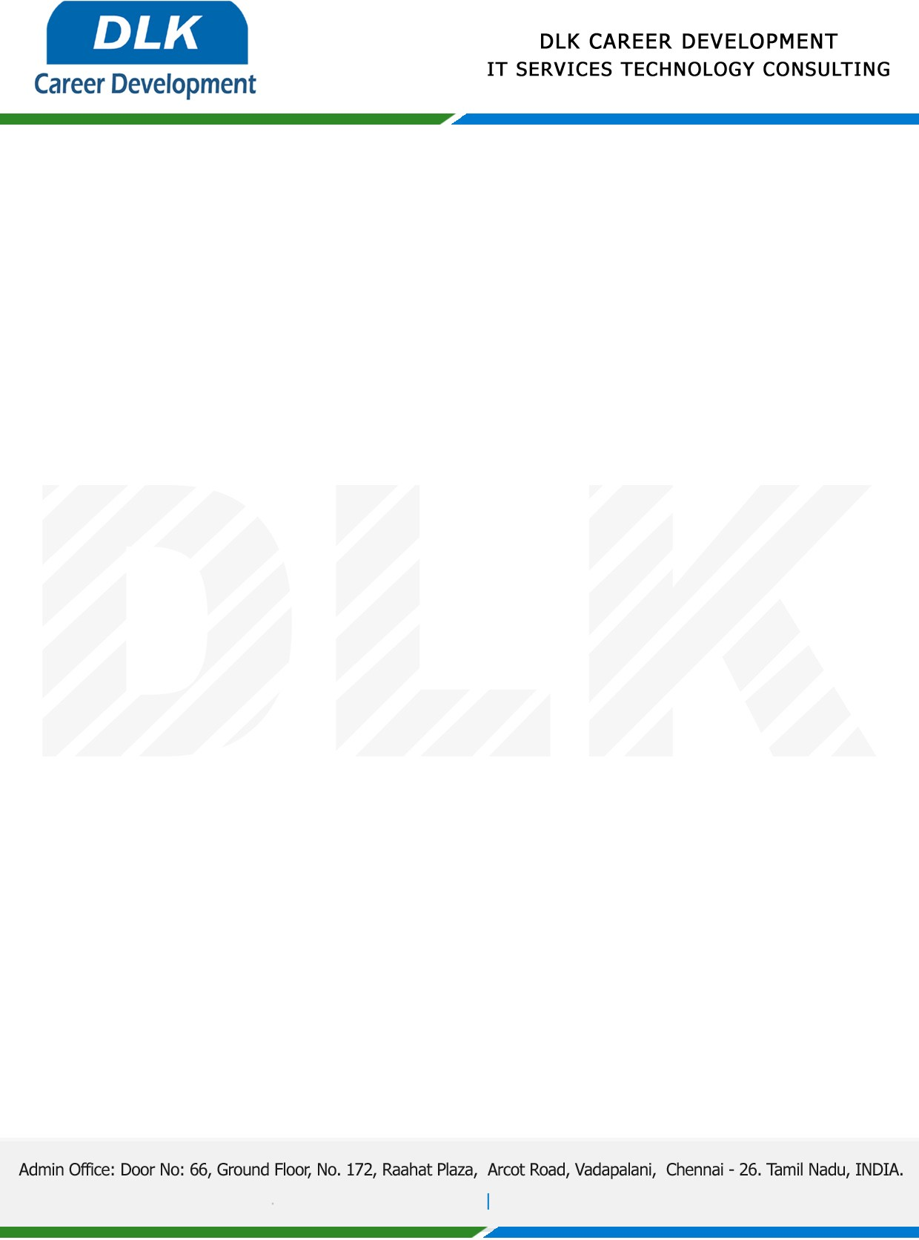




Date – 23 Jan 2025.

Project Confirmation Letter

This is to inform you that Mr Pravin M.R (Register Number: RA2332241010304) pursuing second year MSC (COMPUTER SCIENCE) at SRM Institute of Science and Technology is permitted to do her project work duration from JAN 2025 to MAR 2025. During the Project work the given details are confidential.

Woking on the project title - UPI Fraud Detection Through Machine Learning and Flask Framework
