IBM SkillsBuild
AICTE INTERNSHIP

Name: Prince Rajendraprasad Yadav
College: HVPS Ramniranjan Jhunjhunwala College, Mumbai
Healthcare Agent AI (sdg 3)

Report

Title: Development of an AI-Powered Healthcare Agent for Preventive Health Monitoring and Intelligent Assistance

Introduction
Healthcare management has become increasingly complex due to rising chronic diseases, mental health challenges, and the need for continuous monitoring of personal health data. Many individuals struggle with missed medications, delayed medical attention, and lack of clarity regarding symptom severity. Traditional healthcare systems are often reactive rather than preventive and rely heavily on manual processes.
With advancements in Artificial Intelligence and cloud technologies, intelligent healthcare assistants can play a crucial role in preventive care, early risk identification, and personalized health guidance. This project presents the development of an AI-powered Healthcare Agent that assists users in managing their health through symptom analysis, medication reminders, health tracking, mental health support, and appointment scheduling using modern AI and cloud-based tools.

Problem Statement

- Health data is fragmented across multiple sources.
- Users often ignore early symptoms due to lack of guidance.
- Medication and appointment non-compliance is common.
- Personalized healthcare insights are not easily accessible.

Objective

- Provide a centralized healthcare management platform.
- Enable early symptom assessment using AI.
- Improve medication and appointment adherence.
- Offer personalized health and mental wellness support.
- Ensure secure storage and handling of medical data.

Scope of the System

The system supports:
- Individual users managing personal health data.
- AI-assisted symptom and health analysis.
- Automated reminders and notifications.
- Scalable backend architecture for future enhancements.
The system does not replace medical professionals and is intended for assistance and awareness only.

System Architecture

Streamlit Frontend → Python Backend → Supabase Database → AI Modules → Email Notification Service
High-Level Flow
- User interacts with Streamlit frontend.
- Backend Python logic processes requests.
- Supabase handles authentication and data persistence.
- AI modules analyze symptoms, health logs, and chats.
- Email services send reminders and alerts.
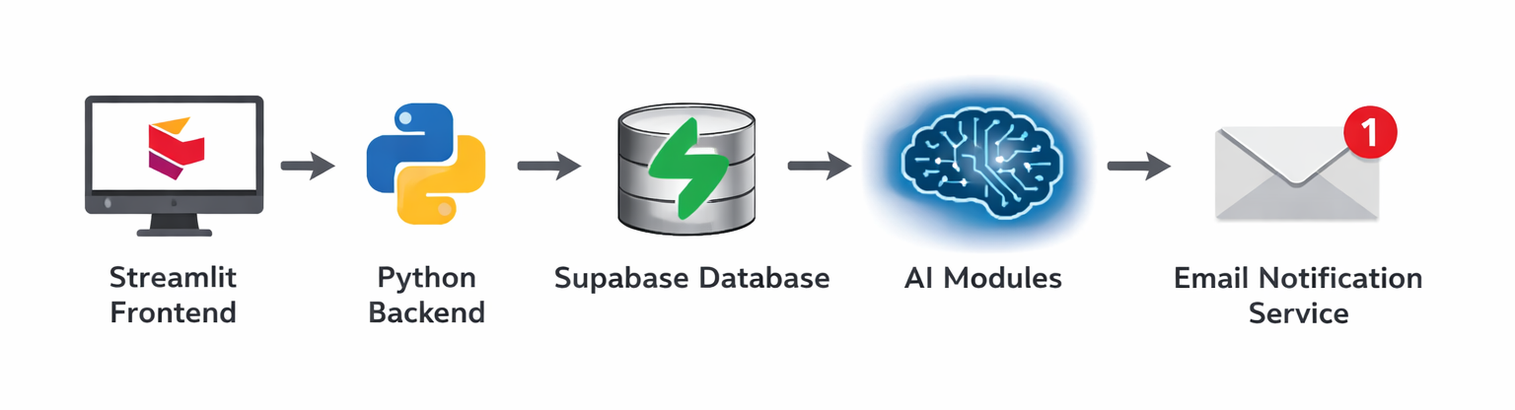
Architecture Components
- Presentation Layer: Streamlit UI
- Application Layer: Python backend modules
- Data Layer: Supabase (PostgreSQL)
- Intelligence Layer: LangGraph + LLM
- Notification Layer: Relay / SMTP Email

Function Modules

  - User Authentication
- Signup and login using Supabase authentication.
- Password hashing and role-based access.
- One-time profile setup after first login.
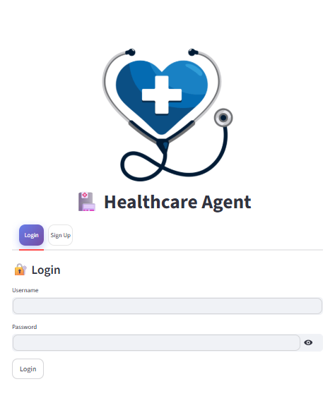
  - Profile Management
- Stores personal and medical details.
- Editable profile information.
- Profile image upload and retrieval.
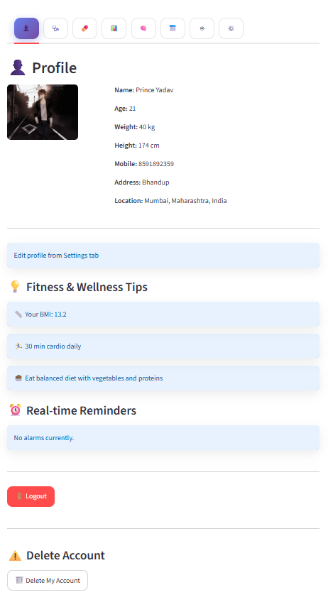

  - Symptom Checker
- Accepts user-reported symptoms.
- AI categorizes symptoms as emergency or non-emergency.
- Provides suggested actions and guidance.
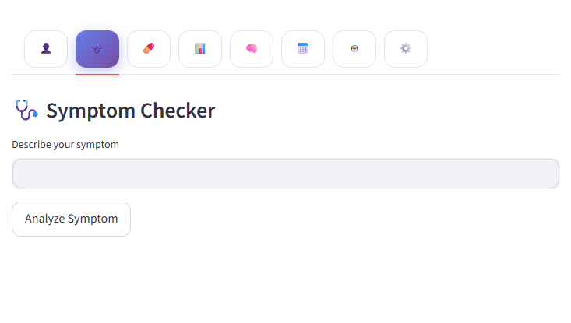

  - Medication Reminder
- Medication scheduling by time and frequency.
- In-app alerts.
- Automated email reminders.
- Background scheduler using Python threading.
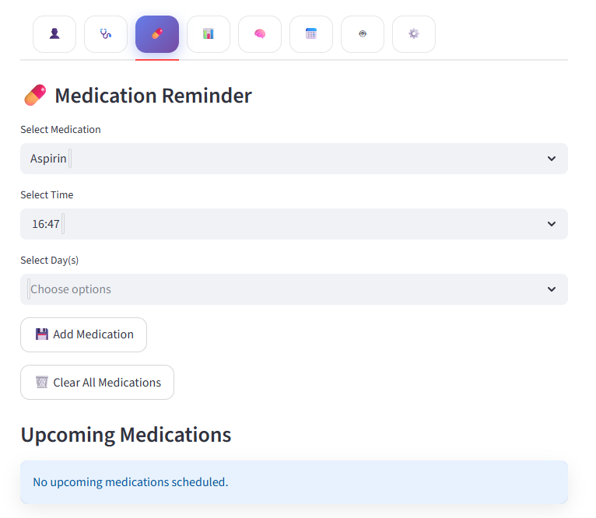

  - Health Tracker
- Logs vitals such as heart rate, sleep, steps, glucose.
- BMI calculation.
- Trend-based AI health suggestions.
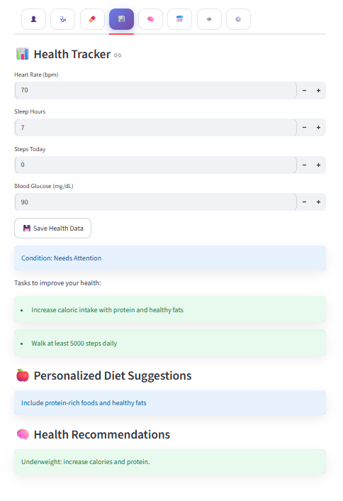
  - Mental Health Support
- Conversational AI for mental well-being.
- Session-based chat storage.
- Privacy-focused interaction design.
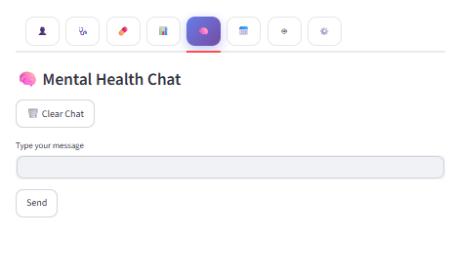
  - Appointment Management
- Schedule, reschedule, and delete appointments.
- Automated email notifications.
- Centralized appointment tracking.
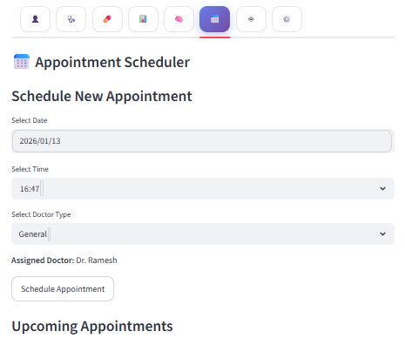

  - Help Chatbot
- AI-driven question answering.
- General healthcare guidance.
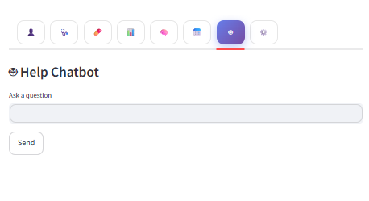

Technical Implementation
- Frontend: Streamlit
- Backend: Python 3.x
- Database: Supabase (PostgreSQL)
- AI Engine: LangGraph with Large Language Models
- Notifications: Relay / SMTP
- Scheduler: Python threading
- Deployment: Render / Streamlit Cloud

Database Design (Supabase)
Key tables include:
- users
- profiles
- health_logs
- medications
- appointments
- mental_health_sessions
- notifications
Relationships are enforced using foreign keys for data integrity.

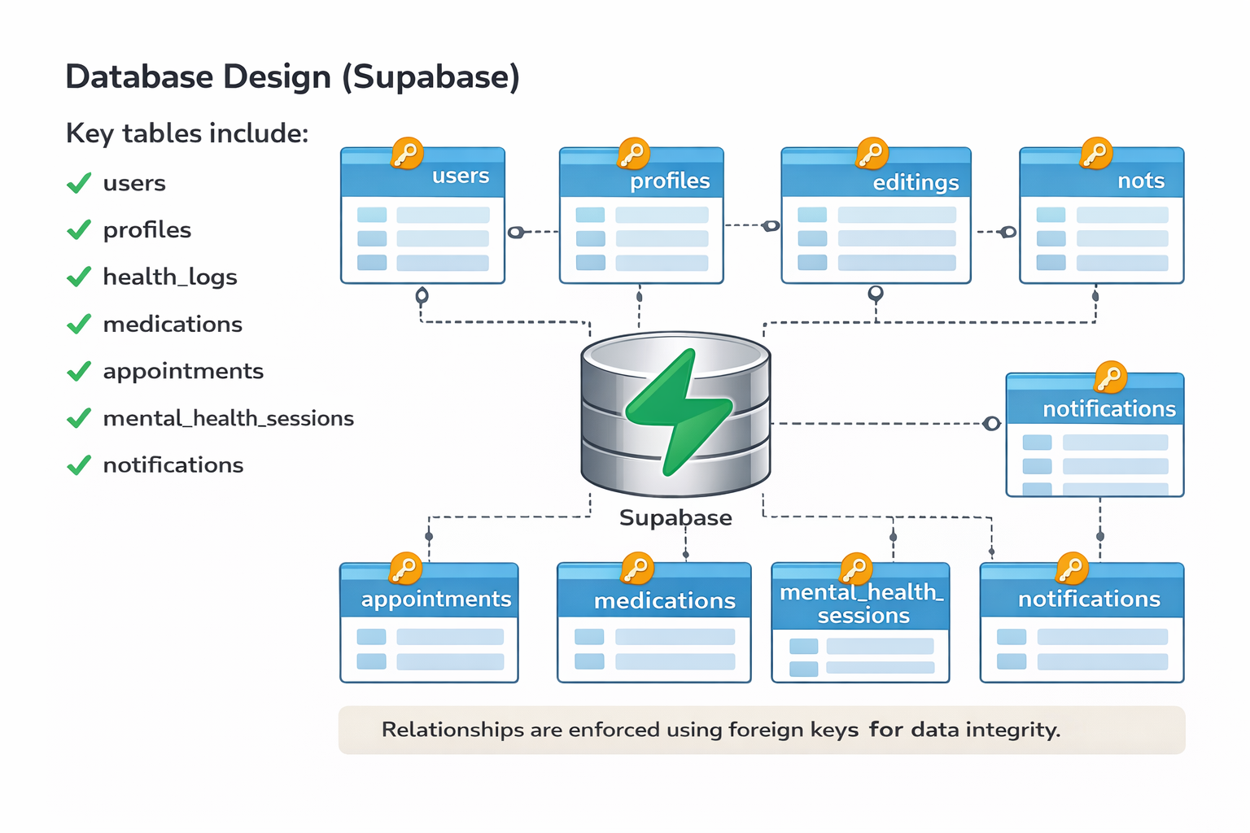

Security Considerations
- Passwords stored using secure hashing.
- Secrets managed through environment variables.
- No plaintext credentials stored.
- Secure role separation using Supabase keys.
- HTTPS enforced in deployment.

Development Strategy
- Local development using virtual environments.
- Cloud deployment using Render or Streamlit Cloud.
- Environment variables configured through platform dashboards.
- Port binding using $PORT for cloud compatibility.

Limitations
- Dependent on internet connectivity.
- Free-tier deployments may experience cold starts.
- AI responses are advisory, not diagnostic.
- Background schedulers pause on free hosting tiers.

Future Enhancements
- Predictive health risk analytics.
- Wearable and IoT device integration.
- Telemedicine and video consultations.
- Multi-language support.
- Health report export (PDF/CSV).
- Enhanced compliance (HIPAA/GDPR).
- Family and caregiver account support.

SDG Alignment
- United Nations Sustainable Development Goal 3
Good Health and Well-Being
- Focus on preventive care, accessibility, and early intervention.

Conclusion
This project successfully demonstrates the development of an AI-powered Healthcare Agent designed to support preventive healthcare and daily health management. By combining AI-driven analysis, secure cloud infrastructure, and automation, the system helps users track health data, understand symptoms, adhere to treatment schedules, and receive personalized guidance.
The solution has strong potential for future expansion, including predictive analytics, wearable device integration, and telemedicine features. Overall, the project aligns with United Nations Sustainable Development Goal 3: Good Health and Well-Being, contributing to accessible and intelligent healthcare solutions.

