Component model
All system is base on MVC concept. Main components are:
1)Oracle Database Express Edition 11g Release 2 is used as system's database.
2)Hibernate framwork is used for interaction with database.
3)The server is Apache TomCat, version 7.0.27.
4)The mail server is Apache James Server.
Information presenting and interaction with client is based on html, css, jsp and javascript. Some elements (as treeView) are using jquery. Also were used bootstrap framework and jstl library (for multilanguage abilities). Controlling level is based on javaBeans and Servlets.
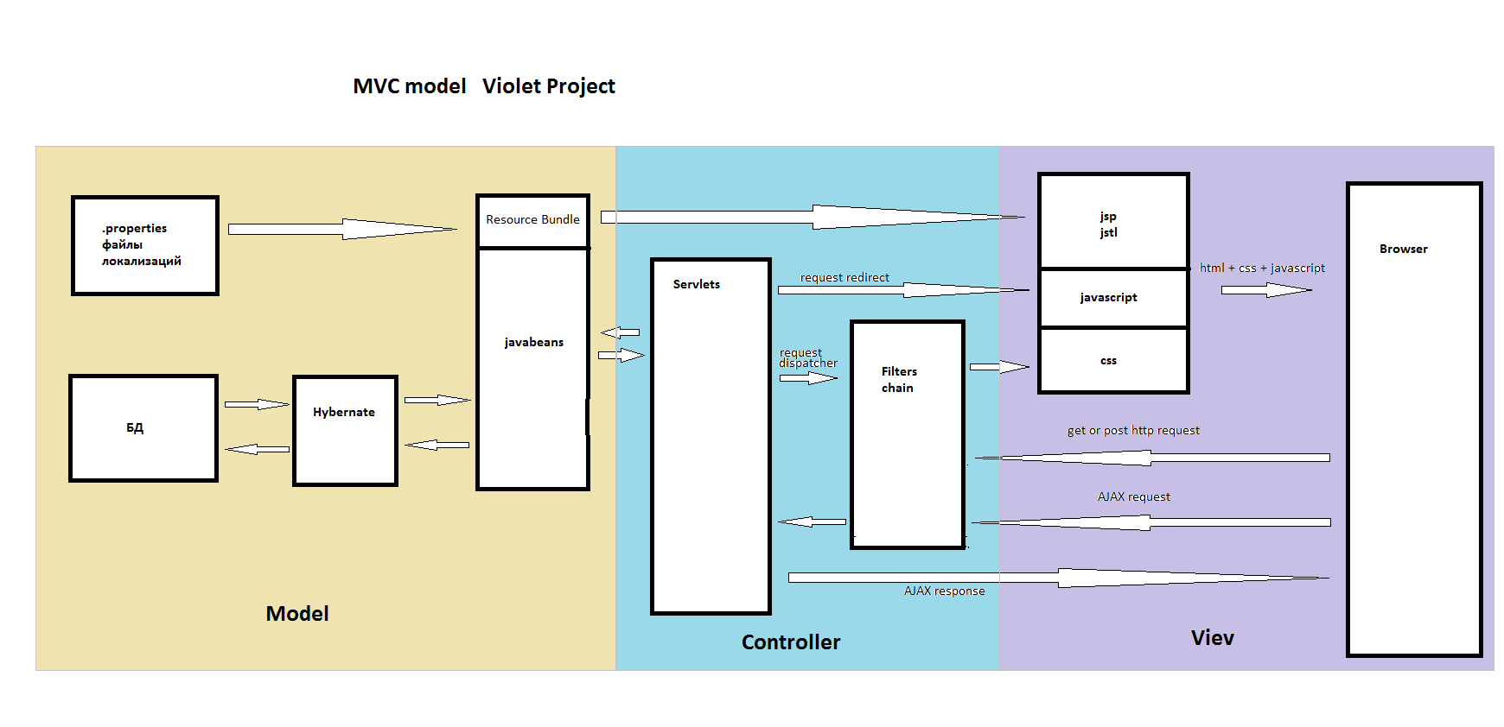
Notations:
1)There were many corrections in resource plan due to the problems of some team members and lack of human resource.
2)Original Designdoc.doc document was made by Yuriy Krivoy ( https://docs.google.com/document/d/1Wo-2exOe8byNusAuSsBkrX48YTdvPn5mMIpDrYrwu4g/edit ).
And this document is correctioned by Allan Farfur.

Resource plan
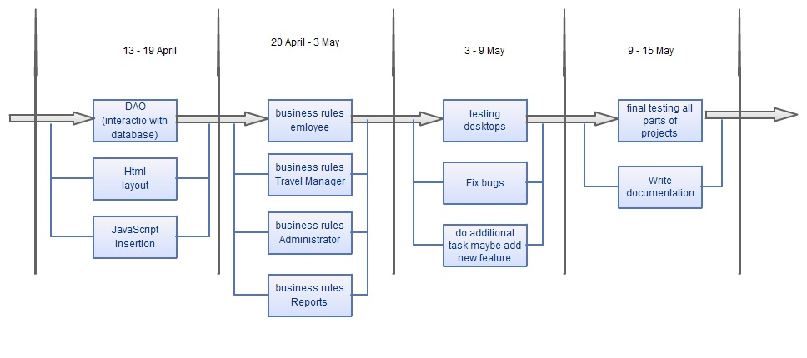

Resource plan (19-26 of April)

Aleksandr Dudinskiy, Pasha Subko, Yura Krivoy | Data editing, join db with interface
Margarita Sitner, Tolik Poluhovich | Excel, connection with GUI, finishing requests
Allan Farfur, Oleg Lunin | Making data processor for TRF requests
Aleksandr Dudinskiy | Department tree in administrator form
Kovalenko Andrew, Sablizkiy Artem | hash Triggers , saving passwords as hashes
Oleg Lunin | multiple connection testing
Vlad Besisko | protection, authentication, authorisation
Farfur Allan | Classes description, data tables description
Yura Krivoy | Finishing use cases, functional requirements
Nasar Gavrishko | adding Mail Server, helping others

Functional requairements
System must automate process of organizing employees business trips. Any employee of HardoSoft company must have access to this server-cilent system through web browser and satisfy all his/her needs that are related to HardoSoft business trips:
1)See all his/her own business trips (current and passed);
2)See all HardoSoft business trips (current and planned);
3)If employee is project manager, then system must give instruments (to this employee) to create a new TRF (trip form), fill it, commit it, edit it, or cancel it;
4)If employee is member of Travel Support department, then system should give instruments to edit any TRF in «Ready» status (in the same country in which employee is working), reject it, complete it, or cancel it;
5)If employee is member of Travel Support department, than there must be access to «Excel button», which makes Excel version of reports travel portal page. Also system must give ability to employee to save Excel document on his/her local computer/device.
6)If employee is member of IT department, then system should give instruments to edit company departments tree (delete, edit, add) and edit any employee (delete, edit, add).

Also system must authenticate any employee before using HardoSoft travel portal;

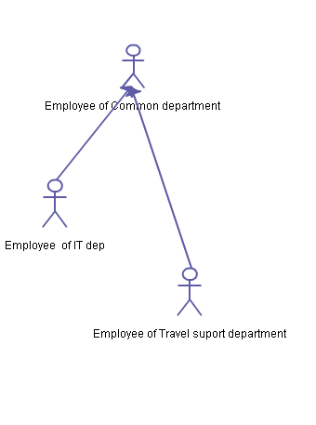

Use cases
(employee of Common Department)
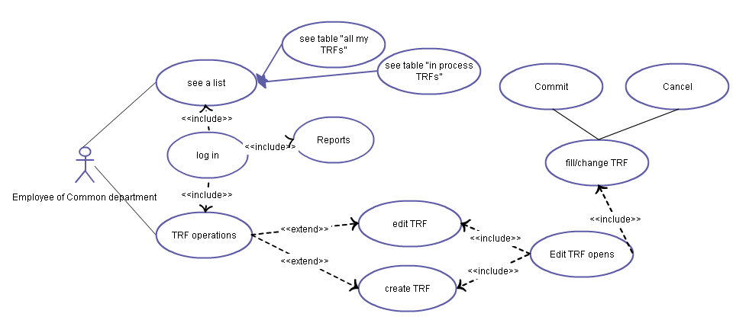

1.First use case:
Use-case name | login
Priority | high
Main actor | Employee of common department
Description | Passing authentication procedure
Launching events | Employee enters HardoSoft travel portal
Input conditions | Employee has internet access and using some browser
Main scenario | On site employee enter login and password in edit box boxes and press login button and moves to home desktop page
Alternative scenario | User enter not correct login or password, sees message that authorization is unsuccessful and remain on the same page
Exceptions
Output conditions | Employee is either authenticated on home page or unathenticated on index(authentication) page

2.Second use case:
Use-case name | Report
Priority | normal
Main actor | Employee of common department
Description | Employee of common department wants to see reports
Launching events | click tab Reports
Input conditions | Employee is on home or any other page of travel portal, must be authenticated
Main scenario | Moving to «reports» page
Alternative scenario | -
Exceptions | -
Output conditions | Employee is on «reports» page

3.Third use case:
Use-case name | Own TRFs (Employee desktop)
Priority | normal
Main actor | Employee of common department
Description | Employee of common department can see list of her/his TRFs (current and all)
Launching events | Passing authentication or clicking tab «Employee»
Input conditions | Employee is authenticated
Main scenario | Employee moves to «Employee» tab and sees his/her TRFs
Alternative scenario | -
Exceptions | -
Output conditions | Employee is on «Employee» page (desktop)

4.Forth use case:
Use-case name | see table “in process TRFs”
Priority | normal
Main actor | Employee of common department
Description | see table “In process TRF”
Launching events | Click «In progress TRFs:»
Input conditions | Employee must be on home desktop (tab «Employee»)
Main scenario | After clicking employee sees all his/her current TRfs
Alternative scenario | -
Exceptions | -
Output conditions | Employee is on home destop, table «In progress TRFs» is deployed, table «All my TRFs» is undeployed

5.Fifth use case:
Use-case name | see table “all my TRFs”
Priority | normal
Main actor | Employee of common department
Description | see table «All my TRFs”
Launching events | Click «All my TRFs:»
Input conditions | Employee must be on home desktop (tab «Employee»)
Main scenario | After clicking employee sees all his/her TRFs
Alternative scenario | -
Exceptions | -
Output conditions | Employee is on home destop, table «In progress TRFs» is undeployed, table «All my TRFs» is deployed

6.Sixth use case:
Use-case name | TRF editing operations
Priority | normal
Main actor | Project manager
Description | Project manager entering TRF editing form
Launching events | Employee clicks «Edit» button near TRF that should be edited
Input conditions | Employee must be on home desktop (tab «Employee»)
Main scenario | After clicking employee sees TRF editing form, TRF changes its status to «Entering»
Alternative scenario | -
Exceptions | -
Output conditions | Employee is on editing TRF form, TRF changed status to «Entering»

7.Seventh use case:
Use-case name | Create TRF
Priority | normal
Main actor | Project manager
Description | Project manager creates new TRF
Launching events | Employee clicks «New» button
Input conditions | Employee must be on home desktop (tab «Employee»)
Main scenario | After clicking employee sees TRF editing form
Alternative scenario | -
Exceptions | -
Output conditions | Employee is on editing TRF form

8.Eighth use case:
Use-case name | Saving TRF
Priority | normal
Main actor | Project manager
Description | Project manager saves changes in edited TRF
Launching events | Employee clicks «Save changes» button
Input conditions | Employee is on TRF editing page
Main scenario | TRF changes are commited to DB, employee stays on the same page
Alternative scenario | -
Exceptions | -
Output conditions | Employee is on TRF editing page

9.Ninth use case:
Use-case name | Commiting TRF
Priority | normal
Main actor | Project manager
Description | Project manager commiting TRF (TRF passes to Travel managers)
Launching events | Employee clicks «Commit» button
Input conditions | Employee is on TRF editing page
Main scenario | If all filelds are filled then: TRF changes are commited to DB, TRF changes it's status, employee stays on the same page
Alternative scenario | If not all fields are filled notification window is displayed
Exceptions | -
Output conditions | Employee is on TRF editing page

10.Tenth use case:
Use-case name | Canceling TRF
Priority | normal
Main actor | Project manager
Description | Project manager canceling TRF
Launching events | Employee clicks «Cancel TRF»
Input conditions | Employee is on TRF editing page
Main scenario | TRF changes it's status, employee stays on the same page
Alternative scenario
Exceptions
Output conditions | Employee is on TRF editing page

11.Eleventh use case:
Use-case name | Close TRF editing form
Priority | normal
Main actor | Project manager
Description | Project manager closes TRF editing form
Launching events | Clicking close cross
Input conditions | Employee is on TRF editing page
Main scenario | Employee goes back to home page
Alternativescenario | -
Exceptions | -
Output conditions | Employee is on home destop, table «In progress TRFs» is deployed, table «All my TRFs» is undeployed

12.Twelfth use case:
Use-case name | TRF status history
Priority | normal
Main actor | Project manager
Description | Project manager wants to see TRF status history
Launching events | Clicking «Status history»
Input conditions | Employee is on TRF editing page
Main scenario | Table «Current status» undeploying, table «Status history» deploying
Alternative scenario | -
Exceptions | -
Output conditions | Employee is on TRF editing page, table «Current status» undeployed, table «Status history» deployed

13.Thirteenth use case:
Use-case name | TRF current status
Priority | normal
Main actor | Project manager
Description | Project manager wants to see TRF editing form
Launching events | Clicking «Current status: editing»
Input conditions | Employee is on TRF editing page
Main scenario | Table «Current status» deploying, table «Status history» undeploying
Alternative scenario | -
Exceptions | -
Output conditions | Employee is on TRF editing page, table «Current status» deployed, table «Status history» undeployed

Use cases
(employee of Travel support Department)
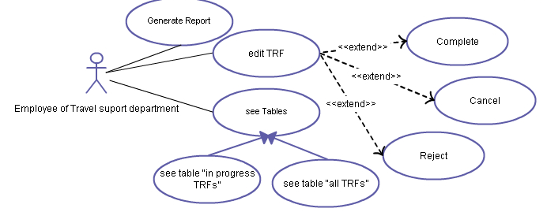

1.First use case:
Use-case name | Travel manager desktop
Priority | normal
Main actor | Employee of travel support department
Description | Employee wants to go to his/her home desktop as Travel manager (differs from Employee home dekstop)
Launching events | Click tab “Travel manager”
Input conditions | Employee is on any travel portal page (tab), authenticated
Main scenario | Employee goes to Travel manager desktop
Alternative scenario | -
Exceptions | -
Output conditions | Employee is on Travel manager home desktop

2.Second use case:
Use-case name | In process TRFs
Priority | normal
Main actor | Employee of travel support department
Description | Employee wants to see all current TRFs in his/her country, that have «Ready» status
Launching events | Click «In progess TRFs»
Input conditions | Employee is on travel manager desktop
Main scenario | Table «In process TRFs» deploying, table «All TRFs» undeploying
Alternative scenario | -
Exceptions | -
Output conditions | Employee is on travel manager desktop, table «In process TRFs» deployed, table «All TRFs» undeployed.

3.Third use case:
Use-case name | All TRFs
Priority | normal
Main actor | Employee of travel support department
Description | Employee wants to see all TRFs in his/her country
Launching events | Click «All TRFs»
Input conditions | Employee is on travel manager desktop
Main scenario | Table «In process TRFs» undeploying, table «All TRFs» deploying
Alternative scenario | -
Exceptions | -
Output conditions | Employee is on travel manager desktop, table «In process TRFs» deployed, table «All TRFs» undeployed.

4.Forth use case:
Use-case name | Edit TRF
Priority | norm
Main actor | Employee of travel support department
Description | Employee of travel support department wants to edit some TRF
Launching events | Click «Edit» button near TRF that should be edited
Input conditions | Employee is on travel manager desktop
Main scenario | Transition to TRF editing form
Alternative scenario | -
Exceptions | -
Output conditions | Employee is on TRF editing page

5.Fifth use case:
Use-case name | Complete TRF
Priority | normal
Main actor | Employee of travel support department
Description | Compliting TRF (if TRF is ok and all trip preparations have been done)
Launching events | Click «Complete» button
Input conditions | Employee is on TRF editing page
Main scenario | TRF changes its status to «Completed»
Alternative scenario | -
Exceptions | -
Output conditions | Employee is on TRF editing page, TRF changed its status to «Completed»

6.Sixth use case:
Use-case name | Cancel TRF
Priority | normal
Main actor | Employee of travel support department
Description | Canceling TRF (if trip could not happaned)
Launching events | Click «Cancel TRF» button
Input conditions | Employee is on TRF editing page
Main scenario | TRF changes its status to «Canceled»
Alternativescenario | -
Exceptions | -
Output conditions | Employee is on TRF editing page, TRF changed its status to «Canceled»

7.Seventh use case:
Use-case name | Reject TRF
Priority | normal
Main actor | Employee of travel support department
Description | Reject TRF if there are some problems in it
Launching events | Click «Reject» button
Input conditions | Employee is on TRF editing page
Main scenario | TRF changes its status to «Rejected»
Alternativescenario | -
Exceptions | -
Output conditions | Employee is on TRF editing page, TRF changed its status to «Rejected»

8.Eigth use case:
Use-case name | Generate report
Priority | normal
Main actor | Employee of travel suport department
Description | Employee wants to have reports in excel format
Launching events | Clicking “Excel” button
Input conditions | Employee is on Reports page (tab)
Main scenario | Employee chooses directory on local computer where he/she wants to save Excel report and clicks «OK». Report is saved on local employees computer
Alternative scenario | -
Exceptions | -
Output conditions | Employee is on Reports page (tab), Excel report is saved on employee's local computer

Use cases
(employee of IT Department)
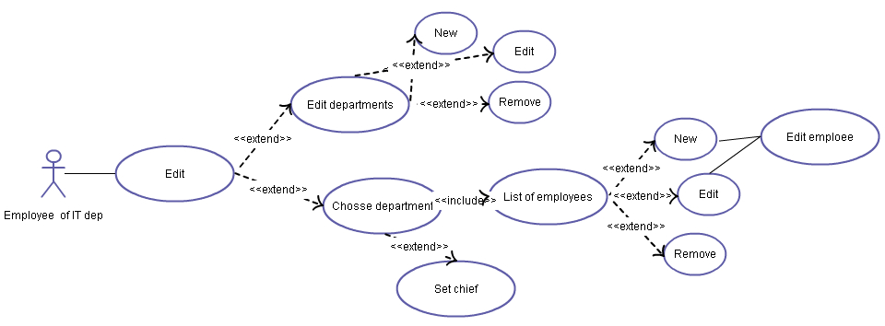

1.First use case:
Use-case name | Administrator desktop
Priority | normal
Main actor | Employee of IT department
Description | Employee wants to go to administrator home page
Launching events | Employee clicks «Administrator» tab
Input conditions | Employee is on any travel portal page, authenticated
Main scenario | Employee goes to administrator desktop
Alternativescenario | -
Exceptions | -
Output conditions | Employee is on administrator desktop

2.Second use case:
Use-case name | New department
Priority | normal
Main actor | Employee of IT department
Description | Employee of IT department creates new department
Launching events | Clicking «New» button under department tree
Input conditions | Employee is on administrator desktop
Main scenario | A window is deployed where Employee enters name of new department, office and city. After clicking «OK» this new department is created as child department to selected in department tree (if no one selected than created one of mains, it means without parent departments)
Alternativescenario | -
Exceptions | -
Output conditions | Employee is on administrator desktop, in department tree appears new department
3.Third use case:
Use-case name | Edit department
Priority | normal
Main actor | Employee of travel IT department
Description | Employee of travel IT department edit department
Launching events | Clicking «Edit» button under department tree
Input conditions | Employee is on administrator desktop
Main scenario | If some department in department tree is selected, then department editing form is displayed. And after editing and clicking «OK» employee returns to administrator desktop
Alternativescenario | If department is not selected, then notification window is displayed
Exceptions | -
Output conditions | Employee is on administrator desktop

4.Forth use case:
Use-case name | Remove department
Priority | normal
Main actor | Employee of travel IT department
Description | Employee of travel IT department removes department
Launching events | Clicking «Remove» button under department tree
Input conditions | Employee is on administrator desktop
Main scenario | If some department in department tree is selected, then this department is removed
Alternativescenario | If department is not selected, then nothing changes
Exceptions | -
Output conditions | Employee is on administrator desktop

5.Fifth use case:
Use-case name | Choose department
Priority | normal
Main actor | Employee of IT department
Description | Employee of IT department choose department
Launching events | Employee clicks on some department in department tree
Input conditions | Employee is on administrator desktop
Main scenario | in right side is displayed list of this department's employees
Alternativescenario | -
Exceptions | -
Output conditions | Employee is on administrator desktop, departments list of employees is displayed on right side of page

6.Sixth use case:
Use-case name | New
Priority | normal
Main actor | Employee of IT department
Description | Employee of IT department creates new employee
Launching events | Employee clicks «New» button under list of employees
Input conditions | Employee is on administrator desktop
Main scenario | Employee goes to employee editing form
Alternativescenario | -
Exceptions | -
Output conditions | Employee is on dmployee editing form

7.Seventh use case:
Use-case name | Edit
Priority | normal
Main actor | Employee of travel IT department
Description | Employee of travel IT department editing Edit employee
Launching events | Employee clicks «Edit» button near employee that should be edited
Input conditions | Employee is on administrator desktop
Main scenario | Employee of IT department in the left side click button “Edit” and edit employees
Alternativescenario | -
Exceptions | -
Output conditions | Employee is on dmployee editing form

8.Eighth use case:
Use-case name | Remove
Priority | normal
Main actor | Employee of travel IT department
Description | Employee of travel IT deletes employee
Launching events | Clicking «Delete» button under list of employees
Input conditions | Employee is on administrator desktop
Main scenario | If some employee is chosen than he/she is removed from employees list of this department
Alternativescenario | If employee is not chosen, then nothing happens
Exceptions | -
Output conditions | Employee is on administrator desktop

9.Ninth use case:
Use-case name | Set Chief
Priority | normal
Main actor | Employee of IT department
Description | Employee of IT department modify employee data
Launching events | Clicking «Chief» combobox
Input conditions | Employee is on administrator desktop
Main scenario | A list of employees is showed from which administrator can choose chief
Alternativescenario | -
Exceptions | -
Output conditions | Employee is on administrator desktop

10.Tenth use case:
Use-case name | Edit employee
Priority | normal
Main actor | Employee of IT department
Description | Employee of IT department edit or create information of employee
Launching events | Click «Save changes» button
Input conditions | Employee is on employee editing form
Main scenario | Changes commit to DB, administrator returnes to administrator desktop
Alternativescenario | -
Exceptions | -
Output conditions | Employee is on administrator desktop

