PROJECT:- EMPLOYEE LEAVE MANAGEMENT SYSTEM
NAME:- RAJESH KUMAR PANDA
EMAIL:- rajeshkumarpanda857@gmail.com
Mobile:- +91 8658182272

ABSTRACT:-

The Employee Leave Management System is an enterprise-oriented web application that centralizes leave operations by providing a structured, real-time workflow for request submission, departmental approval, and balance management. Developed using Flask with a MySQL-backed data layer and real-time event handling via Socket.IO, the system enforces role-based permissions to ensure secure and accountable interactions between employees and managers. It enables seamless leave visibility through dynamic dashboards and calendar views while delivering instant status updates to eliminate manual follow-ups and communication gaps. By prioritizing reliability, performance, and ease of use, the solution supports scalable HR process digitization for organizations seeking efficient workforce availability management without operational overhead.

INTRODUCTION:-
In traditional workplace environments, managing employee leave requests through manual processes, email chains, or paper forms creates inefficiencies, delays, and potential errors. HR departments and managers often struggle with tracking leave balances, maintaining accurate records, and ensuring timely approvals. Employees face uncertainty about their request status and lack visibility into team availability, which can impact project planning and collaboration. The digital transformation of HR processes has become essential for modern organizations. An automated leave management system reduces administrative overhead, ensures data accuracy, provides instant status updates, and creates a transparent audit trail for compliance purposes.
PROBLEM STATEMENT:
Organizations with distributed teams and departmental structures encounter recurring issues in leave administration that stem from the absence of a unified system. Approval processes are slowed by manual handoffs, leave balances are prone to human error, and employees lack real-time awareness of request status or team schedules. Managers, on the other hand, require scoped visibility limited to their departments while maintaining accountability and auditability. The absence of instant communication further amplifies inefficiencies, leading to operational delays and avoidable conflicts in project planning.

SCOPES:
- User authentication and authorization (employees and managers)
- Leave request submission with multiple leave types (vacation, sick, other)
- Department-based approval workflows
- Real-time Socket.IO notifications
- Leave balance tracking and automatic deduction
- Interactive calendar with approved leave visualization
- Request history and status tracking
- Manager dashboard with pending requests queue
- Responsive design for desktop and mobile access

SYSTEM OVERVIEW
System Architecture
The Employee Leave Management System follows a three-tier architecture:
- Presentation Layer (Frontend)
- HTML5, CSS3, JavaScript
- Responsive design using Flexbox/Grid
- Interactive UI components
- Real-time updates via Socket.IO client
- Application Layer (Backend)
- Flask web framework (Python)
- RESTful API endpoints
- Session-based authentication
- Business logic implementation
- Socket.IO server for real-time features
- Werkzeug security for password hashing
- Data Layer (Database)
- MySQL relational database
- Three main tables: users, leaves, notifications
- Foreign key constraints for referential integrity
- Indexes for query optimization
Database Design:
- Users Table
  - Stores employee and manager information
  - Fields: id, name, email, password, role, department, vacation_balance, sick_balance, created_at
  - Role: ENUM('employee', 'manager')
  - Department-based organization
- Leaves Table
  - Tracks all leave requests
  - Fields: id, user_id, user_name, department, leave_type, start_date, end_date, reason, status, submitted_at, manager_comment, approved_by, approved_at, rejected_by, rejected_at
  - Status: ENUM('pending', 'approved', 'rejected')
  - Foreign key reference to users table
- Notifications Table
  - Manages real-time notification history
  - Fields: id, type, message, leave_id, department, created_at, read
  - Foreign key reference to leaves table
  - Department-specific filtering
Key Features and Functionality
- User Authentication
  - Secure login with hashed passwords using Werkzeug
  - Registration system for new employees
  - Session management for persistent login
  - Role-based access control (RBAC)
  - Automatic redirection based on user role
- Employee Features
  - Dashboard Overview: View personal leave balances (vacation and sick days)
  - Leave Request Submission:
    - Select leave type (vacation, sick, other)
    - Choose start and end dates
    - Provide reason for leave
    - Submit to department manager
  - Request History: View all past requests with status
  - Team Calendar: Interactive monthly calendar showing approved team leaves
  - Real-time Notifications: Instant alerts when requests are approved/rejected
- Manager Features
  - Pending Requests Queue: View all pending requests from department employees
  - Approval Workflow:
    - Review request details
    - Approve or reject with comments
    - Automatic balance deduction on approval
  - Department View: See only requests from managed department
  - Team Calendar: Full visibility of department leave schedule
  - All Requests History: Filter and review all historical requests
  - Real-time Notifications: Instant alerts when employees submit new requests
- Calendar Visualization
  - Monthly grid view with navigation
  - Color-coded leave type indicators
  - Employee name display on leave dates
  - Legend for leave type identification
  - Detailed leave list below calendar
Technology Stack
- Backend Technologies:
  - Python 3.8+
  - Flask 2.3.0 (Web framework)
  - MySQL Connector Python 8.0.33 (Database driver)
  - Werkzeug 2.3.0 (Password hashing and security)
- Frontend Technologies:
  - HTML5 (Semantic markup)
  - CSS3 (Modern styling with Flexbox/Grid)
  - JavaScript
- Database:
  - MySQL 8.0+ (Relational database)

User Workflow
- Employee Workflow:
  - Login → View Dashboard → Check Leave Balances
  - Navigate to "New Request" → Fill Form (dates, type, reason)
  - Submit Request → Receive Confirmation
  - Receive Real-time Notification on Approval/Rejection
  - View Updated Balance → Check Team Calendar
- Manager Workflow:
  - Login → View Dashboard → See Pending Count Badge
  - Navigate to "Pending Requests" → Review Details
  - Click "Review" → Read Request Information
  - Approve/Reject with Comment → Submit Decision
  - System Updates Balance (if approved)
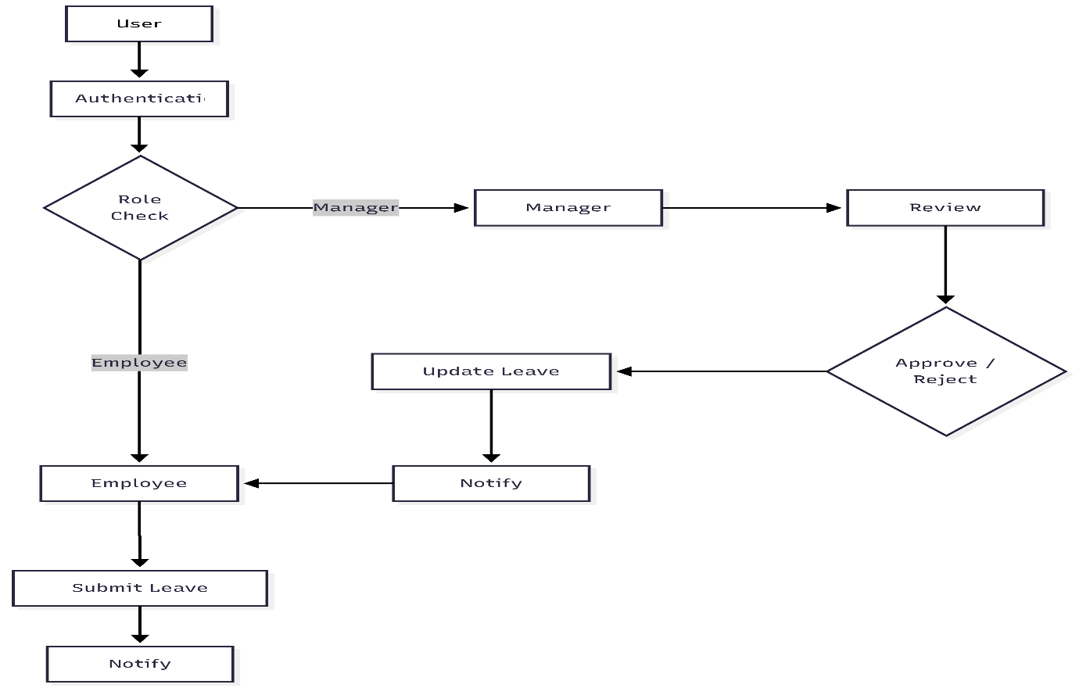
  - Receive Real-time Notification on New Submissions
Figure 1 Workflow of the Employee Leave Management System
Figure 1: workflow diagram of the Employee Leave Management System demonstrating role-based access, leave request submission, managerial review, status update, and notification flow between employees and managers.
TECHNICAL DIAGRAMS
Entity-Relationship (ER) Diagram
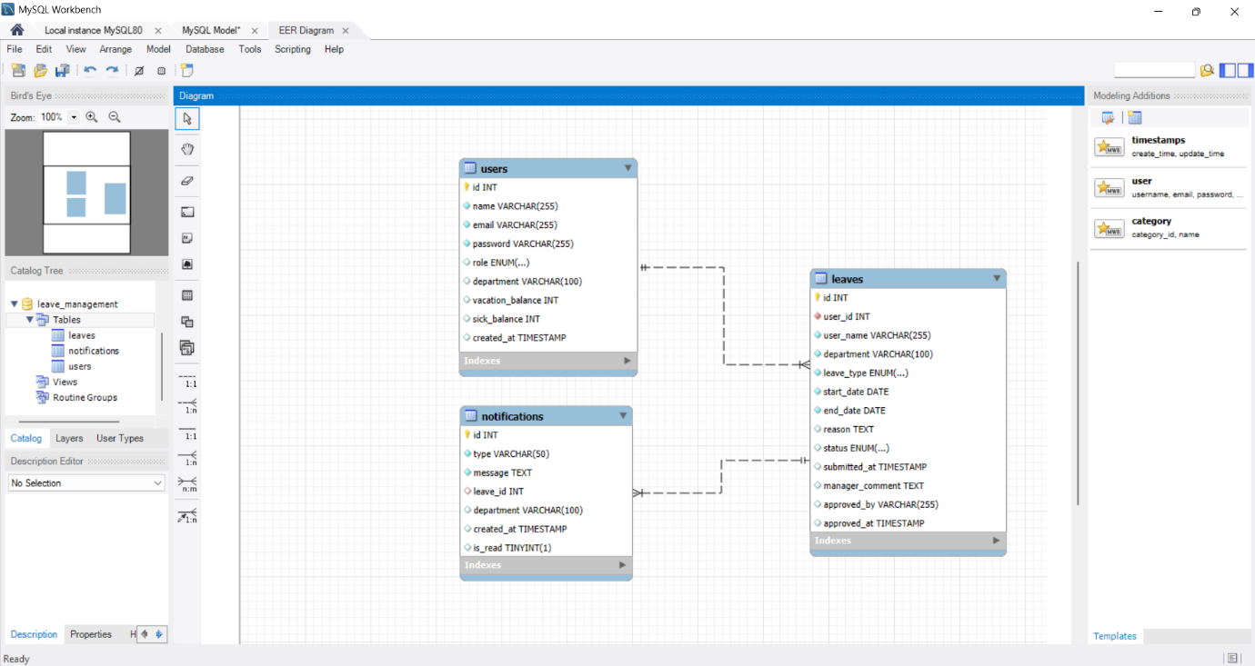
The ER diagram shows the actual MySQL database structure with three tables: users, leaves, and notifications, including all attributes, data types, and foreign key relationships.
Figure 2 Entity–Relationship (ER) Diagram of the Employee Leave Management System
Data Flow Diagram (DFD) - Level 0
The Context Diagram shows the system boundary with external entities (Employee and Manager) and their interactions with the Leave Management System.
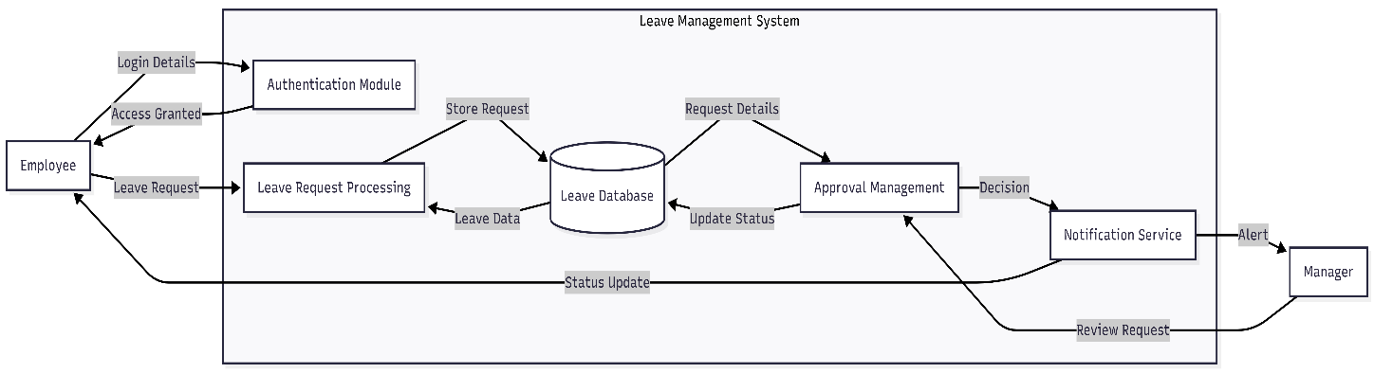
Figure 3 Data Flow Diagram (DFD) of the Employee Leave Management System

Sequence Diagram
This sequence diagram illustrates the complete interaction flow when an employee submits a leave request and a manager approves it, including real-time notifications.
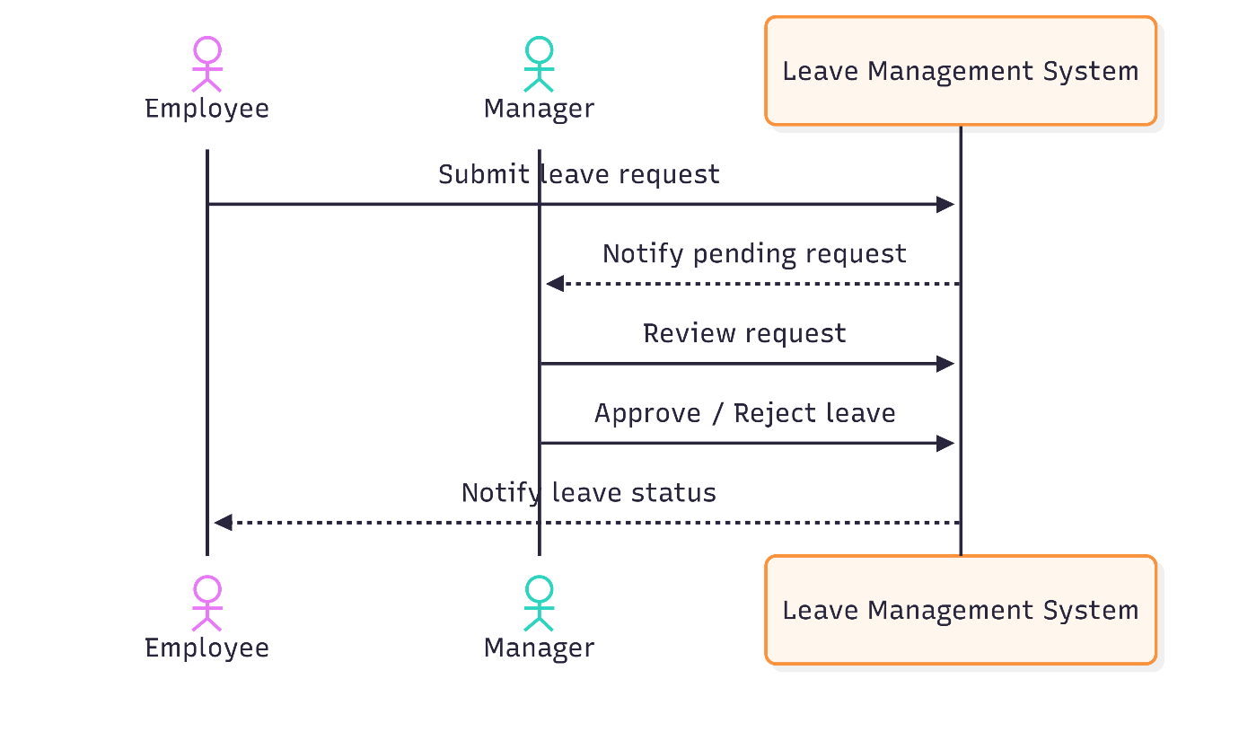
Figure 4 Sequence Diagram of Leave Request and Approval Process

SYSTEM SCREENSHOTS
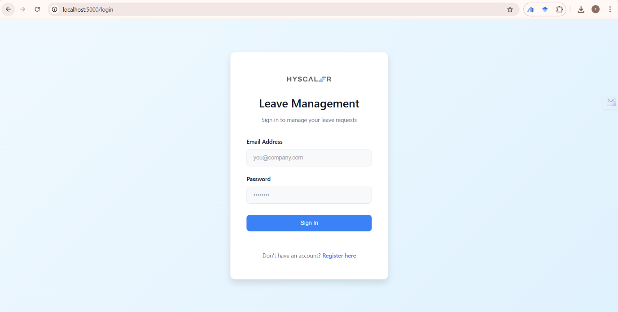
Figure 5 Login Page - User authentication interface
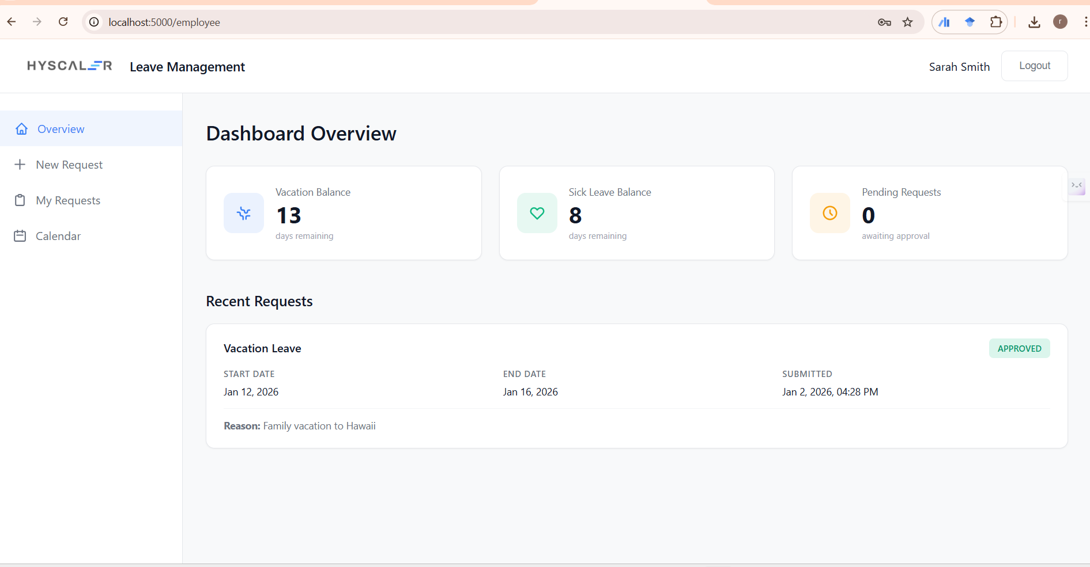
Figure 6 Employee Dashboard - Overview with leave balances
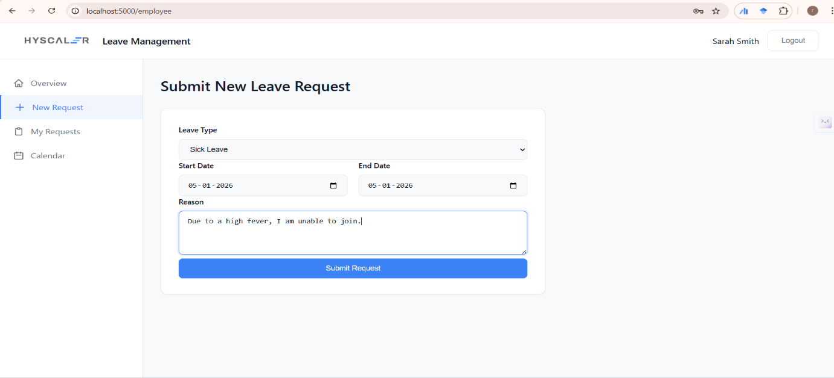
Figure 7 New Leave Request Form - Leave submission interface
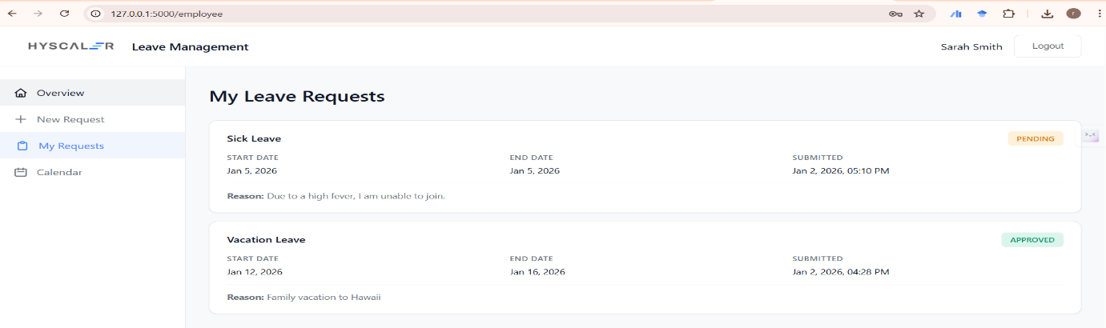
Figure 8 My Requests Page - Request history with status
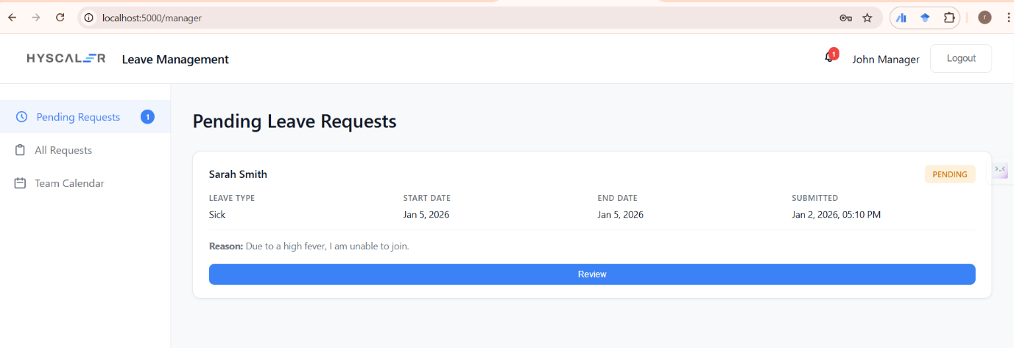
Figure 9 Manager Dashboard - Overview with pending count
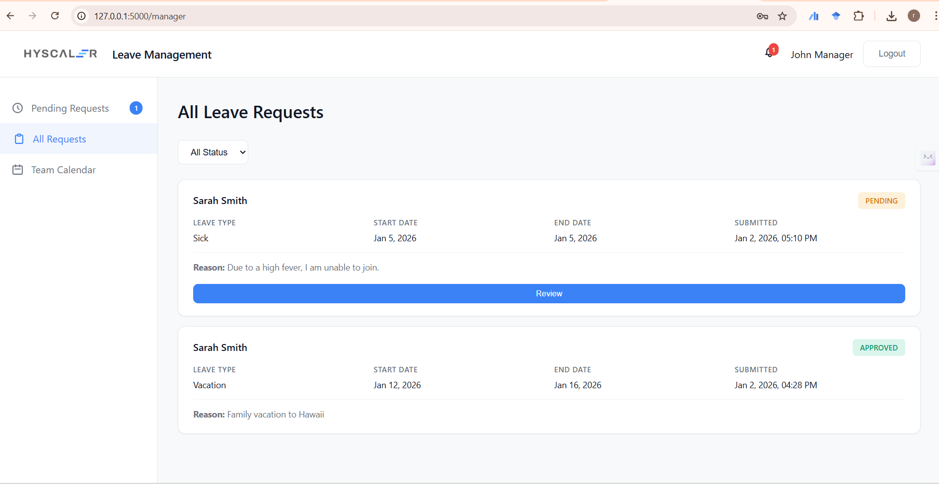
Figure 10 Pending Requests - Manager approval queue
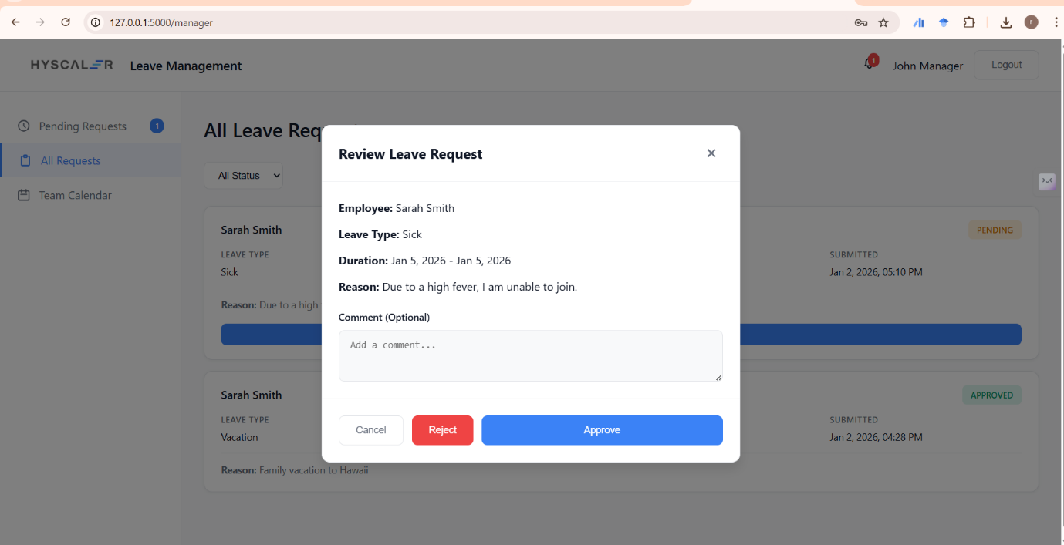
Figure 11 Approval Modal - Leave review and decision interface
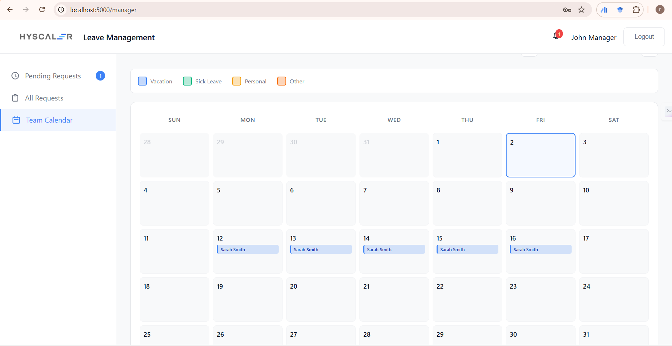
Figure 12 All Department Leaves - Complete leave history

CONCLUSION
The Employee Leave Management System effectively replaces manual leave handling with a centralized, secure, and real-time digital platform. By leveraging Flask, MySQL, and Socket.IO, the system automates leave submission and approval workflows, ensures accurate balance tracking, and provides clear visibility through dashboards and calendar views, resulting in improved efficiency, transparency, and coordination across departments.
This project offered hands-on experience in full-stack development, real-time web architecture, relational database design, and role-based security implementation. It strengthened practical understanding of building scalable, user-centric systems while applying software engineering best practices suitable for real-world organizational environments.

