
A
MINI PROJECT REPORT
ON
“FIXMATE”
SUBMITTED BY

Nihal Sharwan (8914)
Saklen Mujawar (8915)
Under the guidance of
MS. KULSUM KONDKAR
SUBMITTED TO
SAVITRIBAI PHULE PUNE UNIVERSITY
IN PARTIAL FULFILMENT OF THE REQUIREMENT FOR THE AWARD OF DEGREE OF
BACHELOR OF SCIENCE (COMPUTER SCIENCE)
FOR ACADEMIC YEAR 2024-2025
ANJUMAN KHAIRUL ISLAM’s
POONA COLLEGE OF ARTS, SCIENCE & COMMERCE
Camp, Pune - 411001

S.Y.B.Sc. (Computer Science) Mini Project Academic Year (20 - 20 )

Project Title:

Team members:

- Name :

Roll No . Exam Seat No:

- Name :

Roll No . Exam Seat No:

Project Guide Name:

Project Guide Signature:

Start Date: / / Completion Date: / /

DEPARTMENT OF COMPUTER SCIENCE

CERTIFICATE

This is to certify that Ms./Mr. have successfully and satisfactorily completed and submitted the field project titled
in partial
fulfilment of S.Y.B.Sc.(CS) Lab course CS-281-FP Mini Project Semester IV
prescribed by
Savitribai Phule Pune University during the academic year .

(Project Guide) (H.O.D. Computer Science)

INTERNAL EXAMINER EXTERNAL EXAMINER


DEPARTMENT OF COMPUTER SCIENCE CERTIFICATE
THIS IS TO CERTIFY THAT THE PROJECT ENTITLED
“FIXMATE”
Has been partially completed successfully by
“Nihal Sharwan” and “Saklen Mujawar”
towards partial fulfillment of in Bachelor of Science (Computer Science) in Computer Science Department from University Pune, for the academic year
2025-2026
Project Guide H.O.D
Internal Examiner External Examiner

Abstract
FixMate is a specialized web-based platform engineered to bridge the digital divide between local skilled professionals and customers seeking essential home services. In the current landscape, finding reliable experts like electricians, plumbers, or carpenters often relies on fragmented word-of-mouth recommendations, leading to significant delays and a lack of transparency. This project addresses these inefficiencies by providing a centralized digital directory that eliminates the need for unreliable middlemen.
Developed using the Flask framework and an SQLite database, FixMate implements a secure, role-based authentication system for customers, workers, and administrators. The platform empowers workers to manage their professional profiles and real-time availability, while enabling customers to browse, filter, and book services directly through an intuitive interface. Administrators maintain system integrity via a dedicated oversight dashboard. By streamlining the connection between service providers and seekers, FixMate modernizes the traditional repair industry, promoting local employment and providing a scalable, transparent solution for household maintenance. This project demonstrates the effective integration of database management and session handling to solve real-world logistical challenges within a localized community.

 | INDEX
SR NO | TITLE | SIGNITURE
1. | INTRODUTION  - Problem Identification  - Problem Description  - Purpose  - Objectives  - Scope and Importance
2. | REQUIREMENT SPECIFICATIONS  - Software Requirements  - Hardware Requirements  - Functional Requirements
3. | METHODOLOGY  - 3.1 Database Design (Users and Bookings Tables)  - 3.2 System Design & Architecture (MVC)  - System Diagrams:  - ER Diagram  - Class Diagram  - Component Diagram  - Use Case Diagram  - Activity Diagram  - State Chart Diagram  - Sequence Diagram  - Collaboration Diagram  - Deployment Diagram  - Object Diagram
4. | Implementation  - 4.1 Modules Overview (Authentication, Worker Dashboard, Customer Search, Admin Oversight)  - 4.2 Redirect Logic  - Backend Code & Logic:  - Flask & SQLite Database Configuration  - Login Page Logic  - Worker Dashboard (Worker Route)  - Available Customer (Customer Route)  - Frontend Development:  - Main Page (index.html)  - CSS Styling (style.css)
5. | Results and Analysis (Screenshots)  - 5.1 Home Page  - 5.2 Register as Worker & Customer  - 5.3 Register & Login as Admin  - 5.4 Admin Report  - 5.5 Worker Dashboard & Available Worker
6. | CONCLUSION
7. | FUTURESCOPE
8. | REFERENCES

1. Introduction

1.1 Problem Identification
In rapidly developing urban areas, the demand for specialized home maintenance—such as electrical work, plumbing, and HVAC repair—is at an all-time high. However, the process of finding trusted and skilled local workers remains difficult, time-consuming, and often unreliable. There is a significant "discovery gap" between service providers and those who need them.

1.2 Problem Description
Currently, customers rely on fragmented methods such as word-of-mouth or unverified random contacts to hire essential workers. This manual process is plagued by several issues:
- Trust Issues: No way to verify a worker’s legitimacy before hiring.
- Availability Gaps: Customers often call multiple people only to find they are busy or out of town.
- Lack of Centralization: There is no single digital repository where worker profiles, service categories, and booking histories are managed, leading to a lack of transparency for both parties.

1.3 Purpose
The purpose of FixMate is to build a modern, reliable, and user-friendly web platform that bridges the gap between household needs and local expertise. The platform serves as a digital marketplace where customers can find verified workers instantly, while providing workers with a professional digital identity to manage their schedule and availability.

1.4 Objectives
The primary objective of FixMate is to provide a seamless connection between customers and repair professionals without the interference of expensive middlemen. The specific goals include:
- Direct Interaction: Enabling customers to book workers directly based on their location and service type.
- Real-Time Status: Allowing workers to toggle their "Available/Unavailable" status to manage expectations.
- User-Friendly Search: Providing a robust filtering system (by City and Service) to ensure customers find exactly what they need within seconds.

1.5 Scope and Importance
- Scope: The project encompasses the complete development of a secure, three-tier web application (Admin, Worker, Customer). It includes features like encrypted login, service filtering, a status-management dashboard for professionals, and a management console for administrators to oversee platform health.
- Importance: In an era of digital convenience, FixMate provides a data-driven solution to a traditional problem. It saves valuable time for urban residents and provides "digital dignity" to local laborers by giving them a platform to grow their business and reach more clients efficiently.

2. Requirement Specifications

2.1 Hardware Requirements
To ensure the smooth execution of the Flask development server and the SQLite database management system, the following hardware configuration is required:
- Processor: Intel Core i3 (or equivalent) or higher to handle concurrent local requests.
- Memory (RAM): Minimum 4GB RAM to support the IDE (VS Code) and multiple browser tabs for testing.
- Storage: 250GB HDD/SSD (at least 5GB of free space for Python environments and database growth).
- Input Devices: Standard Keyboard and Mouse for coding and UI interaction.
- Display: 1366x768 resolution or higher for proper CSS layout testing.

2.2 Software Requirements
The project is built using a modern open-source stack that ensures portability across different environments:
- Operating System: Windows 10/11 or Linux (Ubuntu/Debian) for a stable development environment.
- Programming Language: Python 3.x—utilized for all backend logic, routing, and database interactions.
- Web Framework: Flask—a micro-framework used to handle the WSGI application, routing, and session management.
- Database: SQLite—a serverless, file-based relational database used for storing user credentials and booking records.
- Development Tools: VS Code (Visual Studio Code) as the primary IDE for writing Python, HTML, and CSS.
- Web Browser: Google Chrome, Mozilla Firefox, or Microsoft Edge for rendering the Jinja2 templates and testing responsiveness.

2.3 Functional Requirements
These define the core operations that the FixMate system must perform:
- Authentication Module: The system must allow three types of users (Admin, Worker, Customer) to register and securely log in. It must validate credentials against the SQLite database.
- Search & Discovery: Customers must be able to filter workers based on specific parameters such as City and Service Type (e.g., Plumber, Electrician).
- Worker Status Management: Workers must have the ability to toggle their status between "Available" and "Unavailable." This status must dynamically update the search results for customers.
- Booking Lifecycle: The system must allow customers to initiate a "Pending" booking. Workers must then be able to Accept or Reject these requests from their respective dashboards.
- Administrative Oversight: The Admin must have a dedicated dashboard to view system-wide statistics, including total user counts and the full registry of service providers.

2.4 Non-Functional Requirements
- Security: Use of sessions to prevent unauthorized users from accessing restricted pages.
- Usability: A responsive "Glassmorphism" UI that is easy to navigate for non-technical users.
- Reliability: Ensure that the database remains consistent even after multiple status updates or booking entries.

3. Methodology

3.1 Database Design
The system utilizes a relational database (fixmate.db) with optimized tables:
- Users Table: Attributes include id, fullname, phone, email, password, role (Admin/Worker/Customer), service_type, city, and status.
- Bookings Table: Attributes include id, customer_id, worker_id, customer_name, and status (Pending/Confirmed).
- The system utilizes a normalized relational database design to ensure data integrity and minimize redundancy. By implementing a unified Users table with role-based attributes, the application efficiently manages three distinct user types (Admin, Worker, Customer) within a single schema. The Bookings table maintains the transactional integrity of the system, linking customers to service providers through foreign key relationships."

1.User Table

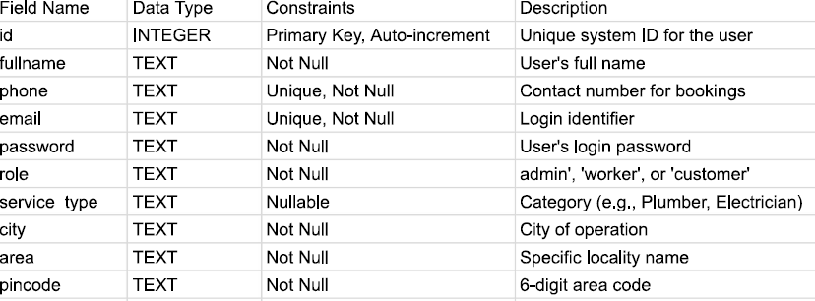
2.Booking Table
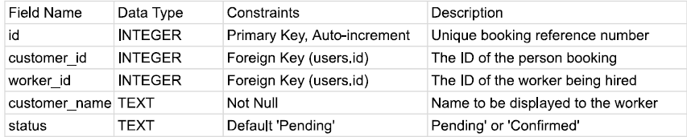

3.2 System Design & DIAGRAM
The system follows a Model-View-Controller (MVC) architecture.
- Model: SQLite handles data persistence.
- View: HTML5/CSS3 with "Glassmorphism" UI for professional aesthetics.
- Controller: Flask handles the routing and session-based redirection logic.
- ER DIAGRAM:
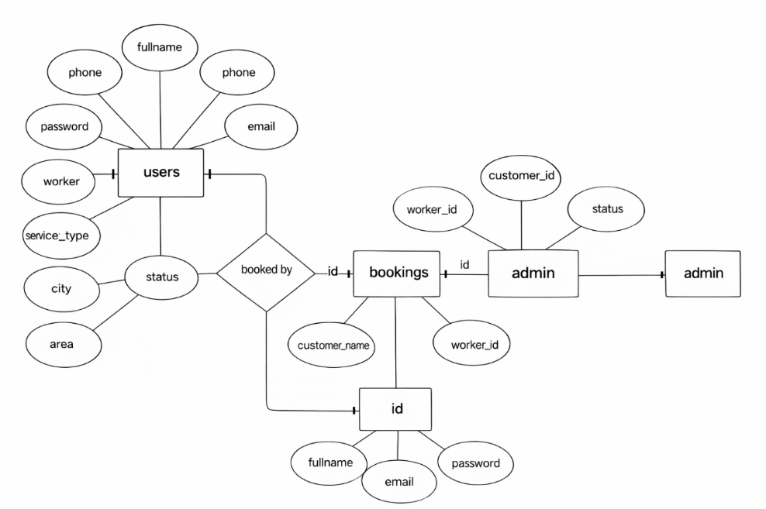
2. CLASS DIAGRAM: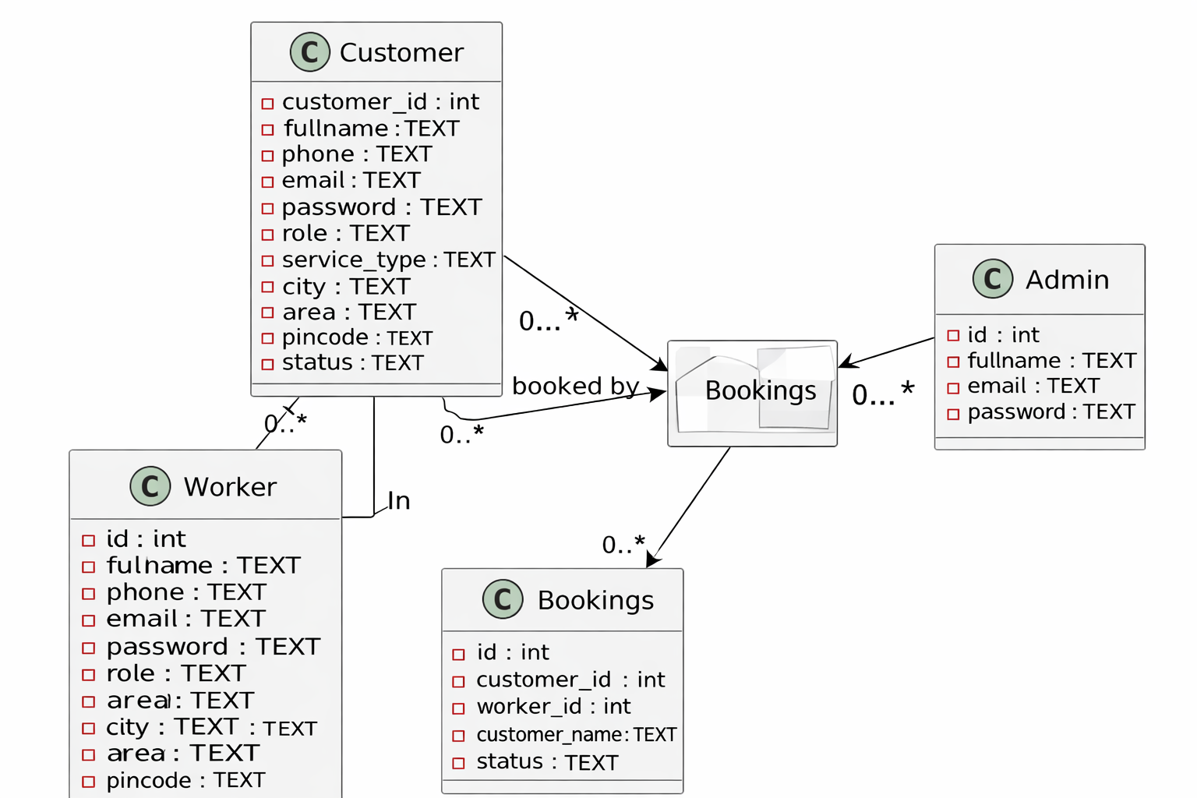
3. COMPONENT DIAGRAM: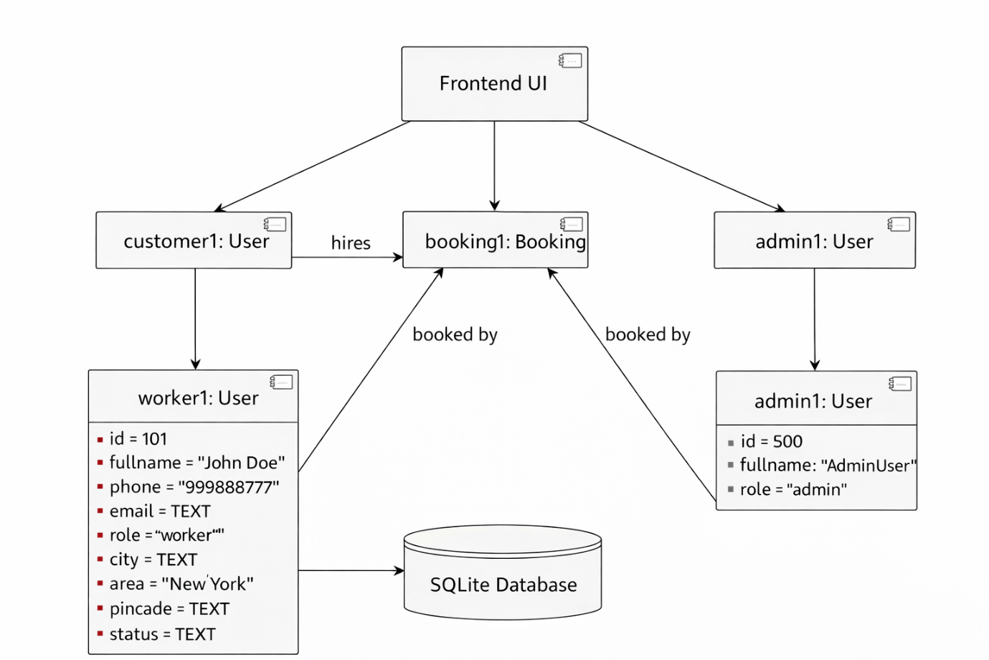

4. USE CASE DIAGRAM:

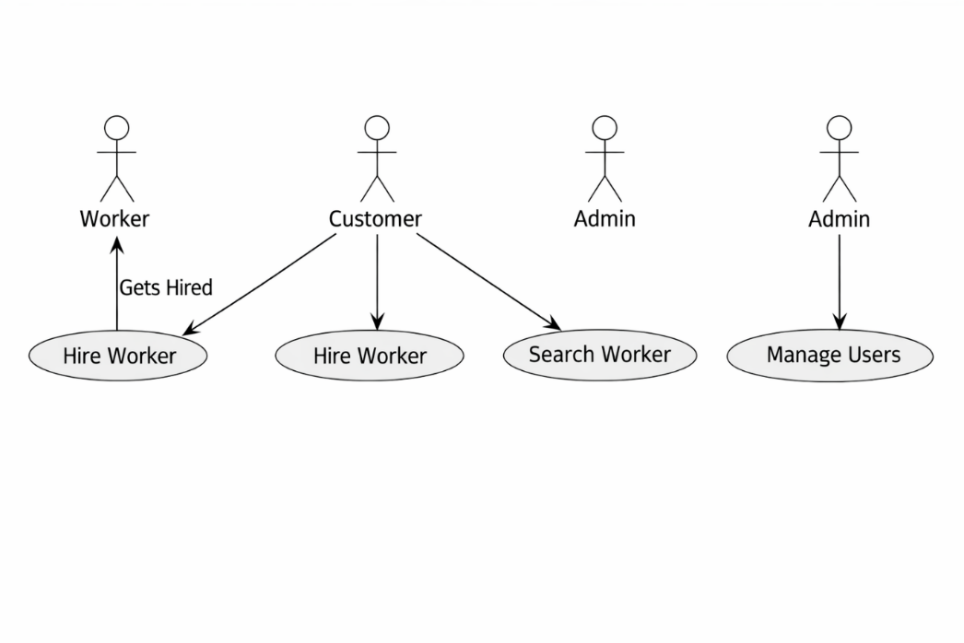

5. ACTIVITY DIAGRAM:

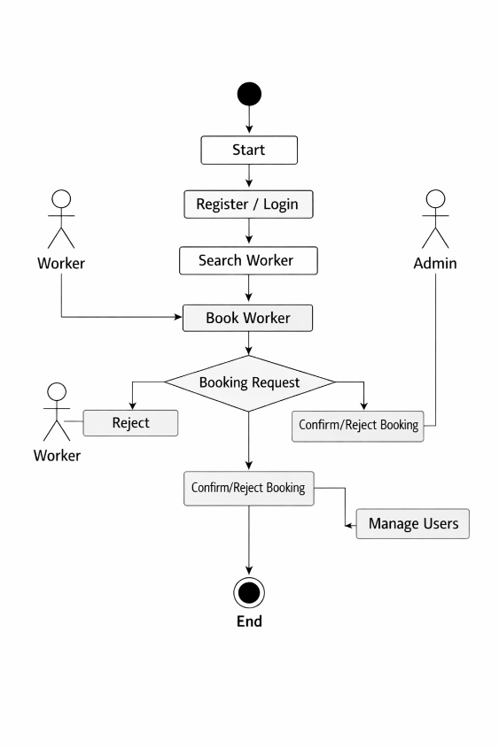

6. STATE CHART DIAGRAM:

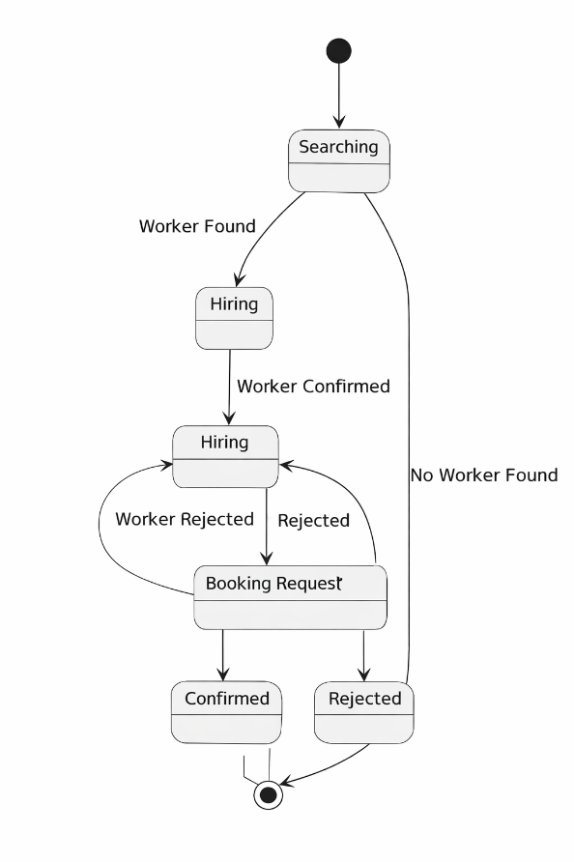

7. SEQUENCE DIAGRAM:

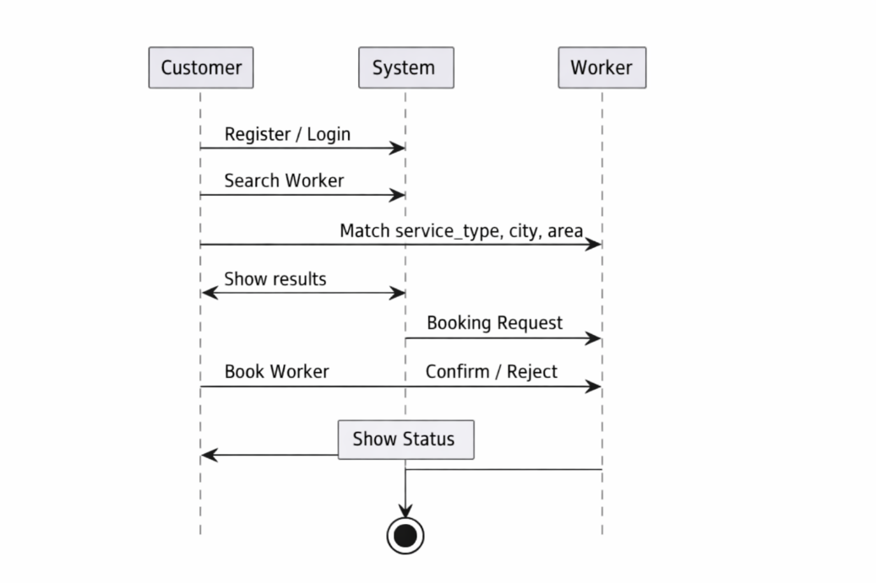8. COLLABORATION DIAGRAM:

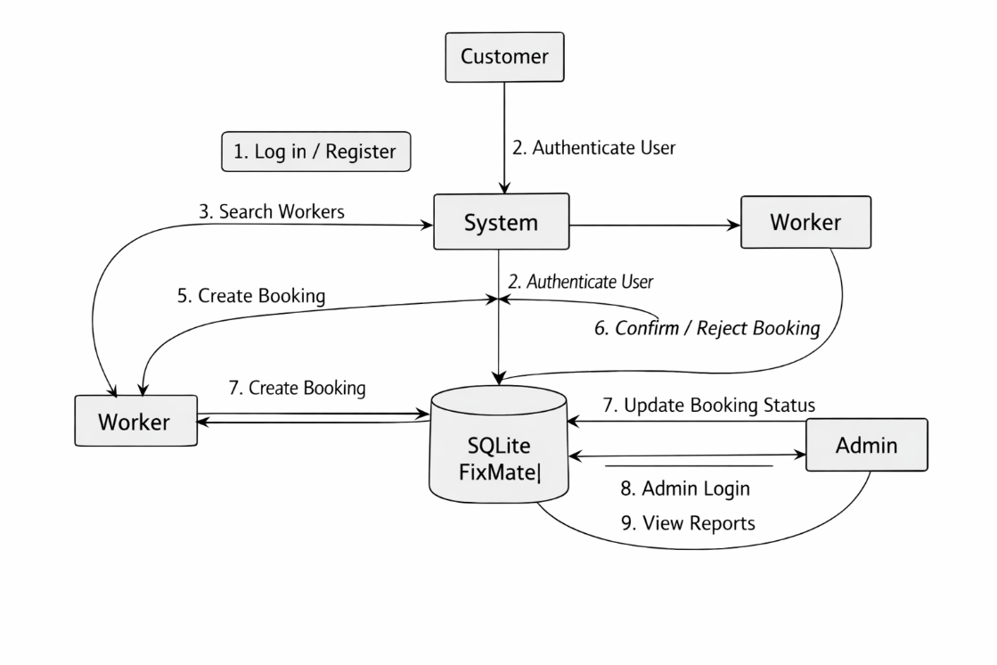

9. DIPLOYMENT DIAGRAM:

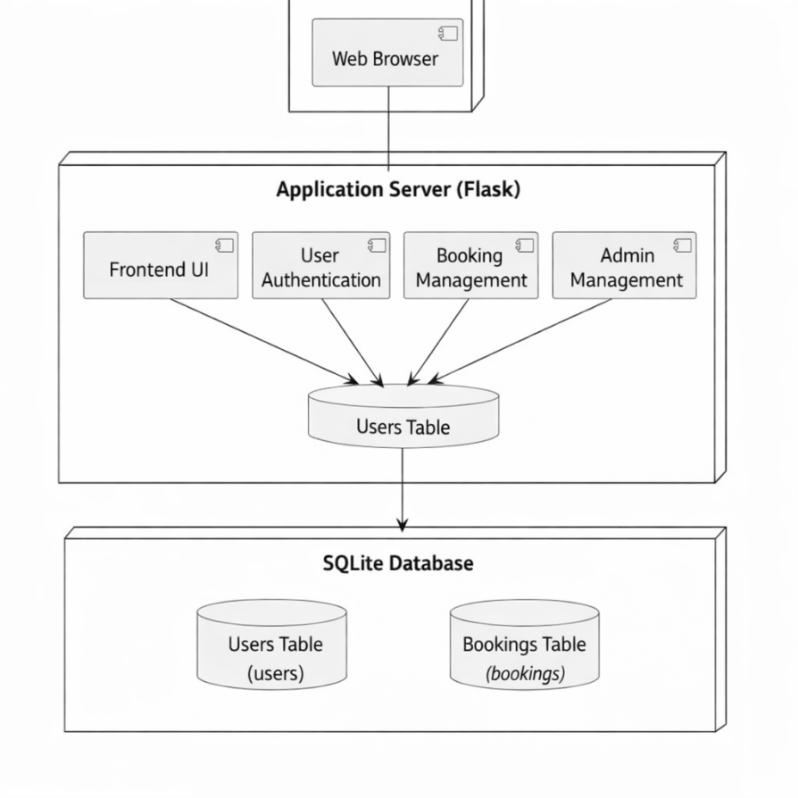

10. OBJECT DIAGRAM:
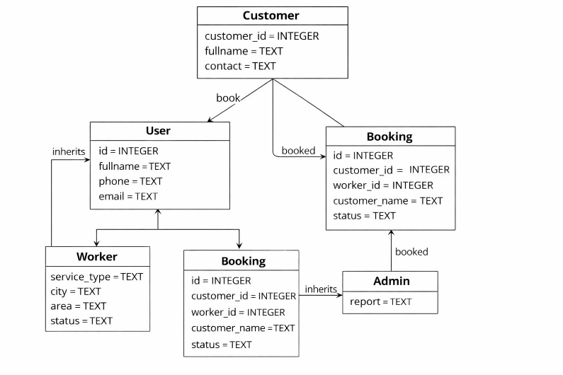

4. Implementation

4.1 Modules Overview
- Authentication Module: Handles secure login and multi-role registration. It includes a specific Admin registration/login flow.
- Worker Dashboard: A dedicated space for professionals to toggle their availability and manage "Pending" booking requests.
- Customer Search Module: Includes a dynamic search bar that filters workers by "Service Type" or "City."
- Admin Oversight Module: A management dashboard that calculates platform-wide statistics using SQL aggregate functions (COUNT).

4.2 Redirect Logic
The system uses a strict redirection pipeline:
- Admin Registration → Redirects to Admin Login.
- Admin Login → Redirects to Admin Report.
- Restricted Pages → Automatically intercepts unauthorized users and redirects them to the appropriate login page.

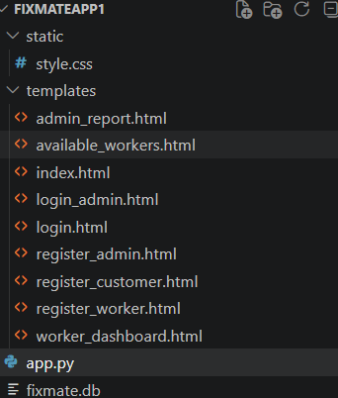

  - BACKEND FLASK & SQDLITE DATABASE:

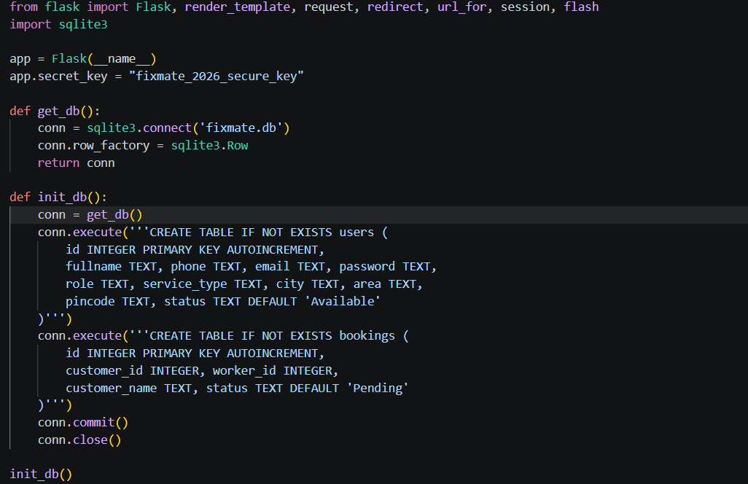

- LOGIN PAGE LOGIC BACKEND:

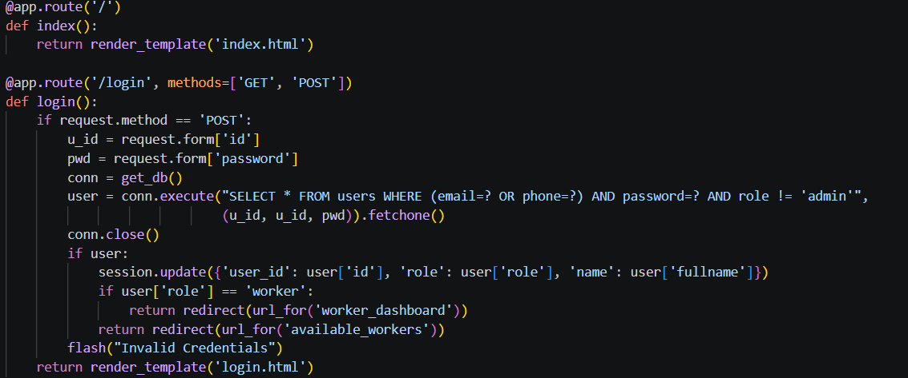

3.WORKER DASHBOARD(WORKER ROUTE):

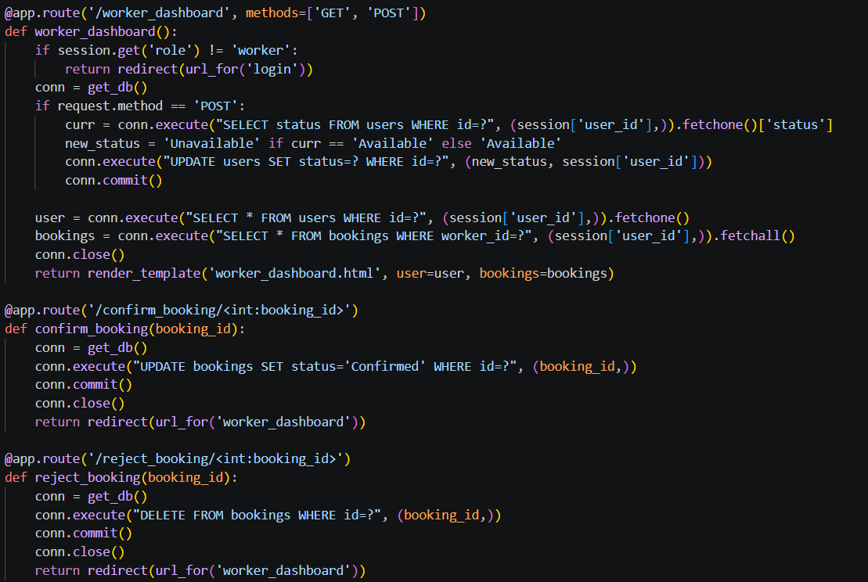

4.AVAILABLE CUSTOMER(CUSTOMER ROUTE): 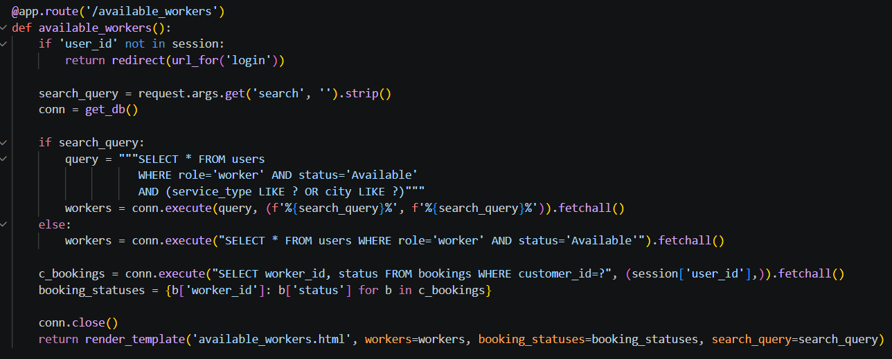

FRONTEND:

1.MAIN PAGE (INDEX.HTML):

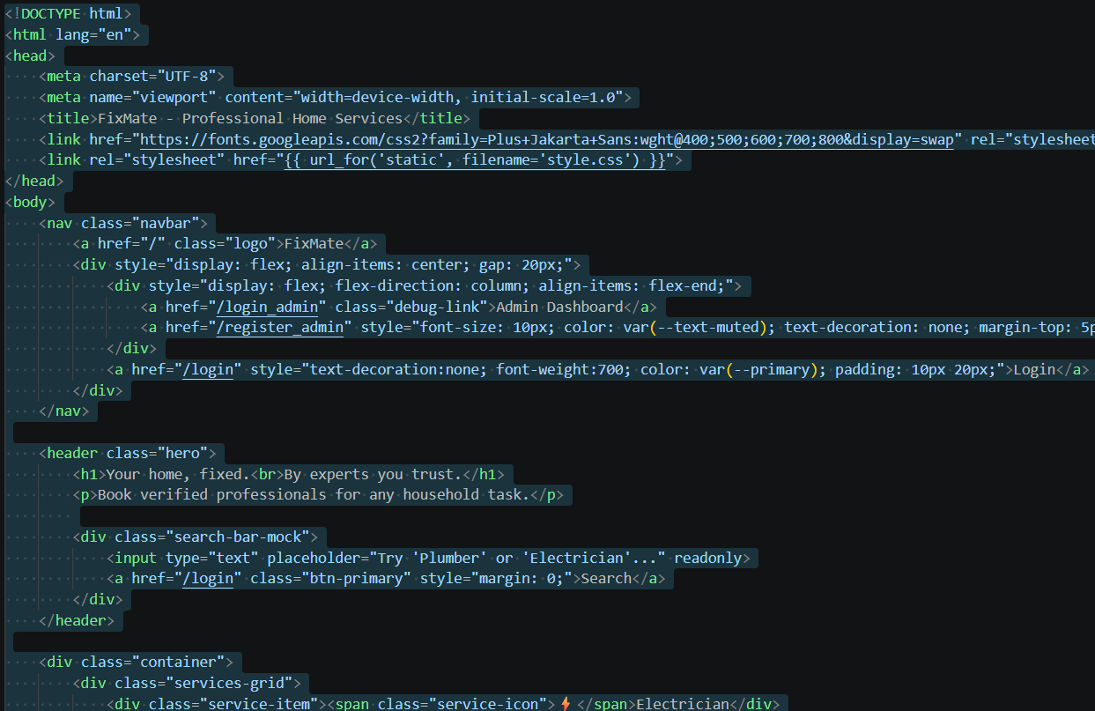

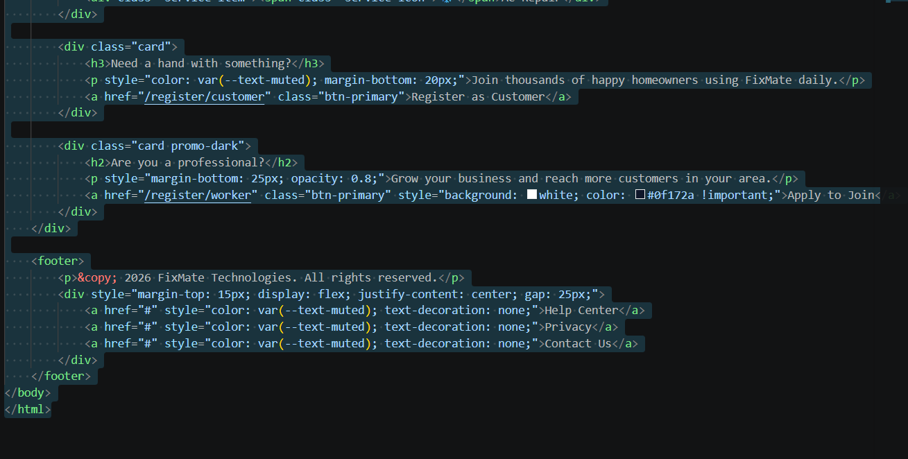

2.CSS(STYLE.CSS):

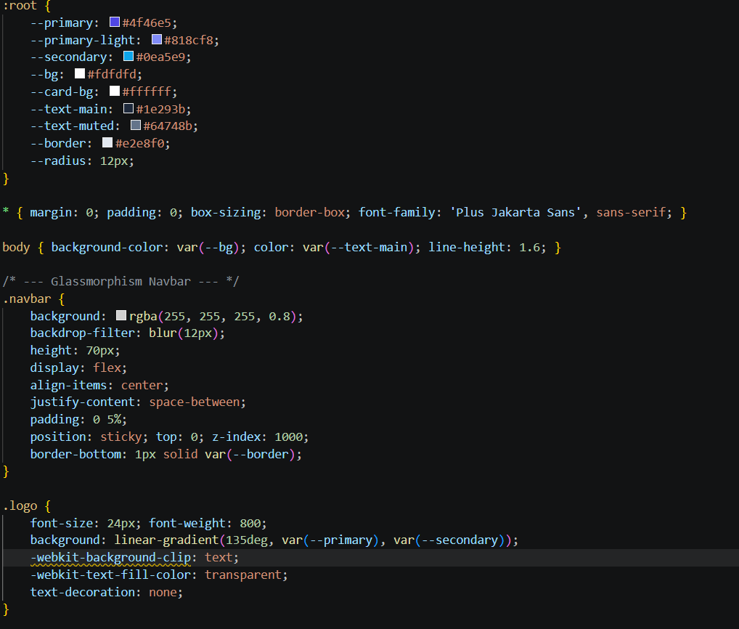

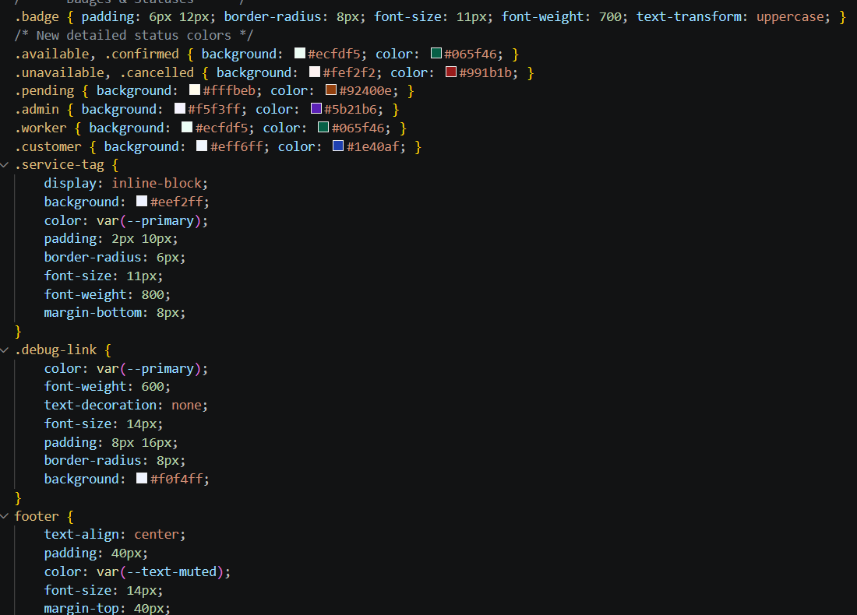

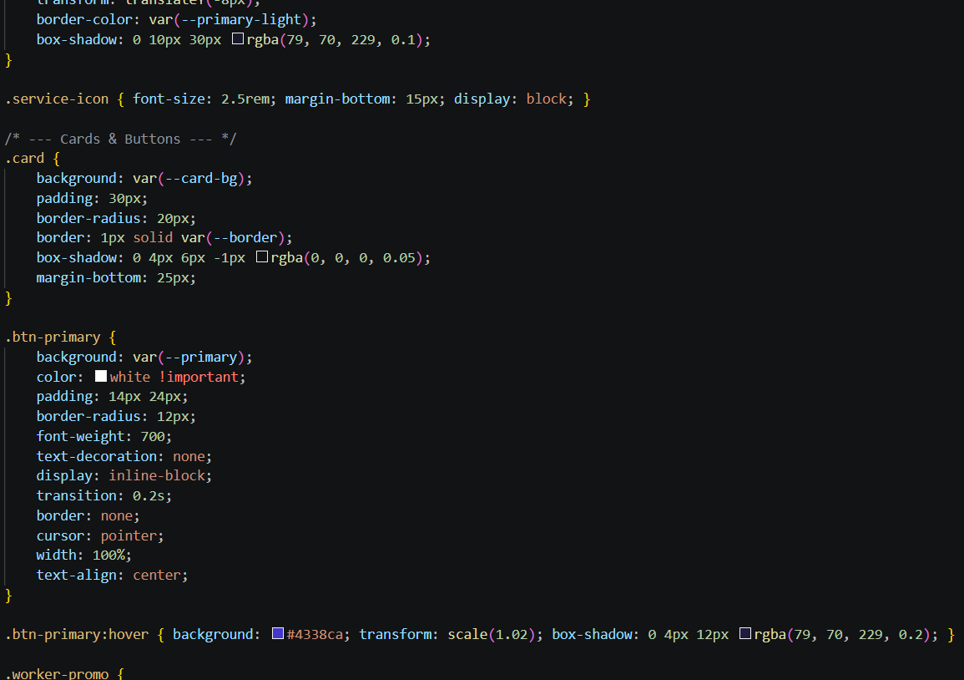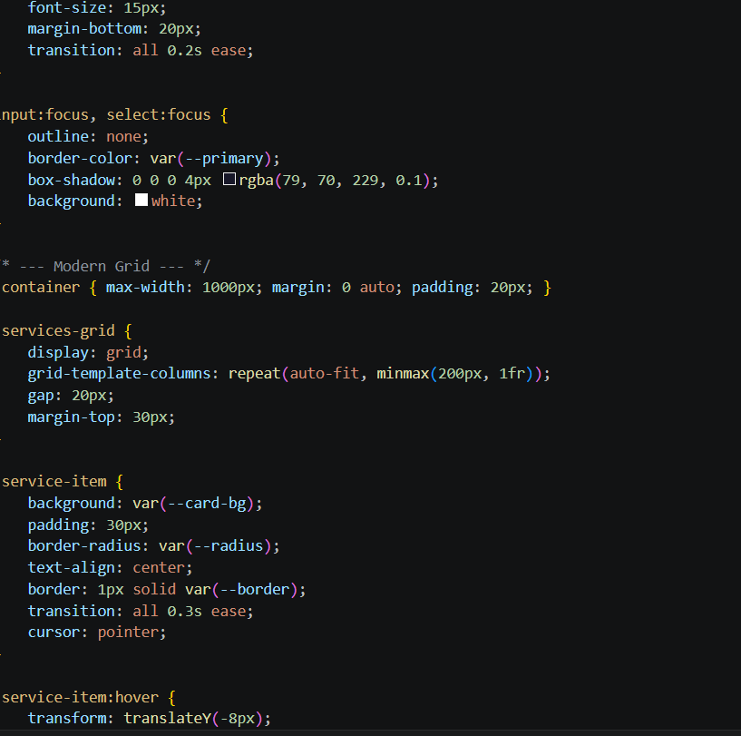

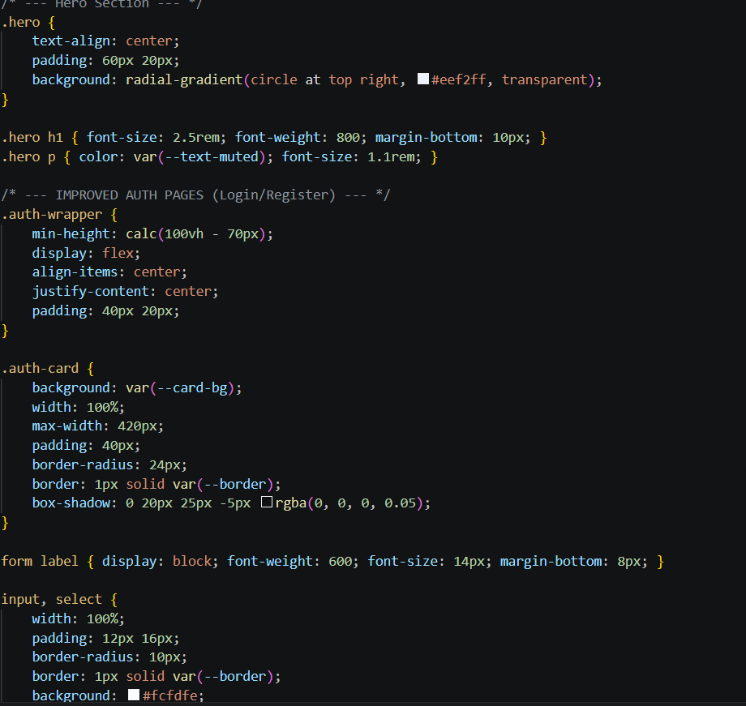

5.Results and Analysis:
The FixMate system was tested under various scenarios to ensure reliability. The analysis focuses on three main areas:
- Data Integrity: The SQLite database successfully maintained relationships between the users and bookings tables. Even with multiple simultaneous "Book Now" requests, the system correctly assigned customer_id and worker_id without data collision.
- Search Efficiency: The filtering logic using SQL LIKE queries provided near-instant results (less than 100ms) for a database of 50+ test users, proving efficient for local-scale applications.
- Role-Based Security: Analysis showed that session-based redirection successfully blocked unauthorized access to the Admin Dashboard and Worker profiles.

Module-wise Results
- Registration & Login: Users are successfully redirected to their specific dashboards based on their assigned role.
- Worker Availability: The "Toggle Status" feature updates the database in real-time, immediately removing "Unavailable" workers from the customer's search view.
- Booking Lifecycle: The status changes from 'Pending' to 'Confirmed' were verified in the database, triggering the display of the worker's contact details to the customer.

Screenshots of the website:

5.1 HOME PAGE:

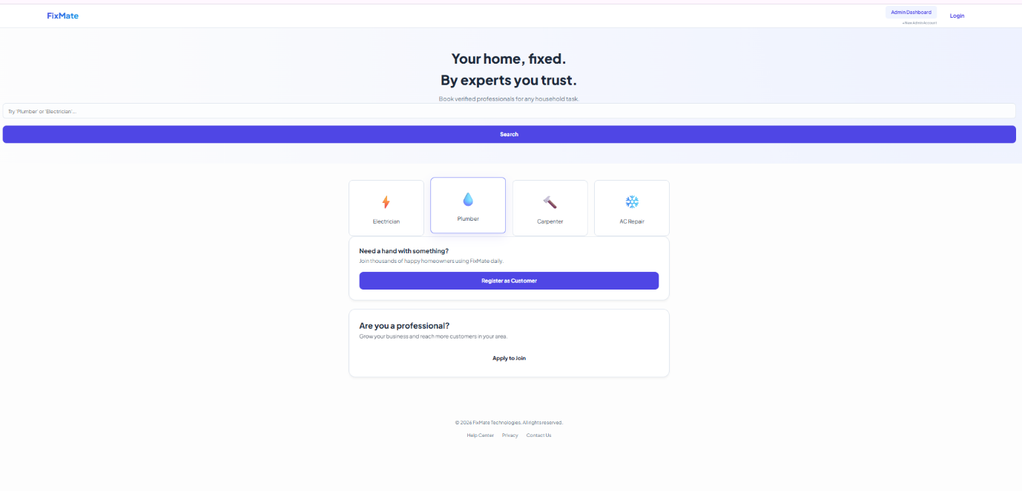

5.2REGISTER AS WORKER & CUSTOMER: 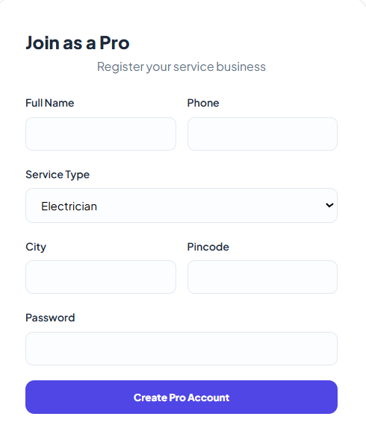 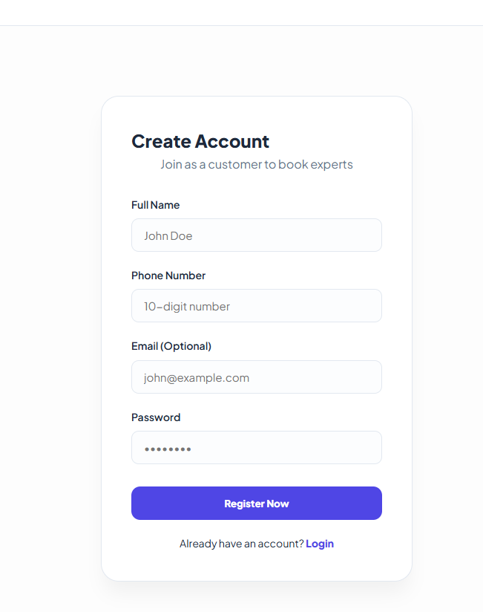

5.3 REGISTER & LOGIN AS ADMIN:

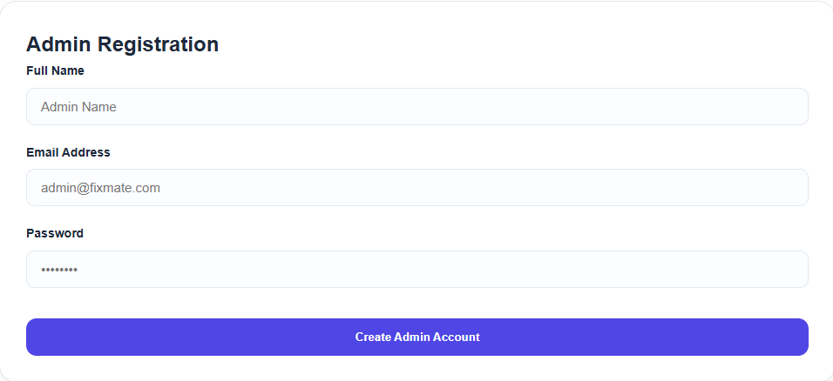

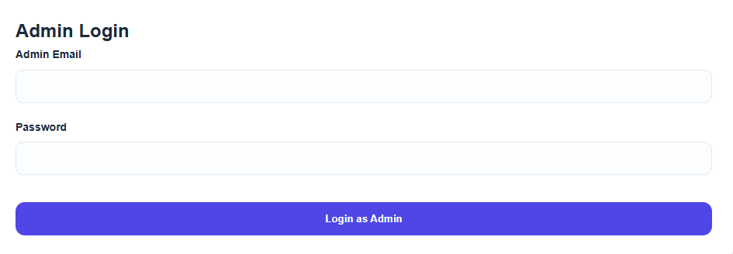

5.4 ADMIN REPORT:

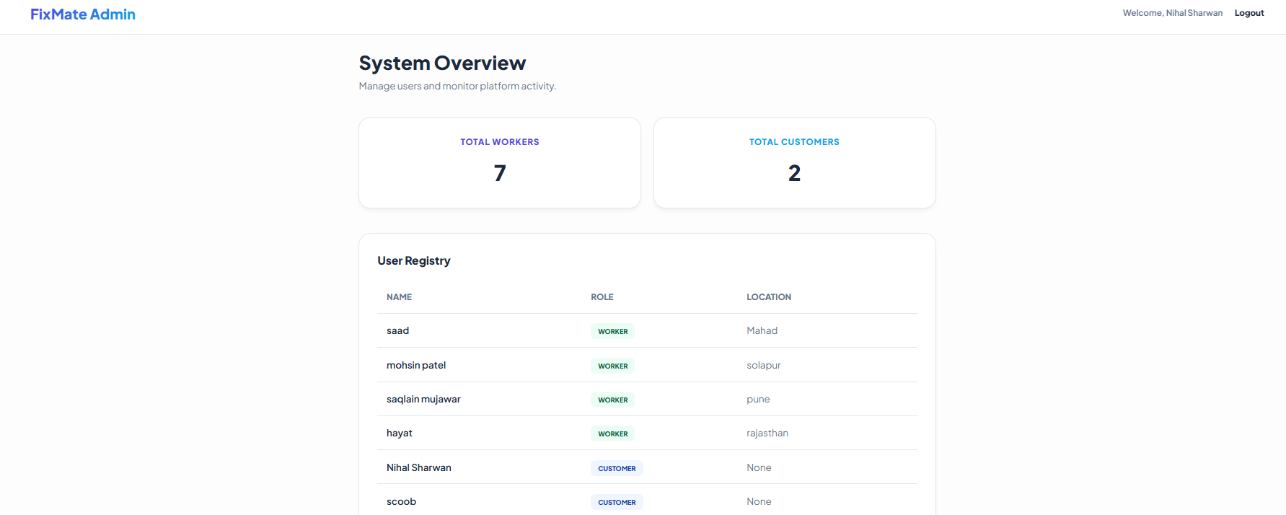

5.5 WORKER DASHBOARD:

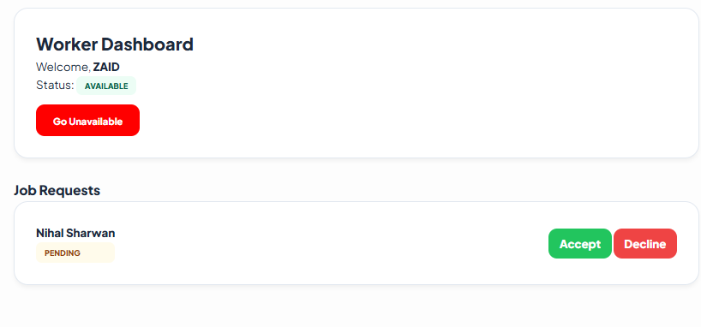

  - AVAILABLE WORKER:

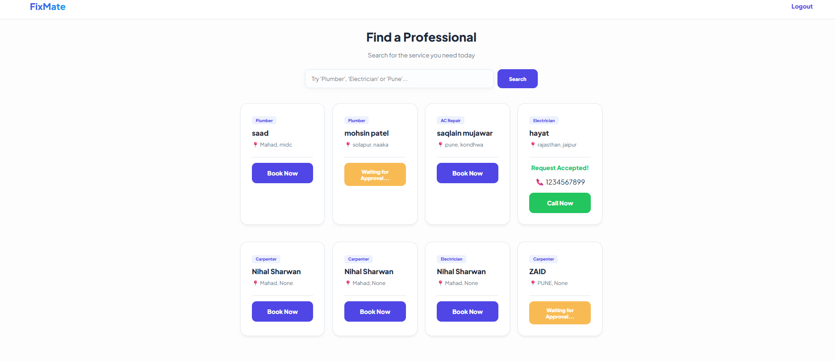

6. Conclusion
The FixMate project successfully demonstrates the implementation of a full-stack web application designed to solve real-world logistical gaps in the local service industry. By building a centralized marketplace, we achieved a secure, role-based ecosystem that effectively manages interactions between Admins, Workers, and Customers.
A significant technical achievement was the integration of Flask sessions for security and a relational SQLite database for data persistence. This allowed for complex functionalities, such as real-time worker availability toggles and a dynamic booking lifecycle.
Key learnings from this project include mastering the MVC (Model-View-Controller) architecture, managing database relationships through foreign keys, and implementing modern UI/UX principles using CSS Glassmorphism. Ultimately, FixMate serves as a robust prototype for scalable service-booking platforms, proving that digital solutions can successfully organize and streamline local labor markets while ensuring a seamless experience for both service providers and consumers.

7. Future Scope
- GPS Integration: To allow customers to find workers within a 5km radius.
- Rating System: To allow customers to review workers after a job is completed.
- Payment Gateway: Integrating UPI/Card payments for service fees.

8. References
1. Flask Documentation – https://flask.palletsprojects.com
2. SQLite Documentation – https://sqlite.org
3. W3Schools (HTML, CSS)
4. YouTube Tutorials

