Chapter 1 – Organization Structure of Industry and General Layout
[COMPANY / ORGANIZATION NAME] is an IT/software organization where web-based solutions and digital services may be planned, developed, tested and maintained according to client or organizational requirements. The internship environment provided exposure to the general workflow followed in frontend development.
A typical web-development organization works through a coordinated structure. Project requirements are communicated by clients or business teams and converted into technical tasks. Designers prepare the visual direction and user experience, while frontend developers implement the interface. Backend developers work on server-side logic and databases, and testers verify functionality and usability before deployment.

1.1 General Organization Structure
Department / Role | Major Responsibility
Management / Project Lead | Planning, coordination, deadlines and project monitoring
UI/UX Design | Interface design, user flow, layout and visual consistency
Frontend Development | HTML, CSS, JavaScript, React and browser-side functionality
Backend Development | Server-side logic, APIs, authentication and data processing
Database / Data | Data storage, retrieval, integrity and maintenance
Testing / QA | Functional, usability, compatibility and regression testing
Deployment / Support | Hosting, releases, maintenance and issue resolution

1.2 Working Environment
The frontend development environment generally consists of computers, code editors, web browsers, project folders, version-control tools and communication systems. Developers work with a structured workflow in which requirements are converted into small tasks, code is written and tested locally, errors are corrected, and completed work is reviewed.

1.3 Role of a Frontend Intern
- Understand assigned requirements and convert them into interface elements.
- Create semantic HTML structures and maintain readable code.
- Apply CSS for layout, typography, spacing, colors and responsive behavior.
- Use JavaScript for interaction, validation and dynamic behavior.
- Learn React.js concepts and create reusable UI components.
- Test pages on different screen sizes and browsers.
- Debug errors using browser developer tools and console messages.

Chapter 2 – Introduction to Web Development Industry
Web development is the process of creating websites and web applications that users access through browsers. Modern web applications combine a user interface with application logic, data services and deployment infrastructure. Frontend development represents the part of the application that users directly see and interact with.
The frontend is responsible for presenting information clearly, accepting user input and responding to user actions. HTML provides structure, CSS controls presentation and layout, and JavaScript provides behavior. React.js builds on JavaScript by providing a component-based approach to creating interfaces.

2.1 Importance of Frontend Development
- Creates the first visual and interactive experience for users.
- Organizes information into understandable layouts.
- Provides responsive interfaces for desktops, tablets and mobile devices.
- Validates and responds to user actions.
- Connects the user interface with application data and APIs.
- Supports maintainable development through reusable components.

2.2 Frontend Development Life Cycle
Stage | Description
Requirement Analysis | Understand purpose, users, features and expected output.
Planning | Break the interface into pages, sections and components.
Design | Decide layout, typography, navigation and visual hierarchy.
Implementation | Write HTML, CSS and JavaScript/React code.
Testing | Check functionality, responsiveness, compatibility and usability.
Debugging | Identify errors and correct their causes.
Review | Improve code quality, appearance and user experience.
Deployment | Prepare the completed application for use or hosting.
Maintenance | Fix issues and update features when requirements change.

2.3 Learning Objectives
- Develop strong fundamentals of HTML, CSS and JavaScript.
- Understand responsive and mobile-friendly web design.
- Learn component-based development using React.js.
- Improve debugging and logical problem-solving skills.
- Understand professional project organization and documentation.
- Gain confidence in developing small frontend applications independently.

Chapter 3 – Technologies, Tools and Software Used
The internship focused primarily on frontend technologies. Each technology was introduced progressively so that the trainee could understand how structure, presentation, logic and component architecture work together.

3.1 HTML
HTML is the standard markup technology used to structure web content. It defines headings, paragraphs, links, images, lists, tables, forms and semantic sections. During training, HTML was used to create the basic structure of webpages before applying CSS and JavaScript.
- Document structure using DOCTYPE, html, head and body.
- Semantic elements such as header, nav, main, section, article, aside and footer.
- Text, links, images, lists and tables.
- Forms, labels, inputs, buttons and basic validation attributes.
- Meaningful class and id naming for styling and scripting.

3.2 CSS
CSS is used to control the visual presentation of HTML documents. Practical learning included selectors, properties, typography, spacing, borders, backgrounds, positioning, Flexbox, Grid and media queries.
- Selectors and specificity.
- Box model: content, padding, border and margin.
- Flexbox for one-dimensional layouts.
- CSS Grid for two-dimensional layouts.
- Responsive media queries.
- Transitions and basic visual effects.
- Reusable classes and organized stylesheets.

3.3 JavaScript
JavaScript adds programming behavior to webpages. The internship covered variables, data types, operators, conditions, loops, functions, arrays, objects, events and DOM manipulation. JavaScript was also used to validate form input and create interactive interface behavior.

3.4 React.js
React.js is a JavaScript library for building user interfaces through reusable components. The internship introduced JSX, functional components, props, state, event handling and hooks. React encourages interfaces to be divided into smaller components that can be developed and reused independently.
- JSX syntax and component structure.
- Functional components.
- Props for passing data between components.
- State for managing changing interface data.
- Event handling.
- Conditional rendering.
- List rendering using keys.
- Basic use of React hooks such as useState and useEffect.

3.5 Development Tools
Tool | Use During Training
Visual Studio Code | Writing and organizing source code.
Web Browser | Running and testing webpages.
Developer Tools | Inspecting elements, console errors, network behavior and layout.
Node.js / npm | Managing JavaScript/React development environment and packages.
Git / GitHub | Version control and project backup, where available.
File Explorer | Organizing project folders and assets.

Chapter 4 – Web Development Processes and Techniques
The development process followed a practical sequence: understand the requirement, plan the page, create structure, apply styling, add interaction, test the result and improve the implementation. This approach helped establish disciplined development habits.

4.1 Requirement Understanding
Before writing code, the purpose of the page or feature was considered. Important elements included target users, required content, navigation, forms, expected interactions and screen sizes. Breaking requirements into smaller tasks made implementation easier.

4.2 HTML Page Structure
A basic webpage was created with a valid HTML document structure. Semantic sections were preferred because they improve organization and make the code easier to understand and maintain.

4.3 CSS Styling and Layout
CSS was applied after the HTML structure was ready. Spacing, dimensions, typography and alignment were adjusted to create a consistent visual layout. Flexbox and Grid were practiced for arranging content, cards, navigation elements and responsive sections.

4.4 Responsive Web Design
Responsive design allows a website to adapt to different screen sizes. Media queries, flexible widths, relative units, flexible images and responsive layout techniques were used to avoid horizontal scrolling and preserve usability on smaller screens.

4.5 JavaScript Interactivity
JavaScript was used to respond to user actions such as clicks, form submission and input changes. DOM methods were practiced to select elements, change content or classes and update the interface dynamically.

4.6 React Component Development
React development involved identifying repeated interface patterns and converting them into components. Components such as navigation bars, cards, buttons, forms and page sections can be reused. Props allow parent components to provide data, while state allows a component to track changing values.

4.7 Testing and Debugging
After implementation, pages were tested in the browser. Console messages, element inspection and responsive device simulation helped identify errors. The debugging process involved reproducing the issue, finding its cause, making a small correction and testing again.

Chapter 5 – Testing of Web Applications
Testing is an essential part of frontend development because a page that looks correct in one situation may fail at another screen size or interaction. During practical learning, testing was treated as a repeated activity rather than only a final step.

5.1 Functional Testing
- Verify that buttons perform the intended action.
- Check navigation links and page transitions.
- Test form input and validation messages.
- Verify dynamic JavaScript behavior.
- Check React state updates and conditional rendering.

5.2 Responsive Testing
Pages were checked at different viewport widths to identify overflow, broken alignment, unreadable text and unsuitable spacing. Responsive testing helped improve layouts for desktop, tablet and mobile screen sizes.

5.3 Cross-Browser Testing
The same interface can behave differently across browsers due to rendering and compatibility differences. Basic cross-browser checks were used to identify obvious layout or functionality problems.

5.4 Debugging with Developer Tools
Area | What Was Checked
Elements | HTML structure, classes, computed styles and layout.
Console | JavaScript errors, warnings and debugging messages.
Network | Requests and loading behavior where applicable.
Responsive Mode | Appearance at different viewport dimensions.
Sources | Loaded files and code during troubleshooting.

5.5 Common Frontend Defects
- Missing or incorrectly nested HTML tags.
- Incorrect CSS selectors or conflicting rules.
- Unexpected margin/padding and alignment problems.
- JavaScript syntax or runtime errors.
- Incorrect event handling.
- React component or state logic errors.
- Mobile layout overflow.
- Broken links or missing assets.

Chapter 6 – Development Practices and Security
Although frontend development is primarily focused on the user interface, good development practices are necessary for maintainability, reliability and security. During training, attention was given to clean code, organized files, safe handling of project information and responsible use of development tools.

6.1 Code Organization
- Use meaningful file, variable, function and component names.
- Keep HTML, CSS and JavaScript responsibilities clear.
- Divide large interfaces into smaller React components.
- Avoid unnecessary duplication.
- Keep project assets organized in appropriate folders.

6.2 Version Control
Version control helps developers maintain a history of changes and return to earlier working versions when required. Git-based workflows can support individual and team development by recording meaningful changes.

6.3 Web Security Awareness
- Avoid placing passwords, secret keys or private credentials in frontend source code.
- Validate user input appropriately and do not assume client-side validation alone is sufficient.
- Use trusted dependencies and keep them updated.
- Be careful with external links, scripts and third-party resources.
- Do not expose sensitive application data through browser-visible code.

6.4 Backup and Documentation
Regular project backups and documentation reduce the risk of losing work. A short description of project purpose, technologies, folder structure and important implementation decisions can make future maintenance easier.

Chapter 7 – Practical Experiences During Internship
The internship provided practical opportunities to apply frontend concepts progressively. The activities below represent a structured learning sequence based on the technologies specified for the internship. Organization-specific tasks should be adjusted to match the actual work completed.

7.1 Creating a Basic HTML Website
A basic website was created using semantic HTML. The activity included setting up the project folder, creating index.html, adding headings and paragraphs, inserting images and links, and organizing content into logical sections.
- Create project folder and HTML file.
- Build document structure.
- Add navigation, content sections and footer.
- Insert images and hyperlinks.
- Open the page in a browser and verify the structure.

7.2 Designing the Website with CSS
CSS was then applied to improve the appearance and layout. Typography, colors, spacing, borders and alignment were adjusted. Flexbox was used to arrange common interface elements.

7.3 Making the Interface Responsive
Responsive rules were introduced to make the page usable on smaller screens. Elements were allowed to wrap or stack when necessary, and spacing and font sizes were adjusted using media queries.

7.4 Adding JavaScript Features
JavaScript was used to create interactive behavior such as button actions, menu toggles, input validation and dynamic content changes. This activity demonstrated how the browser DOM connects webpage structure with programming logic.

7.5 Building Forms and Validation
Forms were designed with labels and input fields. Validation logic was used to identify missing or invalid input and provide user feedback. This reinforced the importance of clear form design and error messages.

7.6 Developing React Components
The next stage involved converting interface sections into React components. Reusable components were created for common elements, while props were used to provide data and state was introduced for interactive values.

7.7 React Hooks and Dynamic UI
Basic hooks such as useState and useEffect were studied to understand stateful interfaces and side-effect handling. Practical examples included updating displayed values and responding to component lifecycle-related events.

Chapter 8 – Detailed Report of Tasks Undertaken
This chapter presents a month-wise and activity-wise record of the three-month frontend internship. It is designed to follow the practical-training style of the reference report while focusing specifically on HTML, CSS, JavaScript and React.js.

8.1 Month 1 – HTML and CSS Foundations
Week | Major Activities | Learning Outcome
Week 1 | Introduction to web development, browser, HTML structure and semantic tags | Understood webpage structure and basic HTML.
Week 2 | Links, images, lists, tables and forms | Created structured content and basic forms.
Week 3 | CSS selectors, box model, typography, colors and spacing | Styled webpages consistently.
Week 4 | Flexbox, layout practice and responsive basics | Created organized and flexible page layouts.
During the first month, the focus was on building a strong foundation. The main objective was not only to learn syntax but also to understand how HTML and CSS work together. Small pages were created and repeatedly modified to observe the effect of structural and styling changes.

8.2 Month 2 – JavaScript and Interactive Interfaces
Week | Major Activities | Learning Outcome
Week 5 | JavaScript syntax, variables, data types and operators | Built programming fundamentals.
Week 6 | Conditions, loops, functions, arrays and objects | Improved logical problem solving.
Week 7 | DOM selection, events and dynamic content | Added interaction to webpages.
Week 8 | Forms, validation, debugging and mini-project work | Developed interactive pages and debugging skills.
The second month introduced programming logic. JavaScript exercises helped transform static webpages into interactive interfaces. Particular attention was given to reading error messages, testing one change at a time and using developer tools during debugging.

8.3 Month 3 – React.js and Project Integration
Week | Major Activities | Learning Outcome
Week 9 | React introduction, JSX and functional components | Understood component-based UI development.
Week 10 | Props, state, events and conditional rendering | Built interactive reusable components.
Week 11 | Hooks, lists, forms and application organization | Developed more structured React interfaces.
Week 12 | Project refinement, testing, debugging and documentation | Improved project quality and completed internship work.

8.4 Suggested Project Structure
A typical React project developed during training can be organized into separate folders for components, pages, assets and styles. This separation makes the application easier to understand and maintain.

Folder / File | Purpose
Project 1 | Frontend Developer Profile Card
Project 2 | Shop-Zone e-commerce Website Homepage
Project 3 | User Profile Management System
Project 4 | Student Directory Interface
Project 5 | Travel Website Homepage

8.5 Overall Skills Developed
- Semantic HTML and structured page development.
- CSS layouts using Flexbox and responsive techniques.
- JavaScript programming and DOM interaction.
- React component-based development.
- Basic state and event management.
- Debugging using browser tools.
- Responsive and user-focused interface development.
- Professional documentation and task planning.
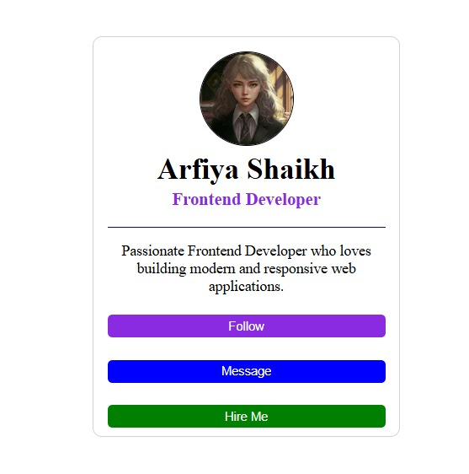

Description of the Project- Frontend Developer Profile Card
The image shows a responsive Frontend Developer Profile Card designed using HTML and CSS. The project represents a social-media-style professional profile and demonstrates basic web design and frontend development basic web design and frontend development concepts.

Key features shown in the figure:
- Profile image displayed in a circular format.
- Name and professional designation displayed prominently.
- A short professional bio.
- Three interactive-style buttons: Follow, Message, and Hire Me.
- A rounded rectangular card layout with a clean border.
- Text is centered to provide a simple and organized appearance.
- The design focuses on user interface (UI), alignment, typography, colors, spacing, and responsive web design.


Description of the project- Shop-Zone E-Commerce Website Home Page
The image shows the home page of an e-commerce website named “Shop-Zone”. The website is designed with a clean and modern user interface for displaying and selling products online.
The top navigation bar contains the Shop-Zone logo along with navigation options such as Home, Products, Categories, About Us, and Contact. The Home option is highlighted to indicate the currently active page.

Purpose
The interface demonstrates the basic structure of an e-commerce website, focusing on product presentation, navigation, pricing, customer ratings, and purchasing functionality. It provides an user-friendly layout that allows customers to browse products and proceed toward purchasing them.
Technologies/Concepts demonstrated:
HTML, CSS, responsive web design, navigation bar, product cards, buttons, pricing display, ratings, and basic e-commerce UI design.

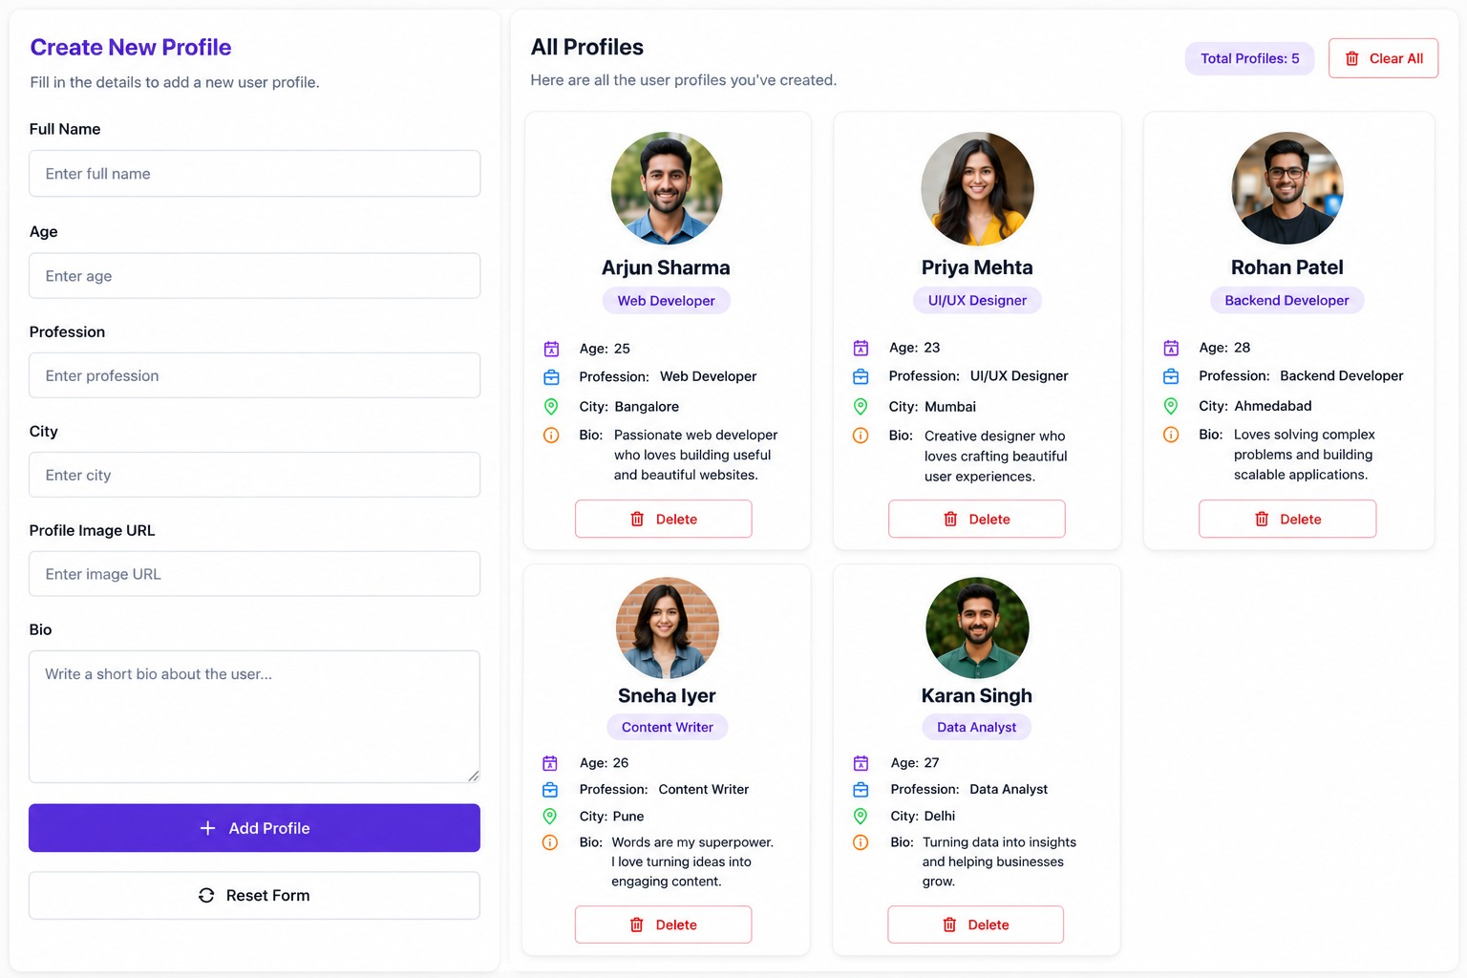.

Description of the image- User Profile Management System
The image shows a User Profile Management System designed to create, display, and manage user profiles through a simple and user-friendly web interface. The interface is divided into two main sections.

Technical Purpose:
This interface demonstrates the implementation of form handling, dynamic profile creation, data display, and CRUD operations (Create, Read, and Delete) in a web application. It can be used as practical example of frontend development and user interface design during the internship.

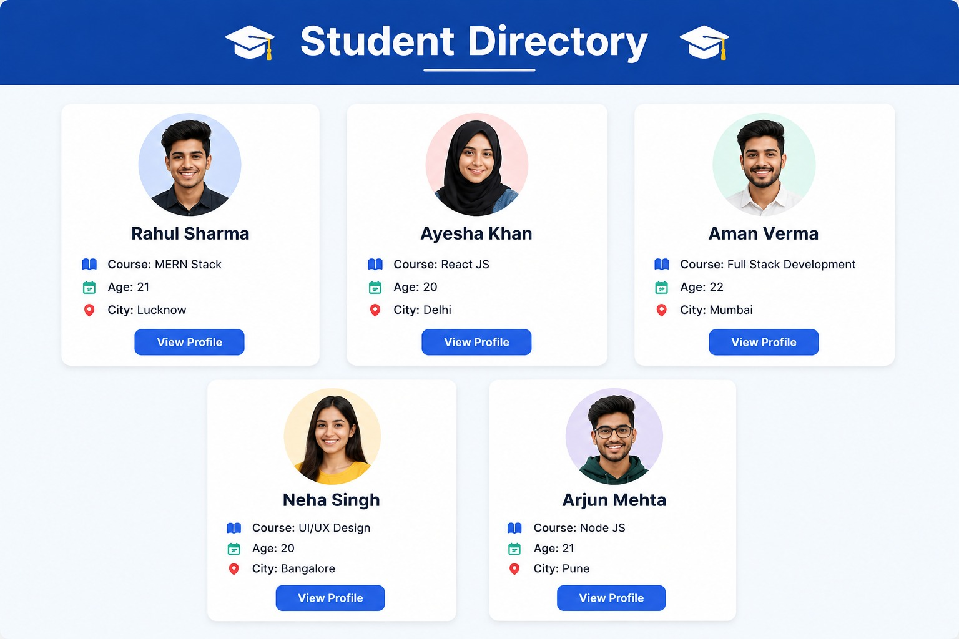

Description of the image- Student Directory Interface
The image shows a Student Directory web interface designed to display student information in an organized and user-friendly manner. The page contains a prominent “Student Directory” heading with an academic-themed graduation cap icon.

Key Features:
- Student directory heading and academic-themed design.
- Individual cards for each student.
- Profile image, name, course, age, and city information.
- Icons for better visual representation of data.
- “View Profile” button for accessing detailed profiles.
- Grid-based layout for organized presentation.
- Clean, responsive, and user-friendly UI design.

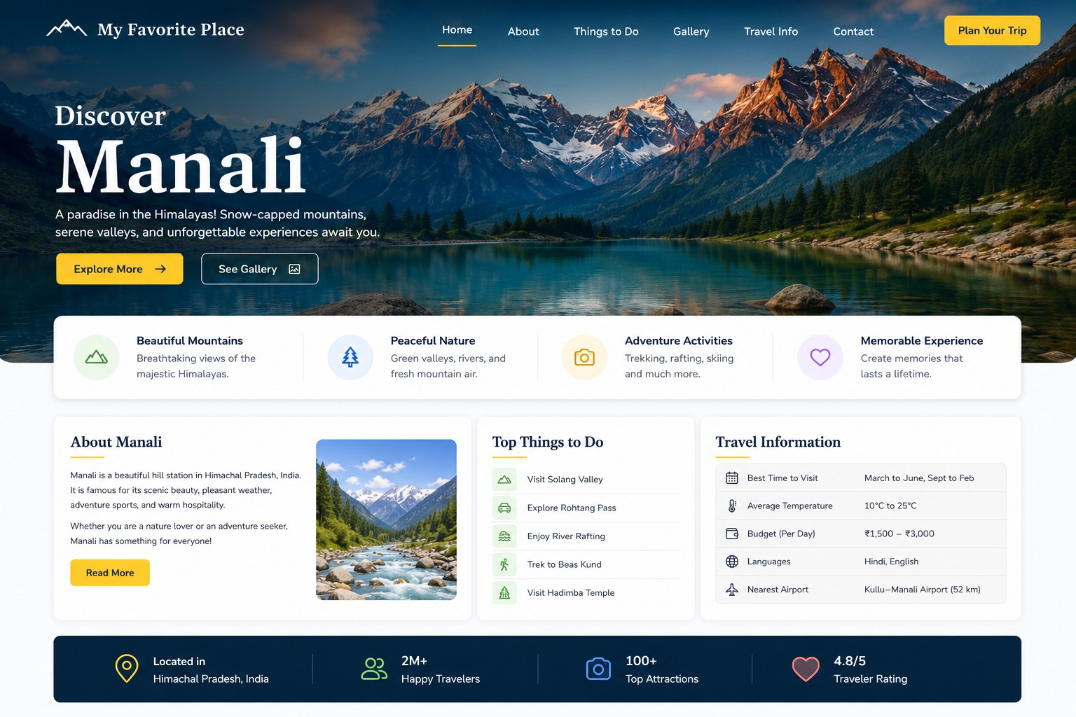

Description of the image- Travel Website Homepage
The image represents the homepage of a travel and tourism website designed to promote Manali, Himachal Pradesh as a tourist destination. The webpage uses a modern, attractive, and user-friendly interface with a scenic Himalayan background.

Key Features Shown in the Interface:
- Navigation Bar
- Hero Section
- Feature Highlights
- About Manali section
- Travel Information

Objective
The main objective of this webpage is to provide tourists with essential information about Manali and encourage them to explore its attractions and plan a trip. It demonstrates the use of web design, UI/UX principles, navigation components, responsive card layouts, icons, images, and call-to-action buttons in developing an attractive tourism website.
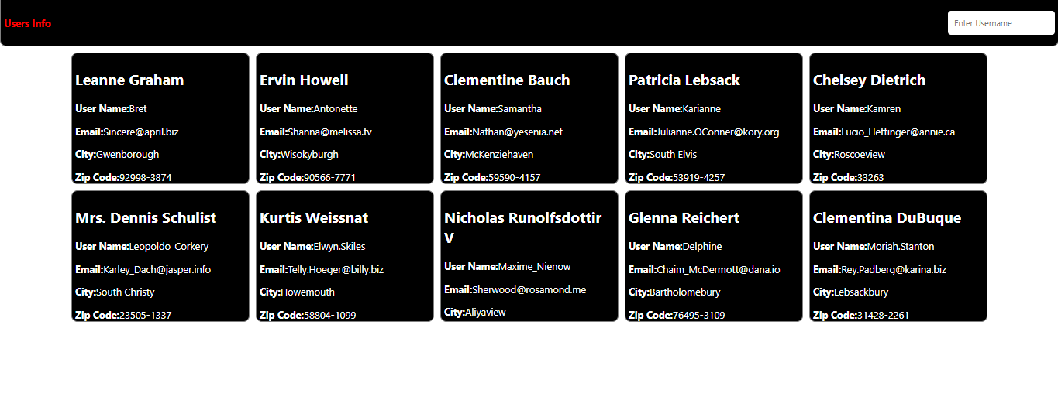

Description of the image- Travel Website Homepage
This project is a simple User Information Management Interface developed using HTML, CSS and JavaScript. It fetches user data from the JSON Placeholder API and displays the information in individual cards. Each card shows the user's name, username, email, city and ZIP code. A search field is provided to find users based on username, email, city or ZIP code.
Key Features Shown in the Interface
- Displays user information in card format.
- Fetches user data using a REST API.
- Shows user's Name, Username, Email, City and ZIP Code.
- Provides a search box for finding users.
- Supports searching by username, email, city and ZIP code.
- Uses responsive flexbox layout for displaying cards.
- Provides a simple black-and-white user interface.
- Automatically reloads all users when the search field is cleared.
- Uses JavaScript DOM manipulation to dynamically create and update cards.
Objective
The main objective of this project is to understand how to fetch data from an API and display it dynamically on a web page using JavaScript. It also helps in learning DOM manipulation, event handling, array methods, searching/filtering data, and creating a simple responsive user interface using HTML and CSS.
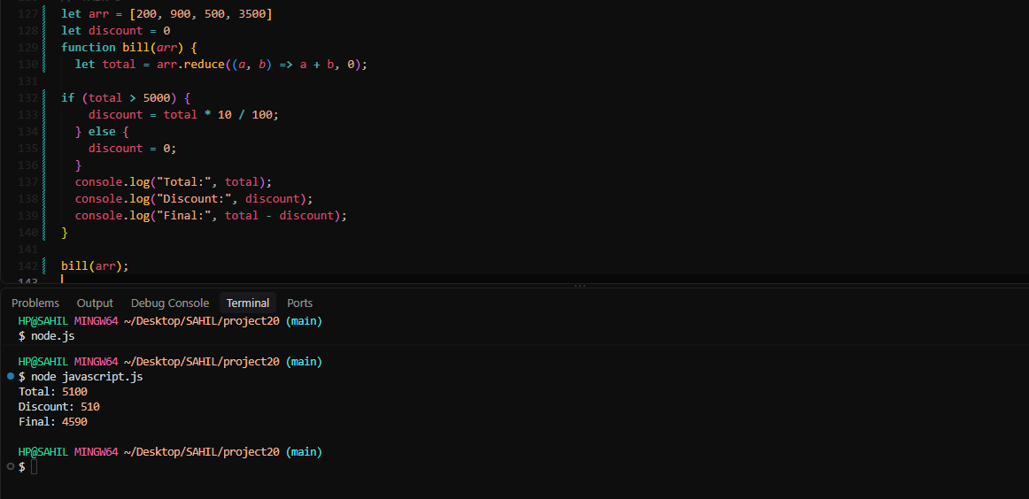

Description of this image- JAVA Script Task
This project is a simple Billing and Discount Calculation Program developed using JavaScript. It takes an array of item prices, calculates the total bill using the reduce () method, and applies a 10% discount when the total amount is greater than ₹5000. The program then displays the total
Key Features Shown in the Interface
- Stores item prices in an array.
- Calculates the total bill using the reduce () method.
- Checks whether the total amount is greater than ₹5000.
- Applies a 10% discount if the condition is satisfied.
- Calculates the final payable amount after discount.
- Displays Total, Discount and Final Amount in the console.
- Uses JavaScript functions and conditional statements.
Objective
The main objective of this project is to understand the use of JavaScript arrays, functions, reduce () method and conditional statements for performing billing calculations. It helps in learning how to calculate totals, apply discounts based on conditions, and display the calculated results using the console.

Chapter 9 – Special / Challenging Experiences
Every practical training experience involves problems that cannot always be understood from theory alone. Frontend development contains many small details involving browser rendering, CSS behavior, asynchronous operations and component state. The following challenges describe typical learning situations associated with the technologies covered in the internship.

9.1 Difficulty in Understanding CSS Layout
One early challenge was understanding why elements did not appear in the expected position. Differences between normal document flow, Flexbox, Grid, margins and padding initially created confusion. Inspecting elements through browser developer tools and changing one CSS rule at a time helped identify the cause.

9.2 Responsive Design Problems
A page that looked correct on a desktop screen could become crowded on a mobile screen. Horizontal overflow, fixed widths and large images were common causes. Flexible dimensions, wrapping, media queries and responsive images helped resolve these problems.

9.3 JavaScript Errors
JavaScript errors sometimes resulted from incorrect syntax, variable names or assumptions about DOM elements. Reading console messages carefully and tracing the code step by step improved debugging ability.

9.4 React State and Props Confusion
Understanding the difference between props and state was an important learning challenge. Props represent data passed into a component, while state represents data managed by the component that may change over time. Building small examples made this distinction clearer.

9.5 Component Rendering Issues
Lists in React require stable keys, and conditional rendering must be written carefully. Missing keys, incorrect conditions or state updates could result in unexpected output. Reviewing component data flow and using smaller components made troubleshooting easier.

9.6 Time Management
Completing multiple learning exercises and project tasks within the available internship period required planning. Breaking larger assignments into smaller objectives helped maintain progress and allowed time for testing and documentation.

9.7 Problem-Solving Approach
Step | Action
1 | Clearly reproduce the problem.
2 | Read the browser or application error message.
3 | Inspect the related HTML, CSS or React component.
4 | Identify the smallest likely cause.
5 | Make one controlled change.
6 | Test the result.
7 | Document the solution when useful.

Chapter 10 – Conclusion

The three-month Frontend Web Development internship provided valuable practical exposure to the technologies and workflow used to create modern web interfaces. The training began with HTML, which established the structure of webpages, and CSS, which was used to control presentation, layout and responsiveness.
JavaScript extended the learning from static content to interactive behavior. Through variables, functions, conditions, events and DOM manipulation, the internship demonstrated how programming logic can respond to user actions and modify the interface.
React.js introduced a more structured approach to frontend development through reusable components, JSX, props, state and hooks. The component-based model helped demonstrate how larger interfaces can be divided into smaller and maintainable units.
Testing and debugging were important parts of the practical experience. Browser developer tools, console messages and responsive testing provided methods for identifying and correcting problems. These activities strengthened patience, attention to detail and logical problem-solving ability.
In addition to technical skills, the internship helped develop professional habits such as organizing files, following task sequences, managing time, accepting feedback and documenting work. The experience therefore helped bridge the gap between classroom knowledge and practical software development.
The internship has created a strong foundation for further learning in advanced React development, API integration, backend technologies, databases, authentication, deployment and full-stack web development. Continuous practice and project-based learning will be important for further professional growth.

Chapter 11 – References / Sources of Information

The following resources are appropriate references for the frontend technologies covered in this report. Organization-specific training material and guidance should also be added where applicable.
- HTML Living Standard / Web platform documentation – MDN Web Docs.
- CSS reference and guides – MDN Web Docs.
- JavaScript reference and guides – MDN Web Docs.
- React documentation – official React documentation.
- Node.js documentation – official Node.js documentation.
- npm documentation – official npm documentation.
- Git documentation – official Git documentation.
- Browser developer tools documentation and practical exercises.
- Training notes, classroom material and guidance provided during internship.
Note: Replace or supplement the above with the exact websites, books, internal training material and project documentation actually consulted during the internship.

