**Simple Gan Implementation**

**Paper : https://arxiv.org/pdf/1406.2661.pdf**

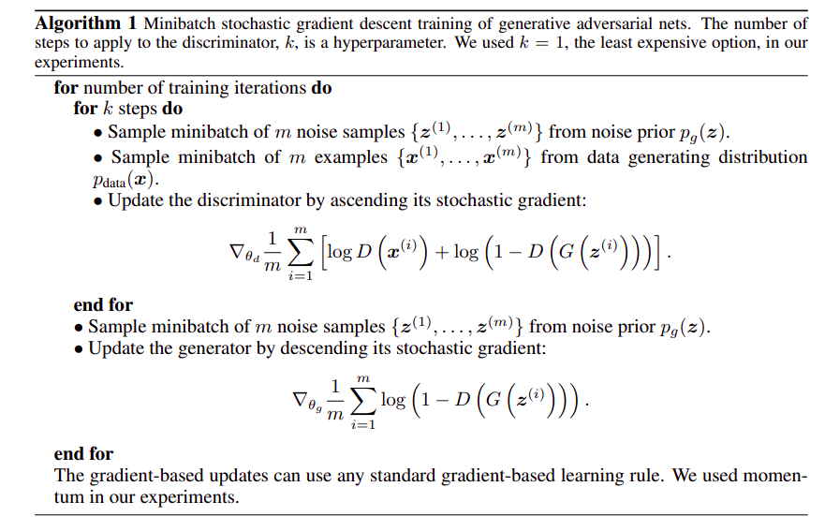

| *# -*- coding: utf-8 -*-* """ Created on Thu Jun 16:11:54 2021  @author: siddy """  **import** torch **import** torch.nn **as** nn **import** torch.optim **as** optim **import** torchvision **import** torchvision.datasets **as** datasets **from** torch.utils.data **import** DataLoader **import** torchvision.transforms **as** transforms **from** torch.utils.tensorboard **import** SummaryWriter *# to print to tensorboard*   **class** **Discriminator**(nn.Module):  **def** **__init__**(self, in_features):  super().__init__()  self.disc = nn.Sequential(  nn.Linear(in_features, 128),  nn.LeakyReLU(0.01),  nn.Linear(128, 1),  nn.Sigmoid(),  )   **def** **forward**(self, x):  **return** self.disc(x)   **class** **Generator**(nn.Module):  **def** **__init__**(self, z_dim, img_dim):  super().__init__()  self.gen = nn.Sequential(  nn.Linear(z_dim, 256),  nn.LeakyReLU(0.01),  nn.Linear(256, img_dim),  nn.Tanh(), *# normalize inputs to [-1, 1] so make outputs [-1, 1]*  )   **def** **forward**(self, x):  **return** self.gen(x)   *# Hyperparameters etc.* device = "cuda" **if** torch.cuda.is_available() **else** "cpu" lr = 3e-4 z_dim = 64 image_dim = 28 * 28 * 1 *# 784* batch_size = 32 num_epochs = 50  disc = Discriminator(image_dim).to(device) gen = Generator(z_dim, image_dim).to(device) fixed_noise = torch.randn((batch_size, z_dim)).to(device) transforms = transforms.Compose(  [transforms.ToTensor(), transforms.Normalize((0.5,), (0.5,)),] )  dataset = datasets.MNIST(root="dataset/", transform=transforms, download=**False**)   loader = DataLoader(dataset, batch_size=batch_size, shuffle=**True**)  opt_disc = optim.Adam(disc.parameters(), lr=lr) opt_gen = optim.Adam(gen.parameters(), lr=lr) criterion = nn.BCELoss()  writer_fake = SummaryWriter(f"logs/fake") writer_real = SummaryWriter(f"logs/real") step = 0  **for** epoch **in** range(num_epochs):  **for** batch_idx, (real, _) **in** enumerate(loader):  real = real.view(-1, 784).to(device)  batch_size = real.shape[0]   *### Train Discriminator: max log(D(x)) + log(1 - D(G(z)))*  noise = torch.randn(batch_size, z_dim).to(device)  fake = gen(noise)  disc_real = disc(real).view(-1)  lossD_real = criterion(disc_real, torch.ones_like(disc_real))  disc_fake = disc(fake).view(-1)  lossD_fake = criterion(disc_fake, torch.zeros_like(disc_fake))  lossD = (lossD_real + lossD_fake) / 2  disc.zero_grad()  lossD.backward(retain_graph=**True**)  opt_disc.step()   *### Train Generator: min log(1 - D(G(z))) <-> max log(D(G(z))*  *# where the second option of maximizing doesn't suffer from*  *# saturating gradients*  output = disc(fake).view(-1)  lossG = criterion(output, torch.ones_like(output))  gen.zero_grad()  lossG.backward()  opt_gen.step()   **if** batch_idx == 0:  print(  f"Epoch [{epoch}/{num_epochs}] Batch {batch_idx}/{len(loader)} \  Loss D: {lossD:.4f}, loss G: {lossG:.4f}"  )   **with** torch.no_grad():  fake = gen(fixed_noise).reshape(-1, 1, 28, 28)  data = real.reshape(-1, 1, 28, 28)  img_grid_fake = torchvision.utils.make_grid(fake, normalize=**True**)  img_grid_real = torchvision.utils.make_grid(data, normalize=**True**)   writer_fake.add_image(  "Mnist Fake Images", img_grid_fake, global_step=step  )  writer_real.add_image(  "Mnist Real Images", img_grid_real, global_step=step  )  step += 1 |
| --- |