Multimodal Emotion Recognition

In this project we are developing multi-model application to detect emotion from various type of digital data such as Text, Speech and Images. To detect emotion we have trained and evaluate performance of multiple AI algorithms such as Xception, MobileNetV2, ResNet50 and VGG19. Each algorithm performance is evaluated in terms of accuracy, precision, recall and FSCORE.

All training datasets are downloaded from KAGGLE repository by using terms like Speech Emotion, Text Emotion and facial expression images.

To implement this project we have designed following modules

1. Upload Emotion Dataset: using this module we can load dataset to application
2. Pre-process Dataset: using this module we will apply processing techniques such as normalization, shuffling and splitting dataset into train and test and split ratio for training is 80% and testing ratio is 20%
3. Train Multimodal Images: using this module we will train and load all 4 algorithms and then perform prediction on test images data to calculate accuracy and other metrics
4. Train Multimodal Speech: using this module we will train and load all 4 algorithms and then perform prediction on test speech data to calculate accuracy and other metrics
5. Train Multimodal Text: using this module we will train and load all 4 algorithms and then perform prediction on test TEXT data to calculate accuracy and other metrics
6. Accuracy Comparison Graph: will plot comparison graph between all algorithm performance
7. Predict Emotion from Webcam: this module will open a webcam and then prediction emotion using live faces
8. Predict Speech Emotion: using this module will upload speech audio file and then best performing model will be applied to predict emotion from speech audio
9. Predict Text Emotion: using this module will upload text file with sentences and then best performing model will prediction emotion from TEXT.

SCREEN SHOTS

To run project double click on ‘run.bat’ file to get below screen

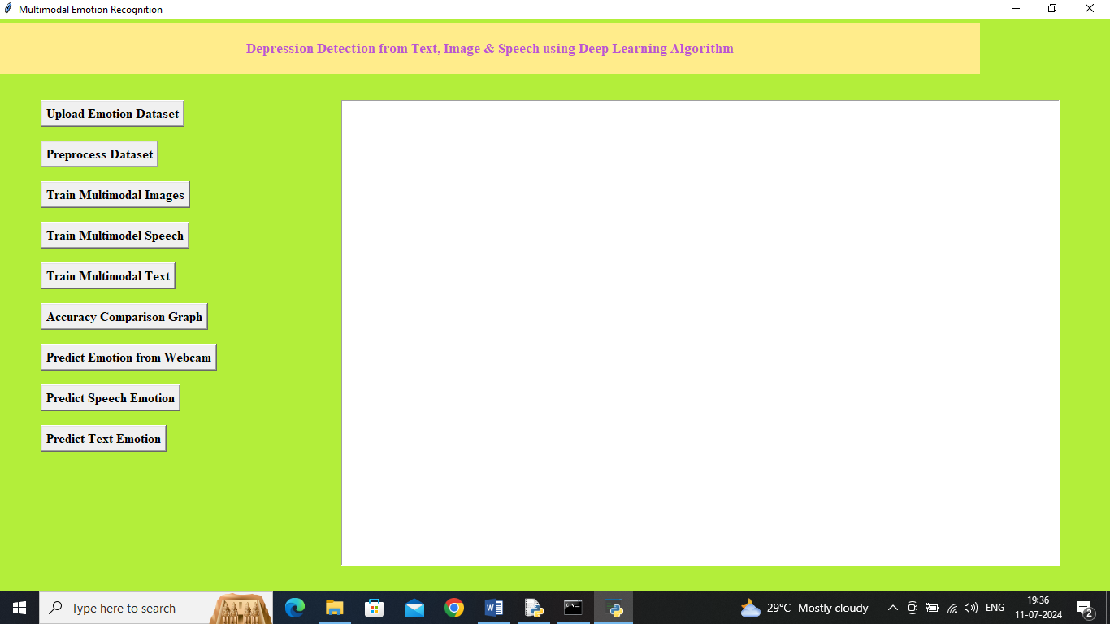

In above screen click on ‘Upload Emotion Dataset’ button to load dataset and get below page

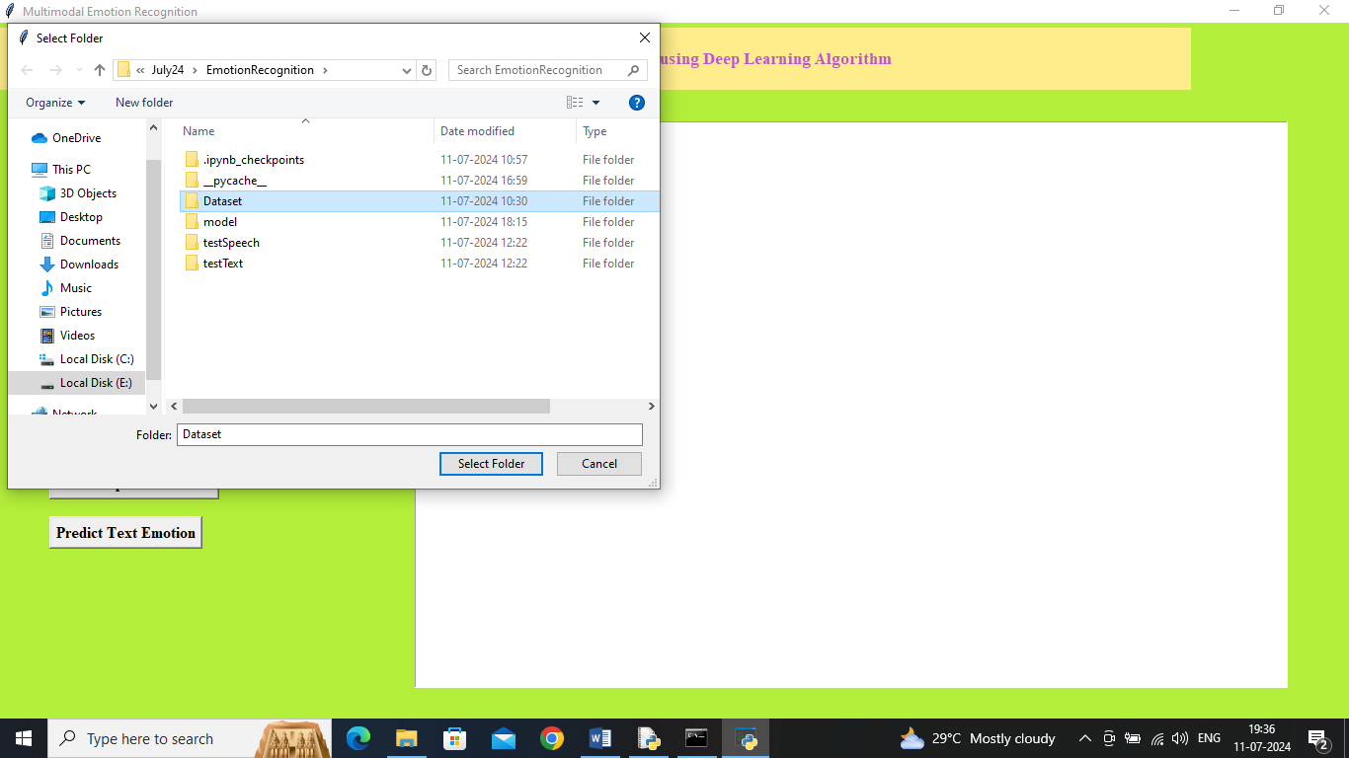

In above screen selecting and uploading entire ‘Dataset’ folder and then click on ‘Select Folder’ button to load dataset and get below page

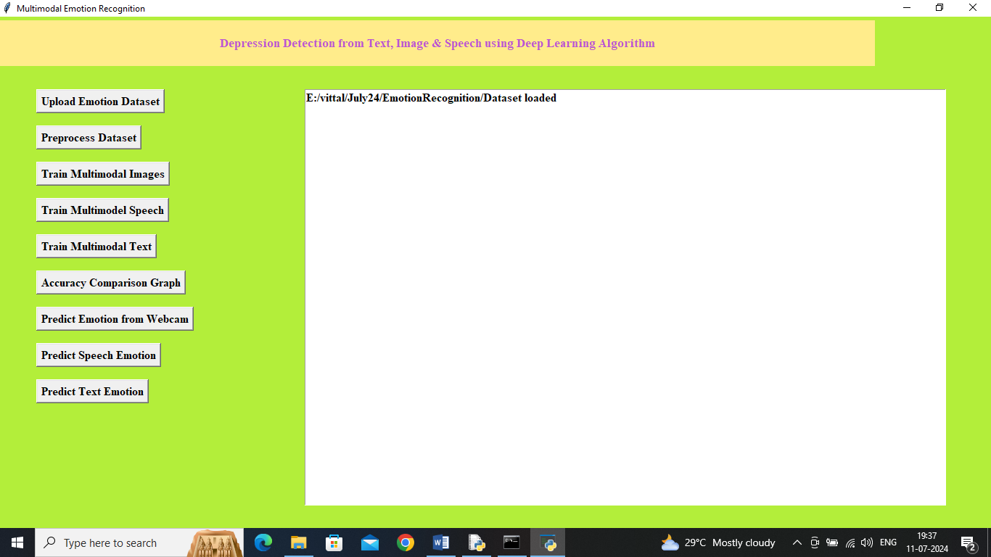

In above screen dataset loaded and now click on ‘Pre-process Dataset’ button to process dataset and get below page

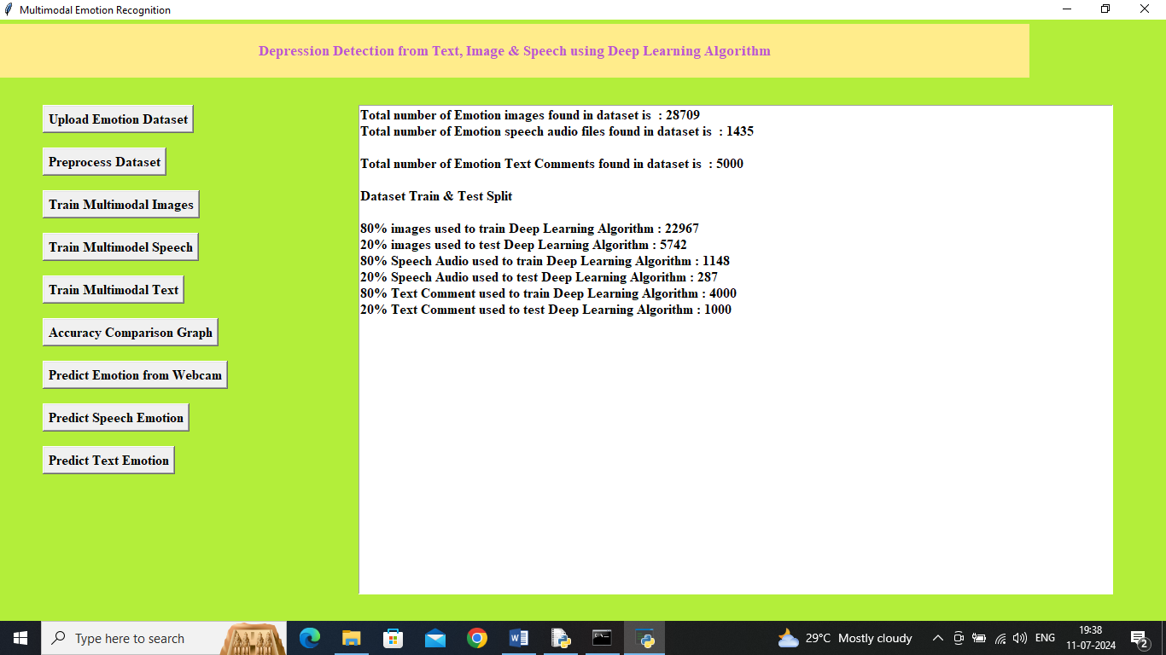

In above screen can see dataset size of each format and then can see train and test size of each dataset and now click on ‘Train Multimodal Images’ button to train all 4 algorithms on facial images and get below page

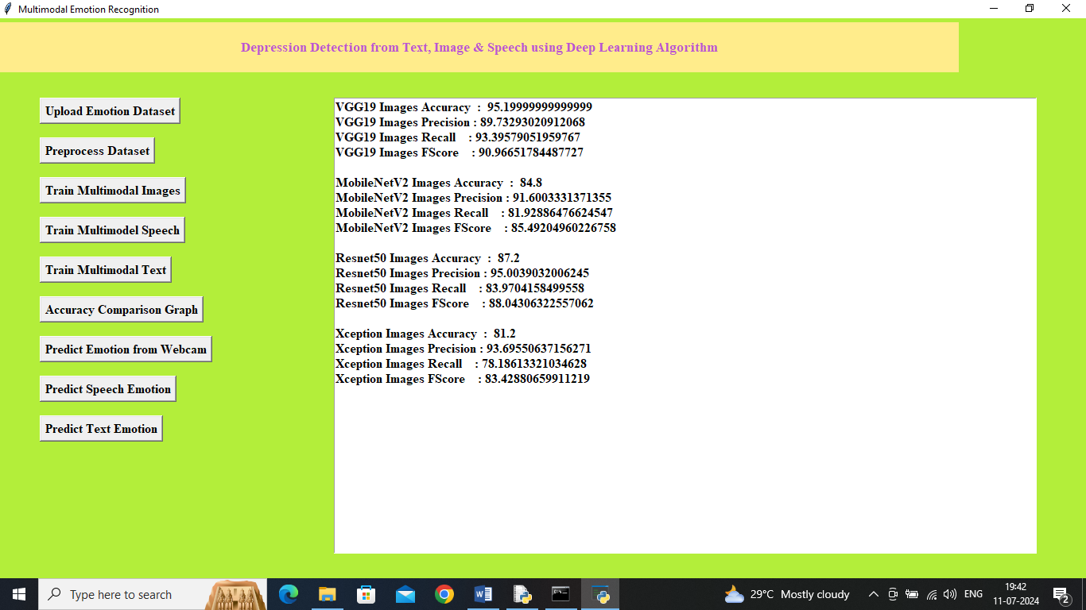

In above screen can see performance of all algorithm on face expression images and now click on ‘Train Multimodal Speech’ button to train all algorithms on speech data and get below page

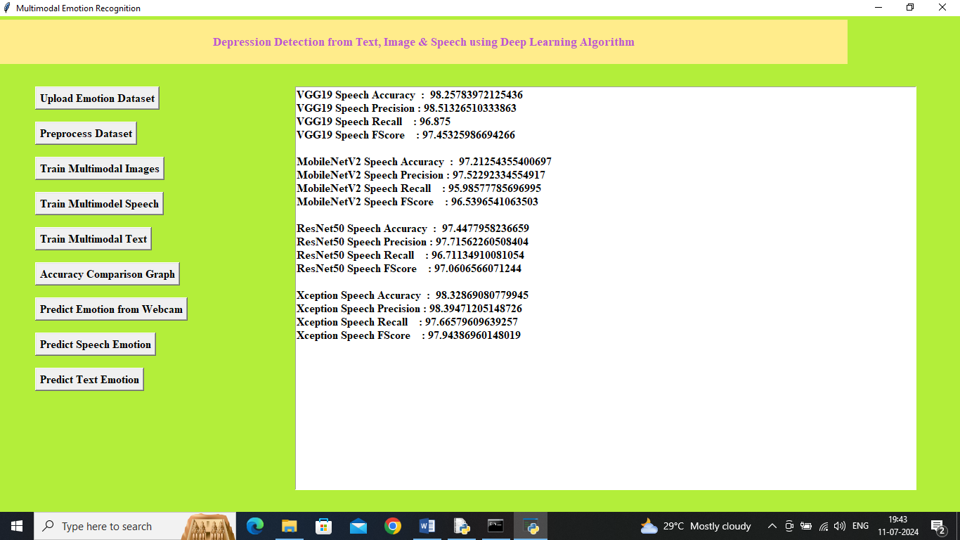

In above screen can see performance of all algorithms on Speech dataset and now click on ‘Train Multimodal Text’ button to train all algorithms on TEXT data and get below output

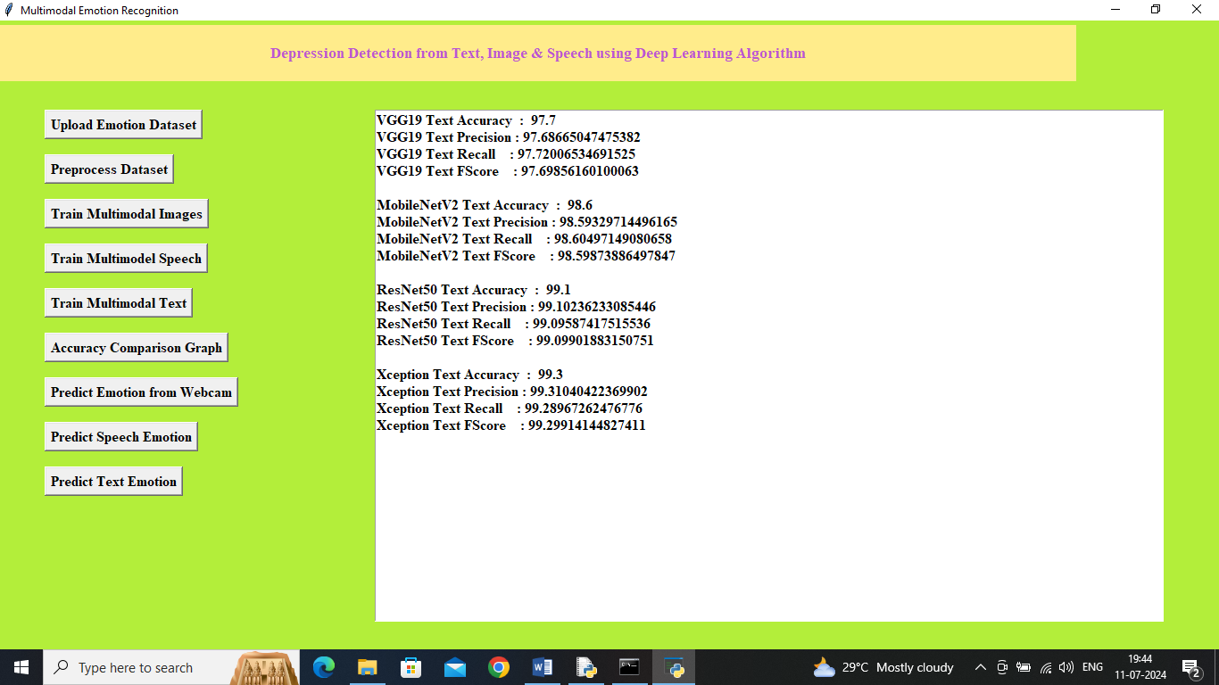

In above screen can see performance of all algorithms on TEXT data and then click on ‘Accuracy Comparison Graph’ button to get below graph

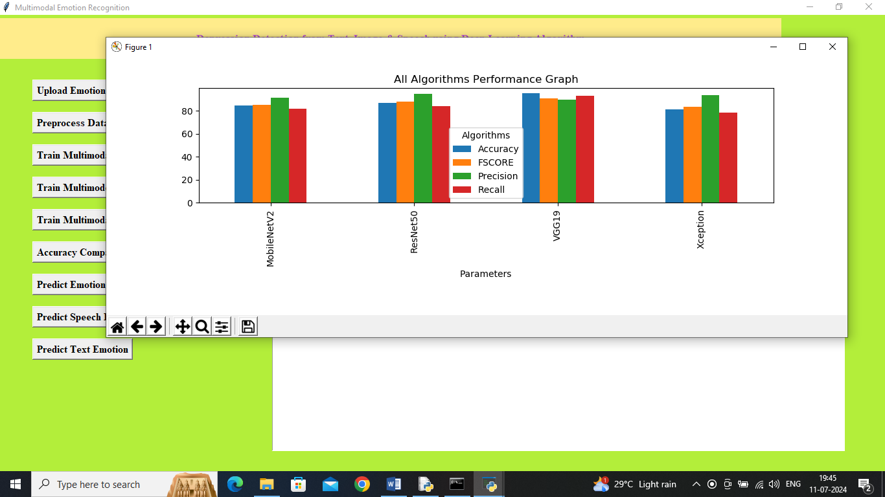

In above graph x-axis represents algorithm names and y-axis represents accuracy and other metrics in different colour bars and in all algorithms VGG19 got better performance for facial emotion. Now close above graph and then click on ‘Predict Emotion from Webcam’ button to get below output

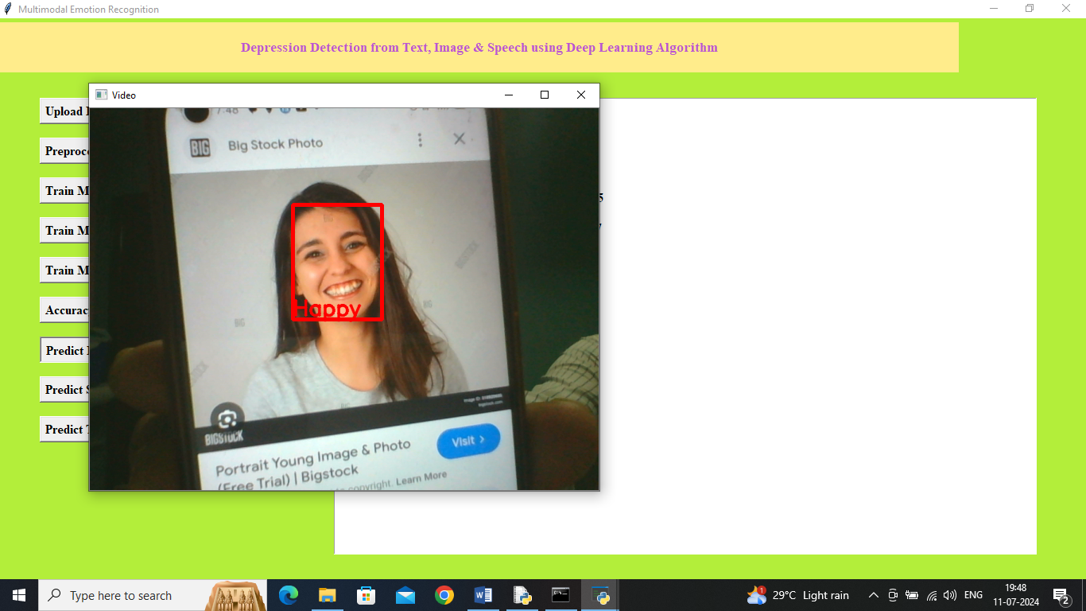

In above screen webcam started and now show your faces to webcam to detect emotion and now click on ‘Predict Speech Emotion’ button to get below output

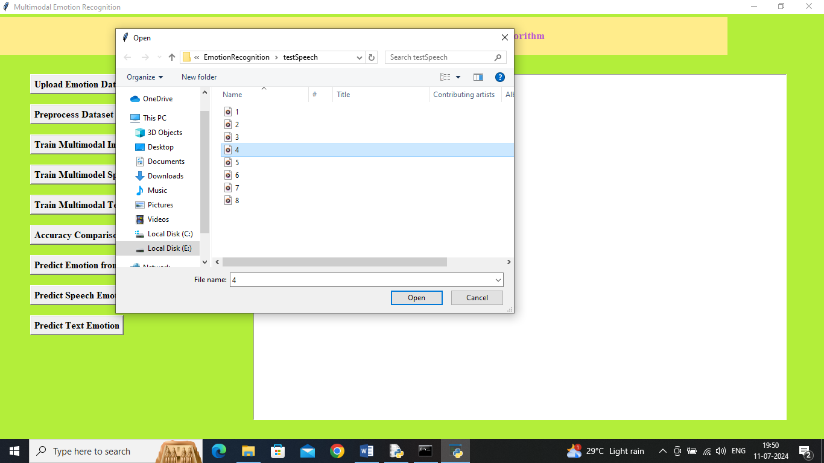

In above screen select and upload ‘audio’ file and then click on ‘Open’ button to get below output

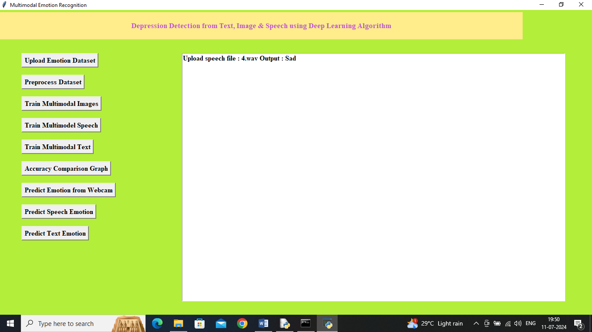

In above screen in text area output can see uploaded audio file emotion predicted as ‘Sad’ and similarly you can upload and test other audio files. Now click on ‘Predict Text Emotion’ button to upload ‘text data file’ and get below output

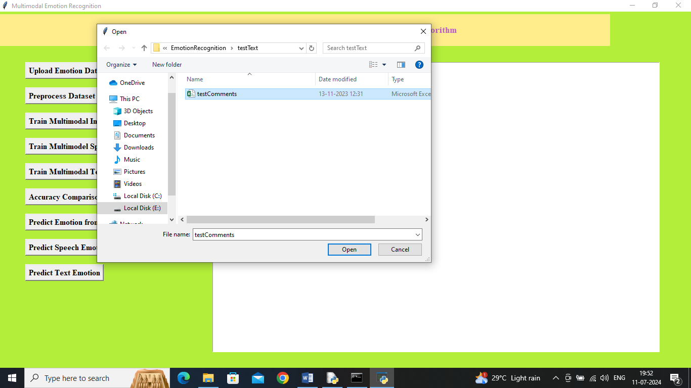

In above screen selecting and uploading ‘test comments’ file and then click on ‘Open’ button to get below output

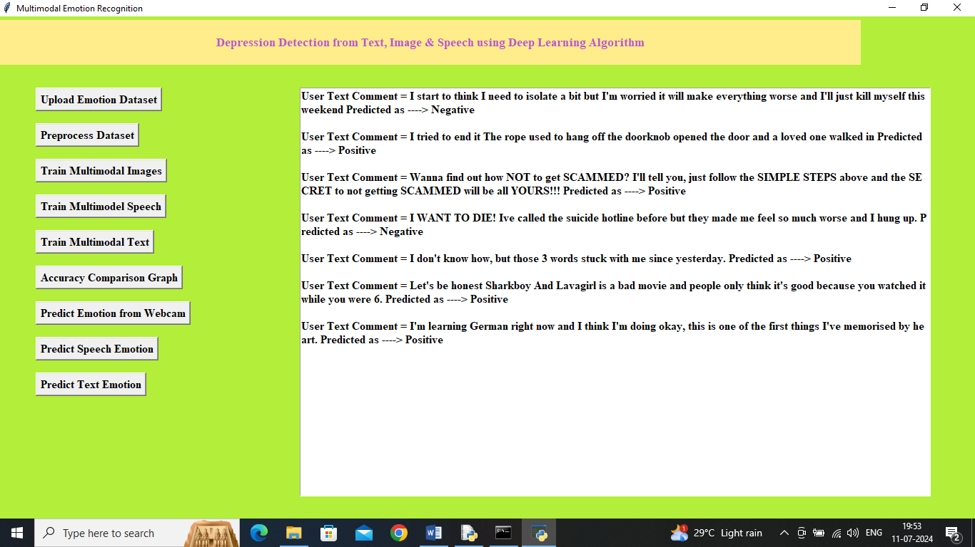

In above screen before arrow symbol --🡪 can see input test sentence from file and after arrow symbol can see predicted emotion as positive and negative.

So by using above application we have done emotion prediction using multiple data versions.