NLP Assignment 4 Report (21L-5673 & 21L-5641)

Wandb

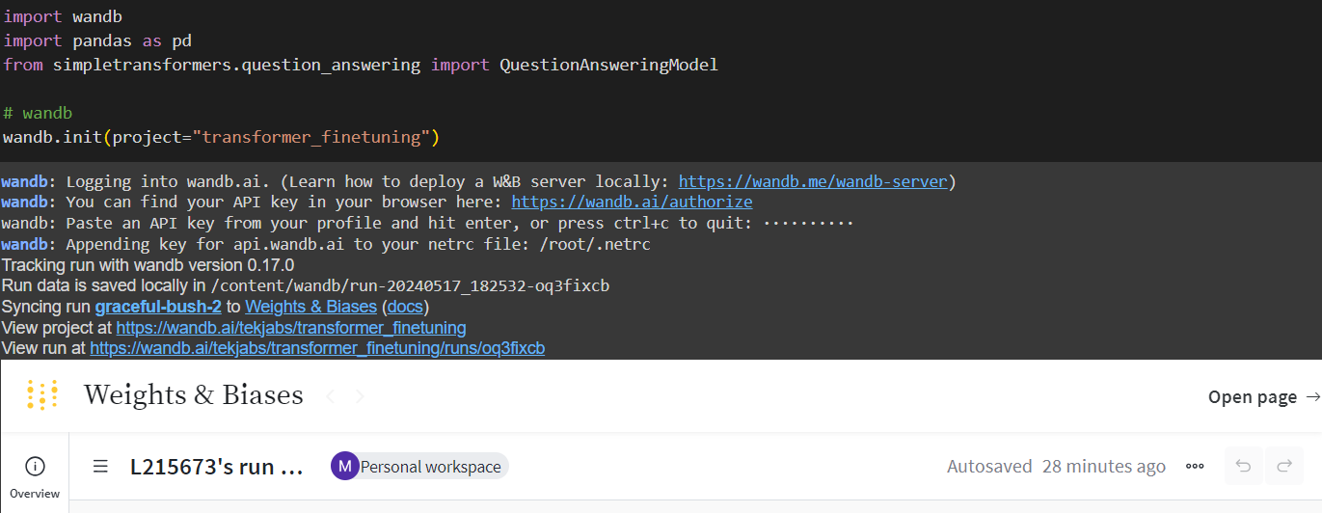

BLEU Scores

Hyperparameters:

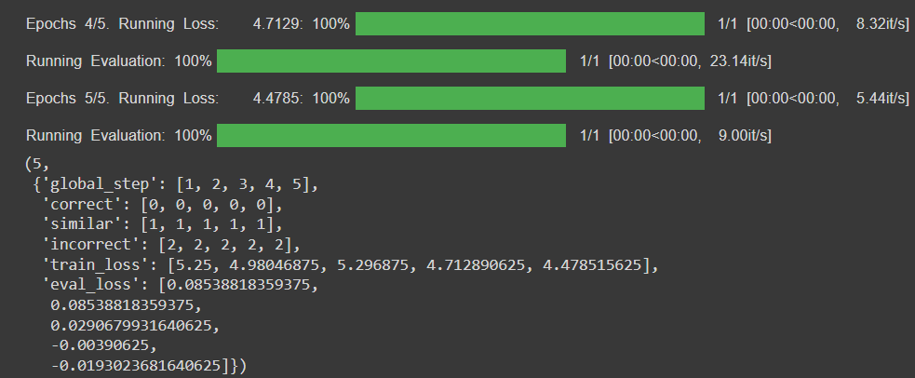

BERT Results:

