**Assignment-1**

Code

<!DOCTYPE html>

<html lang="en">

<head>

    <meta charset="utf-8">

    <meta name="author" content="Rahul Hosakoti">

    <meta name="viewport" content="width=device-width, initial-scale=1">

    <link rel="icon" href="../../../img/icon.png">

    <link href="https://cdn.jsdelivr.net/npm/bootstrap@5.2.3/dist/css/bootstrap.min.css" rel="stylesheet" integrity="sha384-rbsA2VBKQhggwzxH7pPCaAqO46MgnOM80zW1RWuH61DGLwZJEdK2Kadq2F9CUG65" crossorigin="anonymous">

    <title>Bootstrap | Assignment-1</title>

</head>

<body>

    <h2><u>Bootstrap 5 Containers:</u></h2>

    <div class="container-fluid bg-dark text-white py-3">

        <h2>Responsive containor</h2>

        <div class="container bg-primary text-center">

            <h3>My First Bootstrap Page</h3>

            <h6>This part is inside a .container class</h6>

            <p>The .container class provides a responsive fixed width container</p>

            <p>Resize the browser window to see that the container width will change at different breakpoint</p>

        </div>

        <h2>Fluid containers</h2>

        <div class="container-fluid bg-success text-center">

            <h2>My First Bootstrap Page</h2>

            <p>This part is inside a .container-fluid class.</p>

            <p>The .container-fluid class provides a full width container, spanning the entire width of the viewport.</p>

        </div>

    </div>

    <script src="https://cdn.jsdelivr.net/npm/bootstrap@5.2.3/dist/js/bootstrap.bundle.min.js" integrity="sha384-kenU1KFdBIe4zVF0s0G1M5b4hcpxyD9F7jL+jjXkk+Q2h455rYXK/7HAuoJl+0I4" crossorigin="anonymous"></script>

</body>

</html>

Output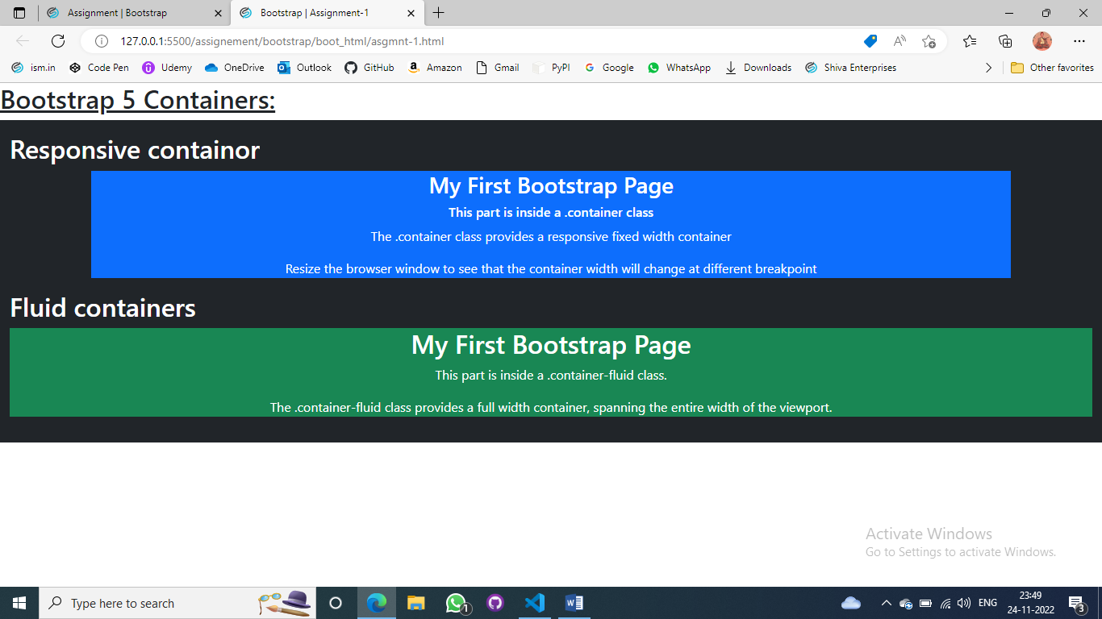

**Assignment-2**

Code

<!DOCTYPE html>

<html lang="en">

<head>

    <meta charset="utf-8">

    <meta name="author" content="Rahul Hosakoti">

    <meta name="viewport" content="width=device-width, initial-scale=1">

    <link rel="icon" href="../../../img/icon.png">

    <link href="https://cdn.jsdelivr.net/npm/bootstrap@5.2.3/dist/css/bootstrap.min.css" rel="stylesheet" integrity="sha384-rbsA2VBKQhggwzxH7pPCaAqO46MgnOM80zW1RWuH61DGLwZJEdK2Kadq2F9CUG65" crossorigin="anonymous">

    <title>Bootstrap | Assignment-2</title>

</head>

<body>

    <h2><u>Container Border and Color:</u></h2>

    <div class="container border border-light bg-light mb-3 p-4">

        <h4>My First Bootstrap Page</h4>

        <p>This container has a border and some extra padding and margin</p>

    </div>

    <div class="container border border-dark bg-dark mb-2 p-4 text-white">

        <h4>My First Bootstrap Page</h4>

        <p>This container has a dark baground color and a white text, and some extra padding and margin</p>

    </div>

    <div class="container border border-primary bg-primary mb-2 p-4 text-white">

        <h4>My First Bootstrap Page</h4>

        <p>This container has a blue baground color and a white text, and some extra padding and margin</p>

    </div>

    <script src="https://cdn.jsdelivr.net/npm/bootstrap@5.2.3/dist/js/bootstrap.bundle.min.js" integrity="sha384-kenU1KFdBIe4zVF0s0G1M5b4hcpxyD9F7jL+jjXkk+Q2h455rYXK/7HAuoJl+0I4" crossorigin="anonymous"></script>

</body>

</html>

Output

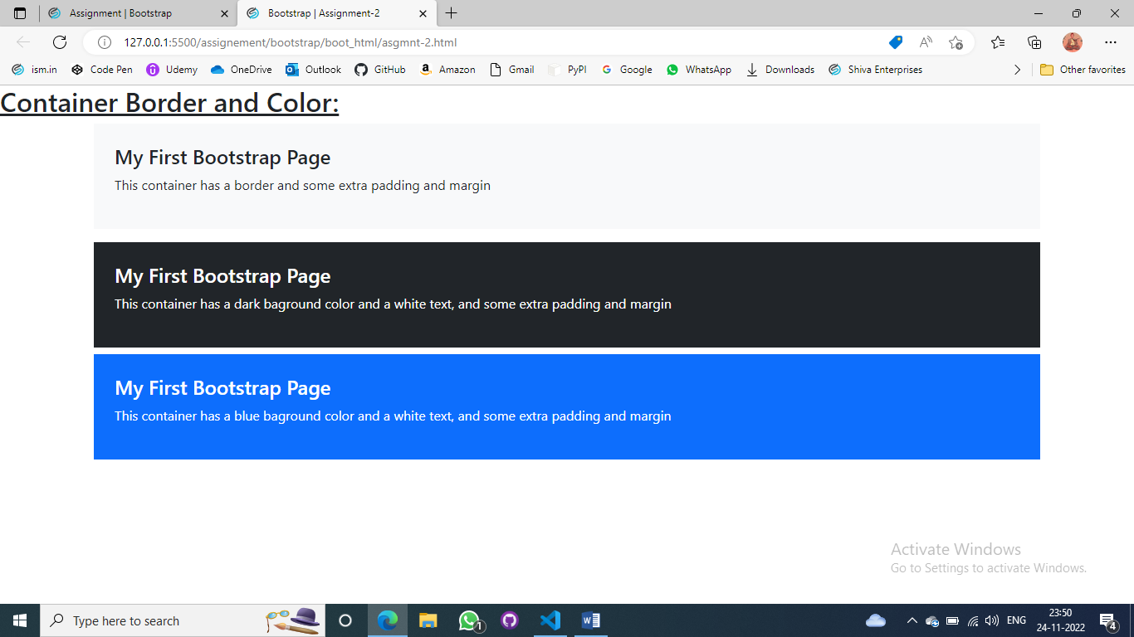

**Assignment-3**

Code

<!DOCTYPE html>

<html lang="en">

<head>

    <meta charset="utf-8">

    <meta name="author" content="Rahul Hosakoti">

    <meta name="viewport" content="width=device-width, initial-scale=1">

    <link rel="icon" href="../../../img/icon.png">

    <link href="https://cdn.jsdelivr.net/npm/bootstrap@5.2.3/dist/css/bootstrap.min.css" rel="stylesheet" integrity="sha384-rbsA2VBKQhggwzxH7pPCaAqO46MgnOM80zW1RWuH61DGLwZJEdK2Kadq2F9CUG65" crossorigin="anonymous">

    <title>Bootstrap | Assignment-3</title>

    <style>

        body{

            margin: 2%;

        }

        p{

            font-size: 30px;

            text-align: center;

            font-weight: 600;

        }

    </style>

</head>

<body>

    <h2><u>Grid:</u></h2>

    <p>Grid system</p>

    <div class="container text-start mb-3">

        <div class="row">

            <div class="col bg-primary py-3">

                Column-1

            </div>

            <div class="col bg-success py-3">

                Column-2

            </div>

            <div class="col bg-warning py-3">

                Column-3

            </div>

        </div>

    </div>

    <div class="container text-start border border-4 border-dark rounded-3 text-center text-white px-4 py-3">

        <div class="row my-2 bg-primary">

            <div class="col py-3">

                Column-1

            </div>

            <div class="col py-3">

                Column-2

            </div>

            <div class="col py-3">

                Column-3

            </div>

        </div>

        <div class="row my-2 bg-success">

            <div class="col py-3">

                Column-1

            </div>

            <div class="col py-3">

                Column-2

            </div>

            <div class="col py-3">

                Column-3

            </div>

        </div>

        <div class="row my-2 bg-warning">

            <div class="col py-3">

                Column-1

            </div>

            <div class="col py-3">

                Column-2

            </div>

            <div class="col py-3">

                Column-3

            </div>

        </div>

    </div>

    <div class="container text-start border border-4 border-dark rounded-3 text-center text-white px-4 py-3 mt-2">

        <div class="row my-2 bg-danger">

            <div class="col py-3">

                Column-1

            </div>

            <div class="col py-3">

                Column-2

            </div>

            <div class="col py-3">

                Column-3

            </div>

            <div class="col py-3">

                Column-4

            </div>

            <div class="col py-3">

                Column-5

            </div>

        </div>

        <div class="row my-2 bg-info">

            <div class="col py-3">

                Column-1

            </div>

            <div class="col py-3">

                Column-2

            </div>

            <div class="col py-3">

                Column-3

            </div>

        </div>

        <div class="row my-2 bg-success">

            <div class="col py-3">

                Column-1

            </div>

            <div class="col py-3">

                Column-2

            </div>

        </div>

    </div>

    <script src="https://cdn.jsdelivr.net/npm/bootstrap@5.2.3/dist/js/bootstrap.bundle.min.js" integrity="sha384-kenU1KFdBIe4zVF0s0G1M5b4hcpxyD9F7jL+jjXkk+Q2h455rYXK/7HAuoJl+0I4" crossorigin="anonymous"></script>

</body>

</html>

Output

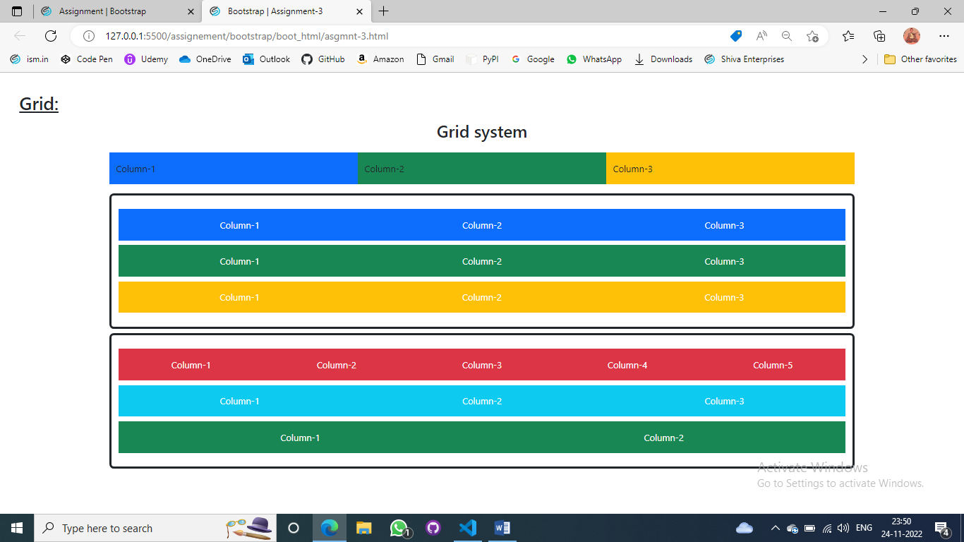

**Assignment-4**

Code

<!DOCTYPE html>

<html lang="en">

<head>

    <meta charset="utf-8">

    <meta name="author" content="Rahul Hosakoti">

    <meta name="viewport" content="width=device-width, initial-scale=1">

    <link rel="icon" href="../../../img/icon.png">

    <link href="https://cdn.jsdelivr.net/npm/bootstrap@5.2.3/dist/css/bootstrap.min.css" rel="stylesheet" integrity="sha384-rbsA2VBKQhggwzxH7pPCaAqO46MgnOM80zW1RWuH61DGLwZJEdK2Kadq2F9CUG65" crossorigin="anonymous">

    <title>Bootstrap | Assignment-4</title>

</head>

<body>

    <div class="m-4">

        <h3><u>Bootstrap Heading:</u></h3>

        <div class="px-4">

            <h1><u>Headings</u></h1>

            <p class="h1">Bootstrap Heading -1</p>

            <p class="h2">Bootstrap Heading -2</p>

            <p class="h3">Bootstrap Heading -3</h2>

            <p class="h4">Bootstrap Heading -4</h3>

            <p class="h5">Bootstrap Heading -5</h4>

            <p class="h6">Bootstrap Heading -6</h5>

        </div>

    </div>

    <script src="https://cdn.jsdelivr.net/npm/bootstrap@5.2.3/dist/js/bootstrap.bundle.min.js" integrity="sha384-kenU1KFdBIe4zVF0s0G1M5b4hcpxyD9F7jL+jjXkk+Q2h455rYXK/7HAuoJl+0I4" crossorigin="anonymous"></script>

</body>

</html>

Output

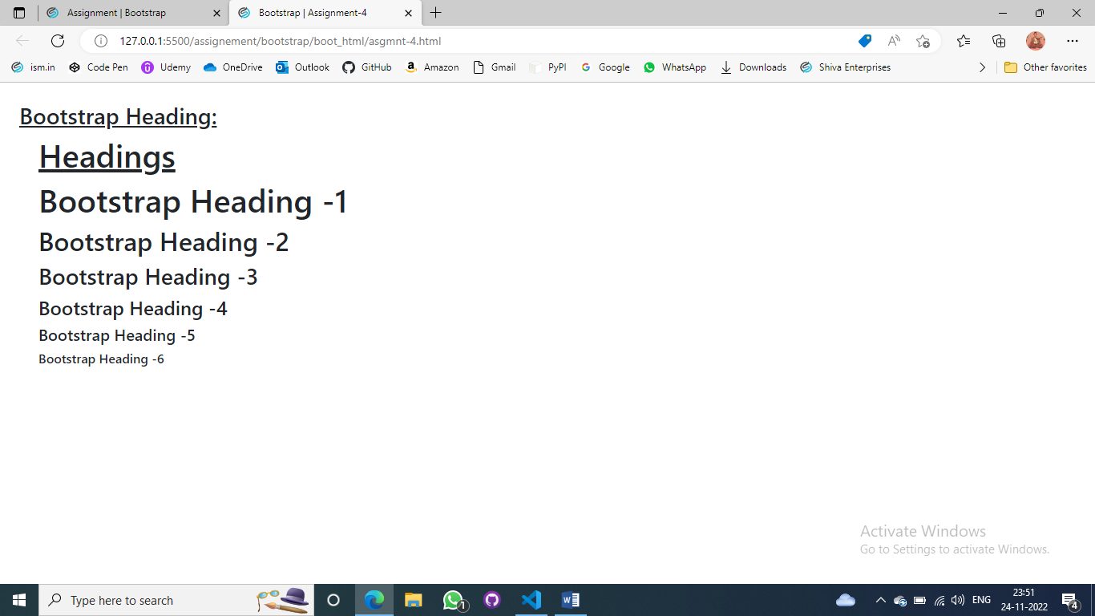

**Assignment-5**

Code

<!DOCTYPE html>

<html lang="en">

<head>

    <meta charset="utf-8">

    <meta name="author" content="Rahul Hosakoti">

    <meta name="viewport" content="width=device-width, initial-scale=1">

    <link rel="icon" href="../../../img/icon.png">

    <link href="https://cdn.jsdelivr.net/npm/bootstrap@5.2.3/dist/css/bootstrap.min.css" rel="stylesheet" integrity="sha384-rbsA2VBKQhggwzxH7pPCaAqO46MgnOM80zW1RWuH61DGLwZJEdK2Kadq2F9CUG65" crossorigin="anonymous">

    <title>Bootstrap | Assignment-5</title>

</head>

<body class="m-3">

    <h2><u>Bootstrap color:</u></h2>

    <div class="pt-3">

        <h3>Bootstrap Colors</h3>

        <div class="container mb-5">

            <h3>Background Color</h3>

            <div class="mb-2 bg-primary">This text is important.</div>

            <div class="mb-2 bg-success">This text indicates success.</div>

            <div class="mb-2 bg-info">This text represents some information.</div>

            <div class="mb-2 bg-warning">This text represents a warning.</div>

            <div class="mb-2 bg-danger">This text represents danger.</div>

            <div class="mb-2 bg-secondary">Secondary background color.</div>

            <div class="mb-2 bg-dark text-white">Dark grey background color.</div>

            <div class="mb-2 bg-light">Light grey background color.</div>

        </div>

        <div class="container-fluid bg-info">

            <h2>Text Color</h2>

            <p class="text-primary">.text-primary</p>

            <p class="text-secondary">.text-secondary</p>

            <p class="text-success">.text-success</p>

            <p class="text-danger">.text-danger</p>

            <p class="text-warning bg-dark">.text-warning</p>

            <p class="text-info bg-dark">.text-info</p>

            <p class="text-light bg-dark">.text-light</p>

            <p class="text-dark">.text-dark</p>

            <p class="text-body">.text-body</p>

            <p class="text-muted">.text-muted</p>

            <p class="text-white bg-dark">.text-white</p>

            <p class="text-black-50">.text-black-50</p>

            <p class="text-white-50 bg-dark">.text-white-50</p>

        </div>

    </div>

    <script src="https://cdn.jsdelivr.net/npm/bootstrap@5.2.3/dist/js/bootstrap.bundle.min.js" integrity="sha384-kenU1KFdBIe4zVF0s0G1M5b4hcpxyD9F7jL+jjXkk+Q2h455rYXK/7HAuoJl+0I4" crossorigin="anonymous"></script>

</body>

</html>

Output

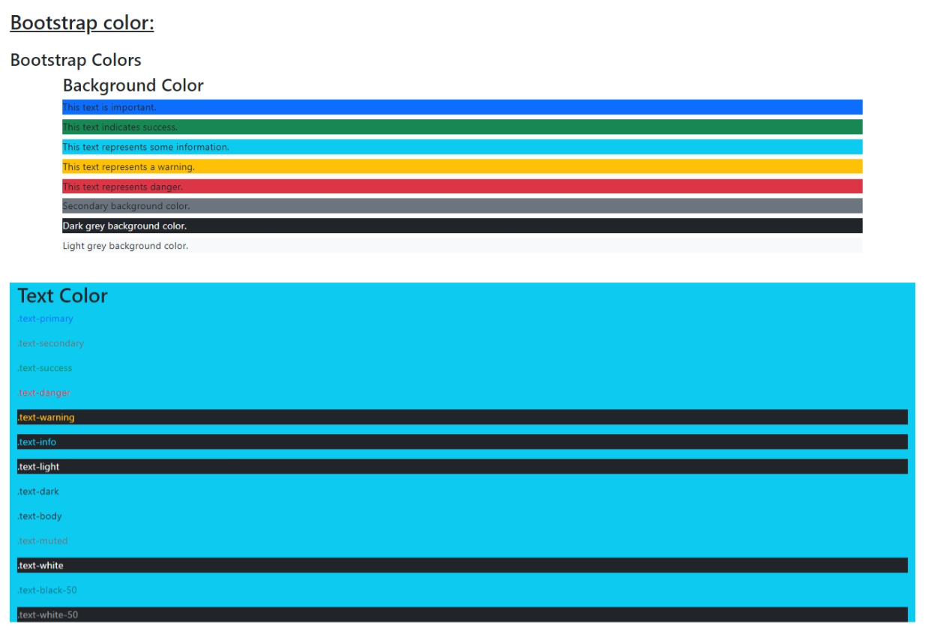

**Assignment-6**

Code

<!DOCTYPE html>

<html lang="en">

<head>

    <meta charset="utf-8">

    <meta name="author" content="Rahul Hosakoti">

    <meta name="viewport" content="width=device-width, initial-scale=1">

    <link rel="icon" href="../../../img/icon.png">

    <link href="https://cdn.jsdelivr.net/npm/bootstrap@5.2.3/dist/css/bootstrap.min.css" rel="stylesheet" integrity="sha384-rbsA2VBKQhggwzxH7pPCaAqO46MgnOM80zW1RWuH61DGLwZJEdK2Kadq2F9CUG65" crossorigin="anonymous">

    <title>Bootstrap | Assignment-6</title>

</head>

<body>

    <h2 class="m-3"><b><u>Bootstrap Images:</u></b></h2>

    <div class="container text-center">

        <h2>Bootstrap 5 Images</h2>

        <div class="container bg-secondary d-flex justify-content-between mb-5">

            <div class="px-5">

                <h4>Rounded Corners</h4>

                <img src="../img/1.jpeg" class="rounded-3" alt="football">

            </div>

            <div class="px-5">

                <h4>Circle</h4>

                <img src="../img/2.jpeg" class="rounded-circle" alt="football">

            </div>

            <div class="px-5">

                <h4>Thumbnail</h4>

                <img src="../img/4.jpeg" class="img-thumbnail" alt="football">

            </div>

        </div>

        <div class="container">

            <h2>Aligning Images</h2>

            <img src="../img/3.jpeg" class="float-start" alt="football">

            <img src="../img/3.jpeg" class="float-end" alt="football">

        </div>

        <div class="d-flex container-fluid mb-4">

            <div class="mx-auto">

                <h4>Centered Image</h4>

                <img src="../img/3.jpeg" alt="football">

            </div>

        </div>

        <div class="container-fluid">

            <h4>Responsive Image</h4>

            <img src="../img/6.jpeg" class="img-fluid" alt="football">

        </div>

    </div>

    <script src="https://cdn.jsdelivr.net/npm/bootstrap@5.2.3/dist/js/bootstrap.bundle.min.js" integrity="sha384-kenU1KFdBIe4zVF0s0G1M5b4hcpxyD9F7jL+jjXkk+Q2h455rYXK/7HAuoJl+0I4" crossorigin="anonymous"></script>

</body>

</html>

Output

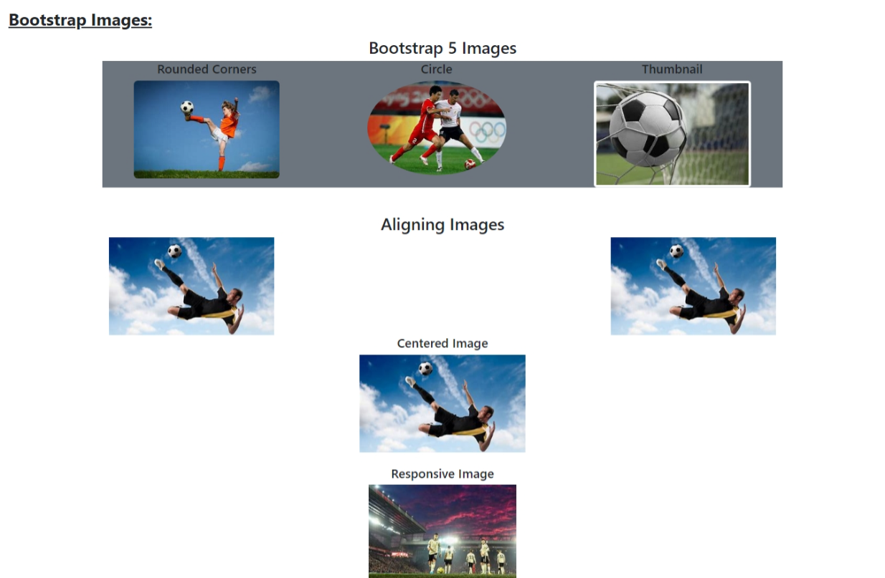

**Assignment-7**

Code

<!DOCTYPE html>

<html lang="en">

<head>

    <meta charset="utf-8">

    <meta name="author" content="Rahul Hosakoti">

    <meta name="viewport" content="width=device-width, initial-scale=1">

    <link rel="icon" href="../../../img/icon.png">

    <link href="https://cdn.jsdelivr.net/npm/bootstrap@5.2.3/dist/css/bootstrap.min.css" rel="stylesheet" integrity="sha384-rbsA2VBKQhggwzxH7pPCaAqO46MgnOM80zW1RWuH61DGLwZJEdK2Kadq2F9CUG65" crossorigin="anonymous">

    <title>Bootstrap | Assignment-7</title>

</head>

<body class="p-4">

    <h3>Bootstrap Alerts:</h3>

    <div class="container-fluid  m-6">

        <div class="alert alert-success" role="alert">

            <b>Sucess!</b> Used to indicate successfule or Positive action.

        </div>

        <div class="alert alert-info " role="alert">

            <b>Info!</b> Usec to indicate informative change or action.

        </div>

        <div class="alert alert-warning" role="alert">

            <b>Warning!</b> Used to indicate a warning that might need attention.

        </div>

        <div class="alert alert-danger" role="alert">

            <b>Danger!</b> Used to indicate a dangerous potentially negative action.

        </div>

        <div class="alert alert-primary" role="alert">

            <b>Primary!</b> Used to indicate an important action.

        </div>

        <div class="alert alert-secondary" role="alert">

            <b>Secondary!</b> Used to indicate a slightly less important action.

        </div>

        <div class="alert alert-dark" role="alert">

            <b>Dark!</b> Dark grey alert.

        </div>

        <div class="alert alert-light" role="alert">

            <b>Light!</b> Light grey alert.

        </div>

    </div>

    <h3>Bootstrap Alert Links</h3>

    <div class="container-fluid m-6">

        <div class="alert alert-success" role="alert">

            <b>Success!</b> You should <a href="#" class="alert-link">read this message</a>.

        </div>

        <div class="alert alert-info" role="alert">

            <b>Info!</b> You should <a href="#" class="alert-link">read this message</a>.

        </div>

        <div class="alert alert-warning" role="alert">

            <b>Warning!</b> You should <a href="#" class="alert-link">read this message</a>.

        </div>

        <div class="alert alert-danger" role="alert">

            <b>Danger!</b> You should <a href="#" class="alert-link">read this message</a>.

        </div>

        <div class="alert alert-primary" role="alert">

            <b>Primary!</b> You should <a href="#" class="alert-link">read this message</a>.

        </div>

        <div class="alert alert-secondary" role="alert">

            <b>Secondary!</b> You should <a href="#" class="alert-link">read this message</a>.

        </div>

        <div class="alert alert-dark role="alert">

            <b>Dark!</b> You should <a href="#" class="alert-link">read this message</a>.

        </div>

        <div class="alert alert-light" role="alert">

            <b>Light!</b> You should <a href="#" class="alert-link">read this message</a>.

        </div>

    </div>

    <h3>Alert Dismissing</h3>

    <div class="container-fluid m-6">

        <div class="alert alert-success alert-dismissible fade show" role="alert">

            <strong>Success!</strong> This alerte box could indicate a successful or positive action.

            <button type="button" class="btn-close" data-bs-dismiss="alert" aria-label="Close"></button>

        </div>

        <div class="alert alert-info alert-dismissible fade show" role="alert">

            <strong>Info!</strong> This alerte box could indicate a neutral informative change or action.

            <button type="button" class="btn-close" data-bs-dismiss="alert" aria-label="Close"></button>

        </div>

        <div class="alert alert-warning alert-dismissible fade show" role="alert">

            <strong>Warning!</strong> This alerte box could indicate a warning that might need attention.

            <button type="button" class="btn-close" data-bs-dismiss="alert" aria-label="Close"></button>

        </div>

    </div>

    <script src="https://cdn.jsdelivr.net/npm/bootstrap@5.2.3/dist/js/bootstrap.bundle.min.js" integrity="sha384-kenU1KFdBIe4zVF0s0G1M5b4hcpxyD9F7jL+jjXkk+Q2h455rYXK/7HAuoJl+0I4" crossorigin="anonymous"></script>

</body>

</html>

Output

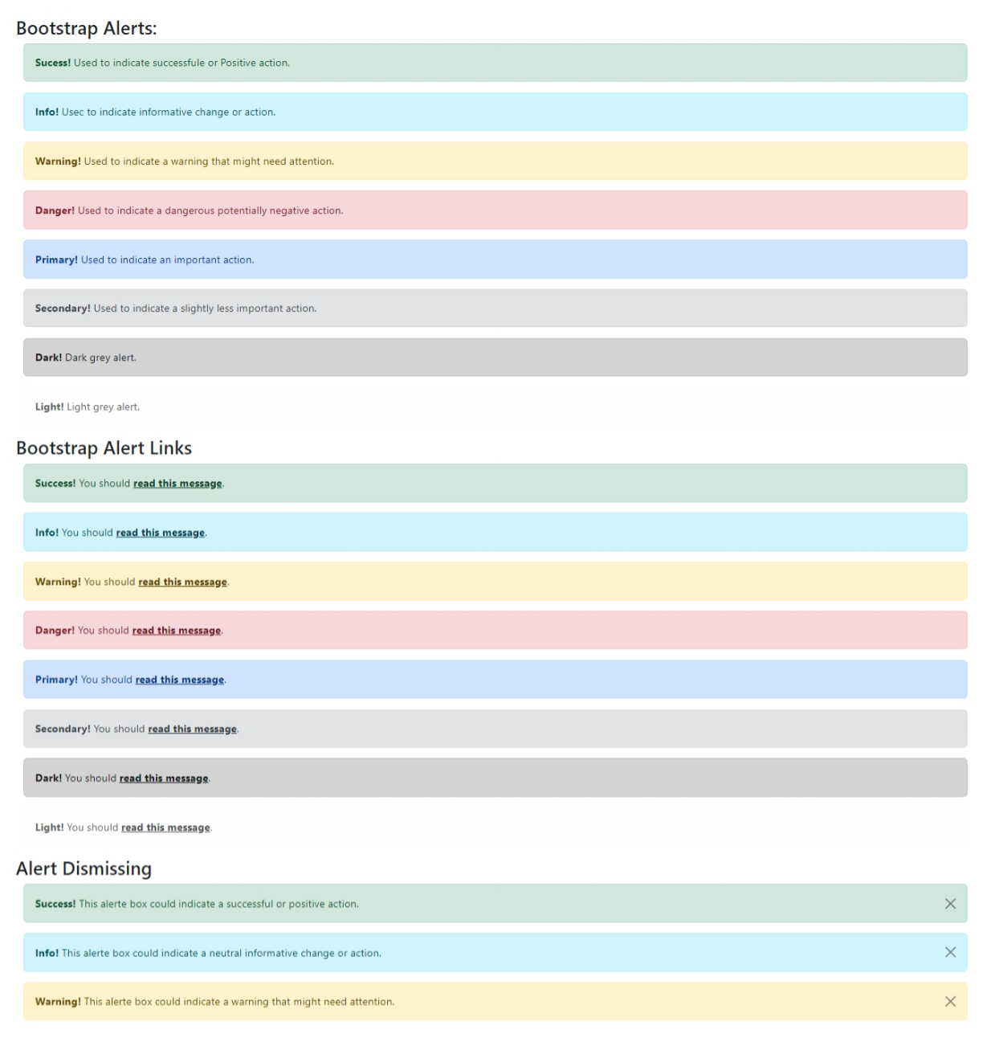

**Assignment-8**

Code

<!DOCTYPE html>

<html lang="en">

<head>

    <meta charset="utf-8">

    <meta name="author" content="Rahul Hosakoti">

    <meta name="viewport" content="width=device-width, initial-scale=1">

    <link rel="icon" href="../../../img/icon.png">

    <link href="https://cdn.jsdelivr.net/npm/bootstrap@5.2.3/dist/css/bootstrap.min.css" rel="stylesheet" integrity="sha384-rbsA2VBKQhggwzxH7pPCaAqO46MgnOM80zW1RWuH61DGLwZJEdK2Kadq2F9CUG65" crossorigin="anonymous">

    <title>Bootstrap | Assignment-8</title>

</head>

<body>

    <div class="container- m-4">

        <h3 class="mb-5"><u>Bootstrap Buttons:</u></h3>

        <hr>

        <div class="container-fluid m-3">

            <h4>Bootstrap Buttons</h4>

            <h6><u>Button Styles</u></h6>

            <button type="button" class="border border-0 bg-light py-3">Basic</button>

            <button type="button" class="btn btn-primary">Primary</button>

            <button type="button" class="btn btn-secondary">Secondary</button>

            <button type="button" class="btn btn-info">Info</button>

            <button type="button" class="btn btn-warning">Warning</button>

            <button type="button" class="btn btn-success">Success</button>

            <button type="button" class="btn btn-danger">Danger</button>

            <button type="button" class="btn btn-dark">Dark</button>

            <button type="button" class="btn btn-light">Light</button>

            <button type="button" class="btn btn-link">Link</button>

        </div>

        <hr>

        <div class="container-fluid m-3">

            <h4>Button Element</h4>

            <a class="btn btn-success" href="#" role="Link Button">Link</a>

            <button class="btn btn-success" type="submit">Button</button>

            <input class="btn btn-success" type="button" value="Input Button">

            <input class="btn btn-success" type="submit" value="Submit Button">

            <input class="btn btn-success" type="reset" value="Reset Button">

        </div>

        <hr>

        <div class="container-fluid m-3">

            <h4>Button Outline</h4>

            <button type="button" class="btn btn-outline-primary">Primary</button>

            <button type="button" class="btn btn-outline-secondary">Secondary</button>

            <button type="button" class="btn btn-outline-danger">Danger</button>

            <button type="button" class="btn btn-outline-warning">Warning</button>

            <button type="button" class="btn btn-outline-info">Info</button>

            <button type="button" class="btn btn-outline-success">Success</button>

            <button type="button" class="btn btn-outline-dark">Dark</button>

        </div>

        <hr>

        <div class="container-fluid m-3">

            <h4>Button Sizes</h4>

            <button type="button" class="btn btn-primary btn-lg">Large</button>

            <button type="button" class="btn btn-primary">Default</button>

            <button type="button" class="btn btn-primary btn-sm">small</button>

        </div>

        <hr>

        <div class="container-fluid m3 d-grid">

            <h4>Block Level Button</h4>

            <button class="btn btn-primary" type="button">Full-width-Button</button>

        </div>

        <hr>

        <div class="container-fluid m-3 d-grid gap-2">

            <h4>Block Level Buttons with Gap</h4>

            <button class="btn btn-primary" type="button">Full-width-Button</button>

            <button class="btn btn-primary" type="button">Full-width-Button</button>

            <button class="btn btn-primary" type="button">Full-width-Button</button>

        </div>

        <hr>

        <div class="container-fluid m-3">

            <h4>Active/Disabled Buttons</h4>

            <button type="button" class="btn btn-primary active" data-bs-toggle="button" aria-pressed="true">Active</button>

            <button type="button" class="btn btn-primary" disabled data-bs-toggle="button">Disabled</button>

        </div>

        <hr>

        <div class="container-fluid m-3">

            <h4>Spinner Buttons</h4>

            <button class="btn btn-success" type="button" disabled>

                <span class="spinner-border spinner-border-sm" role="status" aria-hidden="true"></span>

                <span class="visually-hidden">Loading...</span>

            </button>

            <button class="btn btn-warning" type="button" disabled>

                <span class="spinner-border spinner-border-sm" role="status" aria-hidden="true"></span>

                Loading...

            </button>

            <button class="btn btn-success" type="button" disabled>

                <span class="spinner-grow spinner-grow-sm" role="status" aria-hidden="true"></span>

                <span class="visually-hidden">Loading...</span>

            </button>

            <button class="btn btn-warning" type="button" disabled>

                <span class="spinner-grow spinner-grow-sm" role="status" aria-hidden="true"></span>

                Loading...

            </button>

        </div>

    </div>

    <script src="https://cdn.jsdelivr.net/npm/bootstrap@5.2.3/dist/js/bootstrap.bundle.min.js" integrity="sha384-kenU1KFdBIe4zVF0s0G1M5b4hcpxyD9F7jL+jjXkk+Q2h455rYXK/7HAuoJl+0I4" crossorigin="anonymous"></script>

</body>

</html>

Output

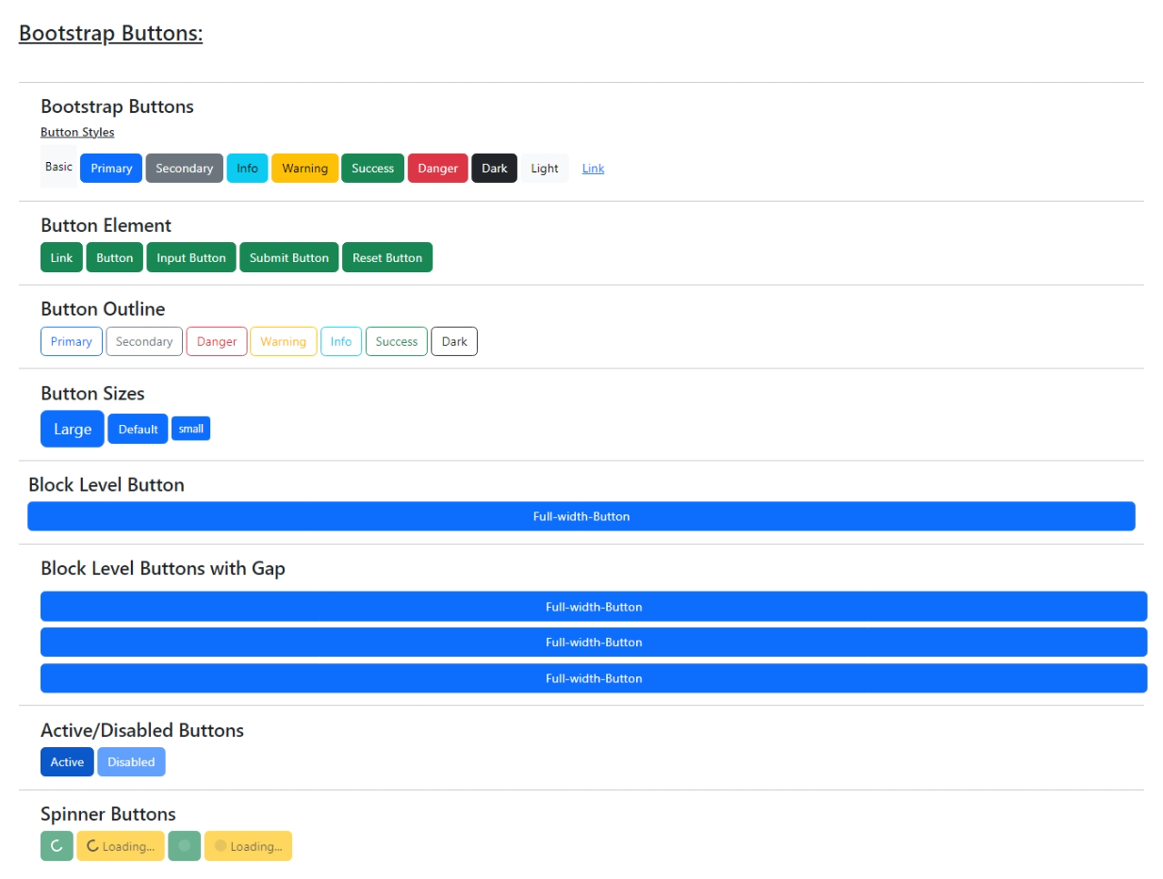

**Assignment-9**

Code

<!DOCTYPE html>

<html lang="en">

<head>

    <meta charset="utf-8">

    <meta name="author" content="Rahul Hosakoti">

    <meta name="viewport" content="width=device-width, initial-scale=1">

    <link rel="icon" href="../../../img/icon.png">

    <link href="https://cdn.jsdelivr.net/npm/bootstrap@5.2.3/dist/css/bootstrap.min.css" rel="stylesheet" integrity="sha384-rbsA2VBKQhggwzxH7pPCaAqO46MgnOM80zW1RWuH61DGLwZJEdK2Kadq2F9CUG65" crossorigin="anonymous">

    <title>Bootstrap | Assignment-9</title>

</head>

<body>

    <div class="container-fluid m-4">

        <h3 class="mb-5"><u>Bootstrap Buttons Groups:</u></h3>

        <h5 class="text-center">Bootstrap Button Groups</h5>

        <hr>

        <div class="container-fluid m-3">

            <h4>Button Grouns</h4>

            <div class="btn-group">

                <button type="button" class="btn btn-info">Back</button>

                <button type="button" class="btn btn-info">Submit</button>

                <button type="button" class="btn btn-info">Next</button>

            </div>

        </div>

        <hr>

        <div class="container-fluid m-3">

            <h4>Large Buttons:</h4>

            <div class="btn-group btn-group-lg">

                <button type="button" class="btn btn-success">Back</button>

                <button type="button" class="btn btn-success">Submit</button>

                <button type="button" class="btn btn-success">Next</button>

            </div>

            <h4>Default Buttons:</h4>

            <div class="btn-group">

                <button type="button" class="btn btn-success">Back</button>

                <button type="button" class="btn btn-success">Submit</button>

                <button type="button" class="btn btn-success">Next</button>

            </div>

            <h4>Small Buttons:</h4>

            <div class="btn-group btn-group-sm">

                <button type="button" class="btn btn-success">Back</button>

                <button type="button" class="btn btn-success">Submit</button>

                <button type="button" class="btn btn-success">Next</button>

            </div>

        </div>

        <hr>

        <div class="container-fluid m-3">

            <h4>Vertical Button Groups</h4>

            <div class="btn-group-vertical">

                <button type="button" class="btn btn-success">Back</button>

                <button type="button" class="btn btn-success">Submit</button>

                <button type="button" class="btn btn-success">Next</button>

            </div>

        </div>

        <hr>

        <div class="container-fluid m-3">

            <h4>Button Group Side by Side</h4>

            <div class="btn-toolbar" role="toolbar" aria-label="Toolbar with button groups">

                <div class="btn-group me-2">

                    <button type="button" class="btn btn-success">Back</button>

                    <button type="button" class="btn btn-success">Submit</button>

                    <button type="button" class="btn btn-success">Next</button>

                </div>

                <div class="btn-group">

                    <button type="button" class="btn btn-warning">Back</button>

                    <button type="button" class="btn btn-warning">Submit</button>

                    <button type="button" class="btn btn-warning">Next</button>

                </div>

            </div>

        </div>

        <hr>

        <div class="container-fluid m-3">

            <h4>Nesting Button Groups & Dropdown Menus</h4>

            <div class="btn-group">

                <button type="button" class="btn btn-primary">1</button>

                <button type="button" class="btn btn-primary">2</button>

                <div class="btn-group">

                    <button type="button" class="btn btn-primary dropdown-toggle" data-bs-toggle="dropdown" aria-expanded="false">3</button>

                    <ul class="dropdown-menu">

                        <li><a class="dropdown-item" href="#">4</a></li>

                        <li><a class="dropdown-item" href="#">5</a></li>

                    </ul>

                </div>

            </div>

        </div>

    </div>

    <script src="https://cdn.jsdelivr.net/npm/bootstrap@5.2.3/dist/js/bootstrap.bundle.min.js" integrity="sha384-kenU1KFdBIe4zVF0s0G1M5b4hcpxyD9F7jL+jjXkk+Q2h455rYXK/7HAuoJl+0I4" crossorigin="anonymous"></script>

</body>

</html>

Output

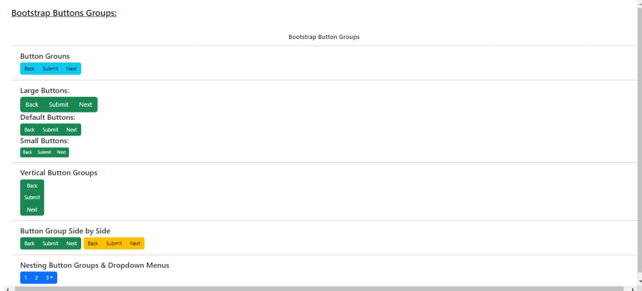

**Assignment-10**

Code

<!DOCTYPE html>

<html lang="en">

<head>

    <meta charset="utf-8">

    <meta name="author" content="Rahul Hosakoti">

    <meta name="viewport" content="width=device-width, initial-scale=1">

    <link rel="icon" href="../../../img/icon.png">

    <link href="https://cdn.jsdelivr.net/npm/bootstrap@5.2.3/dist/css/bootstrap.min.css" rel="stylesheet" integrity="sha384-rbsA2VBKQhggwzxH7pPCaAqO46MgnOM80zW1RWuH61DGLwZJEdK2Kadq2F9CUG65" crossorigin="anonymous">

    <title>Bootstrap | Assignment-10</title>

</head>

<body>

    <div class="container- m-4">

        <h3 class="mb-4"><u>Bootstrap Badges:</u></h3>

        <h4 class="text-center">Bootstrap Badges</h4>

        <hr>

        <div class="container-fluid m-3">

            <h3>Badges</h3>

            <h5>Bootstrap <span class="badge bg-primary">Badge</span></h5>

        </div>

        <hr>

        <div class="container-fluid m-3">

            <h3>Buttons</h3>

            <button type="button" class="btn btn-primary">

                Whatapps <span class="badge text-bg-secondary">10</span>

            </button>

        </div>

        <hr>

        <div class="container-fluid m-3">

            <h3>Positioned</h3>

            <button type="button" class="btn btn-primary position-relative">

                Inbox <span class="position-absolute top-0 start-100 translate-middle badge rounded-pill bg-danger">20+</span>

            </button>

        </div>

    </div>

    <script src="https://cdn.jsdelivr.net/npm/bootstrap@5.2.3/dist/js/bootstrap.bundle.min.js" integrity="sha384-kenU1KFdBIe4zVF0s0G1M5b4hcpxyD9F7jL+jjXkk+Q2h455rYXK/7HAuoJl+0I4" crossorigin="anonymous"></script>

</body>

</html>

Output

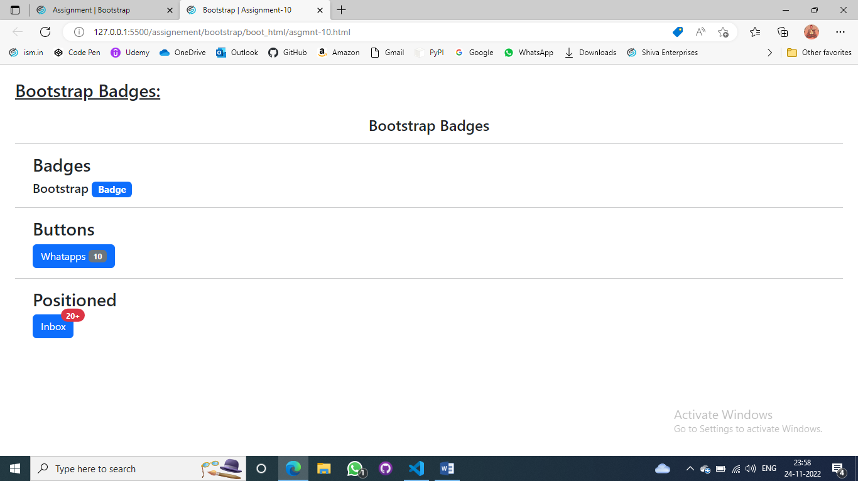

**Assignment-11**

Code

<!DOCTYPE html>

<html lang="en">

<head>

    <meta charset="utf-8">

    <meta name="author" content="Rahul Hosakoti">

    <meta name="viewport" content="width=device-width, initial-scale=1">

    <link rel="icon" href="../../../img/icon.png">

    <link href="https://cdn.jsdelivr.net/npm/bootstrap@5.2.3/dist/css/bootstrap.min.css" rel="stylesheet" integrity="sha384-rbsA2VBKQhggwzxH7pPCaAqO46MgnOM80zW1RWuH61DGLwZJEdK2Kadq2F9CUG65" crossorigin="anonymous">

    <title>Bootstrap | Assignment-11</title>

</head>

<body>

    <div class="container-fluid m-5">

        <h2 class="mb-5"><u>Bootstrap Progress Bars:</u></h2>

        <h5 class="text-center">Bootstrap Progress Bars</h5>

        <hr>

        <div class="container m-3">

            <h4>Basic Progress Bar</h4>

            <div class="progress">

                <div class="progress-bar w-100" role="progressbar" aria-label="Basic example" aria-valuenow="75" aria-valuemin="0" aria-valuemax="100"></div>

            </div>

        </div>

        <hr>

        <div class="container m-3">

            <h4>Progress Bar Label</h4>

            <div class="progress">

                <div class="progress-bar" role="progressbar" aria-label="Example with label" style="width: 75%;" aria-valuenow="75" aria-valuemin="0" aria-valuemax="100">75%</div>

            </div>

        </div>

        <hr>

        <div class="container m-3">

            <h4>Colered Progress Bars</h4>

            <div class="progress">

                <div class="progress-bar bg-warning" role="progressbar" aria-label="Example with label" style="width: 50%;" aria-valuenow="50" aria-valuemin="0" aria-valuemax="100">50%</div>

            </div>

        </div>

        <hr>

        <div class="container m-3">

            <h4>Striped Progress Bars</h4>

            <div class="progress">

                <div class="progress-bar progress-bar-striped" role="progressbar" aria-label="Default striped example" style="width: 40%" aria-valuenow="40" aria-valuemin="0" aria-valuemax="100">40%</div>

            </div>

        </div>

        <hr>

        <div class="container m-3">

            <h4>Animated Progress Bars</h4>

            <div class="progress">

                <div class="progress-bar progress-bar-striped progress-bar-animated bg-danger" role="progressbar" aria-label="Animated striped example" aria-valuenow="55" aria-valuemin="0" aria-valuemax="100" style="width: 55%">55%</div>

            </div>

            <h4>Multiple bars</h4>

            <div class="progress">

                <div class="progress-bar" role="progressbar" aria-label="Segment one" style="width: 20%" aria-valuenow="20" aria-valuemin="0" aria-valuemax="100">20%</div>

                <div class="progress-bar progress-bar-striped bg-success" role="progressbar" aria-label="Segment two" style="width: 30%" aria-valuenow="30" aria-valuemin="0" aria-valuemax="100">30%</div>

                <div class="progress-bar progress-bar-striped progress-bar-animated bg-warning" role="progressbar" aria-label="Segment three" style="width: 40%" aria-valuenow="40" aria-valuemin="0" aria-valuemax="100">40%</div>

            </div>

        </div>

    </div>

    <script src="https://cdn.jsdelivr.net/npm/bootstrap@5.2.3/dist/js/bootstrap.bundle.min.js" integrity="sha384-kenU1KFdBIe4zVF0s0G1M5b4hcpxyD9F7jL+jjXkk+Q2h455rYXK/7HAuoJl+0I4" crossorigin="anonymous"></script>

</body>

</html>

Output

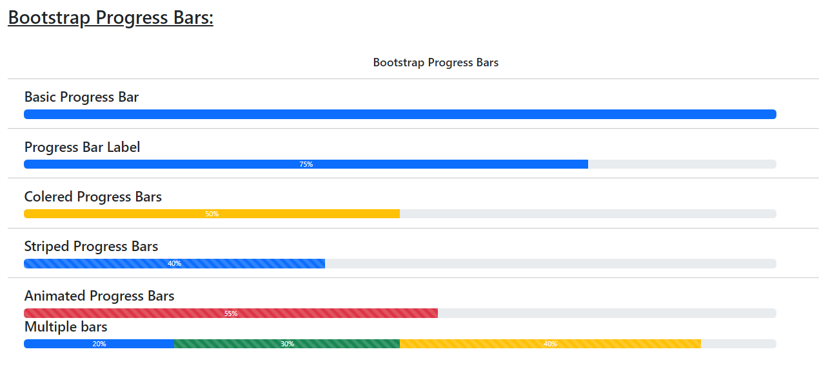

**Assignment-12**

Code

<!DOCTYPE html>

<html lang="en">

<head>

    <meta charset="utf-8">

    <meta name="author" content="Rahul Hosakoti">

    <meta name="viewport" content="width=device-width, initial-scale=1">

    <link rel="icon" href="../../../img/icon.png">

    <link href="https://cdn.jsdelivr.net/npm/bootstrap@5.2.3/dist/css/bootstrap.min.css" rel="stylesheet" integrity="sha384-rbsA2VBKQhggwzxH7pPCaAqO46MgnOM80zW1RWuH61DGLwZJEdK2Kadq2F9CUG65" crossorigin="anonymous">

    <title>Bootstrap | Assignment-12</title>

</head>

<body>

    <div class="container-fluid m-4">

        <h3 class="mb-5"><u>Bootstrap Spinner:</u></h3>

        <hr>

        <h5 class="text-center">Bootstrap Spinner</h5>

        <hr>

        <div class="container m-3">

            <h4>Border Spinner</h4>

            <div class="spinner-border" role="status">

                <span class="visually-hidden">Loading...</span>

            </div>

        </div>

        <hr>

        <div class="container m-3">

            <h4>Colors Spinner</h4>

            <div class="spinner-border text-primary" role="status">

                <span class="visually-hidden">Loading...</span>

            </div>

            <div class="spinner-border text-danger" role="status">

                <span class="visually-hidden">Loading...</span>

            </div>

            <div class="spinner-border text-warning" role="status">

                <span class="visually-hidden">Loading...</span>

            </div>

            <div class="spinner-border text-dark" role="status">

                <span class="visually-hidden">Loading...</span>

            </div>

        </div>

        <hr>

        <div class="container m-3">

            <h4>Growing Spinner</h4>

            <div class="spinner-grow" role="status">

                <span class="visually-hidden">Loading...</span>

            </div>

        </div>

        <hr>

        <div class="container m-3">

            <h4>Growing color Spinner</h4>

            <div class="spinner-grow text-secondary" role="status">

                <span class="visually-hidden">Loading...</span>

            </div>

            <div class="spinner-grow text-info" role="status">

                <span class="visually-hidden">Loading...</span>

            </div>

            <div class="spinner-grow text-primary" role="status">

                <span class="visually-hidden">Loading...</span>

            </div>

            <div class="spinner-grow text-success" role="status">

                <span class="visually-hidden">Loading...</span>

            </div>

        </div>

        <hr>

        <div class="container m-3">

            <h4>Alignment Spinner</h4>

            <div class="spinner-grow mx-5" role="status">

                <span class="visually-hidden">Loading...</span>

            </div>

        </div>

        <hr>

        <div class="container m-3">

            <h4>Size Spinner</h4>

            <div class="spinner-border spinner-border-sm" role="status">

                <span class="visually-hidden">Loading...</span>

            </div>

            <div class="spinner-grow spinner-grow-sm" role="status">

                <span class="visually-hidden">Loading...</span>

            </div>

            <div class="spinner-border" style="width: 3rem; height: 3rem;" role="status">

                <span class="visually-hidden">Loading...</span>

            </div>

            <div class="spinner-grow" style="width: 3rem; height: 3rem;" role="status">

                <span class="visually-hidden">Loading...</span>

            </div>

        </div>

    </div>

    <script src="https://cdn.jsdelivr.net/npm/bootstrap@5.2.3/dist/js/bootstrap.bundle.min.js" integrity="sha384-kenU1KFdBIe4zVF0s0G1M5b4hcpxyD9F7jL+jjXkk+Q2h455rYXK/7HAuoJl+0I4" crossorigin="anonymous"></script>

</body>

</html>

Output

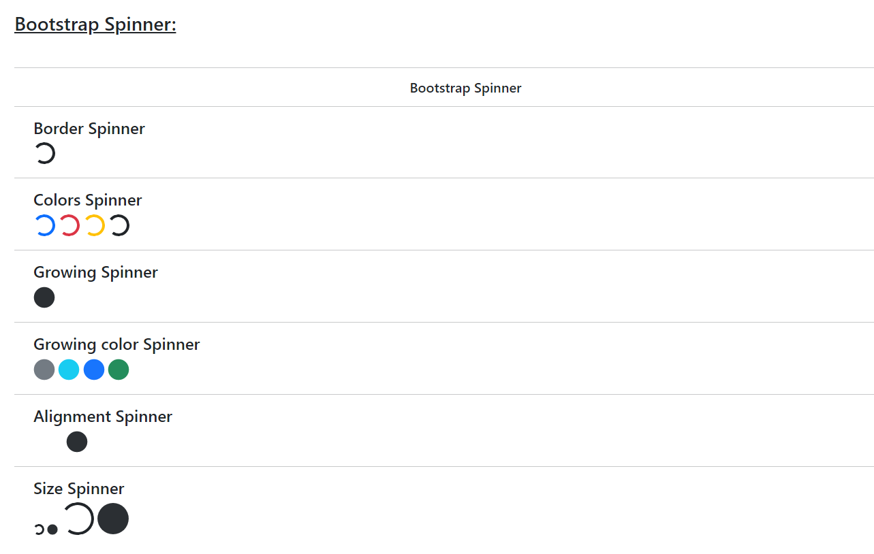

**Assignment-13**

Code

<!DOCTYPE html>

<html lang="en">

<head>

    <meta charset="utf-8">

    <meta name="author" content="Rahul Hosakoti">

    <meta name="viewport" content="width=device-width, initial-scale=1">

    <link rel="icon" href="../../../img/icon.png">

    <link href="https://cdn.jsdelivr.net/npm/bootstrap@5.2.3/dist/css/bootstrap.min.css" rel="stylesheet" integrity="sha384-rbsA2VBKQhggwzxH7pPCaAqO46MgnOM80zW1RWuH61DGLwZJEdK2Kadq2F9CUG65" crossorigin="anonymous">

    <title>Bootstrap | Assignment-13</title>

</head>

<body>

    <div class="container-fluid m-4">

        <h2 class="mb-5"><u>Bootstrap Pagination:</u></h2>

        <hr>

        <h4 class="text-center">Bootstrap Pagination</h4>

        <hr>

        <div class="container m-3">

            <h4>Basic Pagination</h4>

            <nav aria-label="Page navigation example">

                <ul class="pagination">

                    <li class="page-item"><a class="page-link" href="#">Previous</a></li>

                    <li class="page-item"><a class="page-link" href="#">1</a></li>

                    <li class="page-item"><a class="page-link" href="#">2</a></li>

                    <li class="page-item"><a class="page-link" href="#">3</a></li>

                    <li class="page-item"><a class="page-link" href="#">Next</a></li>

                </ul>

            </nav>

        </div>

        <hr>

        <div class="container m-3">

            <h4>Disabled and active states</h4>

            <nav aria-label="...">

                <ul class="pagination">

                    <li class="page-item disabled">

                        <a class="page-link">Previous</a>

                    </li>

                    <li class="page-item"><a class="page-link" href="#">1</a></li>

                    <li class="page-item active" aria-current="page">

                        <a class="page-link" href="#">2</a>

                    </li>

                    <li class="page-item"><a class="page-link" href="#">3</a></li>

                    <li class="page-item">

                        <a class="page-link" href="#">Next</a>

                    </li>

                </ul>

            </nav>

        </div>

        <hr>

        <div class="container m-3">

            <h4>Pagination Sizing</h4>

            <nav aria-label="...">

                <ul class="pagination pagination-lg">

                    <li class="page-item disabled">

                        <a class="page-link">Previous</a>

                    </li>

                    <li class="page-item"><a class="page-link" href="#">1</a></li>

                    <li class="page-item active" aria-current="page">

                        <a class="page-link" href="#">2</a>

                    </li>

                    <li class="page-item"><a class="page-link" href="#">3</a></li>

                    <li class="page-item">

                        <a class="page-link" href="#">Next</a>

                    </li>

                </ul>

            </nav>

            <nav aria-label="...">

                <ul class="pagination pagination-sm">

                    <li class="page-item disabled">

                        <a class="page-link">Previous</a>

                    </li>

                    <li class="page-item"><a class="page-link" href="#">1</a></li>

                    <li class="page-item active" aria-current="page">

                        <a class="page-link" href="#">2</a>

                    </li>

                    <li class="page-item"><a class="page-link" href="#">3</a></li>

                    <li class="page-item">

                        <a class="page-link" href="#">Next</a>

                    </li>

                </ul>

            </nav>

        </div>

    </div>

    <script src="https://cdn.jsdelivr.net/npm/bootstrap@5.2.3/dist/js/bootstrap.bundle.min.js" integrity="sha384-kenU1KFdBIe4zVF0s0G1M5b4hcpxyD9F7jL+jjXkk+Q2h455rYXK/7HAuoJl+0I4" crossorigin="anonymous"></script>

</body>

</html>

Output

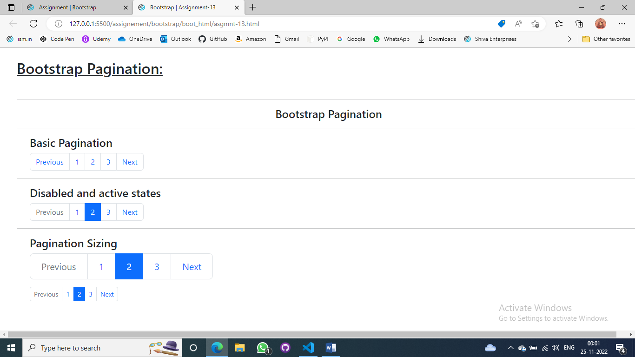

**Assignment-14**

Code

<!DOCTYPE html>

<html lang="en">

<head>

    <meta charset="utf-8">

    <meta name="author" content="Rahul Hosakoti">

    <meta name="viewport" content="width=device-width, initial-scale=1">

    <link rel="icon" href="../../../img/icon.png">

    <link href="https://cdn.jsdelivr.net/npm/bootstrap@5.2.3/dist/css/bootstrap.min.css" rel="stylesheet" integrity="sha384-rbsA2VBKQhggwzxH7pPCaAqO46MgnOM80zW1RWuH61DGLwZJEdK2Kadq2F9CUG65" crossorigin="anonymous">

    <title>Bootstrap | Assignment-14</title>

</head>

<body>

    <div class="container-fluid m-4">

        <h2 class="mb-5"><u>Bootstrap List Group:</u></h2>

        <hr>

        <h4 class="text-center">Bootstrap List Groups</h4>

        <hr>

        <div class="container m-3">

            <h4>Basic List Groups</h4>

            <ul class="list-group">

                <li class="list-group-item">To Do List</li>

                <li class="list-group-item">Study</li>

                <li class="list-group-item">Pay Bills</li>

                <li class="list-group-item">call mom</li>

                <li class="list-group-item">Drop an email</li>

            </ul>

        </div>

        <hr>

        <div class="container m-3">

            <h4>Active State</h4>

            <ul class="list-group">

                <li class="list-group-item active" aria-current="true">Home</li>

                <li class="list-group-item">Picture</li>

                <li class="list-group-item">Music</li>

                <li class="list-group-item">Video</li>

            </ul>

        </div>

        <hr>

        <div class="container m-3">

            <h4>Numbered</h4>

            <ol class="list-group list-group-numbered">

                <li class="list-group-item d-flex justify-content-between align-items-start bg-primary">

                    <div class="ms-2 me-auto">

                        <div class="fw-bold">Open Tickets</div>

                    </div>

                    <span class="badge bg-primary rounded-pill bg-danger">20</span>

                </li>

                <li class="list-group-item d-flex justify-content-between align-items-start bg-danger">

                    <div class="ms-2 me-auto">

                        <div class="fw-bold">close Tickets</div>

                    </div>

                    <span class="badge bg-primary rounded-pill bg-warning">45</span>

                </li>

                <li class="list-group-item d-flex justify-content-between align-items-start bg-success">

                    <div class="ms-2 me-auto">

                        <div class="fw-bold">Solved Tickets</div>

                    </div>

                    <span class="badge bg-primary rounded-pill bg-dark">14</span>

                </li>

            </ol>

        </div>

        <hr>

        <div class="container m-3">

            <h4>Checkboxes</h4>

            <ul class="list-group">

                <li class="list-group-item">

                    <input class="form-check-input me-1" type="checkbox" value="" id="firstCheckbox">

                    <label class="form-check-label" for="firstCheckbox">

                        First checkbox <br>

                        <small>with support text underneath to add more detail</small>

                    </label>

                </li>

                <li class="list-group-item">

                    <input class="form-check-input me-1" type="checkbox" value="" id="secondCheckbox">

                    <label class="form-check-label" for="secondCheckbox">

                        Second checkbox <br>

                        <small>some other text gose here</small>

                    </label>

                </li>

                <li class="list-group-item">

                    <input class="form-check-input me-1" type="checkbox" value="" id="thirdCheckbox">

                    <label class="form-check-label" for="thirdCheckbox">

                        Third checkbox <br>

                        <small>And we end with another snippet of text</small>

                    </label>

                </li>

            </ul>

        </div>

    </div>

    <script src="https://cdn.jsdelivr.net/npm/bootstrap@5.2.3/dist/js/bootstrap.bundle.min.js" integrity="sha384-kenU1KFdBIe4zVF0s0G1M5b4hcpxyD9F7jL+jjXkk+Q2h455rYXK/7HAuoJl+0I4" crossorigin="anonymous"></script>

</body>

</html>

Output

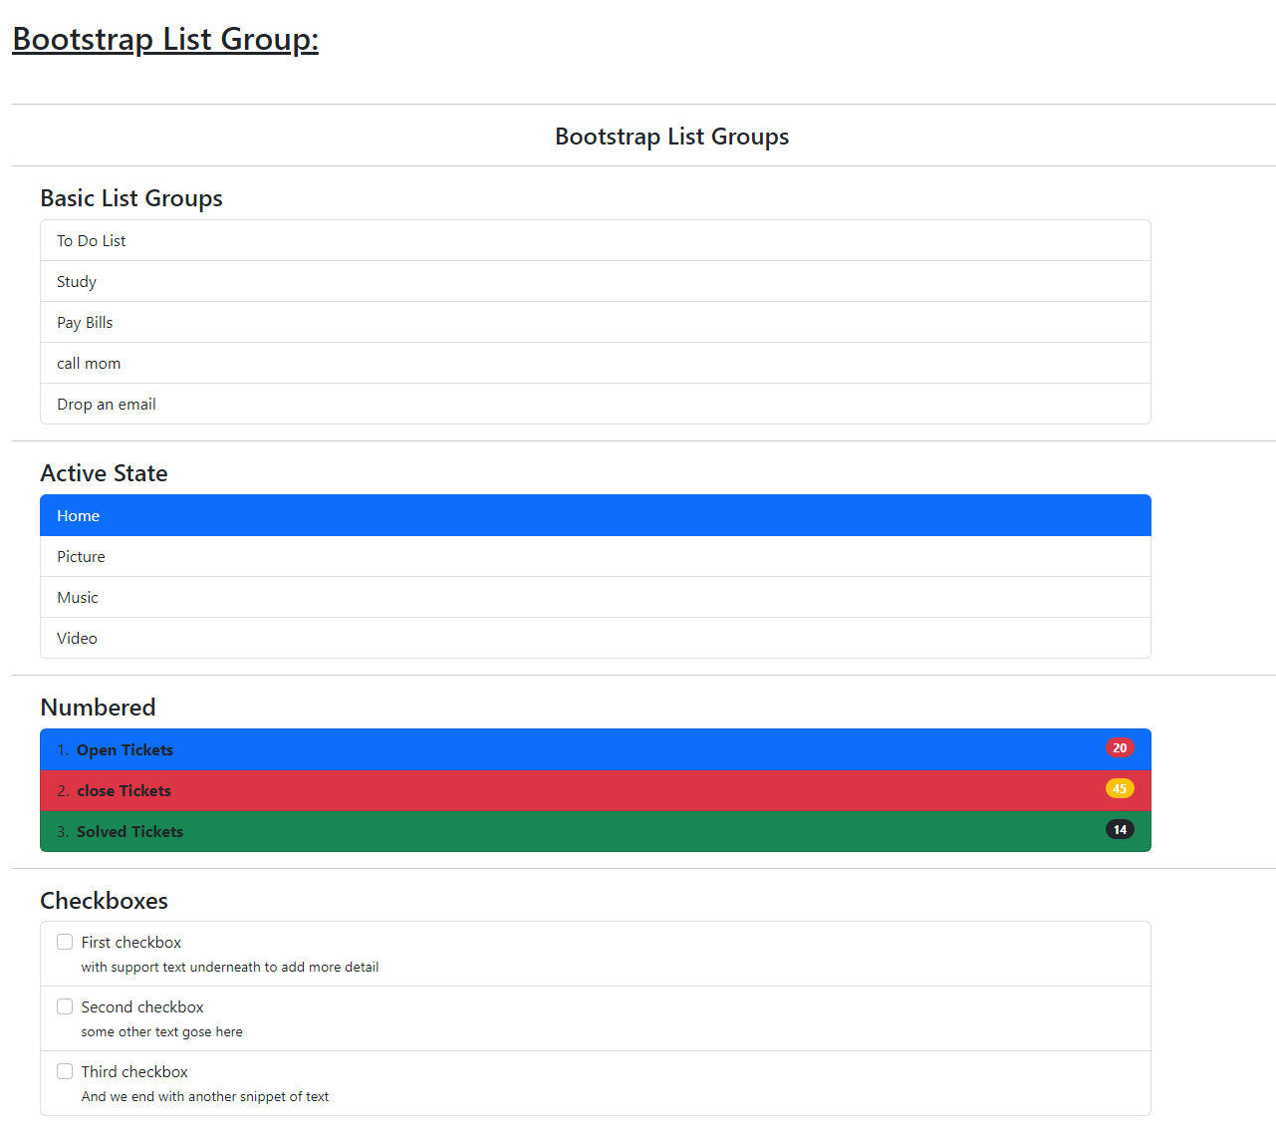

**Assignment-15**

Code

<!DOCTYPE html>

<html lang="en">

<head>

    <meta charset="utf-8">

    <meta name="author" content="Rahul Hosakoti">

    <meta name="viewport" content="width=device-width, initial-scale=1">

    <link rel="icon" href="../../../img/icon.png">

    <link href="https://cdn.jsdelivr.net/npm/bootstrap@5.2.3/dist/css/bootstrap.min.css" rel="stylesheet" integrity="sha384-rbsA2VBKQhggwzxH7pPCaAqO46MgnOM80zW1RWuH61DGLwZJEdK2Kadq2F9CUG65" crossorigin="anonymous">

    <title>Bootstrap | Assignment-15</title>

</head>

<body>

    <div class="container-fluid mt-4">

        <h2 class="mb-5"><u>Bootstrap Card:</u></h2>

        <nav class="navbar navbar-expand-lg bg-primary">

            <div class="container-fluid mx-5">

                <a class="navbar-brand text-white" href="#">

                    <img src="https://getbootstrap.com/docs/5.2/assets/brand/bootstrap-logo.svg" alt="Logo" width="30" height="24" class="d-inline-block align-text-top">

                    Bootstrap

                </a>

                <button class="navbar-toggler" type="button" data-bs-toggle="collapse" data-bs-target="#navbarText" aria-controls="navbarText" aria-expanded="false" aria-label="Toggle navigation">

                    <span class="navbar-toggler-icon"></span>

                </button>

                <div class="collapse navbar-collapse" id="navbarNav">

                    <ul class="navbar-nav">

                        <li class="nav-item">

                            <a class="nav-link text-white" aria-current="page" href="#">Home</a>

                        </li>

                        <li class="nav-item">

                            <a class="nav-link text-white" aria-current="page" href="#">About</a>

                        </li>

                        <li class="nav-item">

                            <a class="nav-link text-white" aria-current="page" href="#">Courses</a>

                        </li>

                        <li class="nav-item dropdown">

                            <a class="nav-link dropdown-toggle text-white" href="#" role="button" data-bs-toggle="dropdown" aria-expanded="false">

                                Help

                            </a>

                            <ul class="dropdown-menu">

                                <li><a class="dropdown-item" href="#">Me</a></li>

                                <li><a class="dropdown-item" href="#">You</a></li>

                                <li><a class="dropdown-item" href="#">Us</a></li>

                            </ul>

                        </li>

                        <li class="nav-item">

                            <a class="nav-link text-white" aria-current="page" href="#">Blog</a>

                        </li>

                        <li class="nav-item">

                            <a class="nav-link disabled text-white" aria-current="page" href="#">Contact</a>

                        </li>

                    </ul>

                </div>

            </div>

        </nav>

        <div class="m-5">

            <h2>Learn Programming</h2>

            <p>Access the 4K ultra HD content absolute FREE on the justjun channel, Enroll on the course and start you discussion today!</p>

            <div class="container row">

                <div class="card col m-2 p-0" style="width: 20rem">

                    <img src="../img/html.jpeg" alt="html" height="100%" width="100%"/>

                    <div class="card-body">

                        <h5 class="card-title">Learn HTML5</h5>

                        <p class="card-text">

                            Learn HTMl5 and build powerful interactive websites in minutes. Enroll this course to learn everthing from scratch for free!

                        </p>

                        <a href="#" class="btn btn-primary">Enroll Now</a>

                    </div>

                    <div class="card-footer">

                        Last Updated on; August, 2020

                    </div>

                </div>

                <div class="card col m-2 p-0" style="width: 20rem">

                    <img src="../img/css.jpeg" alt="html" height="100%" width="100%"/>

                    <div class="card-body">

                        <h5 class="card-title">Learn CSS3</h5>

                        <p class="card-text">

                            Learn CSS and build powerful interactive websites in minutes. Enroll this course to learn everthing from scratch for free!

                        </p>

                        <a href="#" class="btn btn-primary">Enroll Now</a>

                    </div>

                    <div class="card-footer">

                        Last Updated on; August, 2020

                    </div>

                </div>

                <div class="card col m-2 p-0" style="width: 20rem">

                    <img src="../img/js.jpeg" alt="html" height="100%" width="100%"/>

                    <div class="card-body">

                        <h5 class="card-title">Learn JavaScript</h5>

                        <p class="card-text">

                            Learn JavaScript and build powerful interactive websites in minutes. Enroll this course to learn everthing from scratch for free!

                        </p>

                        <a href="#" class="btn btn-primary">Enroll Now</a>

                    </div>

                    <div class="card-footer">

                        Last Updated on; August, 2020

                    </div>

                </div>

            </div>

        </div>

    </div>

    <script src="https://cdn.jsdelivr.net/npm/bootstrap@5.2.3/dist/js/bootstrap.bundle.min.js" integrity="sha384-kenU1KFdBIe4zVF0s0G1M5b4hcpxyD9F7jL+jjXkk+Q2h455rYXK/7HAuoJl+0I4" crossorigin="anonymous"></script>

</body>

</html>

Output

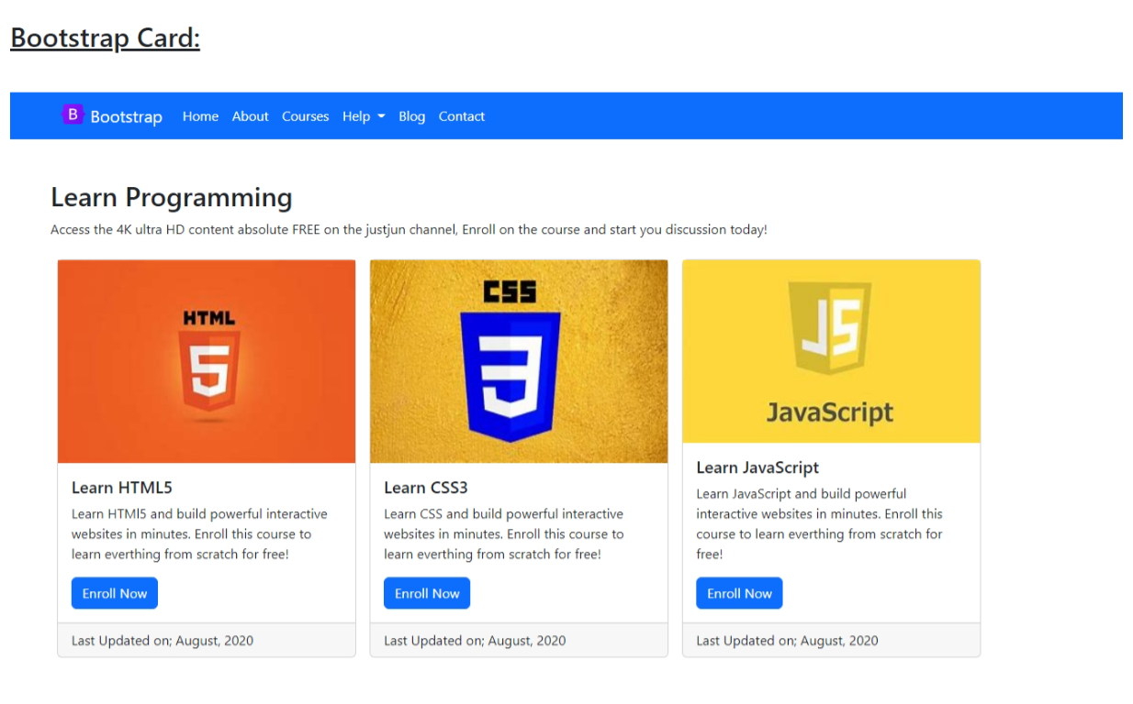**Assignment-16**

Code

<!DOCTYPE html>

<html lang="en">

<head>

    <meta charset="utf-8">

    <meta name="author" content="Rahul Hosakoti">

    <meta name="viewport" content="width=device-width, initial-scale=1">

    <link rel="icon" href="../../../img/icon.png">

    <link href="https://cdn.jsdelivr.net/npm/bootstrap@5.2.3/dist/css/bootstrap.min.css" rel="stylesheet" integrity="sha384-rbsA2VBKQhggwzxH7pPCaAqO46MgnOM80zW1RWuH61DGLwZJEdK2Kadq2F9CUG65" crossorigin="anonymous">

    <title>Bootstrap | Assignment-16</title>

</head>

<body>

    <div class="container-fluid m-4 ">

        <h2 class="mb-5"><u>Bootstrap DropDown:</u></h2>

        <h4 class="text-center">Bootstrap Dropdowns</h4>

        <div class="container d-flex justify-content-evenly m-5">

            <div class="btn-group dropdown">

                <button type="button" class="btn btn-light btn-lg dropdown-toggle" data-bs-toggle="dropdown" aria-expanded="false">

                    Document

                </button>

                <ul class="dropdown-menu">

                    <li><a class="dropdown-item" href="#">Photo</a></li>

                    <li><a class="dropdown-item" href="#">Movies</a></li>

                    <li><a class="dropdown-item" href="#">Music</a></li>

                    <li><a class="dropdown-item" href="#">Games</a></li>

                    <li><a class="dropdown-item p-0"><hr><a class="dropdown-item pl-2" href="#">Trash</a></a></li>

                </ul>

            </div>

            <div class="btn-group dropdown">

                <button type="button" class="btn btn-dark btn-lg dropdown-toggle" data-bs-toggle="dropdown" aria-expanded="false">

                    Document

                </button>

                <ul class="dropdown-menu">

                    <li><a class="dropdown-item" href="#">Photo</a></li>

                    <li><a class="dropdown-item" href="#">Movies</a></li>

                    <li><a class="dropdown-item" href="#">Music</a></li>

                    <li><a class="dropdown-item" href="#">Games</a></li>

                    <li><a class="dropdown-item p-0"><hr><a class="dropdown-item pl-2" href="#">Trash</a></a></li>

                </ul>

            </div>

        </div>

    </div>

    <script src="https://cdn.jsdelivr.net/npm/bootstrap@5.2.3/dist/js/bootstrap.bundle.min.js" integrity="sha384-kenU1KFdBIe4zVF0s0G1M5b4hcpxyD9F7jL+jjXkk+Q2h455rYXK/7HAuoJl+0I4" crossorigin="anonymous"></script>

</body>

</html>

Output

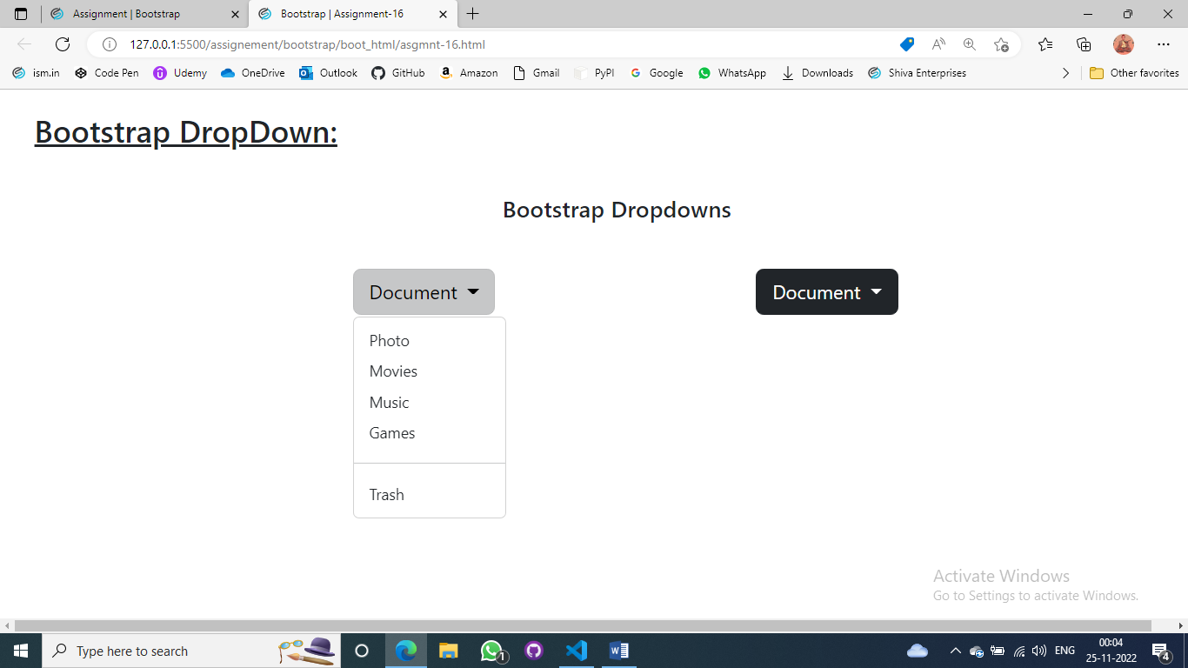

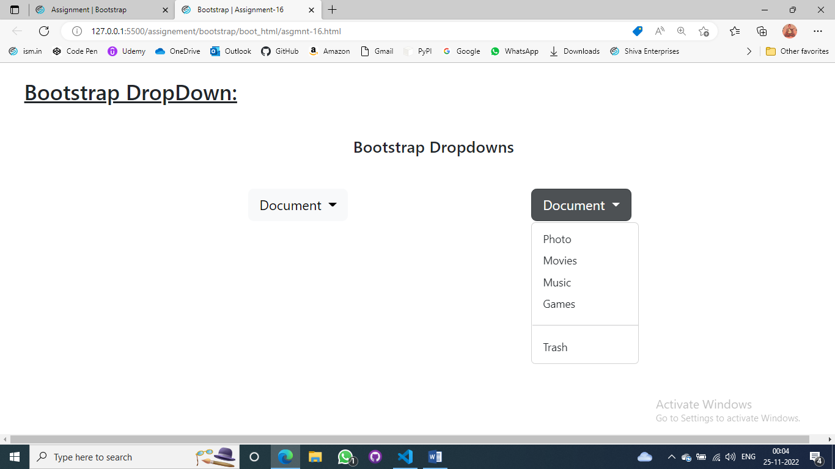

**Assignment-17**

Code

<!DOCTYPE html>

<html lang="en">

<head>

    <meta charset="utf-8">

    <meta name="author" content="Rahul Hosakoti">

    <meta name="viewport" content="width=device-width, initial-scale=1">

    <link rel="icon" href="../../../img/icon.png">

    <link href="https://cdn.jsdelivr.net/npm/bootstrap@5.2.3/dist/css/bootstrap.min.css" rel="stylesheet" integrity="sha384-rbsA2VBKQhggwzxH7pPCaAqO46MgnOM80zW1RWuH61DGLwZJEdK2Kadq2F9CUG65" crossorigin="anonymous">

    <title>Bootstrap | Assignment-17</title>

</head>

<body>

    <div class="container-fluid m-4">

        <h2 class="mb-5"><u>Bootstrap Modal:</u></h2>

        <h4 class="text-center">Bootstrap Modal</h4>

        <div class="container d-flex justify-content-evenly mt-5">

            <button type="button" class="btn btn-primary" data-bs-toggle="modal" data-bs-target="#staticBackdrop">

                Launch Bootstrap Modal

            </button>

            <div class="modal fade" id="staticBackdrop" data-bs-backdrop="static" data-bs-keyboard="false" tabindex="-1" aria-labelledby="staticBackdropLabel" aria-hidden="true">

                <div class="modal-dialog">

                    <div class="modal-content">

                        <div class="modal-header border-0">

                            <h1 class="modal-title fs-5" id="staticBackdropLabel">Modal title</h1><button type="button" class="btn-close" data-bs-dismiss="modal" aria-label="Close"></button>

                        </div>

                        <div class="modal-body">

                            This is a modal sheet, a variation of the modal that docs itself to the bottom of the viewport like the mewer share sheets in iOS

                        </div>

                        <div class="d-grid m-2 gap-2">

                            <button type="button" class="btn btn-primary">Save changes</button>

                            <button type="button" class="btn btn-light text-dark" data-bs-dismiss="modal">Close</button>

                        </div>

                    </div>

                </div>

            </div>

        </div>

    </div>

    <script src="https://cdn.jsdelivr.net/npm/bootstrap@5.2.3/dist/js/bootstrap.bundle.min.js" integrity="sha384-kenU1KFdBIe4zVF0s0G1M5b4hcpxyD9F7jL+jjXkk+Q2h455rYXK/7HAuoJl+0I4" crossorigin="anonymous"></script>

</body>

</html>

Output

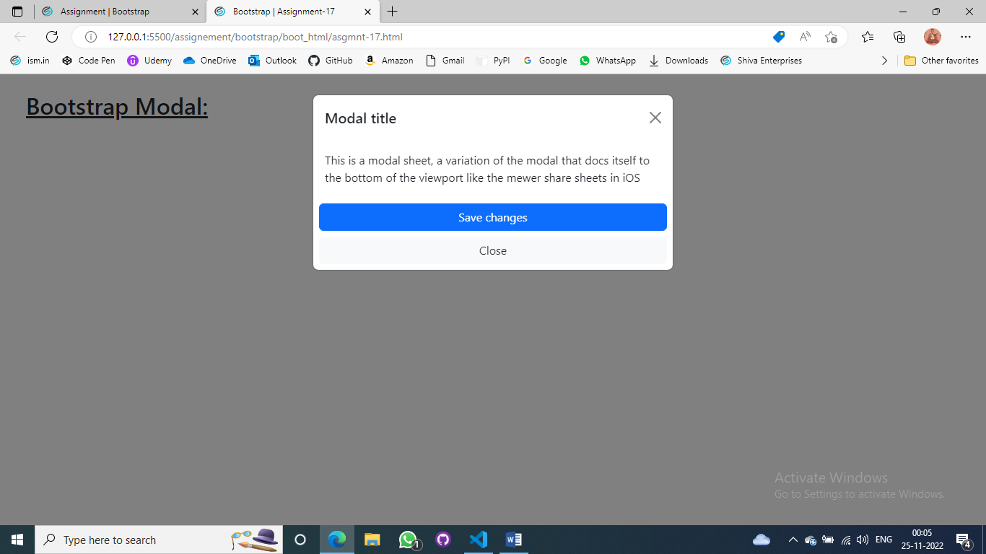

**Assignment-18**

Code

<!DOCTYPE html>

<html lang="en">

<head>

    <meta charset="utf-8">

    <meta name="author" content="Rahul Hosakoti">

    <meta name="viewport" content="width=device-width, initial-scale=1">

    <link rel="icon" href="../../../img/icon.png">

    <link href="https://cdn.jsdelivr.net/npm/bootstrap@5.2.3/dist/css/bootstrap.min.css" rel="stylesheet" integrity="sha384-rbsA2VBKQhggwzxH7pPCaAqO46MgnOM80zW1RWuH61DGLwZJEdK2Kadq2F9CUG65" crossorigin="anonymous">

    <title>Bootstrap | Assignment-11</title>

</head>

<body>

    <div class="container m-5">

        <h2 class="mb-4"><u>Bootstrap Navbar:</u></h2>

        <hr>

        <h4 class="text-center">Bootstrap Navbar</h4>

        <hr>

        <nav class="navbar navbar-expand-lg bg-success">

            <div class="container-fluid">

                <a class="navbar-brand text-white" href="#">

                    ISM UNIV

                </a>

                <button class="navbar-toggler" type="button" data-bs-toggle="collapse" data-bs-target="#navbarText" aria-controls="navbarText" aria-expanded="false" aria-label="Toggle navigation">

                    <span class="navbar-toggler-icon"></span>

                </button>

                <div class="collapse navbar-collapse" id="navbarNav">

                    <ul class="navbar-nav">

                        <li class="nav-item">

                            <a class="nav-link text-white active" aria-current="page" href="#">Home</a>

                        </li>

                        <li class="nav-item">

                            <a class="nav-link text-light" aria-current="page" href="#">Link</a>

                        </li>

                        <li class="nav-item">

                            <a class="nav-link text-light disabled" aria-current="page" href="#">Disbled</a>

                        </li>

                        <li class="nav-item dropdown">

                            <a class="nav-link dropdown-toggle text-light" href="#" role="button" data-bs-toggle="dropdown" aria-expanded="false">

                                Dropdown

                            </a>

                            <ul class="dropdown-menu">

                                <li><a class="dropdown-item" href="#">Web</a></li>

                                <li><a class="dropdown-item" href="#">Python</a></li>

                                <li><a class="dropdown-item" href="#">IOT</a></li>

                            </ul>

                        </li>

                    </ul>

                </div>

                <form class="d-flex" role="search">

                    <input class="form-control me-2" type="search" placeholder="Search" aria-label="Search">

                </form>

            </div>

        </nav>

        <nav class="navbar navbar-expand-lg mx-5">

            <div class="container">

                <a class="navbar-brand" href="#">

                    ISM UNIV

                </a>

                <button class="navbar-toggler" type="button" data-bs-toggle="collapse" data-bs-target="#navbarText" aria-controls="navbarText" aria-expanded="false" aria-label="Toggle navigation">

                    <span class="navbar-toggler-icon"></span>

                </button>

                <div class="collapse navbar-collapse" id="navbarNav">

                    <ul class="navbar-nav">

                        <li class="nav-item">

                            <a class="nav-link active" aria-current="page" href="#">Home</a>

                        </li>

                        <li class="nav-item">

                            <a class="nav-link" aria-current="page" href="#">Link</a>

                        </li>

                        <li class="nav-item">

                            <a class="nav-link disabled" aria-current="page" href="#">Disbled</a>

                        </li>

                        <li class="nav-item dropdown">

                            <a class="nav-link dropdown-toggle" href="#" role="button" data-bs-toggle="dropdown" aria-expanded="false">

                                Dropdown

                            </a>

                            <ul class="dropdown-menu">

                                <li><a class="dropdown-item" href="#">Web</a></li>

                                <li><a class="dropdown-item" href="#">Python</a></li>

                                <li><a class="dropdown-item" href="#">IOT</a></li>

                            </ul>

                        </li>

                    </ul>

                </div>

                <form class="d-flex" role="search">

                    <input class="form-control me-2" type="search" placeholder="Search" aria-label="Search">

                </form>

            </div>

        </nav>

    </div>

    <script src="https://cdn.jsdelivr.net/npm/bootstrap@5.2.3/dist/js/bootstrap.bundle.min.js" integrity="sha384-kenU1KFdBIe4zVF0s0G1M5b4hcpxyD9F7jL+jjXkk+Q2h455rYXK/7HAuoJl+0I4" crossorigin="anonymous"></script>

</body>

</html>

Output

