**Assignment 1**

Html

<!DOCTYPE html>

<html>

<head>

    <meta charset="utf-8">

    <meta name="author" content="Rahul Hosakoti">

    <meta name="viewport" content="width=device-width, initial-scale=1">

    <link rel="icon" href="../img/icon.png">

    <link rel="stylesheet" type="text/css" href="../css/style-1.css">

    <title>First Assignment</title>

</head>

<body>

    <h1>VIBGYOR IMPLEMENTATION:</h1>

    <div class="main">

        <div id="v" class="rb"></div>

        <div id="i" class="rb"></div>

        <div id="b" class="rb"></div>

        <div id="g" class="rb"></div>

        <div id="y" class="rb"></div>

        <div id="o" class="rb"></div>

        <div id="r" class="rb"></div>

    </div>

</body>

</html>

css

*{

    font-family: 'Times New Roman', Times, serif;

}

h1{

    margin: 20px auto;

    text-align: center;

}

div.main{

    position: relative;

    margin:50px auto;

    height: 400px;

    max-width: 50%;

    min-width: 750px;

}

div.rb{

    margin: 10px;

    height: 250px;

    width: 11.5%;

    float: left;

}

#v{

    background-color: violet;

}

#i{

    background-color: indigo;

}

#b{

    background-color: blue;

}

#g{

    background-color: green;

}

#y{

    background-color: yellow;

}

#o{

    background-color: orange;

}

#r{

    background-color: red;

}

Output

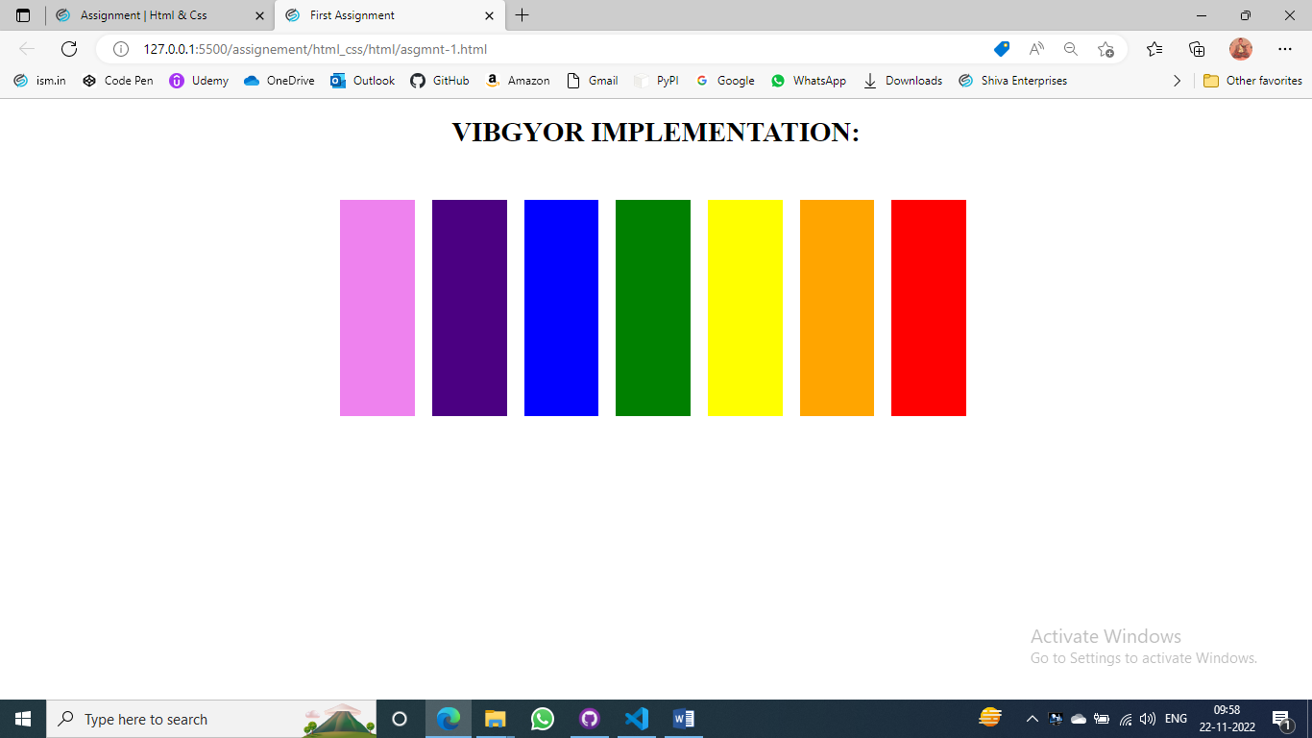

**Assignment – 2**

Html

<!DOCTYPE html>

<html>

<head>

    <meta charset="utf-8">

    <meta name="author" content="Rahul Hosakoti">

    <meta name="viewport" content="width=device-width, initial-scale=1">

    <link rel="icon" href="../img/icon.png">

    <link rel="stylesheet" type="text/css" href="../css/style-2.css">

    <title>Second Assignment</title>

</head>

<body>

    <div class="chessboard">

                <!-- 1st -->

        <div class="white"></div>

        <div class="black"></div>

        <div class="white"></div>

        <div class="black"></div>

        <div class="white"></div>

        <div class="black"></div>

        <div class="white"></div>

        <div class="black"></div>

                <!-- 2nd -->

        <div class="black"></div>

        <div class="white"></div>

        <div class="black"></div>

        <div class="white"></div>

        <div class="black"></div>

        <div class="white"></div>

        <div class="black"></div>

        <div class="white"></div>

                <!-- 3th -->

        <div class="white"></div>

        <div class="black"></div>

        <div class="white"></div>

        <div class="black"></div>

        <div class="white"></div>

        <div class="black"></div>

        <div class="white"></div>

        <div class="black"></div>

                <!-- 4st -->

        <div class="black"></div>

        <div class="white"></div>

        <div class="black"></div>

        <div class="white"></div>

        <div class="black"></div>

        <div class="white"></div>

        <div class="black"></div>

        <div class="white"></div>

                <!-- 5th -->

        <div class="white"></div>

        <div class="black"></div>

        <div class="white"></div>

        <div class="black"></div>

        <div class="white"></div>

        <div class="black"></div>

        <div class="white"></div>

        <div class="black"></div>

                <!-- 6th -->

        <div class="black"></div>

        <div class="white"></div>

        <div class="black"></div>

        <div class="white"></div>

        <div class="black"></div>

        <div class="white"></div>

        <div class="black"></div>

        <div class="white"></div>

                <!-- 7th -->

        <div class="white"></div>

        <div class="black"></div>

        <div class="white"></div>

        <div class="black"></div>

        <div class="white"></div>

        <div class="black"></div>

        <div class="white"></div>

        <div class="black"></div>

                <!-- 8th -->

        <div class="black"></div>

        <div class="white"></div>

        <div class="black"></div>

        <div class="white"></div>

        <div class="black"></div>

        <div class="white"></div>

        <div class="black"></div>

        <div class="white"></div>

    </div>

</body>

</html>

Css

.chessboard {

    width: 800px;

    min-width: 400px;

    height: 800px;

    min-height: 400px;

    margin: 50px auto;

    border: 15px solid #333;

}

.black,.white{

    float: left;

    width: 100px;

    min-width: 50px;

    height: 100px;

    min-height: 50px;

}

.black {

    background-color: black;

}

.white {

    background-color: white;

}

Output

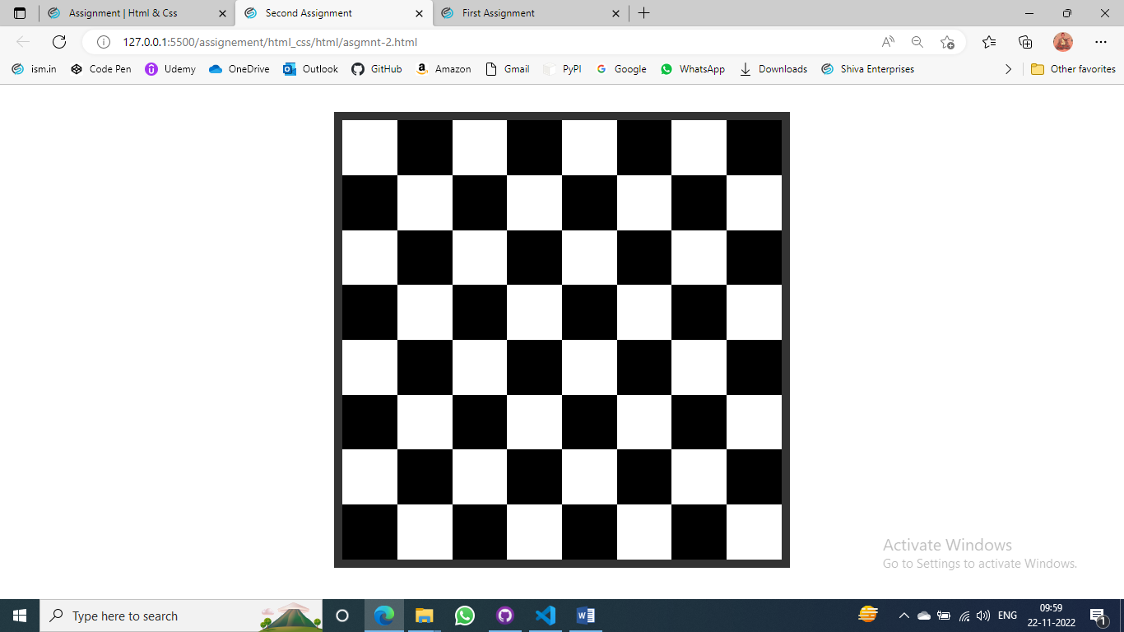

**Assignment – 3**

Html

<!DOCTYPE html>

<html>

<head>

    <meta charset="utf-8">

    <meta name="author" content="Rahul Hosakoti">

    <meta name="viewport" content="width=device-width, initial-scale=1">

    <link rel="icon" href="../img/icon.png">

    <link rel="stylesheet" type="text/css" href="../css/style-3.css">

    <title>Third Assignment</title>

</head>

<body>

    <h2>ISMUNIV GAMBLING GROUP</h2>

    <h4>India's No.1 Gambling Group</h4>

    <br>

    <p id="para">orem ipsum dolor sit amet, consectetur adipisicing elit, sed do eiusmod

    tempor incididunt ut labore et dolore magna aliqua. Ut enim ad minim veniam,

    quis nostrud exercitation ullamco laboris nisi ut aliquip ex ea commodo

    consequat. Duis aute irure dolor in reprehenderit in voluptate velit esse

    cillum dolore eu fugiat nulla pariatur. Excepteur sint occaecat cupidatat non

    proident, sunt in culpa qui officia deserunt mollit anim id est laborum.</p>

    <br>

    <p id="para">orem ipsum dolor sit amet, consectetur adipisicing elit, sed do eiusmod

    tempor incididunt ut labore et dolore magna aliqua. Ut enim ad minim veniam,

    quis nostrud exercitation ullamco laboris nisi ut aliquip ex ea commodo

    consequat. Duis aute irure dolor in reprehenderit in voluptate velit esse

    cillum dolore eu fugiat nulla pariatur. Excepteur sint occaecat cupidatat non

    proident, sunt in culpa qui officia deserunt mollit anim id est laborum.</p>

    <h4>Are You Intersted to Join This Group:</h4>

    <form>

        <label for="name">Enter Name:</label><br>

        <input type="text" name="name"><br>

        <label for="email">Enter Mail Id:</label><br>

        <input type="mail" name="email"><br>

        <label for="mobile">Enter Mobile Number:</label><br>

        <input type="number" name="mobile"><br><br>

        <input type="submit" value="Join Us" id="button">

    </form>

</body>

</html>

Css

*{

    font-family: 'Times New Roman', Times, serif;

}

body{

    background-color: #021630;

    color: white;

}

h2,h4,p{

    text-align: center;

}

p#para{

    position: relative;

    left: 25%;

    width: 50%;

}

form{

    text-align: center;

}

input{

    width: 120px;

}

#button{

    background-color: yellow;

    height: 35px;

    width: 80px;

    font-size: 20px;

    border-radius: 10px;

}

Output

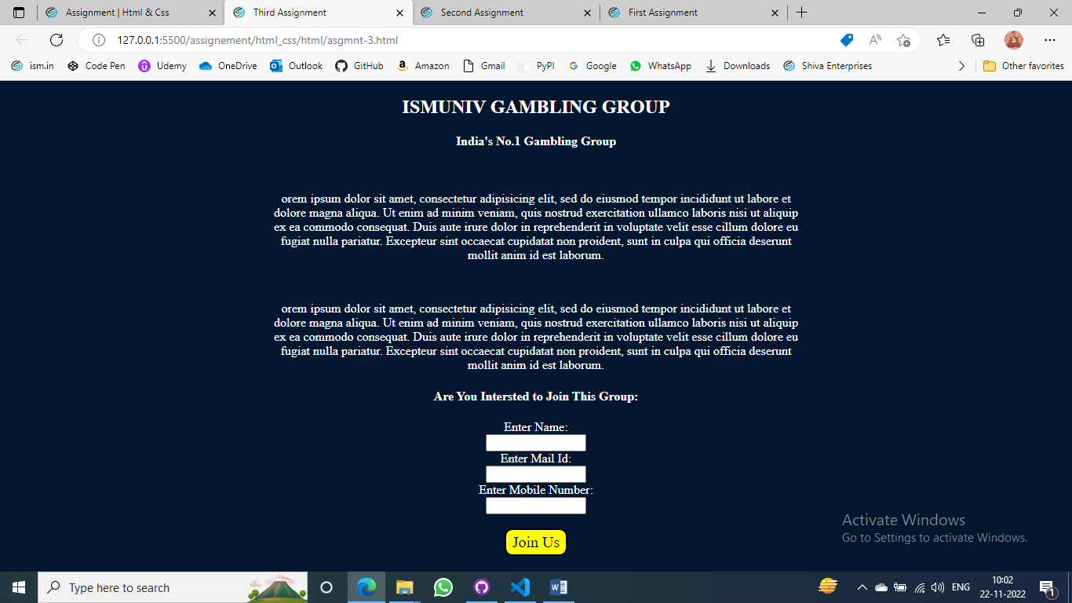

**Assignment – 4**

Html

<!DOCTYPE html>

<html>

<head>

    <meta charset="utf-8">

    <meta name="author" content="Rahul Hosakoti">

    <meta name="viewport" content="width=device-width, initial-scale=1">

    <link rel="icon" href="../img/icon.png">

    <link rel="stylesheet" type="text/css" href="../css/style-4.css">

    <title>Fourth Assignment</title>

</head>

<body>

    <div id="main">

        <div id="m1">

            <p id="date">june 05<sup>th</sup> 2018</p>

            <h1>This is Python Related Post</h1>

            <p id="p1">Lorem ipsum dolor sit amet, consectetur adipisicing elit. Eaque tempore inventore fugit ducimus quaerat est nemo voluptatem magnam, tenetur cumque perferendis, facilis possimus aperiam, distinctio nesciunt deserunt magni suscipit excepturi.</p>

            <p id="p2">Lorem ipsum dolor sit amet consectetur, adipisicing elit. Magnam, fuga in incidunt obcaecati eveniet, enim laboriosam error earum voluptatibus aspernatur, laudantium rerum dolores. Aperiam commodi porro esse non natus vel?</p>

            <p id="p3">Lorem ipsum dolor sit amet consectetur adipisicing elit. Quasi voluptatem quas excepturi, soluta quia fugiat aliquid? Fugit id mollitia deserunt illo quod soluta similique, voluptatibus in ab dolores, nostrum odio?

            </p>

        </div>

        <hr id="r1"size="12px">

        <div id="m2">

            <p id="date">june 05<sup>th</sup> 2018</p>

            <h1>This is Python Related Post</h1>

            <p id="p1">Lorem ipsum dolor sit amet, consectetur adipisicing elit. Eaque tempore inventore fugit ducimus quaerat est nemo voluptatem magnam, tenetur cumque perferendis, facilis possimus aperiam, distinctio nesciunt deserunt magni suscipit excepturi.</p>

            <p id="p2">Lorem ipsum dolor sit amet consectetur, adipisicing elit. Magnam, fuga in incidunt obcaecati eveniet, enim laboriosam error earum voluptatibus aspernatur, laudantium rerum dolores. Aperiam commodi porro esse non natus vel?</p>

            <p id="p3">Lorem ipsum dolor sit amet consectetur adipisicing elit. Quasi voluptatem quas excepturi, soluta quia fugiat aliquid? Fugit id mollitia deserunt illo quod soluta similique, voluptatibus in ab dolores, nostrum odio?

            </p>

        </div>

        <hr id="r2" size="12px">

    </div>

</body>

</html>

Css

#main{

    height: 750px;

    width: 650px;

    font-size: 15px;

    text-align: justify;

    border: 20px solid gray;

    margin: 25px;

}

h1{

    color: darkblue;

}

#date{

    text-transform: uppercase;

    font-size: 25px;

    font-family: 'Gill Sans', 'Gill Sans MT', Calibri, 'Trebuchet MS', sans-serif;

    color: gray;

    padding-left: 10px;

}

#m1,#m2{

    padding: 5px 10px;

}

#p1{

    margin-left: 5px;

    border-left: 10px solid gray;

    padding-left: 5px;

}

hr#r1{

    margin: 0px 15px;

}

hr#r2{

    margin: 0px 15px 10px;

}

Output

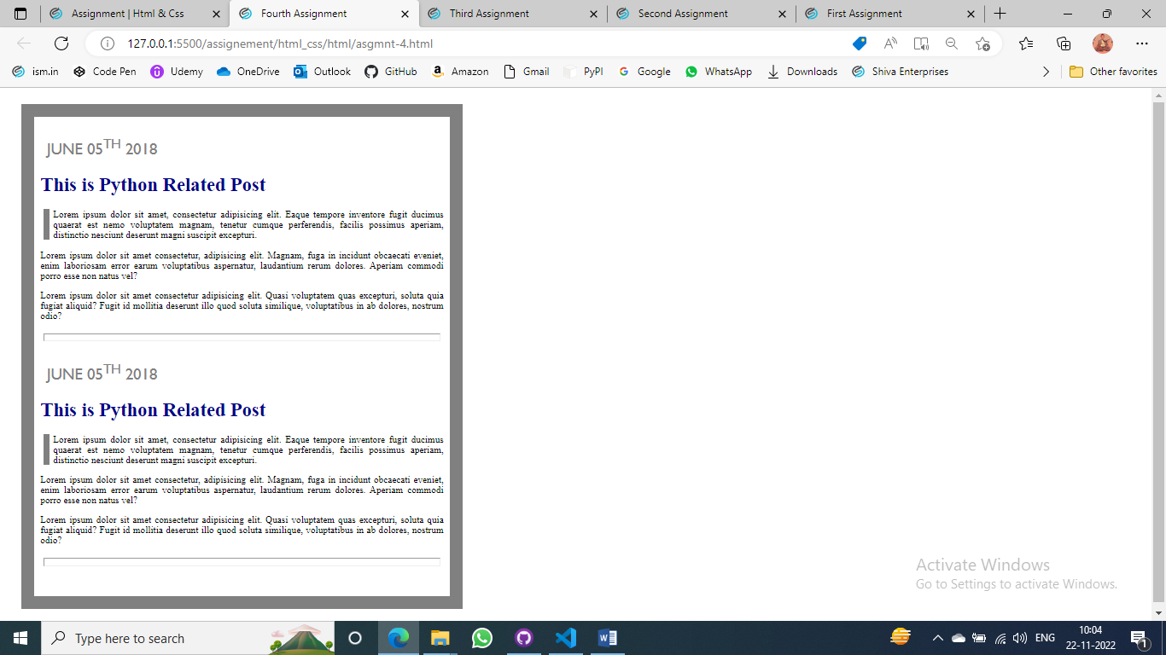

**Assignment-5**

Html

<!DOCTYPE html>

<html>

<head>

    <meta charset="utf-8">

    <meta name="author" content="Rahul Hosakoti">

    <meta name="viewport" content="width=device-width, initial-scale=1">

    <link rel="icon" href="../img/icon.png">

    <link rel="stylesheet" type="text/css" href="../css/style-5.css">

    <title>Fifth Assignment</title>

</head>

<body>

    <img src="../img/1.jpg" alt="img">

    <img src="../img/2.jpg" alt="img">

    <img src="../img/3.jpg" alt="img">

    <img src="../img/4.jpg" alt="img">

    <img src="../img/5.jpg" alt="img">

    <img src="../img/6.jpg" alt="img">

    <img src="../img/7.jpg" alt="img">

    <img src="../img/8.jpg" alt="img">

    <img src="../img/9.jpg" alt="img">

</body>

</html>

Css

body{

    display: flexbox;

    min-width: 480px;

    max-width: 600px;

    height: 480px;

    margin: 100px auto;

}

img{

    border: 3px solid black;

    width: 30%;

    height: 30%;

    padding: auto;

    margin-left: 5px;

    margin-top: 5px;

}

Output

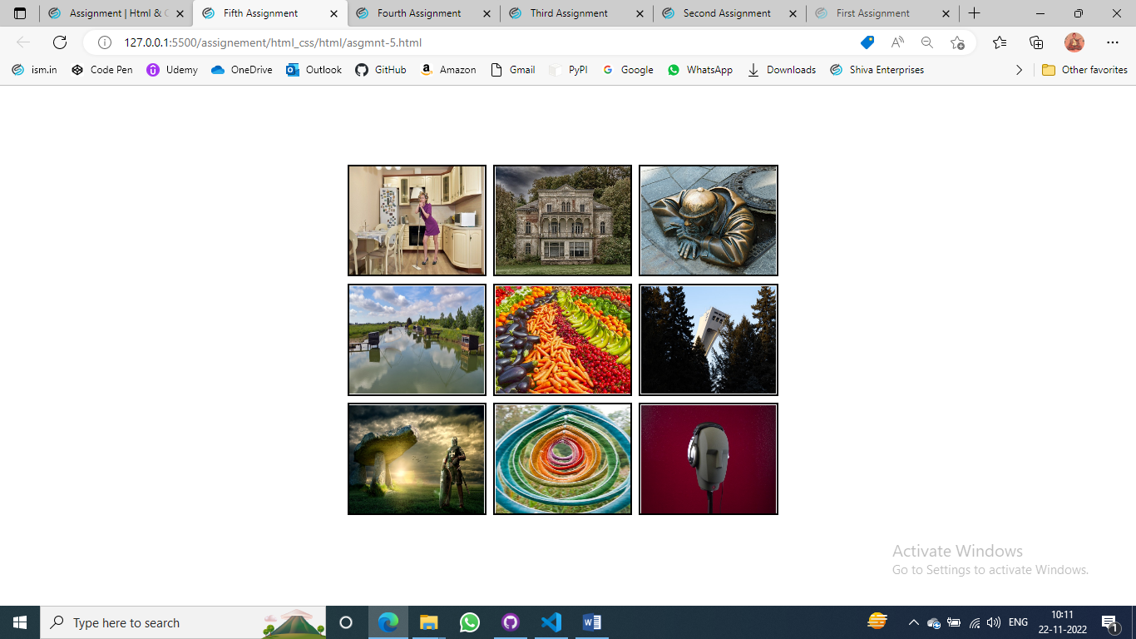

**Assignment-6**

Html

<!DOCTYPE html>

<html lang="en">

<head>

    <meta charset="utf-8">

    <meta name="author" content="Rahul Hosakoti">

    <meta name="viewport" content="width=device-width, initial-scale=1">

    <link rel="icon" href="../img/icon.png">

    <link rel="stylesheet" type="text/css" href="../css/style-6.css">

    <title>Sixth Assignment</title>

</head>

<body>

    <div class="container">

        <div class="col1">

            <nav>Navbar</nav>

        </div>

        <div class="col2">

            <main>Main</main>

            <div class="side">

                <div id="side1">Aside</div>

                <div id="side2">Aside</div>

            </div>

            <footer>Footer</footer>

        </div>

    </div>

</body>

</html>

Css

*{

    box-sizing: border-box;

    margin: 0;

}

.container{

    margin: 5% auto;

    display: flex;

    font-size: 20px;

    text-align: center;

    height: 200px;

    width: 300px;

}

.side{

    display: flex;

}

nav{

    background: rgb(177, 172, 172);

    height: 250px;

    width:auto;

}

main{

    background: rgb(69, 252, 69);

    width: 280px;

    height: 50px;

}

#side1{

    background: whitesmoke;

    height: 150px;

    width: 210px;

}

#side2{

    background: rgb(235, 202, 18);

    height: 150px;

    width: 70px;

}

footer{

    background: rgb(69, 252, 69);

    height: 50px;

    width: 280px;

}

Output

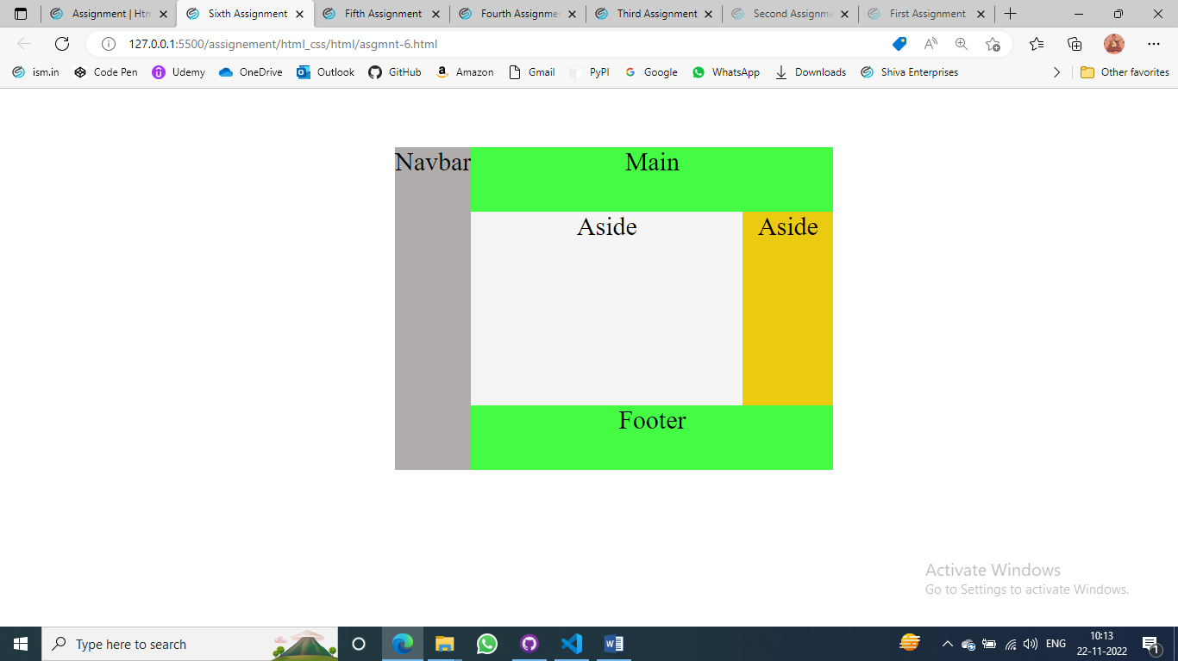

**Assignment -7**

Html

<!DOCTYPE html>

<html lang="en">

<head>

    <meta charset="utf-8">

    <meta name="author" content="Rahul Hosakoti">

    <meta name="viewport" content="width=device-width, initial-scale=1">

    <link rel="icon" href="../img/icon.png">

    <link rel="stylesheet" type="text/css" href="../css/style-7.css">

    <title>Seventh Assignment</title>

</head>

<body>

    <div class="main">

        <div id="nav">

            <nav>

                <a href="#">Logo</a>

                <a href="#">Home</a>

                <a href="#">Products</a>

                <a href="#">Services</a>

            </nav>

        </div>

        <div>

            <input type="text" placeholder="Search" id="search">

            <input type="submit" value="Go" id="button">

        </div>

    </div>

</body>

</html>

Css

.main{

    display: flex;

    flex-direction: column;

    background-color: orange;

    height: fit-content;

    width: 700px;

    padding: 10px;

    margin: 50px auto;

}

div div a{

    text-decoration: none;

    color: #fff;

    font-size: 40px;

    padding: 0px 25px 30px 0px;

}

#nav{

    margin-bottom: 20px;

}

input{

    background-color: white;

    border-color: #fff;

    font-size: 20px;

}

input#search{

    width: 580px;

    height: 30px;

}

input#button{

    width: 80px;

    height: 40px;

    border-radius: 40%;

    font-size: 25px;

    color: orange;

    margin: 10px;

}

Output

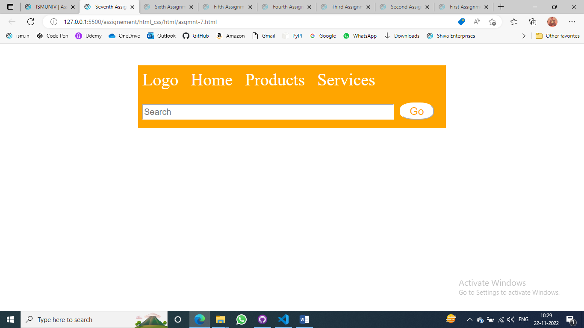

**Assignment-8**

Html

<!DOCTYPE html>

<html>

<head>

    <meta charset="utf-8">

    <meta name="author" content="Rahul Hosakoti">

    <meta name="viewport" content="width=device-width, initial-scale=1">

    <link rel="icon" href="../img/icon.png">

    <link rel="stylesheet" type="text/css" href="../css/style-8.css">

    <title>Eighth Assignment</title>

</head>

<body>

    <div class="main">

        <div>

            <label for="name">Name:</label><br><br>

            <label for="native">Town you were born in:</label><br><br>

            <label for="Email">Email Address:</label><br><br>

        </div>

        <div>

            <input type="text" name="name" id="name"><br><br>

            <input type="text" name="native" id="native"><br><br>

            <input type="email" name="email" id="email"><br><br>

            <input type="submit" value="Submit" id="button">

        </div>

    </div>

</body>

</html>

Css

.main{

    display: flex;

    background-color: rgb(201, 192, 192);

    height: fit-content;

    width: 350px;

    padding: 10px;

    margin: 50px auto;

}

input{

    width: 100%;

    background-color: white;

    border-color: #fff;

}

input#button{

    width: fit-content;

    position: relative;

    left: 130px;

    background-color: rgba(58, 57, 57, 0.671);

    color: white;

}

Output

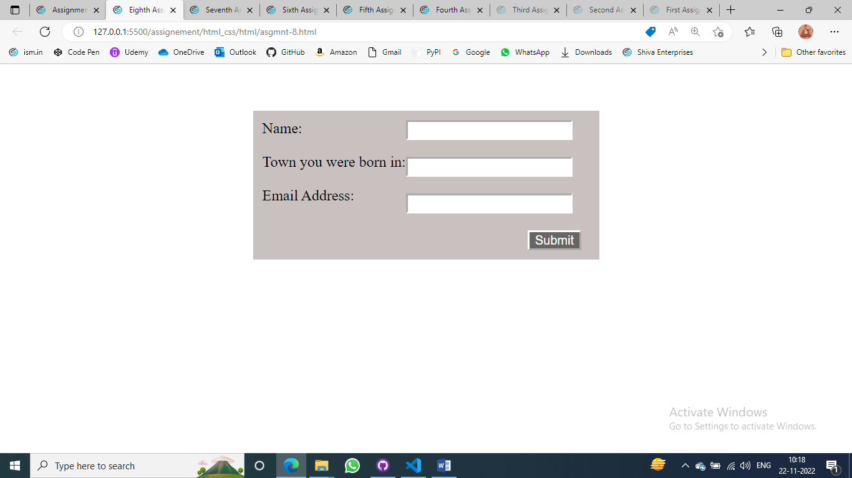

**Assignment-9**

Html

<!DOCTYPE html>

<html>

<head>

    <meta charset="utf-8">

    <meta name="author" content="Rahul Hosakoti">

    <meta name="viewport" content="width=device-width, initial-scale=1">

    <link rel="icon" href="../img/icon.png">

    <link rel="stylesheet" type="text/css" href="../css/style-9.css">

    <title>Ninth Assignment</title>

</head>

<body>

    <div id="main">

        <div id="one">

            <form action="">

                <div id="colomn">

                    <div class="a">

                        <label for="name">Name:</label>

                        <input type="text" name="name" id="name">

                    </div><br>

                    <div class="a">

                        <label for="mobile">Phone:</label>

                        <input type="number" name="mobile" id="mobile">

                    </div><br>

                    <div class="a">

                        <label for="email">Email: </label>

                        <input type="email" name="email" id="email">

                    </div><br>

                    <div class="a"><label for="date">Pickup Date/Time:</label>

                        <input type="datetime-local" name="date" id="date">

                    </div><br>

                    <div class="a">

                        <label for="place">Pickup place:</label>

                        <select id="place">

                            <option value="select">----Select One----</option>

                            <option value="India">ISRO</option>

                            <option value="America">NASA</option>

                            <option value="China">Covid-19</option>

                        </select>

                    </div><br>

                    <div class="a">

                        <label for="dropplace">Dropoff Place:</label>

                        <input type="text" id="dropplace" list="place-2">

                            <datalist id="place-2">

                                <option value="Home">

                                <option value="Shop">

                                <option value="Town">

                            </datalist>

                    </div><br>

                    <input type="submit" name="submit" id="button" value="Submit Booking">

                </div>

            </form>

        </div>

        <div id="two">

            <label for="vichile">Which taxi do you require?</label><br>

                <input type="radio" name="car" id="car">

                    <label for="car">Car</label><br>

                <input type="radio" name="Van" id="van">

                    <label for="van">Van</label><br>

                <input type="radio" name="tuk" id="tuk">

                    <label for="tuk">Tuk Tuk</label><br><br>

            <label for="extra">Extras</label><br>

                <input type="checkbox" name="baby" id="baby">

                    <label for="baby">Baby Seat</label><br>

                <input type="checkbox" name="wheel" id="wheel">

                    <label for="wheel">Wheelchair Access</label><br>

                <input type="checkbox" name="tip" id="tip">

                    <label for="tip">Stock Tip</label>

        </div>

    </div>

</body>

</html>

Css

#main{

    display: flex;

    background-color: rgba(244, 250, 167,0.6);

    height: fit-content;

    width: 100%;

    max-width: fit-content;

    padding: 10px;

    margin: 50px auto;

}

div.a{

    display: flex;

    justify-content: space-between;

}

#one,#two{

    margin: 0px 10px;

}

input#button{

    border-color: rgba(58, 57, 57, 0.671);;

    width: fit-content;

    position: relative;

    left: 200px;

    background-color: rgba(58, 57, 57, 0.671);

    color: white;

}

Output

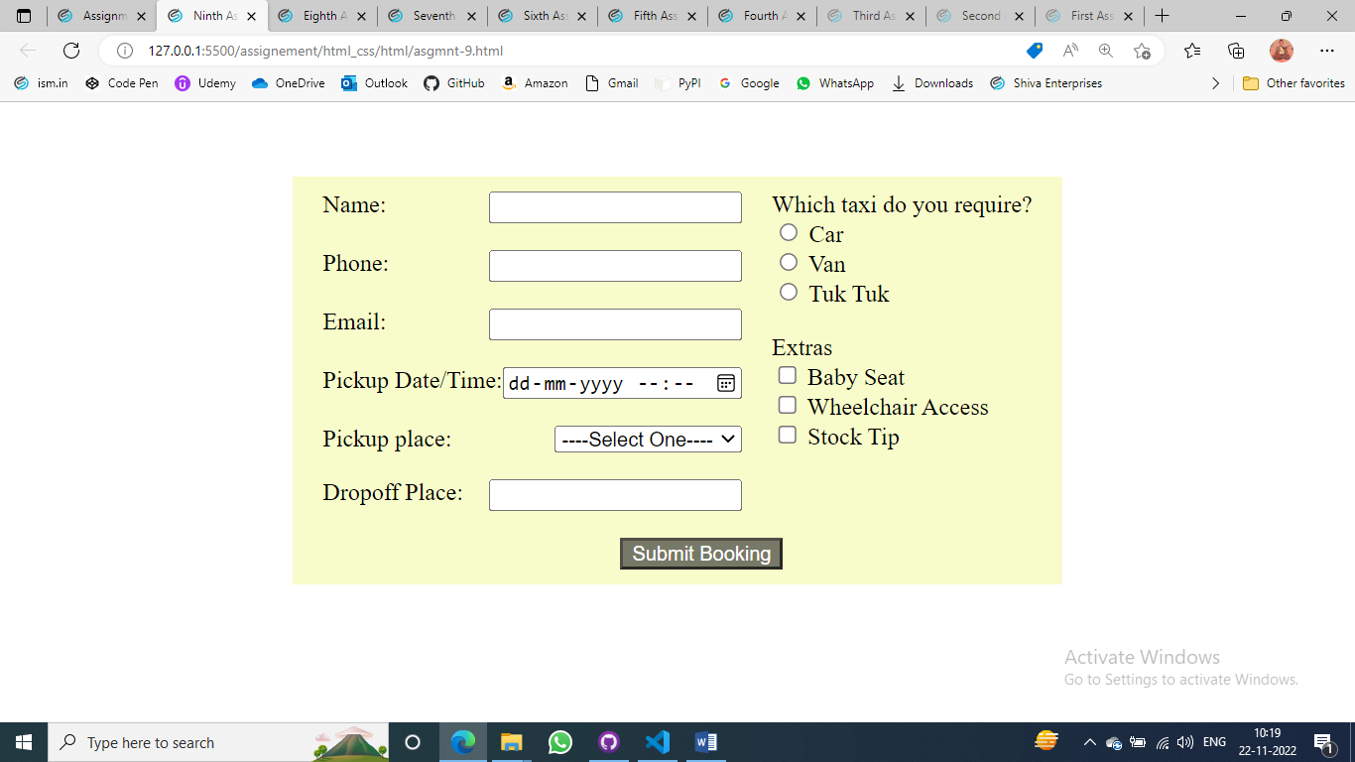

**Assignment-10**

Html

<!DOCTYPE html>

<html>

<head>

    <meta charset="utf-8">

    <meta name="author" content="Rahul Hosakoti">

    <meta name="viewport" content="width=device-width, initial-scale=1">

    <link rel="icon" href="../img/icon.png">

    <link rel="stylesheet" type="text/css" href="../css/style-10.css">

    <title>Tenth Assignment</title>

</head>

<body>

    <div class="main">

        <div class="image"><img src="../img/22.jpg" alt="img"></div>

        <div class="image"><img src="../img/18.jpg" alt="img"></div>

        <div class="image"><img src="../img/16.jpg" alt="img"></div>

        <div class="image"><img src="../img/21.jpg" alt="img"></div>

        <div class="image"><img src="../img/15.jpg" alt="img"></div>

        <div class="image"><img src="../img/12.jpg" alt="img"></div>

    </div>

</body>

</html>

Css

.main{

    display: grid;

    grid-template-columns: 200px 200px 200px;

    width: fit-content;

    margin: 5% auto;

    background-color: whitesmoke;

}

.image{

    margin: 10px;

}

img{

    height: 160px;

    width: 100%;

}

Output

