Memory_Folder Project Documentation
Developer onboarding guide for the local memory, style-learning, and voice-enabled chat system.
Canonical source | docs/PROJECT_DOCUMENTATION.md
Generated report | document/Memory_Folder_Project_Documentation.docx
Shareable export | document/Memory_Folder_Project_Documentation.pdf
Preset | compact_reference_guide

This report summarizes current implementation behavior and intentionally avoids reproducing sensitive system-prompt text.

Developer onboarding guide for the local memory, style-learning, and voice-enabled chat system.
Source of truth: this document is grounded in the current repository code, the existing architecture notes, the supplied diagrams in document/, and the dependency manifests captured with the project.

1. Executive Summary
Memory_Folder is an offline-first personal memory system for a conversational agent. It combines semantic memory retrieval, graph reasoning, adaptive style learning, local or API-backed LLM generation, and optional speech input.
The runtime is centered on integrated_system.py, which wires together:
- Amem/: the memory engine, graph store, vector store, embedding/reranking, DSL, visualization, and local LLM backends.
- LLM_Style/: linguistic feature extraction, emotion analysis, pattern deduplication, and dynamic system-prompt construction.
- ASR/: NeMo-based microphone transcription for voice input.
- server_llm.py: an OpenAI-compatible API client used as a drop-in LLM backend.
The core design pattern is simple: user messages are analyzed, remembered, retrieved, and used to build a per-turn augmented prompt. Memory context is injected only into the current model call so retrieved facts do not leak permanently into chat history.

2. Repository Map
Area | Main files | Purpose
Orchestrator | `integrated_system.py` | CLI chat loop, runtime arguments, memory factory, style/profile update loop, prompt assembly, commands.
Memory core | `Amem/memory.py` | `OfflineMemory`; add/search/traverse/update/delete/history; coordinates all memory stores.
Retrieval wrappers | `Amem/memory_system.py` | Normal graph-first search, explicit `@remember` hybrid search, context construction, command parsing.
Graph store | `Amem/graph_store.py` | SQLite property graph with nodes, edges, edge properties, similarity/merge utilities, traversal helpers.
Vector store | `Amem/vector_store.py` | FAISS vector index plus pickle docstore, metadata filters, rebuild/reset support.
Embedding/rerank | `Amem/local_embedding.py` | Local BGE-M3 embeddings, lexical weights, dense/sparse/ColBERT scoring, graph-enhanced reranking.
Entity index | `Amem/entity_index.py` | SQLite mapping from entity names to memory IDs, aliases, case-insensitive lookups.
LLM backends | `Amem/local_llm.py`, `server_llm.py` | Local GGUF/HF generation and OpenAI-compatible API generation.
Style learning | `LLM_Style/linguistic_analyzer.py`, `LLM_Style/profile_index.py`, `LLM_Style/pattern_deduplicator.py` | Feature extraction, emotion distribution, pattern clustering, style prompt export.
Voice input | `ASR/asr_wrapper.py` | Lazy-loaded NeMo ASR microphone interface for `--voice` and `@voice`.
Config | `configs/offline.yaml`, `Amem/local_config.py` | Paths, retrieval weights, reranker settings, model locations, persistence locations.
Data stores | `local_data/`, `system_outputs/` | FAISS indexes, SQLite DBs, style profile JSON, graph visualizations, prompt outputs.
Tests | `tests/`, root `test_*.py` | Unit/smoke tests for graph, memory, search, and style learning. Some imports are stale; see Known Gaps.

3. System Architecture
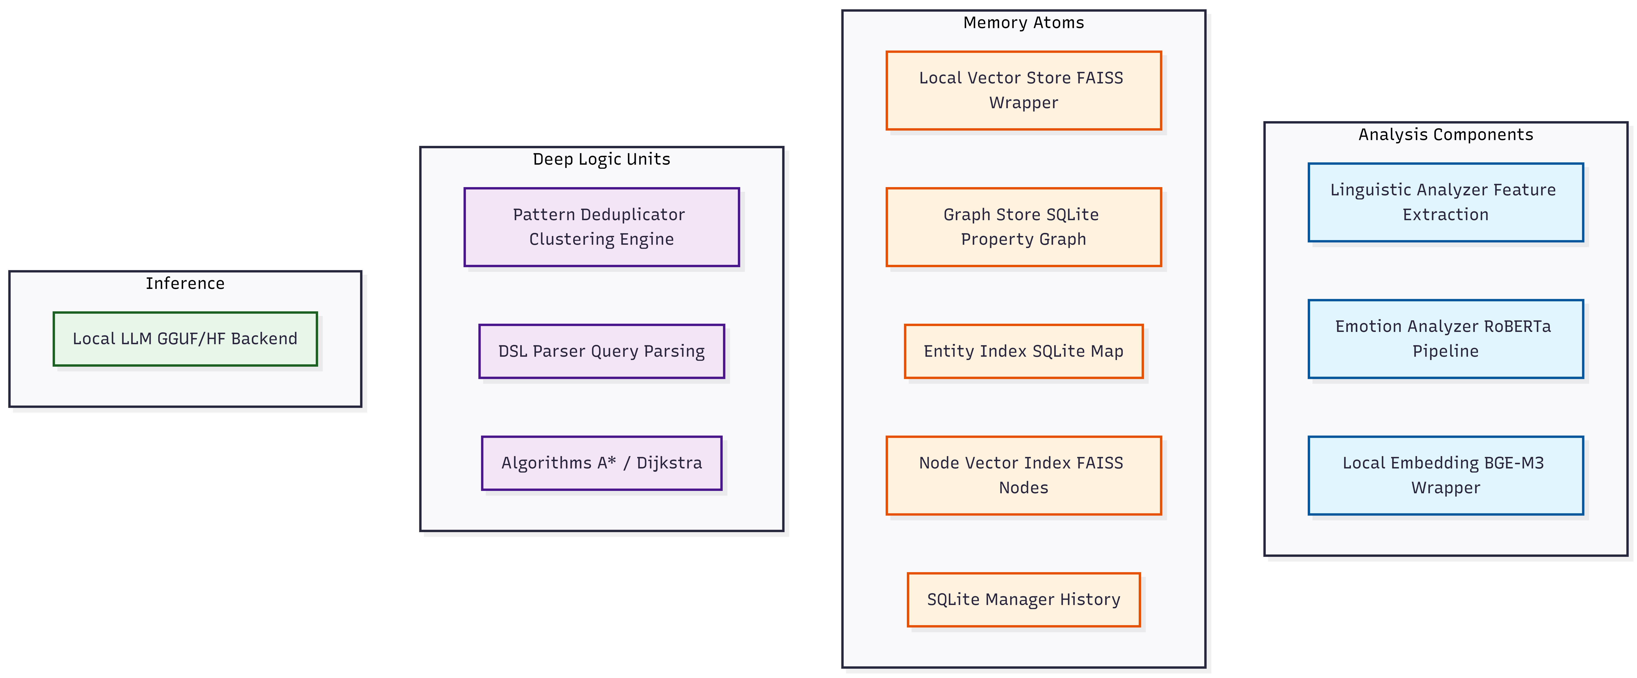
Component inventory
Figure 1. Component inventory. The implementation groups into memory atoms, deep logic units, inference backends, and analysis components.
The system has four major subsystems:
- Memory atoms persist semantic, graph, entity, node-vector, and history state.
- Deep logic units parse DSL queries, deduplicate patterns, and traverse relationship graphs.
- Analysis components extract linguistic features, emotional distributions, and embeddings.
- Inference components generate replies through either local models or OpenAI-compatible server APIs.
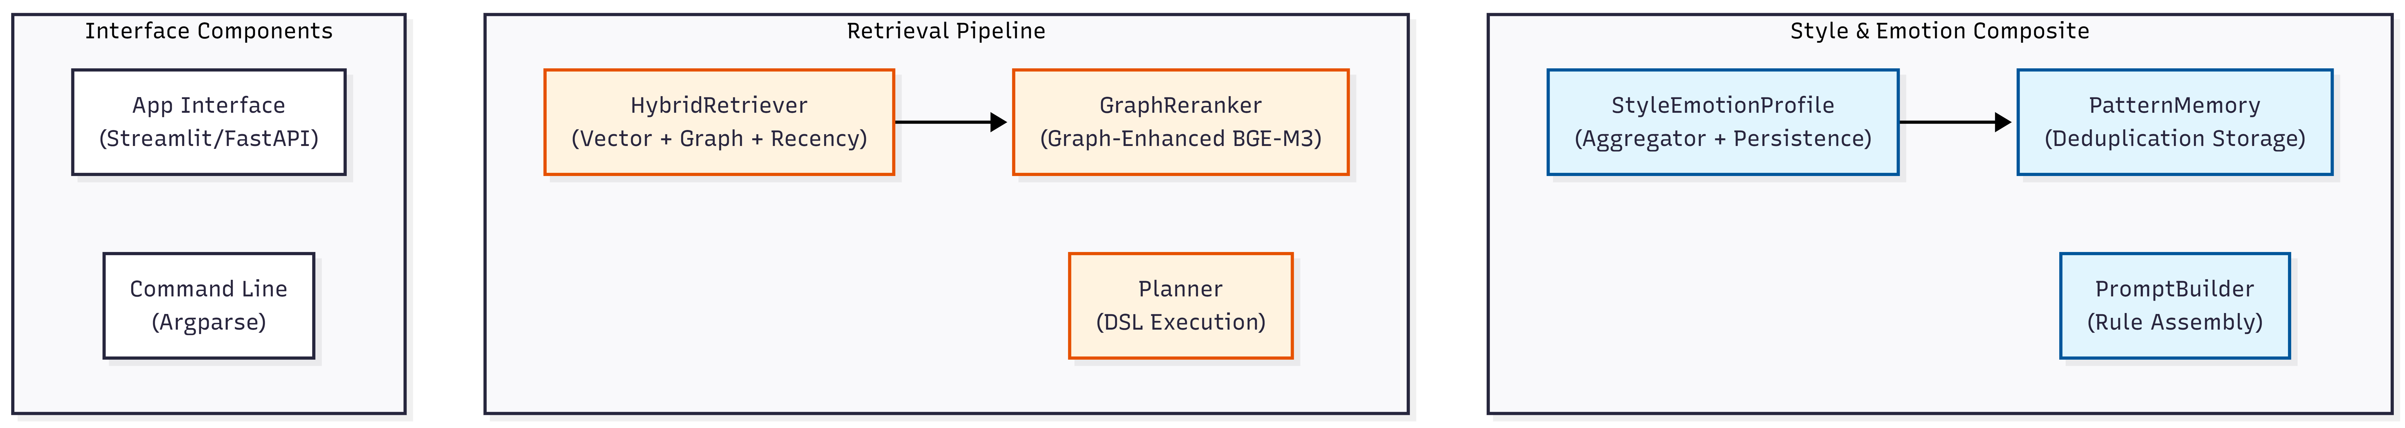
Interface, retrieval, and style components
Figure 2. Interface, retrieval, and style composite. The current repo has CLI orchestration and static interface assets; interface/app.py is referenced by diagrams but is not present as source.
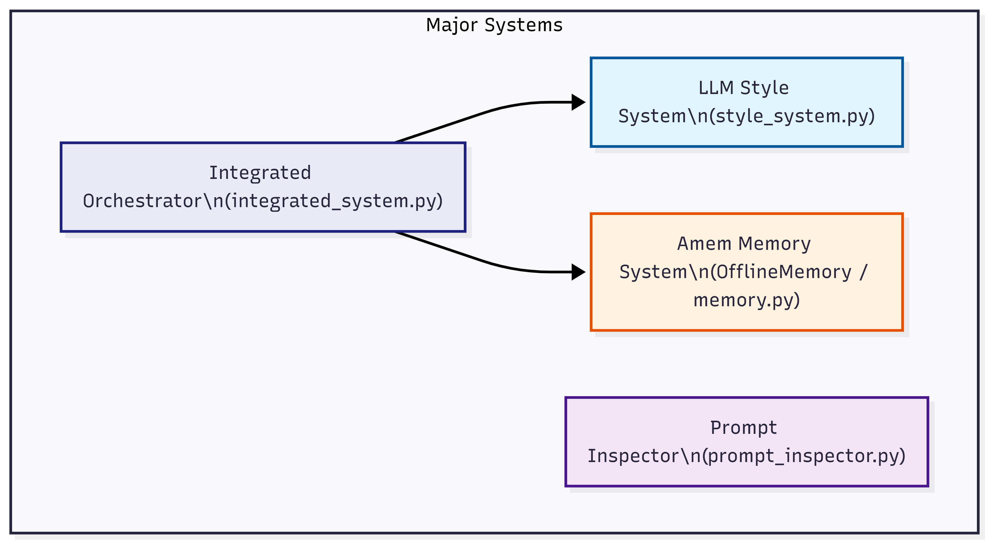
Major systems
Figure 3. Major systems. integrated_system.py currently acts as the executable orchestrator that joins Amem memory, style learning, prompt construction, LLM backend selection, and optional voice input.

4. Runtime Orchestration
integrated_system.py is intentionally a wiring layer. Its file header states that business logic lives in Amem/memory_system.py, Amem/memory.py, and LLM_Style/.
Key responsibilities:
- Load OfflineMemoryConfig from configs/offline.yaml.
- Apply runtime overrides for model paths, generation parameters, index type, reranker top-k, and debug flags.
- Choose an LLM backend:
- --llm-type local: use Amem/local_llm.py.
- --llm-type server: instantiate ServerLLM.
- interactive startup asks the user to choose if no type is supplied.
- Initialize Planner, LinguisticAnalyzer, EmotionAnalyzer, and StyleEmotionProfile.
- Initialize the strict style pattern deduplicator before style updates.
- Build the base system prompt plus dynamic style/emotion section.
- Maintain chat history while injecting memory context only into the current user message.
- Handle commands such as @store, @remember, @delete, @path, @viz, @voice, and @eval.
The chat loop order is:
- Read text or voice input.
- Parse command trigger.
- Detect and persist user/assistant names.
- Update style and emotion profile from the user message.
- Rebuild the dynamic system prompt.
- Retrieve memory context if augmentation is enabled.
- Build a temporary LLM message list with [Memory Context] for the current turn.
- Stream model output.
- Store only clean user/assistant messages in history, not the augmented memory block.

5. Configuration and Environment
The default configuration is configs/offline.yaml.
Important defaults:
Config area | Default path/value | Notes
LLM models | `./models` | Local GGUF or HF models. Server mode bypasses local LLM loading.
Embedder | `./models/bge-m3` | BGE-M3 via `FlagEmbedding`, 1024 dimensions.
Emotion model | `./models/roberta-base-go_emotions` | Local RoBERTa GoEmotions model.
Vector store | `./local_data/faiss` | Stores `Amem.faiss` and `Amem.pkl`.
Graph DB | `./local_data/graph.db` | SQLite property graph.
Entity index | `./local_data/entity_index.db` | SQLite entity-to-memory mapping.
Node vectors | `./local_data/node_vectors` | FAISS-backed node/path vector index.
History DB | `./local_data/history.db` | SQLite audit log for memory changes.
Retrieval | `initial_top_k: 50`, `final_top_k: 10` | Search pool and final result sizing.
Reranker | enabled, `top_k: 10`, `max_passage_length: 96` | Graph-enhanced BGE-M3 reranking.

The dependency manifests in document/ show two separate surfaces:
- Core project: project_pip_packages.txt, project_conda_packages.txt, requirements.pdf, root requirements.txt.
- ASR: asr_pip_packages.txt, asr_conda_packages.txt.
For setup, prefer the captured conda manifests because this workspace did not expose a plain python command on PATH during inspection. Use the project environment explicitly, for example:
conda create --name memory-folder --file document/project_conda_packages.txt
conda activate memory-folder
python integrated_system.py --config configs/offline.yaml
For voice features, use the ASR environment manifest or install the ASR stack separately:
conda create --name memory-folder-asr --file document/asr_conda_packages.txt
conda activate memory-folder-asr
python integrated_system.py --voice
Server mode requires an API key. server_llm.py loads .env and resolves provider keys from NVIDIA_API_KEY, OPENAI_API_KEY, or AZURE_OPENAI_API_KEY depending on the configured base URL.

6. Memory Engine
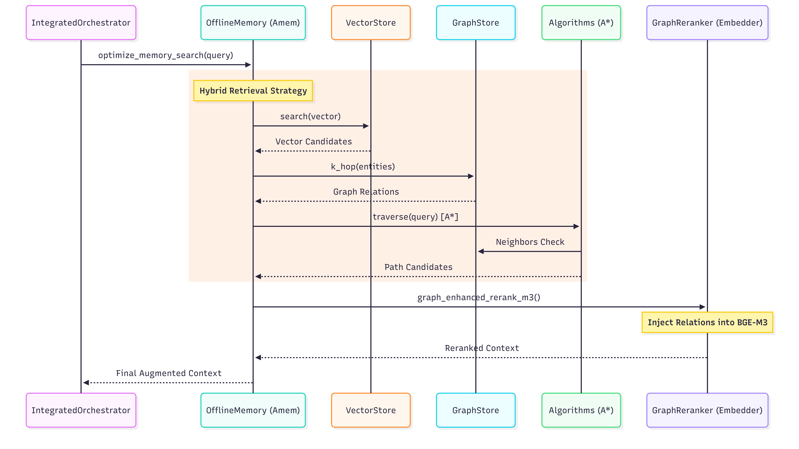
Memory class diagram
Figure 4. Memory class relationships. OfflineMemory owns the major stores and model wrappers.
Amem/memory.py defines OfflineMemory, the main in-process memory API. It coordinates:
- LocalEmbedding for dense vectors and lexical weights.
- LocalVectorStore for semantic recall.
- GraphStore for relationship storage and graph traversal.
- EntityIndex for entity-to-memory lookup.
- NodeVectorIndex for node/path vectors.
- SQLiteManager for audit/history storage.
- LocalLLM or ServerLLM for relationship extraction and final generation.

6.1 Add Pipeline
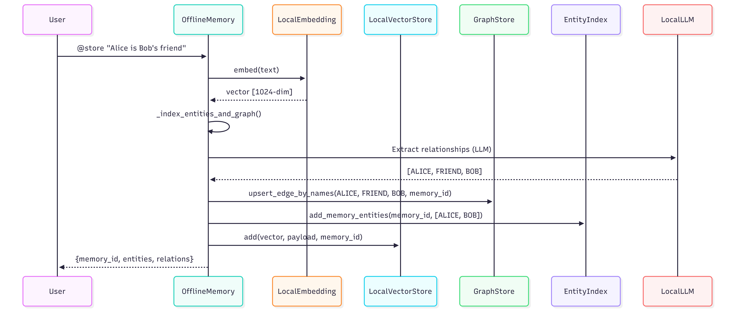
Store sequence
Figure 5. Store sequence. A memory is embedded, analyzed for entities and relationships, inserted into graph/entity stores, added to FAISS, and recorded in history.
OfflineMemory.add() accepts either a string or a list of chat messages. It:
- Normalizes the text input and merges user_id, agent_id, and run_id into metadata.
- Embeds the text with BGE-M3 and collects lexical weights.
- Searches for highly similar memories using FAISS.
- If the update threshold is met, merges text into the existing memory and updates the vector payload.
- If not, creates a new UUID memory ID.
- Calls _index_entities_and_graph() before writing the vector.
- Stores the vector and payload in LocalVectorStore.
- Writes an ADD or UPDATE record to the history database.
The graph is built before FAISS storage so relationship extraction is attempted even if vector persistence later has problems.

6.2 Entity and Relationship Indexing
The entity pipeline has deterministic and LLM-assisted parts:
- Proper-case and quoted-phrase entities are extracted by EntityIndex.
- First-person memories can be associated with the current user_id.
- User and assistant names are detected and persisted in local_data/user_profile.json.
- Relationship triplets are extracted with graph context and written to GraphStore.
- Temporal hints can be attached as edge properties.
- Optional entity and relationship merging exists but is disabled by default in config for performance.

6.3 Search Pipeline
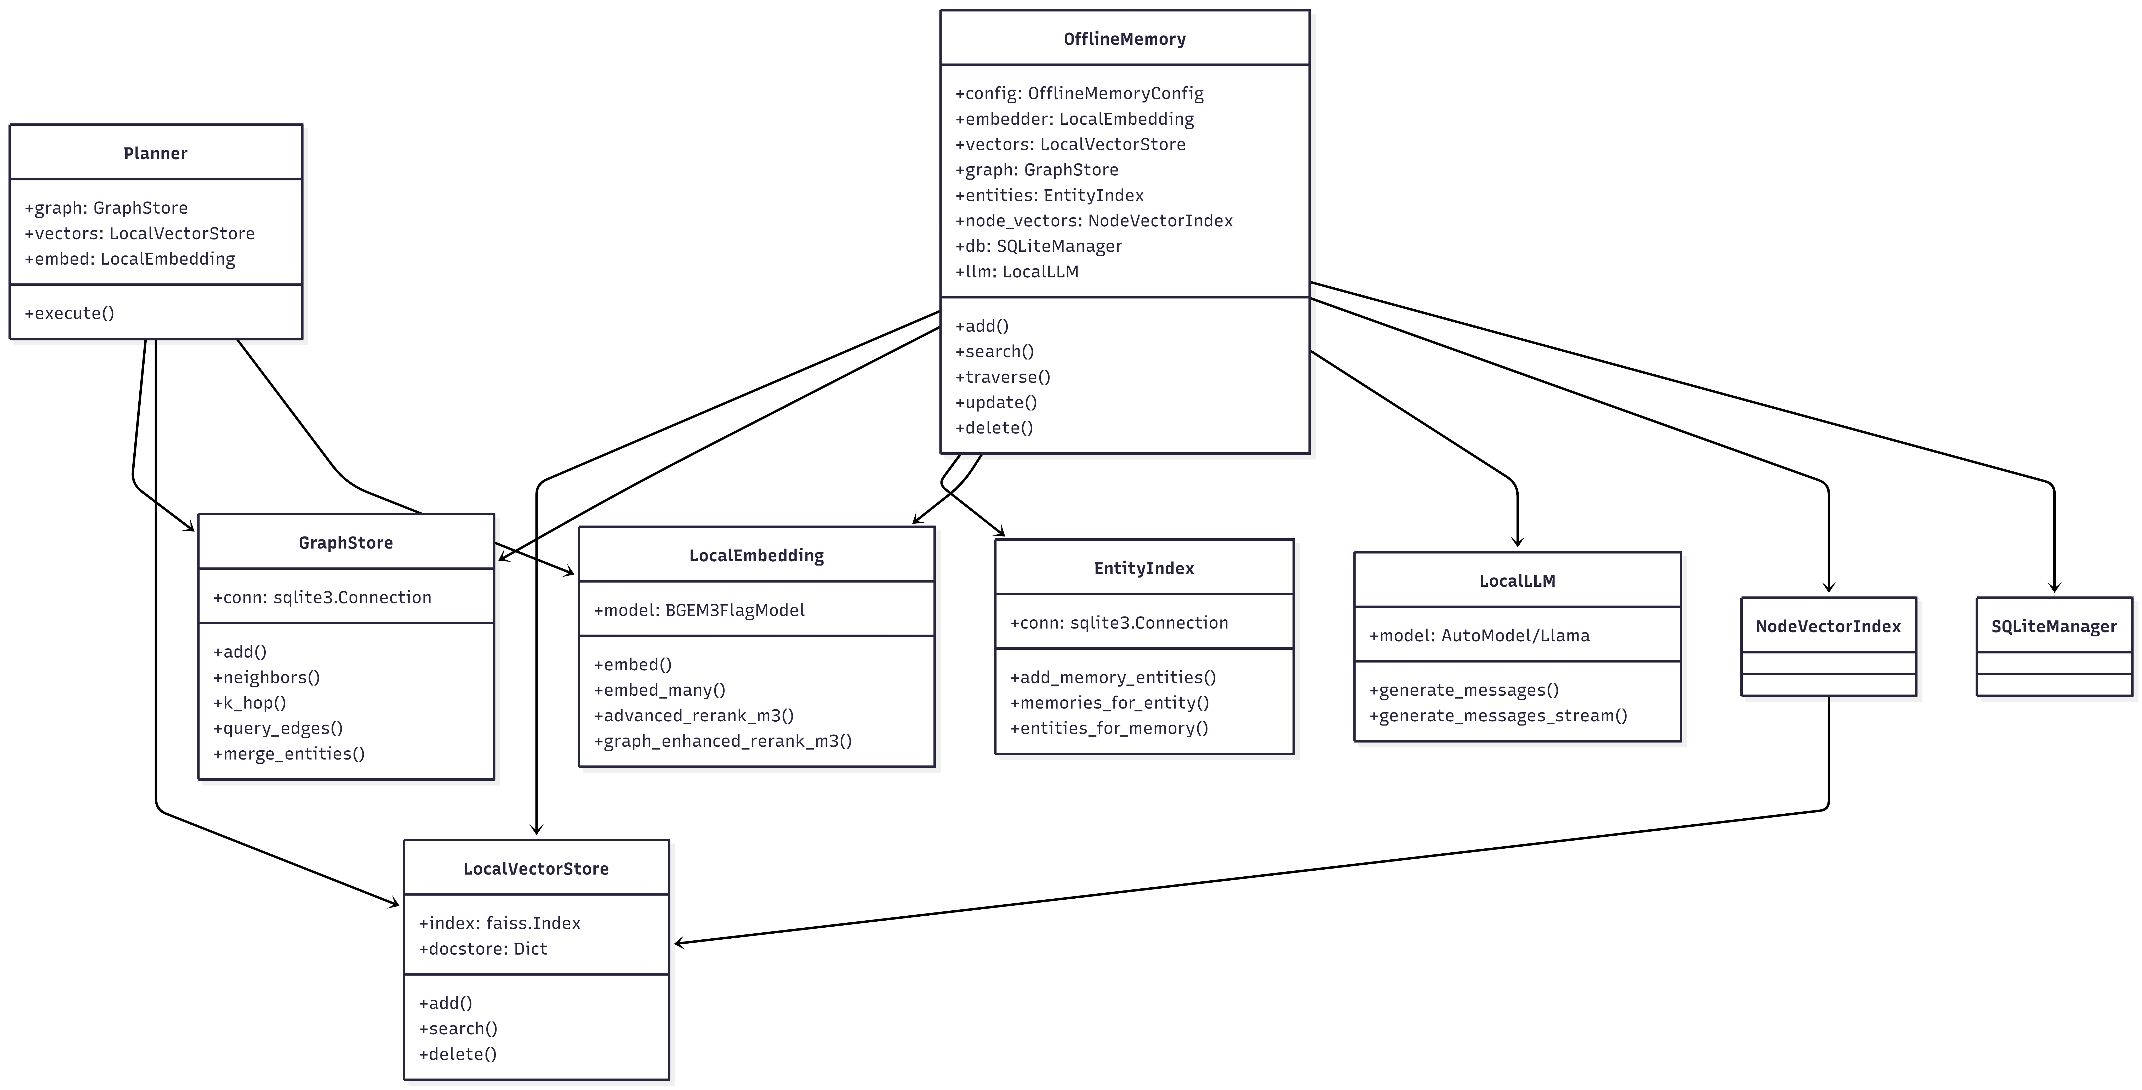
Full hybrid retrieval sequence
Figure 6. Hybrid retrieval sequence. The explicit recall path combines vector candidates, graph relations, A* traversal, and graph-enhanced BGE-M3 reranking.
OfflineMemory.search() performs a full hybrid search:
- Embed the query with BGE-M3 and collect lexical query weights.
- Run FAISS vector search with optional metadata filters.
- Detect query entities, including case-insensitive recovery from graph nodes.
- Run A*-style traverse() from the user_id seed or detected entity.
- Collect memory IDs from traversal nodes and direct query entities.
- Union vector and graph-linked candidates.
- Score candidates using weighted similarity, graph overlap, recency, evidence, and lexical score.
- Build graph context for each top candidate.
- Apply graph_enhanced_rerank_m3() if reranking is enabled.
- Return {"results": [...], "relations": [...]}.

6.4 Graph Traversal
OfflineMemory.traverse() supports possessive-chain style queries such as "Alice's friend's father". It:
- Selects a seed entity, preferring user_id when provided.
- Parses possessive terms into a relation chain.
- Runs an A*-style search over graph neighbors.
- Scores edges by relation label match, edge weight, recency, and hub-degree penalty.
- Returns endpoint nodes and path evidence.
For queries without a chain, it ranks direct neighbors.

6.5 Update and Delete
OfflineMemory.update() updates vector payloads, removes stale graph edges/path vectors for that memory, re-indexes the new text, and writes history.
OfflineMemory.delete() removes a memory from:
- FAISS docstore mapping.
- Graph edges by memory ID.
- Entity index mappings.
- Node/path vectors.
- History log.
delete_all() clears all memory stores and resets traversal caches.

7. Retrieval Modes
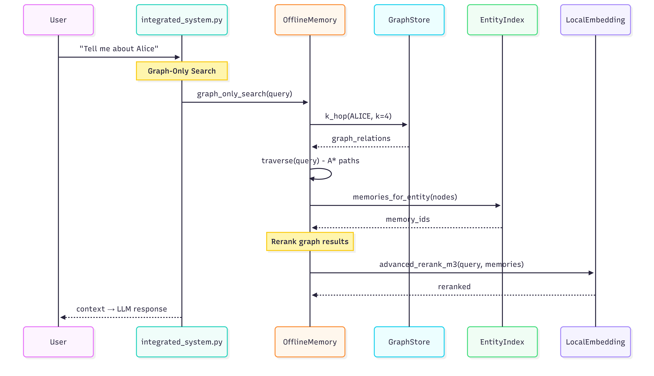
Remember search sequence
Figure 7. Search sequence for explicit memory recall.
Amem/memory_system.py provides two user-facing retrieval modes:

7.1 Normal Chat: Graph-First Search
graph_only_search() is used for normal chat turns. It:
- Suppresses memory retrieval for greetings, fillers, and very short messages.
- Extracts entities from the query.
- Runs A* traversal from the user context.
- Collects entity-linked memory IDs.
- Applies BGE-M3 reranking to graph-retrieved memories.
- Filters by relevance threshold.
This prevents random semantic matches from surfacing during lightweight conversation.

7.2 Explicit Recall: @remember
unified_memory_search() is used when the user writes @remember.
It temporarily disables the internal reranker, increases recall pool size, runs full mem.search(), builds context-augmented document strings, reranks with BGE-M3, filters scores, and returns the strongest memories.

7.3 Context Construction
_get_memory_context() converts retrieved memories and graph edges into the text block injected into the LLM call:
[Memory Context]
Alice --FRIEND--> Bob
Alice is Bob's friend
[User Message]
Who is Alice's friend?
The memory block is used only in messages_for_llm for the current generation. The permanent chat history stores the original user text, not the augmented context.

8. Graph and Storage Layer
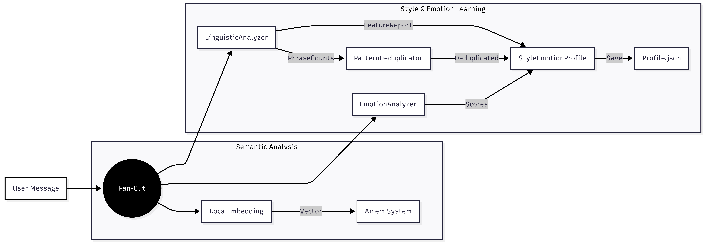
Storage architecture
Figure 8. Storage and analysis architecture. The implementation uses SQLite and FAISS local stores.

8.1 GraphStore
Amem/graph_store.py implements a SQLite property graph.
Core tables:
- nodes(id, name, label, props, cluster_id, created_at, updated_at)
- node_labels(node_id, label)
- node_props(node_id, key, value)
- edges(source, relationship, destination, memory_id, source_id, destination_id, created_at, updated_at, weight)
- edge_props(source, relationship, destination, key, value)
Important APIs:
- upsert() accumulates edge weight when a triplet already exists.
- neighbors() returns in/out/both edges.
- k_hop() performs bounded multi-hop expansion.
- query_edges() filters relationships.
- find_similar_entities() and find_similar_relationships() support merge candidates.
- merge_entities() and merge_relationships() consolidate duplicates.
- recompute_clusters() computes connected components.

8.2 LocalVectorStore
Amem/vector_store.py wraps FAISS and a pickle docstore. It supports FLAT, HNSW, and IVF index types.
Payloads include:
- id
- memory
- hash
- metadata
- stored dense vector
- BGE-M3 lexical weights
Deletion removes docstore mappings but does not hard-delete every FAISS entry for all index types. Search skips stale entries through the idx_to_id mapping. Heavy churn should be followed by rebuild_from_docstore().

8.3 EntityIndex
Amem/entity_index.py stores:
- canonical entities
- aliases
- memory_id to entity associations
It is intentionally lightweight and regex-driven. It also supports case-insensitive memory lookup for entity recovery.

8.4 SQLiteManager
Amem/storage.py owns history/audit persistence. It records add, update, and delete events and exposes get_history(memory_id).

9. Embeddings and Reranking
Amem/local_embedding.py loads BGE-M3 through FlagEmbedding. It sets TRANSFORMERS_OFFLINE=1 by default and resolves local model paths before loading.
Main capabilities:
- embed(text): dense 1024-dimensional embedding.
- embed_with_lexical(texts): dense vectors plus lexical weights.
- lexical_score(): BGE-M3 lexical matching score.
- advanced_rerank_m3(): query-adaptive dense/sparse/ColBERT fusion.
- graph_enhanced_rerank_m3(): appends entity and relationship context to memory text and applies graph-aware boosts.
The advanced fusion logic adapts to query shape:
- factual queries favor sparse/exact matching.
- conceptual queries favor dense semantic matching.
- short queries lean on ColBERT-style fine-grained matching.
- long queries use more dense weighting.
Graph-enhanced reranking adds boosts for entity overlap, graph confidence, and traversal strength.

10. Style and Emotion Learning

Style and emotion learning flow
Figure 9. Style and emotion learning. User text fans out to linguistic analysis, emotion analysis, memory storage, and profile persistence.
The style subsystem learns how the user writes and uses that information to rebuild the system prompt.

10.1 LinguisticAnalyzer
LLM_Style/linguistic_analyzer.py extracts a FeatureReport with:
- structure: sentence length, question/exclamation/period ratios.
- punctuation: commas, dashes, quotes, repeated punctuation, Oxford comma patterns.
- casing: all-caps ratio, lowercase starts, lowercase i.
- emoji: counts and positions.
- elongation and repetition.
- lexical categories: fillers, hedges, slang, affective words.
- dynamic user patterns: frequent, rare, and signature words.
- special features: URLs, handles, keysmashes.
- negative style cues: never capitalizing starts, no semicolon/colon, avoids Oxford comma.
It also exports phrase counts used by the deduplication and pattern memory layer.

10.2 StyleEmotionProfile
LLM_Style/profile_index.py stores lifetime and session-level style aggregates. It:
- applies EMA decay to recency-sensitive session structures.
- tracks emotion history and average emotion distribution.
- requires explicit initialize_deduplicator() before phrase count updates.
- persists deduplication state into local_data/style_emotion.
- exports format_for_llm_system_prompt_detailed().

10.3 Pattern Deduplication
LLM_Style/pattern_deduplicator.py clusters similar patterns with several strategies:
- direct memory lookup.
- elongation variant clustering.
- filler-specific clustering.
- edit-distance clustering.
- semantic clustering with embedding and FAISS support.
The goal is to avoid treating small variants such as stretched words or spelling variants as entirely separate style cues.

10.4 Emotion Analysis
EmotionAnalyzer uses the local roberta-base-go_emotions model when available. It outputs the 28 GoEmotions labels and stores normalized distributions in the profile.
The final prompt uses the top emotional signals but should not reveal raw analysis to the user. The documentation intentionally summarizes the prompt-construction process rather than reproducing the full base prompt.

11. Prompt Construction and Inference
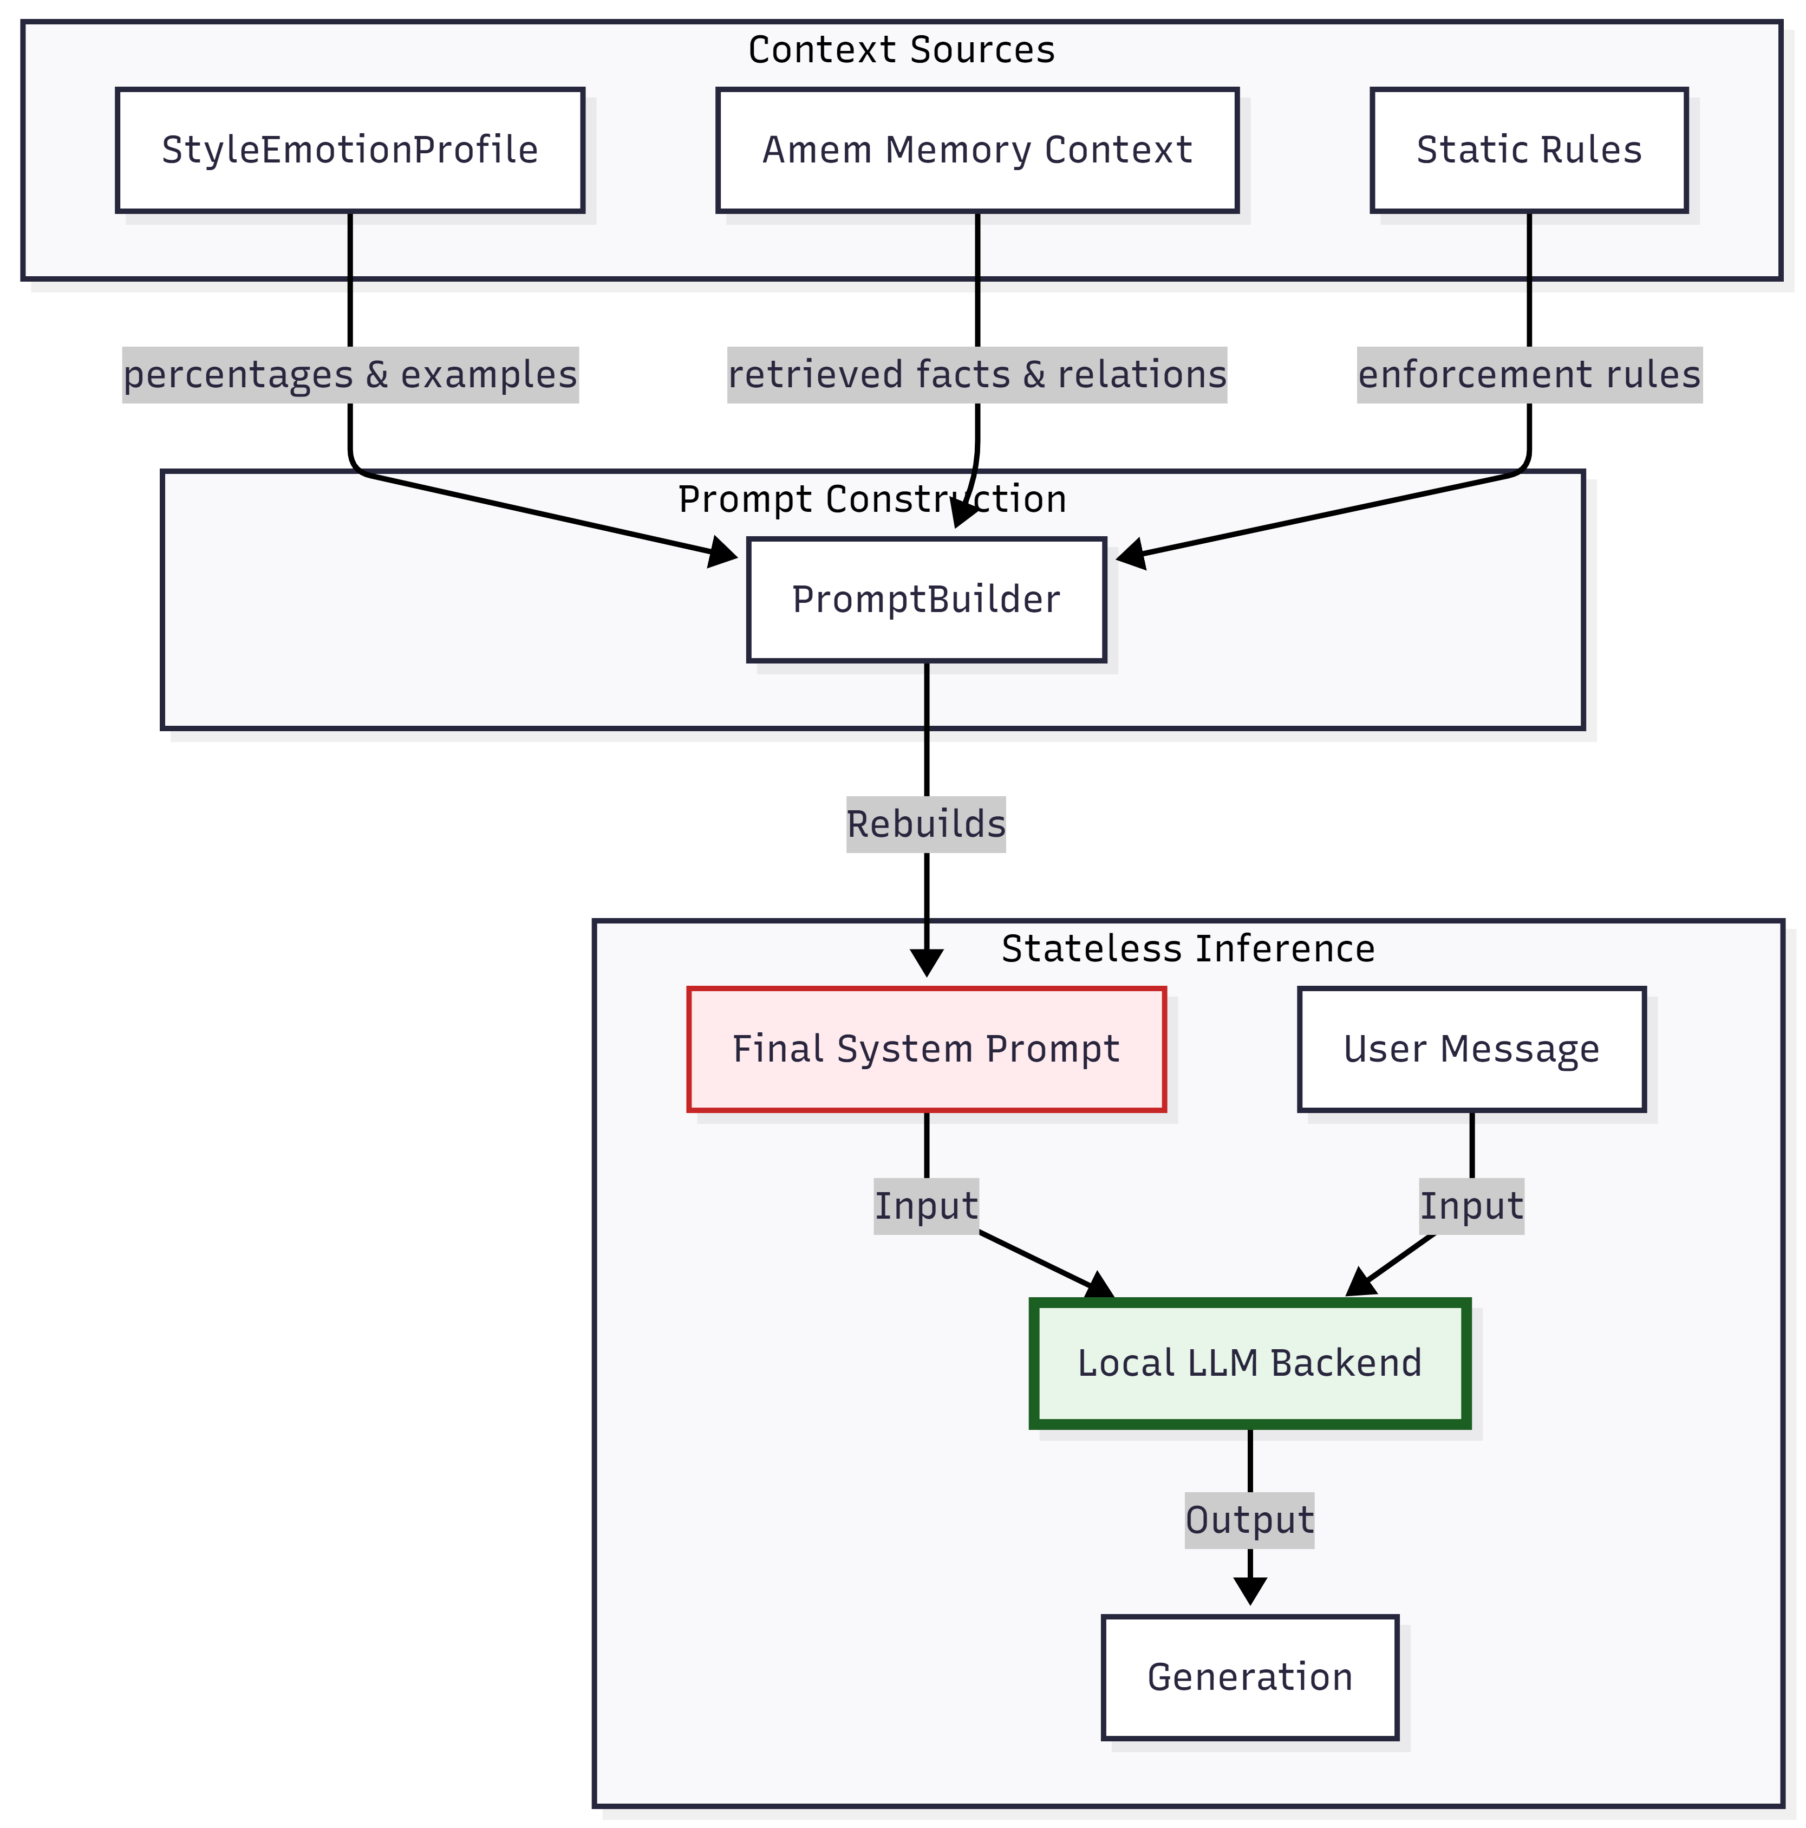
Prompt construction
Figure 10. Prompt construction. Style profile, memory context, and static rules feed the final system prompt and current user message.
compose_system_prompt() in integrated_system.py combines:
- static base behavior rules.
- optional identity block from persisted user/assistant names.
- dynamic style and emotion block from StyleEmotionProfile.
Memory context is not part of the permanent system prompt. It is added to the current user message only when retrieval finds relevant context.

12. LLM Backends

12.1 Local LLM
Amem/local_llm.py supports:
- GGUF loading through llama-cpp-python when .gguf files exist and backend is auto or gguf.
- Hugging Face transformers loading otherwise.
- streaming and non-streaming generation.
- Llama 3.1-style message formatting for both GGUF and HF backends.
GGUF loading adapts context, batch size, and thread count based on available memory.

12.2 Server LLM
server_llm.py exposes the same generate_messages() and generate_messages_stream() interface as LocalLLM.
It uses the OpenAI SDK against:
- NVIDIA Integrate by default.
- local OpenAI-compatible APIs such as LM Studio or Ollama-compatible servers when a custom base URL is supplied.
- Azure/OpenAI-compatible endpoints through environment variables.

13. Voice Input
ASR/asr_wrapper.py is a side-effect-safe wrapper around a NeMo ASR model. It avoids importing ASR/asr.py directly because asr.py contains its own loop.
Voice flow:
- @voice or --voice toggles voice mode.
- ASRInput lazy-loads models/nemotron-speech-streaming-en-0.6b/nemotron-speech-streaming-en-0.6b.nemo.
- A sounddevice.InputStream pushes microphone chunks into a queue.
- Energy-based speech/silence detection identifies utterance boundaries.
- NeMo transcribes the buffered audio.
- The resulting text is passed through the same command and chat loop as typed input.
The ASR dependency surface is much heavier than the core project. Keep it isolated unless voice input is required.

14. User Commands
Command | Behavior
`@store <text>` | Stores text as memory, extracts entities/relationships, updates FAISS/graph/entity/history stores.
`@remember <query>` | Runs explicit hybrid vector + graph search and injects retrieved memory context for generation.
`@delete all` | Deletes all memories from FAISS, graph, entity index, node vectors, and caches.
`@delete <query>` | Deletes matching memory candidates and related entity edges.
`@path <entity1> <entity2>` | Finds graph path using `shortest_path()` and prints relationship chain.
`@viz ALL` | Exports the full graph visualization through PyVis.
`@viz <entity>` | Exports a focused graph visualization for matching entities.
`@voice` | Toggles microphone input.
`@eval <jsonl>` | Runs retrieval evaluation against a JSONL file containing queries and answers.

Normal messages update style/emotion profile and may use graph-first memory augmentation if relevant.

15. Visualization
Amem/visualize.py exports PyVis graph views into local_data/viz/. The bundled assets under lib/vis-9.1.2/ and lib/tom-select/ support local graph viewing without external CDN reliance.
The visualization command gathers FAISS memory texts keyed by graph edge memory_id so graph edges can show their underlying memory evidence.

16. Tests and Benchmarks
Test files exist under tests/ and at the repository root.
Current intended coverage:
- tests/test_graph.py: graph weight accumulation and neighbor lookup.
- tests/test_search.py: traversal/search smoke behavior.
- tests/test_memory.py: add/search/rebuild smoke behavior.
- tests/test_style_learning.py: strict style deduplicator initialization, phrase counts, dynamic prompt generation.
Benchmark artifacts include:
- benchmark_results.json
- benchmark_1_results.txt
- benchmark_2_results.txt
- benchmark_test_data/
During this documentation work, test collection with the bundled Codex Python runtime could not run because pytest was not installed in that runtime. Plain python was also not on PATH. The project manifests do include pytest, so test discovery should be run inside the project conda environment rather than the generic bundled runtime.
Suggested commands inside the project environment:
conda activate memory-folder
python -m pytest --collect-only -q
python -m pytest tests -q

17. Operations and Troubleshooting

Startup
Use server mode when local LLM weights are unavailable or too heavy:
python integrated_system.py --llm-type server --config configs/offline.yaml
Use local mode when all local model files are present:
python integrated_system.py --llm-type local --config configs/offline.yaml

Common Issues
Symptom | Likely cause | Resolution
`python` not recognized | Environment not activated or Python not on PATH | Activate the conda environment created from the project manifest.
`FlagEmbedding not available` | Core dependencies missing | Install project packages or use the captured conda environment.
Missing API key in server mode | `NVIDIA_API_KEY` / `OPENAI_API_KEY` not set | Add key to `.env` or shell environment.
Voice input import errors | ASR dependencies not installed | Use the ASR environment manifest.
Random memories in chat | Query is too broad or threshold too low | Normal chat uses graph-first filtering; use `@remember` for deliberate broad recall.
FAISS stale entries after many deletes | FAISS index cannot hard-delete all entries | Run vector rebuild from docstore in maintenance flow.
Graph visualization empty | No relationship edges present | Store memories with relationship content first, then run `@viz`.

18. Known Gaps and Current-State Caveats
These are documentation-relevant mismatches found while inspecting the repository:
- Some tests import mem0.*, while the current package directory is Amem/. These imports should be updated before relying on the tests as-is.
- tests/test_memory.py and one path in Amem/memory_system.py reference mem.rebuild_vector_index(), but the current visible vector rebuild method is LocalVectorStore.rebuild_from_docstore(). Confirm or add a wrapper before relying on that path.
- Diagrams and older docs reference interface/app.py; the current repo contains interface/templates/ and interface/static/, but no source interface/app.py.
- Some existing architecture files and Amem Memory Architecture.pdf appear to describe an older line count or method inventory. Treat this document as current to the inspected code.
- Root-level requirements.txt, document/requirements.pdf, and captured package manifests disagree on a few versions. Prefer the conda manifests that were exported from the working environments.
- The base system prompt in integrated_system.py is long and sensitive. Documentation should describe its assembly and behavior, not reproduce it wholesale.

19. Onboarding Checklist
- Create the project environment from document/project_conda_packages.txt.
- Confirm model folders exist under models/:
- bge-m3
- roberta-base-go_emotions
- optional local chat model or .gguf
- optional NeMo ASR model
- Configure .env for server mode if needed.
- Run python integrated_system.py --config configs/offline.yaml --llm-type server.
- Store a simple memory with @store Alice is Bob's friend.
- Recall it with @remember Who is Alice's friend?.
- Inspect graph output with @viz ALL.
- Run tests inside the project conda environment after resolving stale mem0 imports.

20. Source Material
Primary code files inspected for this documentation:
- integrated_system.py
- server_llm.py
- Amem/memory.py
- Amem/memory_system.py
- Amem/graph_store.py
- Amem/vector_store.py
- Amem/entity_index.py
- Amem/local_embedding.py
- Amem/local_llm.py
- Amem/local_config.py
- Amem/storage.py
- Amem/node_vectors.py
- LLM_Style/linguistic_analyzer.py
- LLM_Style/profile_index.py
- LLM_Style/pattern_deduplicator.py
- LLM_Style/style_system.py
- LLM_Style/prompt_inspector.py
- ASR/asr_wrapper.py
Supporting documentation and artifacts:
- Architecture.md
- Architecture_Diagram.md
- docs/architecture.md
- docs/api.md
- docs/operations.md
- docs/PATTERN_DEDUPLICATION_SUMMARY.md
- document/Amem Memory Architecture.pdf
- document/requirements.pdf
- document/project_pip_packages.txt
- document/project_conda_packages.txt
- document/asr_pip_packages.txt
- document/asr_conda_packages.txt
- document/Untitled diagram-*.png

