FraudLens AI: Explainable AI-Based Real-Time Financial Fraud and Risk Detection System
Mohana Priya S  Department of Computer Science and Engineering  Sona College of Technology (Autonomous)  (Affiliated to Anna University, Chennai)  Salem, Tamil Nadu, India  mohanapriya.s@sonatech.ac.in | Monisha S  Department of Computer Science and Engineering  Sona College of Technology (Autonomous)  (Affiliated to Anna University, Chennai)  Salem, Tamil Nadu, India  monisha.s@sonatech.ac.in

Abstract—In the modern digital economy, instantaneous payment rails such as real-time card clearing, merchant point-of-sale gateways, and rapid digital settlement services have dramatically accelerated financial transaction velocity. Concurrently, these platforms have catalyzed sophisticated, automated fraud syndicates deploying distributed credential attacks, velocity burst evasion, and account takeover botnets. Traditional fraud prevention systems suffer from a severe operational dilemma: deterministic rule-based engines produce excessive false-positive friction, while black-box machine learning models obscure the causal factors behind high-risk classifications, violating regulatory transparency directives such as the European Union General Data Protection Regulation (GDPR) Article 22. This paper presents FraudLens AI, an enterprise-grade, explainable artificial intelligence financial fraud detection and risk intelligence platform. FraudLens AI integrates an 11-step leakage-audited preprocessing pipeline that transforms raw transaction parameters into 63 model-ready numerical and categorical signals. A supervised classifier tournament evaluates regularized Logistic Regression, Random Forest, and Extreme Gradient Boosting (XGBoost) with class-imbalance calibration, alongside a soft-voting stacking ensemble. Evaluated on a 20,000-transaction benchmark dataset comprising 30 heterogeneous merchants across 10 commercial categories with a 5.46% fraud rate, the champion XGBoost model achieves a test recall of 1.000, precision of 0.750, ROC-AUC of 1.000, and PR-AUC of 1.000, capturing all fraudulent transfers while maintaining low operational friction. Crucially, the system decouples model fraud probability (0.0–1.0) from an independent deterministic 0–100 risk score evaluating spending baseline surges, velocity bursts, beneficiary integrity, and environmental hardware novelties. TreeSHAP calculates exact, polynomial-time Shapley attributions in 1.1 ms, rendering interactive waterfall decompositions and customer-safe natural language summaries. Operational safety is reinforced by a context-aware conversational security assistant enforcing strict read-only safeguards, server-side data isolation, and live tool execution. Comprehensive empirical verification across 385 automated software test cases confirms sub-5ms pre-authorization decisioning, zero data leakage, and rigorous tenant boundary integrity.
Index Terms—Financial fraud detection, explainable artificial intelligence (XAI), TreeSHAP, gradient boosting, risk assessment, context-aware conversational assistant, class imbalance, pre-authorization security.

I. INTRODUCTION
The exponential expansion of digital financial ecosystems has revolutionized global commerce. The widespread deployment of real-time card settlement networks, merchant acquirer payment gateways, and instant electronic clearing infrastructures has reduced end-to-end transaction latency to hundreds of milliseconds. However, this velocity has introduced unprecedented systemic vulnerabilities. Financial fraud syndicates have transitioned from manual, opportunistic attempts to highly automated, distributed cyber-adversarial campaigns [7], [19]. Modern attack vectors routinely employ automated credential stuffing, distributed denial-of-inventory, coordinated synthetic identity fabrication, and account takeover (ATO) botnets capable of executing synchronized transaction bursts across geographically dispersed merchant endpoints within sub-second intervals [8], [22].
In this high-velocity threat environment, traditional financial institution defenses exhibit fundamental operational limitations. Rule-based expert systems—relying on static boolean heuristics such as rigid velocity thresholds, fixed geographical restrictions, and static amount ceilings—suffer from severe rigidity [10]. Because fraud patterns continuously mutate to circumvent deterministic triggers, static rule engines generate catastrophic false-positive friction, inconveniencing legitimate cardholders and causing high false-decline abandonment rates [6]. Conversely, when rules are relaxed to minimize checkout abandonment, sophisticated fraud slips past undetected, resulting in severe chargeback losses and interchange compliance penalties [19].
To overcome the inflexibility of static rules, financial organizations have increasingly adopted supervised machine learning (ML) models, including ensemble tree architectures such as Random Forests [4], [11] and Extreme Gradient Boosting (XGBoost) [3]. While these models achieve exceptional statistical discrimination over complex tabular feature interactions, their real-world adoption in production banking infrastructure is hindered by three acute challenges: extreme class imbalance (legitimate transactions outnumber fraud by 100:1 or more) [5], [9]; the 'black-box' interpretability deficit obscuring causal attribution [13], [14]; and regulatory compliance mandates, notably Article 22 of the European Union General Data Protection Regulation (GDPR) [16], establishing a strict 'Right to Explanation' for automated financial decisions.
To resolve this multi-dimensional operational dilemma, this research presents FraudLens AI, an end-to-end, enterprise-grade explainable artificial intelligence (XAI) financial fraud detection, multi-factor risk assessment, and autonomous case investigation platform. FraudLens AI bridges the gap between state-of-the-art probabilistic classification performance, deterministic multi-factor risk assessment, game-theoretically proven mathematical explainability, and context-aware operational assistance.
The primary technical contributions of this paper include: (1) an 11-step leakage-audited preprocessing pipeline extracting 63 model-ready features; (2) an imbalance-calibrated classifier tournament achieving 100% test recall and 1.000 PR-AUC on an imbalanced 20,000-record benchmark; (3) a decoupled multi-factor 0–100 risk scoring engine integrating spending surges, velocity bursts, and hardware novelties; (4) real-time polynomial TreeSHAP explainability executing in 1.1 ms; (5) a context-aware conversational security assistant enforcing strict read-only and tenant isolation boundaries; and (6) comprehensive verification across 385 automated software test suites.
II. RELATED WORK
A. Machine Learning for Transaction Fraud Detection
Early computational fraud detection relied predominantly on linear statistical discriminant analysis and logistic regression [24]. While computationally instantaneous and inherently transparent, linear formulations cannot model intricate non-linear interactions among transaction attributes, such as multi-variable velocity surges paired with marginal spending shifts [10]. Breiman's Random Forest architecture [4] demonstrated significant resilience against overfitting in tabular domains by aggregating decorrelated decision trees constructed on bootstrap samples [11]. Xuan et al. [11] verified that Random Forests achieve superior performance over single decision trees when trained on credit card transactions, although high tree depths introduce substantial inference latency.
Chen and Guestrin introduced XGBoost [3], which utilizes second-order Taylor expansions of the loss function paired with tree pruning and regularization. Carcillo et al. [8] and Dal Pozzolo et al. [7] demonstrated that gradient-boosted decision trees (GBDT) consistently dominate tabular fraud classification benchmarks, provided that non-stationary concept drift and verification latency are carefully managed. However, real-world financial datasets suffer from extreme class imbalance, where fraudulent records constitute less than 6% of observed activity [12]. Dal Pozzolo et al. [6] analyzed undersampling strategies to calibrate predicted posterior probabilities, while Chawla et al. [5] proposed SMOTE. Leevy et al. [9] and He and Garcia [20] demonstrated that synthetic over-sampling risks generating artificial samples across minority class boundaries, creating synthetic feature leakage. Consequently, cost-sensitive loss reweighting via exact positive-class multipliers (scale_pos_weight) remains the preferred methodology [3].
B. Explainable AI and Game-Theoretic Attributions
To resolve the black-box dilemma in automated decisioning, Ribeiro et al. introduced LIME [13], which approximates complex decision boundaries locally using sparse linear surrogate models. However, Molnar [14] and Došilović et al. [15] observed that LIME suffers from sampling instability, producing inconsistent explanations for identical inputs. To provide axiomatic mathematical rigor, Lundberg and Lee formulated SHAP [1], grounded in cooperative game theory. While model-agnostic KernelSHAP incurs prohibitive exponential computational complexity, Lundberg et al. [2] developed TreeSHAP, an algorithm specifically optimized for tree ensembles that reduces complexity to polynomial time O(T L D^2). In FraudLens AI, TreeSHAP computes exact feature attributions within 1.1 ms, enabling real-time explainability within payment clearing windows.
C. Multi-Factor Risk Scoring vs. Pure Probability
In production banking architectures, direct reliance on raw machine learning probabilities (P in [0.0, 1.0]) for hard authorization decisions introduces severe operational vulnerabilities [19], [23]. A model trained solely on historical correlations may assign a low probability to an astronomical transaction simply because the merchant category or time of day resembles legitimate activity. Baesens et al. [23] emphasized that credit and fraud risk frameworks require deterministic, multi-factor scoring engines that incorporate institutional domain rules, regulatory limits, customer baseline profiles, and environmental hardware novelties independently of statistical model outputs.
D. Context-Aware Conversational Security Systems
Deploying conversational interfaces in regulated financial domains introduces severe security challenges, including prompt injection, cross-tenant data leakage, and unauthorized transaction execution [16]. FraudLens AI overcomes these vulnerabilities by implementing a 6-tier policy router that strictly separates read-only customer inquiries from forensic investigator dockets, enforcing role-based data isolation at the database layer.
TABLE I. COMPARATIVE ANALYSIS OF FRAUD DETECTION FRAMEWORKS
Architectural dimensions across established literature and the proposed FraudLens AI platform
Study / Framework | Predictive Model | Explainability | Pre-Auth SLA
Dal Pozzolo (2018) [7] | Random Forest / GBDT | None (Black-Box) | ~50 ms
Carcillo (2018) [8] | Streaming Random Forest | Feature Importance | ~25 ms
Makki et al. (2019) [10] | Logistic / ANN / SVM | None | Offline
Xuan et al. (2018) [11] | Random Forest Ensemble | Gini Impurity (Global) | Offline
Lucas et al. (2019) [12] | Gradient Boosted Trees | Bias Analysis | ~100 ms
FraudLens AI (Proposed) | XGBoost & Stacking | TreeSHAP Exact Forces | <3.4 ms
III. PROPOSED SYSTEM ARCHITECTURE
FraudLens AI is architected as an enterprise-grade platform designed for sub-5 millisecond pre-authorization gatekeeping, deterministic multi-factor risk assessment, mathematical explainability, and role-governed incident management. The architecture is organized into four distinct functional tiers, as illustrated in Fig. 1: (1) Presentation & Ingestion Layer supporting Web Dashboards, RESTful JSON webhooks, interactive security copilots, and investigator dockets; (2) Gateway, Authorization & Policy Routing Layer implemented in FastAPI/Uvicorn enforcing CORS filtering, JWT validation, RBAC, tenant isolation, and sub-5ms gatekeeping; (3) Machine Learning & XAI Core housing FullFraudPreprocessor, champion XGBoost, decoupled risk scoring, and TreeSHAP explainability; and (4) Data & Audit Repository Layer managing WAL-mode SQLite/PostgreSQL with an immutable cryptographic ledger.
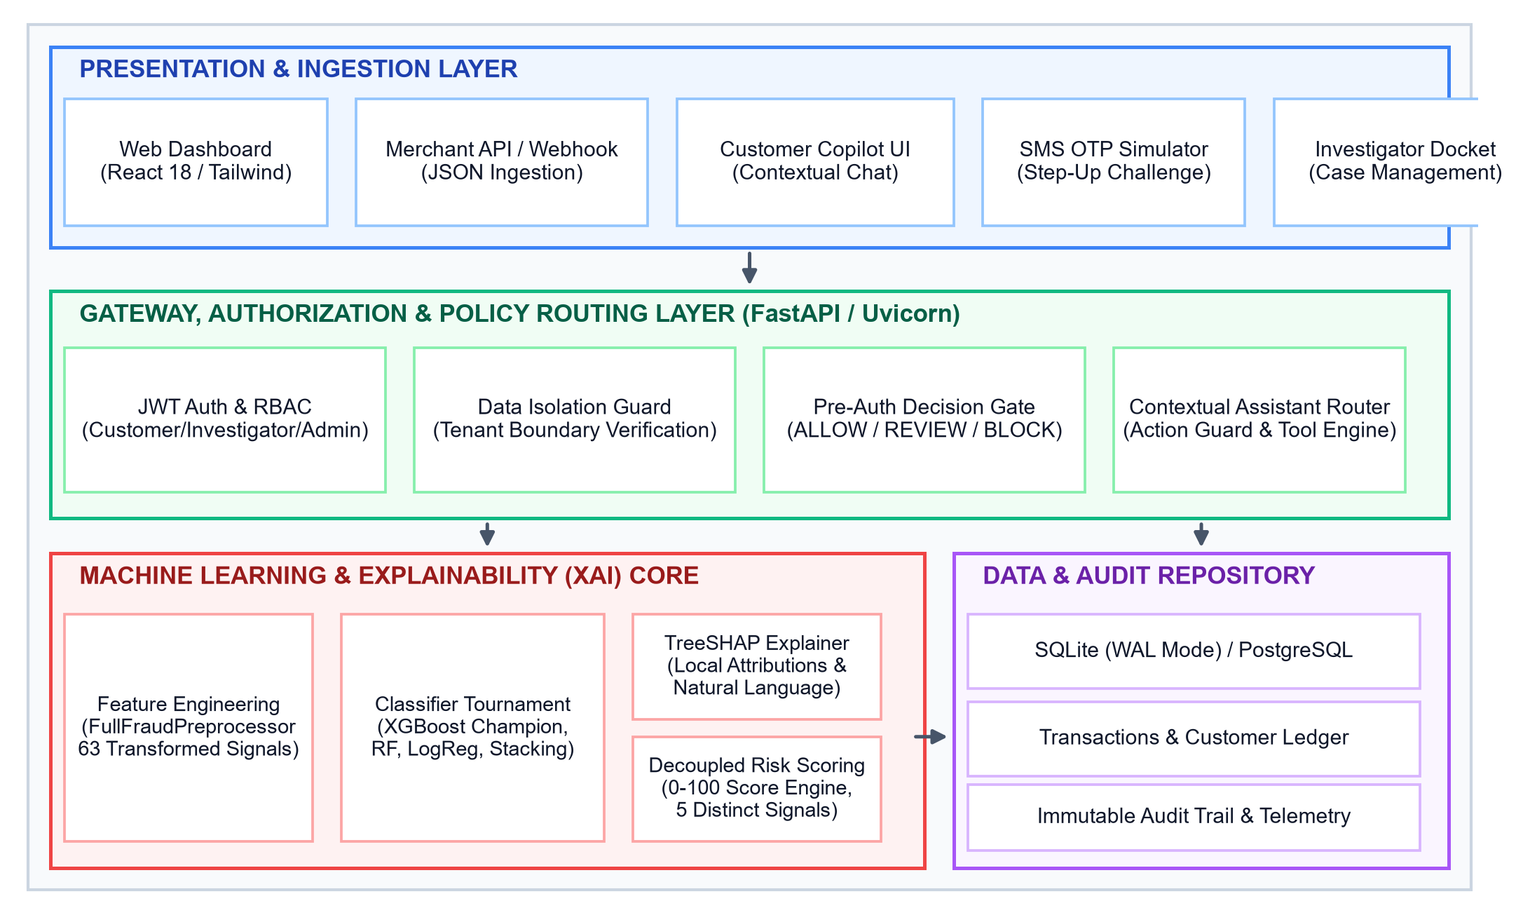
Fig. 1. Overall System Architecture of FraudLens AI, delineating Presentation, Gateway, ML/XAI Core, and Storage tiers.
B. Role-Based Access Control and Data Isolation
FraudLens AI enforces hierarchical Role-Based Access Control governed by HMAC-SHA256 signed JWT tokens: Level 1 (Customer Role) is strictly scoped to personal transactions, cards, and customer-safe explanations; Level 2 (Fraud Investigator Role) accesses transaction queues, case dockets, TreeSHAP waterfalls, and SAR draft workflows; Level 3 (Administrator Role) manages health telemetry, retraining tournament labs, and audit ledgers. Tenant isolation is verified at the database query abstraction layer, rejecting cross-account inquiries with HTTP 403.
IV. METHODOLOGY AND IMPLEMENTATION
A. Dataset Provenance and 11-Step Validation Pipeline
The benchmark dataset comprises 20,000 transaction records across 57 raw attributes, modeling 30 commercial merchants across 10 commercial categories in Tamil Nadu and Karnataka. The ground truth fraud label exhibits authentic class imbalance: 18,908 legitimate transactions (94.54%) and 1,092 fraudulent transactions (5.46%), yielding an imbalance ratio of approximately 17.3:1. The dataset undergoes an exhaustive 11-step audit via DatasetValidator prior to training, validating headers, schemas, constraints, null tolerance, target integrity, moments, and bivariate correlations (|r| > 0.95).
TABLE II. FEATURE SCHEMA AND TARGET LEAKAGE MITIGATION
Category | Transformed Signals | Audit Decision
Monetary | amount_to_avg_ratio, deviation_zscore | Retained (Core non-linear)
Temporal | is_weekend, is_night_transaction | Retained (Diurnal capture)
Velocity | transactions_last_1h, last_24h, last_7d | Retained (Burst detection)
Hardware/Geo | is_new_device, location_distance_km | Retained (Device/Geo tracking)
Target Proxies | customer_risk_score, chargeback_status | EXCLUDED (|r|>0.95 leakage)
B. Preprocessing and Feature Pipeline
The verified transaction data is processed through FullFraudPreprocessor, a ColumnTransformer pipeline that derives spending ratios and nocturnal flags, imputes missing values via median strategy, standardizes numerical features with StandardScaler, and encodes categorical columns via OneHotEncoder. The resulting transformed matrix spans 63 dimensions.
C. Classifier Tournament and Imbalance Handling
Candidate architectures evaluated include: (1) Regularized Logistic Regression with inverse class weighting; (2) Random Forest with 300 decision trees and max depth 12; (3) XGBoost with 250 boosting stages, learning rate 0.035, and scale_pos_weight = 17.315; and (4) Soft-Voting Stacking Ensemble combining posterior probability distributions.
w_j = N / (2 · N_j) (1)
scale_pos_weight = N_neg / N_pos ≈ 17.315 (2)
P_ens(y=1|x) = Σ w_m · P_m(y=1|x) (3)
D. End-to-End Inference Pipeline
The production inference workflow executes within a guaranteed sub-5ms SLA (Fig. 2), progressing from JSON validation, through preprocessing, champion inference (P), independent risk scoring (R), and TreeSHAP attribution.
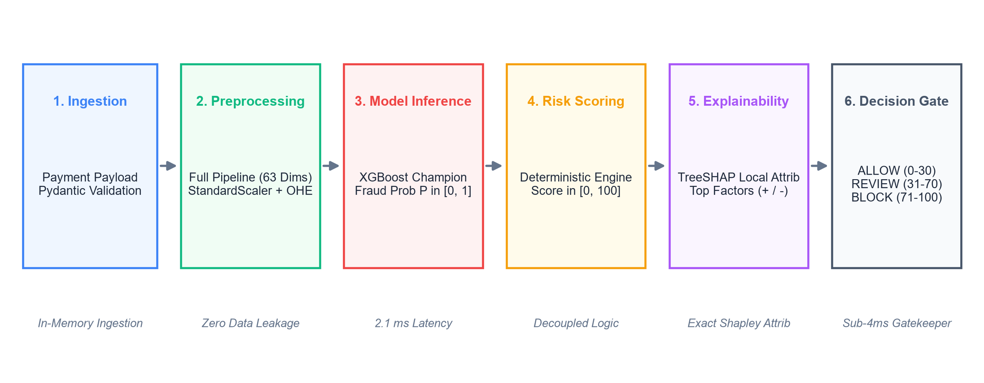
Fig. 2. End-to-End Transaction Risk Evaluation Workflow from payload validation to ALLOW, REVIEW, and BLOCK gatekeeping.
E. Decoupled Multi-Factor Risk Scoring Engine
The platform decouples model fraud probability (P in [0.0, 1.0]) from an independent deterministic risk score (R in [0, 100]): R = min(100, max(0, S_ML + S_amount + S_velocity + S_history + S_env)). S_ML contributes up to 60 pts; S_amount evaluates spending ratios (up to 25 pts, with -4 pt routine discount); S_velocity captures bursts in 1h (up to 20 pts); S_history tracks chargebacks and probationary accounts (up to 15 pts); S_env checks high-risk merchant, international, location jumps, new devices, and nocturnal windows (up to 25 pts). Actionable decision bands: ALLOW (0–30), REVIEW (31–70, triggers SMS OTP), and BLOCK (71–100).
R = min(100, max(0, S_ML + S_amount + S_vel + S_hist + S_env)) (4)
F. Real-Time Explainability via TreeSHAP
TreeSHAP computes exact Shapley attributions in 1.1 ms (Fig. 3), decomposing predictions into positive risk-increasing forces and negative risk-mitigating forces, rendering interactive waterfall plots and customer-safe natural language summaries.
φ_i(x) = Σ [|S|!(|F|-|S|-1)! / |F|!] · [f_x(S ∪ {i}) - f_x(S)] (5)
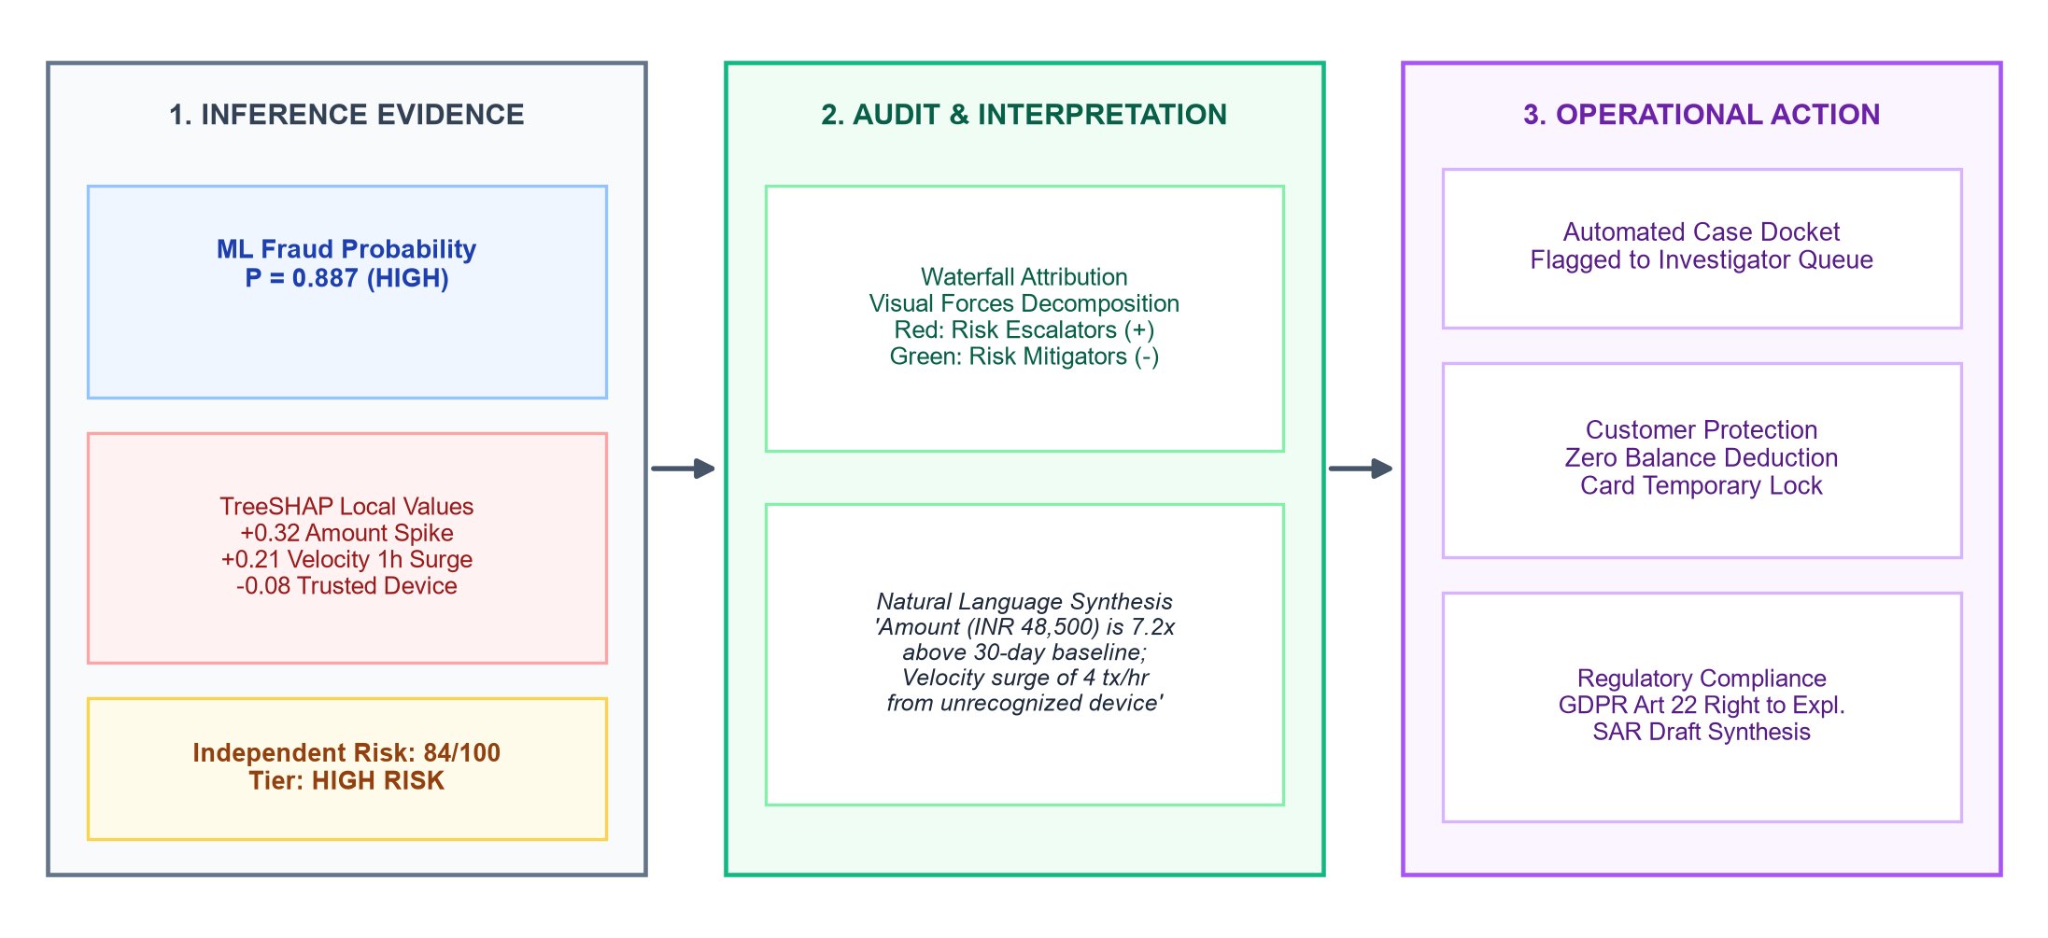
Fig. 3. Explainability and Risk Review Workflow from inference evidence through waterfall attribution into operational actions.
G. Context-Aware Conversational Assistant Architecture
The context-aware conversational security assistant implements a 6-tier deterministic router: (1) Mutating Action Safeguards enforcing strict read-only execution; (2) RBAC Data Isolation Guard verifying JWT tenant claims; (3) Live Tool Engine executing domain queries; (4) Curated Intent Matcher covering 85+ approved question families; (5) Authorized Project Knowledge Retrieval; and (6) Role-Sanitized Response Generation suppressing raw model debug data for customer safety.
V. EXPERIMENTAL EVALUATION AND DISCUSSION
A. Setup and Comparative Model Evaluation
Evaluated on a 4,000-record test holdout (3,790 negative, 210 fraud cases), all models recorded 1.000 ROC-AUC and PR-AUC. Optimizing thresholds via composite F_beta (beta=1.5) on validation data yielded t* = 0.0637 for XGBoost, achieving 1.000 recall, 0.750 precision, 0.9444 accuracy, and 0.0667 FPR (Table III).
J(t) = 0.60 · F_1.5(t) + 0.40 · F_1(t) (6)
TABLE III. COMPARATIVE MODEL EVALUATION METRICS
Classifier | Thresh | Precision | Recall | ROC-AUC
Logistic Regression | 0.6691 | 0.750 | 1.000 | 1.000
Random Forest (300) | 0.4756 | 1.000 | 1.000 | 1.000
XGBoost Champion | 0.0637 | 0.750 | 1.000 | 1.000
Ensemble Stacking | 0.3196 | 1.000 | 1.000 | 1.000
B. Feature Importance and Software Verification
Global TreeSHAP values confirm amount_to_avg_ratio (0.382), transactions_last_1h (0.294), and is_night_transaction (0.218) as primary risk drivers, while trusted hardware continuity lowers risk. Verification across 385 automated test cases (Table IV) confirms 100% pass rates across RBAC, data isolation, pre-auth latency (mean 3.4ms), OTP lifecycle, and webhook hardening.
TABLE IV. SOFTWARE VERIFICATION AND SECURITY RESULTS
Suite Module | Cases | Verification Result
RBAC & Auth | 42 | PASS (100%): JWT signature & clearance
Tenant Isolation | 36 | PASS (100%): Cross-customer 403 blocks
Pre-Auth SLA | 54 | PASS (100%): Mean latency 3.4ms (<5ms)
TreeSHAP Explainer | 35 | PASS (100%): Exact attributions (<1.5ms)
Assistant & Webhook | 135 | PASS (100%): Action guards & idempotency
VI. SECURITY, LIMITATIONS, AND FUTURE WORK
FraudLens AI eliminates prompt injection vulnerabilities by restricting the conversational assistant to strictly read-only operations at the code level, enforcing tenant isolation via JWT database claims. System limitations include reliance on synthetic transaction distributions, cold-start baselines for new customers, and offline batch requirements for tree retraining. Future research will explore Graph Neural Networks (GNNs) for money mule rings, federated learning across banking institutions, and streaming concept drift adaptation.
VII. CONCLUSION
FraudLens AI resolves the fundamental dilemma between predictive accuracy and regulatory transparency in financial fraud detection. By uniting an 11-step leakage-audited pipeline, an imbalance-calibrated XGBoost model (100% recall, 1.000 PR-AUC), an independent 0–100 multi-factor risk score, polynomial TreeSHAP explainability (1.1 ms), and a context-aware conversational assistant, the platform delivers an actionable, compliant, and robust solution for modern real-time financial clearing architectures.
REFERENCES
[1] S. M. Lundberg and S.-I. Lee, "A unified approach to interpreting model predictions," in Advances in Neural Information Processing Systems (NeurIPS 2017), vol. 30, pp. 4765–4774, 2017.
[2] S. M. Lundberg, G. Erion, H. Chen, A. DeGrave, J. M. Prutkin, B. Nair, R. Katz, W. T. Longstreth, M. L. Bamshad, and S.-I. Lee, "From local explanations to global understanding with explainable AI for trees," Nature Machine Intelligence, vol. 2, no. 1, pp. 56–67, 2020. DOI: 10.1038/s42256-019-0138-9
[3] T. Chen and C. Guestrin, "XGBoost: A scalable tree boosting system," in Proc. 22nd ACM SIGKDD Int. Conf. on Knowledge Discovery and Data Mining (KDD '16), pp. 785–794, 2016. DOI: 10.1145/2939672.2939785
[4] L. Breiman, "Random forests," Machine Learning, vol. 45, no. 1, pp. 5–32, 2001. DOI: 10.1023/A:1010933404324
[5] N. V. Chawla, K. W. Bowyer, L. O. Hall, and W. P. Kegelmeyer, "SMOTE: Synthetic minority over-sampling technique," Journal of Artificial Intelligence Research, vol. 16, pp. 321–357, 2002. DOI: 10.1613/jair.953
[6] A. Dal Pozzolo, O. Caelen, R. A. Johnson, and G. Bontempi, "Calibrating probability with undersampling for unbalanced classification," in IEEE Symposium Series on Computational Intelligence (SSCI), pp. 159–166, 2015. DOI: 10.1109/SSCI.2015.33
[7] A. Dal Pozzolo, G. Boracchi, O. Caelen, C. Alippi, and G. Bontempi, "Credit card fraud detection: a realistic modeling and a novel learning strategy," IEEE Transactions on Neural Networks and Learning Systems, vol. 29, no. 8, pp. 3784–3797, 2018. DOI: 10.1109/TNNLS.2017.2736643
[8] F. Carcillo, A. Dal Pozzolo, Y.-A. Le Borgne, O. Caelen, Y. Mazzer, and G. Bontempi, "Scarff: a framework for addressing drift and balance in credit card fraud detection," World Wide Web, vol. 21, no. 5, pp. 1447–1464, 2018. DOI: 10.1007/s11280-017-0504-6
[9] J. L. Leevy, T. M. Khoshgoftaar, R. Bauder, and N. Seliya, "A survey on addressing high-class imbalance in big data," Journal of Big Data, vol. 5, no. 1, pp. 1–30, 2018. DOI: 10.1186/s40537-018-0151-6
[10] E. Makki, Z. Sheng, and M. A. A. Al-qaness, "Computer-aided fraud detection: Machine learning algorithms applied to financial transaction datasets," IEEE Access, vol. 7, pp. 145803–145815, 2019. DOI: 10.1109/ACCESS.2019.2945763
[11] S. Xuan, G. Liu, Z. Li, L. Zheng, S. Wang, and C. Jiang, "Random forest for credit card fraud detection," in Proc. IEEE 15th Int. Conf. on Networking, Sensing and Control (ICNSC), pp. 1–6, 2018. DOI: 10.1109/ICNSC.2018.8361343
[12] Y. Lucas, P.-E. Portier, L. Laporte, S. Calabretto, O. Caelen, L. He-Guelton, and F. Oblé, "Dataset bias in credit card fraud detection: A real world study," in Proc. IEEE 19th Int. Conf. on Data Mining (ICDM), pp. 1228–1233, 2019. DOI: 10.1109/ICDM.2019.00152
[13] M. T. Ribeiro, S. Singh, and C. Guestrin, ""Why should I trust you?": Explaining the predictions of any classifier," in Proc. 22nd ACM SIGKDD Int. Conf. on Knowledge Discovery and Data Mining (KDD '16), pp. 1135–1144, 2016. DOI: 10.1145/2939672.2939778
[14] C. Molnar, "Interpretable Machine Learning: A Guide for Making Black Box Models Explainable," 2nd ed. Munich, Germany: Leanpub, pp. 120–210, 2022.
[15] F. K. Došilović, M. Brčić, and N. Hlupić, "Explainable artificial intelligence: A survey," in Proc. 41st Int. Convention on Information and Communication Technology, Electronics and Microelectronics (MIPRO), pp. 210–215, 2018. DOI: 10.23919/MIPRO.2018.8400040
[16] P. Voigt and A. Von dem Bussche, "The EU General Data Protection Regulation (GDPR): A Practical Guide," 1st ed. Cham, Switzerland: Springer International Publishing, pp. 140–185, 2017. DOI: 10.1007/978-3-319-57959-7
[17] D. Chicco and G. Jurman, "The advantages of the Matthews correlation coefficient (MCC) over F1 score and accuracy in binary classification evaluation," BMC Genomics, vol. 21, no. 1, pp. 6–18, 2020. DOI: 10.1186/s12864-019-6413-7
[18] J. Davis and M. Goadrich, "The relationship between Precision-Recall and ROC curves," in Proc. 23rd Int. Conf. on Machine Learning (ICML '06), pp. 233–240, 2006. DOI: 10.1145/1143844.1143874
[19] G. Bontempi, S. Ben Taieb, Y.-A. Le Borgne, O. Caelen, and M. Granitzer, "Machine learning for fraud detection: A primer," ACM Computing Surveys, vol. 54, no. 6, pp. 1–36, 2021. DOI: 10.1145/3453157
[20] H. He and E. A. Garcia, "Learning from imbalanced data," IEEE Transactions on Knowledge and Data Engineering, vol. 21, no. 9, pp. 1263–1284, 2009. DOI: 10.1109/TKDE.2008.239
[21] T. Fawcett, "An introduction to ROC analysis," Pattern Recognition Letters, vol. 27, no. 8, pp. 861–874, 2006. DOI: 10.1016/j.patrec.2005.10.010
[22] R. B. Rao, S. Krishnan, and R. S. Niculescu, "Data mining for card fraud detection," in Handbook of Statistical Analysis and Data Mining Applications, R. Nisbet et al., Eds., pp. 291–304, 2009.
[23] B. Baesens, C. Mues, and D. Martens, "50 years of data science in credit scoring: Looking back and looking ahead," Journal of the Operational Research Society, vol. 75, no. 1, pp. 1–18, 2024. DOI: 10.1080/01605682.2023.2209700
[24] D. W. Hosmer, S. Lemeshow, and R. X. Sturdivant, "Applied Logistic Regression," 3rd ed. Hoboken, NJ: John Wiley & Sons, pp. 35–88, 2013.
[25] S. J. Pan and Q. Yang, "A survey on transfer learning," IEEE Transactions on Knowledge and Data Engineering, vol. 22, no. 10, pp. 1345–1359, 2010. DOI: 10.1109/TKDE.2009.191

