به نام خدا

تمرین تئوری سیستم های نهفته

محمدعرفان زارع زردینی

پاییز 1402

سوال 1و 2(در تصویر زیر(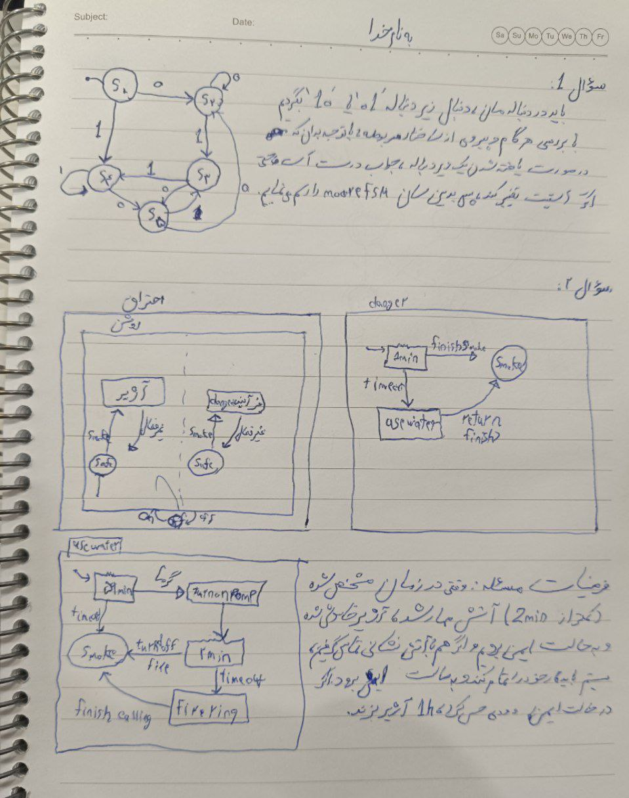

سوال3)

#include <Arduino.h>

const int redPin = 2;

const int yellowPin = 3;

const int greenPin = 4;

const int buttonPin = 7;

const int pinArray[][3] = {

{redPin, LOW, 3000},

{yellowPin, HIGH, 1000},

{greenPin, HIGH, 3000}

};

enum TrafficLightState {

RED,

YELLOW,

GREEN

};

TrafficLightState currentState = RED;

unsigned long previousMillis = 0;

void setup() {

pinMode(redPin, OUTPUT);

pinMode(yellowPin, OUTPUT);

pinMode(greenPin, OUTPUT);

pinMode(buttonPin, INPUT);

digitalWrite(redPin, LOW);

digitalWrite(yellowPin, LOW);

digitalWrite(greenPin, LOW);

}

void loop() {

int buttonState = digitalRead(buttonPin);

if (buttonState == HIGH) {

unsigned long currentMillis = millis();

// Check if the button was pressed and the state has changed

if (currentMillis - previousMillis >= pinArray[currentState][2] && currentState != GREEN) {

previousMillis = currentMillis;

updateState();

}

} else {

digitalWrite(redPin, LOW);

digitalWrite(yellowPin, LOW);

digitalWrite(greenPin, LOW);

}

}

void updateState() {

digitalWrite(pinArray[currentState][0], LOW);

currentState = static_cast<TrafficLightState>((currentState + 1) % 3);

digitalWrite(pinArray[currentState][0], pinArray[currentState][1]);

}