WAAM-3D Thermal Monitoring System Capabilities Request

March 10, 2021

# Introduction:

Mississippi State University will be taking delivery of an ABB palletized weld cell in April. This cell contains an IRB 2600 12 kg/1.85m Reach Robot and IRC 5 controller variant. This WAAM device will utilize a Fronius TPSi 400 power source with the Cold Metal Transfer (CMT) and a Plasma Arc Welding (PAW) module; however, the power source may be subject to change. Our group will initially focus on utilizing the CMT configuration.

To advance initial modeling efforts, test coupons have been produced by Raytheon Technology Research Center (RTRC).During these prints, the shielding gas was changed as well as the print strategy in order to provide preliminary data for Finite Element (FE) model calibration. Four thermocouples were placed on the substrate for each printed part and temperature was recorded throughout the printing process. With the use of the experimental thermocouple data, thermal calibration was successful in matching simulation data to experimental data; however, it is unsure how well temperature measurements at the substrate can be used to provide confidence in melt pool temperatures. In order to better inform our FE thermal model, it is important we are able to capture temperature history near the melt pool. A pyrometer located directly behind the heat source which can record cooling rates as well as inform temperature values near the melt pool would be extremely valuable for FE thermal calibration.

# Temperature Measurement Expectations:

There are two primary goals for the pyrometer implementation: capturing cooling rates behind the melt pool and temperature distributions parallel and perpendicular to the build direction. For experimental testing, the cooling rate data following the melt pool will be used to predict layer dimensions and improve overall build quality. The temperature distribution data will be used for thermal calibration at the printed layer.

The cooling rates during a build are important in the WAAM process ultimately determining the layer width and height as well as affecting the mechanical properties such as hardness and internal stresses within the part. In Figure 1, the cooling rates are shown for the FE thermal simulation at a nodal point along the print path. Global IR data is most likely the best method of acquiring this data.

Figure 1. Heating and cooling rates during the FE thermal simulation at a fixed node located along the top surface of the longitudinal cross-section in the first layer.

The area needed for measurement will most likely vary depending on the size of part being printed; however, based on the current FE thermal simulation results, the measurement area needs to be approximately 165-170 mm2. This area was found by determining the length from the end of the melt pool to a point near room temperature (~25.5 mm) and the width of the part (~6.5 mm) as seen in Figure 2.

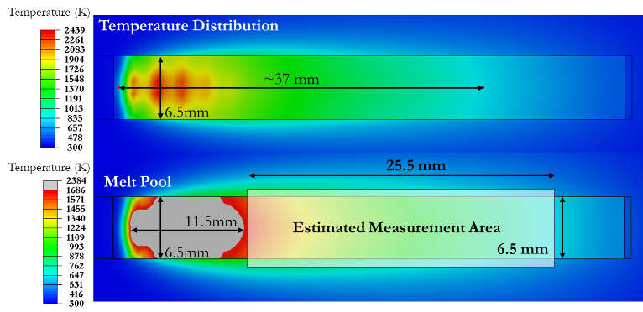

Figure 2. Overall temperature distribution (above) and melt pool dimensions (below) for the first layer from the FE thermal simulation.

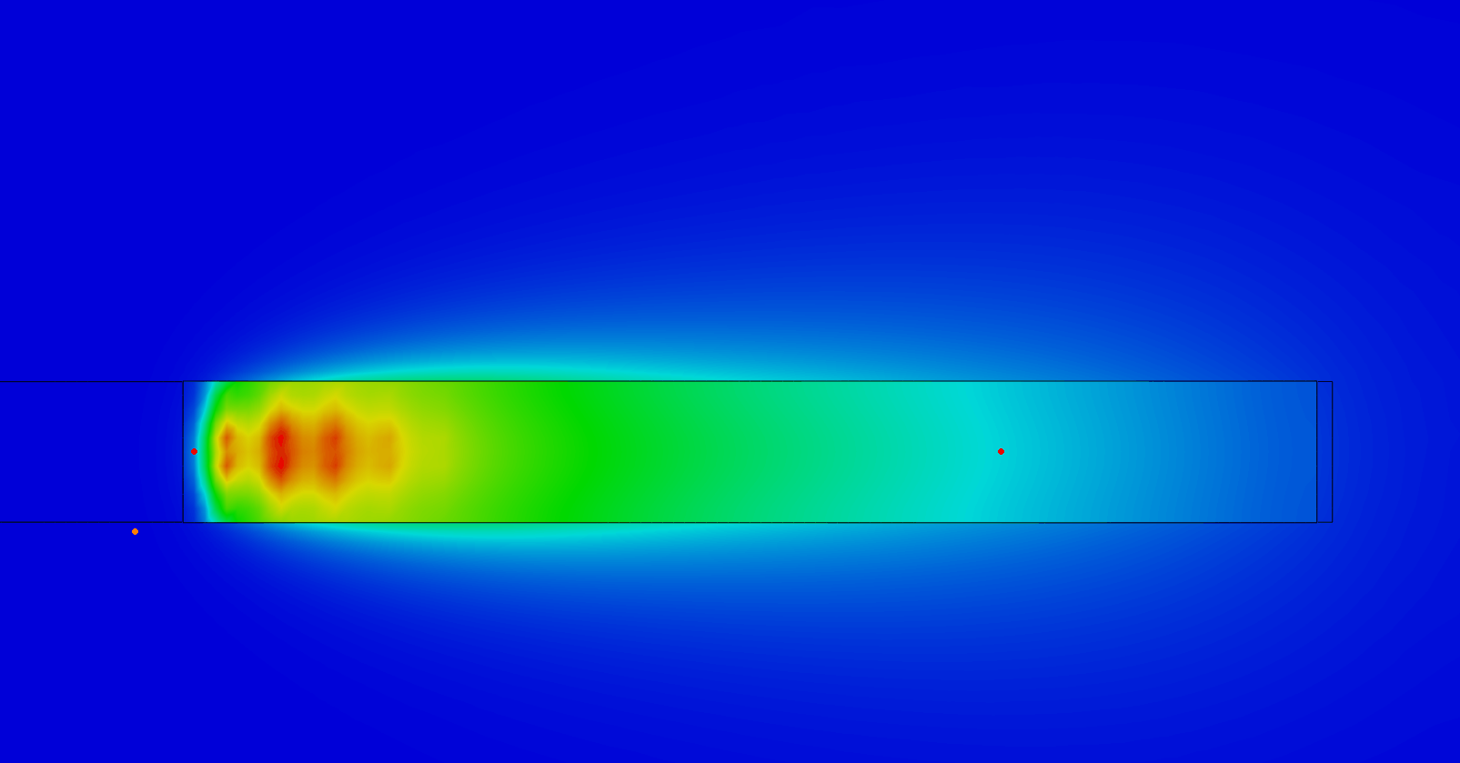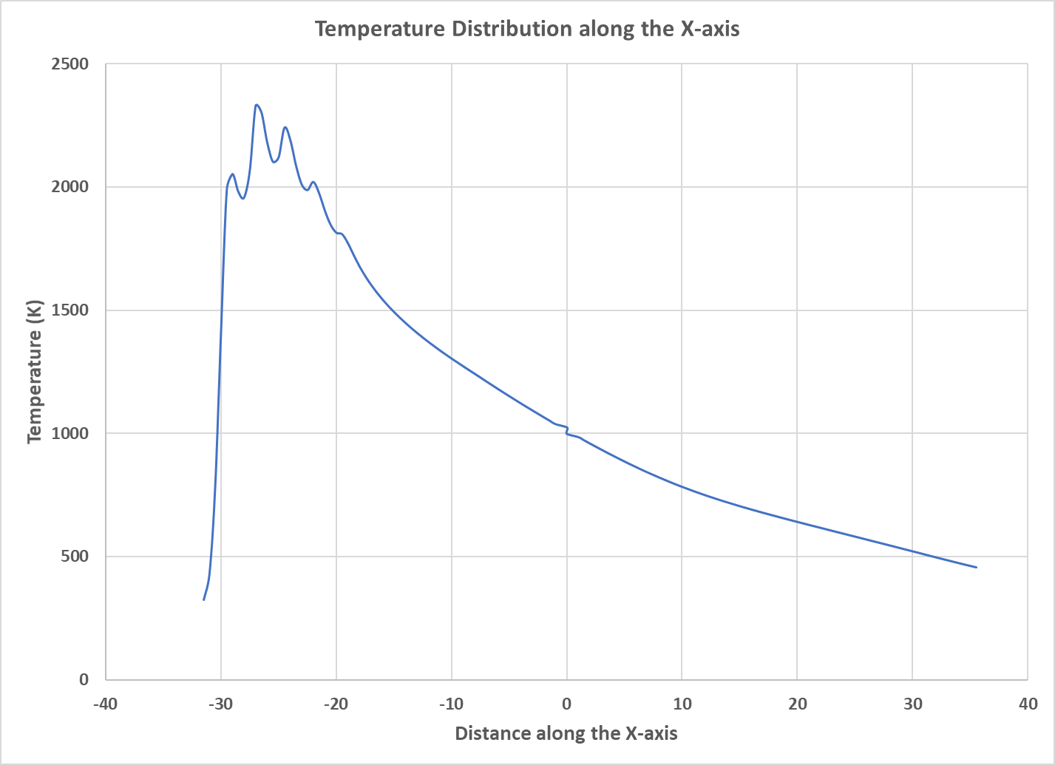

Top View

Figure 3. Temperature distribution along the length of the layer.

Figure 4. Thermocouple data measured on the top and bottom of the substrate compared to our calibrated FE thermal simulation results.

# Pyrometer Resolution Requirements

The spatial resolution requirements we need will depend on the weld width being investigated. The current model has a width of 6.5mm. Based on current simulation model dimensions, approximately 2 pixels/mm is necessary to prevent the need to interpolate temperature values between nodal points. Ideally, the pyrometer will be able to capture temperature values across the full bead width in order to quantify the temperature distribution in the transverse direction.

global IR would provide temperature values on the substrate while also giving insight into the boundary conditions at play during a print which may not be captured with thermocouples.

# Optical Camera Requirements

A high-resolution welding camera would be useful to measure the melt pool geometry. The geometry measurements can then be used to calibrate the parameters for the Goldak heat source model. A setup similar to the one used by Halisch et. al. may prove useful [1].

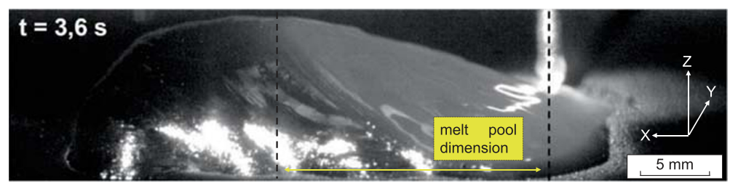

Figure 5: Measuring melt pool dimensions using high speed camera [1]

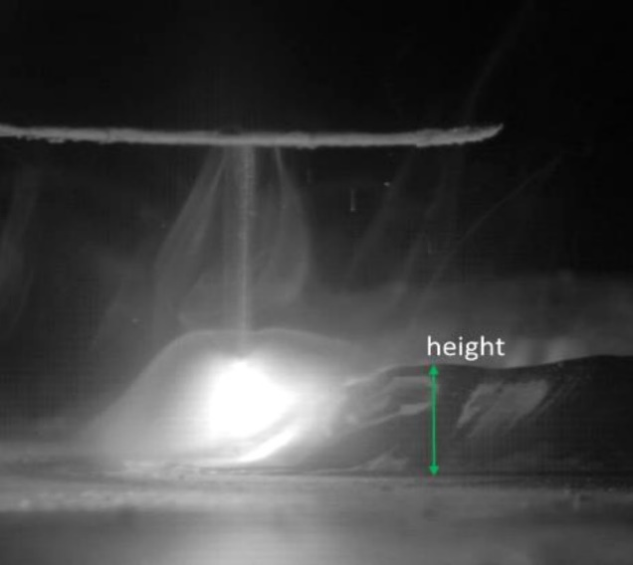 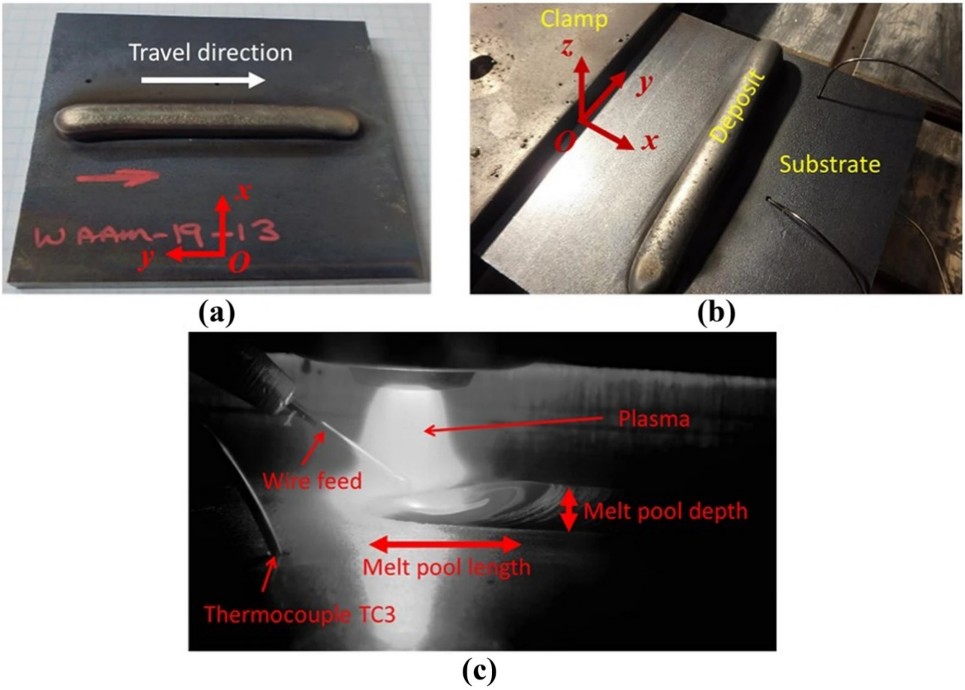

Figure 6: Melt pool images taken using the XIRIS welding camera [2] (left) and unnamed welding camera (right) [3]

# Questions:

* what is the data output for the pyrometers? Will we be able to use pyrometers for closed loop control with our setup?
* Field of view: we are unsure as to the options available for the FOV. As a rule of thumb, the FOV will most likely need to capture the entire width of the layer with some slight excess on either side.
* Shielding gas impacts on pyrometer data
  + Calibration requirements
  + Compatible shielding gas combinations
  + Is there an effect on pyrometer data based on open atmosphere/localized shielding gas conditions vs. global shielding?
* how does the end effector’s camera compare to something like this welding camera <https://www.xiris.com/xiris-xvc-1000e/>
* Will the pyrometers be trailing the melt pool regardless of print strategy or will the welding head be able to move in a way where the pyrometers are no longer following the head?

# References

[1] C. Halisch, T. Radel, D. Tyralla, and T. Seefeld, “Measuring the melt pool size in a wire arc additive manufacturing process using a high dynamic range two-colored pyrometric camera,” *Weld. World*, vol. 64, no. 8, pp. 1349–1356, 2020, doi: 10.1007/s40194-020-00892-5.

[2] Xia, C., Pan, Z., Polden, J., Li, H., Xu, Y., Chen, S., & Zhang, Y. (2020). A review on wire arc additive manufacturing: Monitoring, control and a framework of automated system. *Journal of Manufacturing Systems*, *57*, 31-45.

[3] Jimenez, X., Dong, W., Paul, S., Klecka, M. A., & To, A. C. (2020). Residual Stress Modeling with Phase Transformation for Wire Arc Additive Manufacturing of B91 Steel. *JOM*, *72*(12), 4178-4186.