**Question 1**

B = Box, F = Fruits. r, b, g = red, blue, green. a, o, l = apples, oranges, limes

*P(B=r) = 1/5 P(B=b) = 1/5 P(B=g) = 3/5*

*P(F=a | B=r) = 3/10 P(F=a | B=b) = 5/10 P(F=a | B=g) = 3/10*

*P(F=o | B=r) = 4/10 P(F=o | B=b) = 5/10 P(F=o | B=g) = 3/10*

1. P(F = a) = P(F=a | B=r)P(B=r) + P(F=a | B=b)P(B=b) + P(F=a | B=g)P(B=g)

= 3/10*1/5 + 5/10*1/5 + 3/10*3/5

= 0.06 + 0.10 + 0.18

= 0.34

1. P(F=o) = P(F=o | B=r)P(B=r) + P(F=o | B=b)P(B=b) + P(F=o | B=g)P(B=g)

= 4/10*1/5 + 5/10*1/5 + 3/10*3/5

= 0.08 + 0.10 + 0.18

= 0.36

1. P(B=g |F=o) = $\frac{P(F=o | B=g)P(B=g)}{P(F=o)}$

= $\frac{0.3*0.6}{0.36}$

= 0.5

**Question 2**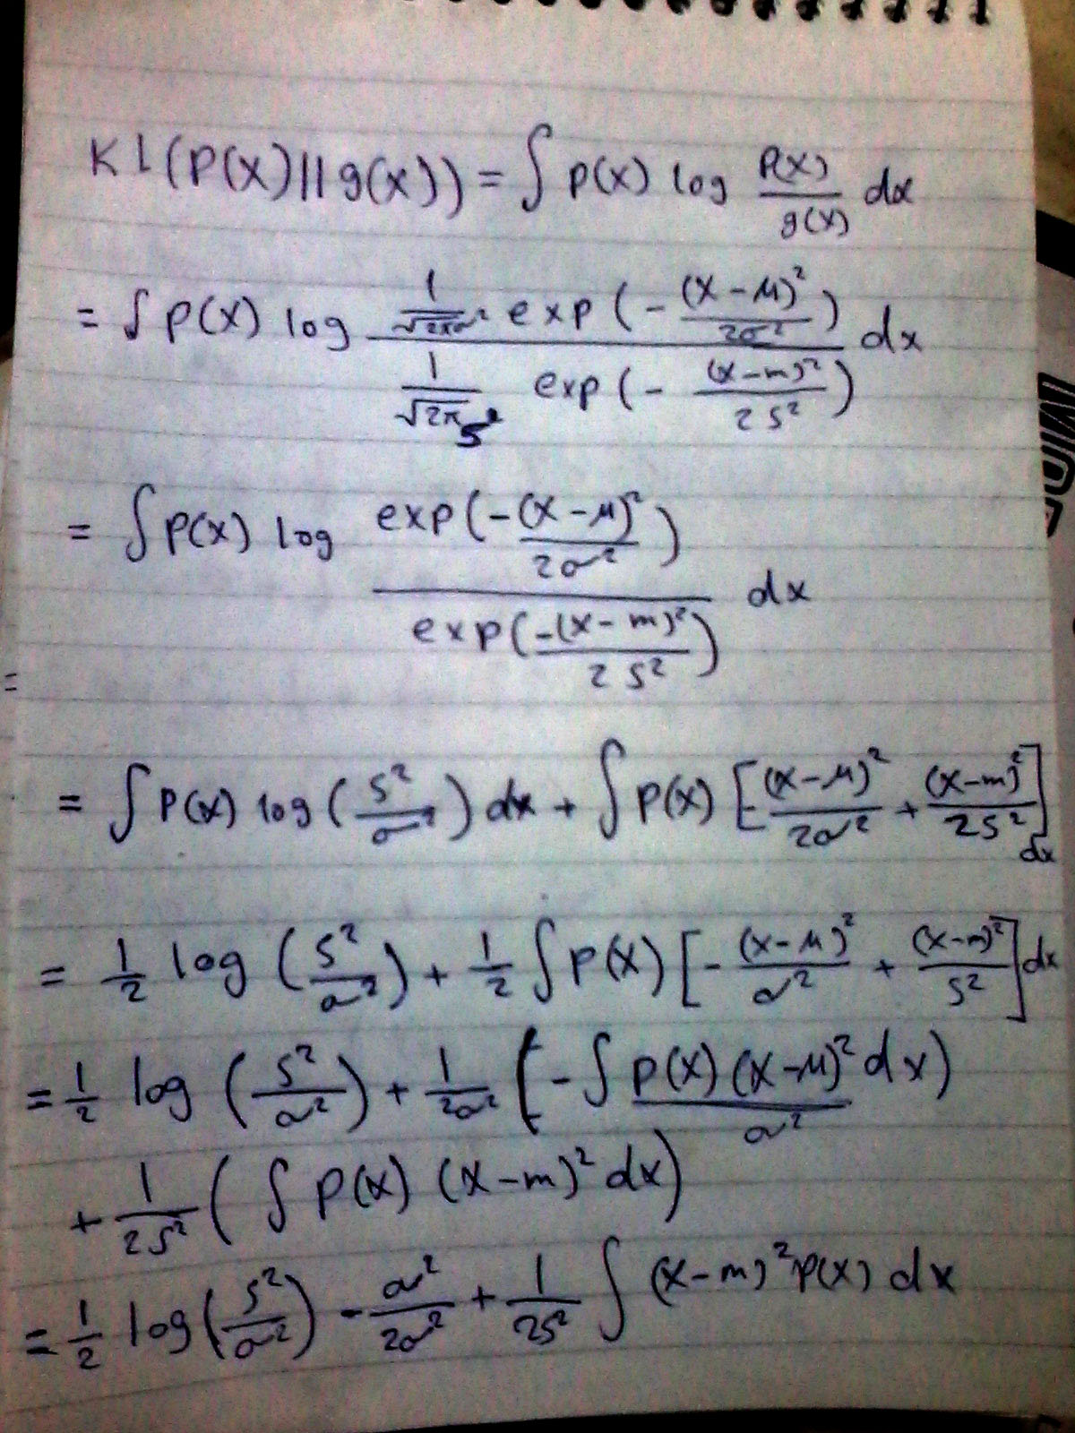

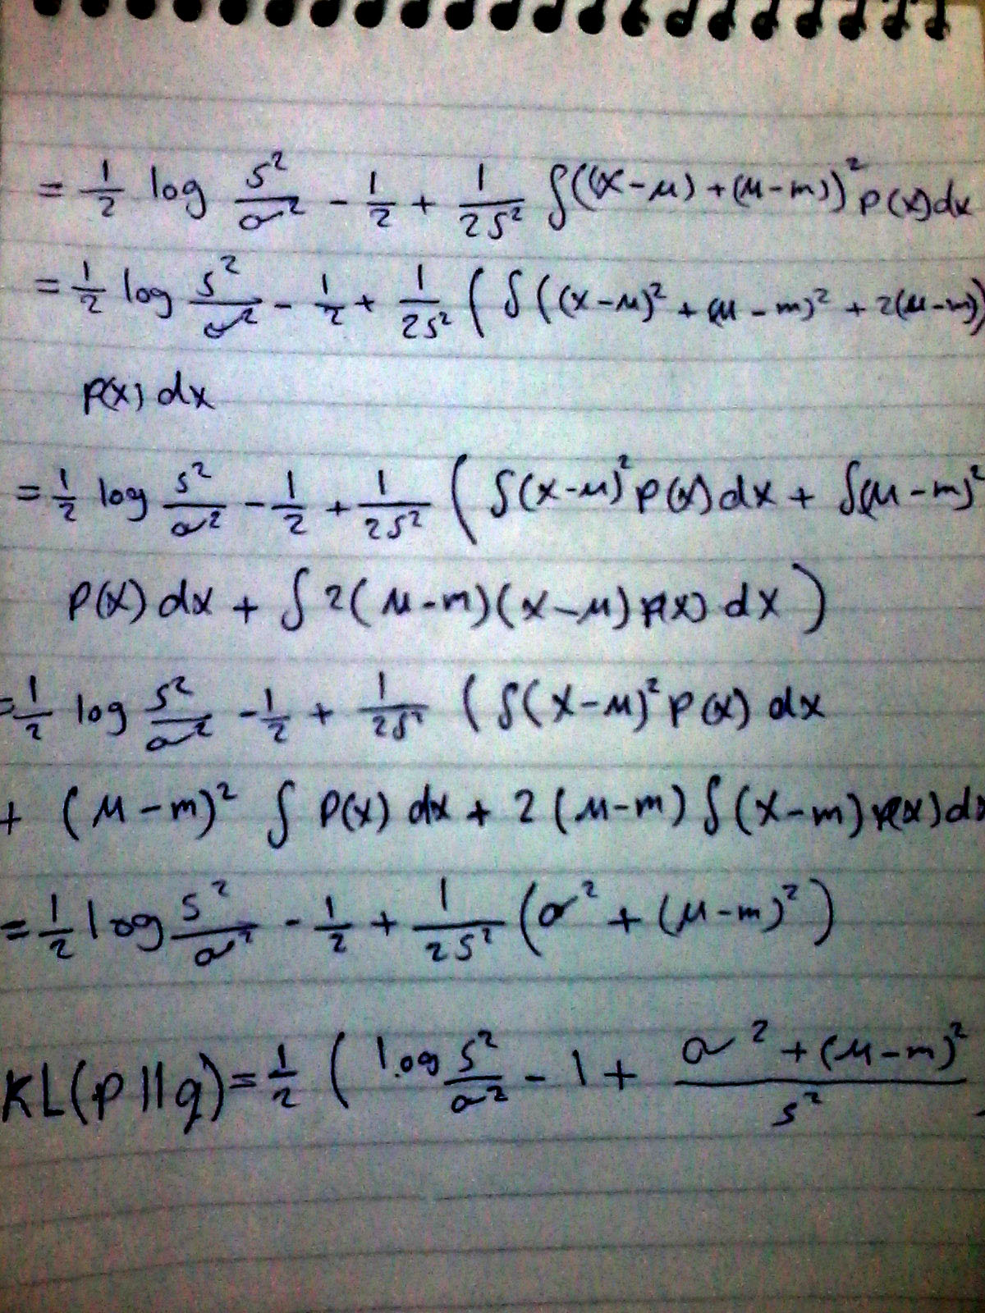

**Question 3**

a)

1. All polynomial combinations up to the third degree
2. الدكتور اعتقد مش طالب اوضح الايرور بتاع الترينينج (الأزرق)

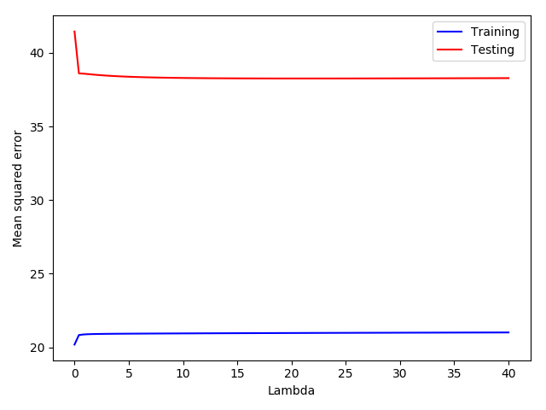

1. Best Lambda achieves a mean squared error about 38.262144.

b)

**Question 4**

1. MSE training: 0.2374

MSE testing: 0.2526

1. MSE training:

MSE testing:

1. MSE training: 0.0540

MSE testing: 0.1543