STUDENT SUGGESTION BOX
A Jakarta EE (JSF + Hibernate + PostgreSQL) Web Application
Video recording: https://drive.google.com/file/d/1Y6UhAObwnFggVOS3PELFXI-jRsjid7qg/view?usp=sharing

Field | Value
Student name | Murenzi Paterne
Registration number
Course / Module | Enterprise Java (Jakarta EE)
Project title | Student Suggestion Box
Technology | JSF 4.0 (Mojarra), Hibernate ORM 6 (hbm.xml, no JPA), PostgreSQL 16, Tomcat 10.1, Docker Compose
Entities with full CRUD | Category and Suggestion
Date

PART 1 - PROJECT DOCUMENTATION

1. Abstract
The Student Suggestion Box is a small web application that replaces the physical suggestion box used in the institution. Students submit suggestions through a web form, each suggestion is classified under a category, and staff review it and move it through a status lifecycle (NEW, UNDER_REVIEW, ACCEPTED, REJECTED). The system is built with Jakarta EE technologies: JSF 4.0 for the presentation layer, CDI for dependency injection, and plain Hibernate ORM 6 with XML (hbm.xml) mappings for persistence into PostgreSQL. The whole application is packaged as a WAR, runs on Apache Tomcat 10.1, and both the application server and the database run as containers orchestrated by Docker Compose. The deliverable demonstrates full CRUD on two entities, three types of validation, and the three ways of applying CSS.

2. Problem Statement
The institution currently collects student feedback through a wooden suggestion box placed in the corridor. Notes are written on paper, dropped in the box, and collected irregularly. This creates several concrete problems:
- Suggestions are lost, torn or unreadable, so genuine student input never reaches management.
- There is no record of who submitted what and when, so nothing can be traced or audited.
- There is no status: a student never learns whether a suggestion was read, accepted or rejected.
- Suggestions are not classified, so management cannot see which service area has the most complaints.
- Producing any report means manually re-typing notes, which takes days and is error prone.
The result is low participation: students stop using the box because they see no outcome.

3. Scope of the Project
In scope
- Managing suggestion categories: create, list, update, delete, activate/deactivate.
- Managing suggestions: submit, list, filter by status, update (including status change), delete.
- Server-side and client-side validation of every submitted field.
- Persistence of all data in a PostgreSQL database through plain Hibernate with XML mappings.
- Packaging as a WAR file and containerised deployment of the application and the database.
Out of scope
- Authentication, authorisation and user account management (planned for a later phase).
- E-mail or SMS notification of students when a status changes.
- File attachments on suggestions, and a public voting/ranking feature.
- Mobile native applications and multi-language support.

4. AS-IS Model
The current (manual) process is shown below.
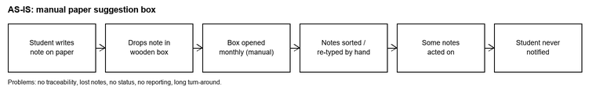
Figure 1 - AS-IS process: manual paper suggestion box
Step | Actor | Weakness
Write suggestion on paper | Student | Illegible, anonymous, no structure
Drop note in the box | Student | No acknowledgement of receipt
Open the box (monthly) | Staff | Long delay; box may overflow or be emptied by anyone
Sort and re-type notes | Staff | Manual, slow, transcription errors
Act on selected notes | Management | Selection is not recorded or justified
(No feedback step) | - | Student never learns the outcome

5. TO-BE Model
The proposed (automated) process is shown below.
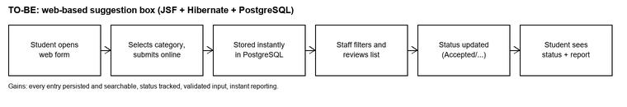
Figure 2 - TO-BE process: web-based suggestion box
Step | Actor | Improvement
Open the suggestion form | Student | Available any time from a browser
Choose a category and submit | Student | Structured, validated, classified input
Data saved to PostgreSQL | System | Immediate, durable, traceable with a timestamp
Filter and review the list | Staff | One screen, filter by status, no re-typing
Update the status | Staff | Lifecycle recorded on the record itself
Consult status and counts | Student / Management | Transparent outcome and instant reporting

6. Business Requirements
ID | Requirement | Priority
BR-01 | A student shall submit a suggestion with a title, a body, an institutional e-mail address and a category. | Must
BR-02 | The system shall store every suggestion permanently with the date and time of submission. | Must
BR-03 | Staff shall create, view, modify and delete suggestion categories. | Must
BR-04 | Category names shall be unique so that reporting is not distorted by duplicates. | Must
BR-05 | Staff shall view, modify and delete suggestions, and change the status to NEW, UNDER_REVIEW, ACCEPTED or REJECTED. | Must
BR-06 | The system shall allow the suggestion list to be filtered by status. | Should
BR-07 | The system shall reject invalid input (empty fields, short titles, non-institutional e-mail addresses) with a clear message next to the field. | Must
BR-08 | A category that is still referenced by at least one suggestion shall not be deleted. | Must
BR-09 | The system shall show the number of categories and of suggestions currently recorded. | Should
BR-10 | The system shall be deployable as a single WAR file on a containerised Tomcat server with a containerised PostgreSQL database. | Must

7. Software Qualities Applied
Software quality | How it is applied in this system
Usability | One screen per entity, a single form for create and update, labelled fields, placeholders, inline error messages and a confirmation message after every action.
Reliability | Every database operation runs inside an explicit Hibernate transaction; a failure rolls the change back and the session is always closed.
Data integrity | NOT NULL and UNIQUE constraints in PostgreSQL, a foreign key from suggestions to categories, and a guard that refuses to delete a category still in use.
Maintainability | Clear layering (view - backing bean - DAO - mapping); mappings are in XML so the schema can change without touching Java code.
Portability | The application is a standard WAR running on any Jakarta EE 10 web container; Docker Compose makes the runtime identical on every machine.
Security | Input is validated on three levels, JSF escapes all output (protection against XSS), and Hibernate uses parameterised queries (protection against SQL injection). Database credentials are supplied as environment variables, not hard-coded.
Performance | A connection pool is configured, the suggestion list is filtered in SQL rather than in Java, and counts are done with aggregate queries.
Scalability | The web tier is stateless apart from the JSF view state, so more Tomcat containers can be added behind a load balancer against the same database.
Testability | DAOs are CDI beans with no view dependency, so they can be unit tested independently of JSF.
Availability | Docker Compose defines a database health check and restarts the application only once the database is ready.

8. Initial Class Diagram
The diagram below shows all entities involved in the complete system. The two entities marked <<CRUD>> are the ones implemented with full CRUD operations in Part 2; Student, Staff and Response belong to the later phases described in the scope.
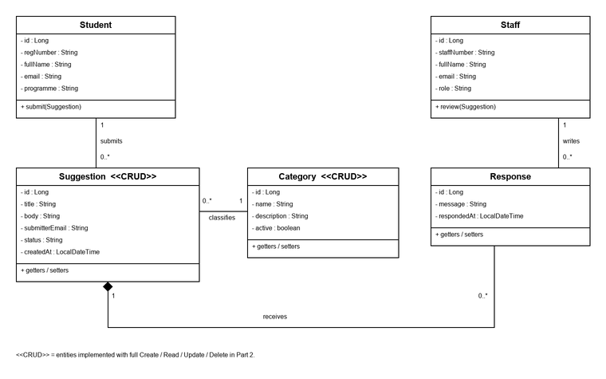
Figure 3 - Initial class diagram
Entity | Responsibility | Key relationships
Student | The person who submits a suggestion. | 1 Student submits 0..* Suggestions
Suggestion | The suggestion itself, with its status lifecycle. | Belongs to 1 Category; has 0..* Responses
Category | Classifies suggestions by service area. | 1 Category classifies 0..* Suggestions
Response | The official reply written by staff. | Belongs to 1 Suggestion; written by 1 Staff
Staff | The member of staff who reviews and replies. | 1 Staff writes 0..* Responses

PART 2 - IMPLEMENTATION (CRUD WITH JSF AND HIBERNATE)

9. Architecture and Technology
Layer | Technology | Artefacts
Presentation | JSF 4.0 (Mojarra), Facelets | template.xhtml, index.xhtml, categories.xhtml, suggestions.xhtml
Controller | CDI (Weld) @Named @ViewScoped beans | CategoryBean, SuggestionBean
Validation | JSF standard, custom, Bean Validation | StudentEmailValidator, UniqueCategoryNameValidator
Persistence | Plain Hibernate ORM 6 native API | CategoryDao, SuggestionDao, HibernateUtil
Mapping | Hibernate XML mapping (no JPA) | Category.hbm.xml, Suggestion.hbm.xml, hibernate.cfg.xml
Database | PostgreSQL 16 (container) | tables categories, suggestions
Runtime | Apache Tomcat 10.1 (container) | suggestionbox.war deployed as ROOT.war

10. Entities Chosen for CRUD
The two entities selected are Category and Suggestion. They are plain Java objects (POJOs) with no JPA annotations; the mapping to the database is done entirely in XML.
Category.hbm.xml
<hibernate-mapping package="rw.ac.suggestionbox.model">
<class name="Category" table="categories">
<id name="id" column="id" type="long">
<generator class="identity"/>
</id>
<property name="name" column="name" type="string" length="60" not-null="true" unique="true"/>
<property name="description" column="description" type="string" length="255"/>
<property name="active" column="active" type="boolean" not-null="true"/>
</class>
</hibernate-mapping>
Suggestion.hbm.xml (extract)
<class name="Suggestion" table="suggestions">
<id name="id" column="id" type="long"><generator class="identity"/></id>
<property name="title" column="title" type="string" length="120" not-null="true"/>
<property name="body" column="body" type="string" length="1000" not-null="true"/>
<property name="submitterEmail" column="submitter_email" type="string" length="120" not-null="true"/>
<property name="status" column="status" type="string" length="20" not-null="true"/>
<property name="createdAt" column="created_at" type="java.time.LocalDateTime" not-null="true"/>
<many-to-one name="category" class="Category" column="category_id" not-null="true" lazy="false"/>
</class>
hibernate.cfg.xml (extract)
<session-factory>
<property name="hibernate.connection.driver_class">org.postgresql.Driver</property>
<property name="hibernate.connection.url">jdbc:postgresql://db:5432/suggestionbox</property>
<property name="hibernate.dialect">org.hibernate.dialect.PostgreSQLDialect</property>
<property name="hibernate.hbm2ddl.auto">update</property>
<mapping resource="rw/ac/suggestionbox/model/Category.hbm.xml"/>
<mapping resource="rw/ac/suggestionbox/model/Suggestion.hbm.xml"/>
</session-factory>

11. CRUD Operations
Each CRUD action is triggered from the JSF page, handled by the backing bean and executed by the DAO through the native Hibernate Session API.
Operation | JSF trigger | Backing bean method | Hibernate call
Create | h:commandButton value="Create" | CategoryBean.save() | session.persist(entity)
Read (list) | h:dataTable value="#{categoryBean.categories}" | CategoryBean.getCategories() | session.createQuery("from Category order by name").list()
Read (one) | h:commandLink value="Edit" | CategoryBean.edit(c) | session.get(Category.class, id)
Update | h:commandButton value="Update" | CategoryBean.save() | session.merge(entity)
Delete | h:commandLink value="Delete" | CategoryBean.delete(c) | session.remove(entity)

The same five operations are implemented for Suggestion in SuggestionDao and SuggestionBean, plus a filter by status.
DAO extract - create and delete inside an explicit transaction
public void save(Category category) {
try (Session session = HibernateUtil.getSessionFactory().openSession()) {
Transaction tx = session.beginTransaction();
session.persist(category);
tx.commit();
}
}
public void delete(Long id) {
try (Session session = HibernateUtil.getSessionFactory().openSession()) {
Transaction tx = session.beginTransaction();
Category managed = session.get(Category.class, id);
if (managed != null) { session.remove(managed); }
tx.commit();
}
}

12. The Three Types of Validation
Type | Where it is declared | Example in this project
1. Standard (built-in) JSF validators | Attributes and tags on the input component in the XHTML page | required="true" on the category name; <f:validateLength minimum="5" maximum="120"/> on the suggestion title
2. Custom validator | A class annotated @FacesValidator implementing jakarta.faces.validator.Validator | StudentEmailValidator (address must end in @student.ac.rw) and UniqueCategoryNameValidator (CDI managed, injects the DAO to reject a duplicate name)
3. Bean Validation (JSR 380) | jakarta.validation constraint annotations on the entity, applied automatically by JSF | @NotBlank, @Size(min=10, max=1000) on Suggestion.body, @Email on Suggestion.submitterEmail, @Size(min=3, max=60) on Category.name

In addition, HTML5 client-side constraints (required, minlength, maxlength, type="email") are rendered with JSF passthrough attributes so obvious mistakes are caught in the browser before a request is sent. Server-side validation is still performed for every field.
Type 1 and 3 - standard validators on the page, Bean Validation on the entity
<!-- categories.xhtml -->
<h:inputText id="name" label="Name" value="#{categoryBean.selected.name}"
required="true" requiredMessage="Category name is required."
pt:required="required" pt:minlength="3" pt:maxlength="60">
<f:attribute name="categoryId" value="#{categoryBean.selected.id}"/>
<f:validator validatorId="uniqueCategoryNameValidator"/>
</h:inputText>
<h:message for="name" styleClass="error"/>
// Category.java
@NotBlank(message = "Category name is required.")
@Size(min = 3, max = 60, message = "Category name must be 3 to 60 characters.")
private String name;
Type 2 - custom validator
@FacesValidator("studentEmailValidator")
public class StudentEmailValidator implements Validator<String> {
private static final String DOMAIN = "@student.ac.rw";
@Override
public void validate(FacesContext context, UIComponent component, String value) {
if (value == null || value.isBlank()) { return; }
if (!value.toLowerCase().endsWith(DOMAIN)) {
throw new ValidatorException(new FacesMessage(FacesMessage.SEVERITY_ERROR,
"Invalid e-mail", "Use your institutional address ending in " + DOMAIN + "."));
}
}
}

13. The Three Ways of Applying CSS
CSS type | Location | Purpose in this project
External | src/main/webapp/resources/css/app.css, loaded with <h:outputStylesheet library="css" name="app.css"/> | Site-wide look: layout, cards, tables, buttons, form grid, error text
Internal | <style> block inside each page, inserted into the template through <ui:insert name="pageStyle"/> | Page-specific rules such as the suggestion status badges and the inactive-category style
Inline | style="..." attribute on individual elements | One-off adjustments such as spacing on a button or the colour of the empty-list message

External - app.css
.data-table { width: 100%; border-collapse: collapse; }
.data-table th, .data-table td { border: 1px solid #d8dce3; padding: 6px 8px; text-align: left; }
.btn { padding: 6px 14px; border: 1px solid #1f3a5f; background: #1f3a5f; color: #fff; }
Internal - suggestions.xhtml
<ui:define name="pageStyle">
<style type="text/css">
.status { font-size: 12px; padding: 2px 6px; border: 1px solid #b9bfc9; }
.status-NEW { background: #eef3fb; }
.status-ACCEPTED { background: #eaf6ec; }
.status-REJECTED { background: #fbeeee; }
</style>
</ui:define>
Inline - index.xhtml / suggestions.xhtml
<p style="margin:0 0 10px 0; line-height:1.5;"> ... </p>
<h:commandButton value="Cancel" styleClass="btn btn-secondary" style="margin-left:8px;"/>

14. Deployment
The project is built with Maven into suggestionbox.war. A two-stage Dockerfile builds the WAR and copies it into a Tomcat 10.1 image as ROOT.war. Docker Compose starts PostgreSQL and the application together; the application waits for the database health check before starting and receives its connection settings as environment variables.
Step | Command
1. Build the WAR only | mvn clean package
2. Build the images and start both containers | docker compose up -d --build
3. Open the application | http://localhost:8080/
4. Follow the application log | docker compose logs -f app
5. Stop the stack | docker compose down
6. Stop and erase the database volume | docker compose down -v

Services: app (Tomcat 10.1, port 8080) and db (PostgreSQL 16, port 5432, database suggestionbox, user suggestion). The schema is created by db/init.sql the first time the volume is created, and Hibernate is configured with hbm2ddl.auto=update so the mappings and the schema stay consistent.

