Markdown (project1)

Michael Rozenbaum

12/10/2016

# Reproducible Research (project 1)

This assignment makes use of data from a personal activity monitoring device. This device collects data at 5 minute intervals through out the day. The data consists of two months of data from an anonymous individual collected during the months of October and November, 2012 and include the number of steps taken in 5 minute intervals each day.

## The data

The data file can be downloaded from [Activity Monitoring Dtata](https://d396qusza40orc.cloudfront.net/repdata%2Fdata%2Factivity.zip). The size is 52KB.

knitr::opts_chunk$set(echo = TRUE)

Download file and unzip it into your current working directory

zipurl <- "https://d396qusza40orc.cloudfront.net/repdata%2Fdata%2Factivity.zip"  
#replace my working directory with yours  
zipdest <- "/Users/Michael/Documents/Data Science/Reproducible Research/week2/project/activity.zip"  
download.file(zipurl,destfile = zipdest,mode = "wb")  
unzip("activity.zip",exdir = "./")  
# packages needed for analysis  
library(ggplot2)  
library(plyr)

Read data in and prepare the data for later analysis

activity <- read.csv("activity.csv")  
#convert date column from factor to date  
activity$date <- as.Date(activity$date)  
# remove NAs from 'steps' data and subset 'activity' in a separate data set  
cleanData <- subset(activity, !is.na(activity$steps))

## What is mean total number of steps taken per day?

This step will produce a histogram showing distribution of total number of steps taken daily.  
This step uses data without NA values.

stepsperday <- tapply(cleanData$steps, cleanData$date, sum, na.rm=TRUE, simplify = TRUE)  
stepsperday <- stepsperday[!is.na(stepsperday)]  
hist(x=stepsperday,col = "red", breaks = 20, xlab = "Total steps per day",  
 ylab = "Frequency", main = "Total daily distribution (missing data ignored)")

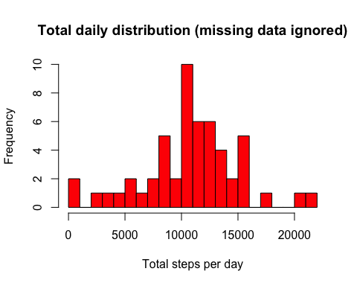

### What is the mean and the median of daily steps taken?

mean(stepsperday)

## [1] 10766.19

median(stepsperday)

## [1] 10765

### mean = 10766.19, median = 10765 .

### What is the average daily activity pattern?

To answer this question, we create a plot of the 5-minute interval (x-axis) and the average number of steps taken, averaged across all days (y-axis).

# calculate mean of steps taken per each interval  
intervalAvg <- tapply(cleanData$steps, cleanData$interval, mean, na.rm=TRUE, simplify=TRUE)  
df_ia <- data.frame(interval=as.integer(names(intervalAvg)), avg=intervalAvg)  
with(df_ia, plot(interval, avg, type="l", xlab="5-minute intervals",  
 ylab="average steps across all days"))

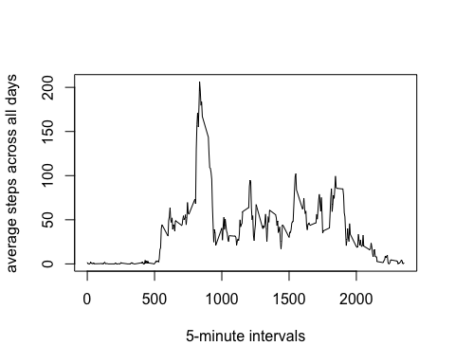

#calculate which interval has maximum number of steps  
max_steps <- max(df_ia$avg)  
df_ia[df_ia$avg == max_steps, ]

## interval avg  
## 835 835 206.1698

### the interval 835 has max number of steps (206).

## Imputing missing values

How many rows with missing values in the original data set?

sum(is.na(activity$steps))

## [1] 2304

There are 2304 rows with missing data.  
In any 5 min. interval with missing value, we will replace the missing value with mean value  
of that interval. A new data set will be create from the original with missing data replaced.

impute <- activity  
NAx <- is.na(impute$steps)  
int_avg <- tapply(cleanData$steps, cleanData$interval, mean, na.rm=TRUE, simplify=TRUE)  
impute$steps[NAx] <- int_avg[as.character(impute$interval[NAx])]

Now we generate histogram showing total of daily steps with missing data imputed.

newSum <- tapply(impute$steps, impute$date, sum, na.rm=TRUE, simplify = TRUE)  
hist(x=newSum, col = "red", breaks = 20, xlab = "Daily steps", ylab = "Frequency",   
 main = "Daily total (missing data imputed)")

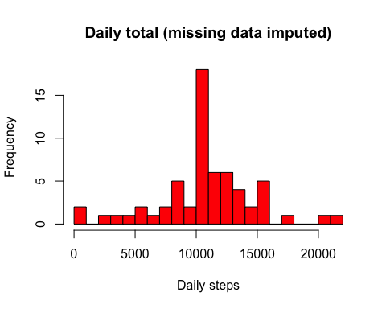

# calculate mean and median of total number of steps taken daily  
mean(newSum)

## [1] 10766.19

median(newSum)

## [1] 10766.19

After the data being imputed, the mean value (10766.19) has not changed. The median value has been affected: new = 10766.19, old = 10765. The new median value is equal to the mean, possibly because mean values were used for imputing. Imputing data impacted frequency counts. They are higher and closer to the mean (see histogram above).

## Are there differences in activity patterns between weekdays and weekends?

First, in the dataset with imputed data, we create a new factor variable with 2 levels: "weekday", "weekend".

# function to distinguish between weekdays and weekends  
weekdayfun <- function(data){  
 wd <- weekdays(data)  
 ifelse(wd == "Saturday" | wd == "Sunday", "weekend", "weekday")  
}  
wk <- sapply(impute$date, weekdayfun)  
impute$wk <- as.factor(wk)  
#head(impute)  
sum(impute$wk == "weekend")

## [1] 4608

The panel plot below shows number of steps taken averaged over 5 minute intervals. The plot displays weekdays and weekends data separately.

wkData <- aggregate(steps ~ wk+interval, data = impute, FUN = mean)  
library(lattice)  
xyplot(steps ~ interval | factor(wk), layout = c(1,2), xlab = "Interval",   
 ylab = "Number of steps", type = "l", lty = 1, data = wkData )

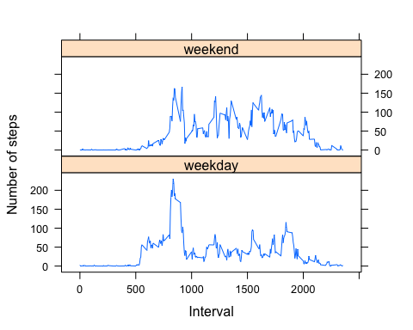

From the plot above we can determine that activities on weekdays start earlier that on weekends. And activities throughout a weekends are higher versus weekdays activities are lower towards the end of a day.