RouteGuardian - Technical Architecture
AI-Powered Safe Route Navigation for Nigeria
Awarri Developer Challenge 2025
System Overview
RouteGuardian is a comprehensive travel safety application designed specifically for Nigeria's unique transportation challenges. The application addresses a critical need in a country where travelers face varied security conditions across different regions, from urban congestion in Lagos to security advisories in northern states. By combining modern mobile technology with artificial intelligence, RouteGuardian empowers users to make informed decisions about their travel routes.
The system follows a three-tier architecture that separates concerns between the user interface, AI processing layer, and external data sources. This design ensures scalability, maintainability, and the ability to operate both online and offline. The Flutter-based frontend provides cross-platform compatibility, while the Python-based N-ATLaS server handles all AI inference and data aggregation tasks.

Technical Architecture Diagram
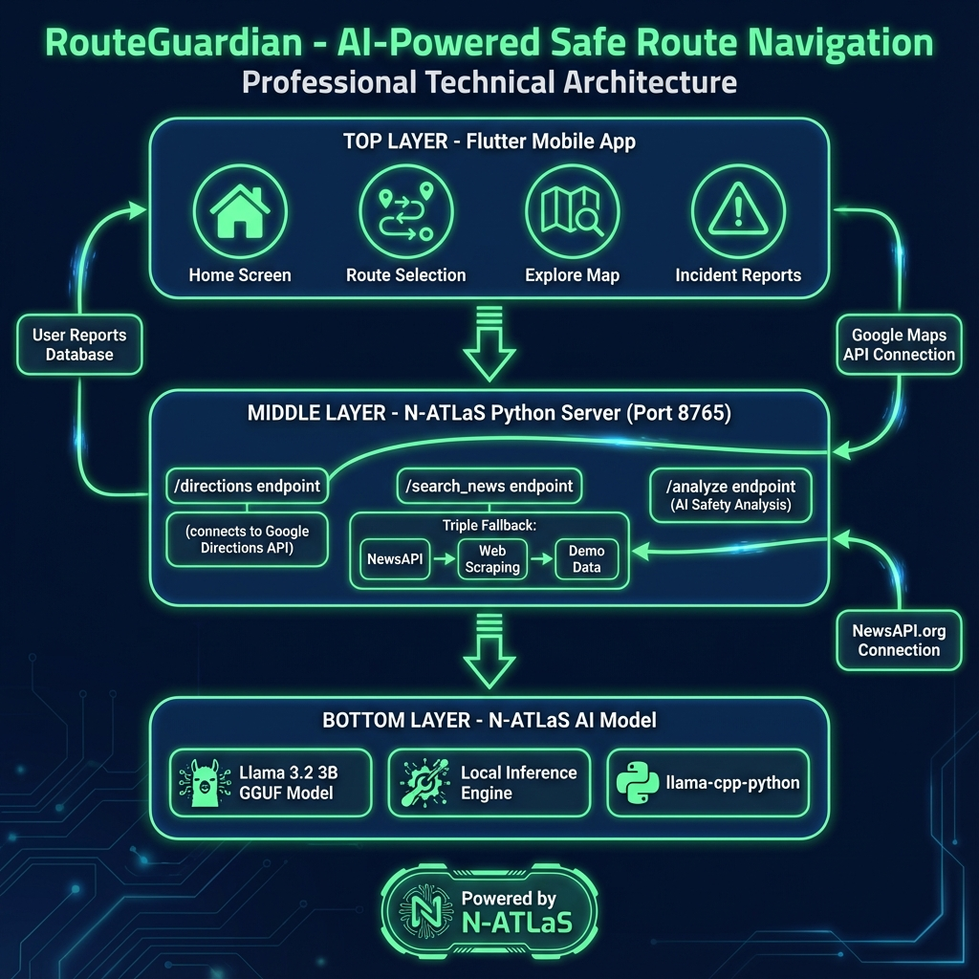
TIER 1: Flutter Mobile Application
• Home Screen - Origin/destination input with GPS
• Route Selection - 3 route alternatives with safety scores
• Explore Map - Incident heatmap visualization
• Report Incident - Community safety reports
↓
TIER 2: N-ATLaS Python Server
• /directions - Google Directions API proxy for CORS bypass
• /search_news - Triple Fallback: NewsAPI → Scraping → Demo
• /analyze - AI text analysis for incident detection
• /severity - Incident severity scoring (0-100)
↓
TIER 3: N-ATLaS AI Model
• Llama 3.2 3B - N-ATLaS.Q2_K.gguf (3GB quantized)
• llama-cpp-python - High-performance local inference
• Privacy-First - On-device processing, no cloud
External Services:
• Google Maps API (Directions, Geocoding, Maps SDK)
• NewsAPI.org (Real-time Nigeria news feed)
• SQLite (Local incident database)
How N-ATLaS is Leveraged
RouteGuardian integrates N-ATLaS (Llama 3.2 3B), The model serves as the core intelligence engine, providing context-aware safety analysis that understands Nigerian locations, security terminology, and local nuances that generic AI models would miss.
AI-Powered Safety Scoring: When a user requests route alternatives, the system collects news articles and incident reports for locations along each route. N-ATLaS processes these texts to identify safety-relevant information, classifying incidents by type (robbery, kidnapping, accident, traffic congestion) and assessing their severity on a 0-100 scale. The model uses natural language understanding to parse headlines like "Security forces deploy on Kaduna-Zaria highway" and determine whether this indicates increased safety (more patrols) or heightened risk (active threat response).
Intelligent Text Classification: The N-ATLaS model performs multi-label classification on news content, identifying incident categories and extracting location mentions. This enables the system to map incidents to specific route segments rather than entire cities, providing granular safety assessments. For example, the model can distinguish between an incident on the Lagos-Ibadan expressway versus one within Lagos city, affecting different routes differently.
Local Inference Architecture: Unlike cloud-based AI solutions, RouteGuardian runs N-ATLaS locally using the llama-cpp-python library. The quantized GGUF model (3GB) is optimized for efficient inference on consumer hardware, enabling real-time analysis without internet dependency. This architecture choice ensures user privacy—travel patterns and location data never leave the device—and provides resilience in areas with poor connectivity, common in many Nigerian regions.
Data Flow & Processing Pipeline
The application implements a sophisticated data pipeline that combines multiple information sources to generate comprehensive safety assessments:
1. Route Request: The Flutter app sends origin and destination coordinates to the N-ATLaS server, which proxies the request to Google Directions API. The server retrieves up to three alternative routes with full polyline data containing 200+ waypoints for accurate road-following visualization.
2. Location Extraction: For each route, the system identifies key locations along the path—cities, highways, and regions that the route traverses. These locations become the search targets for news and incident data.
3. News Aggregation (Triple Fallback): The server implements a robust triple-fallback strategy for news retrieval. First, it attempts NewsAPI.org for high-quality, structured articles. If unavailable, it falls back to Google News web scraping. Finally, if both fail, a curated demo database provides baseline safety information for major Nigerian routes. This ensures the system always provides some level of intelligence, even offline.
4. AI Analysis: Collected news items are fed to the N-ATLaS model for safety analysis. The model evaluates each headline for threat indicators, assigns severity scores, and generates human-readable warnings. Results are aggregated per-route to produce a final safety score (0-100) and prioritized list of concerns.
5. User Presentation: The Flutter app displays route alternatives on an interactive map, with each route color-coded by safety level (green = safe, yellow = moderate, red = avoid). Users can tap routes to see detailed AI-generated warnings and make informed travel decisions.
Key Features
• Multi-Route Alternatives: Provides up to 3 route options with comparative safety scores, allowing users to balance travel time against security concerns
• Real-Time Incident Detection: Automatically discovers and analyzes news from Nigerian sources within the last 24 hours
• Community Reporting: Users can submit incident reports with location, type, and description, contributing to collective safety awareness
• Interactive Heatmap: Visualizes incident density using 500m radius circles with severity-based coloring
• Cross-Platform Deployment: Single codebase runs on Web (Chrome), Android, iOS, Windows, macOS, and Linux
• Offline Capability: Core functionality works without internet using cached data and demo fallbacks
Technical Stack
Frontend: Flutter 3.0+ with Dart, Google Maps SDK, flutter_polyline_points for route rendering, Provider for state management, SQLite for local incident storage.
Backend: Python 3.8+ HTTP server, llama-cpp-python for N-ATLaS inference, urllib for API requests, dotenv for secure configuration management.
AI Model: N-ATLaS Llama 3.2 3B (Q2_K quantization, 3GB), optimized for 4-thread CPU inference with 2048 token context window.
External APIs: Google Directions API, Google Maps SDK, NewsAPI.org, Google News (scraping fallback).

