# Project Documentation

**Group W Members:**  
Mehul Bhargav - 500245513  
Sukhjit Singh - 500237727  
Sahil - 500237277  
Varisdeep Singh - 500245515  
Shivam Bhargav - 500236917

## Screenshots and Explanations

**Newsletter Table in phpMyAdmin**: Displays the 'newsletters' table in the database with one entry showing an email and subscription timestamp.

**Users Table in phpMyAdmin**: Shows the 'users' table in the database with three entries containing user details like Customer ID, Name, Gender, Email, Phone, and other attributes.

**Newsletter Subscription Confirmation Page**: Shows a confirmation message that the user has successfully subscribed to the newsletter.

**IT Agency Website Newsletter Section**: Frontend view of the newsletter subscription section on the IT Agency website.

**Successful Registration Page**: A webpage confirming the successful registration of a user.

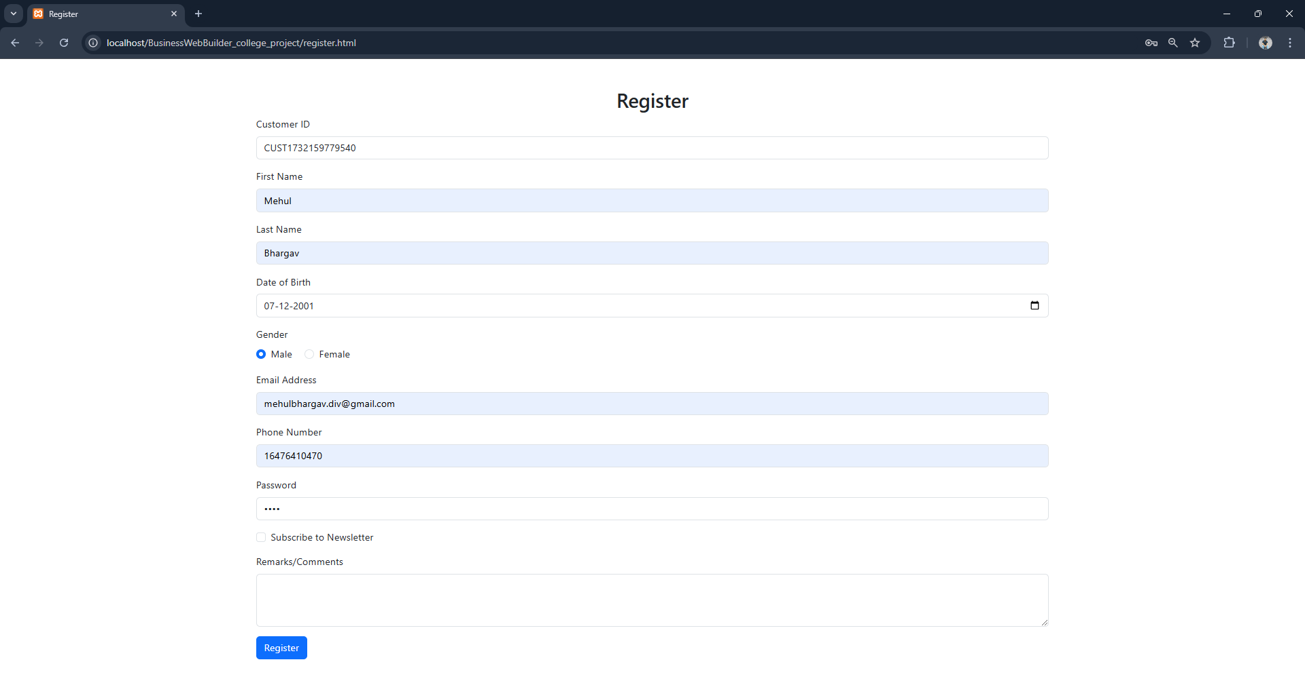

**Registration Form**: Frontend view of the registration form where users can input their details to register.

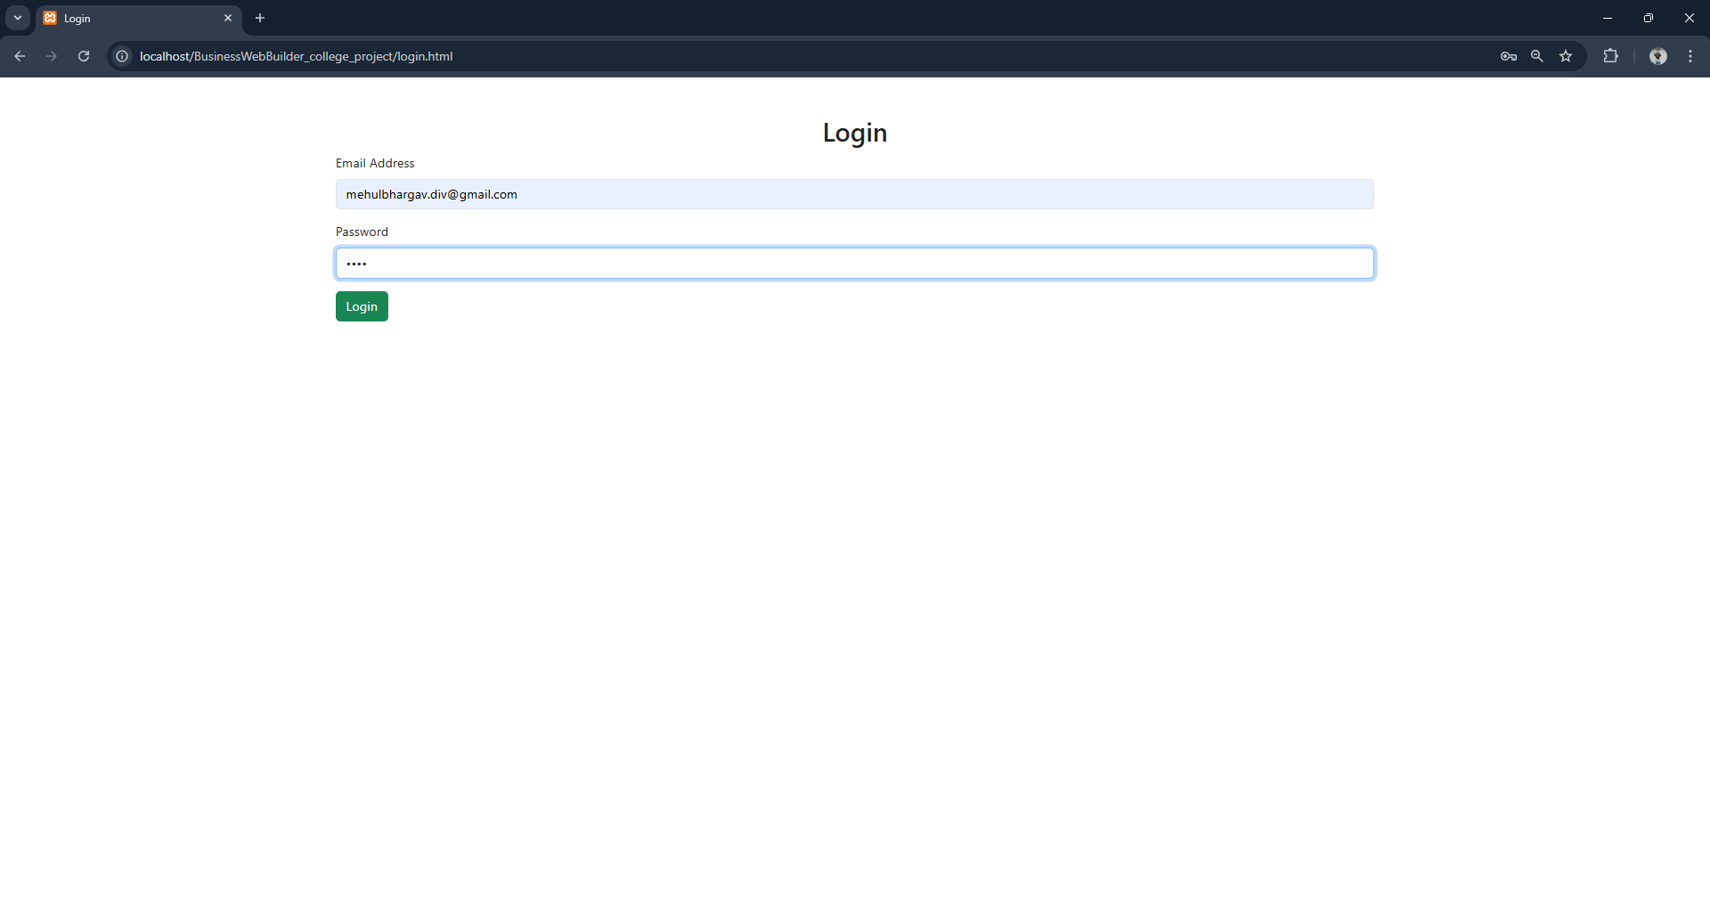

**Login Page**: Frontend view of the login page where users can input their email and password to log in.

**Welcome Page**: A webpage displaying user details after a successful login.

**File Structure in VSCode**: Displays the organized folder structure in the project, including directories for PHP, CSS, JavaScript, and HTML files.

**Register.html Code**: Shows the HTML structure for the registration page.

**Login.html Code**: Displays the HTML structure for the login page.

**Database Connection Code (db.php)**: This PHP file includes the code for connecting to the database using MySQLi. It initializes the connection with localhost, root user, and ITAgencyDB as the database name.

**Login Functionality Code (login.php)**: This file contains PHP code for user login. It verifies the email and password entered by the user, fetching details from the database and displaying a welcome message if the credentials are correct.

**Newsletter Subscription Code (newsletter.php)**: The 'newsletter.php' file processes the newsletter subscription. It takes the email entered by the user, stores it in the database, and displays a confirmation message for successful subscription.

**User Registration Code (register.php)**: This PHP file handles user registration. It takes all the form inputs, hashes the password, and inserts the data into the 'users' table in the database. A unique Customer ID is generated dynamically using a timestamp.