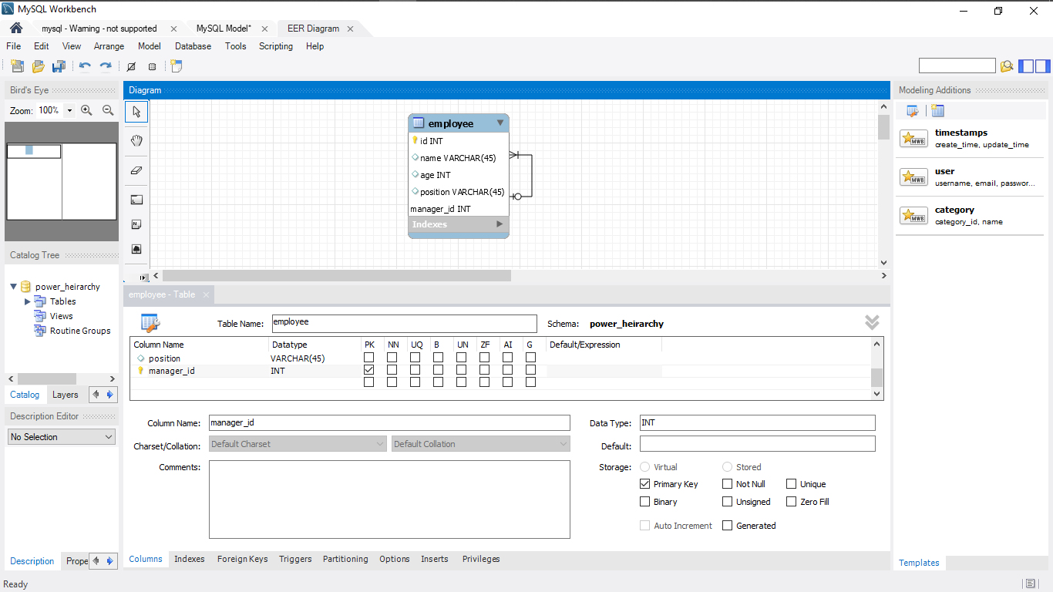1-1

1-2

SELECT

e.name 'Employee Name',

e.position 'Position',

m.name 'Manager Name'

FROM

employee e,

employee m

WHERE

e.manager_id = m.id;

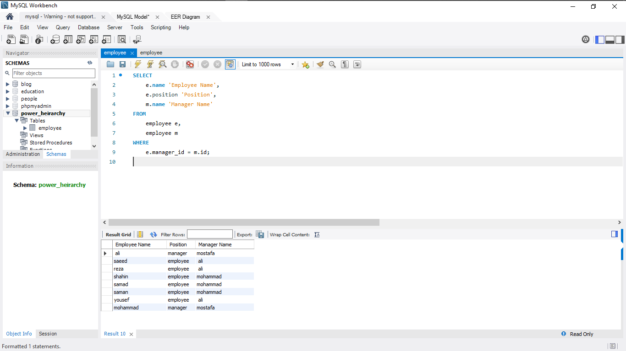

1-3

SELECT

e.id,

e.name 'Employee Name',

e.position 'Position',

m.name 'Manager Name'

FROM

employee e

LEFT OUTER JOIN

employee m ON e.manager_id = m.id;

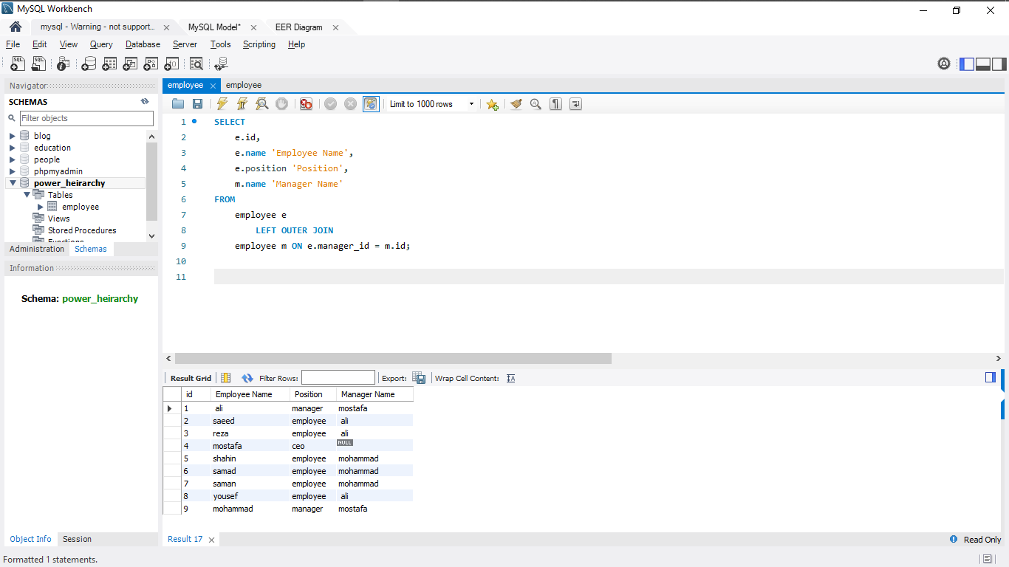

1-4

SELECT

e.id,

e.name 'Employee Name',

e.position 'Position',

m.name 'Manager Name'

FROM

employee e

JOIN

employee m ON e.manager_id = m.id

WHERE

e.id NOT IN (SELECT

e1.manager_id

FROM

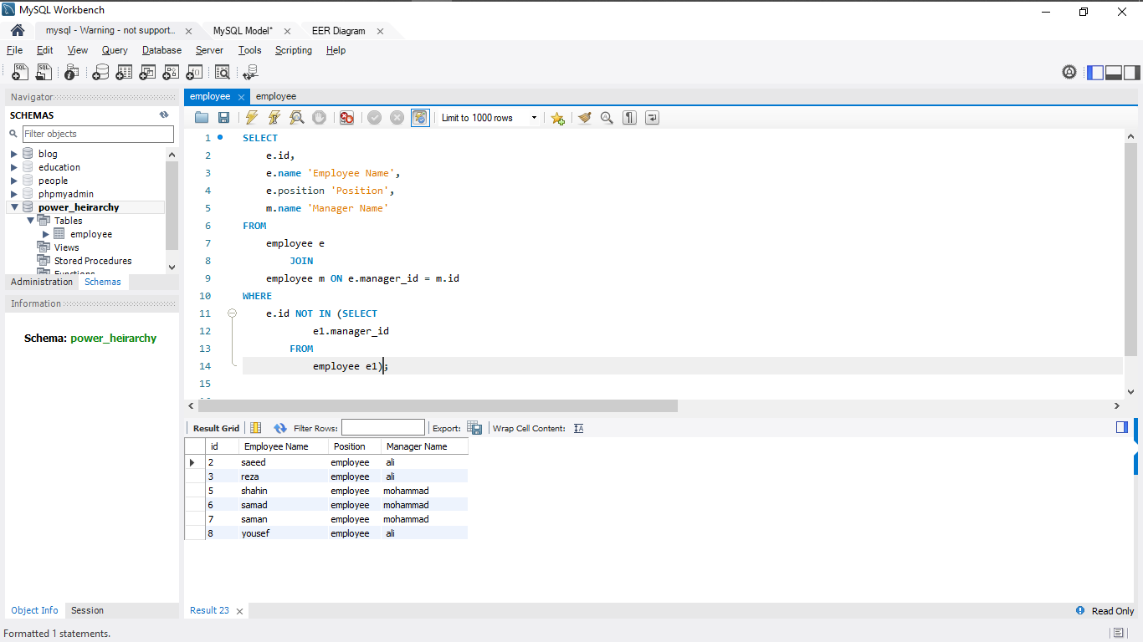 employee e1);

1-5

SELECT

m.id,

m.name 'Manager Name',

m.position 'Position',

COUNT(e.name)

FROM

employee m

JOIN

employee e ON e.manager_id = m.id

GROUP BY m.name;

