**Mualij**

**Project Proposal**



Session: 2021-2025

**Submitted by:**

Abdul Haseeb 2021-SE-22

Zain Ali 2021-SE-23

Umar Waris 2021-SE-28

**Supervised by:**

Mr. Umar Qasim

Department of Computer Science, New Campus **University of Engineering and Technology Lahore, Pakistan**

Contents

**List of Figures** 3

**List of Tables 4**

**Proposal Synopsis 5**

1.1 Abstract 5

1.2 Introduction 5

1.3 Problem Statement 6

1.4 Objectives 6

1.5 Features/Scope 7

1.6 Related Work 8

1.7 Proposed Methodology/System 9

1.8 Tools and Technologies 10

1.9 Team Members Individual Tasks/Work Division 10

1.10 Data Gathering Approach 10

1.11 Timeline/Gantt chart 11

1.12 References 12

i

# List of Figures

1.1 Gantt Chart............................................................................................. 11

ii

# List of Tables

|  |  |  |
| --- | --- | --- |
| 1.1 | Related System Analysis . . . . . . . . . . . . . . . . . . . . . 8 |  |
| 1.2 | Work Division . . . . . . . . . . . . . . . . . . . . . . . . . . . . . .10 |  |

iii

Chapter 1

# Proposal Synopsis

## 1.1 Abstract

In the ever-evolving landscape of healthcare, the exchange of knowledge and expertise among professionals is crucial for delivering high-quality patient care [1].Traditional methods of consultation and information exchange, such as in-person meetings and static databases, can be time-consuming and inefficient. To address these challenges, we propose Mualij, a Doctor-to-Doctor Information sharing System designed similarly to Stack Overflow [2]. This platform will enable doctors to ask questions and have them answered by their peers, fostering a collaborative environment for professional knowledge sharing and problem-solving.

Additionally, Mualij will feature an AI-driven system specifically designed to answer queries related to cardiovascular diseases. The AI will provide accurate and relevant information, assisting doctors in making informed decisions. This integration of AI technology will not only enhance the platform's utility but also ensure that doctors have access to the latest and most reliable medical information.

The primary goal of Mualij is to create an efficient, user-friendly platform that facilitates seamless communication among healthcare providers. By providing a dedicated space for doctors to share insights, discuss complex cases, and seek advice from their peers, we aim to improve the overall quality of healthcare delivery. The inclusion of AI-driven responses for cardiovascular disease queries will further support doctors in their practice, helping them stay updated with the latest advancements and treatment protocols.

In summary, Mualij promises to be a transformative solution for professional interaction in the healthcare sector. By combining the collaborative features of a question-and-answer platform with the advanced capabilities of AI, Mualij will enhance the exchange of knowledge among doctors, ultimately leading to better patient outcomes.

## 1.2 Introduction

The healthcare sector is continuously evolving, with technology playing an increasingly pivotal role in enhancing patient care and accessibility to medical services. The advent of digital platforms has revolutionized many aspects of healthcare, including patient management, diagnosis, and treatment planning. However, there remains a significant gap in the provision of platforms dedicated to professional interaction among doctors. Traditional methods of consultation and information exchange, such as in-person meetings, emails, and static databases, can be inefficient and time-consuming. To address these challenges, we propose the development of Mualij, a comprehensive Doctor-to-Doctor Information sharing System.

Mualij is designed to function as a dynamic, interactive platform where doctors can ask questions, share insights, and provide answers to their peers. This system draws inspiration from Stack Overflow, a widely used platform in the technology sector, known for its robust question-and-answer format. By adapting this model to the healthcare domain, Mualij aims to facilitate the seamless exchange of knowledge and expertise among doctors, fostering a collaborative environment that supports continuous learning and professional development.

At the core of Mualij is an AI-driven system specifically designed to address queries related to cardiovascular diseases. Initially the system will only have support for cardiovascular diseases, and later on more diseases will be added. Cardiovascular diseases are among the leading causes of morbidity and mortality worldwide [3], making it imperative for doctors to have access to the latest and most accurate information. The AI component of Mualij leverages advanced machine learning algorithms and large language models to provide precise and relevant answers to cardiovascular-related queries. This feature ensures that doctors receive timely and reliable information, aiding them in their clinical decision-making processes.

The significance of Mualij lies in its potential to transform the way doctors interact and share knowledge. By providing a dedicated platform for professional collaboration, Mualij aims to overcome the limitations of traditional consultation methods. The system's user-friendly interface, combined with its powerful AI capabilities, will empower doctors to seek advice, discuss complex cases, and stay updated with the latest advancements in their field. Furthermore, the platform's integration of features such as upvoting, commenting, and tagging will enhance the organization and accessibility of information, making it easier for doctors to find and contribute valuable insights.

Overall, this project sets out to address the fundamental challenges in professional interaction among doctors, with a focus on enhancing knowledge sharing and collaboration. By integrating AI technology and adopting a user-centric approach, Mualij aims to make a significant contribution to the healthcare industry's ongoing evolution.

## 1.3 Problem Statement

To develop a Doctor-to-Doctor Information sharing System with integrated AI capabilities for answering cardiovascular disease queries, providing a platform for professional knowledge sharing and consultation among doctors.

## 1.4 Objectives

* + - Develop a user-friendly platform for doctors to ask and answer questions.
    - Implement AI technology to answer queries related to cardiovascular diseases.
    - Facilitate professional collaboration and knowledge sharing among healthcare providers.
    - Ensure the platform is secure and maintains the confidentiality of user interactions.
    - Integrate features for upvoting, commenting, and tagging questions for better organization and accessibility.

## 1.5 Features/Scope

* User registration and authentication for verified doctors.
* Question and answer functionality with tagging and categorization.
* AI-driven responses for cardiovascular disease queries.
* Upvote and comment features for community engagement.
* Secure messaging and notification system.
* User profiles showcasing professional background and expertise.
* Advanced search functionality to find relevant questions and answers.
* Data encryption and privacy protection measures.

## 1.6 Related Work

|  |  |  |
| --- | --- | --- |
| Related Work | Weakness | Proposed Solution |
| [Stack Overflow](https://stackoverflow.com/) | * Not specific to healthcare * Lack of AI consultancy | * Specialized platform for doctors * AI consultancy |
| [HealthTap](https://www.healthtap.com/) | * Limited peer to peer interaction * Lack of AI consultancy | * Enhanced professional collaboration features * AI consultancy |
| [Reddit Health Forums](https://www.reddit.com/r/publichealth/) | * Lack of professional moderation and credibility * Lack of AI consultancy | * Professional verification and moderation of content * AI consultancy |
| [UpToDate](https://www.wolterskluwer.com/en/solutions/uptodate) | * Lack of AI consultancy * Lack of Q&A format | * AI consultancy * Specialized platform for doctors’ Q&A |
| [MedPage Today](https://www.medpagetoday.com/) | * News focused, Lack of Q&A functionality * Lack of AI consultancy | * Platform for doctors’ Q&A * AI consultancy |

Table 1.1 : Related Work

## 1.7 Proposed Methodology/System

To gather stakeholder requirements, we'll conduct interviews and surveys, then draft a Software Requirements Specification (SRS) document. Next, we'll create a prototype to visualize the system's functionality before developing the mobile app. The app will use the proposed AI model to provide information about cardiovascular queries. It will also incorporate user feedback through comments.

After completing the development of the Q&A system, our next step is data collection, focusing on cardiovascular diagnosis within our target region. Our source will be datasets available online, for example: Kaggle. Performing rigorous testing to ensure reliability, the system will be deployed for user access through appropriate channels.

From development plan’s perspective, we will use Agile development methodology [4]. We will divide whole project into iterations and develop each iteration completely and review each iteration according to the plan and after that we perform unit testing. With completing each iteration we will perform integration testing leading to complete development. At the end of each iteration the working product will be reviewed by our supervisor and suggesting changes will be made before moving to next iteration.

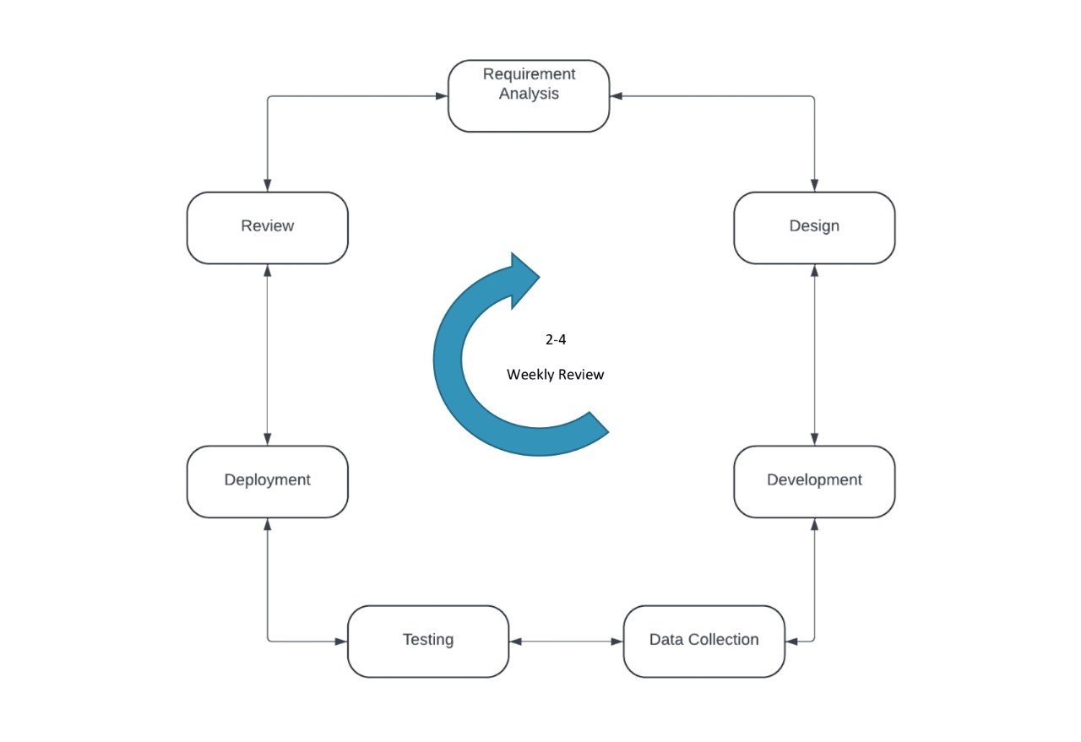

Figure 1.1: Agile methodology

## 1.8 Tools and Technologies

For development of our **Mualij** app, we will be using the following tools.

**IDE:**

• Visual Studio code

**Technologies**:

Front-end/Client Side:

• Flutter

Back-end/Server Side:

• Dart

Database:

• Firebase

## 1.9 Team Members Individual Tasks/Work Division

Project tasks should be equally divided and specified in this section. Individual tasks of team members should be identified in the form of table, as given below.

|  |  |
| --- | --- |
| **Team Member Name** | **Tasks** |
| Abdul Haseeb | Documentation, Design and Application Development |
| Zain Ali | Documentation, Design and Application Development |
| Umar Waris | Documentation, Design and Application Testing |
| Table 1.2: Work Division | |

## 1.10 Data Gathering Approach

For this project, we gather data from healthcare providers, and other sources to understand current challenges in knowledge sharing between healthcare professionals, and creating the AI. We propose introducing this system to enhance accessibility and improve doctors’ engagement. Data collection includes acquiring dataset for the AI model. Additionally, we conduct surveys and feedback collection to refine the system post-development. To rank healthcare providers, we gather customer feedback through comments for sentiment analysis, dynamically ranking providers based on user feedback [5].

## 1.11 Timeline/Gantt chart

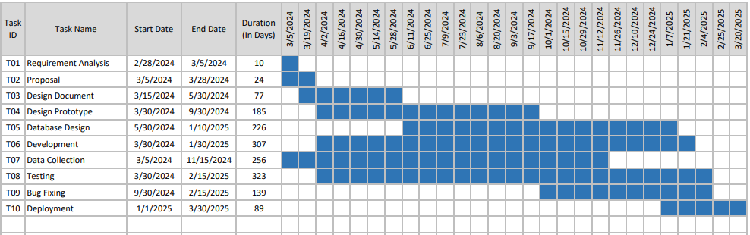

## 1.12 References

## 

|  |  |
| --- | --- |
| [1] | H. James, "Enhancing the Educational Landscape for Advanced Practice Nurses.," *Journal of International Social Research 16,* p. 105, 2023. |
| [2] | M. a. C. S. Allamanis, "Why, when, and what: analyzing stack overflow questions by topic, type, and code.," *10th Working conference on mining software repositories (MSR),* pp. pp. 53-56, 2013. |
| [3] | T. K. S. R. F. P. S. H. a. V. C. Gaziano, "Cardiovascular disease," *Disease Control Priorities in Developing Countries,* vol. 2nd edition, 2006. |
| [4] | L. K. M. P. X. a. B. R. Cao, "A framework for adapting agile development methodologies," *European Journal of Information Systems,* vol. 18, no. 4, pp. 332-343, 2009. |
| [5] | D. P. a. W. Maalej, "User feedback in the appstore: An empirical study," *21st IEEE International Requirements Engineering Conference (RE), Rio de Janeiro, Brazil,,* pp. 125-134, 2013. |