الف)

Nslookup => 10.10.34.36

Ping.eu => 104.244.42.129

به دلیل اینکه ما در آسیا هستیم و سایت ping.eu در اروپا سرور های در دسترس برای هر منطقه متفاوت است، علاوه بر این، سرور های تویتر برای ما فیلتر است اما در اروپا فیلتر نیست، در نتیجه آی پی های فوق نیز باهم متفاوت است.

ب)

10.10.34.36 => 100% loss

104.244.42.129 => 0% loss

پ)

10.10.34.36

1 1 ms 1 ms 5 ms 192.168.1.1

2 107 ms 87 ms 67 ms 10.255.255.255

3 49 ms 34 ms 34 ms 10.234.193.17

4 57 ms 41 ms 34 ms 10.234.199.18

5 54 ms 48 ms 45 ms 10.7.124.1

6 * * * Request timed out.

7 219 ms 357 ms 183 ms 93.118.125.41

8 * * * Request timed out.

9 37 ms 35 ms 36 ms 10.22.26.57

10 36 ms 35 ms 35 ms 80.210.16.70

11 37 ms 37 ms 36 ms 78.39.161.238

12 37 ms 36 ms 37 ms 185.57.202.242

13 55 ms 40 ms 48 ms 185.57.202.229

14 * * * Request timed out.

15 * * * Request timed out.

16 * * * Request timed out.

17 * * * Request timed out.

18 * * * Request timed out.

104.244.42.129

1 2 ms 1 ms 1 ms 192.168.1.1

2 34 ms 33 ms 33 ms 10.255.255.255

3 34 ms 33 ms 34 ms 10.234.193.17

4 35 ms 43 ms 34 ms 10.234.193.9

5 * * * Request timed out.

6 36 ms 35 ms 35 ms 10.234.199.10

7 47 ms 35 ms 64 ms 10.234.198.121

8 37 ms 36 ms 38 ms 10.202.6.30

9 37 ms 36 ms 37 ms 10.21.211.20

10 35 ms 37 ms 36 ms 10.21.211.20

11 104 ms 102 ms 102 ms et-10-0-6-0.ffttr6.frankfurt.opentransit.net [193.251.154.203]

12 105 ms 103 ms 103 ms et-1-0-8-0.ffttr7.frankfurt.opentransit.net [193.251.131.35]

13 110 ms 108 ms 108 ms ntteurope-4.gw.opentransit.net [193.251.247.156]

14 113 ms 107 ms 110 ms ae-3.r20.frnkge13.de.bb.gin.ntt.net [129.250.6.33]

15 111 ms 109 ms 110 ms ae-4.r00.frnkge07.de.bb.gin.ntt.net [129.250.4.77]

16 120 ms 118 ms 117 ms 213.198.82.214

17 343 ms 166 ms 119 ms 104.244.42.129

ج)

|  |  |  |  |  |
| --- | --- | --- | --- | --- |
| owner | location | local/global | Address | Row |
| {ME} | {home} | local | 192.168.1.1 | 1 |
|  |  | local | 10.255.255.255 | 2 |
|  |  | local | 10.234.193.17 | 3 |
|  |  | local | 10.234.199.18 | 4 |
|  |  | local | 10.7.124.1 | 5 |
| Telecommunication Company of Tehran | tehran | global | 93.118.125.41 | 6 |
|  |  | local | 10.22.26.57 | 7 |
| Telecommunication Company of Kermanshah | tehran | global | 80.210.16.70 | 8 |
| Information Technology Company (ITC) | tehran | global | 78.39.161.238 | 9 |
| Information Technology Company (ITC) | tehran | global | 185.57.202.242 | 10 |
| Google LLC | us/ Mountain View | global | 185.57.202.229 | 11 |

|  |  |  |  |  |
| --- | --- | --- | --- | --- |
| owner | location | local/global | Address | Row |
| {ME} | {home} | local | 192.168.1.1 | 1 |
|  |  | local | 10.255.255.255 | 2 |
|  |  | local | 10.234.193.17 | 3 |
|  |  | local | 10.234.193.9 | 4 |
|  |  | local | 10.234.199.10 | 5 |
|  |  | local | 10.234.198.121 | 6 |
|  |  | local | 10.202.6.30 | 7 |
|  |  | local | 10.21.211.20 | 8 |
| France Telecom | Frankfurt | global | 193.251.154.203 | 9 |
| France Telecom | Frankfurt | global | 193.251.131.35 | 10 |
| France Telecom | Paris | global | 193.251.247.156 | 11 |
| NTT America, Inc. | us/ Englewood | global | 129.250.6.33 | 13 |
| NTT America, Inc. | us/ Englewood | global | 129.250.4.77 | 14 |
| NTTEO DE frankfurt facility | Europe/Berlin | global | 213.198.82.214 | 15 |
| Twitter Inc. | America/Los_Angeles | global | 104.244.42.129 | 16 |

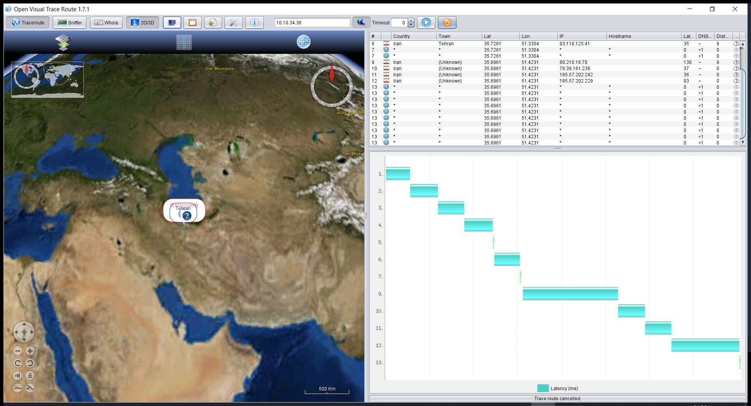

10.10.34.36

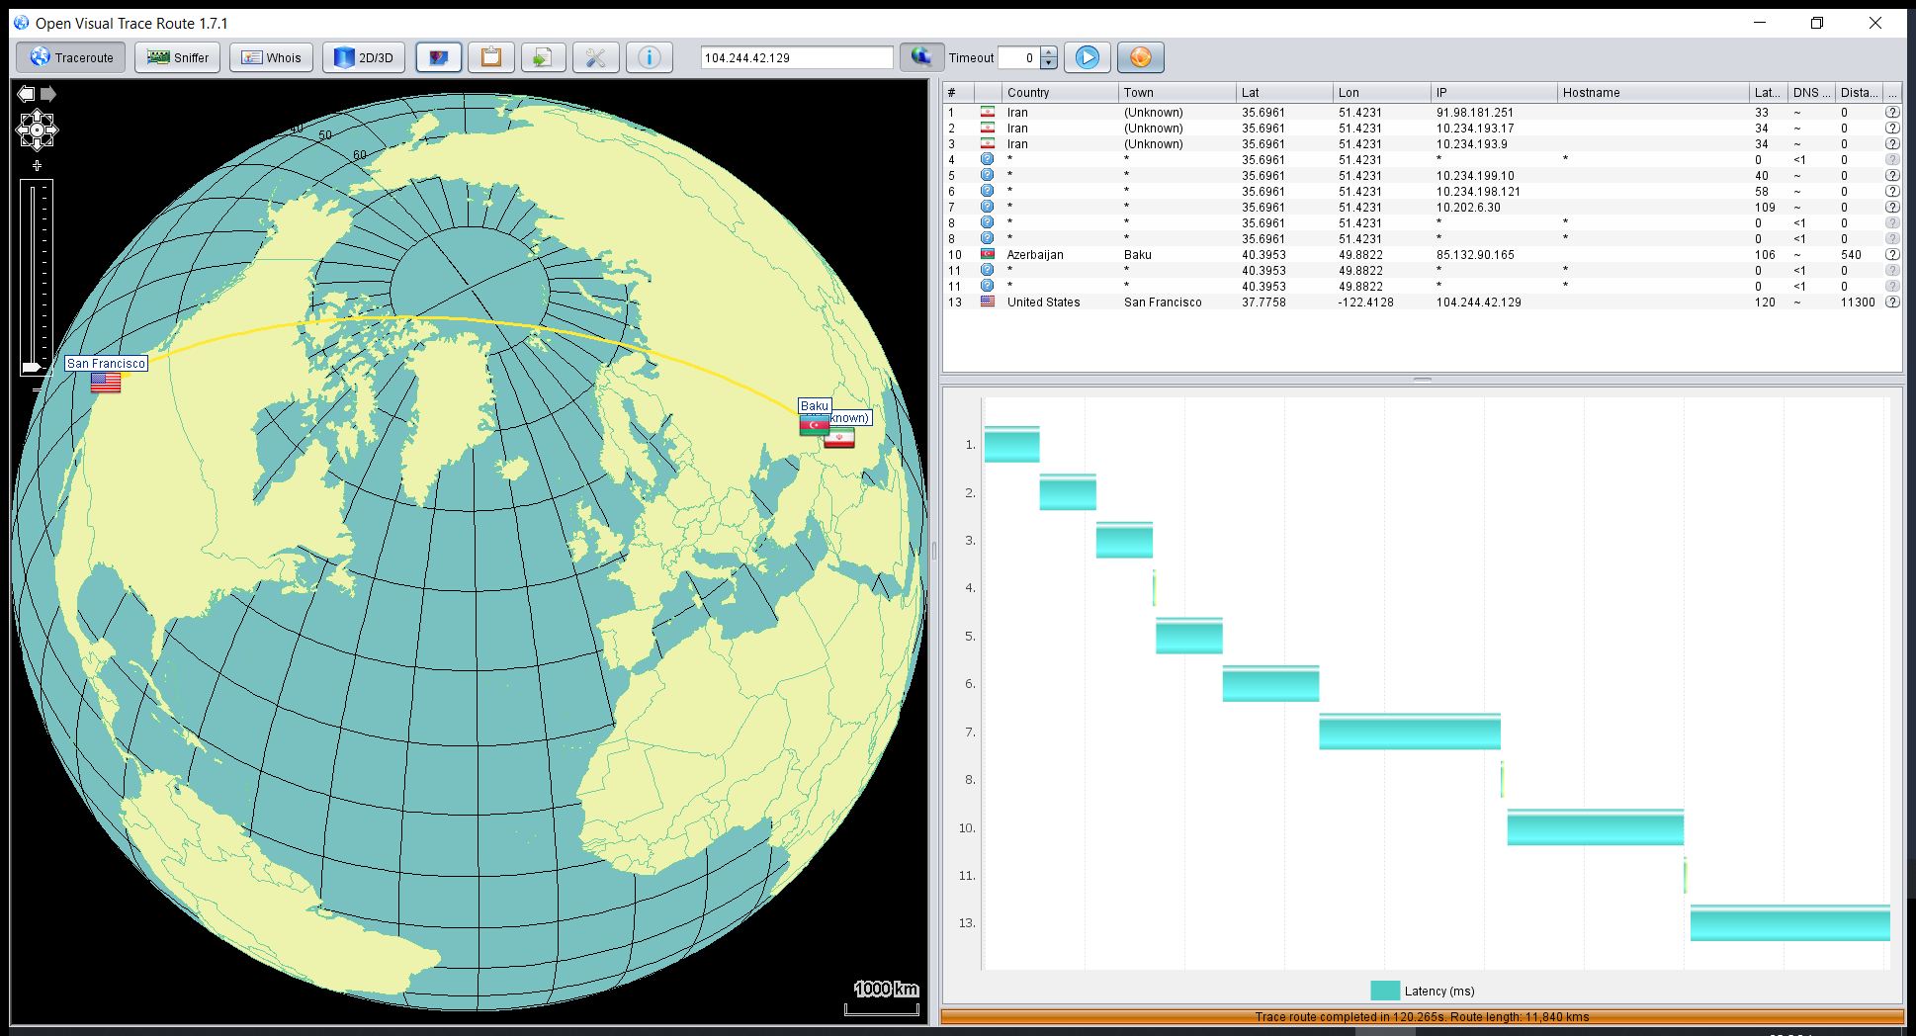

104.244.42.129