BARBERSHOP
BOOKING MANAGEMENT
SYSTEM
Software Requirements and System Design
A working draft for the group project
Project information | Details
Project title | Barbershop Booking Management System
Course / section | [Add course and section]
Group members | [Add group members]
Instructor | [Add instructor name]
Date | October 2026 — update before submission
Version | Static HTML/CSS/JavaScript frontend with Supabase backend plan

Update the bracketed fields and confirm the requirements with your group before submitting.

1. Project overview
The project is a web-based system for managing barbershop appointments. Customers can check the service menu, choose a barber, and book a time instead of relying only on walk-ins. Staff have their own pages to manage the daily schedule, while the owner can maintain the service menu, staff accounts, pay settings, expenses, and reports.

1.1 Problem being addressed
Walk-in queues and manual appointment records can make it hard for customers to estimate waiting time. A barber may also receive overlapping appointments if the schedule is written in different places. The system is meant to make available times easier to check and keep bookings in one shared record. These points describe the project problem; they should not be presented as survey results unless the group collects real evidence from a shop.

1.2 Objectives
- Let customers view the service menu, prices, and barber profiles before booking.
- Let customers make, review, and manage their own appointments.
- Give Admins tools for booking management, barber availability, and review moderation.
- Give barbers a view of their own assignments, booking status, and earnings estimates.
- Give the owner a place to manage staff roles, service prices, pay rules, expenses, and basic reports.
- Use database rules to prevent double-booking and restrict private records by role.

1.3 Scope
Included in the first version | Not included in the first version
Public homepage and service menu | Online payment processing
Customer sign-up and login | SMS appointment reminders
Availability checking and booking records | Automatic email campaigns
Customer, Admin, Barber, and Owner dashboards | Tax filing or full accounting
Reviews, staff permissions, and earnings estimates | Automatic bank transfers or formal payroll
Shared Supabase database with RLS policies | A production support/helpdesk system

The project is being prepared as a school prototype. Before it is used by a real shop, the group still needs to connect and test its own Supabase project, review permissions, and confirm the features with the instructor or shop representative.

2. Functional requirements
ID | Requirement
FR-01 | The public homepage shall show shop information, services, prices, and booking entry points.
FR-02 | The services section shall show each active service name, description, price, and estimated duration.
FR-03 | The barber section shall show active barber display names, short bios, and specialties.
FR-04 | A visitor shall be able to create a customer account and sign in using Supabase Auth.
FR-05 | Public sign-up shall assign the Customer role by default. Users shall not choose an Admin, Barber, or Owner role during registration.
FR-06 | A customer shall select a service, barber, date, and open appointment time.
FR-07 | The system shall calculate booking duration and price from saved service data, not values trusted from the browser.
FR-08 | The system shall reject overlapping active appointments for the same barber.
FR-09 | A customer shall view only their own appointment records and may cancel a confirmed booking at least 24 hours before it starts.
FR-10 | A customer may submit one review for an appointment marked Completed.
FR-11 | An Admin may view and update appointments, maintain barber availability, and approve or reject reviews.
FR-12 | A Barber may view assigned appointments, update the allowed work status, and see personal earnings estimates.
FR-13 | The Owner may add/edit services, assign roles, edit barber profiles, configure pay settings, record expenses, and view summary figures.
FR-14 | The website shall show only approved reviews on the public page.
FR-15 | The system shall store appointment status and booking timestamps so the group can test and demonstrate the workflow.

2.1 Booking status meanings
Status | Meaning
Confirmed | The booking is saved and waiting for the customer to arrive.
Checked in | Staff has confirmed that the customer arrived.
In service | The barber has started the service.
Completed | The service is finished; this can count toward review and earnings calculations.
Cancelled | The booking was cancelled and no longer blocks the barber’s time.
No-show | The customer did not arrive for the booking.

3. Non-functional requirements
Requirement | Description
NFR-01 — Usability | The website should use clear labels, readable text, and a layout that works on phones and desktop screens.
NFR-02 — Security | Private records shall be protected by Supabase Row Level Security (RLS) and role checks in database functions.
NFR-03 — Privacy | Customers shall not read another customer’s bookings or private contact details.
NFR-04 — Reliability | The database shall check availability again when a booking is saved, not rely only on the displayed time slots.
NFR-05 — Maintainability | Text, styling, and behavior should be separated into HTML, CSS, and JavaScript files with comments explaining common edits.
NFR-06 — Compatibility | The interface should work in current versions of Chrome, Edge, and other modern browsers.
NFR-07 — Data integrity | Service duration, price, appointment start/end, and status values shall be validated before a record is saved.
NFR-08 — Availability | The static website should be served through HTTPS. Database backups and Supabase plan limits should be considered before real use.

4. Role and permission matrix
Action | Customer | Admin | Barber | Owner
Browse service menu | Yes | Yes | Yes | Yes
Book appointment | Own only | Operational help | No | May assist
View appointments | Own only | All shop bookings | Assigned only | All shop bookings
Update appointment status | Cancel own by rule | Yes | Assigned only | Yes
Edit barber availability | No | Yes | View own schedule | Yes
Submit customer review | Completed visits | No | No | No
Moderate reviews | No | Yes | No | Yes
View earnings/pay settings | No | No | Own only | All staff
Edit services/prices | No | No | No | Yes
View expenses and business totals | No | Operational booking counts | No | Yes
Assign roles | No | No | No | Yes

Role permissions are enforced in the database as well as the interface. Hiding a button alone is not a security control. The owner account is initialized manually in Supabase, and staff roles are assigned from the Owner dashboard after accounts are verified.

5. Engineering flowchart — booking process
The booking flow starts at the public homepage and continues through customer sign-in, input checks, the availability check, and the database save. Yellow diamonds are decision points. Red boxes show error or alternate outcomes. The database also rejects a collision if two customers try to book the same slot at nearly the same time.
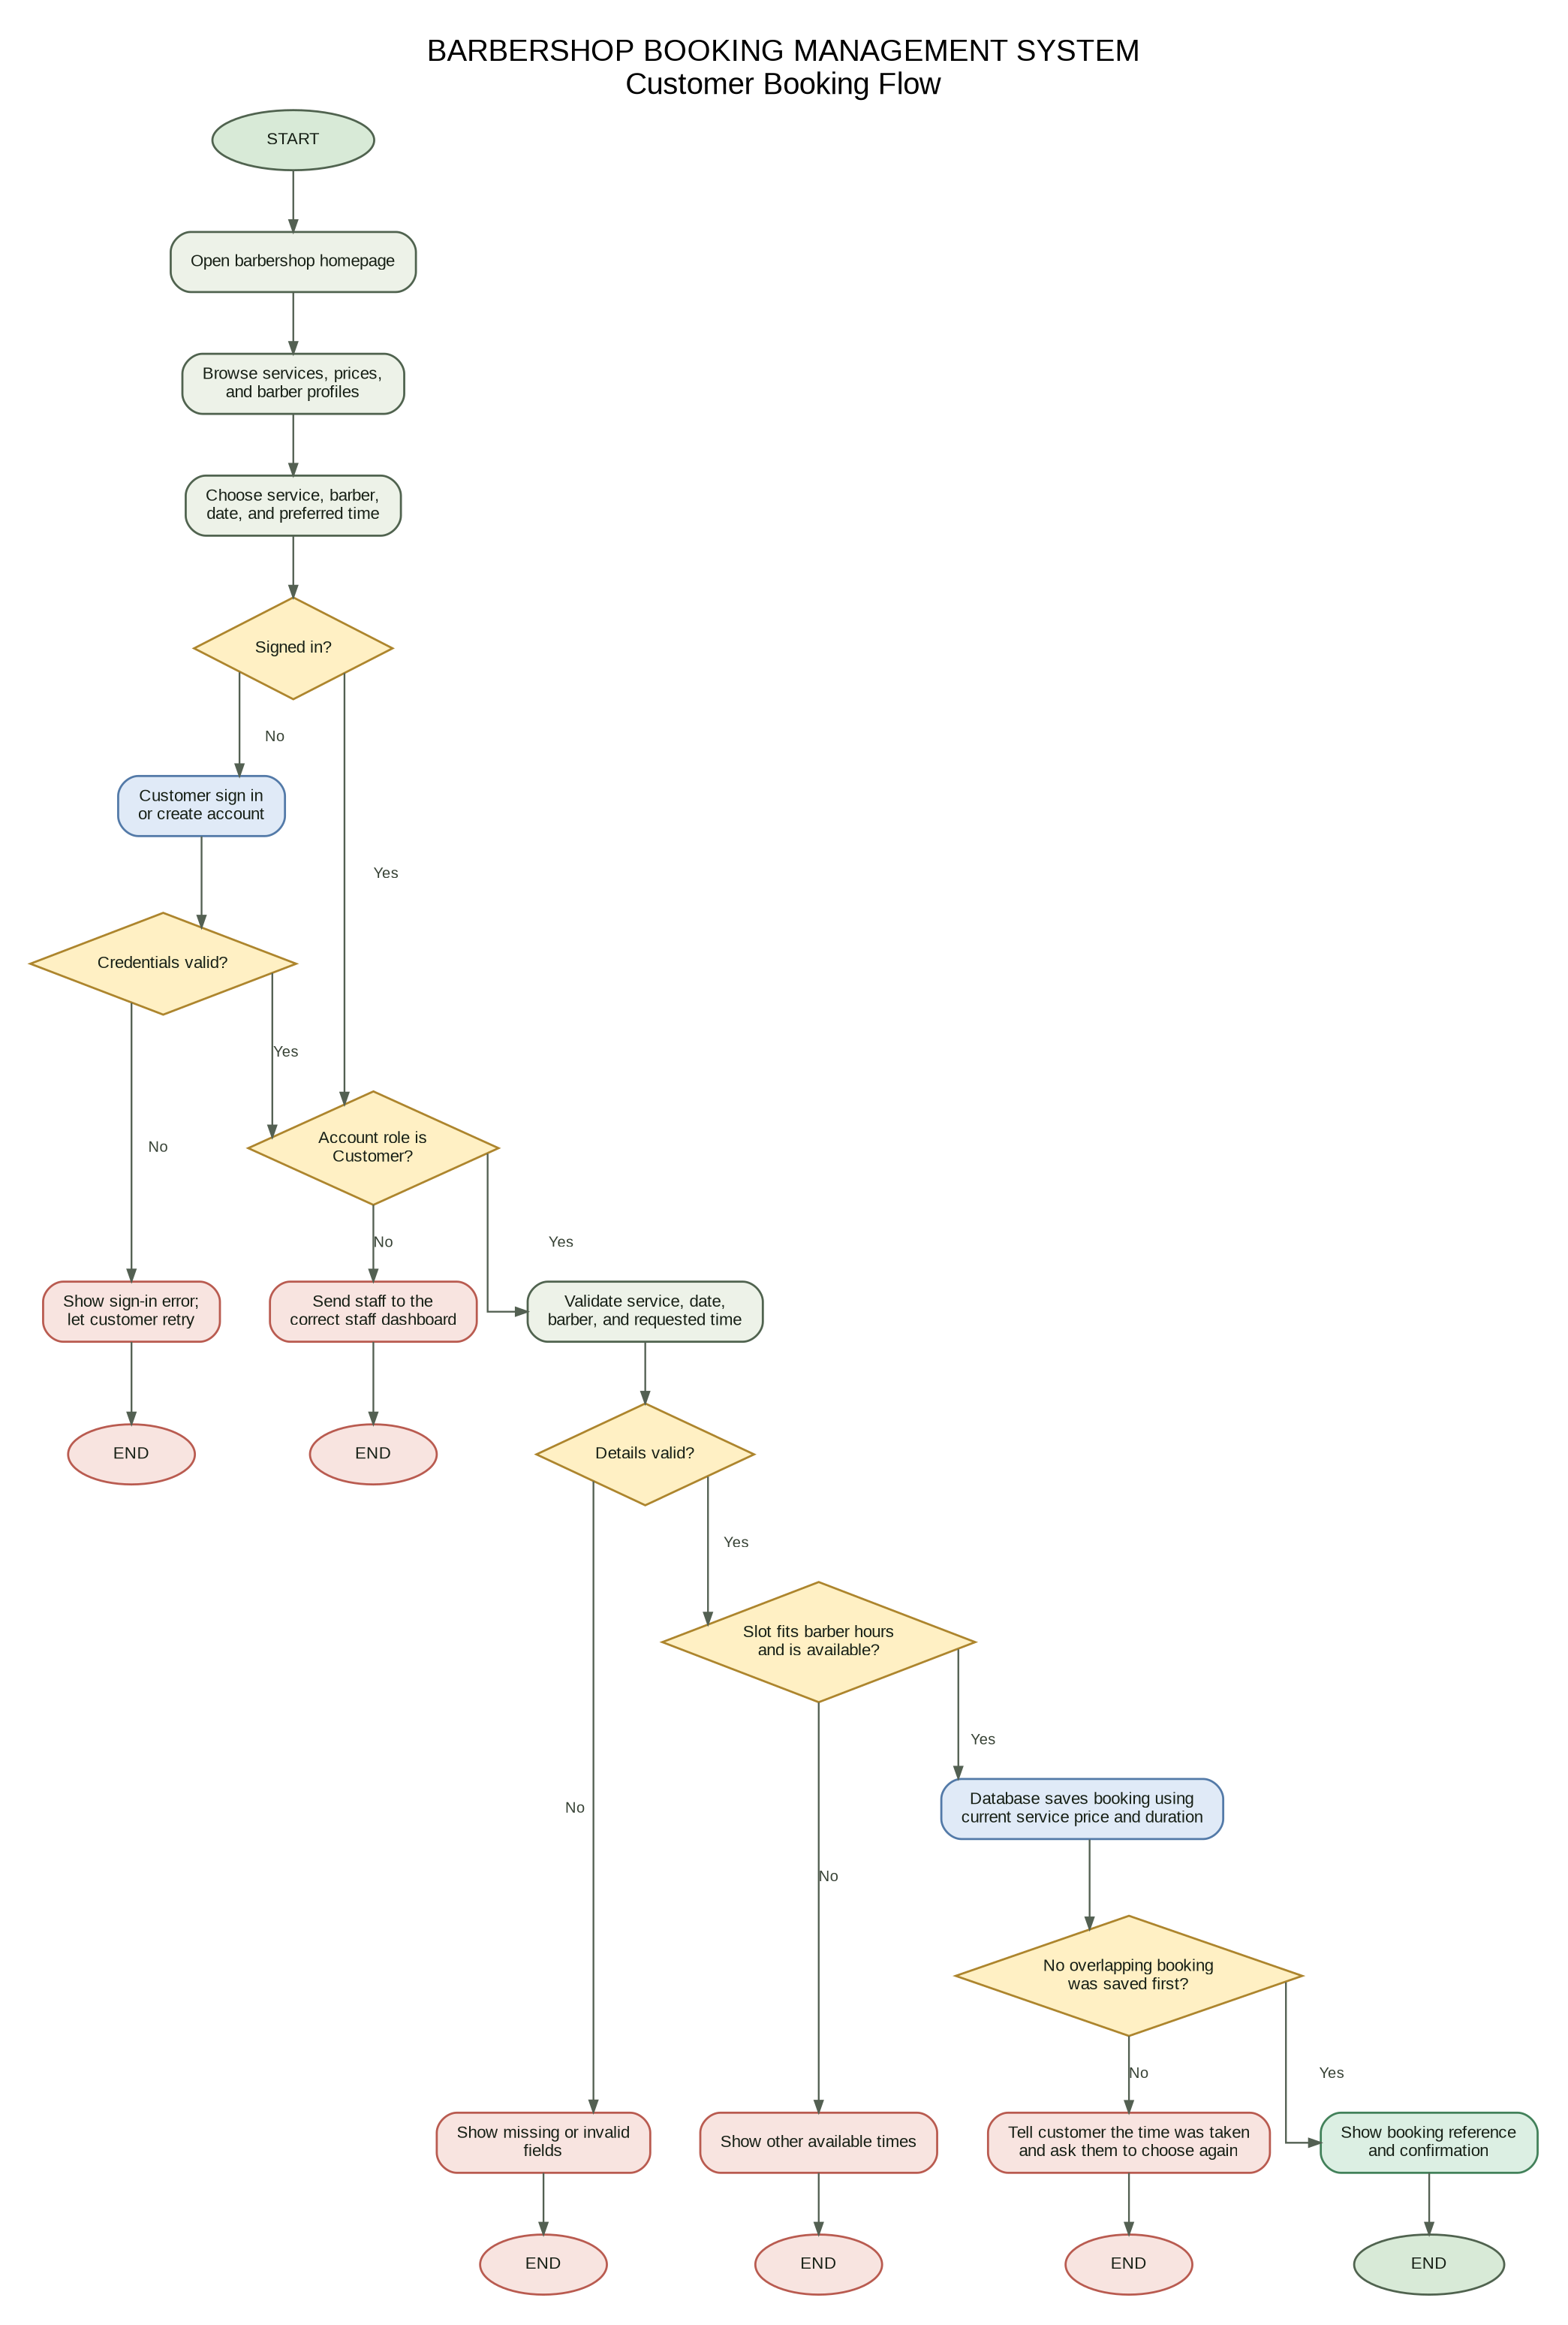
Figure 1. Customer booking flow. The full-resolution PNG and SVG are included in the diagrams folder.

6. Login and role routing
Customers use the customer login entry point, while employees and the owner use the staff login entry point. Both use Supabase Auth, but the profile role decides the dashboard. The chosen login type is checked so a customer account cannot enter the staff area by using the staff button.
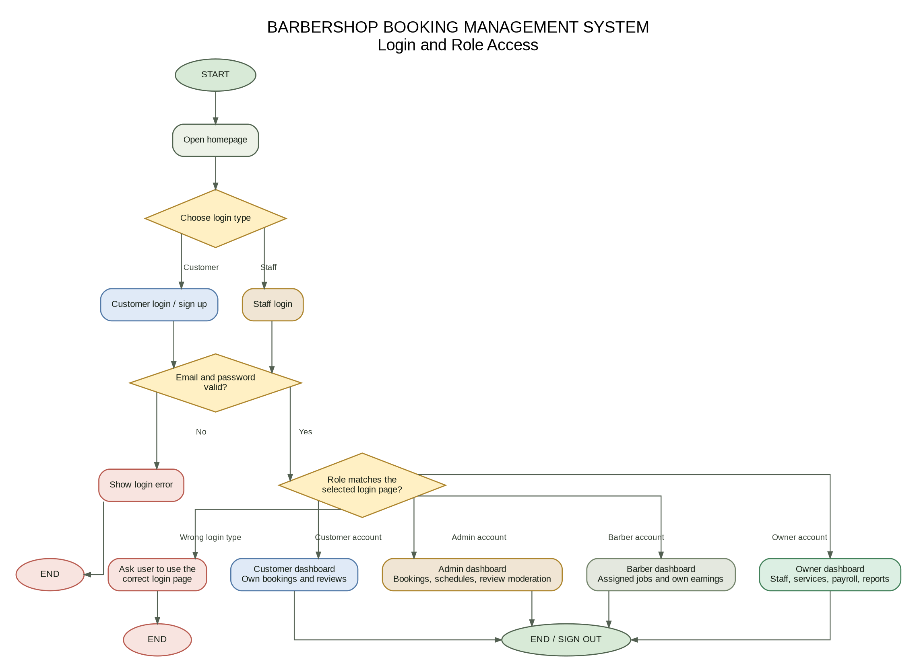
Figure 2. Login and role-access flowchart.

7. Use-case overview
The diagram summarizes the main actions for each type of user. It is a high-level view, so the detailed requirements and permissions table should still be used when building or testing individual features.
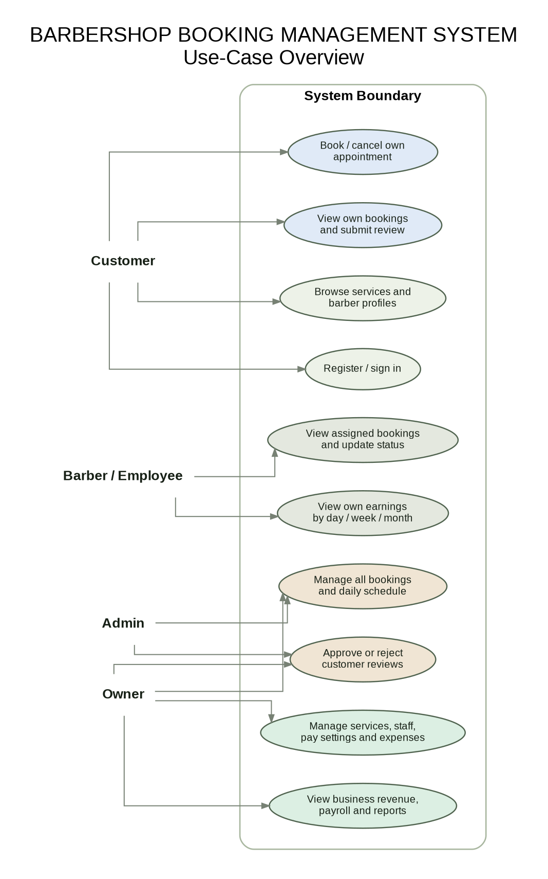
Figure 3. Use-case overview for Customer, Admin, Barber, and Owner.

8. Database design
Table | Purpose
profiles | Account name, email, phone, and role. Linked to Supabase Auth. Public sign-up always starts as Customer.
services | Service name, description, price, duration, ordering, and whether new bookings are allowed.
barbers | Public barber name, bio, specialties, active status, and the linked staff profile.
barber_availability | Work day, opening/closing times, break times, and whether a barber works that day.
pay_settings | Pay type, monthly base pay, commission rate, and last update time. A barber can read only their own settings.
appointments | Customer, service, barber, start/end time, price at booking, notes, and status.
reviews | Appointment, customer, rating, review text, approval status, and moderation details.
expenses | Date, category, description, amount, and the owner account that entered the record.

8.1 Booking integrity
- The booking function reads price and duration from the Services table.
- The available-time function checks work hours, breaks, and current appointments.
- A PostgreSQL exclusion constraint prevents overlapping active appointments for the same barber.
- RLS policies limit what each logged-in role can read or change.
- Customers create bookings and cancel bookings through validated database functions rather than direct table updates.

8.2 Main technologies
Part | Technology | Reason
Page structure | HTML | Defines the public page, forms, and dashboard containers.
Design | CSS | Controls the colors, layout, responsive behavior, and component styling.
Interactions | JavaScript + DOM | Handles forms, button clicks, dashboard rendering, and live requests.
Authentication / database | Supabase Auth + PostgreSQL | Keeps accounts and shared booking records online, with RLS policies.
Publishing | GitHub Pages | Serves the static frontend over HTTPS from the repository.

9. Setup, testing, and maintenance

9.1 Deployment steps
- Create a Supabase project and run the full SQL file in supabase/schema.sql.
- Paste the Supabase Project URL and public publishable/anon key into js/config.js. Never put a service_role key in browser code.
- Copy index.html and the css, js, supabase, diagrams, docs, and tests folders to the root of the GitHub repository.
- Enable GitHub Pages from main / (root), then add the published URL to Supabase Authentication URL Configuration.
- Register an account for the shop owner and assign it the owner role using the SQL command in README.md.
- Register test accounts for Customer, Admin, and Barber; assign roles from the Owner dashboard and test each one.

9.2 Test cases to run
Test | Expected result | Status at document preparation
Open homepage without Supabase config | Preview notice appears and sample cards load. | Static check only; confirm in browser
Register a customer | Supabase Auth account and customer profile are created. | Not yet tested against your project
Book an open time | Appointment is saved and shown to the customer and assigned barber. | Not yet tested against your project
Book the same time again | Database rejects the overlapping appointment. | Not yet tested against your project
Attempt to read another customer booking | RLS does not return the record. | Not yet tested against your project
Change a role as a customer | Database rejects the action. | Not yet tested against your project
Submit review for a non-completed visit | Database rejects the review. | Not yet tested against your project
Admin/Owner edit an availability row | New slot list respects saved opening hours and breaks. | Not yet tested against your project

9.3 Current limitations
At the time this document was prepared, the new frontend files and SQL setup are packaged, but they have not been connected to the group’s own Supabase project or verified on the final public URL. The group must run the live tests before claiming those features work. Email delivery depends on the Supabase Auth settings. The first version does not process payments, send reminders, calculate taxes, or replace a formal payroll/accounting tool.

9.4 References
- Supabase JavaScript client: https://supabase.com/docs/reference/javascript/installing
- Supabase Row Level Security: https://supabase.com/docs/guides/database/postgres/row-level-security
- GitHub Pages quickstart: https://docs.github.com/en/pages/quickstart

