PART B — GROUP PROJECT PROGRESS

Project status snapshot
This draft reflects the files and work prepared for the HTML/CSS/JavaScript + Supabase version. Please revise the status based on what your group has actually pushed, configured, and tested. Do not mark the live database or deployment as complete until you have verified it yourselves.
Project Component | Status | Brief description / current progress
Problem / Project Definition | In Progress | The problem and target users are defined. Any interview findings or statistics still need real evidence.
Requirements Gathering | In Progress | The user roles and main features are listed. Confirm them with the group and instructor.
Functional Requirements | Completed (Draft) | Customer booking, admin scheduling, barber earnings, and owner controls are documented.
Non-Functional Requirements | Completed (Draft) | Usability, privacy, access control, and booking integrity requirements are documented.
Software / System Design | Completed (Draft) | Booking flowchart, role flowchart, and use-case diagram are prepared for review.
UI/UX / Prototype | In Progress | Static frontend files are prepared. Check the pages on the actual laptop and phone sizes.
Database / Data Design | In Progress | Supabase schema is prepared, but it still needs to run in your own Supabase project.
Development / Coding | In Progress | HTML, CSS, JavaScript, and database functions are drafted. Connect the Supabase keys and finish integration.
Testing | In Progress | Static checks can be run locally. Live authentication, booking, and RLS tests remain.
Documentation | In Progress | SRS, flowcharts, report, setup guide, and presentation are prepared. Check them against your real project state.

Overall project completion
Estimated completion: 35% (working estimate). The requirements, diagrams, first frontend, and initial database schema are prepared. The percentage stays below half because the Supabase project has not yet been connected and verified, the public deployment has not been confirmed, and several end-to-end tests still need to be completed.

Current group challenges
The main challenge is connecting the new static website to a real Supabase project and checking that the account roles match the database policies. The team also needs to confirm opening hours, service prices, barber information, and pay rules instead of leaving sample values in place. Until those details are checked, the homepage can be previewed but the live booking workflow should not be described as finished.
Our plan is to run the SQL setup, configure the public Supabase key in js/config.js, publish the files from the repository root, and test one account for each role. We will fix any failed permission or booking tests before sharing the link with other people.

Next three major tasks
- Create the Supabase project and run supabase/schema.sql; check that tables and functions are created without errors.
- Put the static site files at the GitHub repository root, add the Supabase URL and public key, and publish through GitHub Pages.
- Test registration, booking conflicts, customer privacy, Admin schedule changes, Barber earnings, Owner controls, and review approval; record the real results.

PART C — INDIVIDUAL CONTRIBUTION
Use this section as a draft only. Keep the parts that describe your own work and change anything that does not match what you personally did.

1. What have you personally contributed?
I helped plan the Barbershop Booking Management System and organize what each user role should be able to do. I worked through the booking process from the homepage to choosing a service, barber, date, and time, and helped define the separate areas for customers, Admins, barbers, and the owner. I also reviewed the flowcharts and the move toward a simpler HTML, CSS, and JavaScript frontend with Supabase for shared accounts and bookings.

2. Evidence of your contribution
Evidence: the engineering flowchart and role-access diagram in the project diagrams folder. They show the steps of booking, the decision points, and how a signed-in user is sent to the correct dashboard. Add a screenshot of the actual files, code, or GitHub commit you worked on before submitting.
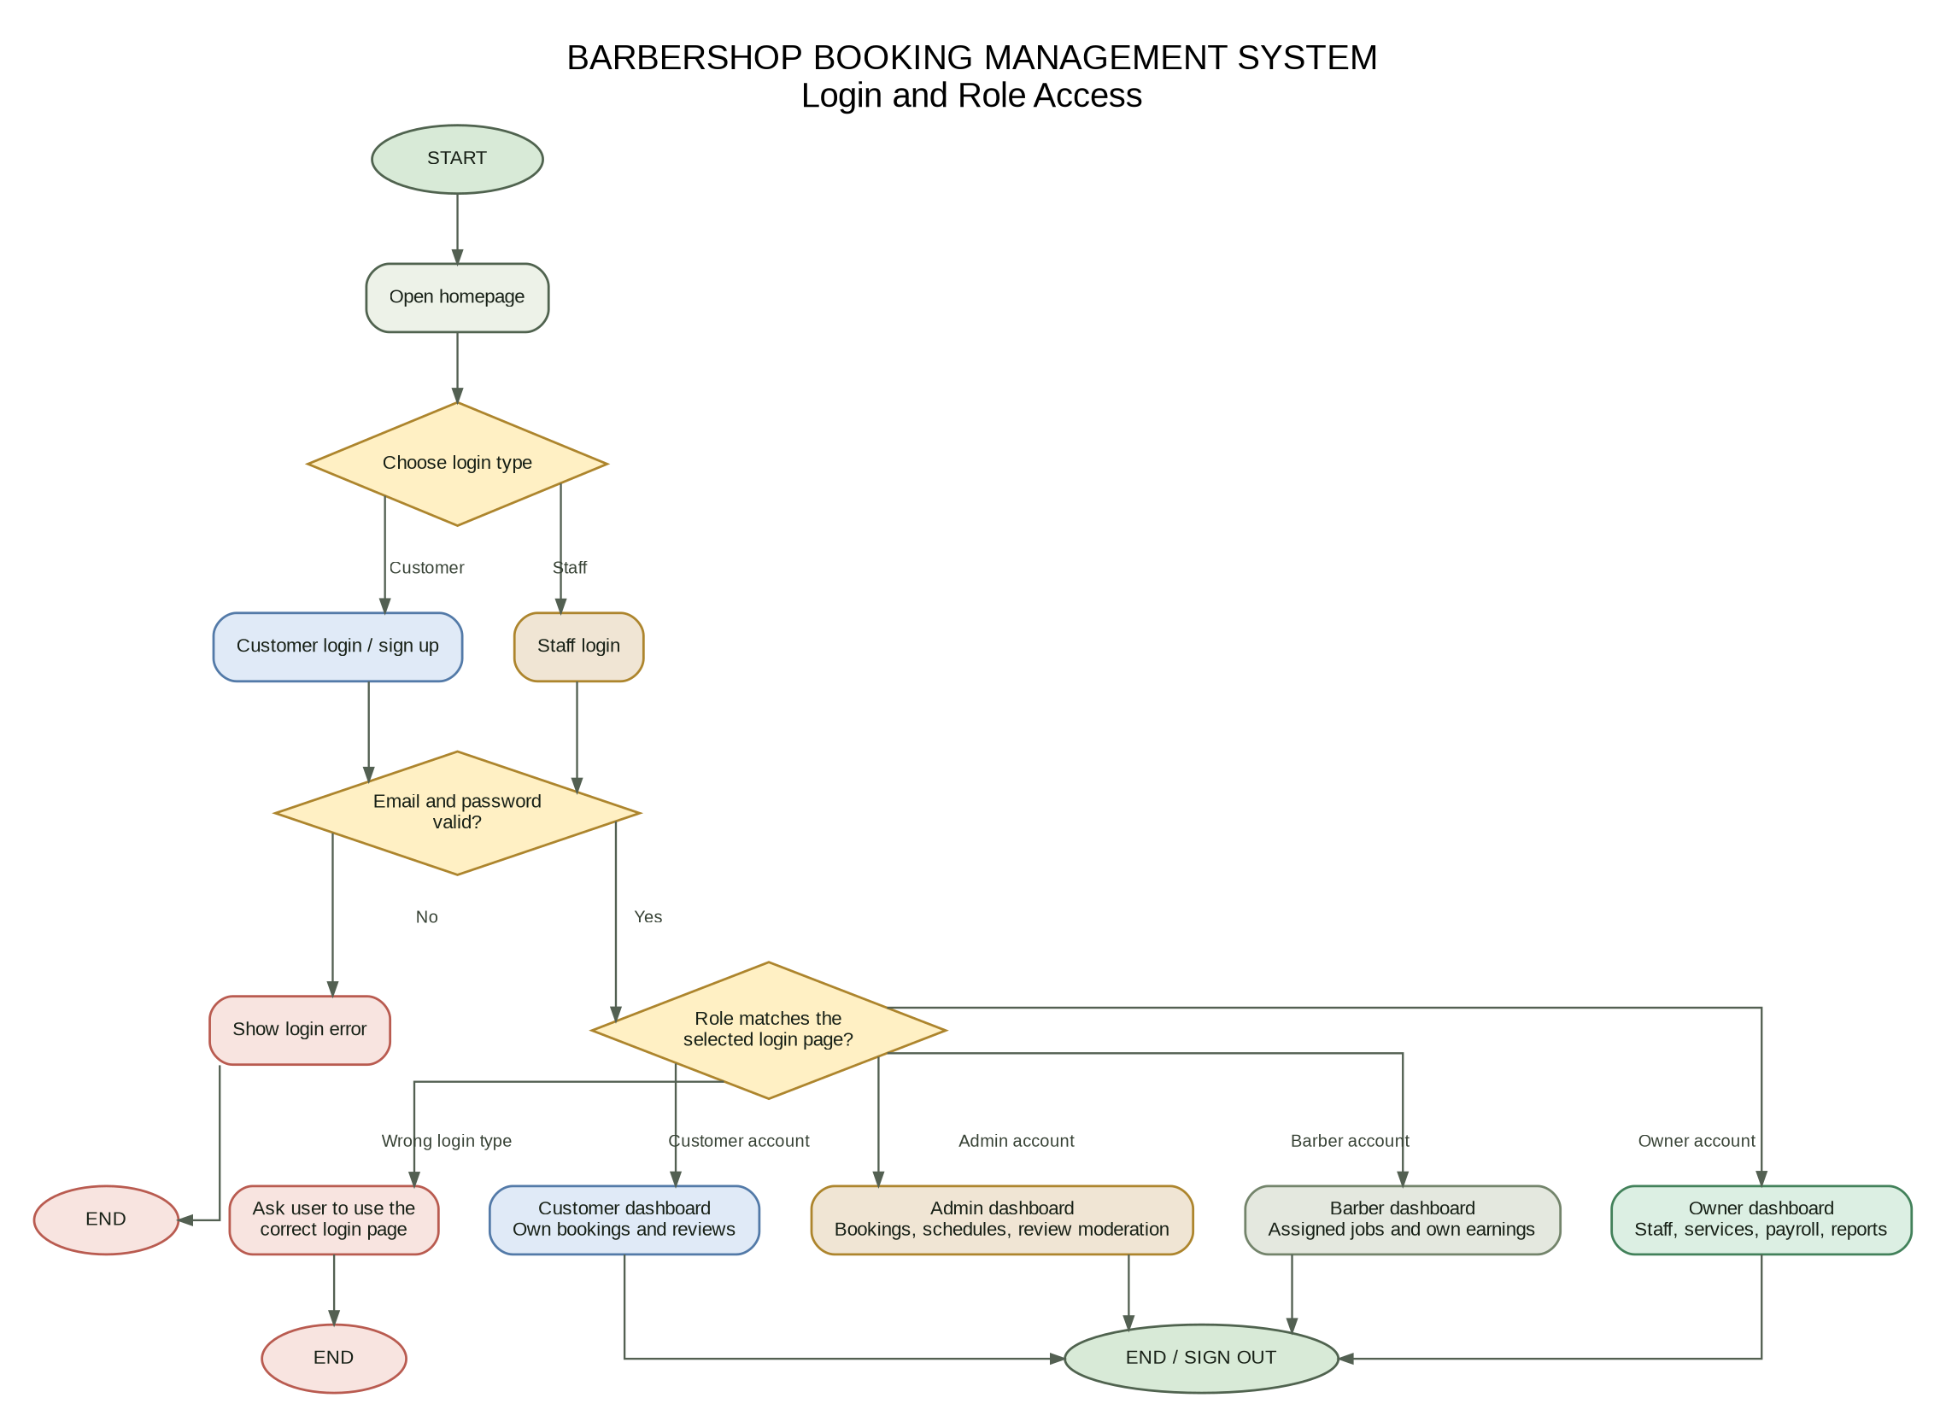
Evidence caption: Role-access flowchart prepared for the project. It shows the separate login choices and the account-role check before each dashboard opens.

3. What are you currently working on?
I am working on getting the static website ready to connect with Supabase and be published from our GitHub repository. The page structure, CSS, JavaScript, SQL schema, and setup notes are prepared, but the website still needs our own Supabase URL and public key. The remaining work is to run the SQL, publish the files from the repository root, and test the live flow.

4. What will you personally work on next?
My next task is to configure Supabase and help test a full booking from a customer account. After that, I will check the Admin, Barber, and Owner dashboards and record screenshots of the results. I plan to finish these checks before our next progress review.

5. Individual reflection (3–5 sentences)
I think we should prioritize the connection between the website and database before adding more features. The booking process must save the right information and stop two customers from taking the same barber’s time slot. We also need to check the permissions for every role, especially customer details and employee earnings. Once those tests pass, it will be easier to prepare the final screenshots and presentation.

PART D — INSTRUCTOR ASSISTANCE
YES. Our group would like to confirm whether publishing the static HTML/CSS/JavaScript frontend with Supabase as the backend satisfies the project requirements. We would also appreciate guidance on how many live end-to-end test cases and how much evidence are expected for the final submission.
Before submitting, replace the draft status and percentage if your real project progress is different. Add your own name, course details, group members, and the required evidence from your own GitHub activity or testing.

