B.
Barbershop Booking
Management System
Software Requirements, System Design, Prototype and Test Plan
Document: Project documentation and Software Requirements Specification (SRS)
Version: 1.0 working draft
Prepared: 20 October 2026
Project type: Computer Engineering / Software Design
Implementation: Python standard-library HTTP server + SQLite + responsive HTML/CSS/JavaScript

Document status
Working draft prepared from the current design and local prototype. Review the assumptions with the group and instructor before submission.

Document guide
This document describes the first working version of the proposed Barbershop Booking Management System. It brings the requirements, role permissions, booking rules, diagrams, database structure, prototype behavior, tests, and next steps into one reference. The prototype is intentionally small enough to run locally for demonstration.
Section | Contents
1–3 | Overview, problem definition, objectives, scope, and assumptions
4–7 | Actors, role permissions, functional requirements, non-functional requirements, and use cases
8–11 | Booking rules, system architecture, engineering diagrams, UI screens, and database design
12–15 | API overview, test plan, setup instructions, limitations and project status

Important distinction
A local prototype is not a production system. The smoke tests listed later validate selected behavior only; they do not establish full security, usability, payroll, or business acceptance.

1. Executive overview
The Barbershop Booking Management System is a proposed web application intended to reduce avoidable queues and uncertain waiting times by allowing customers to review services, select a barber, and request an appointment online. It also gives the shop a consistent way to manage appointments and role-specific work.
The first version provides a public homepage, service and barber listings, customer registration/login, a shared staff login for admins/barbers/owner, booking availability checks, appointment status updates, review moderation, barber earnings estimates, owner-configured pay rules, expense entry, and basic business summary metrics. The application runs locally and stores demo data in SQLite.

2. Problem definition

2.1 Problem statement
Barbershops that rely mainly on walk-in customers or informal messaging can face queues, unclear waiting times, schedule conflicts, and extra work when staff must manually answer booking questions. Customers may not know which barber is available, how long a service will take, or whether a preferred time is already occupied. Staff also need a clear view of assigned appointments and the owner needs a summary of business activity.

2.2 Project objectives
- Provide a simple public page showing services, prices, estimated duration, senior barber profiles, opening hours, and approved reviews.
- Allow customers to create accounts, book an available time, view personal appointment history, and cancel within the stated policy.
- Prevent overlapping appointments for the same barber and ensure each booking fits the selected service duration and opening hours.
- Provide role-appropriate workflows for admins, barbers/employees, and the owner.
- Give barbers an estimate of earnings based on completed services and pay rules configured by the owner.
- Provide design artifacts and test cases that a student group can review, demonstrate, and extend.

2.3 Success criteria
Criterion | Target for the prototype
Usable booking path | A customer can select an active service, barber, future date and time, then receive a booking reference.
Conflict prevention | A second overlapping appointment for the same barber is rejected.
Role separation | Customers, barbers, admins and owner receive distinct permitted views and endpoint access.
Traceable visit | A booking can progress through check-in, in-service, and completed states.
Review control | A customer can review a completed personal appointment; a review remains unpublished until approved.
Demonstrability | The team can run the application locally and repeat the documented test cases.

3. System scope and assumptions

3.1 Included in the first version
- Public homepage, services/prices, senior barber profiles, and approved customer reviews.
- Customer account registration and customer login.
- Shared staff login with server-side role checks for admin, barber/employee, and owner accounts.
- Appointment creation, viewing, customer cancellation, overlap checks, opening-hour checks, and status updates.
- Review submission after completion and moderation by admin/owner.
- Barber earnings estimates by day, week, month, and all time.
- Owner pay-rule and service/price configuration, expense entry, and summary reports.
- SQLite storage, database schema, diagram files, setup instructions, and a basic smoke-test plan.

3.2 Excluded or deferred
- Online payment processing, refunds, and payment gateway integration.
- Email, SMS, push, or messaging-app confirmations.
- Calendar-provider integration and automatic reminders.
- Inventory, product sales, accounting exports, tax reporting, and actual payroll disbursement.
- Password reset, two-factor authentication, persistent production sessions, backups, HTTPS deployment, and advanced audit tooling.
- Multi-branch or multiple-location support.

3.3 Assumptions requiring group validation
Assumption used in the demo | Must be validated before final submission
Opening: Tuesday–Sunday, 9:00 AM–6:00 PM; closed Mondays. | Confirm real business hours, holidays, barber shifts, and breaks.
Appointment starts on 30-minute increments. | Confirm whether actual service start times can be more flexible.
Customer cancellation requires at least 24 hours’ notice. | Confirm the business cancellation/rescheduling policy.
Booking is confirmed automatically when the time is available. | Confirm whether staff must approve every request first.
Barber commission rates are sample values. | Replace with approved compensation rules; do not treat sample values as payroll advice.
Prices, service names, and sample employees are illustrative. | Replace with authorized shop information before any real-world use.
Each active barber is treated as available during the shop hours except for overlapping appointments. | Design individual shifts, breaks, leave, and barber-specific block-out times if needed.

4. Stakeholders and role permissions
The system uses four roles. Customers use the customer portal. Admins, barbers/employees, and the owner use the shared staff portal; the server reads the role attached to the account and applies the corresponding permissions.
Capability | Customer | Admin | Barber / Employee | Owner
Browse public services, prices, barbers, approved reviews | Yes | Yes | Yes | Yes
Create booking | Own bookings | Operational assistance only | No | Operationally allowed
View booking records | Own only | All, for operations | Assigned only | All
Cancel booking | Own, subject to policy | Authorized operations | No; status actions only | Yes
Update visit status | No | Yes | Assigned appointments only | Yes
Submit review | Own completed appointment | No | No | No
Moderate reviews | No | Yes | No | Yes
Manage services and prices | No | No in base design | No | Yes
View own earnings | No | No | Yes | Yes
View all barber earnings / payroll estimates | No | No | No | Yes
Record business expenses | No | No | No | Yes
Access business revenue summary | No | Limited operational metrics | No | Yes
Change pay rules | No | No | No | Yes
Manage user roles and business settings | No | Limited staff operations | No | Yes

Least-privilege rule
Data access is limited to what each role needs. A barber cannot retrieve another barber’s earnings; a customer cannot retrieve someone else’s appointment; and owner-only endpoints reject other roles.

5. Functional requirements
The following requirements describe intended system behavior. “Implemented in demo” means the behavior exists in the included local prototype; it does not imply production readiness.
ID | Requirement | Description | Prototype status
FR-01 | Public homepage | The system shall display barbershop information, booking entry point, opening hours, and navigation. | Implemented
FR-02 | Service catalogue | The system shall list active services, prices, and estimated duration. | Implemented
FR-03 | Barber profiles | The system shall show active barbers, specialties, bios, and average approved ratings. | Implemented
FR-04 | Customer registration | The system shall allow a customer to create an account with name, email, username, and password. | Implemented
FR-05 | Separate login portals | The system shall distinguish the customer portal from the staff portal and verify the assigned role. | Implemented
FR-06 | Customer booking | A signed-in customer shall select service, barber, date, time, and optional note. | Implemented
FR-07 | Availability checking | The system shall validate opening hours, service duration, barber existence, and time overlap. | Implemented
FR-08 | Booking reference | A successful booking shall be stored and return a unique reference code. | Implemented
FR-09 | Personal booking history | A customer shall see only their own appointments. | Implemented
FR-10 | Cancellation policy | A customer may cancel only their own active appointment and only at least 24 hours in advance. | Implemented
FR-11 | Staff booking overview | Admin/owner can view all bookings; a barber can view assigned bookings only. | Implemented
FR-12 | Visit status lifecycle | Authorized staff shall move bookings through confirmed, checked-in, in-service, and completed states. | Implemented
FR-13 | Customer review | A customer may submit one review for their own completed appointment. | Implemented
FR-14 | Review moderation | Admin/owner shall approve or remove pending reviews; only approved reviews appear publicly. | Implemented
FR-15 | Barber earnings | A barber shall see personal earnings estimates for day, week, month, and all-time commission. | Implemented
FR-16 | Owner pay rules | Owner can configure fixed, commission, or hybrid pay rules for a barber. | Implemented
FR-17 | Business expenses | Owner can record dated expenses with category, amount, and description. | Implemented
FR-18 | Business summary | Owner shall see completed service revenue, recorded expenses, and revenue less recorded expenses. | Implemented
FR-19 | Service administration | Owner shall add, update, activate, or deactivate services and pricing. | Implemented
FR-20 | Audit records | Important creation/status/moderation events shall be written to an audit table where currently wired. | Partial
FR-21 | Notifications | System shall send real email/SMS appointment confirmations and reminders. | Deferred
FR-22 | Password recovery | Users shall recover an account securely if a password is forgotten. | Deferred
FR-23 | Payroll disbursement | The system shall pay employees and produce legally compliant payslips. | Out of scope
FR-24 | Staff account management | The owner shall create admin/barber accounts and activate or deactivate their access. | Implemented

6. Non-functional requirements
ID | Quality attribute | Requirement
NFR-01 | Security | Check identity and role on server-side routes; never rely on hidden buttons alone. Demo: role checks are implemented, but production hardening is incomplete.
NFR-02 | Privacy | Customers see personal bookings only; barbers see assigned bookings and personal earnings; cross-employee payroll is owner-only.
NFR-03 | Usability | Use plain labels, visible validation messages, clear statuses, and responsive layouts for common laptop/mobile widths.
NFR-04 | Reliability | Store core records in SQLite, use foreign keys, and reject invalid booking overlaps.
NFR-05 | Performance | Support a small local demonstration without external API dependencies. No production load target has been measured.
NFR-06 | Maintainability | Separate UI (`index.html`), server/API (`app.py`), and database schema (`database_schema.sql`).
NFR-07 | Compatibility | Designed for modern browsers. Browser-based visual QA should be completed on the group’s target devices.
NFR-08 | Data integrity | Use unique usernames, unique booking references, unique review per appointment, constrained role/status values, and appointment indexes.
NFR-09 | Auditability | Retain key appointment/review actions where wired. Add comprehensive audit records before production.
NFR-10 | Recoverability | Database backup and restore procedures are not automated in this demo; define them before deployment.

7. Primary use cases
ID | Use case | Actor | Main flow | Outcome
UC-01 | Browse the shop | Anyone | Open homepage, view active services/prices and barber profiles, and read approved reviews. | Public pages load with available information.
UC-02 | Register / sign in | Customer or staff | User chooses the correct portal and enters credentials or registers as a customer. | Valid account opens a role-appropriate dashboard; invalid credentials show an error.
UC-03 | Book a service | Customer | Choose service, barber, future date/time, and optional note; submit the request. | If all validations pass, the appointment is saved with a unique reference.
UC-04 | Manage a visit | Admin / assigned barber / owner | View booking and progress its status according to permission and allowed transition. | Authorized state transition is saved; invalid transition is rejected.
UC-05 | Review a service | Customer | Choose a completed personal appointment, rating, and optional comment. | One pending review is saved; it is not published before approval.
UC-06 | Moderate reviews | Admin / owner | Review pending submissions and approve or remove them. | Approved reviews are publicly listed; removed reviews are not.
UC-07 | View earnings | Barber | Open earnings dashboard. | Only the signed-in barber’s estimate is returned.
UC-08 | Manage shop finances | Owner | Review summary, record an expense, set pay rules and adjust services/prices. | Owner-only settings are saved; non-owner attempts are rejected.

8. Booking rules and status model

8.1 Rules
- Only active services and active barber accounts can be selected for new bookings.
- Appointments must be in the future and must fall within the configured shop opening window.
- A service’s end time equals its start time plus the service duration; it cannot extend past closing time.
- Two active appointments for the same barber cannot overlap. A cancelled or no-show appointment does not block the time.
- A customer can view and cancel only their own appointments. In the prototype, customer cancellation requires 24 hours’ notice.
- Barbers can change the status of assigned appointments only. Admin and owner can manage all appointment records.
- Only completed appointments can be reviewed, one review per appointment. Reviews remain pending until an admin or owner approves them.
- Commission estimates apply to completed services; booking value is not counted as earnings before service completion.

8.2 Appointment status transitions
Current status | Allowed next status(es) | Who can normally apply it
Pending | Confirmed, Cancelled | Admin / owner
Confirmed | Checked in, Cancelled, No-show | Admin / owner; assigned barber can check in / mark no-show; customer cancellation policy applies
Checked in | In service, Cancelled | Admin / owner; assigned barber can start service
In service | Completed | Admin / owner or assigned barber
Completed | No further changes in base prototype | Terminal
Cancelled / No-show | No further changes in base prototype | Terminal

Prototype test note
The local demo allows authorized staff to progress an appointment through the lifecycle without enforcing the actual arrival time. A real deployment should prevent premature completion or add an explicit authorized override.

9. System architecture
The application is a small three-part local design: a browser interface, a Python HTTP server with JSON endpoints and role checks, and a SQLite database. The HTML contains presentation and interaction logic; app.py validates requests, applies permission and booking rules, and reads/writes the database.
Layer | Component | Responsibilities
Presentation | app/index.html | Homepage, login portals, booking forms, role dashboards, tables, validation messages, responsive layout.
Application | app/app.py | Login/registration, password hashing, session cookie, JSON API, role authorization, overlap checks, status transitions, earnings estimates.
Data | database_schema.sql / app/barbershop.db | Users, services, barber profiles, appointments, reviews, expenses, and audit records with constraints/indexes.

9.1 Main API endpoints
Method / route | Access | Purpose
GET /api/services | Public | List active services and price/duration.
GET /api/barbers | Public | List active barber profiles and approved-review averages.
GET /api/reviews | Public | List approved reviews only.
POST /api/register | Public customer registration | Create customer account and sign in.
POST /api/login | Public; portal-aware | Authenticate customer or staff account.
POST /api/logout | Signed-in account | End current demo session.
GET /api/me | Any current session | Return signed-in account and role.
GET /api/appointments | Signed in | Return role-scoped appointment list.
POST /api/appointments | Customer | Validate and create an appointment.
POST /api/appointments/action | Role-dependent | Change an appointment status or cancel under policy.
POST /api/reviews | Customer | Submit review for a completed personal appointment.
GET /api/reviews/pending | Admin / owner | List reviews awaiting moderation.
POST /api/reviews/action | Admin / owner | Approve or remove a pending review.
GET /api/dashboard | Signed in | Return role-appropriate summary metrics.
GET /api/payroll | Owner | Return employee-level earnings estimates.
POST /api/pay-rules | Owner | Set employee pay method, commission, and monthly base.
POST /api/expenses | Owner | Record a business expense.
POST /api/services/manage | Owner | Add or update a service and its active state.
GET /api/staff | Owner | List admin and barber accounts including active status.
POST /api/staff/manage | Owner | Create admin/barber accounts or activate/deactivate an account.

10. Engineering flowcharts and use-case diagram
The booking flow uses oval terminators for start/end, rectangles for actions, diamonds for decisions, and arrows for order and feedback loops. The role-access flow shows the customer portal and shared staff portal routing to permission-based dashboards.
Symbol | Meaning | Example in this project
Oval | Start or end | Start the booking process or finish after review.
Rectangle / rounded rectangle | Action or process | Browse services, validate details, save a booking.
Diamond | Decision with branches | Is the customer signed in? Is the barber available?
Arrow | Sequence or return path | Continue to the next step or retry after an error.

The diagrams are ordered from the detailed customer booking flow, to the role-access workflow, to the high-level use-case overview. Together they describe how the public website, authenticated dashboards and booking operations fit together.
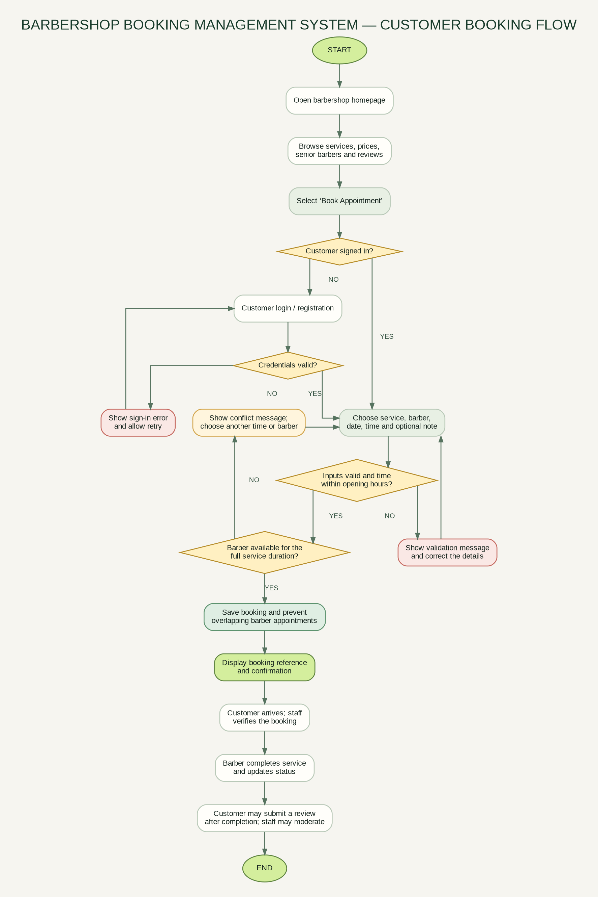
Figure 1. Customer booking engineering flowchart. Diamond shapes identify signed-in state, credential validity, input validation, and barber availability decisions.

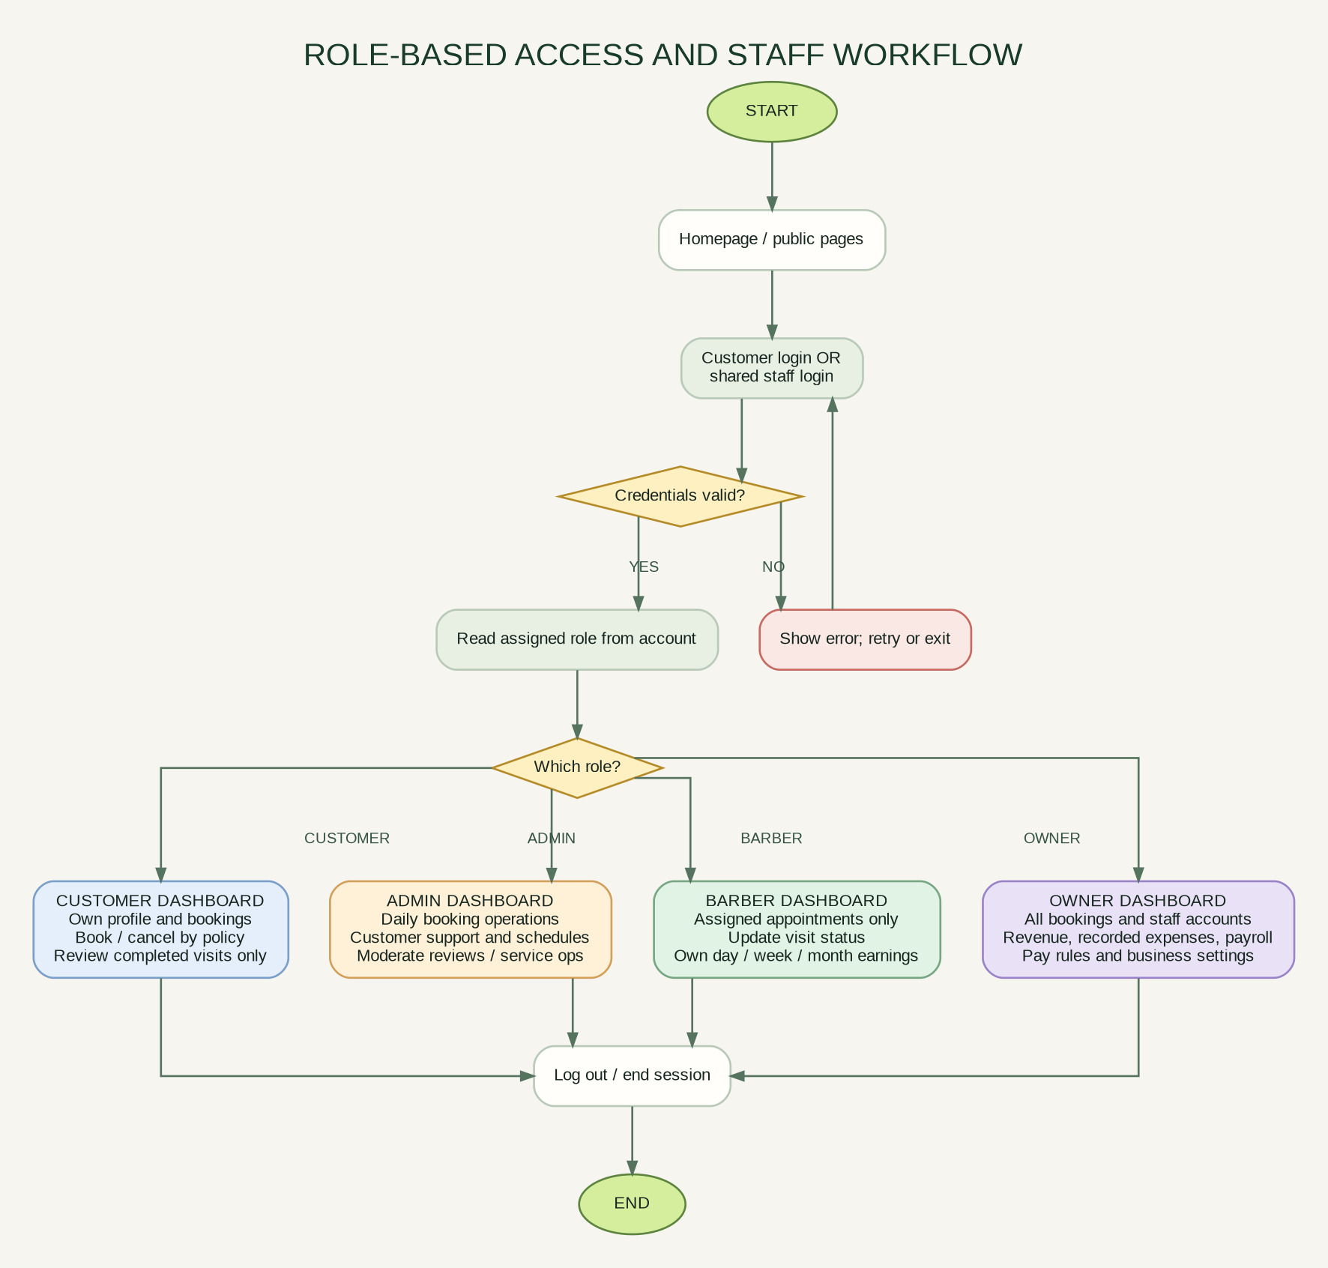
Figure 2. Role-based access workflow showing customer, admin, barber/employee, and owner dashboards.

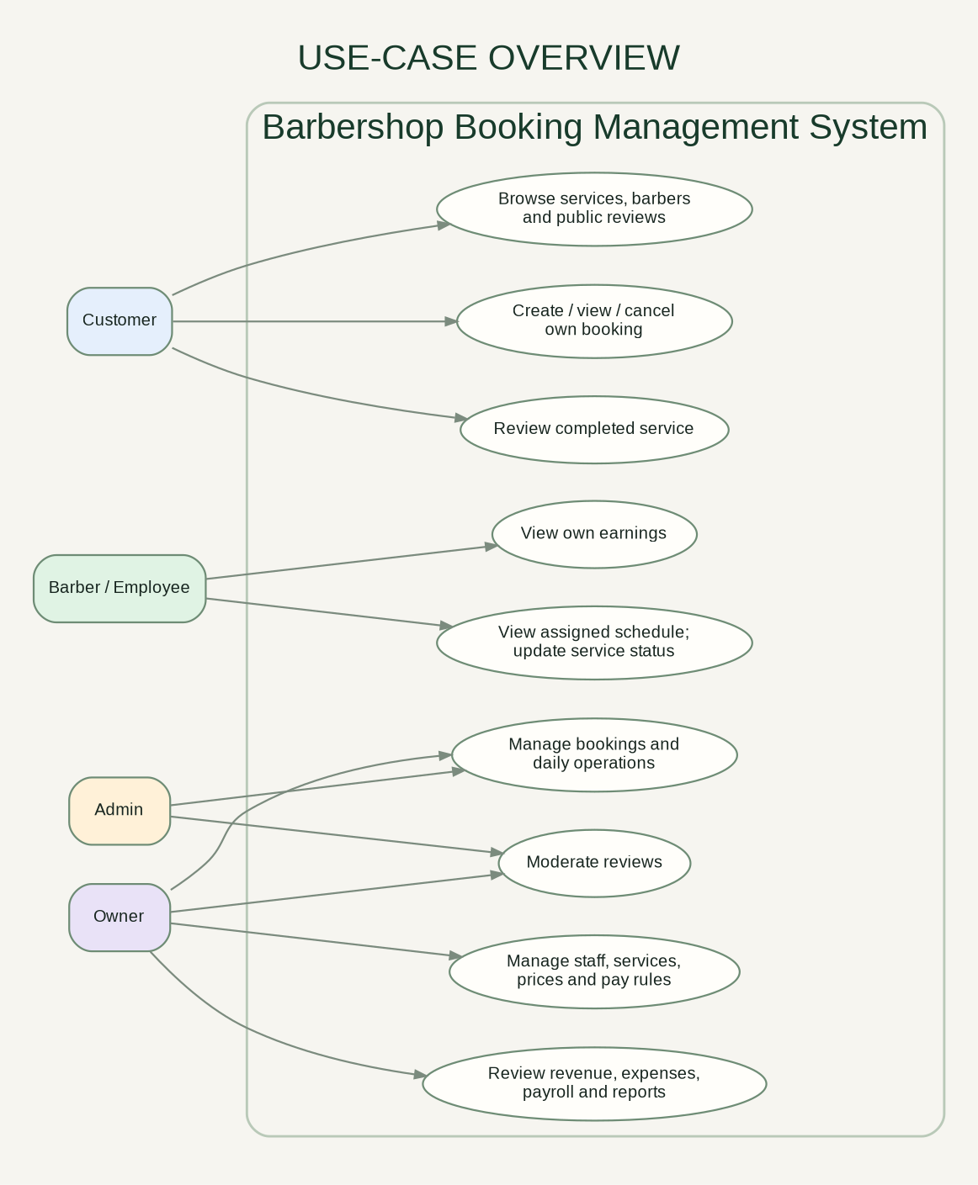
Figure 3. High-level use-case overview for the four system actors.

11. UI/UX screen inventory
Screen / view | Primary elements | Visibility / behavior
Public homepage | Brand header, booking CTA, shop hours, navigation, public sections. | Anyone; directs customers toward booking and sign-in.
Services catalogue | Service name, short description, price, duration, Book button. | Anyone; owner manages active services/prices.
Senior barbers | Name, title, specialty, short bio, approved review rating. | Anyone; booking CTA can preselect a barber.
Approved reviews | Star rating, customer name, service, barber, comment. | Public users only see approved entries.
Customer portal | Login or registration. | Customer accounts only.
Staff portal | Shared login for admin, barber and owner. | Server decides role; users cannot choose a higher role from UI.
Customer dashboard | Metrics, booking form, personal booking table, completed-visit review form. | Own appointments only; 24-hour cancellation policy.
Barber dashboard | Assigned appointment table, status actions, earnings metrics. | Assigned bookings and personal earnings only.
Admin dashboard | All booking operations and pending-review moderation. | No owner-only pay rules, expenses, or cross-employee payroll.
Owner dashboard | Booking overview, summary metrics, expenses, pay rules, payroll estimates, staff accounts, service management and moderation. | Owner-only operations.

12. Database design
The database uses SQLite and enables foreign-key enforcement. Monetary values are stored as integer cents to reduce floating-point rounding issues; API responses convert amounts to decimal currency values for display. The SQL file is included separately for review.
Table | Purpose and key data | Relationships / constraints
users | id, username, password_hash, full_name, email, role, is_active, created_at | Username unique; role restricted to customer/admin/barber/owner.
services | id, name, description, price_cents, duration_minutes, is_active | Name unique; non-negative price; positive duration.
barber_profiles | user_id, title, specialty, commission_percent, monthly_base_cents, pay_method, bio | One profile per barber; user_id references users.
appointments | reference_code, customer_id, barber_id, service_id, date, start/end time, status, note, timestamps | References customer, barber, and service; reference code unique; status constrained.
reviews | appointment_id, customer_id, barber_id, rating, comment, is_approved, created_at | One review per appointment; rating 1–5; links to user and appointment.
expenses | expense_date, category, description, amount_cents, created_by | Non-negative amount; creator references users.
audit_log | actor_user_id, action, entity_type, entity_id, details, created_at | Tracks selected actions; actor references users.

12.1 Core relationships
- One customer can have many appointments; each appointment has one customer, one barber, and one service.
- One barber user has one barber profile and may be assigned many appointments.
- One completed appointment may have zero or one review.
- The owner can record many expenses; an expense records who created it.
- Audit records can refer to users and identify the entity and action for selected changes.

12.2 Indexes and integrity
The schema includes indexes for barber/date/time lookup, customer booking history, booking status, approved review retrieval, and expense date lookup. Unique constraints protect usernames, non-null emails, service names, booking references, and one review per appointment. A production database should add a robust transaction/concurrency strategy around availability checks if multiple bookings can be created at the same time.

13. Testing and quality assurance
An automated local API smoke-test run against a fresh demo database passed all 19 scripted cases covering authentication, booking conflicts, role permissions, appointment lifecycle, registration, payroll access, service management, expense recording and review moderation. This is not equivalent to a full QA cycle. See `docs/Test_Plan.csv` and `tests/smoke_test.py` for the exact cases and current results. Manual browser checks, user acceptance, and production security testing remain outstanding.
Test area | Passed in smoke-test pass | Still needed
Authentication and portals | Valid customer login; portal mismatch blocked; customer registration. | Password recovery, session timeout, brute-force/rate-limit tests, production cookie and HTTPS review.
Booking logic | Valid booking saved; overlapping slot rejected. | Boundary tests for every service duration, closing time, holidays, concurrent booking requests, schedule exceptions.
Role permissions | Customer blocked from payroll; admin blocked from service changes; barber action path checked. | Systematic endpoint-by-role matrix and attempts to access another user’s records.
Reviews | Review submission after completion, pending-review list, owner approval and public display. | Invalid rating, duplicate review, removal, content policy, large text and HTML/XSS tests.
Payroll and reports | Owner payroll rows returned; owner staff account creation/deactivation and role restrictions checked. | Known test fixtures for each pay type, commission rounding, date boundaries, refunds and approved payroll.
UI / UX | Markup and JavaScript syntax checked. | Manual browser layout test at desktop/mobile widths, keyboard access, screen reader and usability review.
Deployment security | Not a production target. | HTTPS/TLS, CSRF protection, rate limiting, secret management, database backups and deployment review.

14. Local installation and demonstration
- Install Python 3.10 or later. The included app uses only the standard library.
- Extract the project ZIP and open a terminal inside `barbershop_project/app/`.
- Run `python app.py`. The server displays the local URL and demo logins.
- Open `http://127.0.0.1:8000` in a browser on the same computer.
- For API smoke tests, keep the server running and run `python tests/smoke_test.py` from the extracted project root. For a repeatable clean run, stop the server and delete `app/barbershop.db` first.
- Use the Customer login for customer accounts and Staff login for admin, barber, and owner accounts.
- Stop the server with Ctrl+C. The SQLite database is created at `app/barbershop.db`; delete it while the server is stopped to reset the demo data.
Role | Username | Password
Customer | customer | customer123
Admin | admin | admin123
Barber / employee | barber1 | barber123
Barber / employee | barber2 | barber123
Owner | owner | owner123

Demo credentials
These are intentionally public sample accounts for local classroom use. Never reuse these passwords in an internet-facing deployment or place real customer information in the sample database.

15. Security, risks and limitations
Risk / limitation | Current handling | Required action before production
Public demo credentials | Only illustrative sample users are seeded. | Remove sample accounts or force new passwords; do not expose the demo to the internet.
Local sessions | Random opaque session cookie; sessions are in server memory. | Use persistent, expiring server-side sessions with rotation and revocation; add CSRF defense and security review.
Transport security | Server binds to loopback only. | Use HTTPS behind a production server and correctly configured security headers.
Concurrent booking race | Availability is checked before insert. | Make availability and booking creation transaction-safe under concurrent requests; consider a scheduling lock/constraint strategy.
Business policy assumptions | Opening, cancellation and pay rules are demo defaults. | Confirm actual rules with owner, barbers and instructor before finalizing.
Payroll estimates | Simple commission/base calculation from completed services. | Validate agreements, local requirements, rounding, deductions, approvals, and payslip reporting with qualified stakeholders.
Limited audit trail | Audit table exists and some events are logged. | Add audit coverage for all sensitive edits, status changes, account changes and payroll actions.
No real notifications/payment | No email/SMS gateway or payment processing is connected. | Add only if required, with secure provider integration and failure handling.
No stakeholder validation | Requirements are based on the current project conversation and explicit assumptions. | Conduct real interviews or walkthroughs and do not invent findings.

16. Current project progress and next steps
Component | Draft status | Current artifact / progress
Problem / project definition | Completed draft | Problem statement, objectives and scope are documented.
Requirements gathering | In progress | Requirements have been drafted; actual shop rules and stakeholder feedback need validation.
Functional requirements | Completed draft | FR-01 through FR-24 documented, with prototype statuses.
Non-functional requirements | Completed draft | Security, privacy, usability, integrity, performance and recovery needs documented.
Software / system design | Completed draft | Booking flow, role access flow and use-case overview generated.
UI/UX / prototype | Completed prototype | Responsive local HTML interface with customer/staff portals and role dashboards.
Database / data design | Completed draft | SQLite schema and relationships defined.
Development / coding | In progress | Core local app, owner staff account management and role-protected API endpoints implemented.
Testing | In progress | 19 automated API smoke-test cases passed; UI acceptance and production security tests remain.
Documentation | Completed draft | SRS/design document, editable progress report, slides, README and test plan created.

16.1 Next three major tasks
- Review assumptions, scope, opening hours, cancellation policy and pay rules with group members, instructor and a real stakeholder if available.
- Run the local application as each of the four roles, execute the full test plan, record screenshots, and fix user-interface or permission issues found.
- Revise the final diagrams and document to match confirmed feedback, then rehearse the presentation and record remaining limitations honestly.

16.2 Individual contribution statement — editable draft
I contributed to the planning and design of the Barbershop Booking Management System by organizing the proposed booking workflow and defining the customer, admin, barber/employee and owner responsibilities. I prepared the initial engineering flowchart, role-access flow, and use-case overview, and helped structure the requirements for appointment validation, review moderation, and staff earnings. I also assembled the local prototype and documentation artifacts for group review.
Student submission reminder
Use this contribution statement only if it accurately reflects what you personally did and can explain during consultation. Attach a screenshot or commit history that shows your actual work. If any part was completed by a groupmate, revise the statement accordingly.

17. Conclusion
The current bundle establishes a coherent first version of the Barbershop Booking Management System: a documented scope, role rules, actual flowchart decision diamonds, a use-case overview, a structured SQLite schema, a locally runnable prototype, and selected smoke tests. The next important step is validation with the group and instructor. Before the project can be described as complete, the team must run the application on its target devices, test all requirements, resolve open issues, and replace unverified assumptions with approved business rules.

