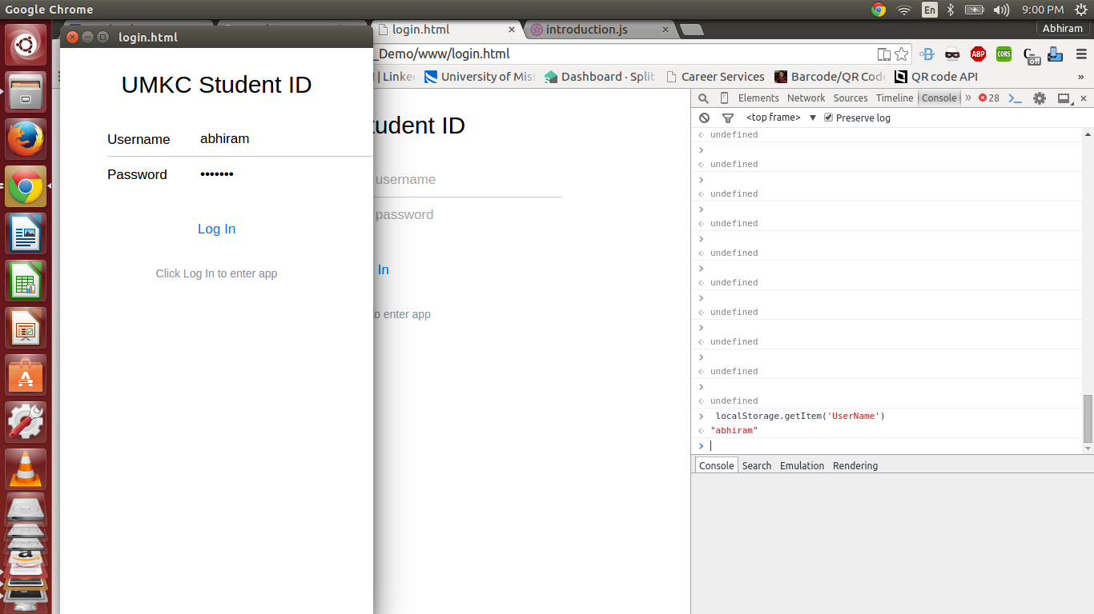

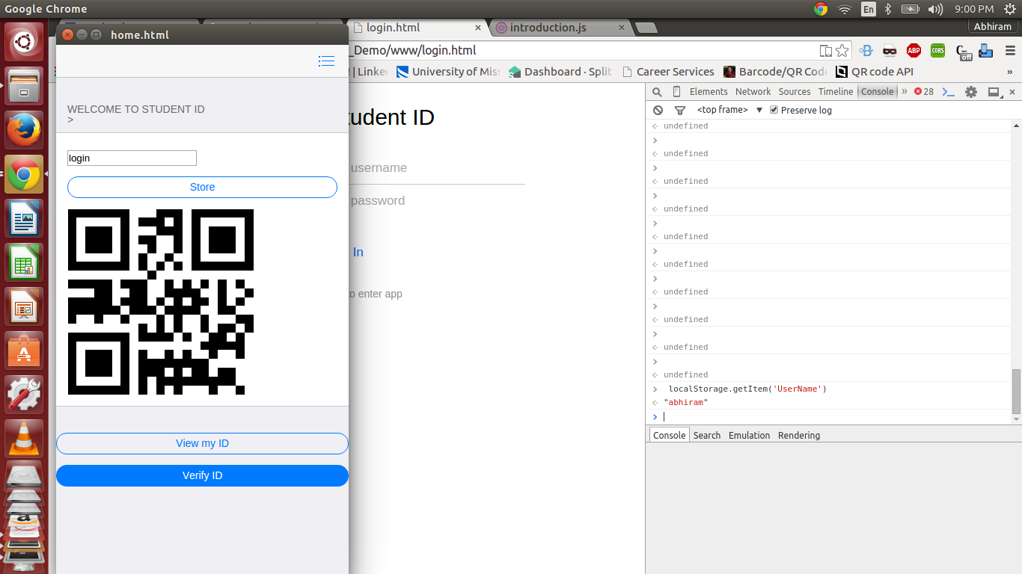

We will be testing whether we get the same username in the localstorage in the login username.

1. Testing with local storage value of username

2. Testing whether the image source value is null or not before execution

3. Testing whether the text box has values or not.

