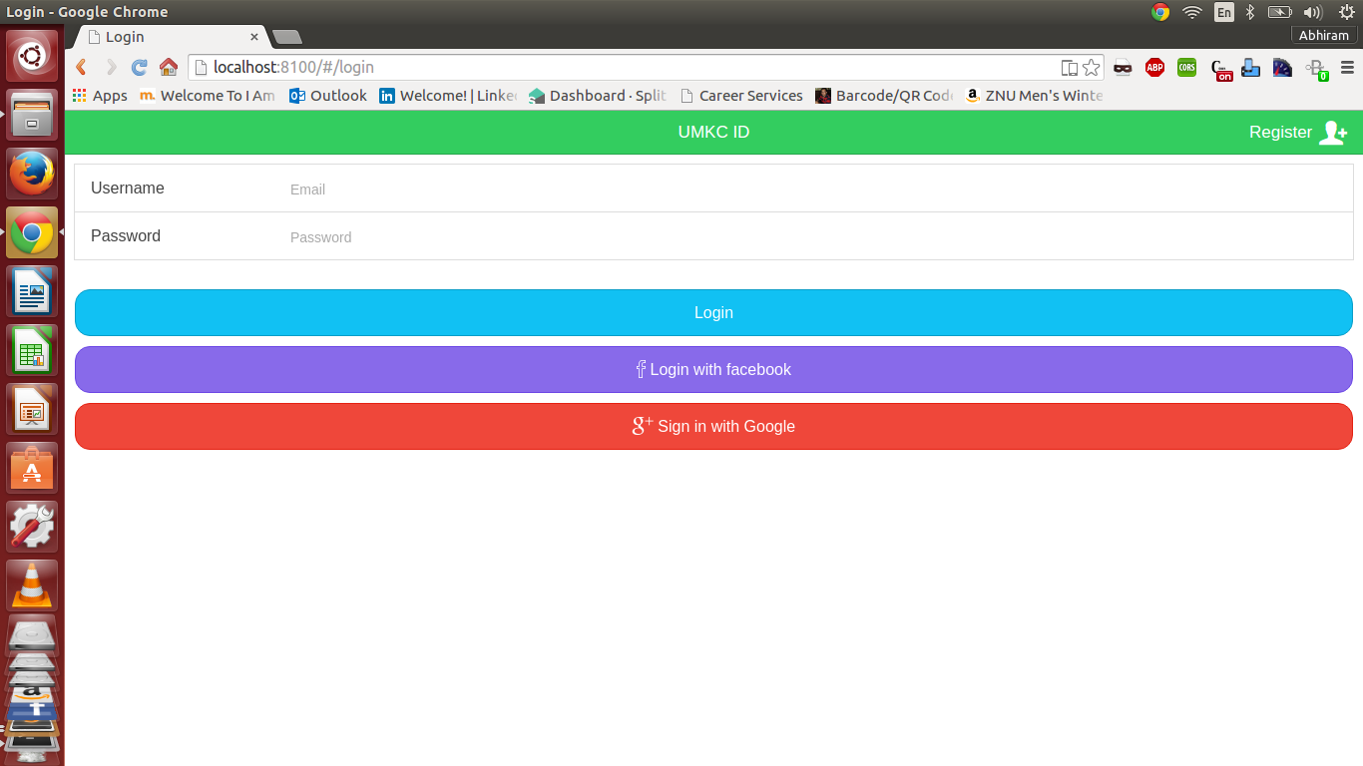

The above is a singleton design pattern. Here we allow only admin to enter into the system. The singleton design pattern doesn't allow us to enter more than one user per application.

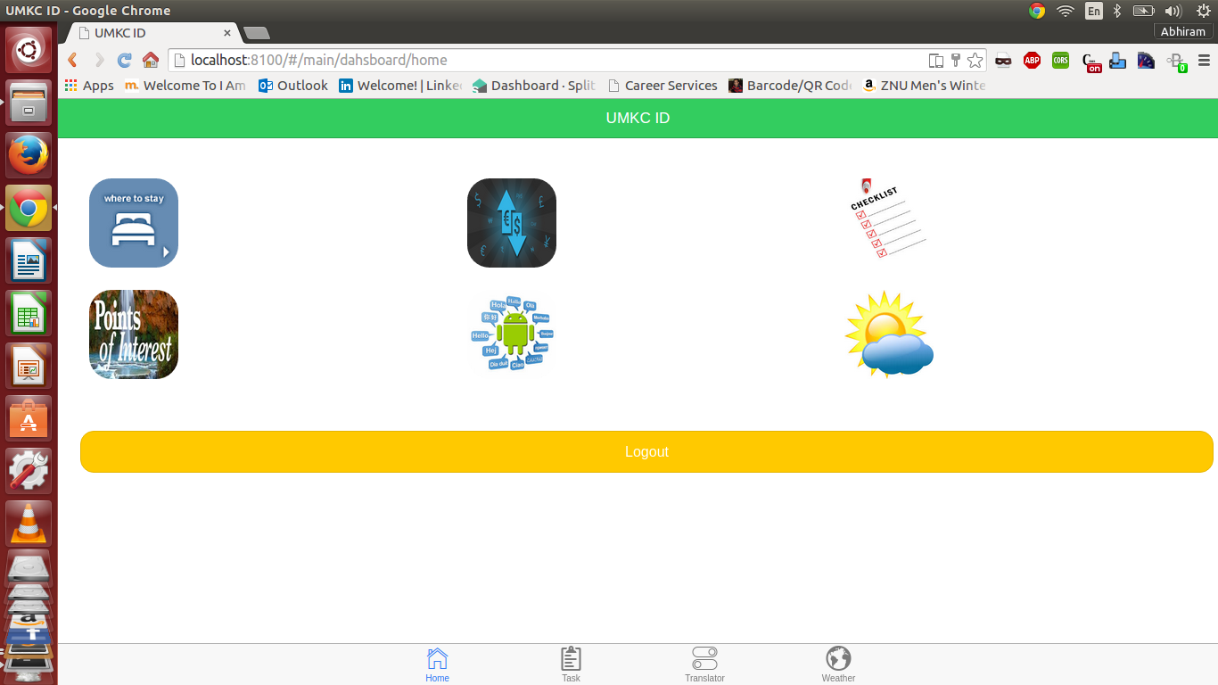

The mixin pattern allows us to use many other features at a time. Here we use check list, and weather and find hotels together to get mixin pattern.

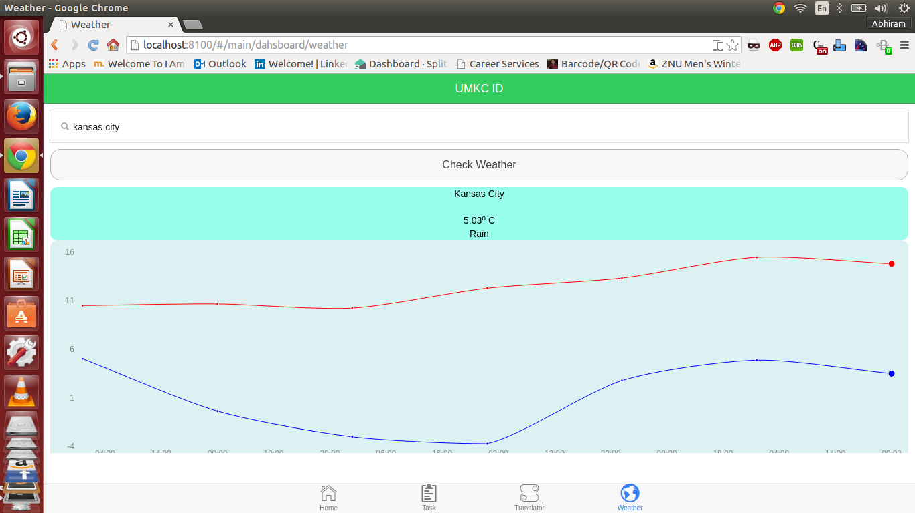

Here We use factory method to get a feature from a set of defined features. For example we used yahoo factory method to get weather data from it.

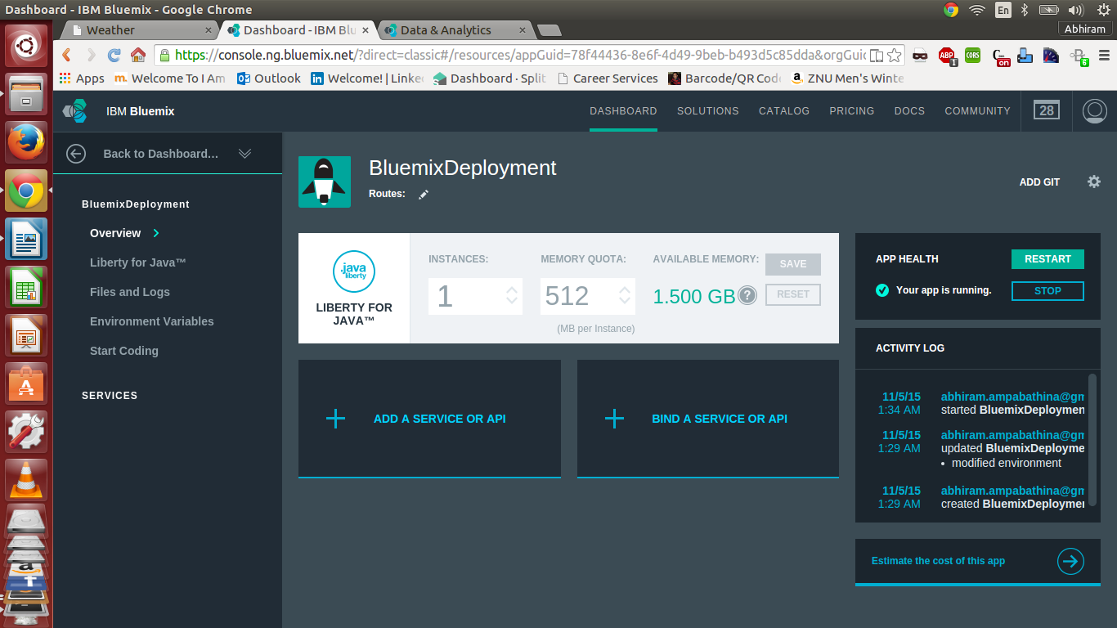

Please find the bluemix deployment.