**Lab 3 Assignment**

1. K means for our project dataset. Our project dataset is heart beat data.

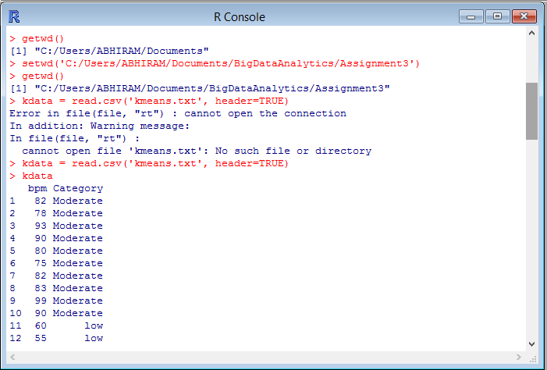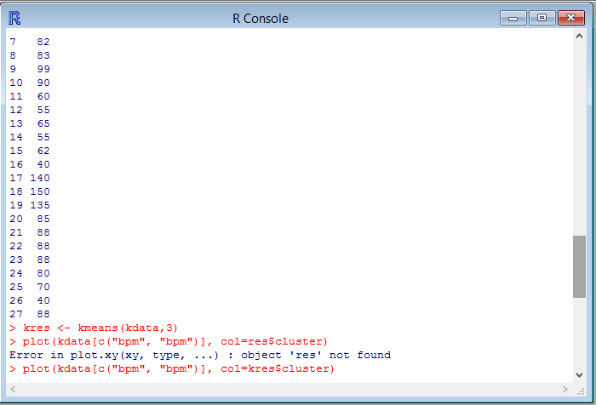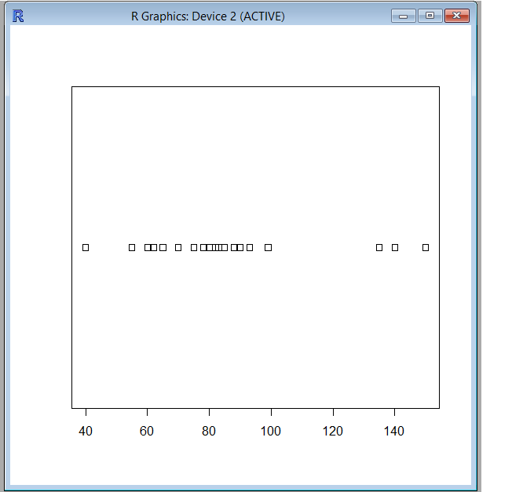

1. K Medoid

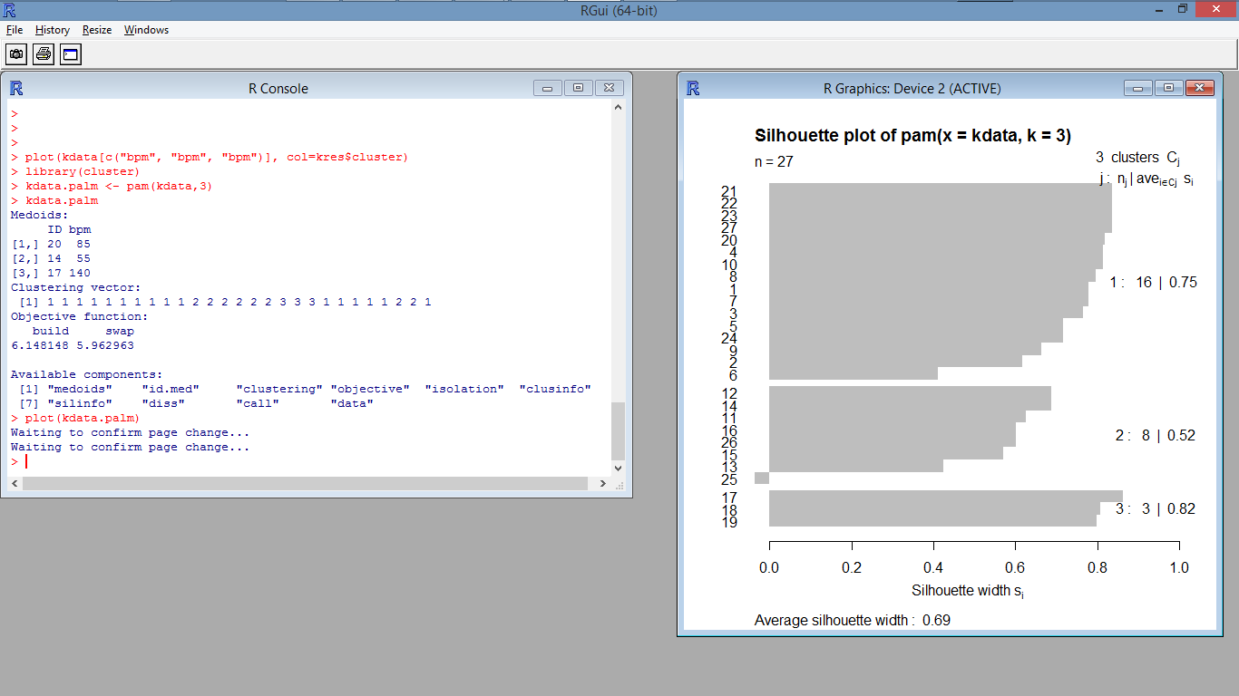

1. Hierarchical Clustering

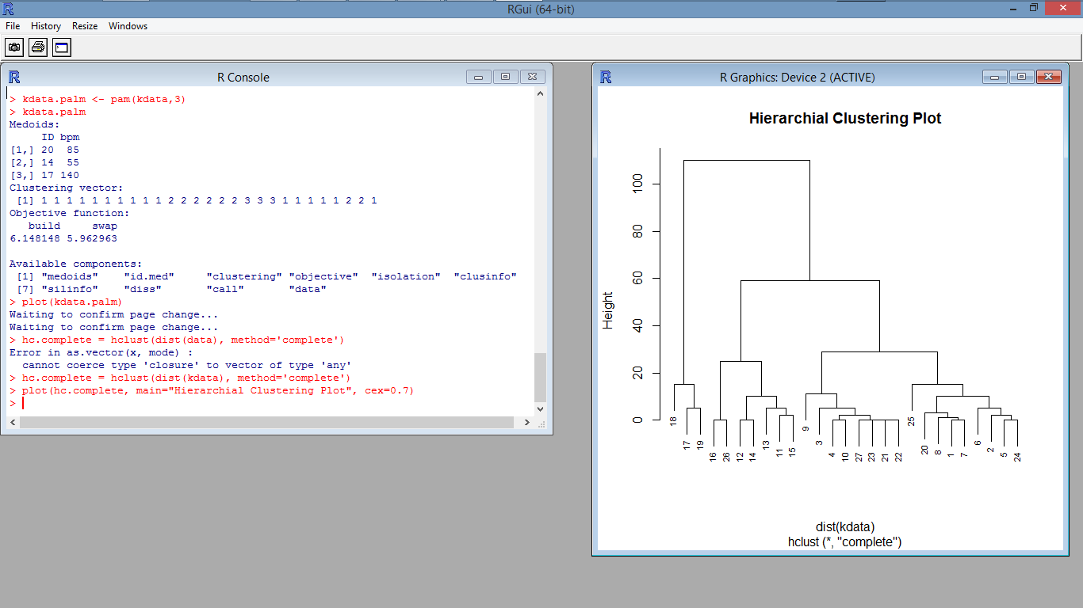

1. Expectation Maximization:

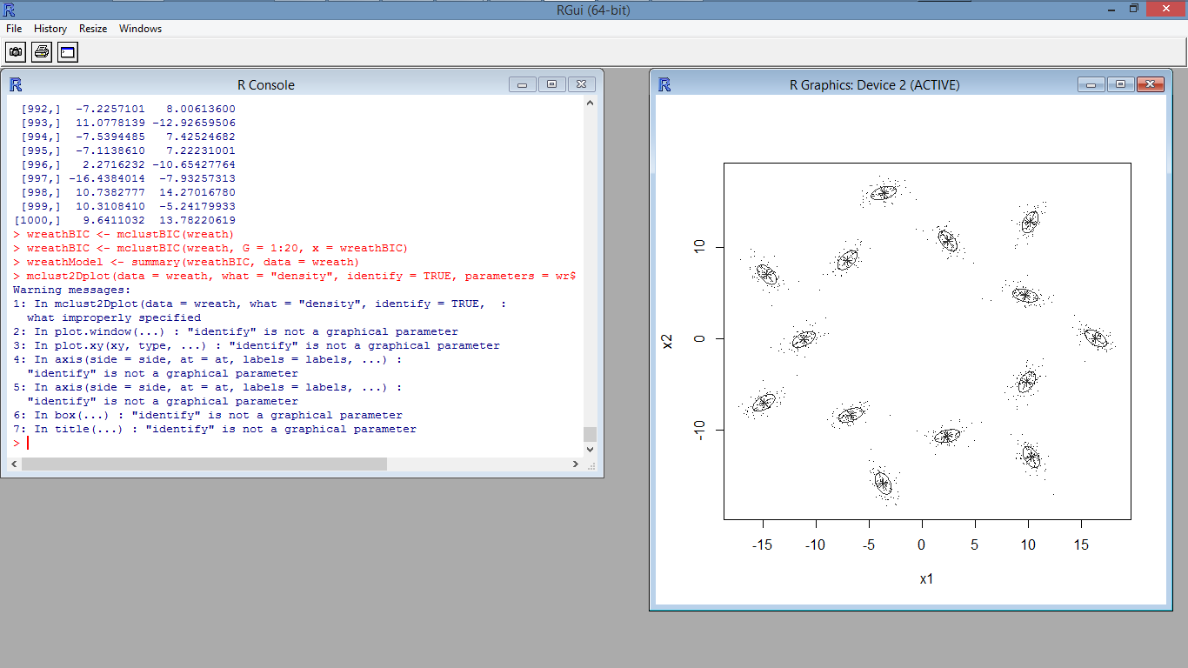

**Heart Rate Android Wear Application**

The application developed is a reminder of the heart rate of a user, who wears the Android watch. The below was observed application observation in the Android wear.

