Abid Ullah  mrabidullah37@gmail.com | +92 325 3960977 | Dera Ismail Khan, Pakistan  https://github.com/mrabidullah | 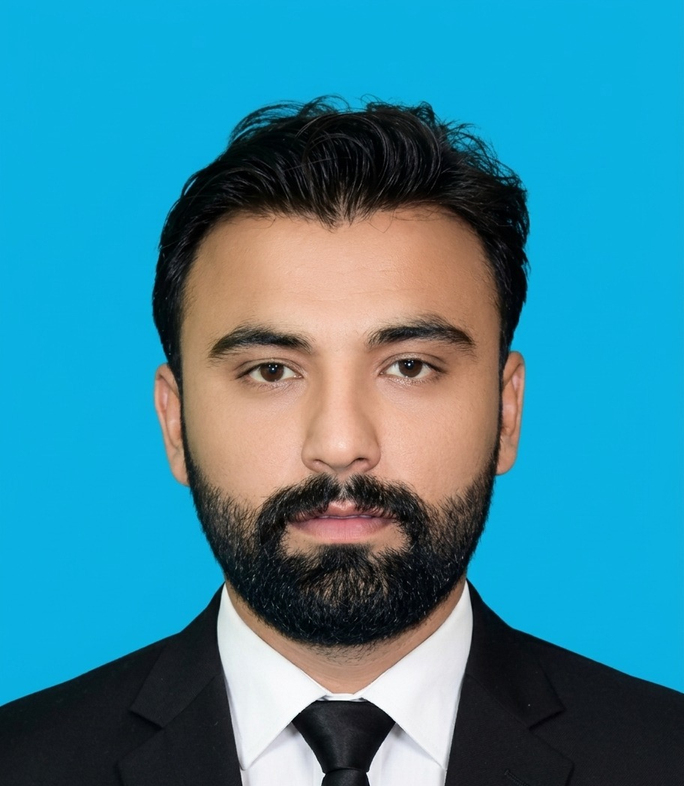

ABOUT MYSELF
I'm a Computer Science graduate (2026) from Government College of Management Sciences (GCMS), Dera Ismail Khan, with two years of hands-on experience as a full-stack Django developer. I've built and shipped projects on my own initiative — an e-commerce platform, a hospital records system, and most recently the official website for my own college — and I'm comfortable owning a build end to end: database design, backend logic, REST APIs, and a responsive front end. I'm looking for a role where I can keep building reliable, user-focused web applications and keep growing as a backend engineer.
WORK EXPERIENCE
Independent Web Developer
Personal & Client Projects (Full-time, self-directed)
- Design and deliver full-stack Django/Python applications for personal and client work, spanning e-commerce, content management, healthcare, and institutional systems.
- Own the full build: requirements, database design, backend logic, responsive front-end, and deployment.
- Work in Git/GitHub throughout, with REST APIs and role-based access control as recurring building blocks.
EDUCATION
Government College of Management Sciences (GCMS) Dera Ismail Khan, Pakistan
Affiliated with Gomal University, Dera Ismail Khan (Khyber Pakhtunkhwa)
Degree: Bachelor of Science, Field of Study: Computer Science 2022 – 2026

Cyberlinks I.T College and Training Center Dera Ismail Khan, Pakistan
Degree: Diploma in Information Technology (DIT), One Year
Peshawar Board of Technical Education Peshawar, Pakistan
Degree: Three-Year Diploma, Field of Study: Electrical Engineering 2018 – 2020
SKILLS
Technical Skills: Python, Django, Django REST Framework, HTMX, Tailwind CSS, HTML5, CSS3, SQLite, PostgreSQL, REST APIs, CRUD, Authentication & Role-Based Access Control, Git, GitHub, VS Code.
Practices: MVT architecture, responsive design, database-driven applications.
PROJECTS
GCMS DIK Official Website
- Building the official website for my college as a 14-app Django project covering admissions, academics, student/teacher portals, the library, events, and a blog, with a custom user model, role-based access, and a signal-driven approval workflow.
Multi-Vendor E-Commerce Platform
- Lets independent vendors manage their own products, inventory, and orders on one platform; built the cart, checkout flow, inventory tracking, authentication, and role-based vendor access. View on GitHub →
Blog & Content Management System
- A Django blog platform with user authentication, post publishing, comments, and real-time form validation using HTMX. View on GitHub →
Hospital Management System
- Manages patient records, doctor profiles, and appointment scheduling, with secure authentication and role-based access. View on GitHub →
Library Management System
- Tracks book catalogues, member records, and issue/return transactions, with a simple admin interface for librarians. View on GitHub →
LANGUAGE SKILLS
Mother tongue: Pashto
Other languages: Urdu (fluent), English (proficient in reading, writing, and comprehension).
REFERENCES
Prof. Faridullah Khan
Phone: +92 333-3911119
Email: 3333911119@gmail.com

