Matthew Britt & Darryn McLeod
2012
Sudoku &
Calkuro
Object Oriented Programming
1005ICT
1005ICT Object Oriented Programming
Darryn McLeod s2797514
Matthew Britt s28353117

Sudoku and Calkuro

Software Development and Testing Document

Introduction
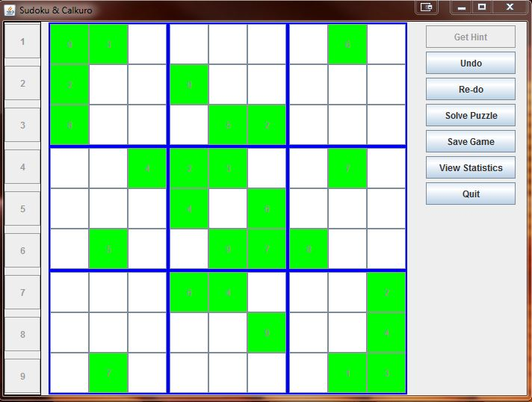

This document is a basic outline regarding the Sudoku and Calkuro Programming Assignment we have been developing, using the Java language for the entirety of this semester. The programming techniques and approaches we learned during the course of this project include, but are not limited to:

- Use of classes to instantiate objects
- Inheritance
- Polymorphism
- Abstract classes and methods
- Reading from, and writing to files
- GUI programming using the Swing library and its components

By using these techniques and tools, we have come to understand and appreciate the advantages of an Object Oriented approach to programming. The next section of this document will explain the key aspects we utilised to implement a fully working, feature rich Sudoku and Calkuro game.

Development

The first step we took when beginning development of this game was to incorporate a Scanner object which can take a File object as it’s parameter with the goal being to read data from a text file that can be stored into a 2-Dimensional Array (an Array of Arrays) . This 2-Dimensional array becomes the grid representing a Sudoku, or Calkuro game.
During this initial phase there were several factors which contributed to a lot of errors and complications. Due to these issues, Exception handling became an important aspect of our approach. With the correct use of “try – catch” blocks we were able to move from simply reading in the grid as raw numbers, to the construction of a working Sudoku game object, using the provided class SudokuGrid.

Once we had created a stable way of operating upon the puzzle created with the SudokuGrid class, we began thinking about implementing an Undo and Redo capability. It was decided we would write a class that could be instantiated when the puzzle is first initialized, as a means of recording the players interactions with the puzzle. Our first iteration of the MovesRecorder class consisted of several arrays. As each move is made within the game, the arrays would be resized to accommodate a value corresponding with a row, column, and number entered. Further research and testing led us to investigation of Java’s ArrayList class. The result was a much cleaner and simpler approach to storing an indeterminate list of values. The retrieval for the use of Undo and Redo also became much simpler as a result of using ArrayList objects.

The Graphical User Interface became our primary focus at this point of development, up until now the only way to play the game was through the use of command line prompts and responses typed in from the keyboard. A GUI would offer a more intuitive and enjoyable means of playing the game.
Two of the classes in the Java Standard Library (Abstract Window Toolkit, and Swing) make the process of implementing features, which would otherwise be very difficult to code and design, a relatively painless undertaking. With the use of Swing and AWT comes a requirement to understanding a fundamental characteristic of Object Oriented Programming: Inheritance.

Through the use of Class Inheritance we produced many sophisticated objects that required minimal customisation to suit our requirements. Some of the key components incorporated into our GUI that were made simpler through the proper use of Inheritance and Abstract Classes are:

- JFrame
- JPanel
- JDialog
- ActionListener (General Event handling)
- MouseListener(Simple way of handling several mouse driven events)

Through combining each of these components, with the help of several other tools, such as LayoutManagers, we were able to deliver a rich, intuitive, and completely functional interface that is driven by events and their handlers.

Conclusion

The development of this project was a challenging and sometimes frustrating endeavour, though in the end, we both have a far deeper understanding of the practical applications and techniques involved with developing Object Oriented software than we would have, without the experience gained from developing this assignment.
The skills and techniques acquired during this project will no doubt cement some of the core fundamentals in Object Oriented Programming. We look forward to building upon the foundations that this assignment has been laid upon in the future.

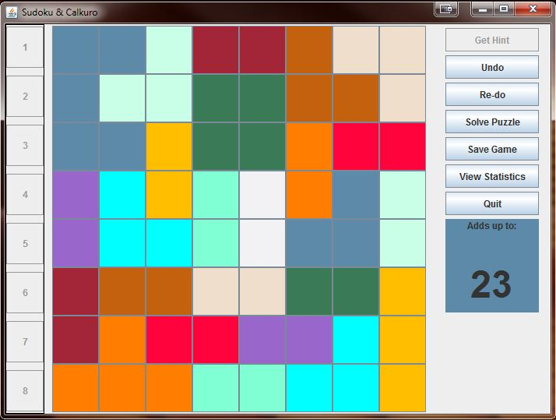

Testing

During the development cycle, we utilized constant testing of code for the purpose of debugging and as a way of ensuring the implementation of new features could integrate seamlessly with existing code. As a result of the functional testing being performed continually throughout the development, we were able to produce a fully functional program.

Once we were satisfied with the final program, we began usability testing to ensure an intuitive, yet functional design in regards to the user interface. This was achieved by having friends and family play the game as we observed their interaction with the interface. Many useful alternatives were discovered as a result of this type of testing. The feedback gained from these tests is partly responsible for the presentation of our submission. After several iterations of this style of testing, and subsequent redesigns, we developed a game which is enjoyable and simple to play, while still performing complicated, code driven calculations in order for the logic of both Sudoku and Calkuro could be represented effectively.

