Front-End Developer 1(Neeraj Mangal and Amandeep Singh)
Front-End Developer 2(Tanisha Bagora)
Backend Developer1(Aditya yadav)
Backend Developer2(Saumya Katiyar)

Sprint 1 (20Dec2024 – 30Dec2024)

Front-End Developer 1 (React.js)
Responsibilities:
- Convert the Figma designs into a responsive React.js application.
- Implement components for navigation, user authentication (login, registration, password reset), and static pages.
- Integrate API endpoints for data fetching and form submissions.
Key Focus: Ensure the UI is intuitive and matches the design specifications.
Tasks:
- Implement the navigation bar as per the Figma design.
- Develop the user authentication components (login, registration, password reset).
- Integrate API endpoints for user authentication.
- Ensure the application is responsive and matches the design specifications.

Front-End Developer 2 (React.js)
Responsibilities:
- Implement components for forum and notifications.
- Integrate API endpoints for displaying and managing forum posts and notifications.
Key Focus: Ensure the UI is functional and integrates smoothly with backend services.
Tasks:
- Implement the forum section where users can create posts and comments.
- Integrate API endpoints for forum posts and comments.
- Develop a notifications system that displays real-time alerts and messages to users.
- Ensure the UI is consistent and user-friendly.

Back-End Developer 1 (Spring Boot)
Responsibilities:
- Develop RESTful APIs based on the defined API flow.
- Implement business logic for handling user management, appointment management, authentication, and notification systems.
- Ensure secure and efficient database interactions.
Key Focus: Ensure the backend is robust, secure, and scalable.
Tasks:
- Set up the project structure in Spring Boot.
- Implement CRUD operations for appointments.
- Develop the user management API (CRUD operations for user profiles).
- Implement security measures for user authentication (MFA, OAuth).
- Create endpoints for sending and retrieving notifications.
- Ensure efficient database interactions and data integrity.
- Use Kafka for real-time appointment notifications and updates.

Back-End Developer 2 (Spring Boot)
Responsibilities:
- Implement business logic for forum management and profile management.
- Integrate Cloudinary for image handling.
Key Focus: Ensure seamless integration of backend services and third-party tools.
Tasks:
- Implement endpoints for managing pet profiles and medical histories.
- Develop endpoints for forum posts and comments.
- Integrate Cloudinary for image upload, retrieval, and transformation.

Project Management and Approach

1. Agile Methodology
- Break down the project into sprints (2 weeks each).
- Conduct regular stand-up meetings (daily or every other day) to track progress and address blockers.
- Use a project management tool like Jira or Trello to manage tasks and track progress

2. Define Clear Milestones
Sprint 1 (20Dec2024 - 30Dec2024):
- Front-End Developer 1: Set up project structure, implement navigation, user authentication, and static pages of the website.
- Front-End Developer 2: Implement forum management and notifications.
- Back-End Developer 1: Set up project structure, implement user management API/Authentication API.
- Back-End Developer 2: Implement forum management API and profile management API.
Sprint 2 (1Jan2025 - 16Jan2025):
- Front-End Developer 1: Develop components for profile management and integrate APIs.
- Front-End Developer 2: Implement forum and pet management components.
- Back-End Developer 1: Implement forum management API and notification system.
- Back-End Developer 2: Develop forum management API and integrate Kafka for notifications.

3. Code Reviews and Testing
- Conduct regular code reviews to ensure code quality and maintainability.
- Implement unit tests and integration tests to catch issues early.

4. Continuous Integration/Continuous Deployment (CI/CD)
- Set up a CI/CD pipeline to automate testing and deployment.
- Use tools like Jenkins, GitHub Actions, or GitLab CI for automation.

5. Documentation
- Maintain clear and updated documentation for the codebase, APIs, and any integration setups.
- Ensure everyone on the team has access to the documentation and knows how to use it.

- Frontend(React.js)
src/
├── assets/
│ ├── images/
├── components/
│ ├── common/
│ ├── Button.js
│ ├── InputField.js
│ ├── layout/
│ ├── Header.js
│ ├── Navigation.js
│ ├── auth/
│ ├── Login.js
│ ├── Register.js
│ ├── PasswordReset.js
│ ├── dashboard/
│ ├── Dashboard.js
│ ├── appointments/
│ ├── AppointmentList.js
│ ├── AppointmentForm.js
│ ├── forum/
│ ├── ForumList.js
│ ├── ForumPost.js
│ ├── notifications/
│ ├── NotificationList.js
├── hooks/
│ ├── useAuth.js
│ ├── useFetch.js
├── pages/
│ ├── HomePage.js
│ ├── LoginPage.js
│ ├── RegisterPage.js
│ ├── PasswordResetPage.js
│ ├── DashboardPage.js
│ ├── AppointmentPage.js
│ ├── ForumPage.js
│ ├── NotificationPage.js
├── services/
│ ├── api.js
│ ├── authService.js
│ ├── appointmentService.js
│ ├── forumService.js
│ ├── notificationService.js
├── utils/
│ ├── validators.js
│ ├── helpers.js
├── App.js
├── index.js

Explanation of Each Folder:
1. assets/:
images/: Store all image assets.
2. components/:
common/: Common reusable components like buttons and input fields.
layout/: Layout components like header and navigation.
auth/: Components related to authentication (login, register, password reset).
dashboard/: Components for the user dashboard.
appointments/: Components for managing appointments.
forum/: Components for forum posts and comments.
notifications/: Components for notifications.
3. hooks/:
Custom hooks for managing state and side effects.
4. pages/:
Main pages of the application that use components to create complete views.
5. services/:
Service files for managing API requests and business logic.
6. utils/:
Utility functions and helpers.
7. App.js:
Main application component that sets up routing and global settings
8. index.js:
Entry point of the React application, renders the App component.

- Backend(Spring Boot)

src/
├── main/
│ ├── java/
│ └── com/
│ └── petcareconnect/
│ ├── config/
│ ├── SecurityConfig.java
│ ├── KafkaConfig.java
│ ├── controller/
│ ├── AuthController.java
│ ├── UserController.java
│ ├── AppointmentController.java
│ ├── ForumController.java
│ ├── NotificationController.java
│ ├── dto/
│ ├── UserDto.java
│ ├── AppointmentDto.java
│ ├── ForumPostDto.java
│ ├── NotificationDto.java
│ ├── entity/
│ ├── User.java
│ ├── Appointment.java
│ ├── ForumPost.java
│ ├── Notification.java
│ ├── exception/
│ ├── CustomException.java
│ ├── GlobalExceptionHandler.java
│ ├── repository/
│ ├── UserRepository.java
│ ├── AppointmentRepository.java
│ ├── ForumPostRepository.java
│ ├── NotificationRepository.java
│ ├── security/
│ ├── JwtTokenProvider.java
│ ├── CustomUserDetailsService.java
│ ├── service/
│ ├── UserService.java
│ ├── AppointmentService.java
│ ├── ForumPostService.java
│ ├── NotificationService.java
│ ├── util/
│ ├── EmailUtil.java
│ ├── SmsUtil.java
│ ├── PetCareConnectApplication.java
├── resources/
│ ├── static/
│ ├── templates/
│ ├── application.properties
├── test/
│ ├── java/
│ └── com/
│ └── petcareconnect/
│ ├── AuthControllerTest.java
│ ├── UserServiceTest.java

Explanation of Each Folder:
1. config/:
Configuration files for security, Kafka, and other settings.
2. controller/:
REST controllers for handling HTTP requests.
3. dto/:
Data Transfer Objects for passing data between layers.
4. entity/:
Entity classes representing database tables.
5. exception/:
Custom exceptions and global exception handlers.
6. repository/:
Repository interfaces for database interactions.
7. security/:
Security-related classes (e.g., JWT token provider, user details service).
8. service/:
Service classes containing business logic.
9. util/:
Utility classes for common tasks (e.g., email, SMS).
10. PetCareConnectApplication.java:
Main Spring Boot application class.
11. resources/:
Static resources, templates, and configuration files.
12. test/:
Test classes for unit and integration testing.

- Authentication Flow Diagram
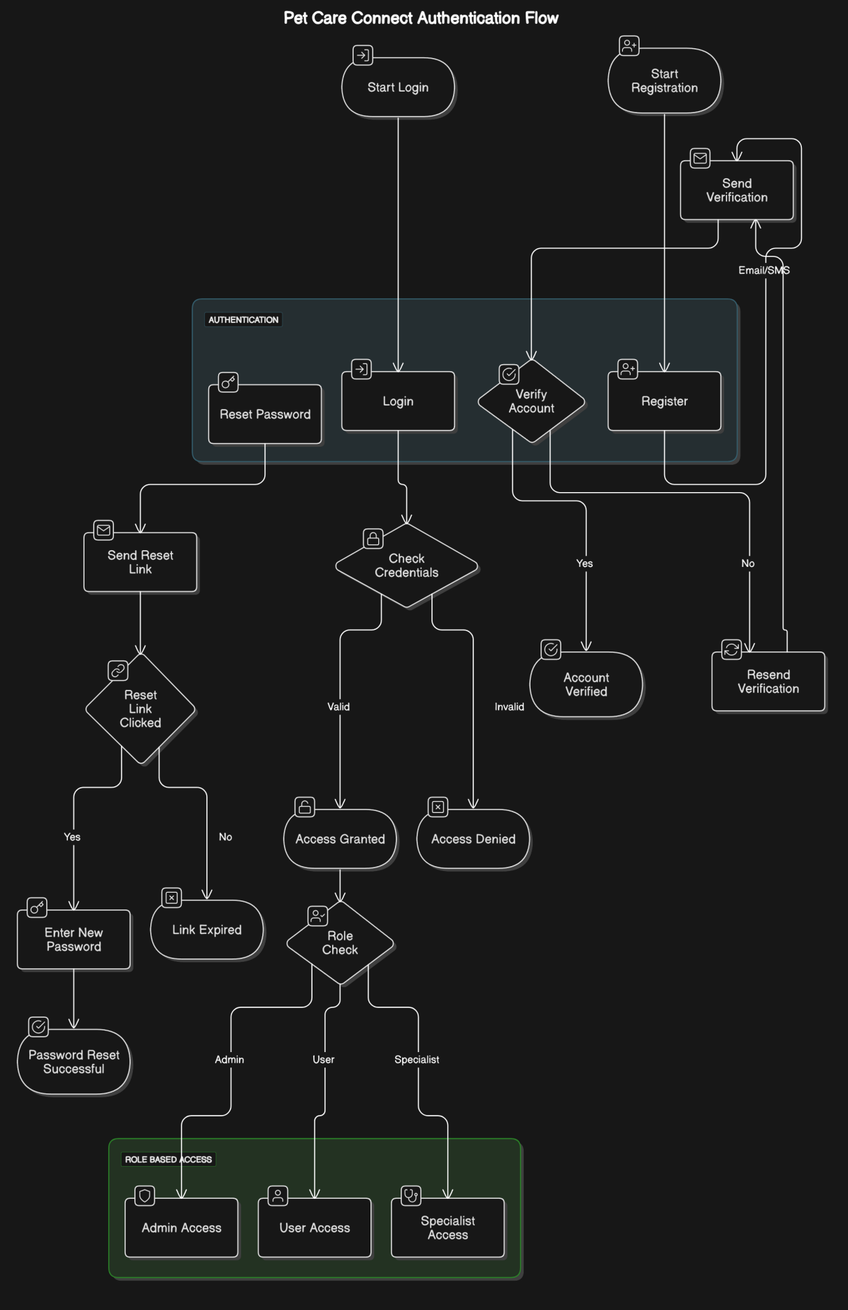

- Forum Management Flow Diagram
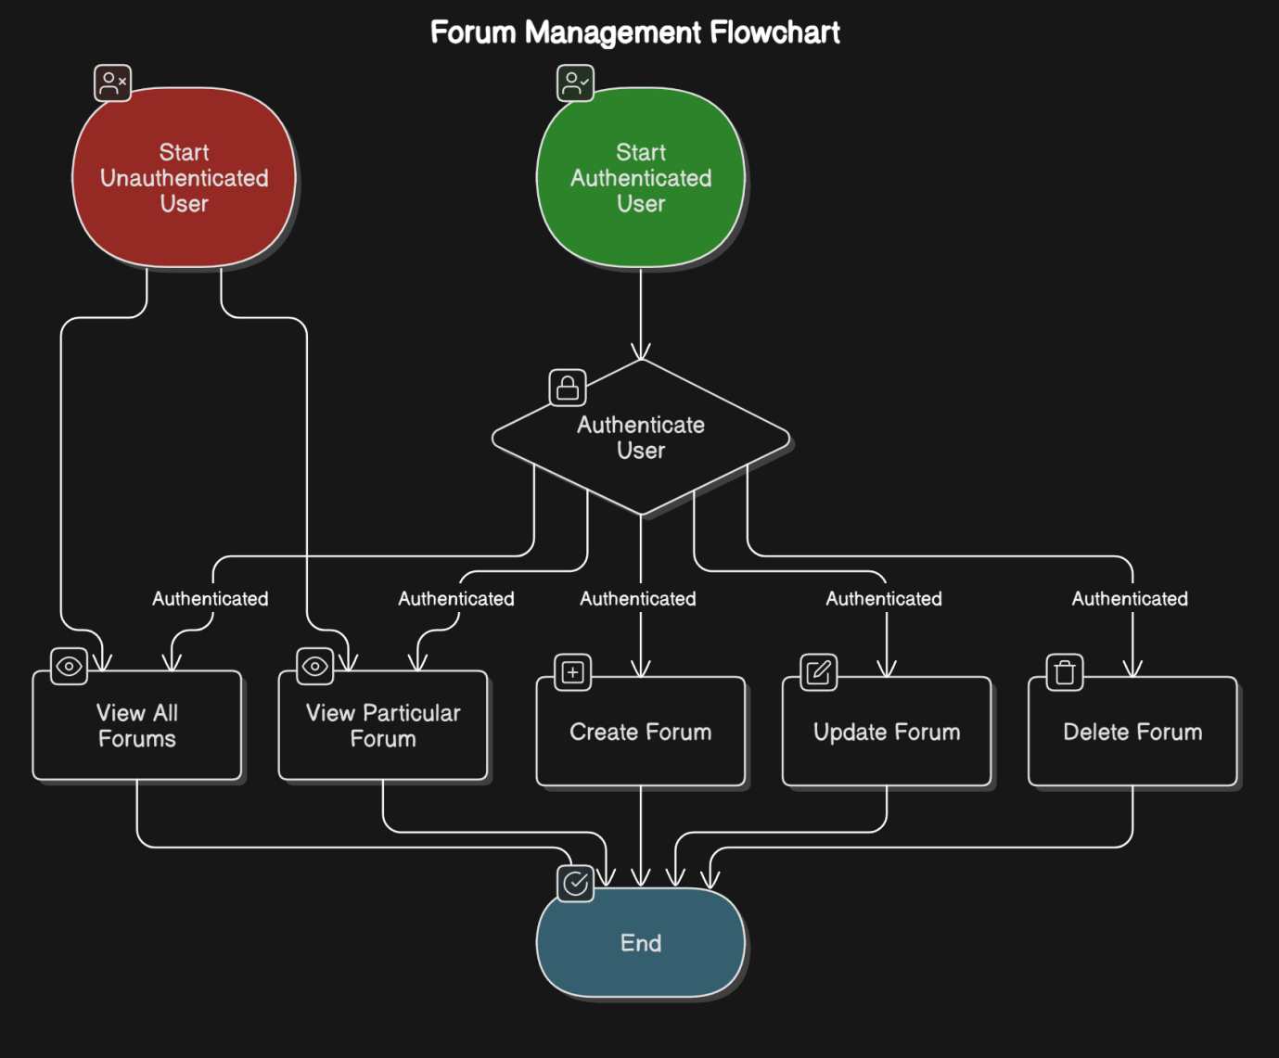

- Appointment Management Flow Diagram
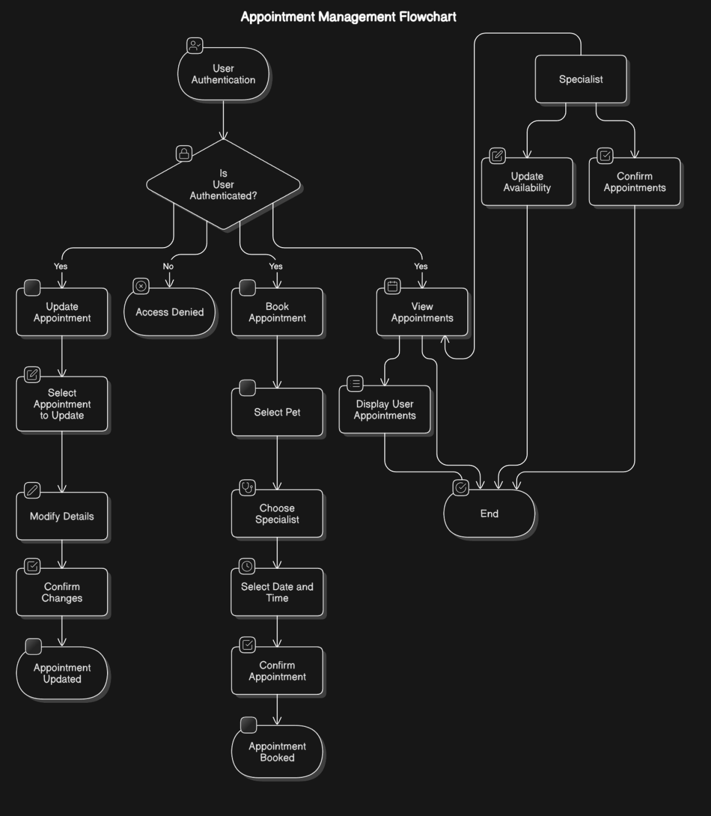

- Detailed Flow Diagram
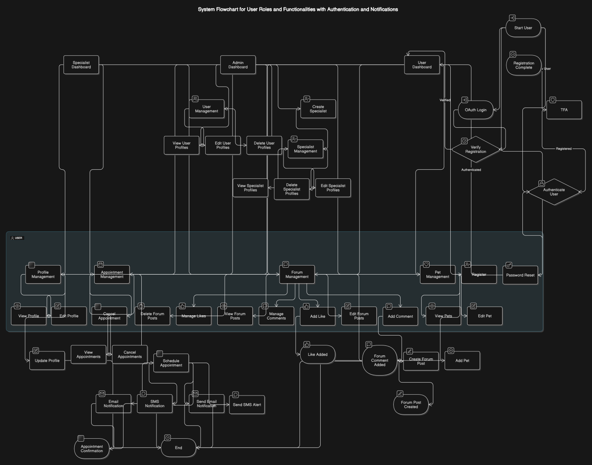

- Database Schema
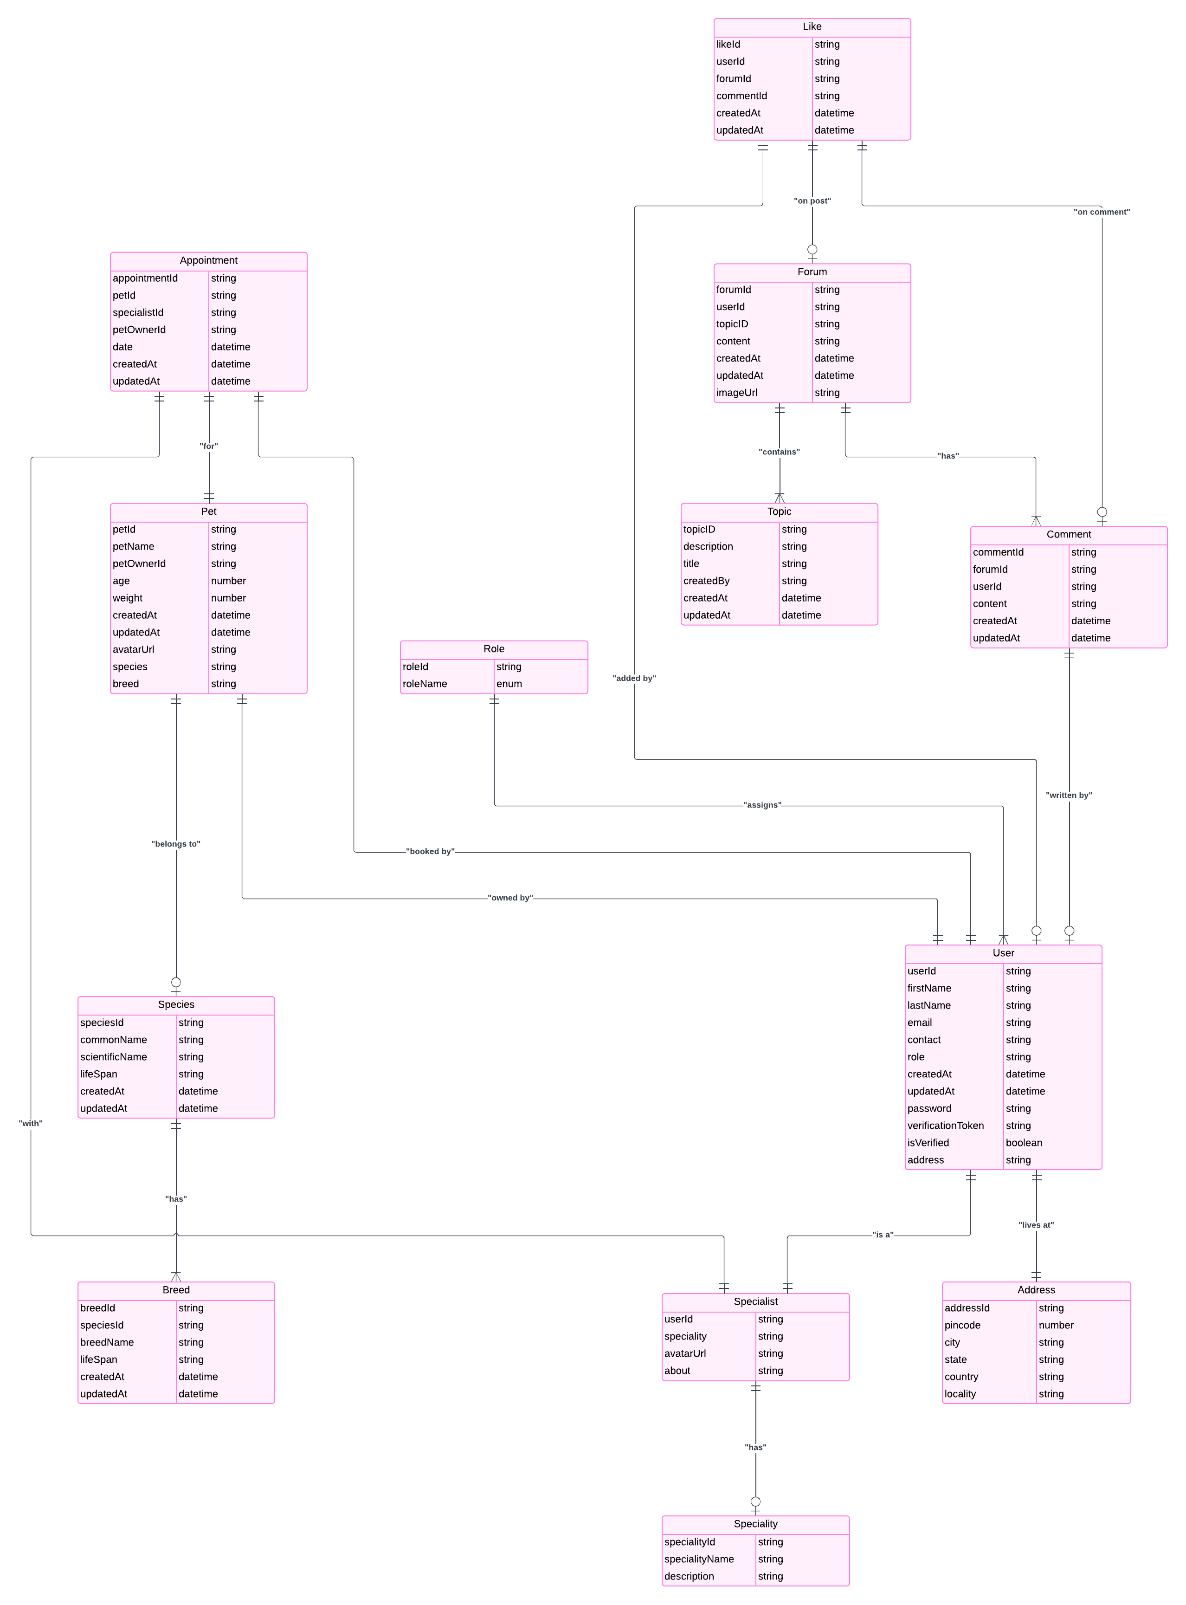

API Endpoints

User Authentication and Management (Handled by Back-End Developer 1)
Register User
Endpoint: POST /api/v1/auth/register
Description: Registers a new user after email/SMS verification.
Request Body:
{
"username": "string",
"email": "string",
"password": "string",
"verificationCode": "string"
}
Response:
{
"message": "User registered successfully",
"userId": "string"
}
Send Verification Code
Endpoint: POST /api/v1/auth/send-verification
Description: Sends a verification code via email or SMS.
Request Body
{
"emailOrPhone": "string"
}
Response:
{
"message": "Verification code sent"
}
Login User
Endpoint: POST /api/v1/auth/login
Description: Authenticates a user and initiates MFA.
Request Body:
{
"username": "string",
"password": "string"
}
Response:
{
"token": "string",
"mfaRequired": true,
"userId": "string",
"roles": ["USER", "SPECIALIST", "ADMIN"]
}
OAuth Login (Google or GitHub)
Endpoint: POST /api/v1/auth/oauth/login
Description: Authenticates a user using Google or GitHub OAuth.
Request Body:
{
"provider": "google" // or "github"}
Response:
{
"token": "string",
"userId": "string",
"roles": ["USER", "SPECIALIST", "ADMIN"]
}
MFA Verification
Endpoint: POST /api/v1/auth/mfa
Description: Verifies the MFA code.
Request Body:
{
"userId": "string",
"mfaCode": "string"
}
Response:
{
"message": "MFA successful",
"token": "string"
}
Password Reset Request
Endpoint: POST /api/v1/auth/password-reset-request
Description: Sends a password reset link or code to the user's email or phone.
Request Body:
{
"emailOrPhone": "string"
}
Response
{
"message": "Password reset link/code sent"
}
Password Reset
Endpoint: POST /api/v1/auth/password-reset
Description: Resets the user's password using the reset link or code.
Request Body:
{
"resetToken": "string",
"newPassword": "string"
}
Response:
{
"message": "Password reset successful"
}
Get User Profile
Endpoint: GET /api/v1/users/{userId}
Description: Retrieves the user's profile details.
Roles: USER, SPECIALIST, ADMIN
Response:
{
"userId": "string",
"username": "string",
"email": "string",
"profileDetails": {
"fullName": "string",
"address": "string",
"phone": "string",
"avatarUrl": "string"
}}
Update User Profile
Endpoint: PUT /api/v1/users/{userId}
Description: Updates the user's profile details.
Roles: USER, SPECIALIST, ADMIN
Request Body:
{
"fullName": "string",
"address": "string",
"phone": "string",
"avatarUrl": "string"
}
Response:
{
"message": "Profile updated successfully"
}

Appointment Management (Handled by Back-End Developer 1)
Create Appointment
Endpoint: POST /api/v1/appointments
Description: Schedules a new appointment.
Roles: USER, SPECIALIST, ADMIN
Request Body:
{
"userId": "string",
"specialistId": "string",
"dateTime": "string",
"status": "string" // 'scheduled', 'completed', 'cancelled'}
Response:
{
"message": "Appointment scheduled successfully",
"appointmentId": "string"
}
Get Appointments
Endpoint: GET /api/v1/appointments
Description: Retrieves a list of appointments.
Roles: USER, SPECIALIST, ADMIN
Response:
[
{
"appointmentId": "string",
"userId": "string",
"specialistId": "string",
"dateTime": "string",
"status": "string"
}]
Update Appointment
Endpoint: PUT /api/v1/appointments/{appointmentId}
Description: Updates the details of an appointment.
Roles: USER, SPECIALIST, ADMIN
Request Body:
{
"dateTime": "string",
"status": "string"
}
Response:
{
"message": "Appointment updated successfully"
}

Delete Appointment
Endpoint: DELETE /api/v1/appointments/{appointmentId}
Description: Deletes an appointment.
Roles: USER, SPECIALIST, ADMIN
Response:
{
"message": "Appointment deleted successfully"
}

Forum Management (Handled by Back-End Developer 2)
Create Forum Post
Endpoint: POST /api/v1/forum/posts
Description: Creates a new forum post.
Roles: USER, SPECIALIST, ADMIN
Request Body:
{
"title": "string",
"content": "string",
"image": "file"
}
Response:
{
"message": "Forum post created successfully",
"postId": "string"
}
Get Forum Post:
Endpoint: GET /api/v1/forum/posts
Description: Retrieves a list of forum posts.
Roles: USER, SPECIALIST, ADMIN

Response:
[
{
"postId": "string",
"title": "string",
"content": "string",
"image": "string",
"createdAt": "string",
"author": {
"userId": "string",
"username": "string"
}
}]

Add Comment to Forum Post
Endpoint: POST /api/v1/forum/posts/{postId}/comments
Description: Adds a comment to a forum post.
Roles: USER, SPECIALIST, ADMIN
Request Body:
{
"authorId": "string",
"content": "string"}
Response:
{
"message": "Comment added successfully",
"commentId": "string"
}
Get Comments for Forum Post
Endpoint: GET /api/v1/forum/posts/{postId}/comments
Description: Retrieves comments for a specific forum post.
Roles: USER, SPECIALIST, ADMIN
Response:
[
{
"commentId": "string",
"authorId": "string",
"content": "string",
"createdAt": "string"
}]

Notification System (Handled by Back-End Developer 1)
Get Notifications:
Endpoint: GET /api/v1/notifications
Description: Retrieves a list of notifications for the user.
Roles: USER, SPECIALIST, ADMIN
Response:
[
{
"notificationId": "string",
"userId": "string",
"message": "string",
"readStatus": "boolean",
"createdAt": "string"
}]

Mark Notification as Read
Endpoint: PUT /api/v1/notifications/{notificationId}
Description: Marks a notification as read.
Roles: USER, SPECIALIST, ADMIN
Response:
{
"message": "Notification marked as read"
}

Pet Management (Handled by Back-End Developer 1)

Create Pet Profile
Endpoint: POST /api/v1/pets
Description: Adds a new pet profile.
Roles: USER
Request Body:
{
"ownerId": "string",
"name": "string",
"species": "string",
"breed": "string",
"age": "number",
"medicalHistory": "string"
}
Response:
{
"message": "Pet profile created successfully",
"petId": "string"
}
Get Pet Profiles
Endpoint: GET /api/v1/pets
Description: Retrieves a list of pet profiles for the user.
Roles: USER
Response:
[
{
"petId": "string",
"ownerId": "string",
"name": "string",
"species": "string",
"breed": "string",
"age": "number",
"medicalHistory": "string"
}]
Update Pet Profile
Endpoint: PUT /api/v1/pets/{petId}
Description: Updates a pet profile.
Roles: USER
Request Body:
{
"name": "string",
"species": "string",
"breed": "string",
"age": "number",
"medicalHistory": "string"}
Response:
{
"message": "Pet profile updated successfully"
}
Delete Pet Profile
Endpoint: DELETE /api/v1/pets/{petId}
Description: Deletes a pet profile.
Roles: USER
Response:
{
"message": "Pet profile deleted successfully"
}

