Software Requirements Specification
For
PetCare Connect

Prepared By:
Aditya Yadav (240850120011)
Amandeep Singh (240850120017)
Neeraj Mangal (240850120089)
Saumya Katiyar (240850120127)
Tanisha Bagora (240850120149)
Table of Contents
- Introduction…………………………………………….3
  - Purpose……………………………………………3
  - Scope………………………………………………3
  - Definitions, Acronyms, and Abbreviations……4
  - References……………………………………….4
  - Overview………………………………………….5
- Overall Description…………………………………6
  - Product Perspective……………………………..
  - Product Features……………………………………..
  - User Classes and Characteristics…………………..
  - Operating Environment…………………………………
  - Design and Implementation Constraints………….
- System Features………………………………………..
  - Vet Appointment Scheduling………………………
  - Pet Health Records…………………………………….
  - Community Forums……………………………………
- External Interface Requirements……………………
  - User Interfaces…………………………………………
  - Hardware Interfaces……………………………………
  - Software Interfaces…………………………………….
  - Communication Interfaces……………………………
- System Requirements………………………………………..
  - Functional Requirements…………………………….
  - Non-Functional Requirements……………………….
  - Database Schema………………………………………
- Use Case Descriptions…………………………………
  - Use Case 1……………………………………………..
  - Use Case 2……………………………………………..
  - Use Case 3…………………………………………….
- Data Flow Diagrams…………………………………………..
  - Level 0 DFD……………………………………………..
  - Level 1 DFD……………………………………………
  - Flow Chart……………………………………………..

- Technical Requirements……………………………………..
  - Database Requirements………………………………
  - Network Requirements……………………………….
- Performance Requirements………………………………….
  - Data Processing and Synchronization……………
  - Forum Interactions……………………………………
  - API Performance………………………………………
- Security Requirements…………………………………….
  - Authentication and Authorization…………………...
  - Vulnerability Management……………………………
  - Secure API Usage……………………………………..
- User Documentation……………………………………….
  - Introduction to the Platform………………………..
  - Getting Started………………………………………..
  - Scheduling Vet Appointments……………………..
  - Engaging in Community Forums………………….
  - Notifications and Alerts……………………………..
  - Frequently Asked Questions(FAQs)………………..
- Glossary………………………………………………………
  - DFD (Data Flow Diagram)……………………………..
  - Health Records………………………………………….
  - MFS (Multi-Factor Authentication)………………….
  - OAuth 2.0………………………………………………..
  - RBAC (Role-Based Access Control)…………………

1. Introduction
  - Purpose
The purpose of this document is to outline the functional and non-functional requirements of the pet management platform. This platform is designed to assist pet owners in managing their pets' well-being through efficient vet appointment scheduling, comprehensive health records, and an engaging community forum.

1.2 Scope
The pet management platform enables pet owners to:
- Schedule and manage veterinary appointments seamlessly.
- Maintain and access detailed health records of their pets.
- Engage in community forums to discuss pet care and connect with other pet owners.
This system aims to enhance pet care management and provide a collaborative space for pet enthusiasts.

1.3 Definitions, Acronyms, and Abbreviations
- SRS (Software Requirement Specification): A detailed document that defines the software system's functionalities, requirements, and constraints. It serves as a blueprint for developers, testers, and stakeholders to understand the project's scope and deliverables.
- UI (User Interface): The interactive components of the software that allow users to interact with the system, including buttons, forms, menus, and other visual elements. The UI is designed to ensure ease of use and accessibility for all user classes.
- DB (Database): A structured collection of data that is stored and managed electronically. In this project, the database will store information such as user profiles, pet health records, appointment details, and forum posts.

1.4 References

The following references have been used in the development of this SRS:
- IEEE Standard 830-1998: IEEE Recommended Practice for Software Requirements Specifications.
  - This standard outlines the best practices for drafting software requirement specifications.
  - Link: IEEE SRS Standard
- Pet Health Record Guidelines: Guidelines provided by veterinary organizations for maintaining and sharing pet health records.
  - Source: American Veterinary Medical Association (AVMA).
  - Link: AVMA Guidelines
- Data Protection and Privacy Regulations: Reference to GDPR (General Data Protection Regulation) for ensuring data privacy and security compliance.
  - Source: European Union GDPR Portal.
  - Link: GDPR Official Site
- Forum and Community Management Best Practices: Research from online communities and forums like Stack Exchange and Reddit for building engaging and safe user forums.
  - Source: Online Community Management Guide.
  - Link: Community Guide
- UI/UX Design Principles: Guidelines from Nielsen Norman Group on designing user-friendly and accessible interfaces.
  - Source: Nielsen Norman Group.
  - Link: NNG UX Guidelines

1.5 Overview
The document covers system features, functional requirements, functional requirements, use cases, and technical requirements.

2. Overall Description

2.1 Product Perspective

This platform integrates with third-party APIs for vet clinics, secure cloud storage for pet health records, and social networking tools for community forums. It provides a responsive web application.

2.2 Product Features
- User registration and profile management.
- Appointment scheduling and reminders.
- Digital pet health record management.
- Community forums with categories and discussion threads.

2.3 User Classes and Characteristics
- Pet Owners: Primary users managing pets.
- Veterinarians: Secondary users who provide services.
- Administrators: Manage user data, forums, and appointments.

2.4 Operating Environment
- Web browsers: Chrome, Firefox, Safari, Edge.
- Mobile platforms: iOS and Android.
- Server environment: Cloud-hosted .

2.5 Design and Implementation Constraints
- Compliance with data privacy laws (e.g., GDPR).
- Real-time updates for scheduling and forums.
- Scalability for increasing user base.

3. System Features

3.1 Vet Appointment Scheduling
- Book, reschedule, or cancel appointments.
- Receive reminders via email/SMS.

3.2 Pet Health Records
- Store medical history, vaccination records, and prescriptions.
- Track health milestones.

3.3 Community Forums
- Post and reply to discussions.
- Create topics within categories.
- Like, report, or moderate posts.

4. External Interface Requirements

4.1 User Interfaces
- Intuitive dashboard for pet management.
- Notifications and alerts.

4.2 Hardware Interfaces
- Smartphones and computers.

4.3 Software Interfaces
- Integration with clinic management systems.
- Cloud storage APIs for health records.

4.4 Communication Interfaces
- Email and SMS for reminders.
- Chat features within forums.

5. System Requirements

5.1 Functional Requirements
- Users can register, log in, and manage profiles.
- Appointments can be booked, rescheduled, and cancelled.
- Users can upload and view health records.
- Forums allow posting, replying, and moderating content.

5.2 Non-functional Requirements
- Maintainability
- Security
- Accessibility

5.3 Database Schema

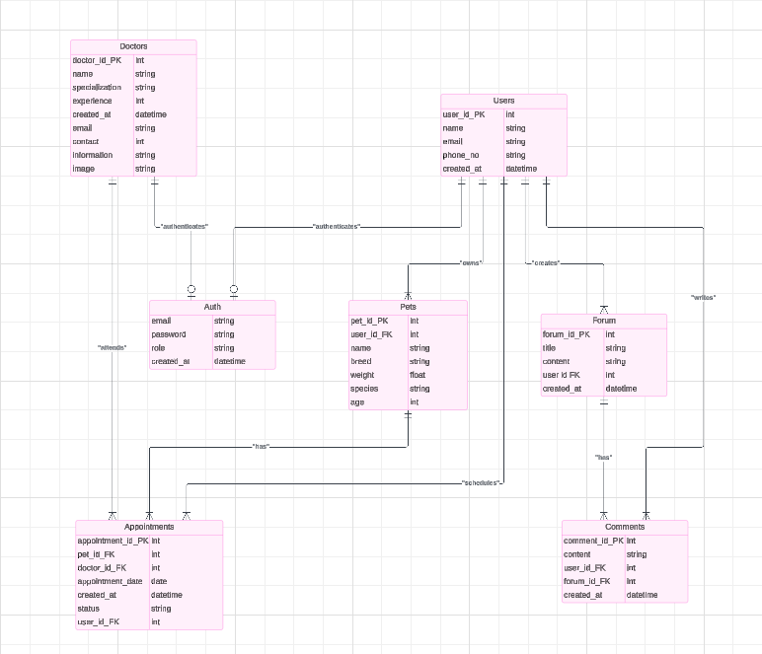

6. Use Case Descriptions
6.1 Use Case 1:
Scheduling a Vet Appointment
Actors: Pet Owner, Veterinarian
Description: The user searches for a clinic, selects a time slot, and confirms the booking.
6.2 Use Case 2:
Viewing and Updating Pet Health Records
Actors: Pet Owner
Description: The user views health history or uploads new records.
6.3 Use Case 3:
Engaging in Community Forums
Actors: Pet Owner
Description: The user creates posts, replies to threads, and likes content.

7. Data Flow Diagrams
7.1 Level 0 DFD
7.2 Level 1 DFD
7.3 Flow Chart

8. Technical Requirements
8.1 Database Requirements
- Relational database for structured data.
- MongoDB for forum discussions.
8.2 Network Requirements
- High-speed connectivity.

9. Performance Requirements
9.1 Data Processing and Synchronization
- The system should process and synchronize new health record uploads, user profile updates, and forum posts within 5 seconds of submission to maintain data consistency across the platform.
- Database queries must execute within 1 second for fetching data such as user profiles, pet health records, or appointment details.
9.2 Forum Interactions
- Posting a new discussion or replying to a thread should take less than 2 seconds to process and reflect in the user interface.
- Community forums must support real-time updates for activities such as likes, replies, and reports without requiring a page refresh.
9.3 API Performance
- APIs used for integration with veterinary clinics and cloud storage must have an average response time of less than 500 milliseconds for all requests.
- API endpoints should be able to handle 1,000 requests per second under peak loads.

10. Security Requirements
10.1 Authentication and Authorization:
- Multi-factor authentication (MFA) must be implemented for all user accounts to enhance security.
- Role-based access control (RBAC) must restrict sensitive actions (e.g., modifying health records or administrative tasks) to authorized users only.
10.2 Vulnerability Management:
- Conduct regular security audits and penetration testing to identify and address vulnerabilities.
- Ensure that all third-party libraries and dependencies are up-to-date and free from known vulnerabilities.

10.3 Secure API Usage:
- APIs must be secured with OAuth 2.0 for authentication and access control.
- Rate-limiting must be implemented to prevent abuse or denial-of-service attacks.

11. User Documentation
The platform will include a detailed and user-friendly guide to ensure all user classes can efficiently navigate and utilize its features. The guide will be structured as follows:

11.1 Introduction to the Platform:

Overview of the platform's purpose and key features.
Explanation of how the platform benefits pet owners and veterinarians.

11.2 Getting Started:

Step-by-step instructions on account registration and login.
Guidance on profile setup, including adding pets and personal details.

11.3 Scheduling Vet Appointments:

Detailed steps for searching veterinary clinics.
Instructions for booking, rescheduling, and canceling appointments.
Screenshots showing the booking interface and confirmation process.

11.4 Engaging in Community Forums:
Overview of forum features such as posting, replying, and liking content.
Steps for creating a new discussion thread.
Explanation of moderation tools for reporting inappropriate content.
11.5 Notifications and Alerts:

Guide to enabling and customizing notification settings for appointments and forum activities.
Example screenshots of notification prompts.

11.6 Frequently Asked Questions (FAQs):

Common troubleshooting scenarios with solutions (e.g., password recovery, appointment conflicts).

Links to customer support for additional help.

12. Glossary
This section defines technical terms, acronyms, and abbreviations used throughout the document to ensure clarity and ease of understanding for all stakeholders.
12.1 DFD (Data Flow Diagram):
A graphical representation of the flow of data within a system, showing how input data is processed and output.
12.2 Health Records:
Digitally stored medical and health-related information for pets, including vaccination history, prescriptions, and diagnostic results.
12.3 MFA (Multi-Factor Authentication):
A security process that requires users to verify their identity through two or more methods, such as passwords and a one-time code sent via SMS.
12.4 OAuth 2.0:
A standard for authorization that provides secure access to resources without sharing credentials.
12.5 RBAC (Role-Based Access Control):
A method of regulating access to computer or network resources based on the roles of individual users.
12.5 UI (User Interface):
The part of the application that users interact with, including visual elements like buttons, forms, and dashboards.
13. API Planning

