DAY8 SESSION ASSIGNMENTS (Theory)

1. When to use (Rapid Application Development) RAD model When not to use (Rapid Application Development) RAD model?

Ans: RAD can be used when:

- the client is not very clear about what he wants and the requirements can change.
- there is high avaliability of designers for modelling, and very sound technical team.
- The budget is high enough to afford their cost along with the cost of automated code generating tools.
- There is a need to create a system that can be modularized in 2-3 months of time.
- resourses with high business knowledge are availiable and there is need to present system in short span ( a prototype).
- When there is a need of modularization in incremental steps.

RAD can not be used when:
- there is not a highly skilled technical/ designer team.
- The system cannot be modularized.
- The budget is not high enough.
- The user cannot be invoved throughout the life cycle.
- Management is good and the requirements are static.

2. Define an ER diagram of a software Organization with all the relationship model that was discussed in the classroom.

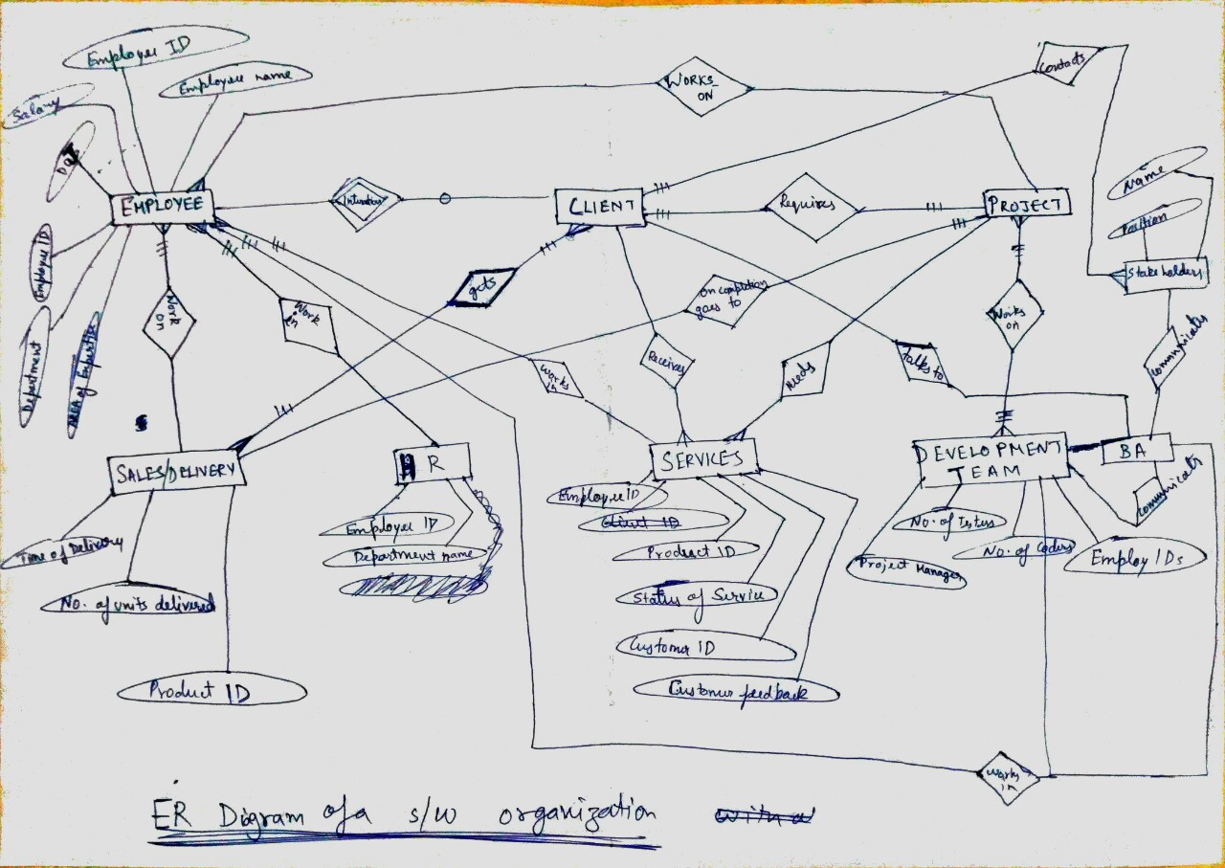

3. Describe the Entity Relationships for the following diagram.

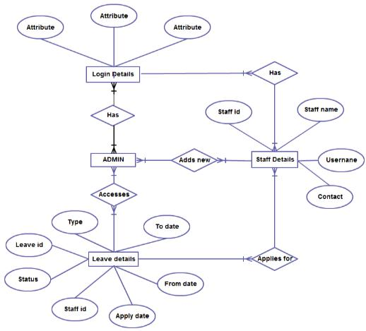

ANS: There are a total of 4 entities whischa are:
1. Login details:
It has 3 attributes and is associated with Staff Details and ADMIN entity.
2. ADMIN:
Admin does not has any attributes but is associated with 3 other entities i.e. the Login details, Staff Details and Leave details.

3. Staff Details:
Staff details has 4 attributes (staff name, user name, contact and staff id), and is associated with 2 other entities i.e. admin and leaves details.

4. Leave details:
It has 7 attributes i.e. type, leave id, status, staff id, apply date, from date and to date.

- Many admins can have many login details.
- Many admins can add many new Staff details.
- Staff details contains Login details.
- Many Admin can access leave details of a staff containing attributes such as type of leave, leave id, status of leave, staff id who is on leave, applying date, duration of leave etc..
- Staff details also contain leave details that he/she applies for.

