The Islamia University of Bahawalpur
Department of Information Technology


Project Proposal
(SCOPE DOCUMENT)
For

< E-commerce Web Application>
Version 1.0

By

Muhammad Raees Bashir

F22BINFT1M01261
Session Spring/Fall 2022 – 2026

Supervisor
Ms. Kainat

Bachelor of Science in Computer Science(Information System)

SCOPE DOCUMENT REVSION HISTORY

No. | Comment | Action
Supervisor Signature
Date:
2

Table of Contents
Abstract 1
Introduction 1
Problem Statement 1
Problem Solution for Proposed System 2
Related System Analysis/Literature Review 2
Advantages/Benefits of Proposed System 3
Scope 3
Modules 4
Software Process Methodology 4
Mockups 5
Conclusion 6

3

Project Category: (Select all the major domains of proposed project)
A-Desktop Application/Information System B-Web Application/Web Application based Information System

C- Problem Solving and Artificial Intelligence D-Simulation and Modeling E- Smartphone Application F-
Smartphone Game G- Networks H- Image Processing Other (specify category) E- Smartphone
Application

Abstract
The project aims to develop an e-commerce website focusing on creating a fully functional online platform using HTML, CSS, and JavaScript. The website will encompass various webpages catering to different aspects of the e-commerce experience, including product browsing, selection, purchasing, and order management. By combining front-end programming languages and adhering to user-centric design principles, the project endeavors to create a top-class e-commerce solution that can serve as a showcase of students' skills and knowledge in web development.

Introduction
E-commerce has emerged as a dominant force in the retail industry, offering convenience and accessibility to consumers worldwide. However, developing a successful e-commerce website requires a comprehensive understanding of both technical aspects and user behavior. This project seeks to bridge the gap between theory and practice by providing students with an opportunity to apply their knowledge of HTML, CSS, and JavaScript to create a real-world e-commerce solution. Through this hands-on experience, students will gain valuable insights into the complexities of web development and learn how to design and implement user-friendly interfaces that drive engagement and conversion.

Problem Statement
Traditional methods of shopping are increasingly being replaced by online alternatives, necessitating the need for robust e-commerce platforms. However, many existing solutions suffer from usability issues, security vulnerabilities, and performance limitations. Developing an effective e-commerce website requires a holistic approach that addresses these challenges while also meeting the evolving expectations of online consumers.

Problem Solution for Proposed System

The proposed system aims to tackle the challenges identified in the problem statement by leveraging the power of HTML, CSS, and JavaScript. By combining these front-end technologies, the project seeks to create a seamless and intuitive user experience that encourages exploration and facilitates transactions. Additionally, stringent security measures will be implemented to protect user data and ensure safe online transactions. By prioritizing performance optimization and responsive design, the website will deliver a consistent experience across various devices and screen sizes, further enhancing usability and accessibility.

Related System Analysis/Literature Review
E-commerce Platforms
- Weaknesses: Many e-commerce platforms face common challenges, including complex user interfaces, slow loading times, and inconsistent product information. Additionally, issues related to security breaches and payment processing errors can erode trust among consumers.
- Proposed Project Solution: The proposed e-commerce project aims to address these weaknesses by prioritizing user experience and performance optimization. Through intuitive user interfaces, streamlined checkout processes, and robust security measures, the project seeks to enhance the overall shopping experience for users.

Future Directions
- Personalization: Future e-commerce platforms could benefit from advanced personalization algorithms that tailor product recommendations and promotions based on individual user preferences and behavior.
- Integration of Augmented Reality (AR): With the rise of AR technology, integrating AR features into e-commerce platforms could allow users to visualize products in their own environment before making a purchase, enhancing the online shopping experience.
- Blockchain Technology: Blockchain-based solutions for e-commerce could provide increased transparency and security in transactions, reducing the risk of fraud and ensuring the authenticity of products.
In summary, while existing e-commerce platforms offer convenience and accessibility to consumers, there are opportunities for improvement in addressing common weaknesses and embracing emerging technologies. By focusing on enhancing user experience, implementing advanced features, and leveraging innovative technologies, future ecommerce platforms can stay competitive and meet the evolving needs of online shoppers.

Advantages/Benefits of Proposed System
Advantages
The proposed e-commerce website offers several advantages and benefits, including:
- Enhanced user experience: Intuitive navigation, visually appealing design, and interactive features will create a seamless shopping experience for users.
- Secure transactions: Robust security measures, including SSL encryption and PCI compliance, will safeguard user data and protect against online threats.
- Scalability: The modular architecture of the website allows for easy scalability and customization to accommodate future growth and changes in business requirements.
- Learning opportunity: By actively participating in the development process, students will gain practical experience in web development and acquire valuable skills that are highly sought after in the job market.

Scope

The scope of the project encompasses the design, development, testing, and deployment of a fully functional e-commerce website using HTML, CSS, and JavaScript. Key features and functionalities include: • Homepage: Welcome users and showcase featured products or promotions.
- Product listing page: Display a catalog of products with filtering and sorting options.
- Product detail page: Provide detailed information about individual products, including images, descriptions, and pricing.
- Shopping cart: Allow users to add and manage items in their shopping cart before proceeding to checkout.
- User authentication: Enable users to create accounts, log in, and manage their profiles.
- Payment gateway integration: Integrate secure payment gateways, such as PayPal or Stripe, to facilitate online transactions.
- Order management: Allow users to track their orders, view order history, and manage shipping and billing information.

Modules
The project will be divided into several modules, each focusing on a specific aspect of the e-commerce website. These modules include:
- Front-end development: Designing and implementing user interfaces using HTML, CSS, and JavaScript.
- Back-end development: Developing server-side logic and database integration to support dynamic content and user interactions.
- Security implementation: Implementing security measures to protect user data and ensure safe online transactions.
- Testing and debugging: Conducting thorough testing to identify and fix any issues or bugs in the system.
- Deployment and maintenance: Deploying the website to a live server and providing ongoing maintenance and support as needed.

Software Process Methodology
The project will follow an agile development methodology, allowing for iterative and incremental progress. Regular sprints will be conducted to prioritize tasks, track progress, and solicit feedback from stakeholders. This iterative approach enables flexibility and adaptability, allowing the project team to respond quickly to changes and deliver high-quality results in a timely manner.

Tools and Technologies
The Student Accommodation Hub app can be built using a variety of tools and technologies.

Tools and Technologies for Proposed Project
IDE: Visual studio
Languages: HTML, CSS and JS

Mockups

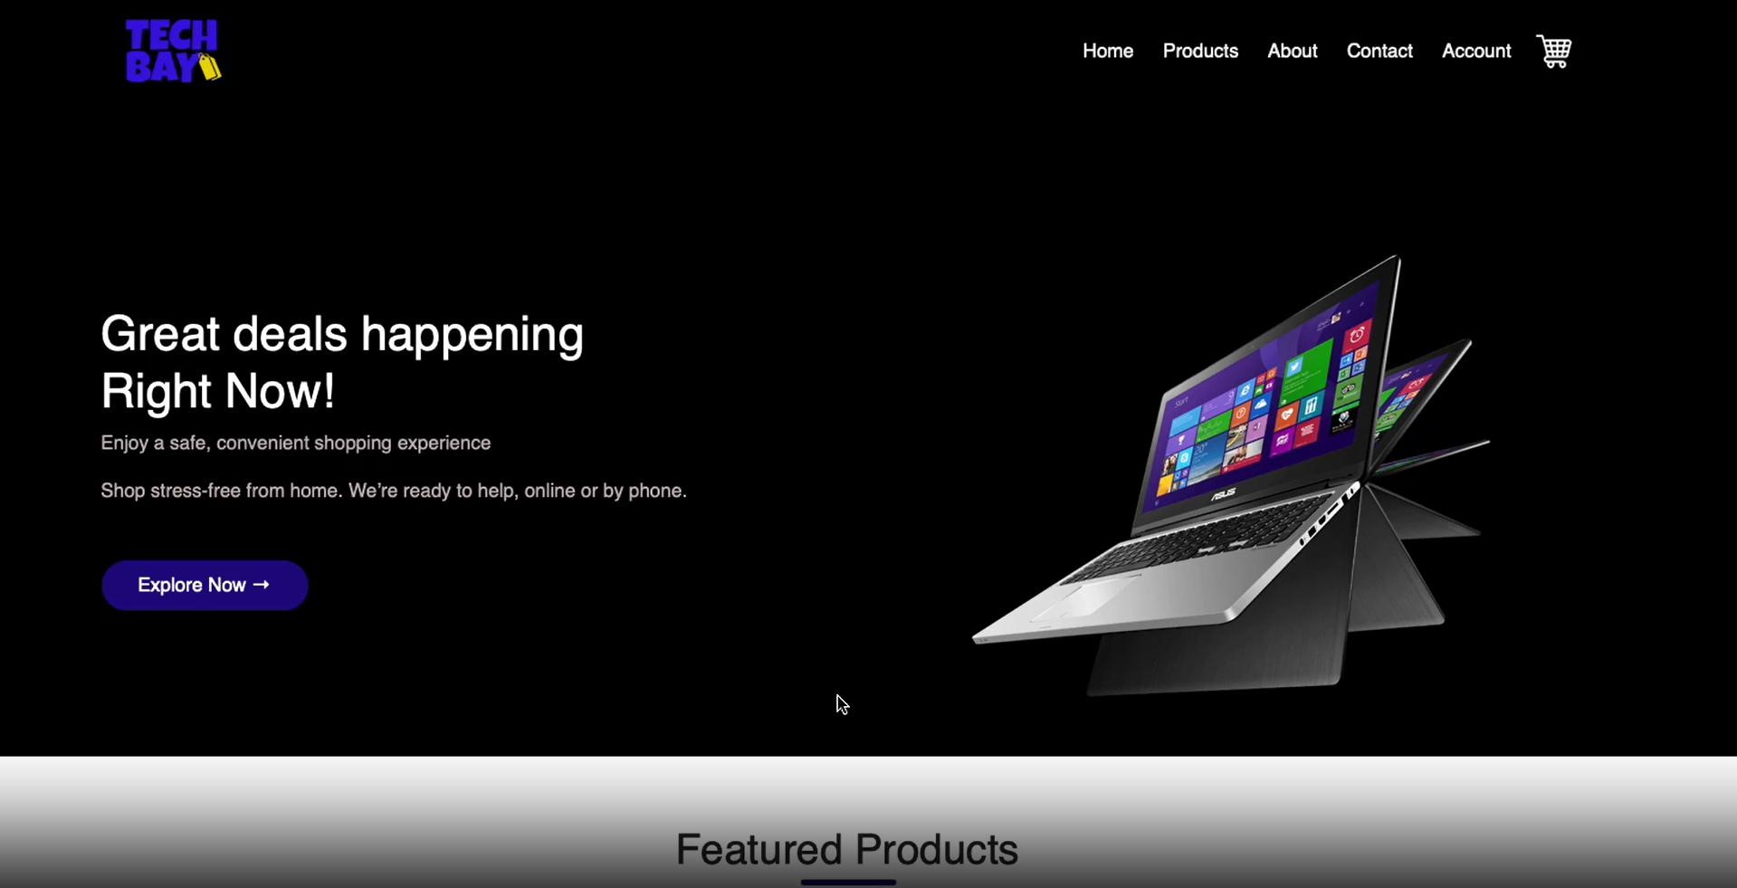

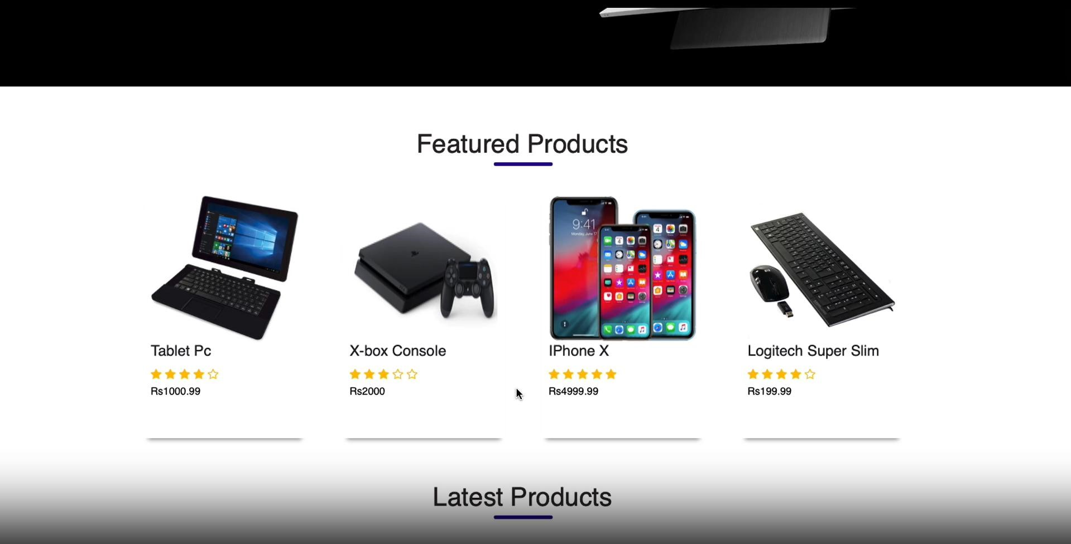

Conclusion

In conclusion, this project presents an exciting opportunity for students to develop a top-class e-commerce website using HTML, CSS, and JavaScript. By combining technical expertise with user-centric design principles, the project aims to create a user-friendly online platform that delivers a seamless shopping experience for users while also providing valuable learning opportunities for students.

