Logdists comparisons after subtracting the error contribution from the intrinsic scatter of the FP.

1. North vs South consistency check

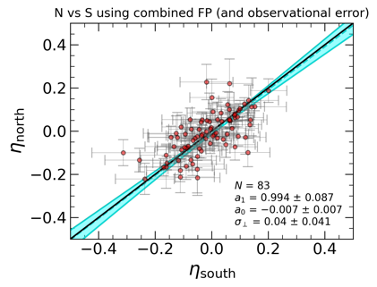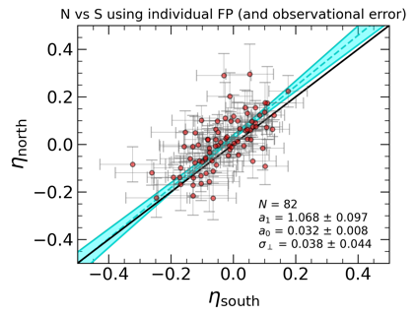

1. Cross-survey consistency check

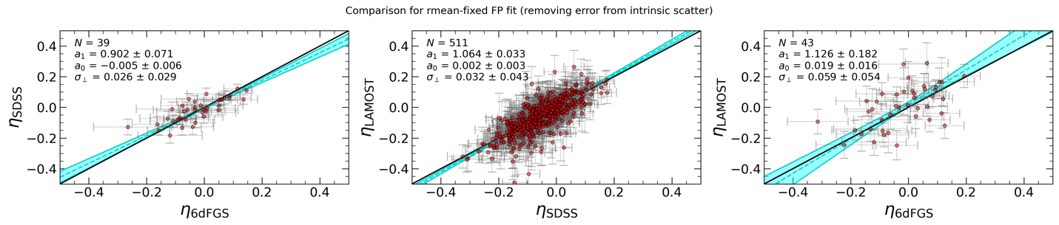

1. PV bias vs redshift

Logdists comparisons using the total error (observational + intrinsic).

1. North vs south consistency check

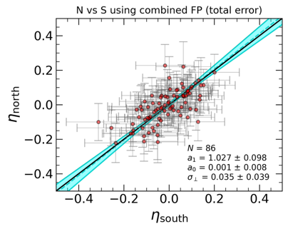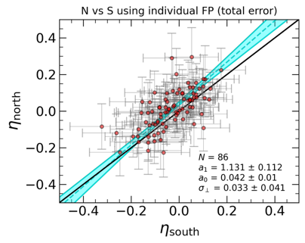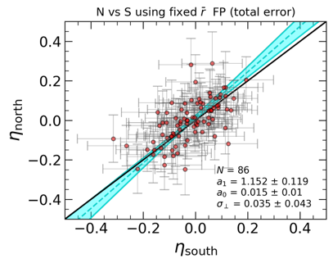

1. Cross-survey consistency check

