**1. Database Structure**  
  
**1.1 Main master table: MST_COUNTER**

This table holds the current number of all counters of all organizations. This table is updated at the request of the actual physical counter itself – at varied frequency.

|  |  |  |  |  |
| --- | --- | --- | --- | --- |
| **orgID** | **localCounterID** | **currentNo** | **lastSync** | **version** |
| AmbankKJ001 | CustService001 | 2003 | 2016-03-03 17:49:20.423 | 1 |
| AmbankKJ001 | CustService005 | 3001 | 2016-03-03 17:49:20.423 | 2 |
| KlinikAmpang005 | Receipt001 | 0003 | 2016-03-03 17:49:20.423 | 1 |

**orgID**: Unique identifier for organization i.e. KlinkAmpang001, AmbankKJ002

**localCounterID**: Unique identifier for each local counter. An organization might have multiple counters for multiple purposes.

**currentNo**: Current number on display for that particular counter i.e. 00xx. Updated at the request of the actual physical counter itself.

**lastSync**: Time for last update. Updated at the request of the actual physical counter itself.

**version**: Running number for every update. Updated at the request of the actual physical counter itself.

**1.2. Organization counter table: ORG_COUNTER**  
for each user tapping, an entry in this counter table is created. This counter table can have multiple numbers of local counters (each is unique and differentiated by combining orgID and localCounterID)

|  |  |  |  |  |  |  |
| --- | --- | --- | --- | --- | --- | --- |
| **orgID** | **localCounterID** | **userNo** | **paddingNo** | **userID** | **lastSync** | **version** |
| AmbankKJ001 | CustService001 | 2050 | 10 | mrafsyam@gmail.com | 2016-03-03 17:49:20.423 | 1 |
| KlinikAmpang005 | Receipt001 | 0005 | 10 | aizat@gmail.com | 2016-03-03 17:49:20.423 | 2 |

**userID**: Unique Identifier for each user i.e. hash(email)

**userNo**: User number taken from number machine i.e. 00xx

**paddingNo**: How many number left before reaching userNo before push notification should be sent out, can be fixed at 10

# **2. Events**

2.1 Physical counter at an organization sends an update on the counter number.   
  
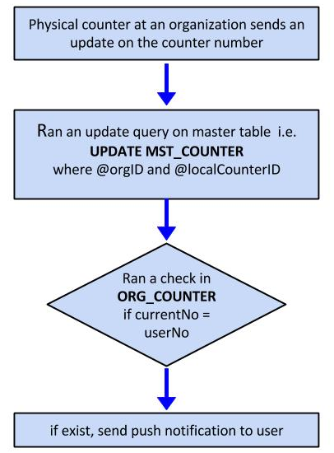

## 2.2 User register or update at a counter

